Carli McAvoy
11/29/2025
Module 7.2 Assignment

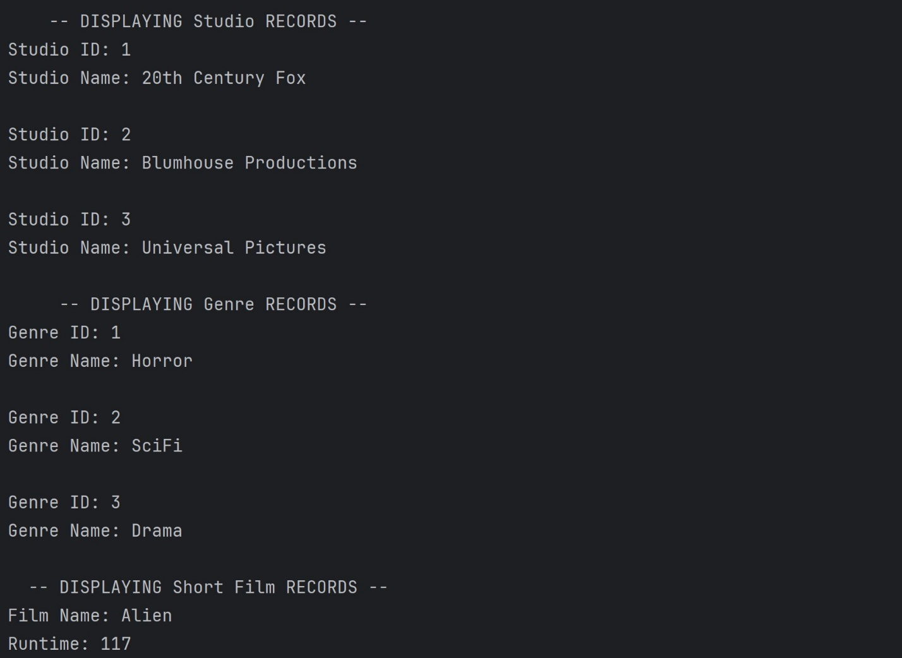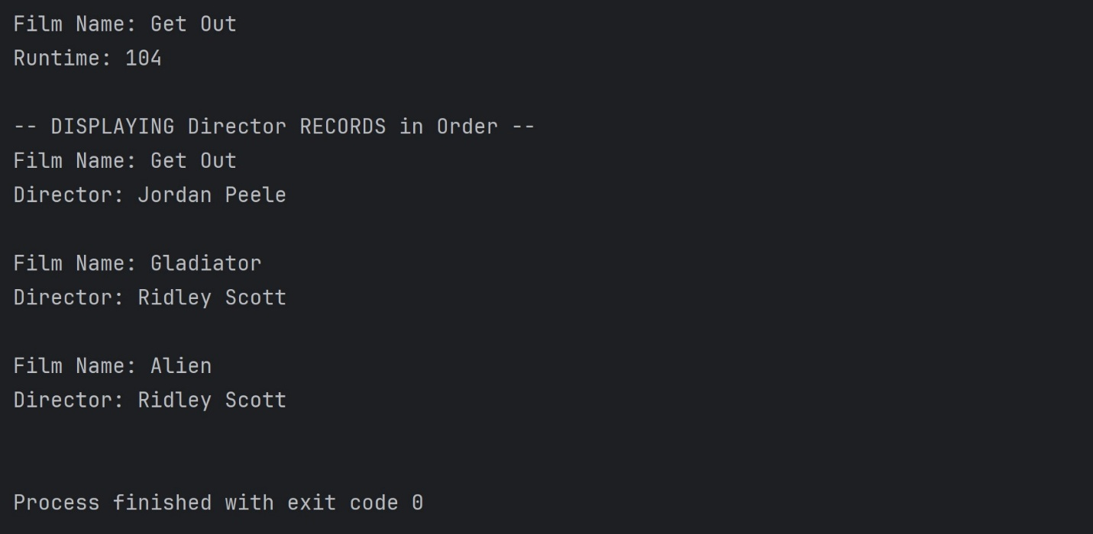

https://github.com/CarliMcAvoy/csd-310.git

