Carli McAvoy
11/29/2025
Module 8.2 Assignment
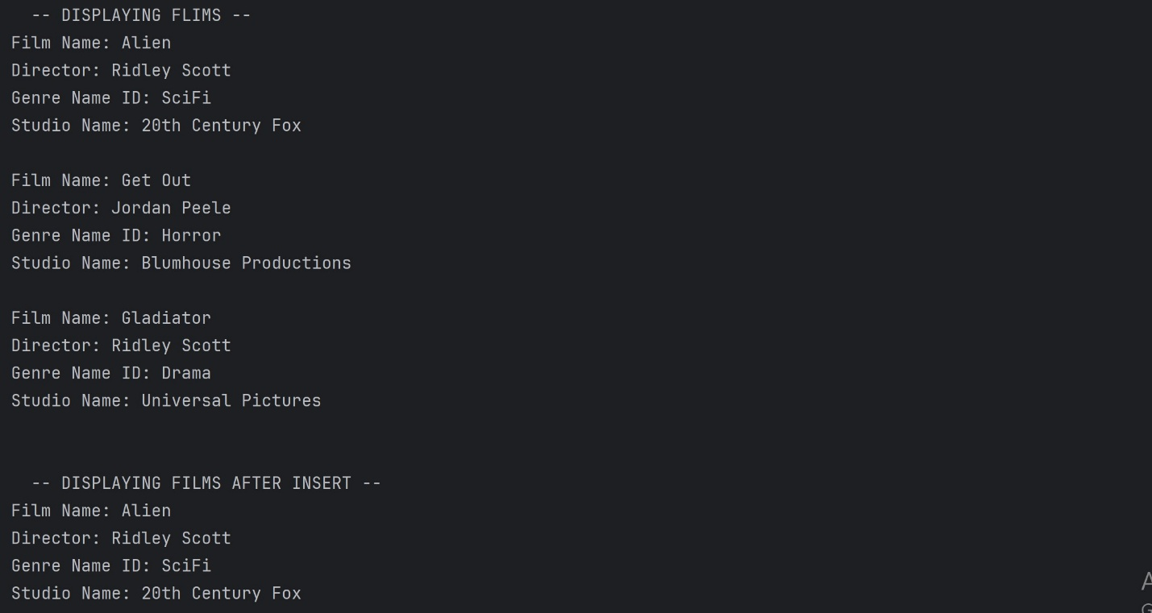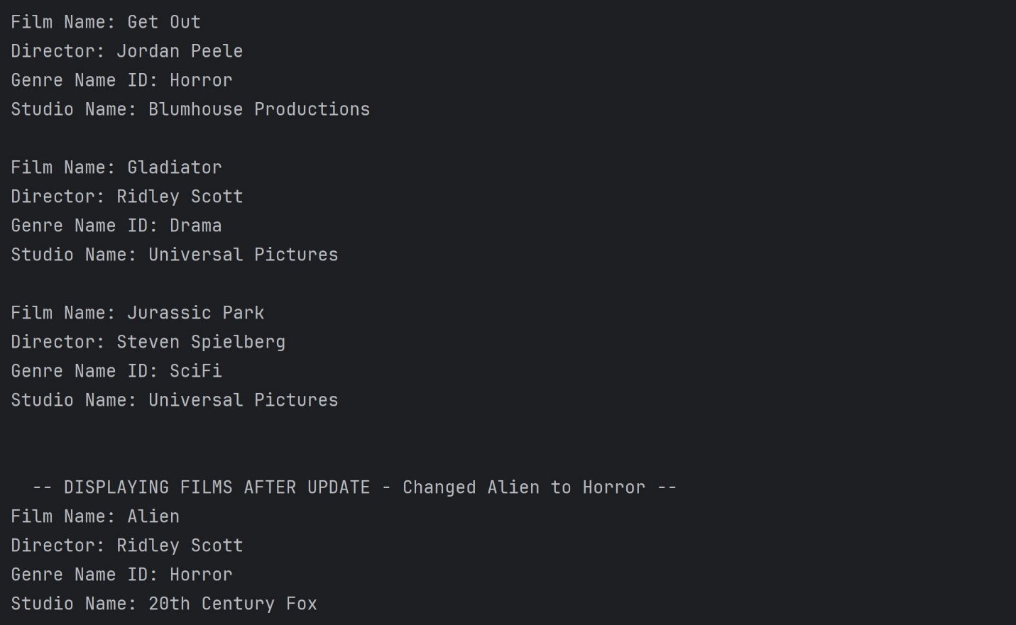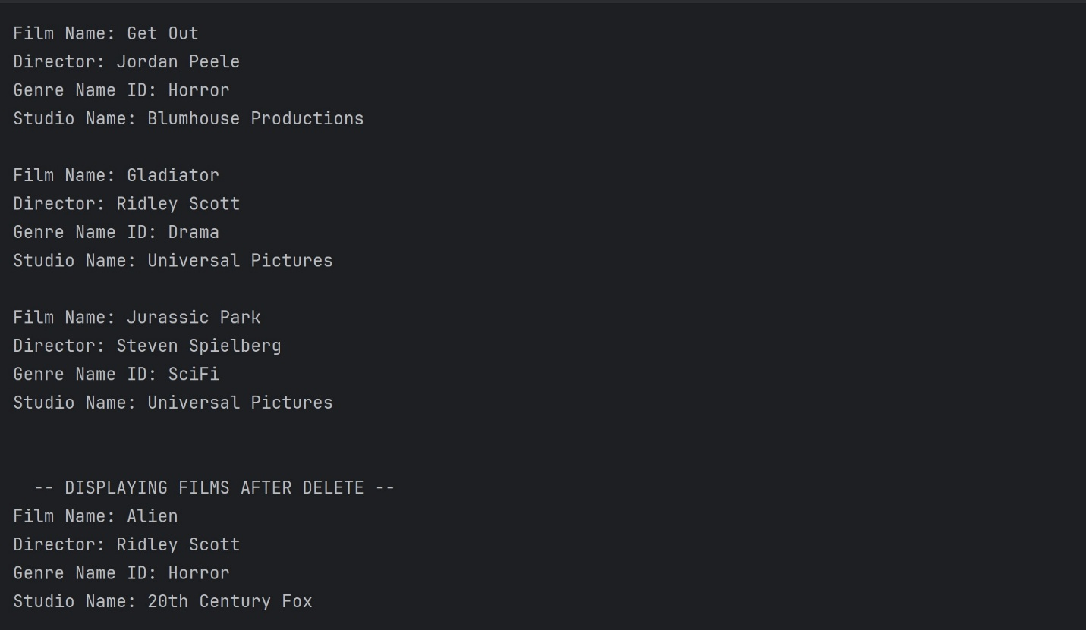
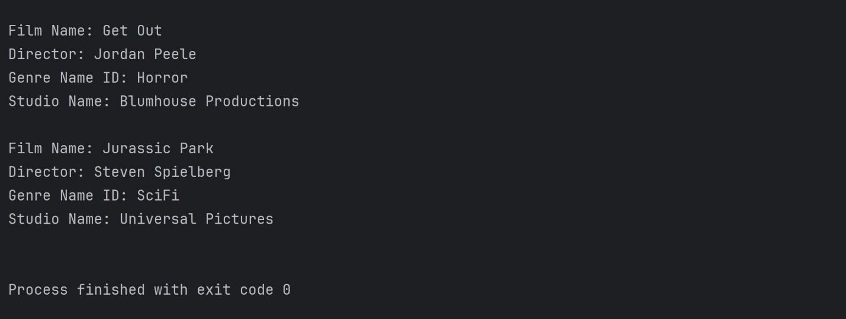
NOTE: I had difficulty using cursor as a parameter in the show_films function so I opted to use it how we did in module 7 and made it a global variable.

https://github.com/CarliMcAvoy/csd-310.git

