Carli McAvoy
2/8/2026
Module 5.2 Assignment

Front-end Style Guide
- Color Palette:
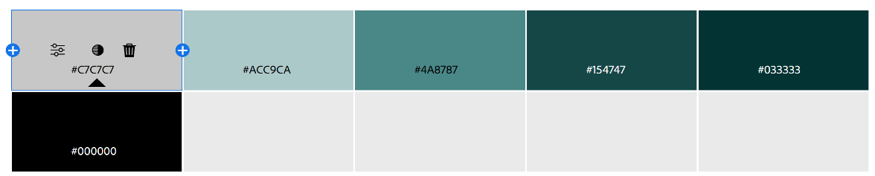
- Fonts:
  - Primary: “Playfair Display”, serif;
  - Secondary: “DM Sans”, sans-serif
- Elements:
  - <header>, <nav>, <div>,
  - <h1>, <h2>, <h3>, <p>, <ul>, <a>
  - <img>, <figure>, <figcaption>, <hr>, <br>

Wireframe
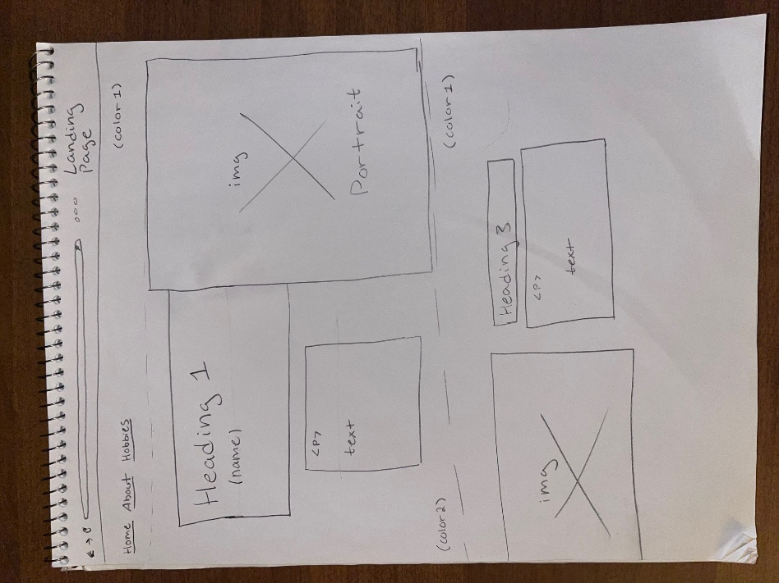

Interview
- Where were you raised and what did you like to do for fun growing up?
  - I was born in Massachusetts, but I was raised in west North Carolina. I loved to be outside in nature or playing music when I was younger.
- What are some accomplishments you’re proud of?
  - Teaching myself to play the guitar, being a part of my high school’s chorus, helping my mom work at the nursing home, and coming out to my friends and family as a part of the LGBTQ community.
- What are some things about yourself that you like?
  - Always having a strong integrity and helping those around me.
- What career did you imagine yourself having when you were younger?
  - Being a nurse like my mom or a veterinarian.
- What would you say are the most important aspects of your life right now?
  - Taking care of my home, my family, my partner, and my animals.
- What sort of hobbies do you have?
  - I love gardening, woodworking with my dad, pole dancing, yoga, and baking.
- What inspires you to keep up with your hobbies?
  - For joy and a sense of stability, learning new things, and feeling connected to my body. I loved baking for my mom as a kid, and I would often do gardening with my grandmother.
- Where do you see yourself in the future?
  - I see myself owning my own business selling home-grown goods and taking care of farm animals.
- Where do you want to travel?
  - I want to go to South America and Africa. I want to see the native animals in the jungles and in the desert. Maybe Greece, “Mamma Mia” style.
- Do you think you have a specific purpose in life?
  - To be a safe space for people and animals, and to learn as much as I can.

Subject Bio
Abigail Vadeboncoeur, although only 26 years old, has been living a life full of creativity, self-discovery, care for those around her, and endless generosity. Born in the northern state of Massachusetts, Abigail brought her Boston attitude down to North Carolina where her parents would find the home in which Abigail would spend most of her childhood.
Abigail spent most of her time outside in the woods, admiring the wildlife and picking up trash in the area around her neighborhood. When she wasn’t enamored with nature, Abigail found herself playing Taylor Swift on the guitar and would eventually join her high school chorus class. Full of an innate desire to help those around her, Abigail would often help her mother at the nursing home where she worked, tend to her grandmother’s garden, and bake desserts for her family. Being aware of her natural ability to nurture, Abigail often imagined herself following in her mother’s footsteps to become a nurse or a veterinarian.
In high school, Abigail continued to navigate her identity and establish truths about who she was and what she wanted to accomplish in her life. She found herself expressing her creativity not only through music, but through physical movement such as yoga, and eventually through pole dancing. Soon after graduating high school, Abigail found the courage to come out to her family as part of the LGBTQ community. Finding this courage proved to be difficult. There was little support and even less representation around her to give her the space to explore her identity comfortably, and some of her older family members faced prejudice after coming out themselves. However, Abigail finds herself now surrounded by support and unconditional love from those who matter most.
Now, Abigail finds herself living in a ranch home with her partner raising four dogs, two cats, and around twenty chickens. Abigial has continued to find joy in gardening, baking, hiking, yoga, pole dancing, caring for and rescuing animals, and has taken up woodworking which she enjoys doing with her father. Although her dream career has yet to be reached, Abigail is determined to open her own business selling her own vegetables, chicken eggs, natural goods, and eventually butcher her own farm animals. Through life’s challenges, Abigail remains a beacon of kindness for every being around her, and wishes only to provide safety and longevity for all those she meets along the way.

Photos
