Carli McAvoy
6/6/2026
Module 1.3 Assignment
Configurations
GitHub: https://github.com/CarliMcAvoy/csd-430.git

IDE (Intellij IDEA) with Tomcat version 11.0.22 and Jakarta EE plugins:
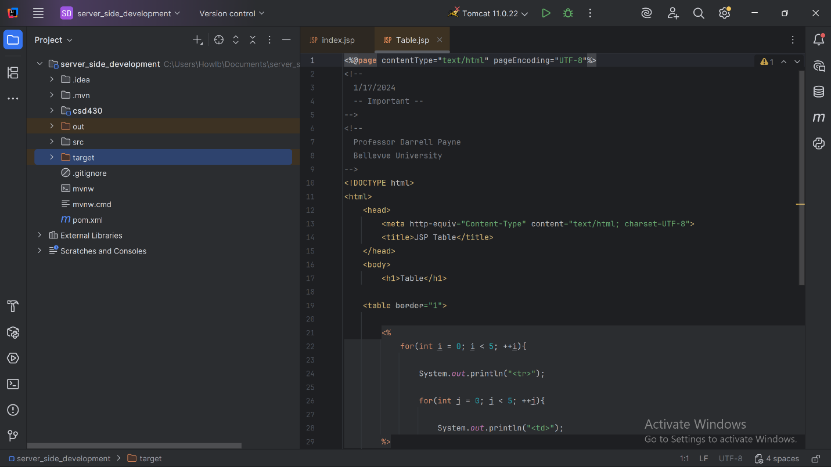

Launch of index and Table JSP files:
