Steps – Group Project

Check working directory in github

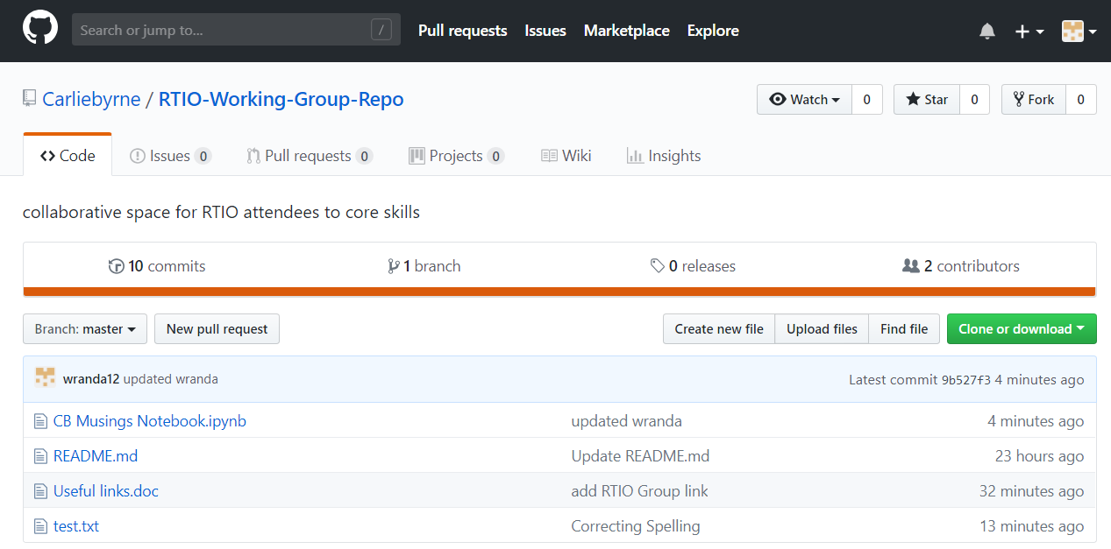

Chose you notebook (txt can be directly edit insitu and committed

Don’t forget to commit with comment

Open gitkraten to clone

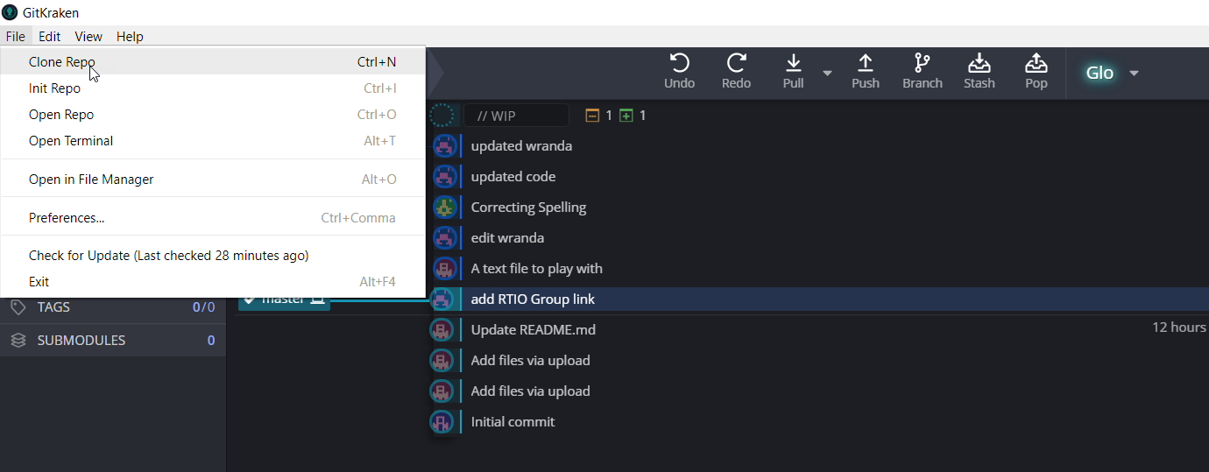

Clone Repo



Create your working directory

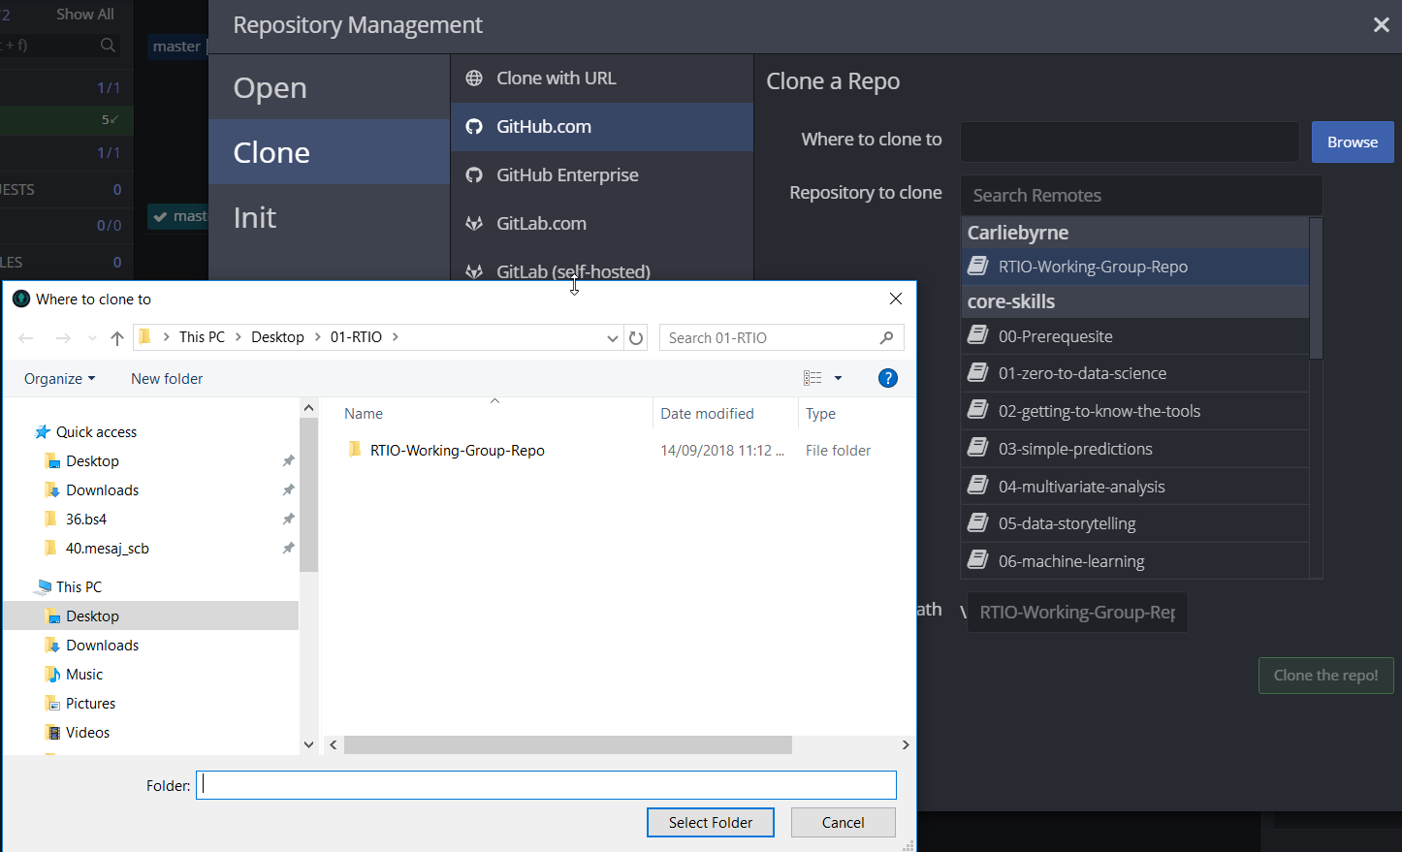

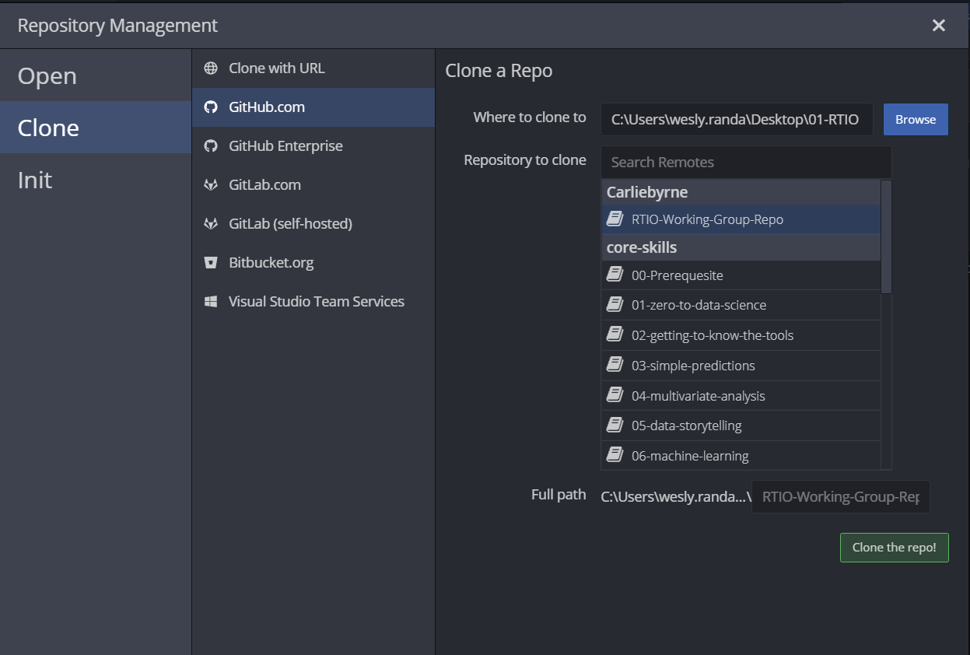

Clone the report

NOTEBOOK JUPITER

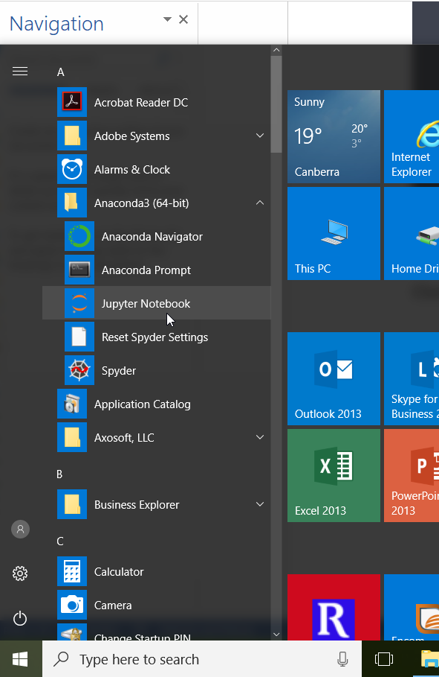

Find your working directory

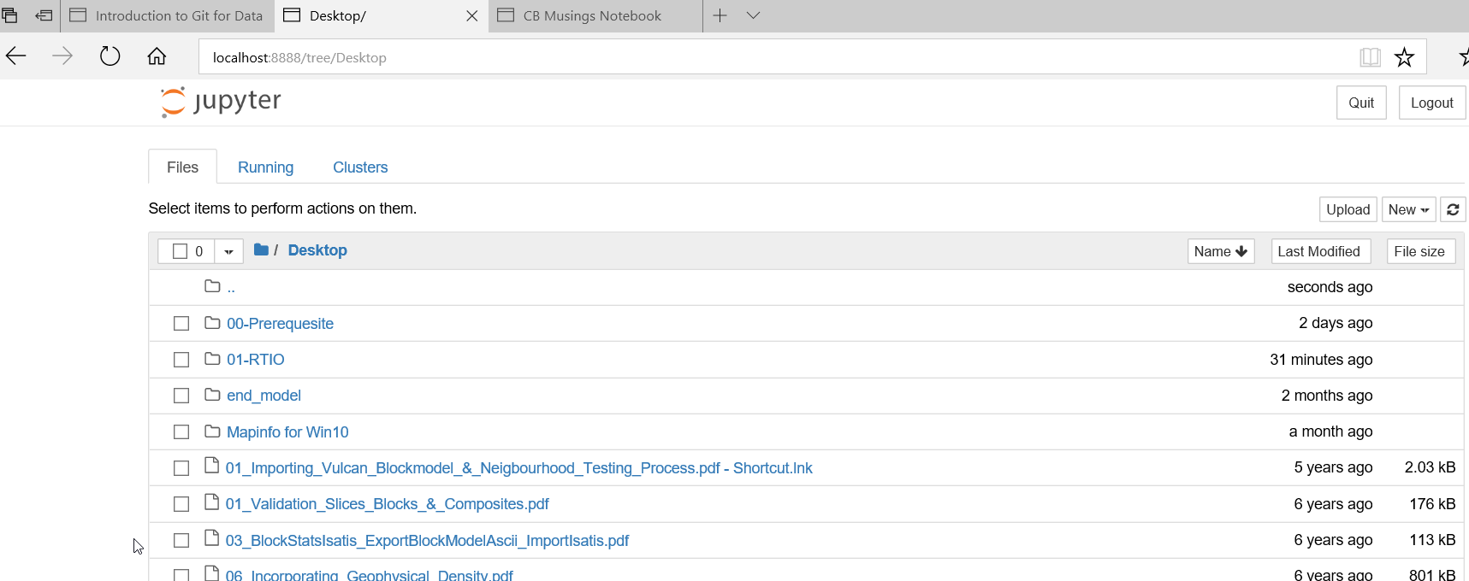

Once you find the working directory

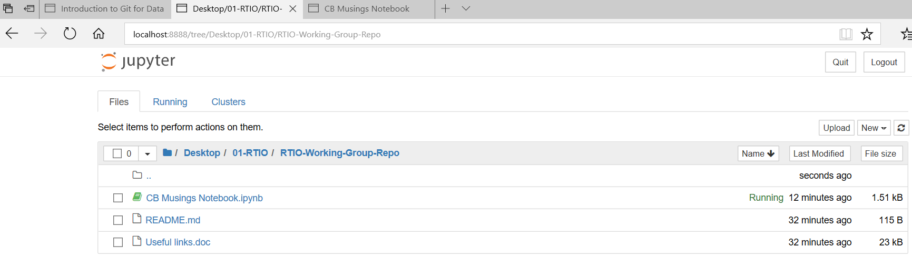

Open the python file

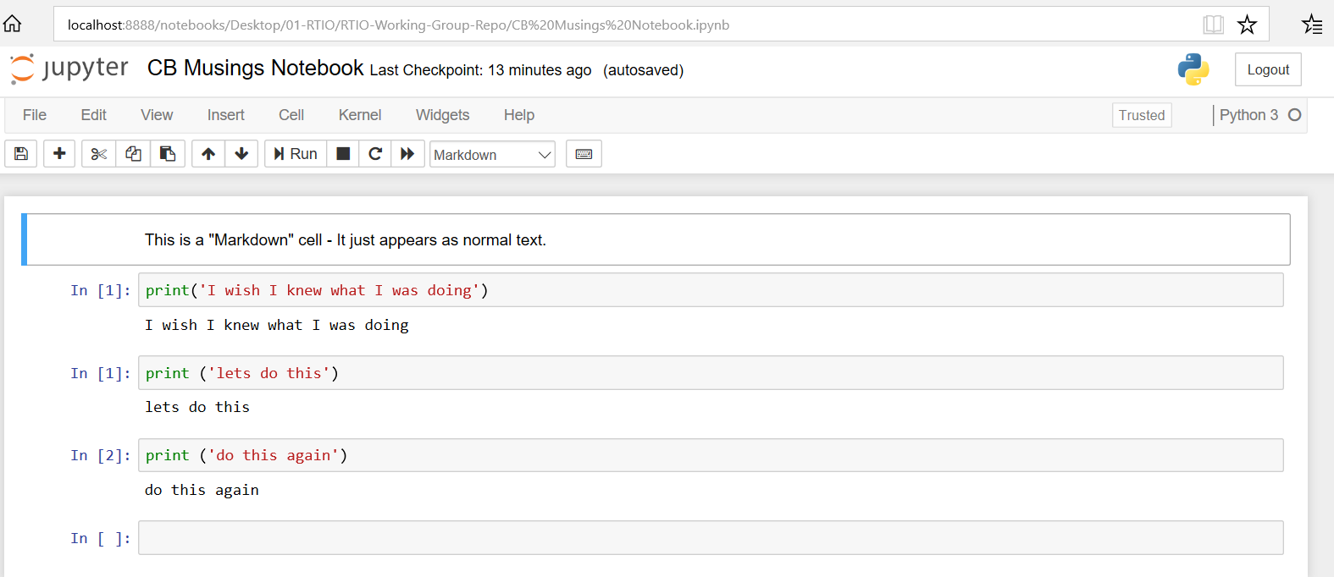

Do your editing – work and after finish

Fine your python file in the working directory

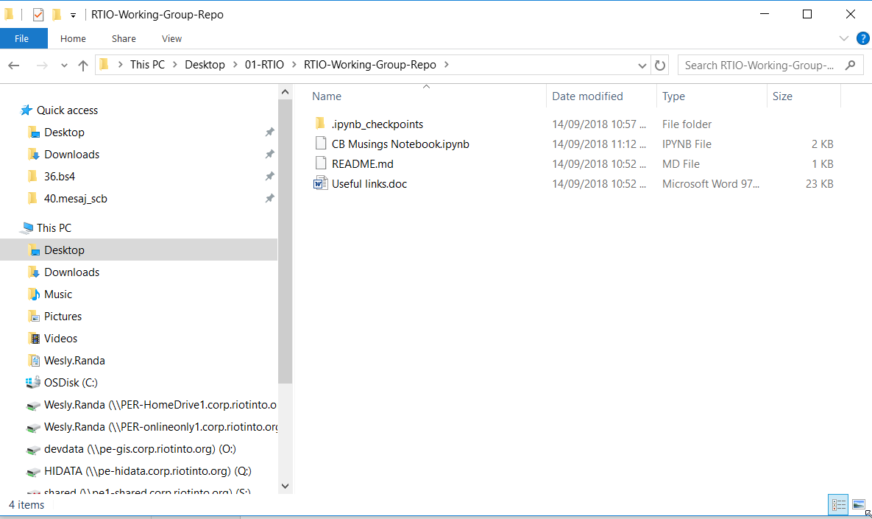

Drag into github

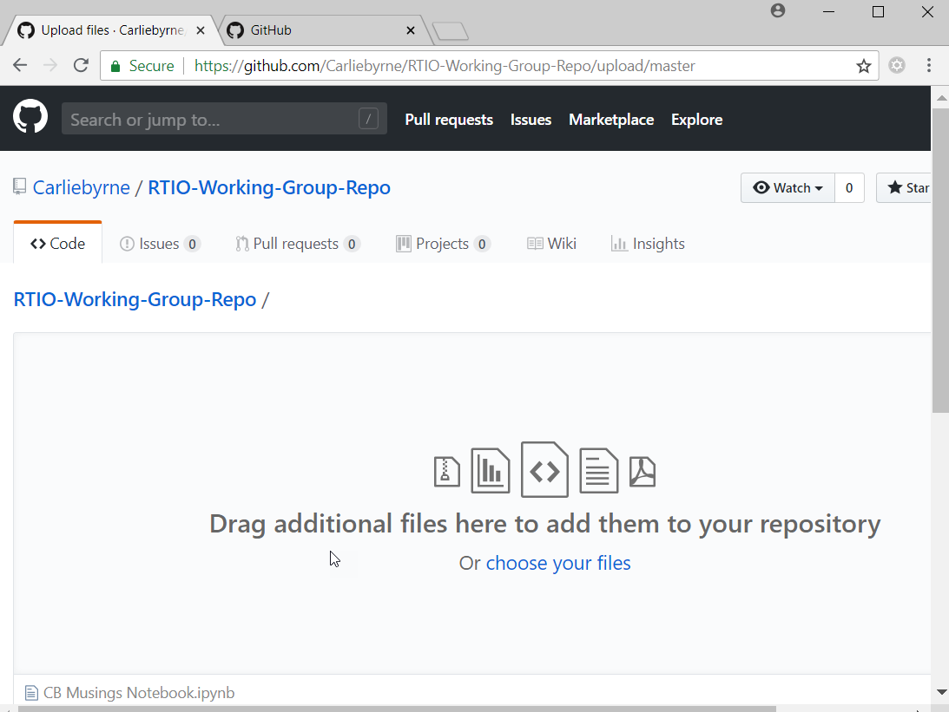

Commit with the change

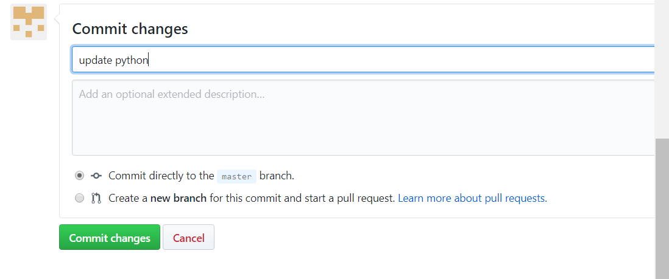

Check the version by refresh the page

