Abstract
The monitoring report system is a web application intended for the Department of the Interior and Local Government (DILG) of Bulacan. For rapid and accurate monitoring of their reports from Municipal/City Local Government Operators Officer (MLOGG/CLGOO). An Automated Report System is used for accurate submission and monitoring of reports immediately. Without this kind of system, the monitoring report of the DILG of Bulacan will be conducted manually by using a sample paper. The conceptual framework shows the researchers used the Input-Process-Output (IPO), model. It is a widely used approach in system analysis in describing the structure of an information processing program. The researchers gathered requirements needed in the study, such as pieces of information needed and used in their current manual monitoring system. The method and techniques used in the study is the conduct of interview and direct observation. The result shows that having an Automated Report System for the DILG - Bulacan is an advantage for its officials and staff. It strongly agreed that having an Automated Reports System in their office is very effective and efficient in keeping and monitoring records. The hypotheses of the study are significantly accepted with an overall weighted mean of 4.49. Therefore, the system is acceptable and is recommended for use.

CHAPTER 1
THE PROBLEM AND ITS BACKGROUND

Introduction
Today, we are living in a world where Technology is greater and better than before. As time goes on, the development of technology becomes more advanced and it makes our daily lives easier. Computers are the best example of a high technology, where everyone in the world, a company or an individual, has access to it. Computers are highly intelligent programmable advice where a developer has freedom of what feature he wants to have in it and use it to work efficiently. By developing a system, a computer has been playing a big role to everyone when it comes to either business or personal purposes. A computer system can make our work faster and help us perform multitasking. In this study, a computer is used to provide better research and presentation to provide that it is better than using the traditional manual method of work.
Technology is giving a lot of benefits for companies, government agencies, businesses, schools, and other forms of transactions. The use or involvement of advanced technology makes the work easy, fast and real-time through the fully automated system. With that being said, the proponents of Bulacan Polytechnic College decided to adopt the concept of automation process in regards with this and with the advent of Internet Technology now obviously popular and faster from the medium in the delivering update reports, the researchers take the opportunity to develop a system entitled "Automated Reports System: An Instrument Designed For Department of the Interior and Local Government (DILG) of Bulacan through Mobile Technology" with the advancement in technology where smartphones are very common, proponents propose the Mobile Technology enables them to easily produce information and reports. The MLGOO/CLMGOO or Municipal Local Government can make reports using the Mobile Technology and the Staff will easily view or check the reports posted.
Background of the Study
The study will focus on the Development of an Automated Reports System through Mobile Technology for the Department of the Interior and Local Government (DILG) of Bulacan. The main purpose of the system is to provide an easy way to upload and view reports from the Central office to Regional Office down Provincial Director into Staff and Municipal Local Government Operational Officer/City Local Government Operational Officer (MLGOO/CLGOO).
The Philippine Department of the Interior and Local Government (Kagawaran ng Interyor at Pamahalaang Lokal), abbreviated as DILG, is the executive department of the Philippine government responsible for promoting peace and order, ensuring public safety and strengthening local government capability aimed towards the effective delivery of basic services to the citizenry.
The Department is a primary catalyst for excellence in local governance that nurtures self-reliant, progressive, orderly, safe and globally competitive communities sustained by God-centered and empowered citizenry.
The Department shall promote peace and order, ensure public safety, and strengthen the capability of local government units through active people participation and a professionalized corps of civil servants.

Statement of the Problem
The general problem of the study is the difficulty of DILG on how to monitor the reports that they need to post online or before the deadline. Thus, the proponents formulated questions that are important in developing the system and these are:
- To know the status of the current monitoring reports system used by the Department of the Interior and Local Government (DILG) Bulacan.
- To know if there is a need for enhancement of the current system?
- To identify the problems encountered by the DILG Provincial office in terms of reports.
- To identify the basic features of the developed system intended for the office.
- To distinguish the acceptability of the developed system for the Department of the Interior and Local Government (DILG) of Bulacan in terms of;
  - Accuracy;
  - Efficiency;
  - Reliability;
  - Security; and
  - User – Friendly

The Significance of the Study
The proposed system will provide notifications to become real-time, accurate, effective and easy to access with their smartphones. Each employee and administrator can easily access their various reports instantly when and where in their smartphones. Instant notifications and being Web-Based application it will reduce paper works the information will be saved to the database.
The Development of an Automated Report System through Mobile Technology for Department of the Interior and Local Government (DILG) of Bulacan: A Web-Based monitoring of reports that will be beneficial to the following;
Department of the Interior and Local Governments Provincial Office Bulacan. The team can immediately monitor the status of the reports from the located City/Municipalities in Bulacan. It will also help the team in creating an effective and decisive decision seminar on how to act fast to help the people in need.
Provincial Director. The head officer of the Department of the Interior and Local Government of Bulacan is the admin to the proposed system and the one who controls o to monitor the system.
Senior Officer/Staff. The head of staff of every MLGOO/CLGOO in-charge for easy access and monitoring of the status of reports.
Researchers. To test their skills and abilities but at the same time they are learning they will gain experience on how to create their own company and how will they face the problems that a real company is facing in real life.
Future Researchers. The study of the previous researchers can be used as their reference for their future researchers or study.

Status of the Current System
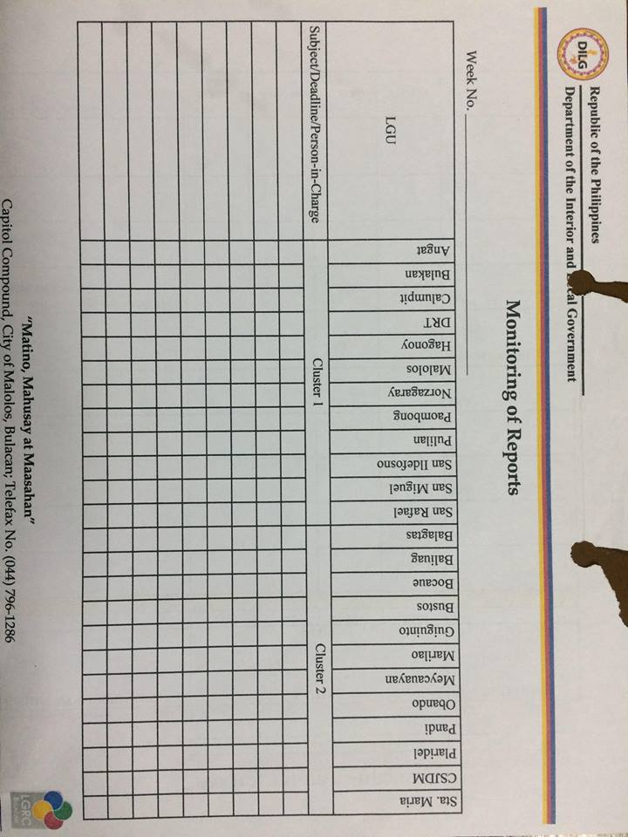
Similar to other organizations, DILG-Bulacan also uses a manual way to monitor the reports of selected Municipalities in Bulacan to get data or information. When the reports have been received by the staff or officers-in-charge on that report they mark the simple monitoring sheet. The Monitoring Reports Sheet is a simple paper to monitor who among the MLGOO/CLGOO submit reports on the time required by the Provincial Office.

Figure 3.1
Existing System - Manual Monitoring Reports

Replacing the Current System
With the help of the interview and research conducted, the proponents would like to replace the current monitoring reports system of the Department of Interior and Local Government (DILG) Bulacan into Development of an Automated Reports System through Mobile Technology for Department of the Interior and Local Government (DILG) of Bulacan that will conserve the time used in submitting reports that needs to make communication faster.

Scope and Delimitation
The proponents aim to develop a Web-Based monitoring system that will help the administrators and employees of the Department of the Interior and Local Department (DILG) for easy access. The system will only be used by the Department of the Interior and Local Department Provincial Office of Bulacan. The system is designed to update reports. In access control, the super admin can control each Municipal or City Local Government Operations Officer in case of malicious attacks. Also, the Municipal or City Local Government Operations Officer needs the approval of the administrators upon registering on the system.
The system is developed only for the Department of the Interior and Local Government (DILG) Provincial Office of Bulacan and cannot be used by other establishments nor other companies. The report cannot be filtered weekly, monthly, and yearly.

CHAPTER II
THEORETICAL FRAMEWORK

RELEVANT THEORIES
The researchers adapted three theories related to the Web-based monitoring system and Project Sustainability Monitoring specifically the theory of change, web-based theory, and the system theory.
The Theory of Change
The pieces and steps are necessary to bring about a given long-term goal. It describes the types of interventions (whether a single programme or a comprehensive community initiative) that bring about the results hoped for. It includes the assumptions (often supported by research) that stakeholders use to explain the process of change. (IEE, 2003)

The Systems Theory
This theory suggests that if a system is evaluated and improved, feedback is significant to calibrate the effect from the previous state and make necessary adjustments. (Stichweh R, 2007)

Web-based theory
Explores the shifts in society, culture and the media which have been brought about by the growth of the World Wide Web. It identifies significant readings. Web sites and hypertext archive resources that illustrate the critical discussion and the Internet and it mediates these discussions, indicating key positions within each debate and pointing the reader to key texts. (Burnett, 2000)
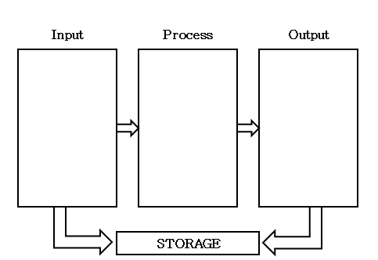
Reports from Provincial Director to Staff / Officers
Print the report using google drive or MS Office and Phone call and text the MLGOO/CLGOO to see the reports on the provincial office of Bulacan.
Figure 2.1
Theoretical Framework of the Existing System
Figure 2.1 shows that the study used the Inpu0Process-Output framework wherein the Staff will INPUT all reports needed from the Provincial Director’s Office, the MLGOO/CLGOO to PROCESS and fill-in all the information needed for the report. the OUTPUT will be all the reports submitted by the MLGOO/CLGOO be placed in the storage system.

Related Studies
Technologies of the Fourth Industrial Revolution1 are blurring the lines between the physical, digital and biological spheres of global production systems. The current pace of technological development is exerting profound changes in the way people live and work. It is impacting all disciplines, economies, and industries, perhaps none more so than production, including how, what, why and where individuals produce and deliver products and services. However, amid overcharged media headlines and political and social landscapes, business and government leaders find it difficult not only to have an accurate understanding of where these technologies can create real value but also to successfully focus on the appropriate and timely investments and policies needed to unlock that value. (A.T. Kearney, 2017)
The data science ‘tsunami' led by multinational companies like Amazon, Google, Facebook, Uber, Alibaba, Tencent, etc. is radically changing how we work and socialize and is disrupting employment. The disruption caused by the key technologies—namely artificial intelligence, Internet of Things (IoT), big data, behavioral/predictive analytics, and blockchain technologies—offers the greatest potential in the public sector to transform the way governments engage with citizens, make policy-decisions and manage the national infrastructure. Sophisticated data and analytics infrastructures, when combined with trusted recordkeeping concepts such as blockchain distributed ledger and smart contract technologies, may provide a feasible framework to redefine public services in a decentralized, lower cost, more efficient and personalized manner.
Many governments have established a digital government or eGovernment program to introduce data science technologies into the public sector. Data science technologies pioneered in the private sector are ripe for transforming the public sector. Applications can include public engagement through natural language text and speech Chatbots and intelligent assistants; support of civil servants via AI-based Robo-advisors; securing public records using blockchain distributed ledgers, and encoding and codifying laws using blockchain smart contracts. Further application areas may include using big data and behavioral/predictive analytics for public policy development; automating the courts using AI-based judicial systems and online dispute resolution, and managing the national infrastructure in real-time using the Internet-of-Things technology. (P. Treleaven, 2018)
Conceptual Framework
Development of an Automated Reports System through Mobile Technology for Department of the Interior and Local Government (DILG) of Bulacan
Development of an Automated Report System
Through Mobile Technology
Figure 2.2
Conceptual Framework of the Proposed System

Figure on shows that the input procedure is the development of an automated report system for the Department of the Interior and Local Government (DILG) of Bulacan. Wherein the process is to upload the reports through the web-based system by the Staff or Senior Officer-in-charge that will be submitted to the MLGOO/CLGOO. Continuing the procedure is when the output will be on the downloading and monitoring of reports, as well as the ease in accessing of the MLGOO/CLGOO/PD thru the web-based system and it will automatically save all the report on the database system.

Definition of Terms
The following terms are operationally defined by the proponents for better understanding and clarity:
Admin. Refers to the Provincial Director of the Department of the interior and Local Government (DILG) Bulacan who is in-charge to monitor the submitted reports.
Automated. This refers to the evolution of the system from manual or existing systems to the modernized system.
Database. Refers to the Storage of the Automated Report System: An Instrument Designed for Department of Interior and Local Department (DILG) of Bulacan through Mobile Technology.
Real-time. Refers to the happening in the actual time.
Smartphone. It refers to the gadget that works like a computer and has a touchscreen and color display features with a graphical user interface.
Users. It pertains to the Staff, Senior Officer, MLGOO/CLGOO of the Department of Interior and Local Government (DILG) Bulacan describing the structure of an information processing program or other processes.

CHAPTER III
METHODOLOGY OF THE STUDY

Methods and Techniques
The study is applied research focused on the information dissemination issues. Applied Research refers to scientific study and research that seeks to solve practical problems. It is used to find a solution to every reported problem and develop innovative technologies than to acquire knowledge for knowledge sake.
Research Method
The proponents made research for the process of monitoring reports of the Department of Interior and Local Government (DILG) of Bulacan, which is the manual way. They have come up with the idea that the manual way should really be changed into an automated one.
Based on the research, the reports coming from the Central Office down to the Regional Office to Provincial Office wherein the staff or the senior officers will distribute the reports into the Municipal/City Local Operation Officer (MLGOO/CLGOO) via google drive or Email to send. The manual monitoring reports is a sample paper wherein the person-in-charge of the reports she/he will record on the manual monitoring sheet those MLGOO/CLGOO who submitted reports. While the Report System, it is the MLGOO/CLGOO that will make a call to the staff or the senior officer for clarification of the information regarding the reports.
Library Method
The proponents used resources material such as thesis documents. It is written by local students in which their study is related to the software project of the proponents. It provides a general idea and knowledge in developing and designing software.
Interview
To know the point of view and to gather information as well. The proponents interviewed Sir. Benedict M. Pangan (ADA IV) and Sir. Paolo Israel S. Franco (LGOO III) of Department of the Interior and Local Government (DILG) of Bulacan on September 10, 2018 (see appendix)
Peer-to-Peer
The proponents divided the task to minimize the workloads and make all the team members productive. Jaymart Maala, the team leader is in charge of the documentation and act as the group researcher and front-end. Aldrich Tome and Carlo Delos Santos were assigned to create the front-end and back-end of the system.

Target Clientele
The Development of an Automated Report System is intended for use primarily by the Department of the Interior and Local Government (DILG) of Bulacan. In terms of report system, it will provide an easy way to upload and view reports from the Central office to Regional Office down Provincial Director into Staff and Municipal Local Government Operational Officer/City Local Government Operational Officer (MLGOO/CLGOO).

Designed Features of the Developed System
The Important attributes that to enhance the current monitoring reports system of the Department of the Interior and Local Government (DILG) Bulacan are the following.
- Accurate – the data and information used and the database contains the exact information
- Efficient – the Web-Based performs proficiently. Also, it uses the least amount of inputs but provides the greatest amount of information regarding the queries.
- Reliable – the source where the data are gathered gives trustable information and the mobile application consistently perform according to its specification.
- Secure – the Web-Based is equipped with the security username, password and position in the Administrator part to prevent other users to utilize and modified information without consent.
- User-Friendly - the Web-Based is designed in such a way that it is easy to use, learn and understand.

Proposed System
Development of an Automated Reports System through Mobile Technology for Department of the Interior and Local Government (DILG) of Bulacan
Staff/Officers edit the reports using the google drive in the proposed system the send to MLGOO/CLGOO to view the reports and edit using the system.
Register / login
Reports from provincial Director

*
*
Figure 3.1
The framework of the Proposed System

The admin will upload the reports on the proposed system via Google Drive to send Staff or Senior Officer-in-charge on the report given by the admin. It will be sent to MLGOO/CLGOO to view the report by using Google Doc. MLGOO/CLGOO to input data and report the status of their Municipality. All reports will be processed and sent to the Staff or Senior Officer to view the report from MLGOO/CLGOO and automatically be saved on the database of the system.

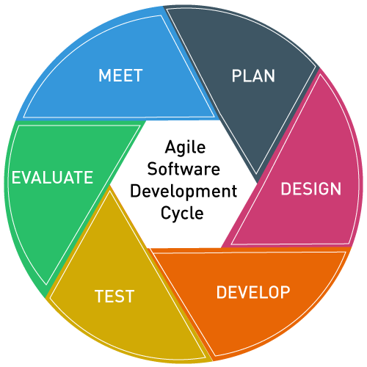
Developmental Process of the Study

Figure 3.2
Agile Software Development Cycle

Agile Development is an umbrella term for several iterative and incremental software development methodologies, the most agile methodologies include Extreme Programming (XP), Scrum, Crystal, Dynamic System Development Method (DSDM), Lean Development and Feature-Driven Development (FDD). They all fundamentally incorporate interaction and the continuous feedback that it provides to successively refine and deliver a software system. They all involve continuous planning, continuous testing, continuous integration, and other forms of the continuous evolution of both the project and the software. They are all lightweight, especially compared to traditional monitoring reports process. What is more important about the agile method is that they if all focus on empowering people to collaborate and make the decision together efficiently and effectively.

Determining the Acceptability
To determine the acceptability of the system, the Likert scale were used:

Table 3.1
Statistical Margin
Intervals | Description
4.50 – 5.00 | Highly Acceptable (HA)
3.50 – 4.49 | Acceptable (A)
2.59 – 3.49 | Moderately Acceptable (MA)
1.50 – 2.49 | Unacceptable (UA)
1.00 – 1.49 | Highly Unacceptable (HU)

Title | Indicators | Rating |  |  | Mean | Description
Title | Indicators | Expert 1 | Expert 2 | Expert 3 | Mean | Description
Accuracy | 1. The information coming from the website is legitimate.
Accuracy | 2. The database contains and provides valid information.
Accuracy | 3. The data representation is precise.
General Weighted Mean
The data were subjected to a test for the statistical mean of all criteria. Table 3.2 Accuracy

Title | Indicators | Rating |  |  | Mean | Description
Title | Indicators | Expert 1 | Expert 2 | Expert 3 | Mean | Description
Efficiency | 1. The Web Application appears on the browser for less than 60 seconds.
Efficiency | 2. The Web Application responds within 20 seconds once the data is entered.
Efficiency | 3. The Web Application providing an answer to queries.
General Weighted Mean
Table 3.3 Efficiency

Title | Indicators | Rating |  |  | Mean | Description
Title | Indicators | Expert 1 | Expert 2 | Expert 3 | Mean | Description
Reliability | 1. The data source of the web application is trustworthy.
Reliability | 2. The output data of the web application is dependable.
Reliability | 3. The web application assures reliable information.
General Weighted Mean
Table 3.4 Reliability

Title | Indicators | Rating |  |  | Mean | Description
Title | Indicators | Expert 1 | Expert 2 | Expert 3 | Mean | Description
Security | 1. The source code cannot be easily modified on the internet?
Security | 2. The web application cannot prone to any malicious attack.
Security | 3. The information cannot be easily altered.
General Weighted Mean
Table 3.5 Security

Table 3.6 User – Friendliness
Title | Indicators | Rating |  |  | Mean | Description
Title | Indicators | Expert 1 | Expert 2 | Expert 3 | Mean | Description
User  Friendliness | 1. The fonts, the image used suited to each other.
User  Friendliness | 2. The web application supports any browser.
User  Friendliness | 3. There are no broken links and hypermedia.
General Weighted Mean

CHAPTER IV
PRESENTATION, ANALYSIS, AND INTERPRETATION OF DATA

This chapter presents, analyzed and interprets the data gathered by the researchers.
The summary of the output is tabled at the end of the chapter to distinguish the acceptability of the proposed system.
1. To know the status of the current monitoring reports system used by the Department of the Interior and Local Government (DILG) Bulacan.
The current manual monitoring report system of the Department of Interior and Local Government of Bulacan using simple paper is monitored by the Provincial Staff of DILG.

The Provincial Staff of the DILG of Bulacan were satisfied with how they monitor and gather the report's data from the MLGOO/CLGOO to the current system.

2. To know if there is a need for enhancement of the current system.
Replacing the current system will be a preference if the developed system will do better than the current traditional manual monitoring system and can go with the latest technology trends and future demands of the specific user.

3. To identify the problems encountered by the DILG Provincial office in terms of reports.
According to the interviewee, the current monitoring report system is incapable of processing the data of the report continuously since it is tedious for the staff top encode and monitor the submitted reports manually.

4. To identify the basic features of the developed system intended for the office.
The important attributes that enhanced the current monitoring reports of the Department of Interior and Local Government of Bulacan are the following:
- Accuracy – the data and information used and presented in the webpage are error-free and the database contains exact information.
- Efficiency– web-based monitoring performs faster. It also uses the least amount of inputs but provides the greatest amount of information regarding the queries.
- Reliable – the sources where the data are gathered and stored are accurate and keep pieces of information wherein the web-based consistently perform according to its specification.
- Secured – the web-based monitoring is equipped with an email address and password that cannot be accessed by the unauthorized user.
- User-Friendly – the web-based monitoring is design in such a way that it is easy to use, learn and understand.

5. To distinguish the acceptability of the developed system for the Department of the Interior and Local Government (DILG) of Bulacan in terms of;
A survey form was created to assess the acceptability of the developed system and was given to the experts. Their responses to the statements about the accuracy, efficiency, reliability, security, and user-friendliness were tallied and have given their corresponding weights.

5.1. Accuracy
One of the important aspects of a functional web-based is its accuracy in giving legitimate and precise information. It is what makes the application of any kind useful to the user. Table 1 presents the weighted mean of the experts' response regarding the accuracy of the Automated Reports System for the Department of the interior and Local Government of Bulacan.
Title | Indicators | Rating |  |  | Mean | Description
Title | Indicators | Expert 1 | Expert 2 | Expert 3 | Mean | Description
Accuracy | 1. The information coming from the website is legitimate. | 5.00 | 5.00 | 5.00 | 5.00 | High Acceptable
Accuracy | 2. The database contains and provides valid information. | 4.00 | 5.00 | 5.00 | 4.67 | High Acceptable
Accuracy | 3. The data representation is precise. | 5.00 | 5.00 | 5.00 | 5.00 | High Acceptable
General Weighted Mean |  |  |  |  | 4.89 | High Acceptable
Weighted Mean and Description of the Expert Response on the Accuracy of the Developed System
Table 5.1

The experts generally rated the system as highly acceptable in terms of accuracy as being revealed by the general weighted mean of 4.89
5.2. Efficiency
The effective delivery of information and providing answers to what is being asked is another criterion in developing web-based. Table 2 shows the weighted mean and description of the experts' response on the efficiency of the Automated Reports System for the Department of the interior and Local Government of Bulacan.

Title | Indicators | Rating |  |  | Mean | Description
Title | Indicators | Expert 1 | Expert 2 | Expert 3 | Mean | Description
Efficiency | 1. The Web Application appears on the browser for less than 60 seconds. | 5.00 | 4.00 | 4.00 | 4.33 | Acceptable
Efficiency | 2. The Web Application responds within 20 seconds once the data is entered. | 5.00 | 5.00 | 5.00 | 5.00 | High Acceptable
Efficiency | 3. The Web Application providing the answer to queries. | 5.00 | 5.00 | 5.00 | 5.00 | High Acceptable
General Weighted Mean |  |  |  |  | 4.78 | High Acceptable
Weighted Mean and Description of the Expert Response on the Efficiency of the Developed System
Table 5.2

The experts generally rated the system as highly acceptable in terms of efficiency as being revealed by the general weighted mean of 4.78.

5.3 Reliability
The ability of the system to perform the task provided and how reliable the output it generated makes the reliability of functional web-based. Table 3 shows the weighted mean and description of the experts' response on the reliability of the Automated Reports System for the Department of the interior and Local Government of Bulacan.

Title | Indicators | Rating |  |  | Mean | Description
Title | Indicators | Expert 1 | Expert 2 | Expert 3 | Mean | Description
Reliability | 1. The data source of the web application is trustworthy. | 5.00 | 5.00 | 5.00 | 5.00 | High  Acceptable
Reliability | 2. The output data of the web application is dependable. | 5.00 | 5.00 | 5.00 | 5.00 | High Acceptable
Reliability | 3. The web application assures reliable information. | 5.00 | 4.00 | 5.00 | 4.76 | High Acceptable
General Weighted Mean |  |  |  |  | 4.89 | High Acceptable
Weighted Mean and Description of the Expert Response on the Reliability of the Developed System
Table 5.3

The experts generally rated the system as highly acceptable in terms of reliability as being revealed by the general weighted mean of 4.89.
5.4. Security
The accuracy, efficiency, reliability, and user-friendliness of the web-based will be useless if it is not secured and is easily penetrated. Security is one of the most important aspects of a well-developed web-based. Table 4 shows the weighted mean and description of the experts' response on the reliability of the Automated Reports System for the Department of the interior and Local Government of Bulacan.

Title | Indicators | Rating |  |  | Mean | Description
Title | Indicators | Expert 1 | Expert 2 | Expert 3 | Mean | Description
Security | 1. The source code cannot be easily modified on the internet? | 3.00 | 4.00 | 3.00 | 3.33 | Moderately Acceptable
Security | 2. The web application cannot prone to any malicious attack. | 4.00 | 3.00 | 3.00 | 3.33 | Moderately Acceptable
Security | 3. The information cannot be easily altered. | 4.00 | 4.00 | 3.00 | 3.67 | Acceptable
General Weighted Mean |  |  |  |  | 3.44 | Moderately Acceptable
Weighted Mean and Description of the Expert Response on the Security of the Developed System
Table 5.4

The experts generally rated the system as moderately acceptable in terms of security as being revealed by the general weighted mean of 3.44.

5.5. User-Friendly
Making a system function must not only the center of web-based development. It must consider the users of the application, how important it is and how it can be easily understood even by users who are not that knowledgeable in using web-based. Table 5 shows the weighted mean and description of the experts' response on the user-friendliness of the Automated Reports System for the Department of the interior and Local Government of Bulacan.

Title | Indicators | Rating |  |  | Mean | Description
Title | Indicators | Expert 1 | Expert 2 | Expert 3 | Mean | Description
User  Friendly | 1. The fonts, the image used suited to each other. | 4.00 | 4.00 | 4.00 | 4.00 | Acceptable
User  Friendly | 2. The web application supports any browser. | 5.00 | 5.00 | 4.00 | 4.67 | High Acceptable
User  Friendly | 3. There are no broken links and hypermedia. | 4.00 | 5.00 | 5.00 | 4.67 | High  Acceptable
General Weighted Mean |  |  |  |  | 4.44 | Acceptable
Weighted Mean and Description of the Expert Response on the Security of the Developed System
Table 5.5
The experts generally rated the system as acceptable in terms of security as being revealed by the general weighted mean of 4.67.
Over All Rating
The data shows the evaluation summary of the proposed system rated by the experts in regards to the proposed system's Accuracy, Efficiency, Reliability, Security, and User-Friendliness.
Table 5.6 shows that the developed system garnered the highest expert mean of 4.89 in the terms of its Acceptability and Reliability with a verbal interpretation of high acceptable while the proposed system's Security got the lowest expert mean with 3.44 and a verbal interpretation of moderately acceptable. Using the 5-point rating scale, the Automated Reports System for the Department of the Interior and Local Government of Bulacan had a general weighted mean of 4.49 interpreted as acceptable.
Criteria | Expert’s Mean | Description
Accuracy | 4.89 | High Acceptable
Efficiency | 4.78 | High Acceptable
Reliability | 4.89 | High Acceptable
Security | 3.44 | ModeratelyAcceptable
User-Friendliness | 4.44 | Acceptable
General Weighted Means | 4.49 | Acceptable
Expert’s Evaluated Mean of the Developed System
Table 5.6

CHAPTER V
SUMMARY, CONCLUSIONS, AND RECOMMENDATIONS
Summary
This thesis entitled “Automated Reports System for the Department of Interior and Local Government of Bulacan” results shows that the evaluation summary of the proposed system rated by the experts in regards with the proposed system’s Accuracy, Efficiency, Reliability, Security, and User-Friendliness. The developed system garnered the highest expert mean of 4.89 in the terms of its Acceptability and Reliability with a verbal interpretation of high acceptable while the proposed system’s Security got the lowest expert mean with 3.44 and a verbal interpretation of moderately acceptable. While the Automated Reports System for the Department of Interior and Local Government of Bulacan has a general weighted mean of 4.49 and interpreted as acceptable.

Conclusions
From the above findings of the study, the research arrived at the following conclusions:
- On the assessment done by the experts, the proposed system is acceptable based on its performance criteria.
- The developed system security needs to be improved.
- There is a possibility that the proposed system could be a great replacement for the old system.

Recommendations
In line with the aforementioned findings and conclusions, the following recommendations are hereby offered:
1. The possibility that the proposed system could be a great replacement of the manual system;
2. The system will support and help the MLGOO/CLGOO in sending reports on time.
3. The Automated Reports System for the Department of Interior and Local Government of Bulacan will be a great help for the Provincial Director in monitoring the submission of the reports;

