WORK IMMERSION PORTFOLIO

Submitted by: Jamil Evangelista Torres

Grade/Section: Grade 12-GAS 1

TIMELINE

1. 

**I will graduate senior high.**

1. 

**I will study for college.**

5.

1. 

**I will graduate college.**

1. 

**I will apply for a job.**

1. 

**I will save money.**

1. 

**I will be married.**

PRE-IMMERSION

**JAMIL EVANGELISTA TORRES**

0344 Talabahan, Brgy. Bagna, City of Malolos, Bulacan

Mobile: 09068218479 Email: [torres.jamil@yahoo.com](mailto:torres.jamil@yahoo.com)

January 16, 2019

**JOEL CRUZ**

Supervisor

Unli Crabs and Shrimp

Brgy. Bulihan, City of Malolos, Bulacan

Dear Sir:

I am a grade twelve student of Senior High School at City of Malolos Integrated School – Atlag (CMIS-Atlag). In partial fulfillment of the requirements of the grade level. I am required to have a work immersion for a total of 80 hours starting January 16, 2019.

I would like to apply as a trainee in your company because I believe that the training and experience I will acquire will broaden my knowledge about my track.

Attached herewith is my Resume for further reference.

Thank you for any consideration that you may give this letter of application.

Respectfully yours,

**JAMIL EVANGELISTA TORRES**

**JAMIL EVANGELISTA TORRES**

0344 Talabahan, Brgy. Bagna, City of Malolos, Bulacan

Email: torres.jamil@yahoo.com

09068218479

**OBJECTIVES**

To improve and develop my skills in my new working experience. I preferred this job because it is one of the companys I know. I am confident to show you my skills and knowledge on this job.

**PERSONAL INFORMATION**

Nickname : Jham

Age : 18

Date of Birth : September 28, 2000

Civil Status : Single

Nationality : Filipino

Religion : Catholic

Height : 5’7

Weight : 40

Gender : Male

Father's Name : Arcenio Moron Torres

Mother's Name : Zenaida Avendano Evangelista

**EDUCATIONAL BACKGROUND**

**Senior High School** : **City of Malolos Integrated School - Atlag**

Atlag, City of Malolos, Bulacan

General Academic Strand 12

June 2017- present

**Junior High School : City of Malolos Integrated School - Atlag**

Atlag, City of Malolos, Bulacan

June 2013 – March 2017

**Primary : Bagna Elementary School**

Bagna, City of Malolos, Bulacan

June 2007 – March 2013

**SEMINARS AND TRAININGS**

**COMPETENCY BASED ECONOMIES THROUGH FORMATION OF ENTERPRISE**

**NEW BUSINESS CREATION COURSE FOR THE YOUTH**

Sacro Costato Retreat House, Quezon City

May 23-25, 2017

**CHARACTER REFERENCE**

**MYRA T. MENDINA**

**Work Immersion Coordinator**

City of Malolos Integrated School – Atlag

093516814138

**ALLAN D. LALIC**

**Work Immersion Coordinator**

City of Malolos Integrated School – Atlag

09655498371

**ELYND R. SALONGA**

**General Academic Strand 2 Adviser**

City of Malolos Integrated School – Atlag

09260822288

I certify that to the best of my knowledge and skills, this resume correctly describes my qualification and myself.

_____________________________

**JAMIL EVANGELISTA TORRES**

**Applicant**

**PRE-IMMERSION SEMINAR ESSAY**

Before we started our actual immersion, they gave us a pre-immersion seminar so that we can be ready. As expected, she gave us learnings on what we should and not should do on our actual immersion.

And because of this, we were able to gather this learnings during our immersion. And it is because of the help of this pre-immersion seminar. We were able to follow the rules and regulations, work hard and do it for our own good.

But there are times that we were not able to follow that rules. But because of the guidance of our teachers, we were able to cope this wrong doings and we were able to finish it successfully.

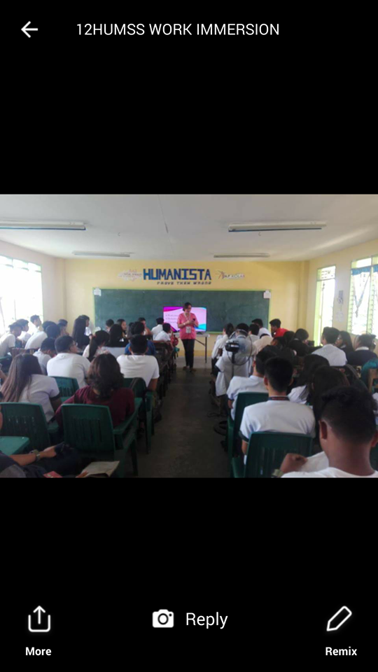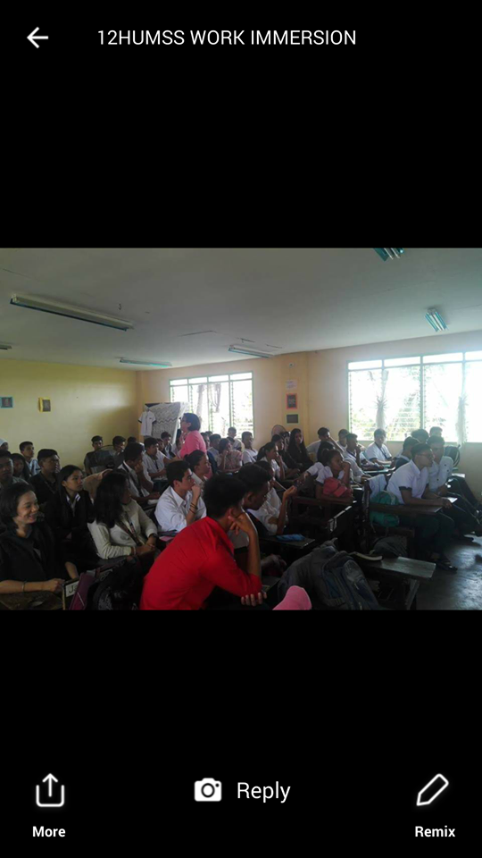

**MOCK JOB INTERVIEW NARRATIVE**

Last November of 2018, we had a mock job interview and it happened in the senior high school place. I failed to experience the interview because I came late. I taught I will have a chance to experience interview, but I failed.

But still, I was able to experience immersion and I was assigned to Unli Crabs and Shrimp. Despite that I failed to be interviewed, I still able to experience immersion.

IMMERSION PROPER

COMPANY PROFILE

Unli Crabs and Shrimp started in an idea of Chef Roel Cruz, restaurant’s owner. Chef Roel started as a chef in a ship, while his brother Sir Joel Cruz is a waiter in other country. Chef Roel’s dream was to built a restaurant if one day he retires from his job. When Chef Roel went home in our country, he used a unused spot in a dormitory to built a restaurant that is unique and hard to find in the City of Malolos. When his brother, Sir Joel also went home in our country, they helped together Chef Roel’s dream restaurant, that is why Unli Crabs and Shrimp was born.

 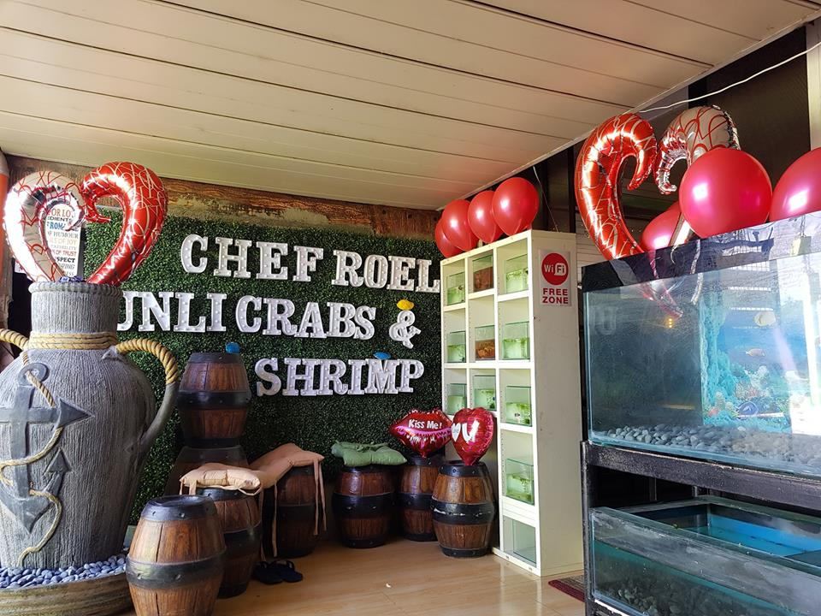

ORGANIZATIONAL CHART

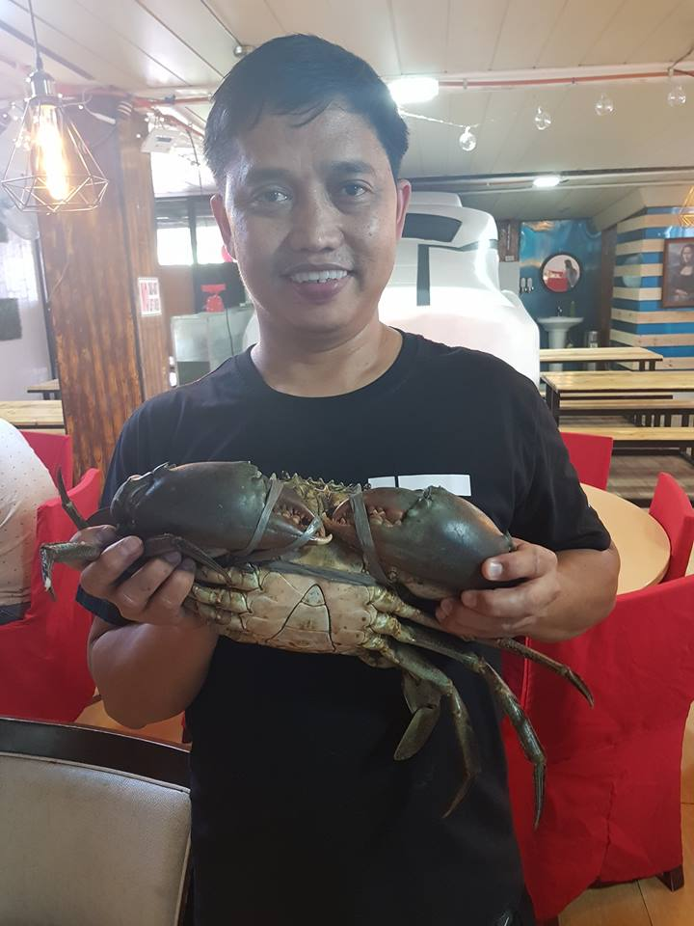

**CHEF ROEL CRUZ**

OWNER



**JOEL CRUZ**

HEAD WAITER





**MARY GRACE BULURAN CRUZ ROWENA DACURO**

HEAD COOK COOK

WRITTEN REPORT ON ACTIVITIES PERFORMED / DAILY DIARY

GALLERY

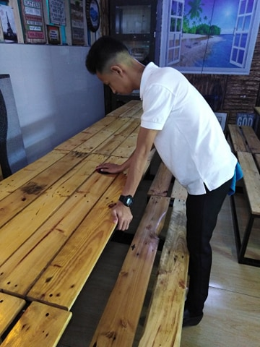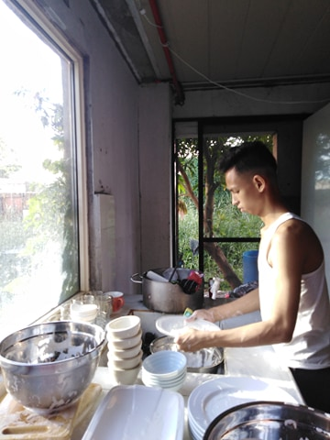 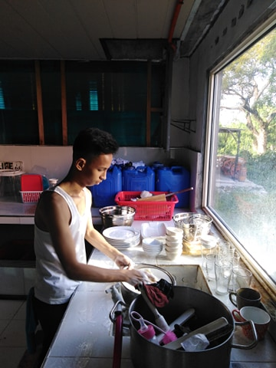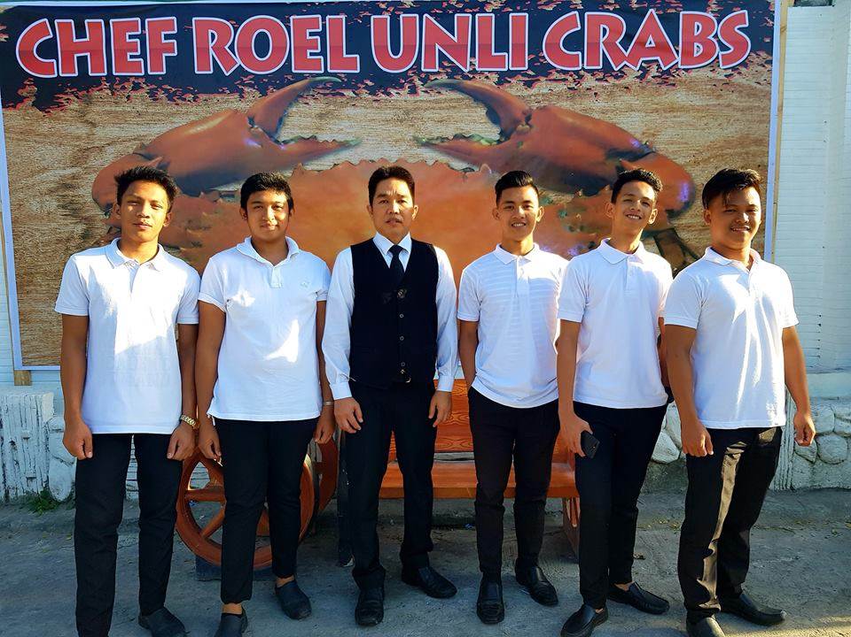 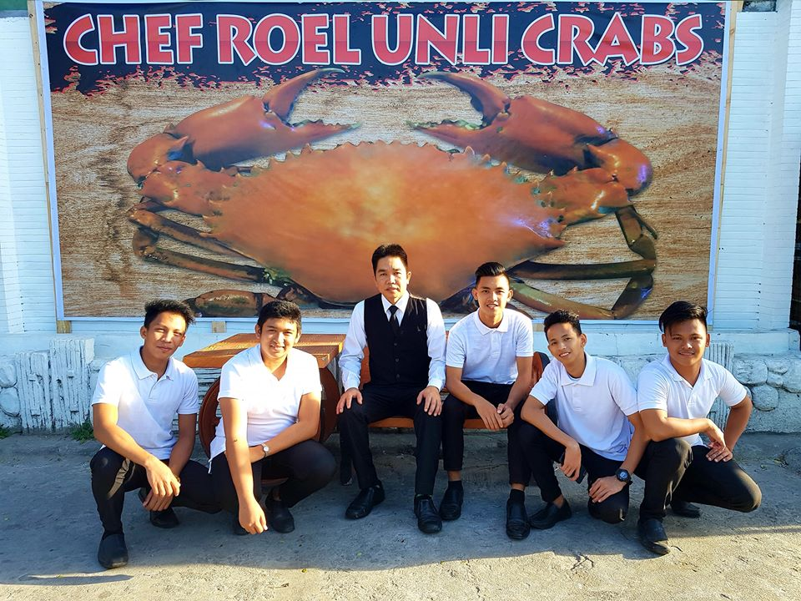 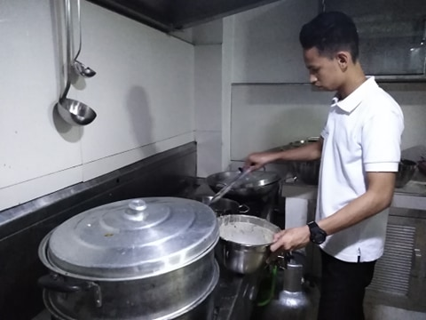

DAILY TIME RECORD

(DTR)

EVALUATION

UPDATED RESUME

**JAMIL EVANGELISTA TORRES**

0344 Talabahan, Brgy. Bagna, City of Malolos, Bulacan

Email: torres.jamil@yahoo.com

09068218479

**OBJECTIVES**

To improve and develop my skills in my new working experience. I preferred this job because it is one of the companys I know. I am confident to show you my skills and knowledge on this job.

**PERSONAL INFORMATION**

Nickname : Jham

Age : 18

Date of Birth : September 28, 2000

Civil Status : Single

Nationality : Filipino

Religion : Catholic

Height : 5’7

Weight : 40

Gender : Male

Father's Name : Arcenio Moron Torres

Mother's Name : Zenaida Avendano Evangelista

**EDUCATIONAL BACKGROUND**

**Senior High School** : **City of Malolos Integrated School - Atlag**

Atlag, City of Malolos, Bulacan

General Academic Strand 12

June 2017- present

**Junior High School : City of Malolos Integrated School - Atlag**

Atlag, City of Malolos, Bulacan

June 2013 – March 2017

**Primary : Bagna Elementary School**

Bagna, City of Malolos, Bulacan

June 2007 – March 2013

**SEMINARS AND TRAININGS**

**COMPETENCY BASED ECONOMIES THROUGH FORMATION OF ENTERPRISE**

**NEW BUSINESS CREATION COURSE FOR THE YOUTH**

Sacro Costato Retreat House, Quezon City

May 23-25, 2017

**WORK EXPERIENCE**

**WORK IMMERSION**

UNLI CRABS AND SHRIMP

Bulihan, City of Malolos, Bulacan

January 16, 2019 – February 9, 2019

**CHARACTER REFERENCE**

**MYRA T. MENDINA**

**Work Immersion Coordinator**

City of Malolos Integrated School – Atlag

093516814138

**ALLAN D. LALIC**

**Work Immersion Coordinator**

City of Malolos Integrated School – Atlag

09655498371

**ELYND R. SALONGA**

**General Academic Strand 2 Adviser**

City of Malolos Integrated School – Atlag

09260822288

I certify that to the best of my knowledge and skills, this resume correctly describes my qualification and myself.

_____________________________

**JAMIL EVANGELISTA TORRES**

**Applicant**

RUBRICS FORM

**PORTFOLIO**

**IN**

**CREATIVE**

**NON-FICTION**