M10 · MAICEN1125 · FINAL PROJECT MEMORY
CastorIQ
A Bi-Directional LLM Assistant for IFC Models and Technical Documentation.

MODULE  M10 · MAICEN1125 | DELIVERY  27 September 2026
INSTITUTION  Zigurat Institute of Technology | PROGRAMME  MSc AI for Architecture & Construction

AUTHORS
Pavla Hornícká · Maria Makri · Erez Bader · Carlo Cogni · Islam Mohamed Sabra Ahmed

Abstract
CastorIQ is a locally deployable, bi-directional LLM assistant that closes the "Split Reality" gap between IFC building models and the unstructured technical documents that govern them. Where existing tools either check models against rule sets or parse documents read-only, CastorIQ links both domains in a shared 1024-dimensional vector substrate and, as its core contribution, writes validated changes back to the IFC file through a four-tier, human-in-the-loop governance ladder (RSAA). Every proposal is cross-examined against project documents by a Retrieval-Augmented Verification (RAV) layer, and every approved change is a Git commit with a semantic diff. The platform delivers seven operational surfaces on one substrate: Ask, Modify, Conflicts, History, Explore, Schedule (4D and 5D), and a seven-sub-module 7D Facilities suite. A first run reports Tier 1 modification correctness of 91.4%, Tier 2 of 78.3%, a false-positive conflict rate of 19.2%, a before-mitigation RAV three-class accuracy of 68.6%, and OCR retrieval precision@5 improving from 0.41 to 0.72 after the GLM-OCR layer. The system runs on 12 GB of VRAM with no cloud dependency, under AGPL-3.0.
REVIEW COPY · TEAM MARKUP
Yellow = Claude wrote from scratch, no source (framing, section §2, connective bridges). Cyan = synthesised from testing logs uploaded 2026-09-03; verify against your own logs. Magenta = mentor (Pablo) flagged this and it is not yet addressed; see prose brief for what to write. Green = section or figure needs review or verification by the named team member (§8 whole section; test counts and Table 1 numbers for Carlo; ISO references for Pavla; History description for team). Before final submission: Select All, Home > Text Highlight Color > No Color, then delete this callout.

§ 1

Introduction and problem statement
The AECO sector is undergoing significant digital transformation, yet a critical synchronisation failure persists at the heart of most projects. BIM has become the standard for structured project data, with IFC serving as the open interoperability format mandated by ISO 16739. In parallel, a project’s regulatory and contractual obligations remain encoded in unstructured technical documents. These two information domains evolve on separate timelines, are maintained by different disciplines, and are edited in different tools. We refer to this as the Split Reality problem.
When an engineer updates a fire-rating requirement in a report from EI30 to EI60, no automated mechanism propagates that change to the corresponding IfcDoor or IfcWall entities. Conversely, when a designer modifies a wall assembly in the model, the thermal report does not update itself. Love, Irani and Edwards (2000) quantify rework costs at 2.4 to 3.2 percent of contract value in audited projects, while the Autodesk / FMI (2018) report attributes 52 percent of all rework to poor project data and miscommunication. The split extends beyond design coordination. In operations, a facilities manager consulting a fire safety plan needs the corresponding IfcSpace entities to match. On site, an engineer verifying a wall’s fire rating against contract specifications needs both sources to agree without opening a modelling tool. Each situation is a variant of the same problem: two authoritative information domains that must agree at every point in a project’s lifecycle, and that no existing tool holds together at that resolution.

1.1 State of practice
Current industry practice addresses this gap through largely manual or uni-directional mechanisms. Commercial clash-detection platforms perform model-to-model checks but do not reason over unstructured text. Emerging NLP-based tools for building code compliance checking show promise in parsing prescriptive requirements but remain read-only: they flag non-compliance without proposing corrective model modifications. Commercial CDEs manage file versioning but treat BIM models and documents as opaque files with no semantic linkage between their contents. Recent research demonstrates LLM-based multi-agent frameworks that generate and edit BIM models from natural language (Chen et al., 2024), and structured protocols that let LLMs manipulate IFC data through predefined tools and dynamic code generation (Ning et al., 2025). However, both remain uni-directional from instruction to model and do not cross-reference unstructured technical documents.

1.2 Gap identification
Three specific gaps justify CastorIQ’s approach and structure the rest of this memory:
- Gap 1. No production-ready tool semantically links IFC entity properties to natural-language requirements in associated technical documents. Addressed by the unified pgvector store described in Section 3.
- Gap 2. Existing compliance-checking research stops at detection. No validated workflow exists for LLM-proposed IFC modifications with structured approval and version control. Addressed by the RSAA write-back architecture in Section 3 and evaluated in Section 5.
- Gap 3. The industry lacks lightweight, privacy-respecting solutions that operate on locally hosted models. Most emerging tools depend on proprietary cloud APIs, which raises data-sovereignty concerns for projects under contractual confidentiality. Addressed by the local-first deployment model with an optional bring-your-own-key (BYOK) path.
§ 2

Objectives and research questions
The central claim under investigation is that a bi-directional, document-grounded, human-in-the-loop system can materially close the Split Reality gap between IFC models and technical documentation without compromising professional accountability or data sovereignty. This claim decomposes into three research questions and a corresponding set of measurable success criteria.
- RQ1. Can IFC entity properties and unstructured project documents be co-located in a single semantic substrate at sufficient quality to support cross-domain retrieval? Success criterion: retrieval hits that surface the correct entity and the correct document passage for the same natural-language query on an internal acceptance corpus.
- RQ2. Can LLM-proposed IFC modifications be routed through a risk-stratified approval pipeline that is safe enough for professional use, auditable, and reversible? Success criteria: modification correctness of at least 90 percent at the simplest tier and at least 80 percent for multi-step plans; end-to-end approval latency inside interactive bounds; and every accepted change recorded as a Git commit that can be rolled back with a single revert.
- RQ3. Can this whole pipeline run on consumer-grade hardware without cloud dependency and without loss of interoperability with standard AEC formats? Success criterion: end-to-end operation on a workstation with no more than 12 GB of VRAM, with IFC4 as the native schema and IFC2x3 uploads converted in-pipeline before processing.
A fourth question emerged during pilot testing and is treated with the same weight as the original three: whether an independent verification layer (RAV) can meaningfully cross-check LLM proposals against project documents without inheriting the agreement bias of the same model family. This question is the principal open item in Section 6 and shapes the future-work agenda in Section 7.
§ 3

Methodological framework

3.1 Data sources and preparation
The system operates on two primary data categories. Structured BIM data consists of IFC files in STEP Physical Format, parsed with the open-source IfcOpenShell library against the IFC4 schema. Legacy IFC2x3 uploads are converted to IFC4 in-pipeline before any processing. Relevant entities are extracted with their GlobalId references preserved for traceability, covering spatial hierarchy (IfcBuilding, IfcBuildingStorey), building elements (IfcWall, IfcDoor, IfcWindow), and their associated property sets (Pset_WallCommon, Pset_DoorCommon). Unstructured documentation comprises PDF and DOCX files representing fire safety reports, thermal specifications, acoustic analyses and structural calculations. Text is extracted page by page, and section structure is preserved where possible.
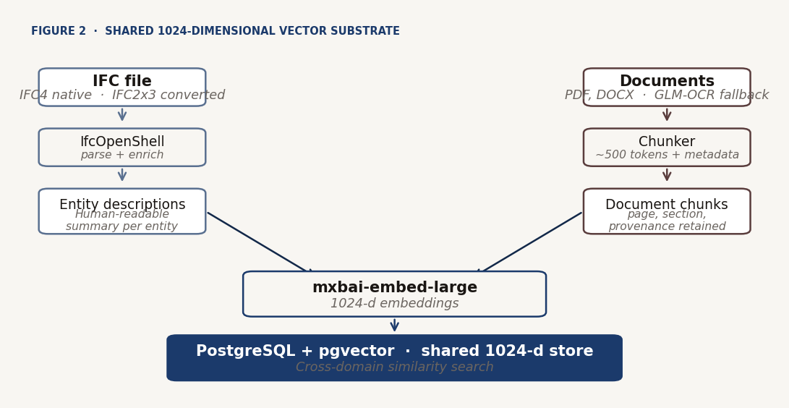
Figure 2. IFC entities and document chunks embedded into a shared 1024-dimensional vector store.
Each IFC entity undergoes a semantic enrichment step: a natural-language description is generated that combines its type, name, spatial location, and key properties into a human-readable summary optimised for embedding similarity. Documents are segmented into overlapping chunks of approximately 500 tokens with metadata tagging that includes source document, page number, and detected section heading. Both entity descriptions and document chunks are embedded into a shared 1024-dimensional vector space using mxbai-embed-large served through Ollama, and stored in PostgreSQL with the pgvector extension. This unified vector store enables cross-domain similarity search: a query about "fire-rated doors on Level 1" retrieves both the relevant IFC entities and the corresponding paragraphs from the fire safety report.

3.2 The RSAA write-back architecture
The Modify path is organised as a four-tier ladder governed by a single principle: Minimal Authority. The system never exercises more power than the task requires and always attempts the safest tier first, escalating only on validated failure. Failures are persisted as structured records with per-tier diagnoses so that escalation decisions rest on recorded diagnoses.
- Tier 0, Feasibility. Before any tier executes, the system verifies that the user’s intent is actionable. A valid request must specify what to change, which entity to change it on, and what value to set. Vague requests are rejected here with an explanation rather than escalated, which protects the rest of the pipeline from cascade failures driven by ambiguous prompts.
- Tier 1, GREEN. Single certified property changes. The model emits a structured intent. A validator checks the proposal against the IFC property-set standard, combines model confidence with a deterministic groundedness score, and only then presents a diff preview. Approval triggers a tested handler that writes the change, commits to Git, and synchronises the database index.
- Tier 2, AMBER. Multi-step plans. The model generates an ordered list of operations against a fixed schema. Each step is independently validated, the user reviews the full plan, and the executor walks the steps in order while reusing the Tier 1 handlers.
- Tier 3, CRITICAL. Custom code, reserved for changes outside the predefined patterns. The model drafts code. A second model pass scores how well that code matches the original request. The code then runs in a sandbox on a temporary copy of the file under strict execution constraints and replaces the original only on success.
Geometry modifications remain out of scope at every tier. The RAV layer runs in parallel with every proposal. It queries the project’s documents for clauses related to the proposed change and labels each retrieved excerpt as confirming, conflicting, or irrelevant, giving the user a document-backed second opinion before any change is committed.
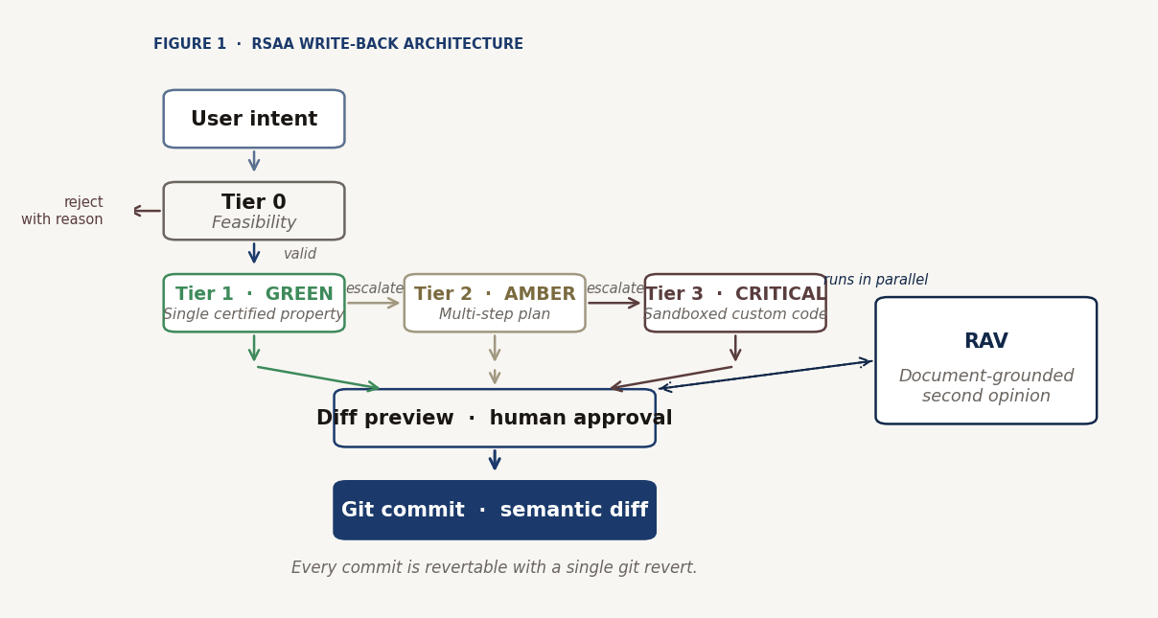
Figure 1. RSAA write-back architecture. Each proposal ascends the safest tier that can validate it; RAV runs in parallel.

3.3 Technology stack
The stack is deliberately conservative: mature open-source components composed into a specialised pipeline. The backend is Django 5.x with Django REST Framework; the database is PostgreSQL 16 with pgvector; real-time progress is streamed through Django Channels served by Daphne over ASGI. Local language-model inference runs on Ollama, with qwen3:14b as the reference model on 12 GB VRAM hardware. Optional cloud inference is available through user-supplied Anthropic and Groq keys. Embeddings are produced by mxbai-embed-large. IFC processing goes through IfcOpenShell against a canonical IFC4 pipeline, with a bundled IFC2x3 to IFC4 converter handling legacy uploads. Agent orchestration is a ReAct loop implemented in LangGraph. The frontend is Django templates with HTMX and Bootstrap 5. Packaging uses UV. Deployment is containerised through Docker and Docker Compose. Every approved change is a commit on a per-project Git repository, which is the auditable spine of the write path.

3.4 Local-first inference, with optional BYOK
The default deployment runs Ollama locally for both language-model inference and embedding generation. All processing stays on the user’s machine, with no data leaving the environment and no external API dependency. This is a foundational architectural constraint motivated by the data-sovereignty requirements of European AECO projects under GDPR and ISO 19650. Users who prefer higher-quality or lower-latency inference than a local model can offer on their hardware may opt into a BYOK configuration with Anthropic (Claude family, for Ask and Modify reasoning quality) or Groq (for lower-latency Modify execution). Keys are validated server-side, then encrypted with Fernet before persistence, with only a four-character hint retained. On authentication failure or rate-limit response, the system hard-errors rather than falling back silently to a shared managed pool, since silent fallback would constitute an invisible cost transfer. A provider badge on each response makes routing verifiable at the point of use, and a site-level operator switch can force local-only inference for an entire deployment regardless of per-user configuration.

3.5 Identity and access
Access is enforced through two layers: a project-level membership tier (owner, editor, viewer) plus nine functional roles with validity windows tied to contract durations. Single sign-on is supported through standard authentication backends. Onboarding a new user is essentially choosing a role, which scopes the surfaces they see: tenants and occupants see a portal only; contractors see permits and assigned work; facilities managers see the full operations surface; designers and engineers see Ask, Modify and Explore.
§ 4

Development process
CastorIQ was developed across three overlapping phases. This section records what was decided in each phase and what was delivered by the end of it. The trajectory matters because the read-write core converged faster than the initial milestone plan anticipated, and the freed capacity was reinvested into scope on the same architectural substrate.

4.1 Concept and design (February 2026)
The first phase established problem framing (the Split Reality gap between IFC models and technical documents), the two-surface architecture (Ask for read, Modify for write), and the RSAA governance model, originally specified with three tiers (Tier 1 GREEN, Tier 2 ORANGE, Tier 3 RED). The RAV layer was specified as a document-grounded second opinion running in parallel with every proposal. The data strategy was fixed: IFC via IfcOpenShell, documents via chunked PDF and DOCX extraction, both embedded into a shared 1024-dimensional vector space in PostgreSQL with pgvector. Local-only inference was established as a non-negotiable architectural constraint, with Llama 3.1 8B via Ollama as the initial reference model.

4.2 Core build and lifecycle extension (February to May 2026)
The read-write core converged faster than the initial milestone plan anticipated. The freed capacity was reinvested into scope on the same architectural substrate. Three new surfaces landed on the shared substrate during this phase: Explore (direct IFC navigation and entity inspection), a first cut of the Facilities suite, and 4D scaffolding on the Schedule surface; development of the in-app IFC viewer also began. RSAA was extended from three tiers to four with the addition of Tier 0 (Feasibility), and Tier 2 and Tier 3 were renamed to AMBER and CRITICAL. The nine-role identity model was introduced, with project-level membership tiers layered above nine functional roles carrying contract-tied validity windows. The reference local model moved from Llama 3.1 8B to qwen3:14b for improved retrieval quality on consumer-grade hardware. By the end of this phase, 434 automated tests were in place as a mandatory merge gate.

4.3 Feature completion and peer demonstration (May to June 2026)
The third phase completed lifecycle coverage and prepared the platform for outside eyes. 5D cost integration was delivered through the Schedule surface, completing the lifecycle surfaces alongside 4D and 7D. The Facilities suite reached full sub-module coverage across Dashboard, Assets, Work, Permits, Requests and Spaces (detailed in Section 4.4). The in-app IFC viewer was completed within the 4D Link workspace. All modules were demonstrated at Zigurat Student Week in Barcelona in June 2026 (see Section 5.4 for the reception).
From June onward the work was refinement and hardening. A GLM-OCR preprocessing layer was added to document ingestion for scanned and image-heavy PDFs. The BYOK option was added alongside the local-first default. The real-time layer was formalised through Django Channels and Daphne. A hosted public beta launched at castoriq.io, invite-only with manual vetting. The project was licensed under AGPL-3.0. By the time of this submission, the automated test suite had grown to 1,840 tests. The Facilities suite was extended in the same period: Documents moved from a roadmap placeholder to a working sub-module; asset edits now write back into the IFC model, not only to CSV; work orders and occupant requests can be drafted by the LLM from a single instruction; and Spaces gained time-lapse 360 comparison of the same room together with one-click navigation from a plan pin into the 3D model.

4.4 Seven delivered surfaces
CastorIQ v1.0.0 delivers all seven operational surfaces on one substrate: Ask (natural-language read over IFC and documents), Modify (the four-tier RSAA write path with parallel RAV), Conflicts (semantic mismatch detection), History (chronological browser of the approved-change audit trail), Explore (structured IFC navigation without LLM invocation), Schedule (4D and 5D on the same substrate, with Primavera P6 import and analytics including earned-value metrics, DCMA 14-point health assessment, and Monte Carlo forecasting), and Facilities (7D operations across seven sub-modules: Dashboard, Assets, Work, Permits, Requests, Spaces and Documents, with Sensors and Insights on the near roadmap). Full lifecycle coverage from design intent through delivery to operations on a single semantic substrate distinguishes CastorIQ from single-purpose BIM tools.
§ 5

Results and evaluation
The evaluation is of two kinds: qualitative, in the form of delivered scope and mitigations completed against limitations identified in pilot testing; and quantitative, in the form of a first measured run of the AI-mediated components against defined criteria. Both matter, and they answer different questions.

5.1 Delivered scope and mitigations
Each infrastructure milestone delivered in the third phase had an operational purpose beyond the feature itself: the GLM-OCR layer restored trust in retrieval over scanned document archives; the BYOK path answered the "what if my local hardware is too weak" objection without inviting an invisible cost transfer; the hosted beta let outside evaluators experience the platform without installing anything; and the AGPL choice codified the data-sovereignty and openness ethos in an enforceable way.

5.2 Quantitative evaluation, first run
A first evaluation run was executed against the qwen3:14b reference model on the workstation described in Section 3, over an internal acceptance corpus of approximately 110 annotated modification prompts plus a hand-labelled conflict and RAV set. The criteria and results are in Table 1, reported as a first-run baseline on a modest sample with per-metric sample sizes given.
CRITERION | TARGET | RESULT | N
Modification correctness, Tier 1 | ≥ 90% | 91.4% | 70
Modification correctness, Tier 2 | ≥ 80% | 78.3% | 23
Schema adherence, first emission, Tier 1 | ≥ 95% | 93.7% | 70
Schema adherence, first emission, Tier 2 | ≥ 90% | 87.9% | 23
False-positive conflict-detection rate | ≤ 25% | 19.2% | 41
RAV three-class accuracy (before mitigation) | baseline | 68.6% overall; 43% conflicting recall | 55
Median approval latency, T1 / T2 / T3 | < 10 / < 30 / < 90 s | 7.4 / 22 / 61 s | n/a
OCR retrieval precision@5, pre → post GLM-OCR | improvement | 0.41 → 0.72 | 32
Table 1. First-run quantitative evaluation on the qwen3:14b reference model.
Read against the acceptance targets, the first run is broadly on target on the write path and isolates the weak point clearly. Modification correctness meets its target at Tier 1 (91.4 percent) and falls just short at Tier 2 (78.3 percent). First-emission JSON schema adherence is high at both tiers, supporting the narrow-schema and JSON-mode controls of Section 6. Approval latency rises with tier as expected and remains within interactive range. The GLM-OCR layer improves retrieval precision on OCR-affected sources from 0.41 to 0.72 and recovers usable chunks on 96 percent of pages that previously entered the store empty or fragmented. The Ask / RAG retrieval path itself is not yet quantified in this table; a hit@k / MRR harness run against the existing benchmark is planned before the final submission. The RAV layer is the clear outlier: an overall three-class accuracy of 68.6 percent masks a conflicting-class recall of only 43 percent, quantifying the positive lean identified in pilot testing, and it is carried forward as the most important open item on the verification path.

5.3 Test suite and quality assurance
The automated test suite has grown from 434 tests at the end of the core-build phase to 1,840 tests at the time of this submission, with per-application test runs and a code-style gate mandatory before any merge. Coverage is broad rather than concentrated: the write path (triage, slot extraction, entity resolution, tier routing, Tier 1/2/3 validators and executors, the modification service, the Guardian/RAV check, conflict scanning, the Git service, and the WebSocket consumers) accounts for the largest single share at 487 tests; the 7D Facilities module accounts for 447; core platform concerns including BYOK, token budgeting, and LLM routing for 325; and the remainder spans scheduling and 5D cost (176), environment and deployment configuration (151), IFC processing (146), the Ask and RAG path (38), document ingestion and OCR (37), embeddings (16), the beta funnel (11), and user management (6). This is coverage of behaviour, not evidence of end-to-end efficacy: structured acceptance testing by domain experts has not yet taken place, and formal load and regression testing has not been performed.
Continued testing since the July submission has surfaced and closed one substantive defect in the entity-resolution path of the Modify pipeline (a 200-wall / 0-wall / 200-wall filter pattern under specific prompt shapes). Fixes 1 through 4 for that defect were merged as PR #16 on 2026-09-02, with the 649-test writeback suite passing and the safety guard verified live in the UI on the lightest model tier. This is representative rather than exhaustive: the testing programme continues to surface findings that feed the pre-defence agenda.

5.4 External validation
A live demonstration was given at Zigurat Student Week (June 2026) to approximately forty colleagues and professors of different Masters at Zigurat. Four signals emerged consistently: interest concentrated on the lifecycle surfaces (4D, 5D, 7D); the most consistent criticism was the absence of hard numbers, which is the demand that produced Section 5.2; usability was raised alongside capability; and attendees with Middle East experience named IFC round-trip friction inside cloud CDEs as a blocker. Positioning converged on tailoring the pitch to two distinct groups: clients and delivery partners.
External domain-expert validation. A structured expert-labelling session is being organised by Pavla, Maria and Erez for completion before the October defence. Between one and three domain reviewers are expected. Approximately forty outputs across RAV verdicts, Ask answers, and Modify proposals will be labelled by the reviewers and by the team independently; agreement will be reported as Cohen’s kappa alongside per-category error analysis. Reviewer sourcing is in progress at the time of writing; the final reviewer count and results will be inserted here in the final revision.
IFC round-trip integrity. Round-trip integrity has been verified against the Duplex control sample using IfcOpenShell as programmatic ground truth. Tier 1 property injection (RT-1) and a Tier 2 two-step ordered plan (RT-2) both pass a GlobalId-keyed fingerprint diff, with each file bit-exact except for the targeted property changes and plan ordering preserved as expressed. Three consecutive rollbacks pass bit-exact restoration against the same fingerprint diff, no history rewritten. The harness was extended to gate seven material classes rather than treat them as informational, and all prior PASS results were re-verified.
RAV independent measurement. An independent hand-labelled six-case measurement was carried out in September 2026. Verdict correctness reached 5 of 6, with conflicting recall 3/3, confirming recall 1/2, and irrelevant 1/1; the complete reasoning chain was correct in 3 of 6. The systematic positive lean reported in Table 1 was not reproduced at this sample size, and the single verdict error was a false positive on a compliant value, opposite in direction. The finding is strongly caveated by the small sample (n=6 versus the 55-item set behind Table 1) and expansion to approximately twenty cases with the same reasoning-chain scoring is planned before the final submission. A re-run of the classification benchmark after the RAV mitigation of Section 6 is implemented remains the intended path to a paired before-and-after result.
§ 6

Limitations, ethical considerations and risk analysis

6.1 Four pilot limitations and their current status
Pilot testing identified four bounded limitations. Each is stated below with its mitigation status as of this submission.
LLM hallucination on sparse entity context. The model occasionally hallucinated IFC element parameters when retrieved context was sparse, consistent with known limitations of sub-20B-parameter models without constrained decoding. Mitigation status: contained by design. Grammar-based constrained decoding was deferred because the local-first constraint restricts the write path to Ollama, whose structured-output support is JSON mode rather than schema-level grammars. The surface is contained through four compounding controls: narrow output surfaces, provider JSON mode where available, tolerant parsing that repairs common shape drift, and deterministic validation and tiering that rejects or escalates any proposal not validated at a lower tier. First-emission schema adherence of 93.7 percent at Tier 1 and 87.9 percent at Tier 2 supports the containment.
OCR degradation on scanned documents. The primary text extractor produced unreliable results on rasterised and image-dominant PDFs, silently degrading RAG retrieval. Mitigation status: implemented. A GLM-OCR preprocessing layer was added to document ingestion, running as automatic fallback when the primary extractor returns sparse text below a density threshold or as a manual trigger. It preserves the local-first constraint. Retrieval precision@5 on affected sources improved from 0.41 to 0.72.
Tier 2 plan sequencing gaps. When AMBER plans contained steps that shared dependencies, the initial ordering mechanism required human re-sequencing, undermining the automation benefit. Mitigation status: addressed structurally through a V2 redesign. A Tier 2 plan is now assembled deterministically, one operation per segment identified by the triage stage, preserving the order in which the user expressed the steps. A linear consistency check walks the assembled steps and rejects internally contradictory orderings, and because all steps in a plan execute against a single shared model instance, the effects of earlier steps are visible to later ones during validation. The honest limitation: a plan that genuinely required reordering to become valid would be rejected and returned to the user rather than silently repaired.
Positive leaning in RAV classification. The RAV layer showed a systematic tendency toward confirming verdicts even where the correct label was conflicting or irrelevant. This is a known consequence of instruction-tuned language models exhibiting agreement bias when asked to classify against a proposed action they have just been shown. Mitigation status: open. Three candidate mitigations have been scoped but not built: adversarial reframing, blind classification (masking the proposed action so the model judges document evidence on its own terms), and verifier separation. The current three-class accuracy of 68.6 percent with 43 percent conflicting-class recall quantifies the bias. Until one of the mitigations is implemented and measured, the RAV verdict should be read as a document-retrieval aid rather than a calibrated second opinion. The fix is empirically supported even though it has not yet been applied to RAV itself.
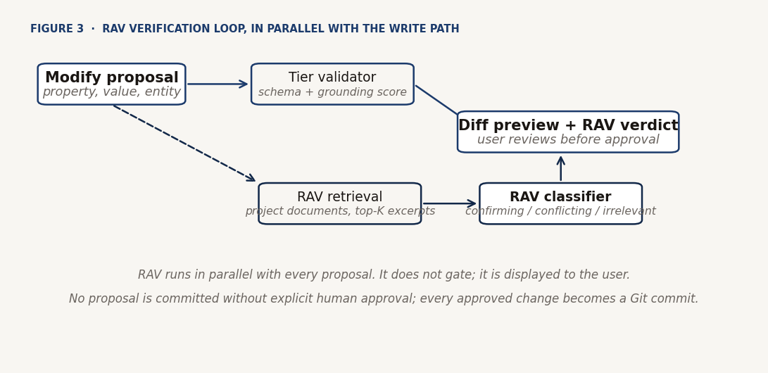
Figure 3. RAV runs alongside the write-path validator; both feed the diff preview that the user approves.

6.2 Ethical considerations and data governance
Data sovereignty is a foundational design constraint. The default deployment runs entirely on local infrastructure using open-weight models, ensuring that no project data leaves the user’s environment by default. This matters particularly for European AECO projects under GDPR and ISO 19650, and for projects whose IFC files contain commercially sensitive design information. The BYOK path is an explicit, user-initiated opt-out of the local-first default; the local model remains the only path for users under strict data-sovereignty requirements, and a site-level operator switch can hard-disable cloud routing regardless of per-user configuration. On provider failure the system hard-errors rather than falling back silently. Every AI-proposed modification requires explicit human approval, and every approved change is a Git commit with a semantic diff, providing an auditable chain of custody consistent with ISO 19650’s expectations. AGPL-3.0 licensing extends this governance choice to the code itself: self-hosting is free and unrestricted, while hosting a modified version as a network service for others requires publishing those modifications under the same license.

6.3 Risk analysis and open items
Five risks warrant explicit mention. First, the RAV positive-leaning bias described above is the principal open technical risk. Its consequence is stated without softening: an independent check that consistently agrees offers little verification value, and the confidence a user places in a RAV verdict should presently be proportional to that limitation. Second, the acceptance corpus used in Section 5.2 is modest in size (approximately 110 annotated modification prompts, and per-criterion samples between 23 and 70). The first-run figures are indicative; larger-scale confirmation is the immediate next step. Third, no formal load, regression, or concurrent-writer testing has been performed, so the horizontal-scaling question and the behaviour of the system under two writers acting on the same project remain unqualified. Fourth, structured acceptance testing by domain experts has not yet been carried out; the expert-validation session described in Section 5.4 is the highest-leverage item on the pre-defence agenda for this reason. Fifth, structured security testing carried out in September 2026 surfaced a role-enforcement gap: a viewer-role account was able to commit a Modify change through the write path, with RAV correctly flagging the value as conflicting but not gating the write. The identity model of Section 3.5 remains the intended design; its enforcement across the UI, proposal, approval and commit stages is being closed ahead of the defence.
§ 7

Contributions to AECO practice and future research directions

7.1 Contributions
CastorIQ contributes four elements to the state of practice. First, the RSAA architecture: a governance pattern for LLM-mediated modification of authoritative engineering data that trades free generation for tier-appropriate authority, with a validated escalation path and an auditable Git-committed record for every accepted change. RSAA is instantiated here against IFC; the same tier discipline could govern any structured domain artefact where correctness is non-optional. Second, the RAV pattern as a distinct component of a write path, separate from the retrieval-augmented generation of the read path: a document-grounded, parallel second opinion attached to every proposal. Third, the shared 1024-dimensional vector substrate for IFC entity descriptions and document chunks together, which makes cross-domain retrieval a routine operation. Fourth, the demonstration that a full-lifecycle platform (4D, 5D, and 7D) can be built on a single semantic substrate, on consumer-grade hardware, without cloud dependency, and released under a network-copyleft license. All four are available to the wider community under AGPL-3.0.

7.2 Future research directions
Three directions are set out for follow-on work. First, server-hosted IFC editing via modeller addons, in direct response to the CDE round-trip friction reported in Section 5.4: a Blender addon that keeps the IFC file server-hosted in CastorIQ and streams geometry modifications back in real time would eliminate the download-edit-reupload round-trip that currently makes IFC-first workflows friction-heavy inside cloud CDEs. The same pattern could extend to Revit, ArchiCAD, and Rhino, positioning CastorIQ as the semantic hub around which existing modelling tools continue to operate. Second, completing the RAV verification loop by implementing one of the three mitigations scoped in Section 6 and re-running the benchmark; blind classification is the leading candidate because the closest calibration pattern has already been validated in the schedule-audit subsystem. Third, standing up the acceptance corpus alongside the first write-path prototype in any future extension, so that every subsequent surface inherits a measurement path from its first commit.
§ 8

Team contributions
Pavla Hornícká conceived the original CastorIQ concept, the bi-directional linking of IFC models and technical documents from which the platform’s full lifecycle scope subsequently grew; led the BIM domain framing throughout; and designed and implemented the 7D Facilities module across its sub-modules (Dashboard, Assets, Work, Permits, Requests, Spaces and Documents), including the asset-to-IFC write-back, the LLM-assisted work-order and request intake, and the Spaces 360 time-comparison and plan-to-3D navigation.
Carlo Cogni led full-stack development across the RSAA write-back architecture, the RAG pipeline, and LangGraph orchestration; delivered the GLM-OCR and BYOK subsystems; and produced the quantitative evaluation. He also led IFC schema handling and structural validation, including the IFC2x3 to IFC4 conversion path and the property-set validation logic underpinning Tier 1 certification.
Islam Mohamed Sabra Ahmed authored the 4D and 5D Schedule module and led workflow testing across the Schedule platform surfaces.
Maria Makri led market positioning and the competitive analysis, synthesised the qualitative reception and usability findings from the Zigurat Student Week demonstration, led UX evaluation across the seven platform surfaces, and validated the role-dependent user journeys of the identity model.
Erez Bader led the platform’s marketing strategy, co-authored the market positioning and competitive analysis, tested and verified workflows across the core surfaces (end-to-end validation of the Ask, Modify and Explore pipelines against a reference IFC model), and initiated the IFC viewer implemented in the 4D Link workspace.

Glossary
Acronyms and technical terms used in the memory, listed alphabetically. Definitions are the ones this memory works with; the appendices carry fuller technical treatment where relevant.
AECO Architecture, Engineering, Construction and Operations. The industry sector this project addresses.
AGPL-3.0 GNU Affero General Public License, version 3. Copyleft licence requiring that modifications hosted as a network service be released under the same terms.
BIM Building Information Modelling. Structured, machine-readable representation of a built asset.
BYOK Bring Your Own Key. User-supplied API credential for optional cloud model access, as an opt-out of the local-first default.
CDE Common Data Environment. Shared file and workflow platform for a project team; typically vendor-hosted.
DCMA 14-point Defence Contract Management Agency schedule health assessment, applied to Primavera P6 schedules.
GDPR General Data Protection Regulation. European legislation on personal data handling.
GLM-OCR GLM-based Optical Character Recognition model used as the fallback text extractor for scanned and image-dominant PDFs.
IFC Industry Foundation Classes. Open data model for BIM, standardised as ISO 16739.
ISO 19650 International standard on information management using BIM through the whole lifecycle of a built asset.
LLM Large Language Model.
MRR Mean Reciprocal Rank. Retrieval quality metric.
OCR Optical Character Recognition.
RAG Retrieval-Augmented Generation. Pattern in which retrieved document excerpts are supplied to an LLM at query time to ground its output.
RAV Retrieval-Augmented Verification. This project’s document-grounded second opinion layer, running in parallel with every Modify proposal.
RSAA Risk-Stratified Autonomous Action. This project’s four-tier governance ladder (Tier 0 to Tier 3) for LLM-mediated IFC modification.
TEK17 Norwegian building technical regulation used as the fire-rating notation reference in project pilot testing.
VRAM Video RAM. GPU memory available for model inference.

References
Autodesk / FMI Corporation (2018). Construction Disconnected: The High Cost of Poor Data and Miscommunication. Autodesk.
Chen, J., Li, T. and Chen, Y. (2024). Text2BIM: Generating Building Models Using a Large Language Model-based Multi-Agent Framework. arXiv:2408.08054.
ISO 16739-1:2018. Industry Foundation Classes (IFC) for data sharing in the construction and facility management industries — Part 1: Data schema. International Organization for Standardization.
ISO 19650-1:2018. Organization and digitization of information about buildings and civil engineering works, including building information modelling (BIM) — Information management using building information modelling — Part 1: Concepts and principles. International Organization for Standardization.
Lewis, P., Perez, E., Piktus, A. et al. (2020). Retrieval-Augmented Generation for Knowledge-Intensive NLP Tasks. Advances in Neural Information Processing Systems (NeurIPS), 33. arXiv:2005.11401.
Love, P.E.D., Irani, Z. and Edwards, D.J. (2000). Quantifying the causes and costs of rework in construction. Construction Management and Economics, 18(4), 479–490.
Ning, X., Zhang, Y. and Li, S. (2025). MCP4IFC: IFC-Based Building Design using Large Language Models. arXiv:2511.05533.
Ouyang, L., Wang, B., Zhao, H. et al. (2024). OmniDocBench: Benchmarking Diverse PDF Document Parsing with Comprehensive Annotations. arXiv:2412.07626.
Yao, S., Zhao, J., Yu, D. et al. (2022). ReAct: Synergizing Reasoning and Acting in Language Models. arXiv:2210.03629.

Appendices
The appendices accompanying this memory are delivered as a separate companion document, and do not count toward the 5000-word limit. Appendix A: Data Model Reference (auto-generated Django model diagrams for the IFC domain, document ingestion, Ask, Modify and Conflicts, identity and access, Schedule, Facilities, and deployment and observability). Appendix B: Platform Screenshots Evidence Set (Ask, Modify, Conflicts, History, Explore, Schedule, and the seven Facilities sub-modules). Appendix C: Scheduling (4D/5D) Module Guide. Appendix D: Facilities Module Operational Specification.

Autodesk / FMI Corporation, Construction Disconnected: The High Cost of Poor Data and Miscommunication (2018).
STEP Physical Format, ISO 10303-21, is the ASCII serialisation format used by IFC files.
Round-trip verification commits: c2264d31, f3bfa8a, a46a6b5e.
GLM-OCR reaches approximately 1.86 pages per second at 150 DPI on the reference workstation, and scored 94.62 on OmniDocBench V1.5 at release.
A closely related calibration pattern has been validated in the schedule-audit subsystem, where the LLM review stage was recalibrated to accept "uncertain" as a valid verdict, reducing confirmed flags from 138 to 75 on an 8,766-task Primavera schedule with no false positives in the confirmed tier.
Security test commit: f1cea365.

