Appendix A: Data Model Reference
This appendix reproduces the Django model diagrams for the CastorIQ persistence layer. Each diagram shows a subset of the schema grouped by operational surface, using standard class-diagram notation. Bold fields are required. Fields typeset in italic (created_at, updated_at) are inherited from the abstract UUIDModel and TimestampedModel base classes. SingletonModel subclasses hold site-wide configuration and are constrained to a single row. Every foreign-key relationship is labelled at both ends using Django's related_name convention.
A.1 Overview
The full data model spans forty-two concrete models organised around a central Project node. The User node aggregates authentication, per-user configuration, and audit trails. Every operational surface described in Section 4 (Ask, Modify, Conflicts, History, Explore, Schedule, Facilities) is backed by a dedicated cluster of models that share these two anchors.
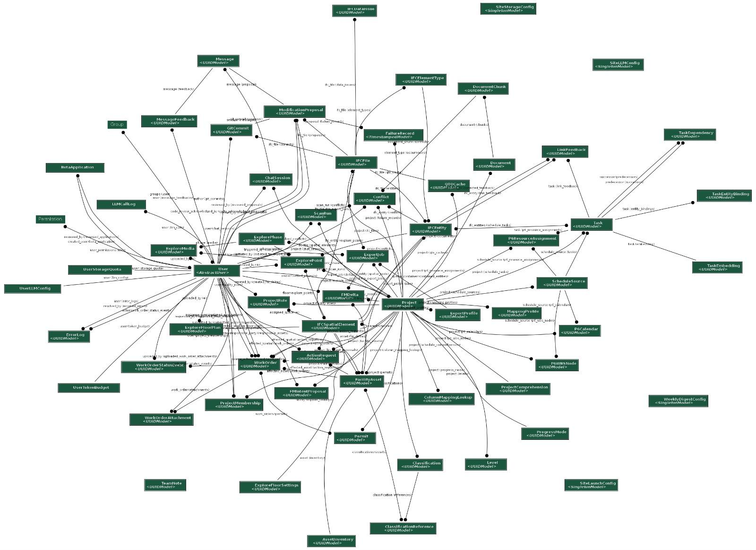
Figure A.1. Full CastorIQ data model. Forty-two models with Project and User as the two hub nodes. Domain-specific clusters are decomposed in the sections that follow.
A.2 IFC domain
The IFC domain persists parsed IFC content in normalised form so that the read and write paths can query and mutate individual entities without reopening the source file. IFCFile is the per-upload container that carries the raw file, schema version, and processing status. IFCEntity holds one row per parsed IFC instance with its global_id, ifc_type, property JSON, and the 1024-dimensional embedding used for retrieval. IFCSpatialElement mirrors the containment hierarchy (site, building, storey, space) and is joined back to IFCEntity through a one-to-one relation. IFCElementType records the type occurrences that let the platform reason about typed families. IFCDataIssue captures parser-level anomalies for the operator dashboard. Level is a lightweight projection of storeys used by the Explore surface. QTOCache stores the pre-computed quantity take-off for 5D work so that Facilities and Schedule can read cost roll-ups without re-traversing the IFC.
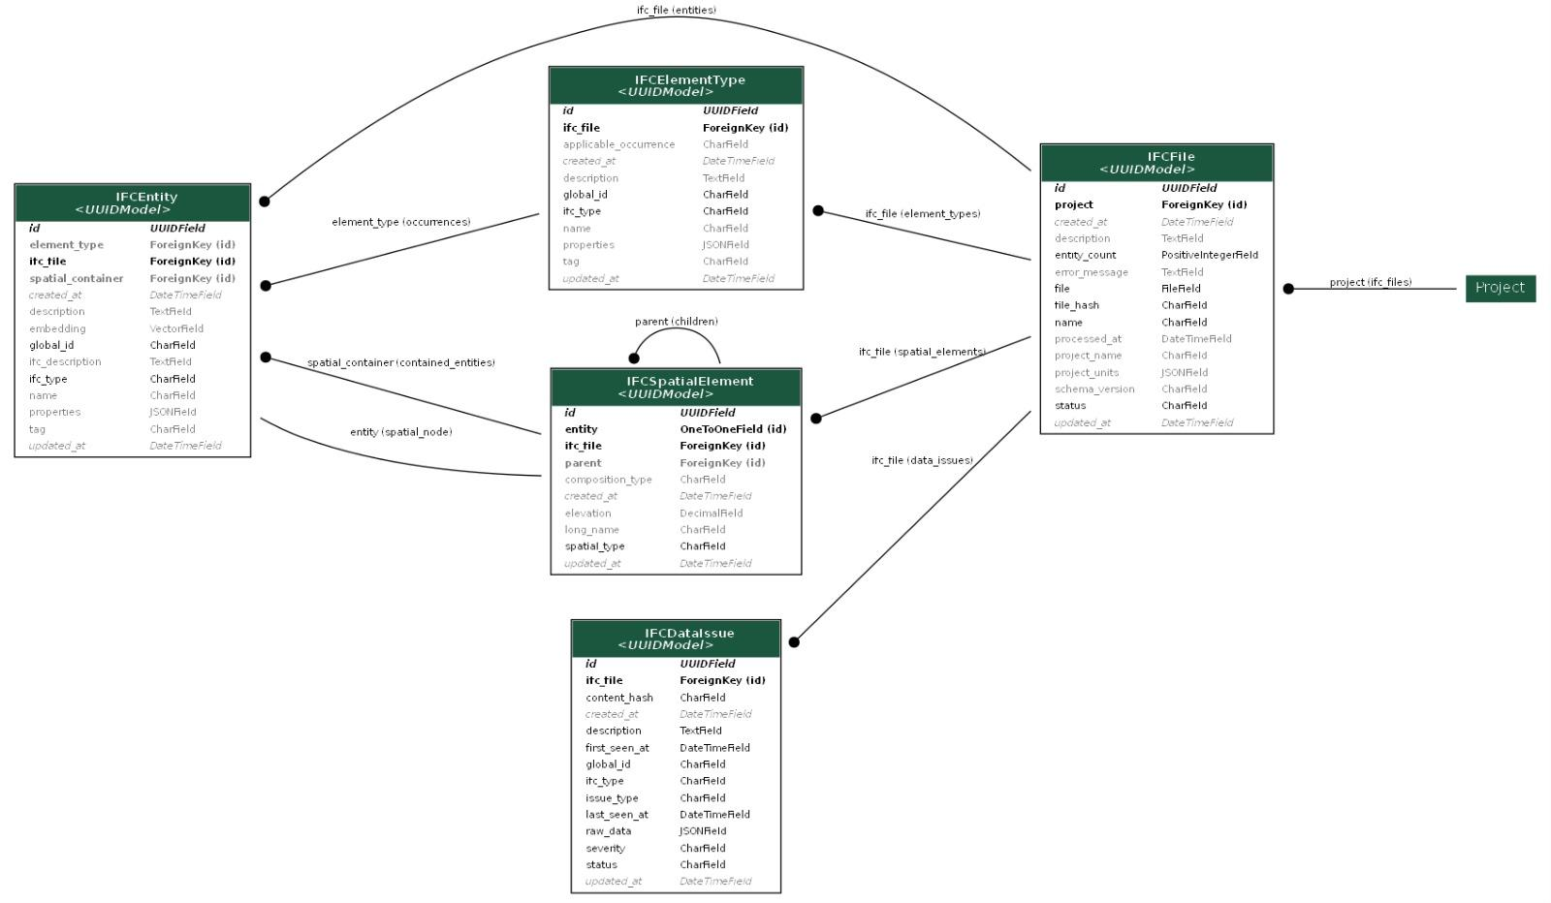
Figure A.2. IFC domain: parsed file, entity, spatial hierarchy, element type, and data-issue models.
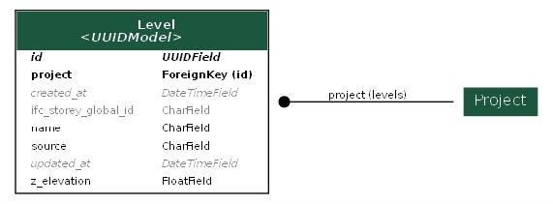
Figure A.3. Level projection used by Explore.
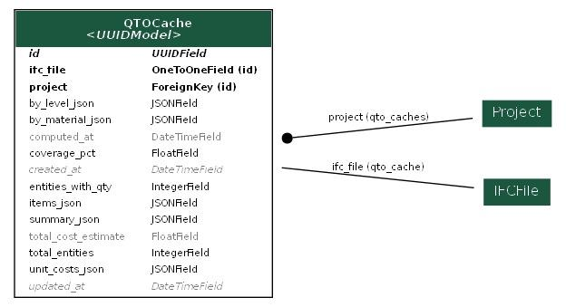
Figure A.4. QTOCache: cached quantity take-off keyed by project and IFC file.
A.3 Document ingestion
Uploaded PDFs and DOCX files are persisted as Document records with a chunk_count, OCR status, and per-page metadata. Each document is split into DocumentChunk rows at approximately five hundred tokens with configurable overlap. Chunks carry their own embedding, chunk index, source (native text or OCR extraction), and start and end character offsets so that citations in Ask answers can be anchored back to the exact span of the source. The has_visual_content flag and OCR fields on Document route scanned pages through the GLM-OCR layer described in Section 5.
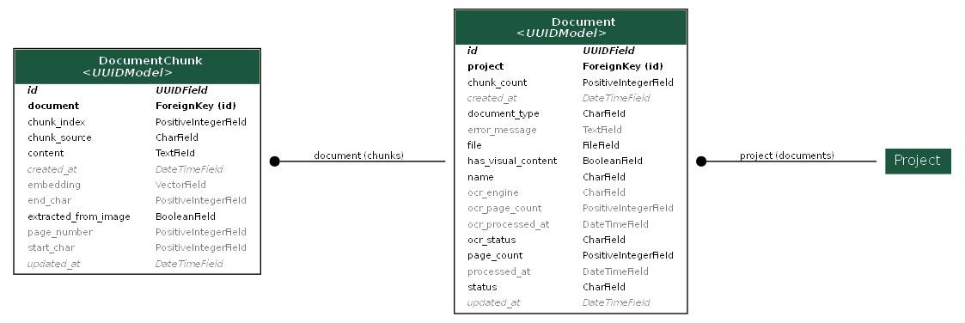
Figure A.5. Document ingestion: source document and chunk records.
A.4 Ask
The Ask surface persists conversational context as ChatSession, Message, and MessageFeedback. Sessions are scoped to a project and a user. Messages carry the role (user, assistant, system), the retrieved context that grounded the answer, and a flag indicating whether the message produced a modification proposal. MessageFeedback records the thumbs and free-text comments used to calibrate the evaluation set. The is_compaction_summary and compacted_at fields support the conversation-compaction path that lets long sessions stay inside the model context window.
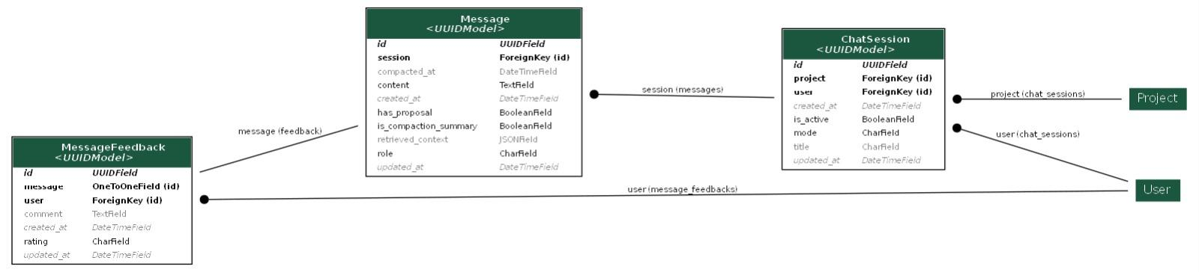
Figure A.6. Ask: chat session, message, and feedback models.
A.5 Modify and Conflicts
The Modify path centres on ModificationProposal. Since the rewrite of 15 September 2026 it holds the request, the generated code, the target GlobalIds, the measured diff, the fingerprint of the file the code ran against, the path of the reviewed scratch copy, the model that wrote the blind explanation, whether the document check was skipped, when flagged rows were acknowledged, and the Guardian result. The tier, operation, intent and filter fields are kept for the history of the first, tiered design. Every applied proposal is linked one-to-one with a GitCommit record that stores the commit hash, affected entity counts, diff data, and rollback flag. Conflict records the outputs of the document cross-check between document chunks and IFC entities, with severity, resolution notes, and a suggested fix. ScanRun groups conflict detections into batches so that per-run statistics stay auditable. FailureRecord persists failed write-path attempts with a deterministic failure class, the failing phase, a diagnosis, and whether a retry can help.
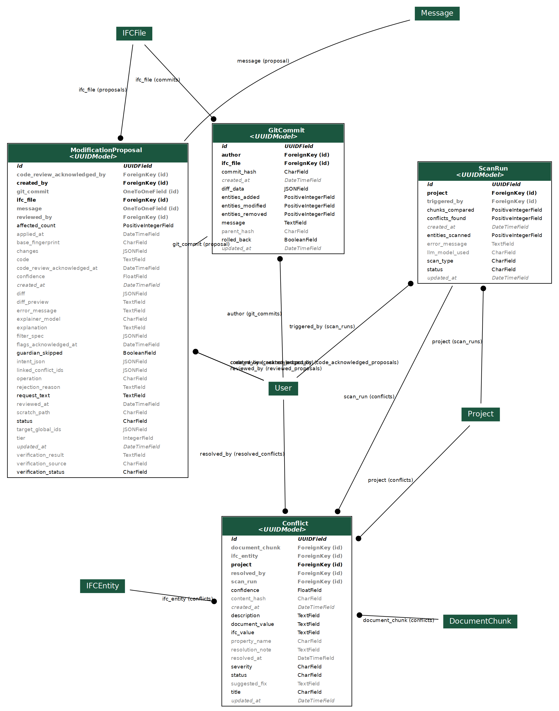
Figure A.7. Modify and Conflicts: proposal, commit, conflict, and scan-run models, regenerated after the rewrite of 15 September 2026.
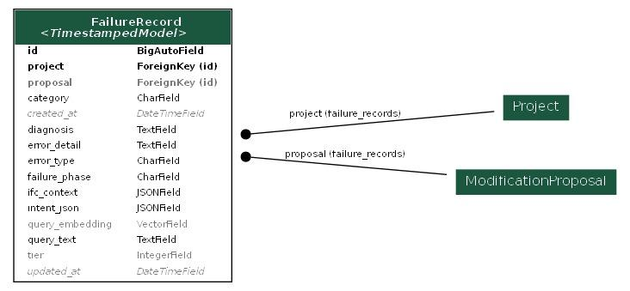
Figure A.8. FailureRecord: structured diagnostics for failed write-path attempts; the tier and intent fields belong to the first design.
A.6 Identity and access
Authentication uses the Django abstract User model extended with Group and Permission for role-based access. Project-level access is enforced by ProjectMembership, which pairs a user with a project and a permission tier (owner, editor, viewer). ProjectRole layers nine functional roles on top of membership with validity windows tied to contract durations and an optional spatial assignment for role scopes that apply to a specific area of the building. BetaApplication records the hosted-beta invitation queue with reviewer, IP, user agent, and provisioning status.
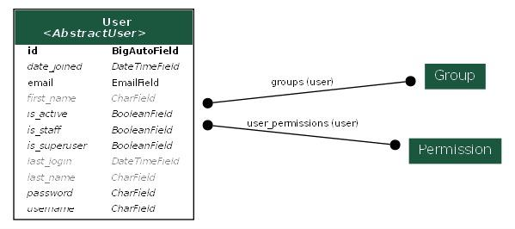
Figure A.9. Django auth base: user, group, permission.
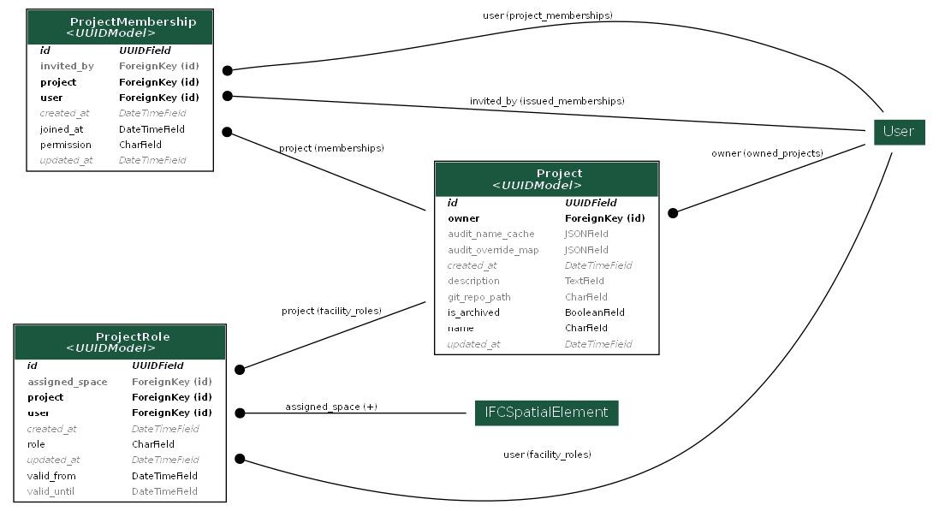
Figure A.10. Project membership and functional roles.
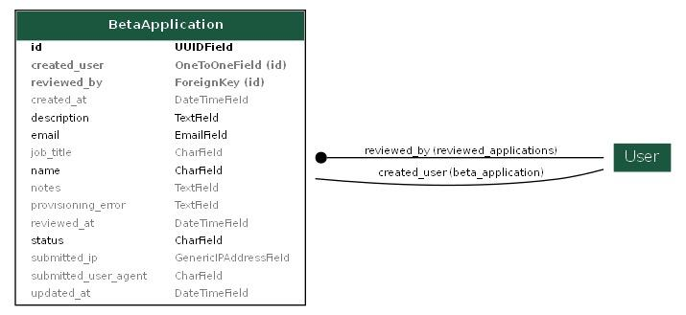
Figure A.11. Beta application queue.
A.7 Schedule (4D)
The Schedule domain ingests Primavera P6 exports and native project schedules through ScheduleSource. Task is the atomic work item with dates, cost, duration, criticality, and the physical or non-physical classification used by the audit. TaskEmbedding stores the vector used to bind tasks to IFC entities. TaskDependency captures predecessor and successor links with lag. TaskEntityBinding records the LLM proposed link between a task and an IFC entity, its confidence, and the review status. LinkFeedback persists human corrections that retrain the binding model. P6WBSNode, P6ResourceAssignment, and P6Calendar preserve the P6-native structure so that round-trip export is lossless. ProjectComprehension caches the LLM generated project summary that shortens cold-start Ask queries about the schedule. MappingProfile and ColumnMappingLookup remember how columns from a given source file are mapped, so the same vendor export does not need re-mapping on re-upload. ProgressMode toggles the project between planning and execution phases.
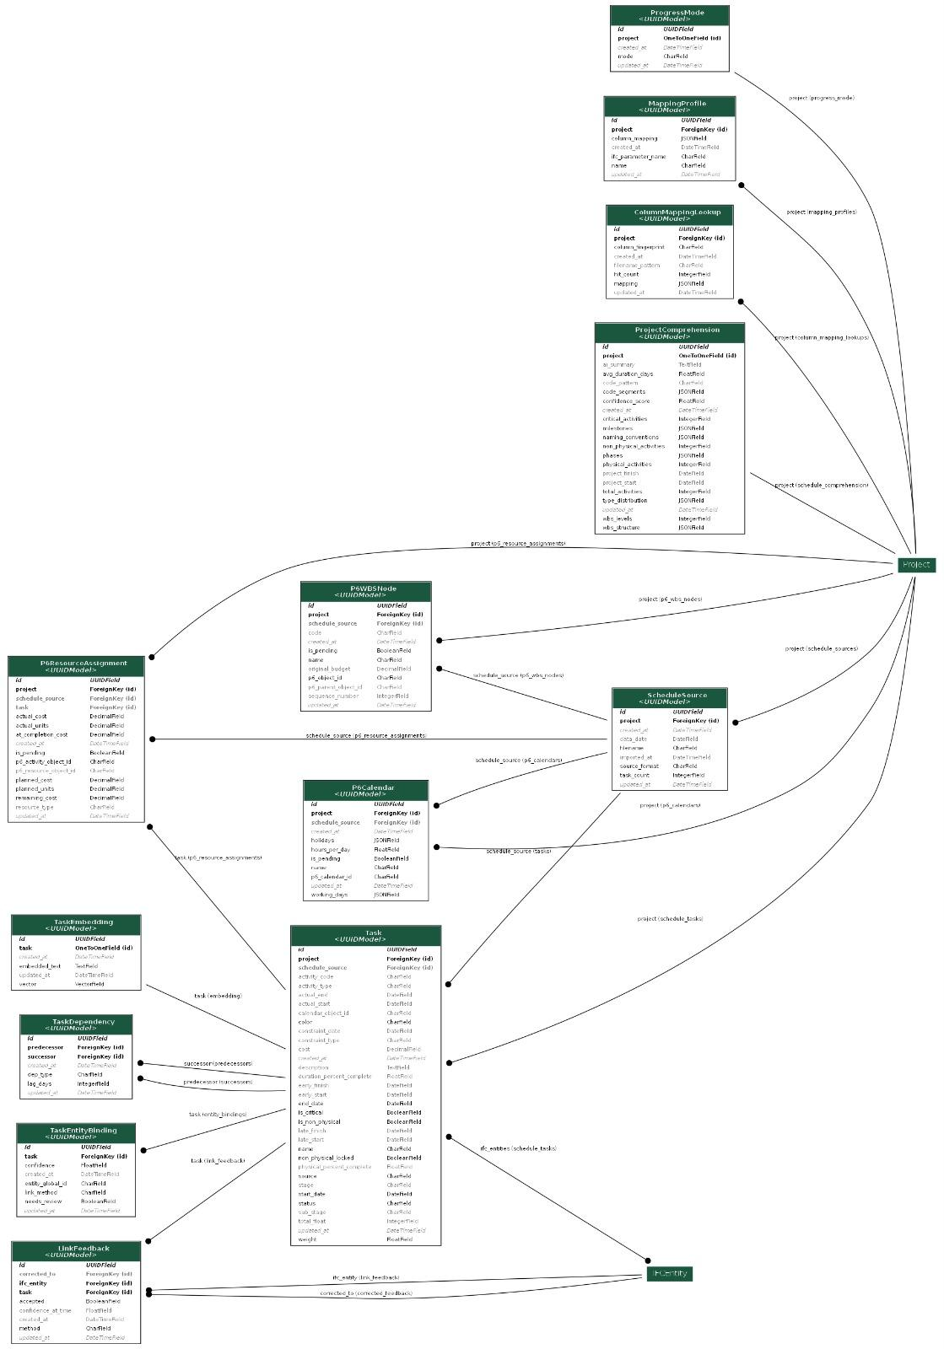
Figure A.12. Schedule (4D) domain: task, dependency, binding, and P6-native models.
A.8 Facilities (7D) and Explore
The Facilities domain covers the seven sub-modules described in Section 4. FacilityAsset extends an IFCEntity with operational fields (barcode, commissioning date, warranty, expected service life). AssetInventory records financial state (current value, depreciation, replacement cost, warranty windows). WorkOrder is the operational unit with assignee, source, priority, dates, and status; WorkOrderStatusEvent is the immutable audit trail for status transitions; WorkOrderAttachment holds uploaded evidence. ActionRequest is the lightweight ticket that residents and tenants submit, which can be promoted to a WorkOrder. Permit and Classification (with ClassificationReference) support regulatory tracking. FMIntentProposal and FMDelta are the Facilities equivalent of the Modify pipeline: proposed operational changes that write back to the model as versioned deltas after review. ExportJob is the run log for one Export IFC attempt, recording the delta, entity and conflict counts taken at plan time, the resulting commit hash on success, and the failure reason otherwise. ExportProfile holds the per-project allowlist of operations and property sets that FM edits may write into the IFC. The Explore surface persists user-authored annotations as ExplorePhase, ExplorePoint, ExploreMedia, ExploreFloorPlan, and ExploreFloorSettings, which let non-BIM users layer photos and notes onto floor plans without opening a modelling tool.
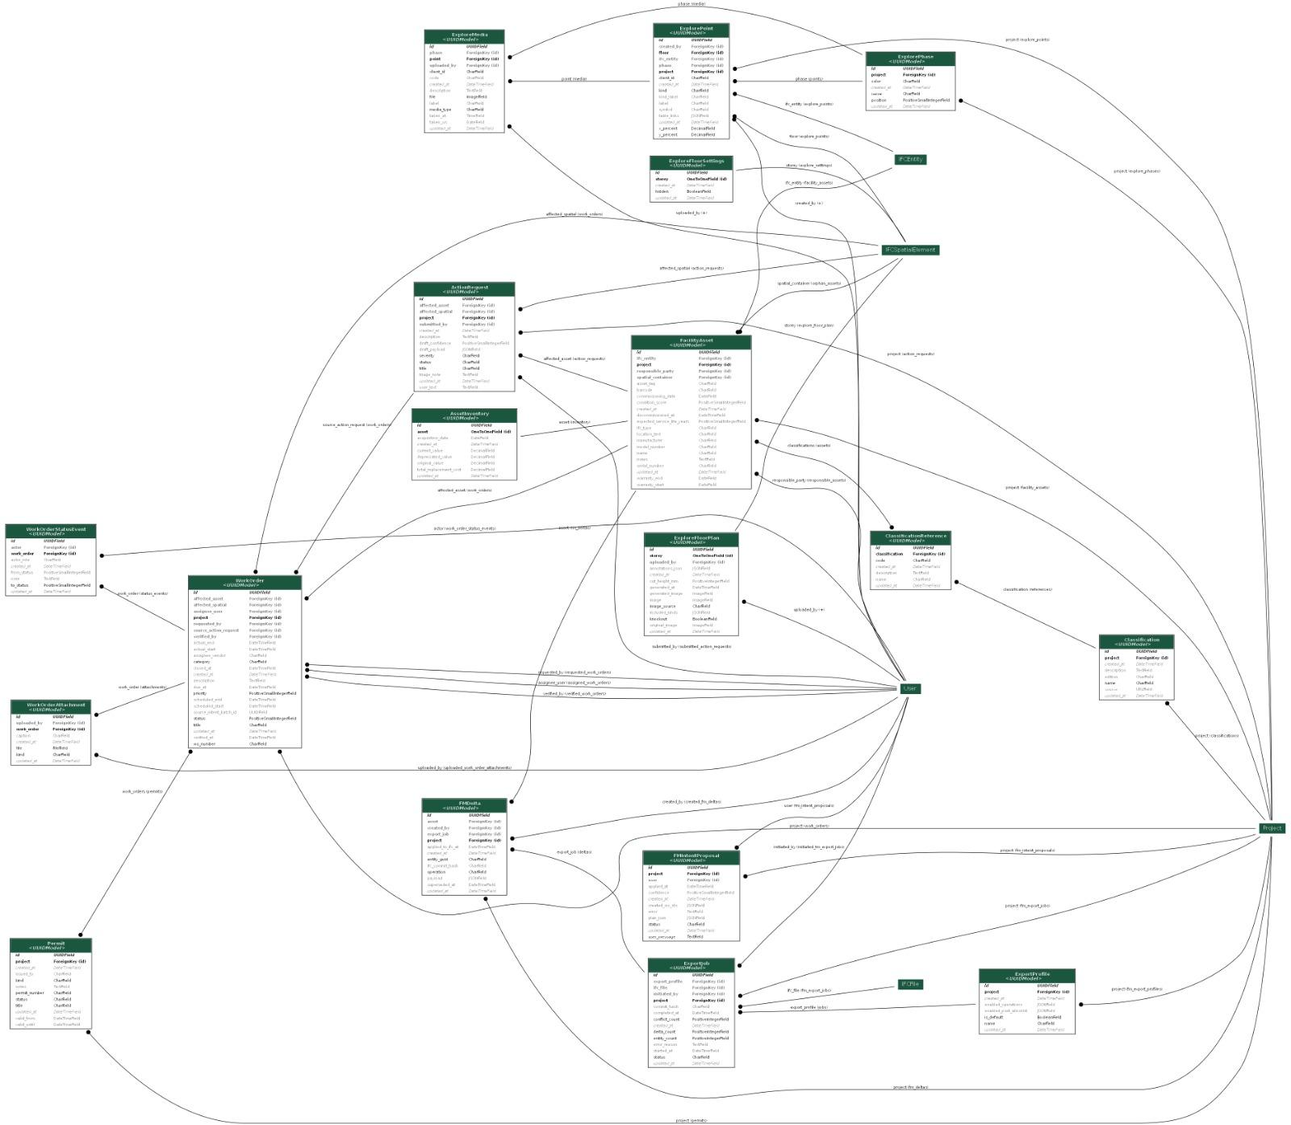
Figure A.13. Facilities (7D) and Explore domains: asset, work order, action request, permits, exports, and floor-plan annotations.
A.9 Deployment and observability
Site-wide configuration lives in singleton tables. SiteStorageConfig sets default per-user quotas. SiteLLMConfig selects the site default Ask and Modify providers and the operator switch that can force local-only inference. SiteLaunchConfig gates the public-application banner. WeeklyDigestConfig controls the operator digest email. Per-user configuration is split across UserLLMConfig (BYOK keys encrypted with Fernet, four-character hints, model overrides, theme), UserTokenBudget (daily cloud-inference cap and hard block flag), and UserStorageQuota (cached usage and per-user hard block). Observability tables persist operational telemetry: ErrorLog captures Python exceptions with request context, severity, and Supabase mirror status; LLMCallLog records every call to a language model with token counts, latency, provider, purpose, and estimated cost, which is what feeds the cost analytics referenced in Section 5. TeamNote is the in-app annotation stream the operator team uses to triage incidents.
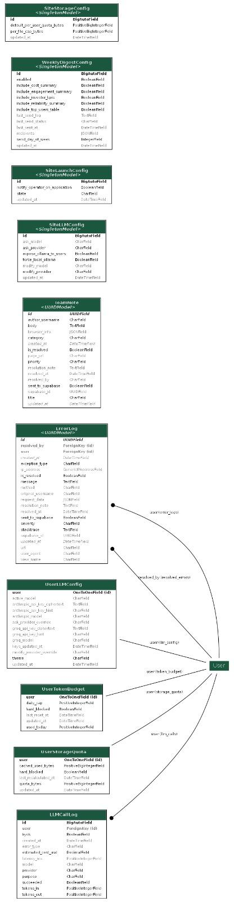
Figure A.14. Deployment and observability: site configs, per-user configs, and telemetry tables.

Appendix D: Facilities Module Operational Specification
This appendix reproduces the client-facing operational guide for the 7D Facilities module. The system-level summary is in Section 4.4 of the memory; the text below is the reference that facility managers, editors, tenants, and occupants read to understand what each sub-module does and how the sub-modules share the underlying IFC model and role system.
D.1 Overview
Castor is a single map of the building that stays authoritative across its whole life, from handover through daily operations to renovations twenty years later. The Facilities tab is where that map turns into daily work: tracking assets, managing jobs, processing tenant requests, and standing on top of a living IFC model. Everything is organised into focused sub-modules that share one common map (the IFC model) and one common access-control system, so every editor edits with the same authority and every occupant sees the same source of truth.
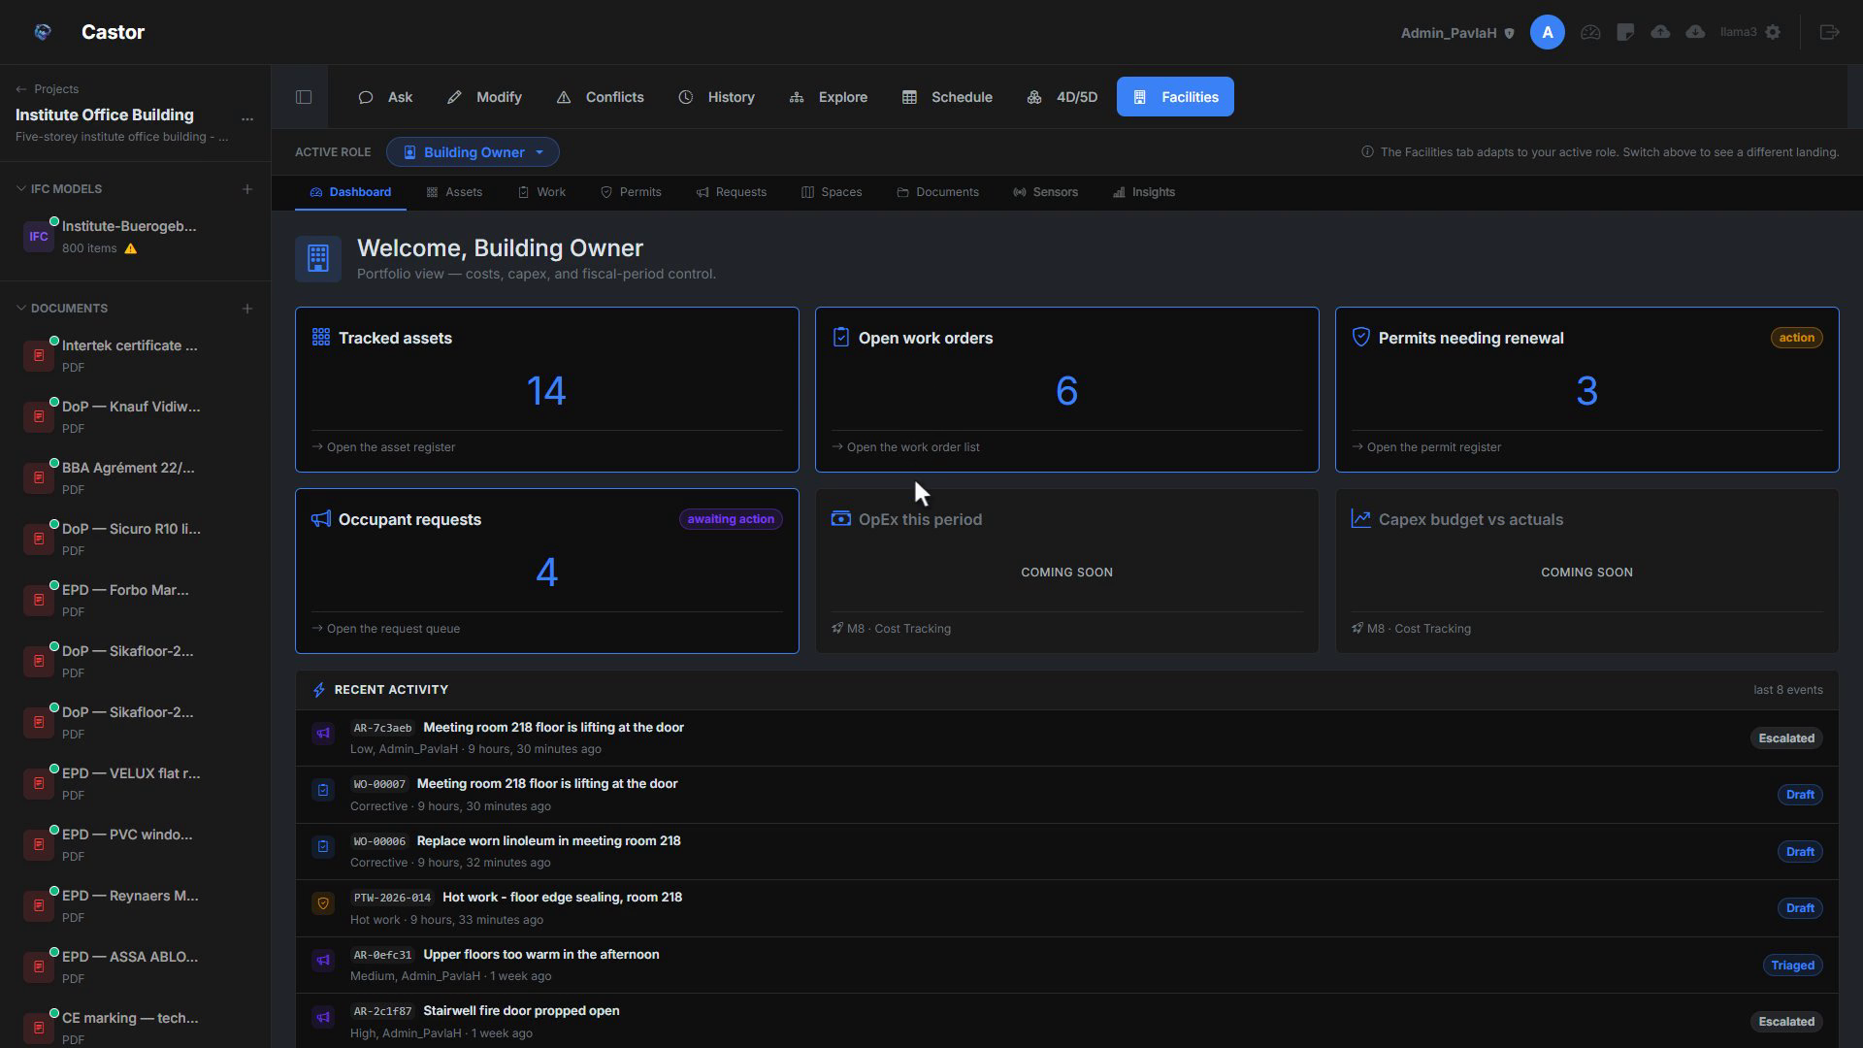
Figure D.1. Facilities tab landing and sub-module map.
D.2 Dashboard
Whoever opens Facilities first lands on the Dashboard, and what they see depends on their role in the project. Project Owners get a top-down view: asset counts, open work orders, overdue permits, and recent activity across the building. Editors (facility managers, technicians) see their assigned work orders, permits about to expire, and a shortcut to whatever they last touched. Tenants and Occupants land on a simplified portal: the Report a problem form, the status of requests they have already submitted, and read-only building info. The tab pivots to Occupant Mode automatically for these roles. Users who hold more than one role can switch their active role from a pill in the top bar, and the whole tab re-renders to that role’s surface. The dashboard is a switching yard, not a place where work happens.
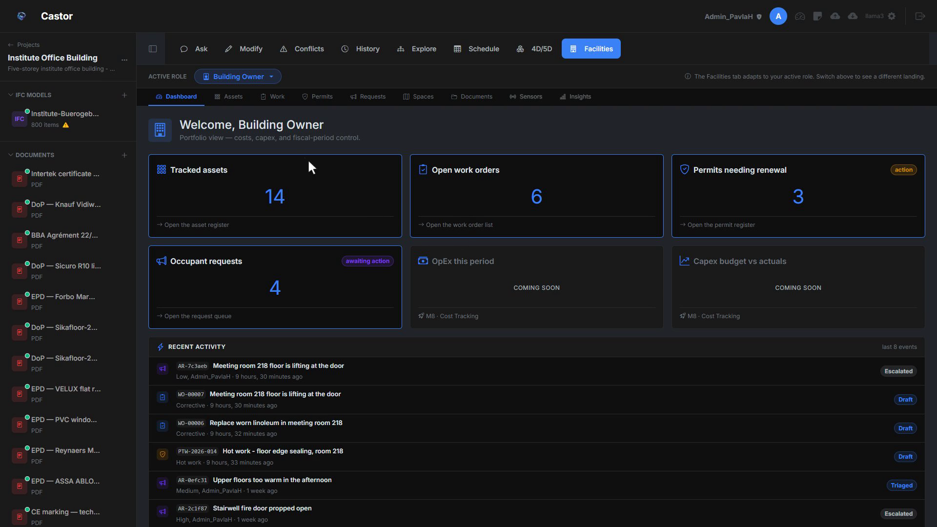
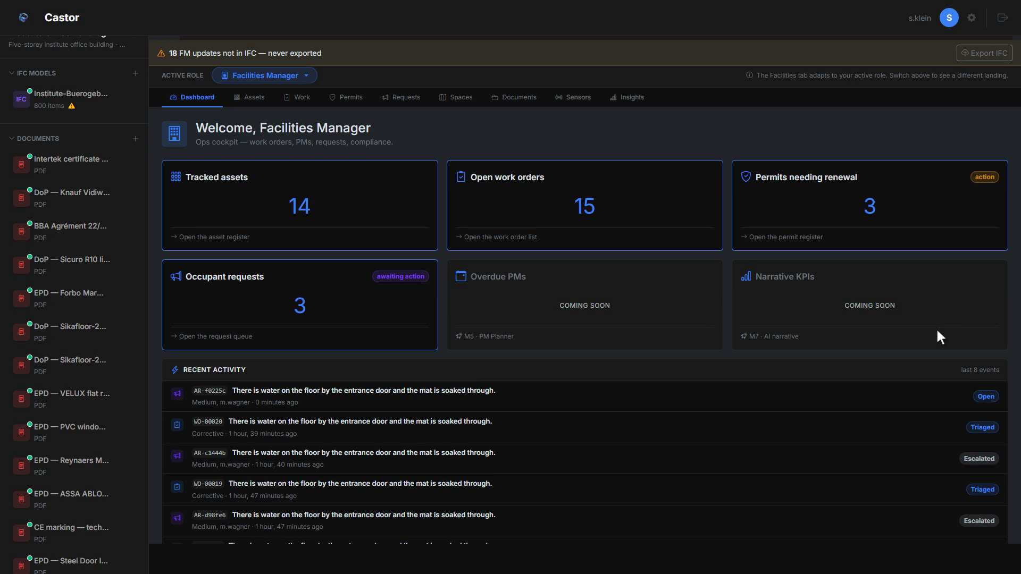
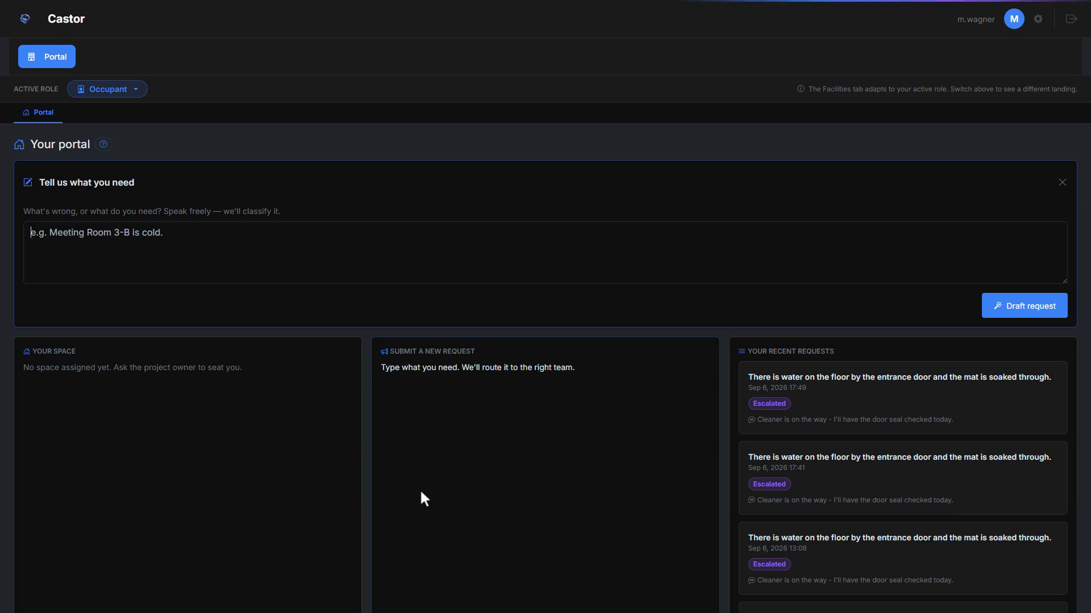
Figure D.2. Role-aware Dashboard: Owner, Editor, and Occupant views of the same project.
D.3 Assets
Every piece of equipment, furniture, or fitting the facilities team is responsible for lives in the Asset Register. Each row is a FacilityAsset with the metadata a facility manager reads over and over: tag, manufacturer, model, serial, commissioning date, warranty end, condition score, responsible party, and any classification codes (Uniclass, OmniClass, MasterFormat). Two flavours of asset coexist. Linked assets are hooked to an IFCEntity in the IFC model, so name, location, and IFC type read straight from the model. Orphan assets are items not in the IFC (post-handover additions, fire extinguishers, service vehicles, loose furniture). The register can be populated by promoting entities from the IFC in bulk, creating manually one by one, or importing a CSV with a dry-run preview before commit. Every asset card carries a QR code, printable one at a time from the card or in A4 sheets (twenty-four stickers per page) from the QR Management sub-tab.
Asset data also travels back to the model, not only out to CSV. When a linked asset’s tracked fields change (manufacturer, model, serial, commissioning date, warranty dates), the edit is queued as a change to the IFC itself. An Export IFC preview shows exactly what would change, entity by entity, on the matching IfcDoor, IfcWall, or IfcWindow property sets before anything is written, and the write follows the same human-approved path as any other model change, so the register and the model stay in step in both directions.
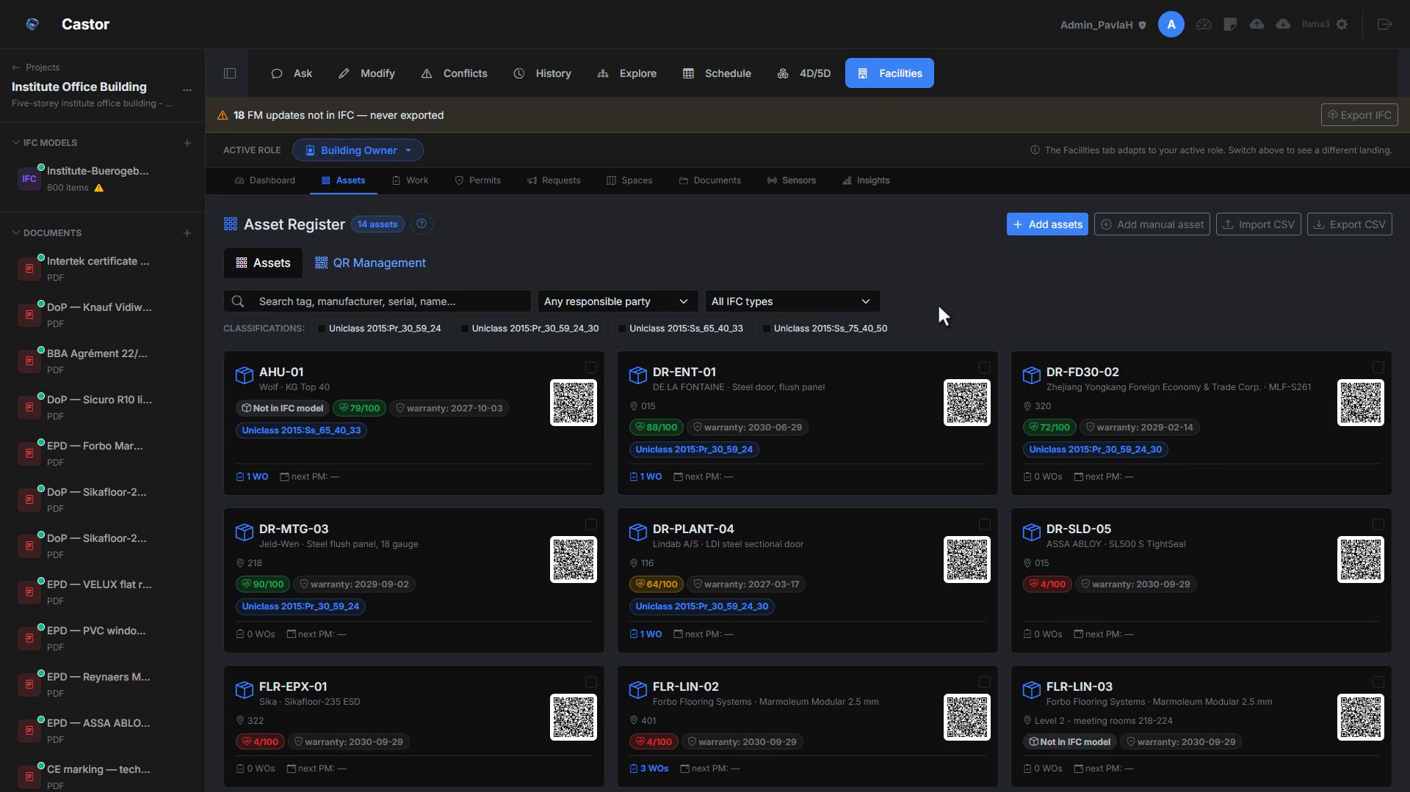
Figure D.3a. Asset Register: linked and orphan assets with QR codes.
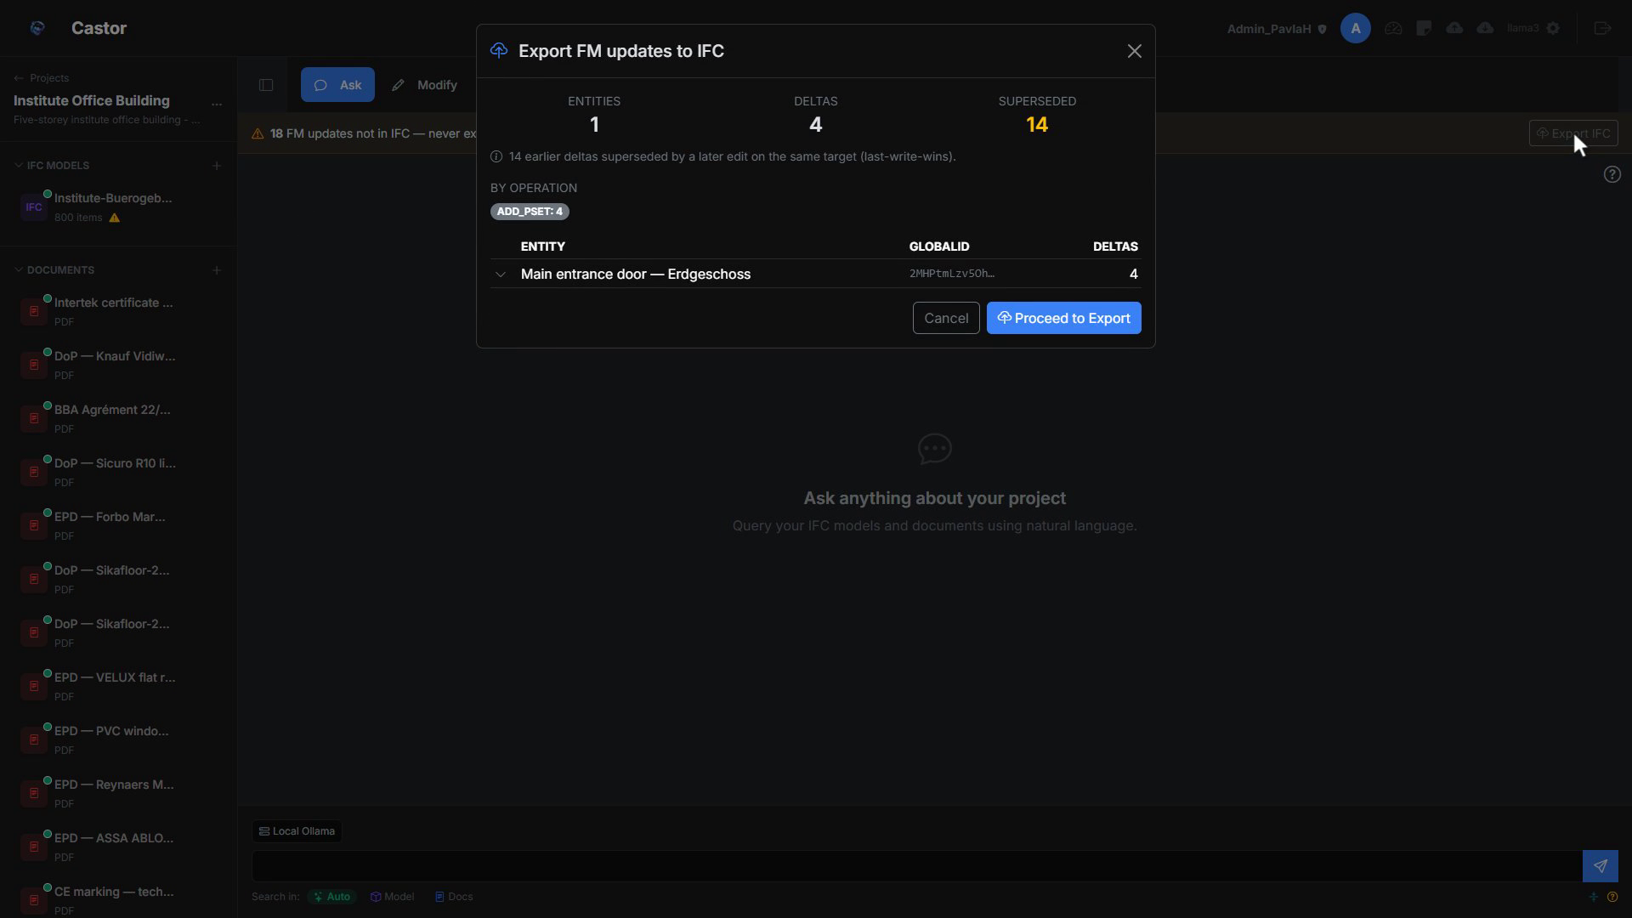
Figure D.3b. Export IFC preview: per-entity diff of tracked field changes before write.
D.4 Work
The Work module manages WorkOrder records, units of work with a status, an assignee, a due date, and a link back to the asset (and often the space) they affect. Categories cover the FM reality: corrective, preventive, inspection, safety, cleaning, and modification. Three views over one dataset are available: List (a classic table with filters, sort, and bulk actions), Kanban (columns for each status with drag-and-drop transitions), and Calendar (due dates across month, week, or day). Each work order has its own detail page with a timeline of status events, file attachments, and links to any permits it requires. Priority (Low, Medium, High, Critical) drives sort order and colour coding. Work orders can also be raised in bulk from a single instruction: describe a batch in plain language, for example a quarterly inspection of every fire door on a level, and the module drafts the matching set of orders for review. Nothing is created until the user confirms the proposed list, after which all the orders open at once, each anchored to its asset and space.
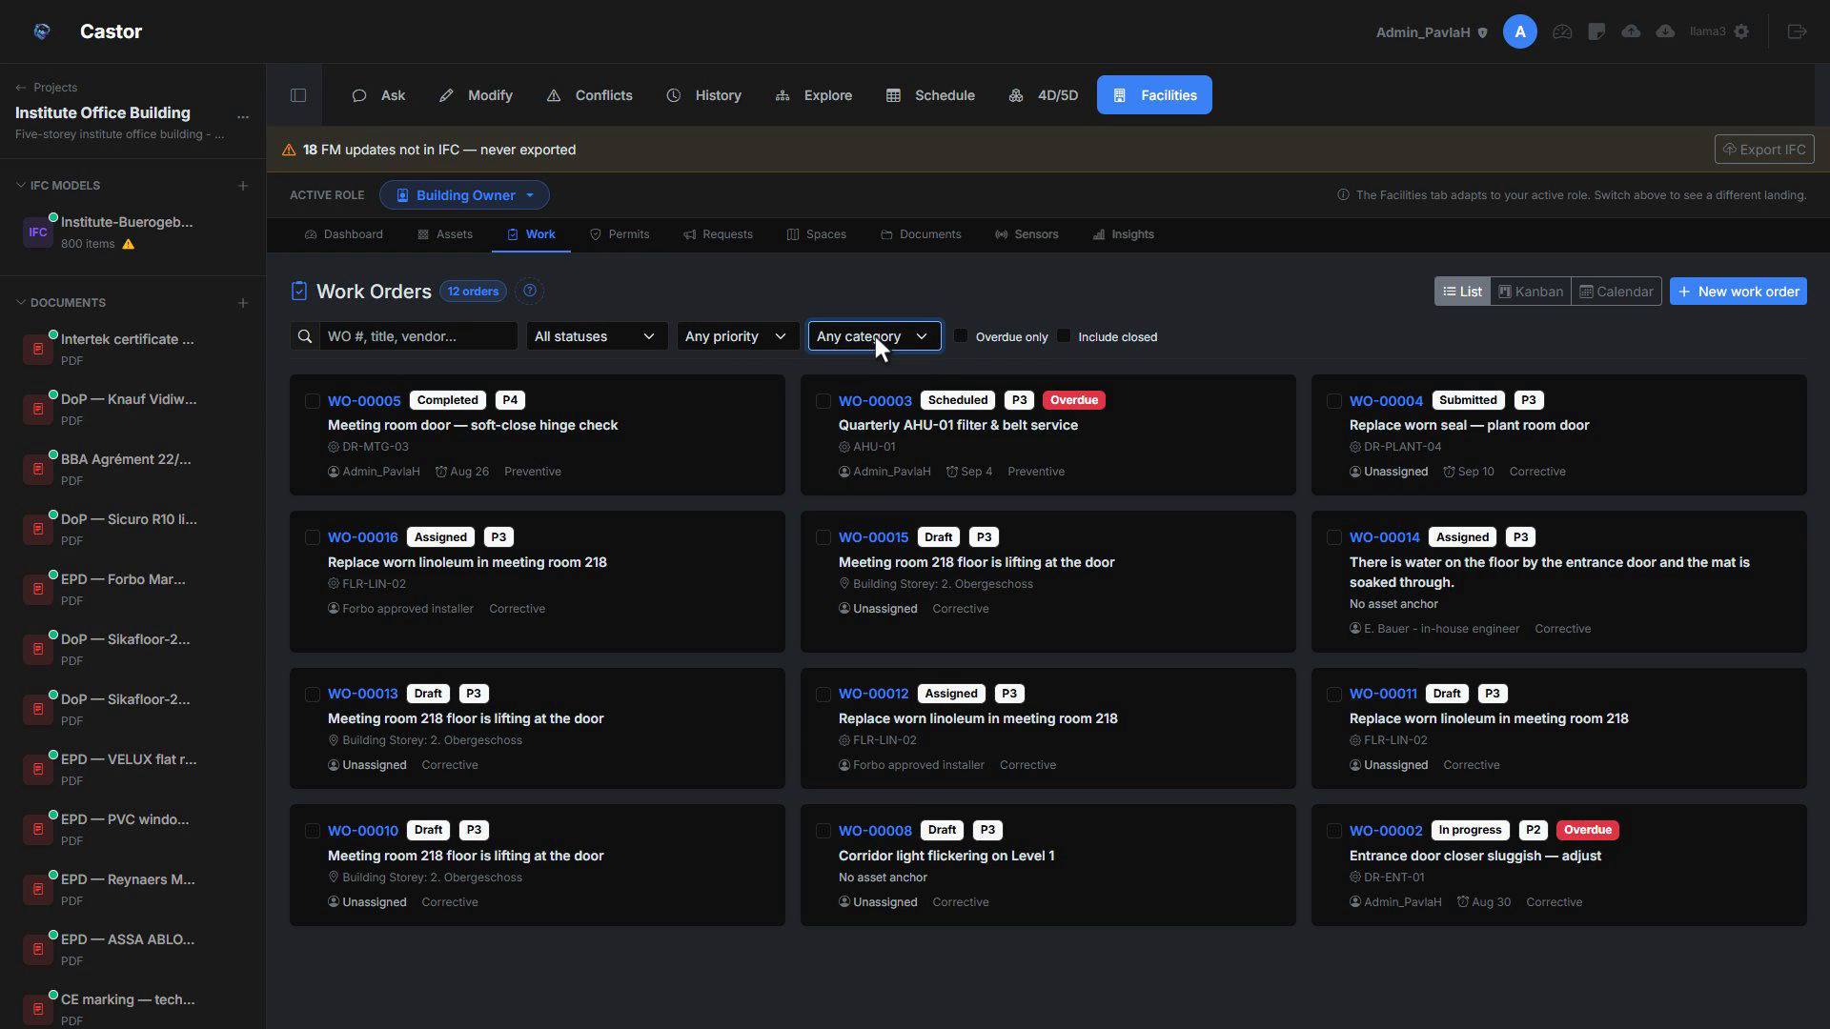
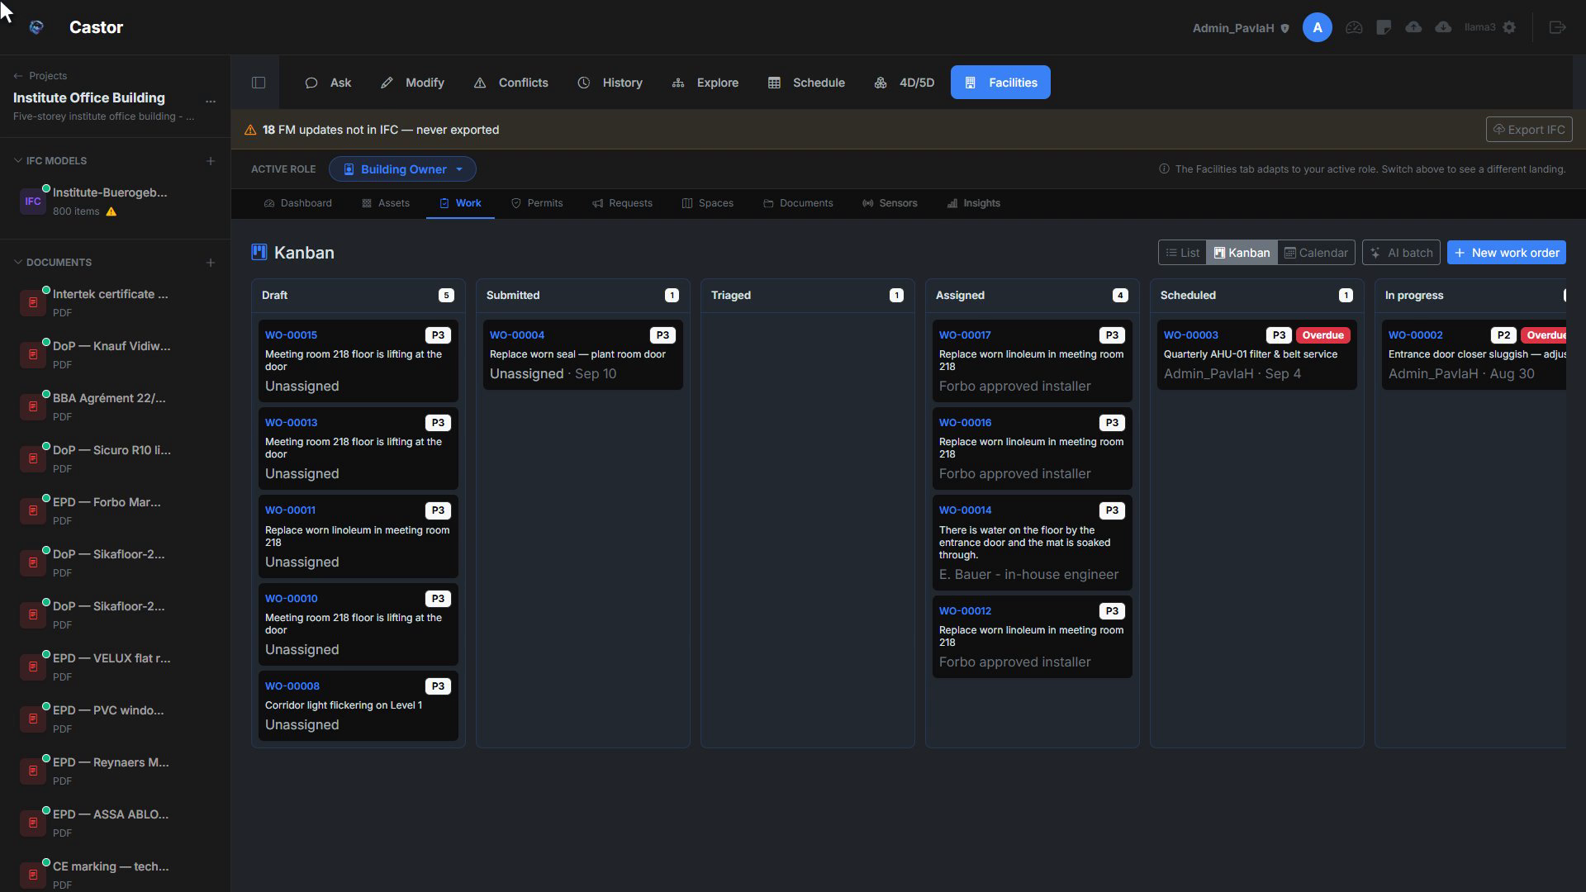
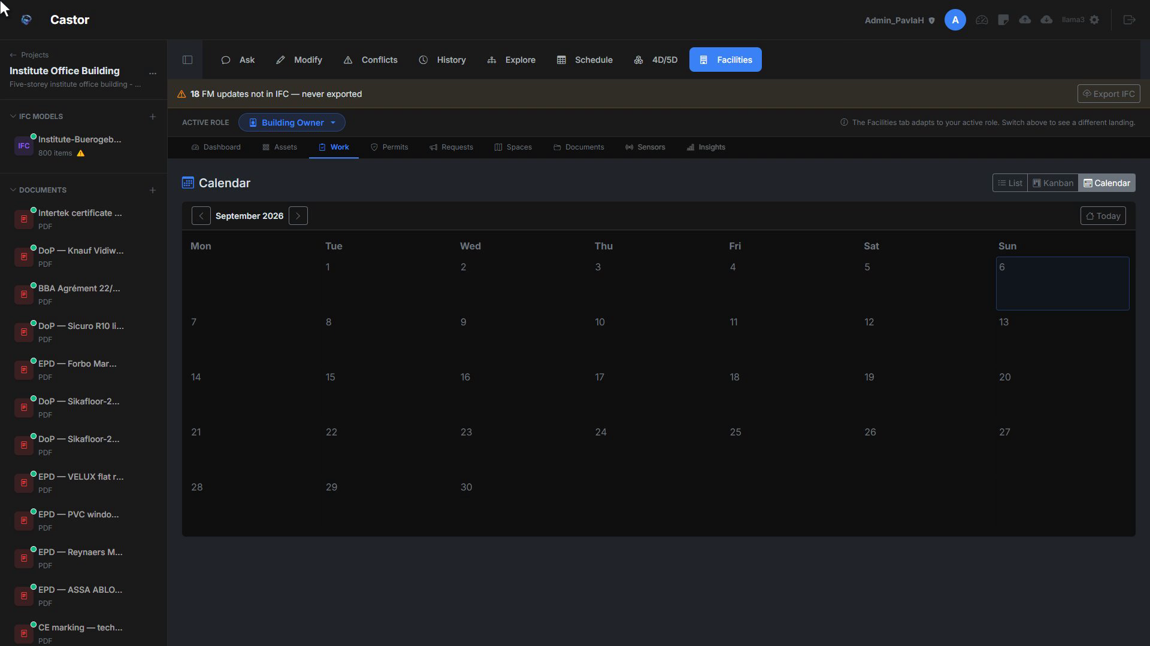
Figure D.4. Work orders across List, Kanban, and Calendar views.
D.5 Permits
Some jobs need a Permit to Work before anyone can start: hot work, confined space, working at heights, electrical isolation. The Permits module tracks these documents from draft to pending approval, to active, to expired or revoked, with the responsible person, valid-from and valid-to dates, and any conditions. Permit records attach to work orders. Before a technician can transition a work order to In Progress, the required permits must be active. If a permit is revoked, the linked work order goes back on hold automatically. Castor does not ship a hard-coded permit vocabulary; each facility defines the templates that match its safety regime.
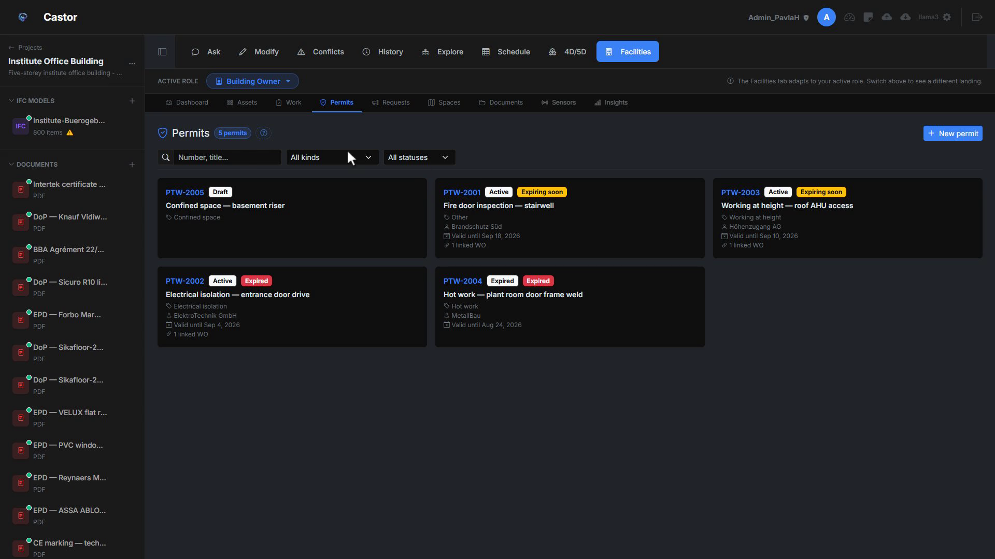
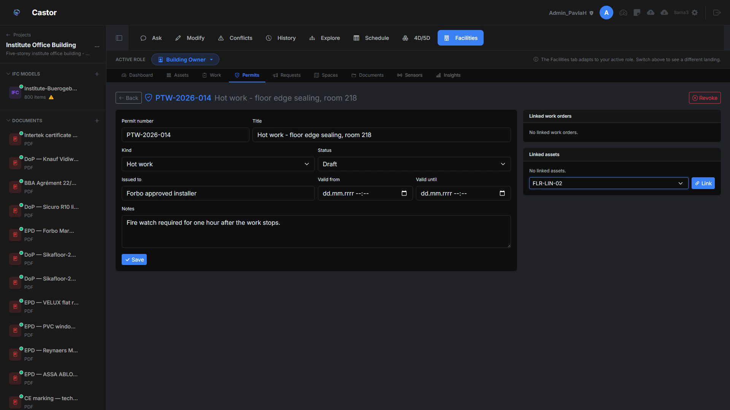
Figure D.5. Permit lifecycle from draft to expired, with work-order gating.
D.6 Requests
The Requests module (backed by ActionRequest) is where tenants and occupants report problems: a flickering light, a leaking tap, a broken door handle. The intake form is simple: category, location (picked from the IFC spatial tree or free text), description, and optional photos. It works for logged-in occupants and for anonymous kiosk submissions with an email address. An occupant does not have to complete the form field by field: they can describe the problem in their own words, for example that there is water on the floor by the entrance door, and Castor drafts a structured request from that text, proposing a title, a severity, and the affected location to confirm. Once submitted, a request enters the triage pipeline: Submitted (waiting for an editor to look), Triaged (editor confirms it is a real issue), Converted to Work Order (with the original description and photos attached; the requester gets a confirmation with the WO reference), or Rejected or Duplicate (closed with a reason the requester can read). The occupant sees the status of every request they have raised in their portal dashboard.
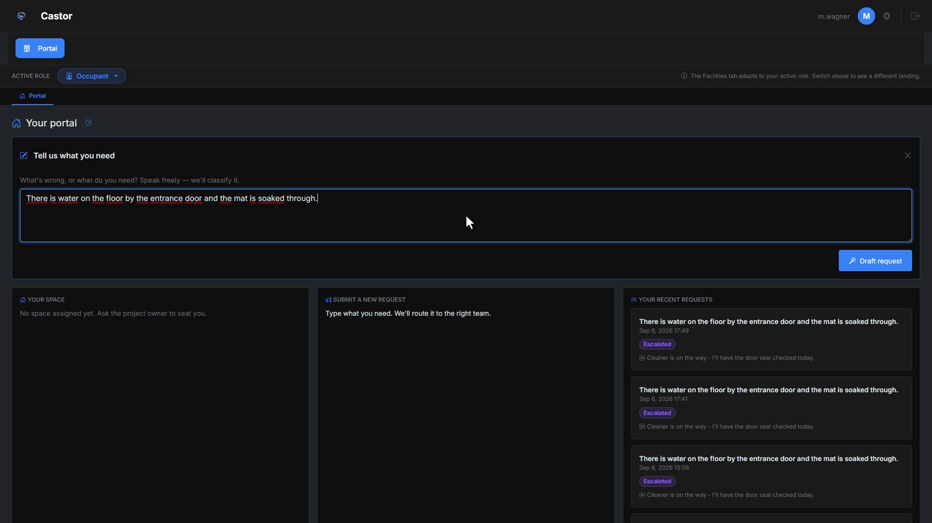
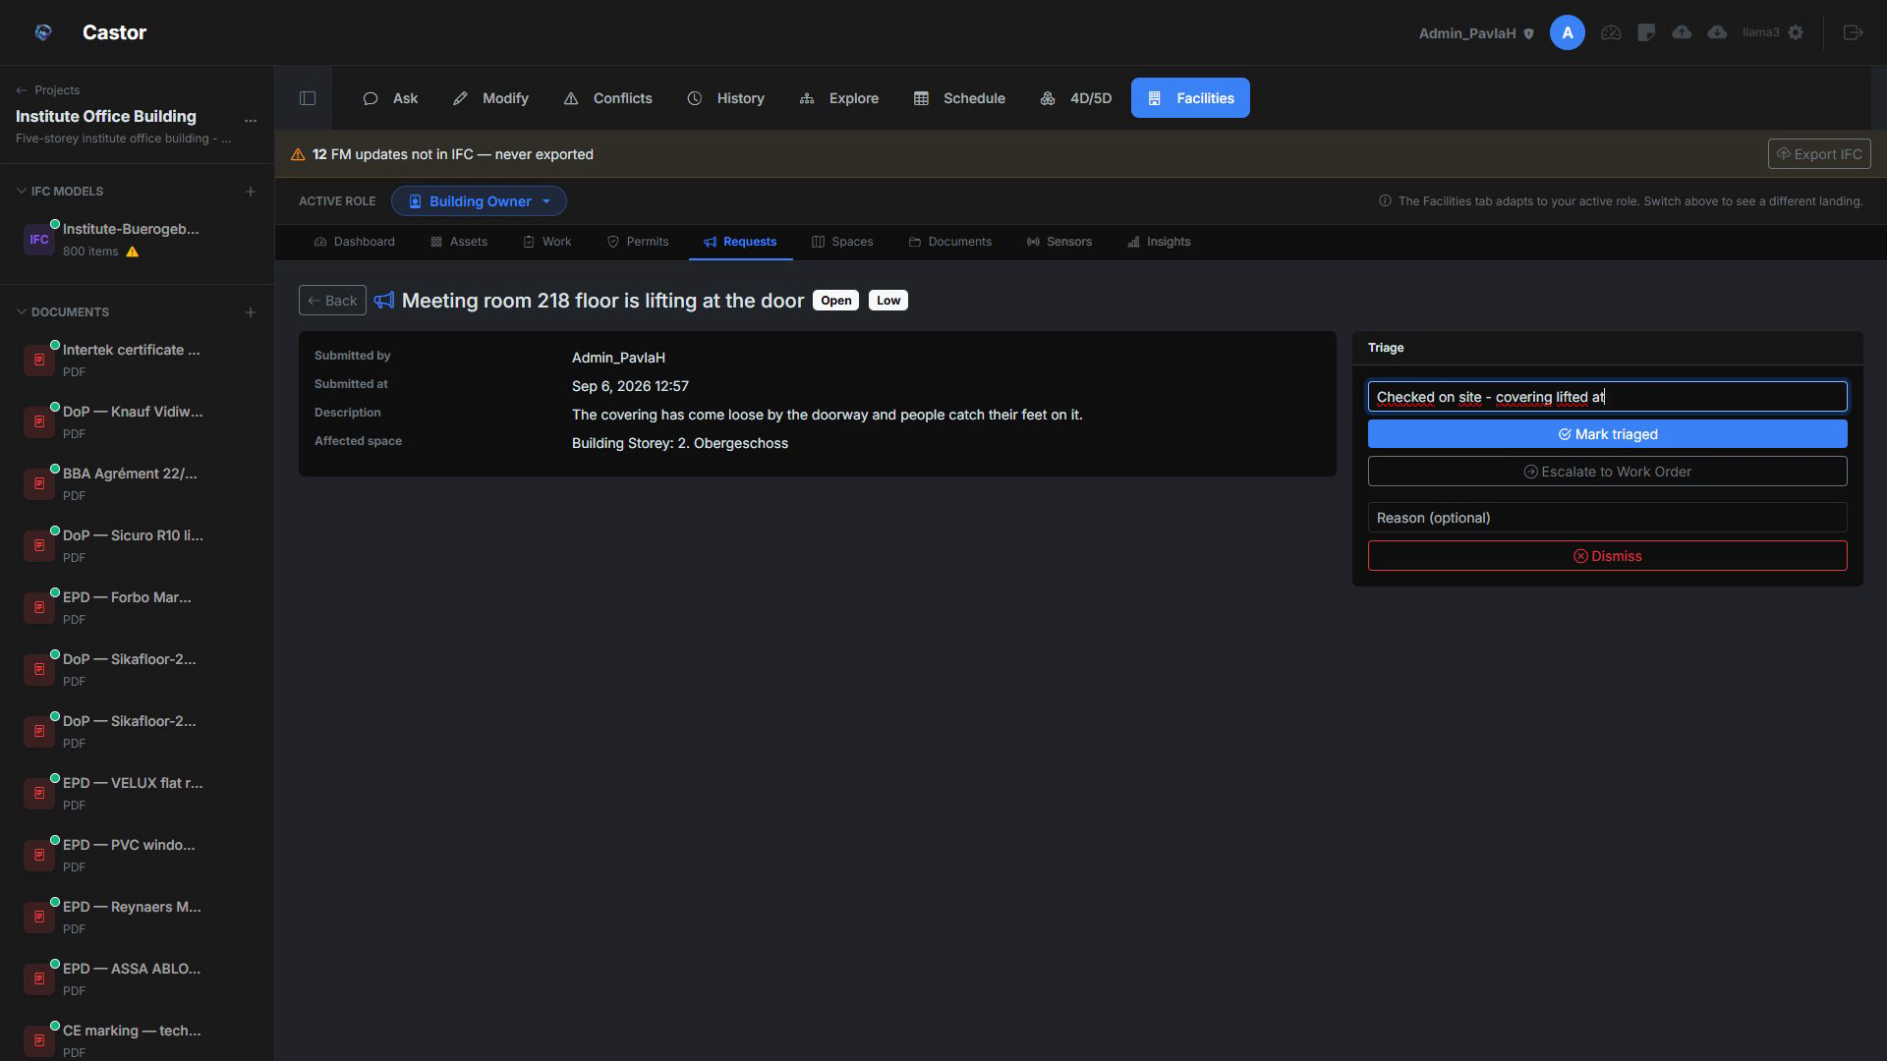
Figure D.6. Occupant intake form and the request triage pipeline.
D.7 Spaces
Spaces turns the IFC model into a set of interactive 2D plans that can be walked around, pinned, annotated, and shared across the whole team. Every storey in the building becomes its own sheet. Points can be dropped on the plan to mark cameras, sensors, photo positions, or any custom location. Each pin ties back to a room in the IFC and carries its own timeline of photos, 360 panoramas, and metadata. Floor plans are obtained in two ways: upload an existing PNG, JPG, or PDF drawing (with optional white-background knock-out for dark themes), or generate from IFC by slicing the model horizontally at a chosen cut height (1.2 m by default, the architectural standard) and rendering a clean 2D plan on the fly. Both sources coexist per storey, and both appear together in the plans manager once generated. Pins can be Photo (numbered), Camera, Sensor, or a Custom type with its own symbol. A Paint-style drawing toolbar over the plan supports pencil, line, rectangles, ellipses, triangle, arrow, star, text, and eraser, with twenty-one preset colours plus a custom picker, three brush widths, and undo and redo. Annotations are organised into named layers per storey (renovation scheme, maintenance zones, security walk-through) that can be toggled on and off independently, and a rectangle can trace a room straight onto the drawing.
A pin’s panel reaches into the model. Linking a pin to a room fills in the room’s GlobalId and pulls through its data; the pin can be given a room phase (construction, fit-out, occupied), and the panel lists the IFC elements that belong to that room, with the option to add further tables. Each photo carries its own date and description, and a switch flips the timeline between the flat (2D) and 360 archives. When a pin holds two or more 360 versions, Compare opens them in one viewer: dragging turns the view to look around the room, and a slider down the middle wipes between the two versions, so the same room reads as a clear before and after across visits. From the pin, Focus in 3D carries the user straight into the 3D model with the camera standing inside that room and a Back to Spaces return; the same one-tap bridge sits on an asset as View in 3D and View in IFC.
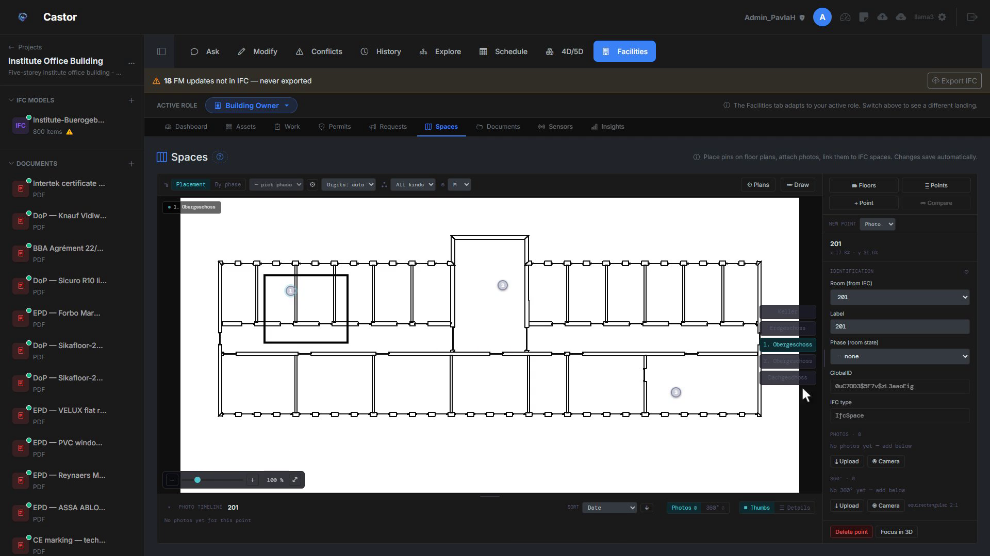
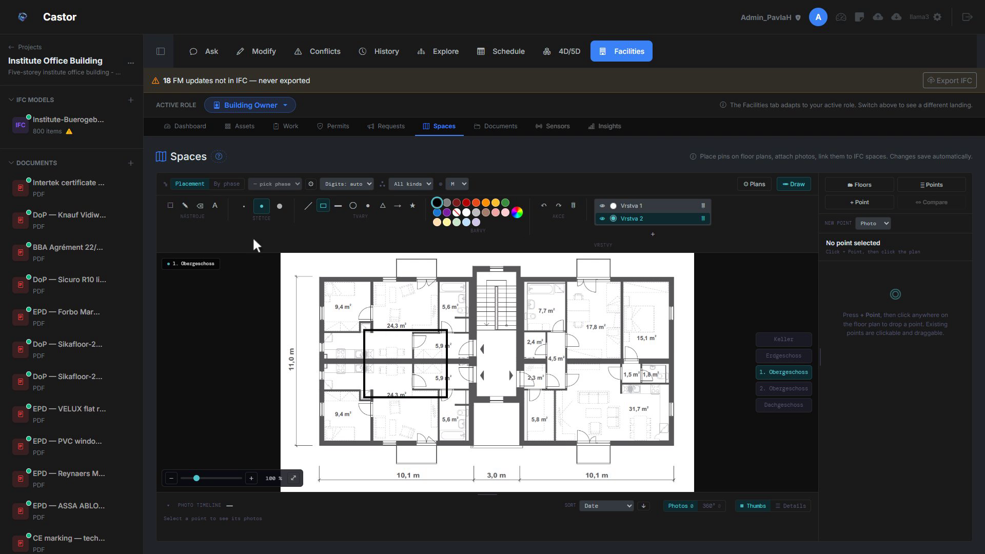
Figure D.7a. Spaces floor plan: pins, annotation layers, and the Paint-style toolbar.
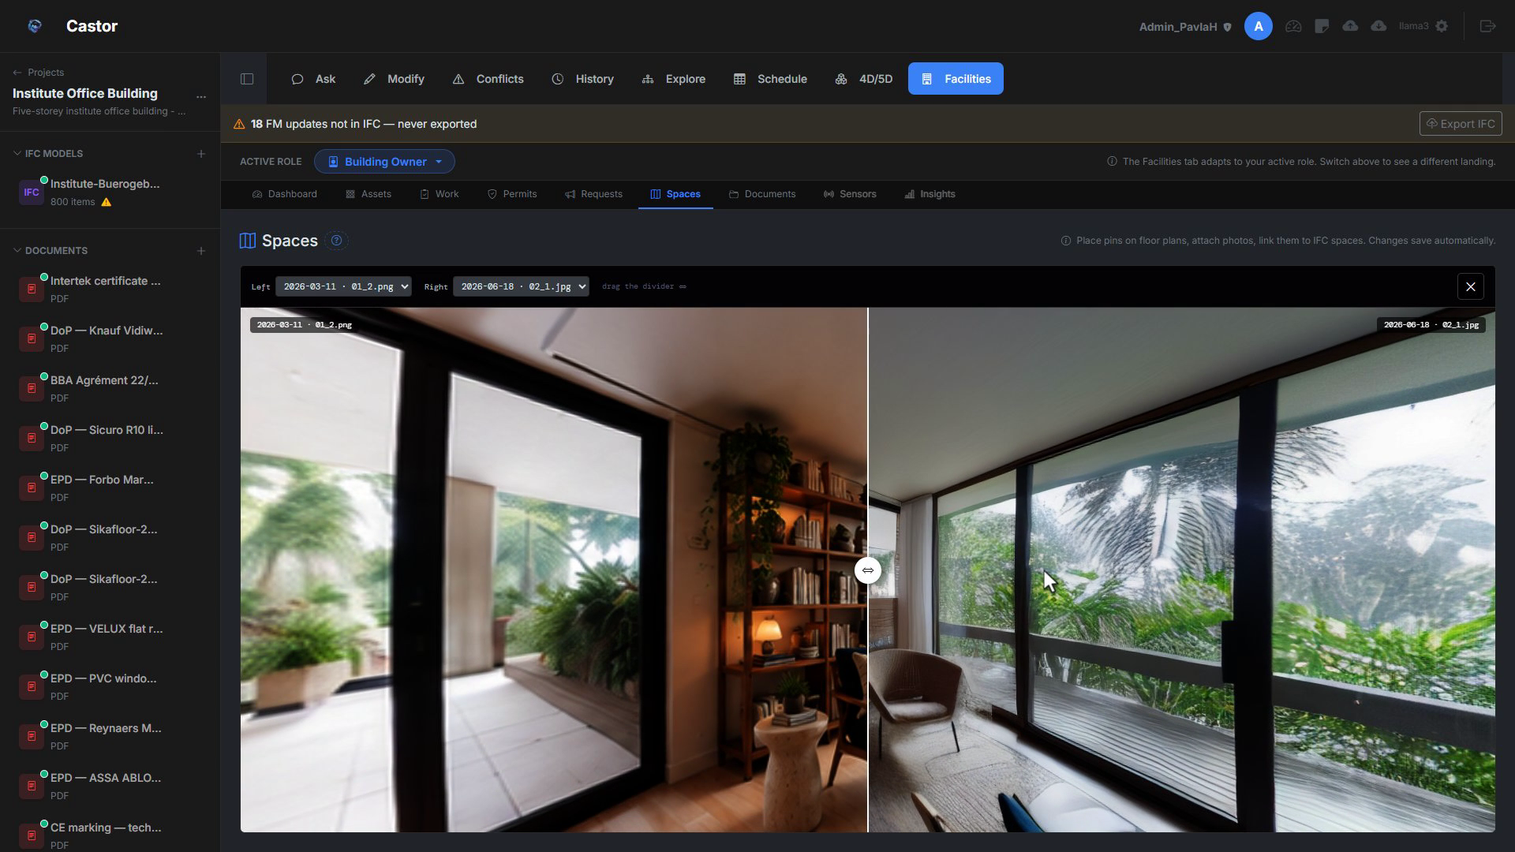
Figure D.7b. Before-and-after 360 Compare: slider wipe between two versions of the same room.
D.8 Documents
Every certificate, datasheet, and report lives in one searchable library and can be organised into folders that hang off any card: an asset, a work order, a permit, or a request. A folder on an asset keeps its EPDs, declarations of performance, and certificates next to the thing they certify; a folder on a permit holds its method statement. The library filters by type (PDF, Word, scanned PDF), so a technician finds the right document without leaving Facilities. Because folders bind to cards rather than to a separate silo, a document filed against a work order is one tap from the asset and the space that work order affects.
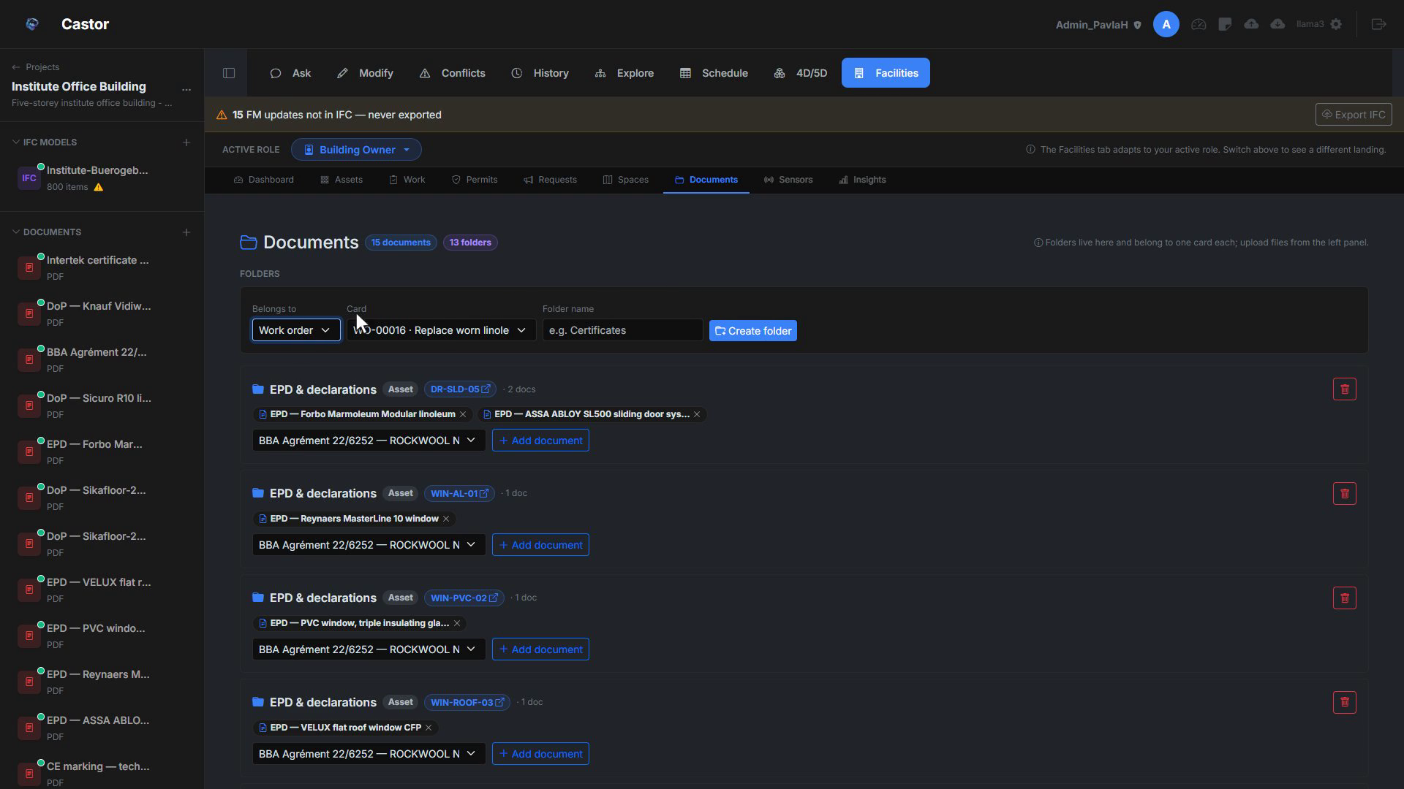
Figure D.8. Document library folder attached to an asset card.
D.9 Module integration
Everything in Facilities is stitched together by two shared references. The first is the IFC spatial tree: a work order on a broken light knows which room it is in because the asset knows, and the asset knows because it is linked to an IfcSpace (or anchored to one for orphans). The second is the role system (Owner, Editor, Viewer, Tenant): every action every module offers checks the same role of the current user against the same project. That is why placing a photo pin in Spaces, creating an asset in the register, filing a request from the tenant portal, attaching a document to a card, and issuing a work order all land in the same building’s timeline. There is no synchronisation between tools because there was only ever one tool.
D.10 FM workflow placement
Facilities is designed to carry the building through every phase after design. At handover, the architect delivers the IFC and the client generates plans for every storey in minutes without waiting for CAD exports. During commissioning, technicians photograph installations and tag each shot to a pin; the timeline captures who did what, and when. In operations, camera positions and maintenance history live on the same plan, and occupants file requests that turn into work orders in one click. For renovation, the new scheme is drawn on a fresh annotation layer and toggled against the existing plan for stakeholder reviews. In field service, printed QR labels take the technician from a scanned sticker to the asset page in one tap.
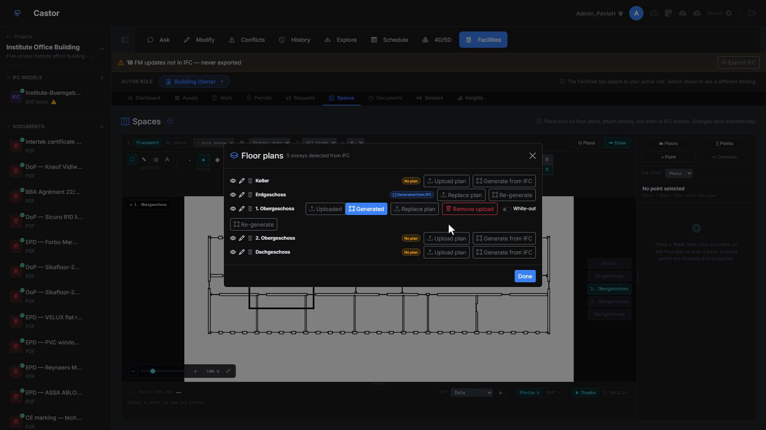
Figure D.10. Facilities across the FM lifecycle: handover, commissioning, operations, renovation, field service.
D.11 Roadmap
Two sub-tabs remain greyed out for now. Sensors, for live BMS and IoT readings and camera feeds tied to the model, and Insights, for reporting, KPIs, and cost or total-cost-of-ownership analytics. They are placeholders so the shape of the full platform is visible; each will follow the same pattern of rooting in the IFC, respecting the role system, and sharing the same navigation.

Appendix E: Testing Log of the Rewritten Write Path
This appendix reproduces the fourteen findings logged on 16 September 2026, when the rewritten write path of Section 3.2 was tested by hand through the interface. Section 5.4 of the memory cites them by row number. The scored record is docs/evaluation/2026-09-16-expert-testing-v3.md. The complete log, 138 rows from two team members, is in docs/evaluation/testing-log/ at the tag fmp-final, exported from the team's spreadsheet with its row numbers unchanged.
E.1 Method
Entries are chronological and never revised: a later reading that supersedes an earlier one is a new dated row that cites the original. Every claim is checked against an independent reading of the same file, which for this log means IfcOpenShell scripts. The rows below were measured on the buildingSMART Duplex model, converted to IFC4, with two planted requirement briefs and three planted numeric violations, using qwen2.5-coder:14b on a machine with 6 GB of graphics memory. Rows are comparable only within one build; row 84 marks the change to the rewritten pipeline.
E.2 Findings
Row | Area | Verdict | Finding, one line
84 | build boundary | — | V2 deleted; three V2 defects (SET_MATERIAL corruption, non-deterministic tier routing, entity resolver) closed by construction, not by fix. Log states the before/after is two designs, not one pipeline across versions.
85 | grounding, type resolution | fail 2/3 phrasings | IfcWall on an IfcWallStandardCase declined ("no IfcWall entities"); GlobalId alone declined with a wrong reason; exact subtype accepted and executed. Every decline fail-closed, no guessing (V2 returned a 200-wall proposal on the same input).
86 | proposal card, blind explanation, Guardian | pass | Blind explanation, produced without the request: "ThermalTransmittance of 1 IfcWallStandardCase changed from 0.31 to 0.99". Diff row computed from the file. Guardian verdict, arithmetic and clause correct.
87 | grounding scope | fail, then narrowed | Material change declined as "no material information"; the wall has an IfcMaterialLayerSetUsage. Grounding does not surface materials. The log's concern that materials sit outside the diff is withdrawn in row 91 (spec V-1: materials, container, decomposition, classifications, groups and type are snapshotted).
88 | Guardian re-run | inconclusive | Verdicts improved on 4/6 versus V2 but the old four-clause brief was cited, so the distractor clauses were not in context. Controlled re-run in row 94.
89 | conflict scan telemetry | changed | First non-zero ScanRun counters of the whole evaluation (76 entities, 3 conflicts) and the configured model used instead of a pinned llama3. Matched to ground truth in row 96.
90 | Ask, read path | fail, unchanged | IsExternal still not in the entity description (parser.py whitelist); out of V3 scope, as expected. The V3 card shows IsExternal = True for the same wall, which localises the defect to the description, not storage.
91 | sandbox and diff | pass | ThermalTransmittance written to an IfcRoof; file comparison shows only IfcPropertySingleValue, IfcPropertySet, IfcRelDefinesByProperties changed, pset unshared (spec C-2). One case; the log defers to the bake-off's 46/46 for the population claim.
92 | parser, data quality | unchanged | 58 open issues, identical to pre-V3; two parser root causes remain open.
93 | conflict scan throughput | fail vs. the UI's stated expectation | 95 pairs sequentially at about 106 s each on 6 GB, projected beyond 2.5 h. Coverage rose 18 → 95 pairs. Not comparable to any published latency.
94 | Guardian clause selection | pass 5/5, controlled | Old brief removed; 0.35, 1.60, 0.20, 0.99, 1.80 all cited the applicable exterior-wall clause 2.1, none the clause whose threshold the value matched. On V2 the same wall cited foundation, window, party-wall and utility-room clauses.
95 | Guardian verdict logic, numeric | fail 3/4 compliant flagged | Above 0.30: four correct conflicts. Below 0.30: 0.28, 0.22, 0.20 all "possible conflict". Exactly 0.30: confirm. The verdict tests equality with the threshold, not direction.
96 | conflict scan detection | mixed | Telemetry and routing fixed; three findings are all missing-property (one correct roof clause 3.1 hit); numeric detection 0/3, unchanged. Deleting a document cascades to its Conflict rows.
97 | Guardian verdict logic, textual | fail 1 false negative | EI60 on an EI60 clause: confirm, correct, distractor not cited. EI30 (a violation): "no relevant docs". Textual under-flags, numeric over-flags; only the exact match confirms in both.
Table E.1. Findings on the rewritten write path, 16 September 2026. Row numbers are those of the spreadsheet and of erez.csv.
Over the controlled Guardian set (rows 94 to 97), the applicable clause was cited 6 of 6 times and the verdict was correct 6 of 10 times: three compliant numeric values were flagged as conflicts, and one non-compliant textual value was passed as undocumented. The Guardian prompt defines a conflict as a document that states a different value, which explains both directions.
E.3 What the log does not give
The log is narrative: each row is a finding built from several prompts, and no row reuses a prompt of the benchmark corpus. No agreement statistic between the tester and the harness can therefore be computed from it. The per-prompt protocol that would give one is docs/fmp-delivery/expert-rerun-protocol.md.

