M10 · MAICEN1125 · FINAL PROJECT MEMORY
CastorIQ
A Bi-Directional LLM Assistant for IFC Models and Technical Documentation.

MODULE  M10 · MAICEN1125 | DELIVERY  27 September 2026
INSTITUTION  Zigurat Institute of Technology | PROGRAMME  MSc AI for Architecture & Construction

AUTHORS
Pavla Hornícká · Maria Makri · Erez Bader · Carlo Cogni · Islam Mohamed Sabra Ahmed

Abstract

CastorIQ is a locally deployable, bi-directional LLM assistant that closes the "Split Reality" gap between IFC building models and the unstructured technical documents that govern them. Where existing tools either check models against rule sets or parse documents read-only, CastorIQ links both domains in a shared 1024-dimensional vector substrate and, as its core contribution, writes changes back to the IFC file under maximal verification: the model writes the change as IfcOpenShell code, the code runs once on a copy, the measured diff is gated deterministically and explained by a second model that never sees the request, and a human approves the measured result. A Retrieval-Augmented Verification (RAV) layer checks every proposal against the project documents, and every approved change is a Git commit. Seven operational surfaces share one substrate: Ask, Modify, Conflicts, History, Explore, Schedule (4D and 5D) and 7D Facilities. On 8 GB of graphics memory a 7B local model passed 41 of 95 write-back benchmark prompts, and 46 of 46 written files changed nothing outside the selection; a cloud model passed 65 of 95. A retrieval fix raised the F1 of the document conflict scanner from 0.24 to 0.74. Over four public models, Ask answered 20 of 22 questions with one right answer and 11 of 14 narrative ones. Everything runs without cloud dependency, under AGPL-3.0.
REVIEW COPY · TEAM MARKUP

Yellow = Claude wrote from scratch, no source (framing, section §2). Cyan = synthesised from the team testing log (the spreadsheet of 16 Sep 2026; rows are cited in the text); verify against your own rows. Magenta = mentor (Pablo) flagged this and it is not yet addressed; see prose brief for what to write. Green = section or figure needs review or verification by the named team member (§8 whole section; ISO references for Pavla; History description for team). Tracked changes = what the V3 rebuild changed against the team draft of 16 Sep 2026; switch Word to Simple Markup to read the result. Please comment rather than edit: the text is rebuilt from docs/fmp-delivery/report-sections/, so edits made here are carried over by hand. This copy is for review only. Submit the file without _REVIEW in its name.
WHAT CHANGED IN THE V3 REBUILD, AND WHY
Section | What changed | Why
Abstract | Pipeline description and every number replaced | The old figures traced to no record; the new ones come from the dated benchmark records
§1 | Two citations and the rework statistic corrected; Gap 2 reworded | Checked against the sources: Text2BIM is Du et al., MCP4IFC is Nithyanantham et al., the rework paper is Love and Li, the PlanGrid/FMI report says 48 percent
§2 | RQ2 and RQ3 criteria rewritten; RQ4 status updated | The tier targets no longer exist; 8 GB is the machine the benchmarks ran on
§3.1 | Citations added | IfcOpenShell, pgvector and retrieval-augmented generation were used but not cited
§3.2 and Figure 1 | Rewritten and redrawn | The tiered pipeline was replaced on 15 Sep 2026; the old design stays as one dated paragraph
§3.3 to §3.5 | Models updated; LangGraph and ReAct removed; editor gate stated | qwen3:14b is no longer the reference model; nothing in the code uses LangGraph; the viewer-role fix shipped with the rewrite
§4 | Measurement programme added; test count updated | The Student Week criticism produced the benchmarks; the suite collects 2,672 tests on 16 Sep
§5 | Rewritten around an evidence map (Table 5.1); harness names link to their code; retrieval coverage rows added | Table 1 had no source; every number now links to its record, run file and, through Appendix F, the code that computes it
§5.4 | Team testing cited by row | Erez's rows of 16 Sep and Maria's planted-conflict set replace the "being organised" text
§6 and Figure 3 | Limitations rewritten; Figure 3 redrawn; OCR stated as a convenience with a manual route for precision | Two limitations are closed by the rewrite; the Guardian verdict finding is new; OCR accuracy is out of scope
§7 | First contribution changed | Maximal verification replaces the tier ladder
§8 | Every line edited | New roles in the rewrite and the testing; each person confirms their own line
Glossary and References | Four terms added, RSAA redefined; four references corrected, four added, ReAct removed | Follows the text above
Appendices | A.5, A.7 and A.8 updated; D pointer and figure numbers fixed; E and F added | See the appendices review copy

§ 1

Introduction and problem statement
The AECO sector is undergoing significant digital transformation, yet a critical synchronisation failure persists at the heart of most projects. BIM has become the standard for structured project data, with IFC serving as the open interoperability format standardised as ISO 16739. In parallel, a project's regulatory and contractual obligations remain encoded in unstructured technical documents. These two information domains evolve on separate timelines, are maintained by different disciplines, and are edited in different tools. We refer to this as the Split Reality problem.

When an engineer updates a fire-rating requirement in a report from EI30 to EI60, no automated mechanism propagates that change to the corresponding IfcDoor or IfcWall entities. Conversely, when a designer modifies a wall assembly in the model, the thermal report does not update itself. Love and Li (2000) measured direct rework costs of 2.4 and 3.15 percent of contract value on two audited projects, and FMI and PlanGrid (2018) attribute 48 percent of all rework on US jobsites to poor project data and miscommunication. The split extends beyond design coordination to operations and site verification. Each situation is the same problem: two authoritative information domains that must agree at every point in a project's lifecycle, and that no existing tool holds together at that resolution.

1.1 State of practice
Current industry practice addresses this gap through largely manual or uni-directional mechanisms. Commercial clash-detection platforms perform model-to-model checks but do not reason over unstructured text. NLP-based tools for building code compliance checking parse prescriptive requirements but remain read-only: they flag non-compliance without proposing corrective model modifications. Commercial CDEs manage file versioning but treat models and documents as opaque files with no semantic linkage. Recent research demonstrates LLM-based multi-agent frameworks that generate and edit BIM models from natural language (Du et al., 2024), and protocols that let LLMs manipulate IFC data through predefined tools and dynamic code generation (Nithyanantham et al., 2025). Both remain uni-directional from instruction to model, do not cross-reference technical documents, and check a change against the model's stated intent rather than by measuring what the executed code did to the file.

1.2 Gap identification
Three specific gaps justify CastorIQ's approach and structure the rest of this memory:
- Gap 1. No production-ready tool semantically links IFC entity properties to natural-language requirements in associated technical documents. Addressed by the unified vector store of Section 3.1.

- Gap 2. Existing compliance-checking research stops at detection. No validated workflow exists for LLM-proposed IFC modifications whose effect on the file is measured before a human approves it. Addressed by the write-back architecture of Section 3.2 and evaluated in Section 5.
- Gap 3. The industry lacks lightweight, privacy-respecting solutions that operate on locally hosted models. Most emerging tools depend on proprietary cloud APIs, which raises data-sovereignty concerns for projects under contractual confidentiality. Addressed by local-first deployment with an optional bring-your-own-key (BYOK) path.
§ 2

Objectives and research questions
The central claim is that a bi-directional, document-grounded, human-in-the-loop system can materially close the Split Reality gap without compromising professional accountability or data sovereignty. It decomposes into three research questions with measurable success criteria.

RQ1. Can IFC entity properties and unstructured project documents be co-located in a single semantic substrate at sufficient quality to support cross-domain retrieval? Success criterion: questions with one right answer (counts, storey names, schema) answered correctly over public IFC models the system has never seen.

RQ2. Can LLM-proposed IFC modifications be made safe enough for professional use, auditable and reversible? Success criteria: no approved change touches anything outside the entities the user was shown; every proposal is measured correct, repaired or rejected, never applied on the model's own report; every accepted change is a Git commit that a single revert rolls back. The pass rate of a local model on a benchmark is reported as the ceiling of that model, not as a criterion.

RQ3. Can the pipeline run on consumer-grade hardware without cloud dependency and without loss of interoperability? Success criterion: end-to-end operation with 8 GB of graphics memory, IFC4 as the native schema and IFC2x3 uploads converted in-pipeline.

A fourth question emerged during pilot testing: whether an independent verification layer (RAV) can cross-check proposals against project documents without inheriting the agreement bias of the same model family. The conflict scanner was measured, diagnosed and improved (Section 5.2.2) and the per-proposal check was tested by hand (Section 5.4); the residual is the principal open item of Section 6.
§ 3

Methodological framework

3.1 Data sources and preparation
The system operates on two data categories. Structured BIM data consists of IFC files in STEP Physical Format, parsed with IfcOpenShell (IfcOpenShell contributors, 2025) against the IFC4 schema; IFC2x3 uploads are converted to IFC4 in-pipeline. Entities are extracted with their GlobalIds, covering spatial hierarchy (IfcBuilding, IfcBuildingStorey), building elements (IfcWall, IfcDoor, IfcWindow) and their property sets. Unstructured documentation comprises PDF and DOCX fire safety reports, thermal specifications, acoustic analyses and structural calculations, extracted page by page with section structure preserved where possible.
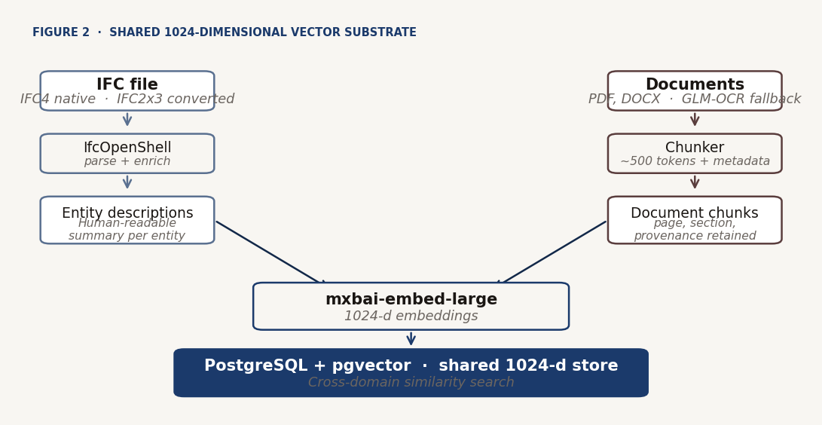
Figure 2. IFC entities and document chunks embedded into a shared 1024-dimensional vector store.

Each IFC entity is given a natural-language description combining its type, name, spatial location and key properties. Documents are segmented into overlapping chunks of about 500 tokens tagged with source, page and section heading. Both are embedded into one 1024-dimensional space with mxbai-embed-large through Ollama and stored in PostgreSQL with pgvector (pgvector contributors, n.d.), so a query about "fire-rated doors on Level 1" retrieves both the entities and the paragraphs of the fire safety report. The read path is retrieval-augmented generation (Lewis et al., 2020) over this store.

3.2 Write-back under maximal verification
The Modify path has one pipeline and one principle: the model is given full authority to write the change, and what the change did to the file is verified before a human sees it. Five steps, two model calls.
Ground. Without a model call, the request is paired with exact facts from the file's index: every storey and space, the count of each entity type, and the property sets on the types the request names, as literal strings, so the code is composed from names that exist.
Generate. One model call writes two functions in a single block: select(model) returns the target entities and modify(model, targets) changes those and only those. A request that is not a modification (a greeting, a question, a geometry change) is answered with a single REJECT line and a reason.
Run. A separate process opens a scratch copy of the file, snapshots it, runs select then modify, snapshots again, and returns the targets and the measured diff.
Verify. Any change outside the selected entities, or to geometry, is a scope violation: the code goes back to the model with the error, at most twice. A diff row whose value or property name is not in the request, or that adds or removes an entity, is flagged and must be ticked by the user. A second model then reads the code and the diff without the request and writes one sentence on what the change does. A reviewer that sees the request can parrot it; a blind explanation cannot.
Approve. If the original is unchanged since the proposal (fingerprint check), the reviewed copy replaces it atomically, the change is committed to the project's Git repository with the code, and the index is refreshed from the stored diff. The code never runs a second time: the approved diff and the applied diff are the same bytes.
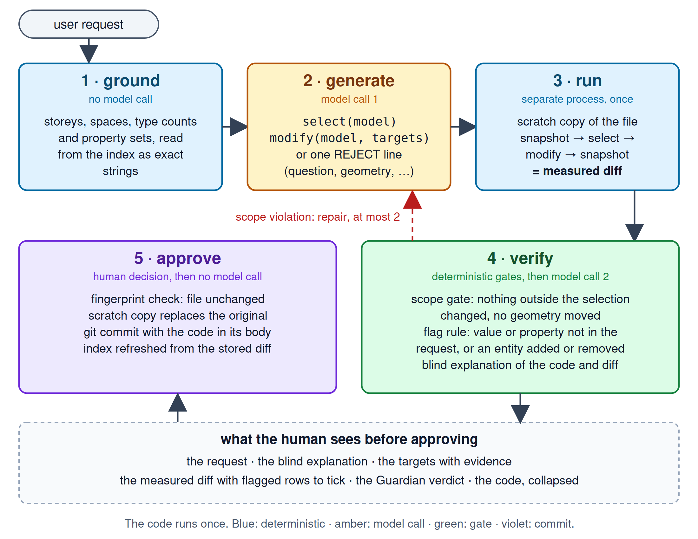
Figure 1. Write-back pipeline. The code runs once on a copy; the measured diff is gated, explained blind and approved; the copy is swapped in.
From minimal authority to maximal verification. The first design (February to September 2026) followed the opposite principle: a four-tier ladder (feasibility, certified property changes through pre-coded handlers, multi-step plans, custom code) gave the model no more power than the request needed. Its failures lived between its five to eight small model calls per request: each call was on schema, and nothing checked that the fourth still meant what the first understood; its preview showed what the model said it would do, not what it did. The tiers were replaced on 2026-09-15; the argument and the alternatives rejected are in the repository's design log. Geometry modifications remain out of scope. The RAV layer (Guardian) searches the project documents when a proposal is made and reports on the card; it advises and never blocks.

3.3 Technology stack

Django 5.x; PostgreSQL 16 with pgvector; real-time progress through Django Channels on Daphne. Local inference runs on Ollama: a code-tuned model for Modify (qwen2.5-coder:7b on 8 GB, 14b recommended at 12 GB) and a general model for Ask (llama3.1:8b); optional cloud inference through user-supplied Anthropic and Groq keys. Embeddings by mxbai-embed-large; IFC processing by IfcOpenShell on a canonical IFC4 pipeline. Frontend in Django templates with HTMX and Bootstrap 5; packaging with UV; deployment with Docker Compose. Every approved change is a commit on a per-project Git repository, the auditable spine of the write path.

3.4 Local-first inference, with optional BYOK

The default deployment runs language-model inference and embedding locally, so no data leaves the user's machine: a foundational constraint motivated by the data-sovereignty requirements of European AECO projects under GDPR and ISO 19650. Users may opt into BYOK with Anthropic or Groq; keys are validated server-side and encrypted with Fernet. On authentication or rate-limit failure the system hard-errors rather than falling back silently to a shared pool, which would be an invisible cost transfer. A provider badge on each response makes routing verifiable, and a site-level switch can force local-only inference regardless of user configuration.

3.5 Identity and access

Access is enforced in two layers: a project membership tier (owner, editor, viewer) and nine functional roles with validity windows tied to contract durations. The role scopes the surfaces a user sees, from an occupant portal to the full Modify tab. The write path requires the editor tier at the HTTP and WebSocket layer, not only in the interface.
§ 4

Development process

CastorIQ was developed across three overlapping phases, the last of which was reshaped by a measurement programme.

4.1 Concept and design (February 2026)

The first phase established the problem framing, the two-surface architecture (Ask for read, Modify for write) and a tiered, minimal-authority governance model for the write path, with the RAV layer as a document-grounded second opinion on every proposal. The data strategy was fixed: IFC via IfcOpenShell, documents via chunked PDF and DOCX extraction, both embedded into one vector space in PostgreSQL with pgvector. Local-only inference was a non-negotiable constraint, with Llama 3.1 8B via Ollama as the first reference model.

4.2 Core build and lifecycle extension (February to May 2026)

The read-write core converged faster than planned, and the freed capacity went into scope on the same substrate: Explore, a first cut of the Facilities suite, 4D scaffolding on the Schedule surface, and the start of the in-app IFC viewer. The tiered write path gained a fourth, feasibility tier, and the nine-role identity model was introduced. By the end of this phase 434 automated tests were a mandatory merge gate.

4.3 Completion, demonstration and measurement (May to September 2026)

The third phase completed lifecycle coverage: 5D cost on the Schedule surface, the full Facilities suite (Section 4.4) and the IFC viewer in the 4D Link workspace. All modules were demonstrated at Zigurat Student Week in June 2026 (Section 5.4). Hardening followed: GLM-OCR for scanned PDFs, BYOK, the real-time layer, an invite-only hosted beta at castoriq.io, and AGPL-3.0 licensing. Facilities gained Documents, asset edits written back into the IFC model, LLM-drafted work orders and requests, and 360 time-lapse comparison in Spaces.
The demonstration's most consistent criticism was the absence of hard numbers. The answer was a measurement programme (Section 5.2): a first write-path benchmark on 2026-08-05; a RAV baseline on 2026-08-30 that located the layer's bottleneck in retrieval; and on 2026-09-15 the retrieval fix and the replacement of the tiered write path by the pipeline of Section 3.2, each measured the day it landed. Two team members ran structured manual testing against independent ground truth throughout (Section 5.4).

4.4 Seven delivered surfaces

CastorIQ v1.0.0 delivers seven operational surfaces on one substrate: Ask (natural-language read over IFC and documents); Modify (the verified write path with RAV on the card); Conflicts (semantic mismatches between documents and model); History (the approved-change audit trail); Explore (structured IFC navigation without an LLM); Schedule (4D and 5D, with Primavera P6 import, earned value, DCMA 14-point health and Monte Carlo forecasting); and Facilities (7D operations across Dashboard, Assets, Work, Permits, Requests, Spaces and Documents). Lifecycle coverage from design intent to operations on one semantic substrate distinguishes CastorIQ from single-purpose BIM tools.
§ 5

Results and evaluation

The evaluation is of three kinds: delivered scope; quantitative measurement by reproducible harnesses; and independent testing by team members outside the write path against external ground truth. Every number below is copied from a dated record in the repository and can be checked against its committed run artifact. Table 5.1 maps each result to its source at the tag fmp-final, the commit this memory describes (evaluation records, run artifacts); Appendix F maps each figure to the code that computes it, and docs/evaluation/recount.py recomputes Tables 5.2 to 5.4 from the run files with no model.

5.1 Delivered scope and mitigations

Each milestone of the third phase had an operational purpose: GLM-OCR restored retrieval over scanned archives; BYOK answered "my hardware is too weak"; the hosted beta let outside evaluators in without an installation; AGPL made data sovereignty enforceable. The write-path rewrite closed three defects found by manual testing by construction, since the components no longer exist: a silent material corruption in a pre-coded handler, non-deterministic tier routing, and an entity resolver that returned a default set.

5.2 Quantitative evaluation
Result | Harness and corpus | Models, machine, date, repeats | Record | Artifacts
Table 5.2, Modify | benchmark_writeback: 98 prompts, 95 scored, on Ifc4_SampleHouse.ifc | qwen2.5-coder:7b, claude-sonnet-4-6; RTX 4070 Laptop, 8 GB, no offload; 2026-09-15; worse of 2 runs | 2026-09-15-writeback-v3-bakeoff.md | writeback-v3-2026-09-15-qwen2.5-coder-7b-review5-repeat2.json, writeback-v3-2026-09-15-claude-sonnet-4-6.json
Table 5.3, RAV | benchmark_rav: 26 planted cases over 15 entities, three documents; --coverage for retrieval | llama3.1:8b, qwen2.5-coder:7b; same machine; 2026-09-15; 3 runs, min–max; coverage 2026-09-16, no model | 2026-08-30-rav-benchmark.md, 2026-09-15-rav-retrieval-fix.md, 2026-09-16-rav-retrieval-coverage.md | rav-2026-09-15-{before,after}-*-repeat3.json, rav-2026-09-15-ablate-qwen2.5-coder-7b.json, rav-2026-09-16-coverage.json
Table 5.4, Ask | benchmark_ask: 10 questions × 4 public IFC models, answers computed by IfcOpenShell | llama3.1:8b; same machine; 2026-09-15; 1 run | 2026-09-15-ask-benchmark.md | ask-2026-09-15.*.json
Tiered pipeline, history | benchmark_writeback (V2): 92 prompts | llama3.1:8b; 2026-08-05; 1 run | 2026-08-05-writeback-nl-benchmark.md | none survives
Section 5.4, testing | manual, IfcOpenShell and Solibri as ground truth, 138 logged findings | qwen2.5-coder:14b, 6 GB, for the rewritten write path; 2026-05-18 to 2026-09-16 | 2026-09-16-expert-testing-v3.md | testing-log/erez.csv, maria.csv
Table 5.5, tests | pytest --collect-only over src/ and tests/e2e | 2026-09-16 | this section | none
Table 5.1. Where every number in this section comes from. Records are dated and never edited; artifacts carry every case's outcome and live under runs/.

5.2.1 Modify: natural-language write-back
 | Local floor, qwen2.5-coder:7b (8 GB) | Frontier ceiling, claude-sonnet-4-6 (cloud)
passed (scored) | 41 / 95 | 65 / 95
targets match (select() returned exactly the named entities) | 19 / 64 | 38 / 64
diff match (the measured diff holds the expected rows and counts) | 18 / 66 | 39 / 66
integrity (nothing outside the selection changed, no geometry moved; independent re-read of the written copy) | 46 / 46 | not measured on this row
reject / no-change handled correctly | 23 / 29 | 26 / 29
repairs used (at most 2 per request) | 59 | 58
latency median / p90 per request | 6.4 s / 14.0 s | 8.1 s / 21.5 s
tokens in / out (cost) | 509,066 / 26,081 (local) | 896,951 / 72,510 ($3.78)
Table 5.2. Write-back bake-off. A refused change case scores false on targets and diff. The ceiling row was re-scored from its artifact after a same-day harness correction; the record keeps both figures.
How the rows fail matters more than the pass rate. Of the 56 failures in the 7B run measured earlier the same day, before a prompt change that moved five edge cases, 19 were proposals on the wrong entities (a subtype confused with its parent, a name fragment missed), 15 rejections after three code errors (a hallucinated helper, a wrong API keyword) and 10 rejections after three empty selections. None was a change outside the selection: every wrong attempt ended in a repair or a rejection, which is the property the design guarantees. Two-thirds of the ceiling row's 30 failures are corpus conventions, such as a Revit export suffix read as a STEP id. The blind explanation stated property, value and count, and nothing the diff did not show, on 10 of 10 randomly sampled passing cases. The tiered pipeline was measured once (Table 5.1): 64 / 91 on whether the router chose the corpus's tier and 53 / 53 on journal fidelity. Those figures score the choice of tier, Table 5.2 scores what the executed code did to the file; they are not comparable.

5.2.2 Retrieval-augmented verification: the conflict scanner
The conflict scanner applies the RAV layer to the whole model. Its first measured run (2026-08-30) quantified the weakness pilot testing had reported: precision 0.29, recall 0.20, recall on clear conflicts 1 of 11. Its diagnosis was that retrieval, not the model's comparison, was the bottleneck: with entities chosen per requirement chunk by embedding distance, identical external walls crowded each other out and no thermal chunk reached any wall or window, so whole conflict cases never reached the model. Ablating the four prompt-level mitigations moved results only within the variation between runs. The fix was therefore in retrieval: two exact lookup passes before the embedding pass, verification of a finding's claimed current value against the index, and attribution of a finding to the chunk that quotes the requirement.
 | before (mean [min–max], n=3) | after (mean [min–max], n=3) | delta vs. baseline spread
llama3.1:8b precision | 0.29 [0.26–0.31] | 0.71 [0.68–0.73] | +0.42, spread 0.05
llama3.1:8b recall | 0.20 [0.20–0.20] | 0.77 [0.76–0.80] | +0.57, spread 0.00
llama3.1:8b F1 | 0.24 [0.23–0.24] | 0.74 [0.72–0.75] | +0.50, spread 0.02
qwen2.5-coder:7b precision | 0.60 [0.57–0.67] | 0.70 [0.67–0.74] | +0.10, equal to the spread
qwen2.5-coder:7b recall | 0.16 [0.16–0.16] | 0.65 [0.64–0.68] | +0.49, spread 0.00
qwen2.5-coder:7b F1 | 0.25 [0.25–0.26] | 0.68 [0.65–0.71] | +0.42, spread 0.01
recall on clear conflicts (worst of three) | 1 / 11 on both models | 9 / 11 (llama) · 6 / 11 (coder)
aligned requirements left alone (worst of three) | 21 / 26 (llama) · 25 / 26 (coder) | 18 / 26 (llama) · 21 / 26 (coder) | the cost of the fix
key entities reached by any requirement chunk (no model) | 11 / 15 | 15 / 15 | deterministic
key entities reached by every document that constrains them (no model) | 5 / 15 | 15 / 15 | deterministic
Table 5.3. Conflict scanner before and after the retrieval fix: same corpus, settings and day, three runs each, scored per entity over 25 conflict triples and 26 negatives.
A seven-arm ablation attributes the gain. With the retrieval passes off, recall falls from 0.72 to 0.28 and clear-conflict recall back to 1 of 11. With value verification off, recall falls to 0.56, because a model that copies the document's value into the "current value" field had its real conflicts dropped as already matching. With everything off, the baseline returns. What still fails is the model's reading: a marginal case (0.117 against 0.10) is never found, an absent property is read as "not applicable", and two to four more aligned requirements are flagged.

5.2.3 Ask: question answering over public models
Fixture (schema) | Exact answers, passed / scored | Narrative answers, passed / scored | skipped | median latency
open-house (IFC4, 23 entities) | 4/4 | 2/3 | 3 | 3.3 s
duplex (IFC2X3, 241 entities) | 5/6 | 4/4 | 0 | 2.7 s
fzk-haus (IFC4, 51 entities) | 6/6 | 2/3 | 1 | 2.2 s
office-a (IFC2X3, 901 entities) | 5/6 | 3/4 | 0 | 2.0 s
total | 20 / 22 | 11 / 14 | 4
Table 5.4. Ask benchmark, first published run. An answer passes when the exact count, storey names, schema string or an expected keyword appears and it is not a refusal.
Counts of doors, windows and walls, storey lists and the schema were right on every model. The five failures are two space counts answered from excerpts instead of the count recipe, two narrative answers that explained a method instead of answering, and one correct "no fire rating in this model" that the scorer counts as a refusal. Retrieval quality is not measured directly: hit@k and MRR are future work.

5.2.4 What is not measured, and threats to validity
OCR accuracy is out of scope: GLM-OCR is a free, local convenience for scanned pages, not expected to match frontier multimodal models (Section 6.1). The tier-level correctness, schema-adherence and latency figures of the July draft traced to no record and are withdrawn. The 12 GB and 24 GB rows, an adversarial sandbox corpus and an expert labelling scored against the harness with Cohen's κ (Cohen, 1960) are open. Each row is one model on one machine and claims nothing beyond it. The Modify and planted-conflict corpora were written by the authors, and their disputed conventions are documented, not fixed after the fact. Samples are small, so every rate carries its denominator. Local models are non-deterministic at temperature 0.1: Modify rows keep the worse of two runs, RAV rows report the range of three, and a change counts as an improvement only beyond the baseline's range.

5.3 Test suite and quality assurance

The suite collects 2,676 tests plus 19 Playwright end-to-end tests, with ruff lint and format as a merge gate. Model, embedding, Git and file-system boundaries are mocked; only the harnesses call a model. The suite shows behaviour under specified inputs, not end-to-end efficacy.
Area | Tests
Facilities (7D) | 473
Quantities / 5D takeoff | 412
Write-back (pipeline, Guardian, conflict scanner, RAV harness, Git, consumers) | 419
Core platform (BYOK, budgets, LLM routing, staff) | 338
IFC processing (parser, diff, sandbox, round-trip) | 295
Scheduling (4D) | 263
Environments and deployment | 162
Ask / RAG and the Ask benchmark scorer | 109
5D cost | 66
Documents and OCR | 37
Classification | 35
IFC viewer, embeddings, users, beta funnel, MetaCastor, model quality | 67
Playwright end-to-end | 19
Table 5.5. Collected tests per application, pytest --collect-only, 2026-09-16.

5.4 External and independent validation

Peer demonstration. At Zigurat Student Week (June 2026), about forty colleagues and professors saw a live demonstration. Interest concentrated on the lifecycle surfaces; the most consistent criticism was the absence of hard numbers, which produced Section 5.2; usability was raised alongside capability; and attendees with Middle East experience named IFC round-trip friction inside cloud CDEs as a blocker.

Expert testing of the write path. Two team members who did not write the write-path code logged structured testing chronologically, never revising an entry. They checked every claim against an independent reading of the same file: IfcOpenShell scripts on the buildingSMART Duplex model, and Solibri Model Checker on two further test sets. On the rewritten pipeline, the hand check corroborated what the harness measures. The blind explanation stated property, value and count and nothing else, and the diff shown was computed from the file (erez.csv row 86). A committed write on an IfcRoof changed only its own property-set entities (row 91). The check also found four open defects:
- Type resolution. The exact IFC class is required, and a supertype or bare GlobalId is declined (row 85). Every decline is now a refusal, where the tiered pipeline had proposed changes to 200 walls.
- Materials. Material assignments are compared by the diff but not offered to the model (row 87).
- Guardian verdicts. Under control, the Guardian cited the applicable clause 6 of 6 times, where the tiered build had failed 4 of 4 (rows 83, 94, 97). But it confirms only an exact match: compliant values below a maximum are flagged and a non-compliant textual value passes, for 6 correct verdicts of 10 (rows 95, 97).
- Scan throughput. The conflict scan checks pairs one at a time, about 106 s each on that machine (row 93).
The log is narrative, not per-prompt, so no agreement statistic against the harness is reported.
Planted conflicts, three measurements. Maria's Solibri-referenced scan detected 5 of 5 planted conflicts at class level, all missing-property, with no false positives against 7 aligned requirements (maria.csv row 14). Erez's numeric threshold violations were detected 0 of 3 on both pipelines (rows 79, 96). The 2026-08-30 harness showed the same split on a third model: missing-property recall 4 of 13 against clear numeric 1 of 11. Three evaluators, models and corpora agree that numeric comparison is the weakest conflict class. The retrieval fix raised it to 9 and 6 of 11 on the harness corpus, but the fixed scanner still found 0 of 3 on Erez's corpus, which the authors did not write: the gain has not yet been shown to transfer.
§ 6

Limitations, ethical considerations and risk analysis

6.1 Four limitations and their current status

Base models write weak IfcOpenShell code. A 7B code model hallucinates helpers and mis-selects subtypes. Status: contained by design. Because the code runs on a copy and its effect is measured, a wrong attempt ends in a repair or a rejection, never in a wrong proposal that passes as right (46 of 46, Table 5.2). The cost is the pass rate, the ceiling of the local model rather than of the design. Grounding is the open half: exact class names are required and materials are not offered (Section 5.4).
OCR on scanned documents. The primary extractor silently degraded retrieval on rasterised PDFs. Status: mitigated for convenience. A free, open-source GLM-OCR layer runs locally as automatic fallback on sparse text, described by its published OmniDocBench result (Ouyang et al., 2024). Its accuracy is not measured and is not expected to match frontier multimodal models. For precision, a user can extract the text of a scanned document with such a model, for example Gemini, save it as a text PDF and upload that instead.
Read-path grounding. Testing found that entity descriptions carry properties from a fixed keyword list, so IsExternal is reported absent while the write path reads it from the same index, and that "none of the walls" can be asserted from half the walls (erez.csv rows 27, 42, 43, 90). Status: open; the fix is a one-line list change, re-embedding, and a coverage statement in answers.
RAV verdict logic. On the conflict scanner, measurement located the weakness the July draft reported in retrieval, and the fix raised recall from 0.20 to 0.77 on the harness (Table 5.3), though not yet on an independent corpus. The per-proposal Guardian now cites the applicable clause, but its prompt calls any different stated value a conflict, so it over-flags compliant numeric improvements and passes a non-compliant categorical value (Section 5.4). Status: open; the fix is to derive the verdict from the comparison the clause implies. Until then the verdict is a retrieval aid with a correct citation; it never blocks.
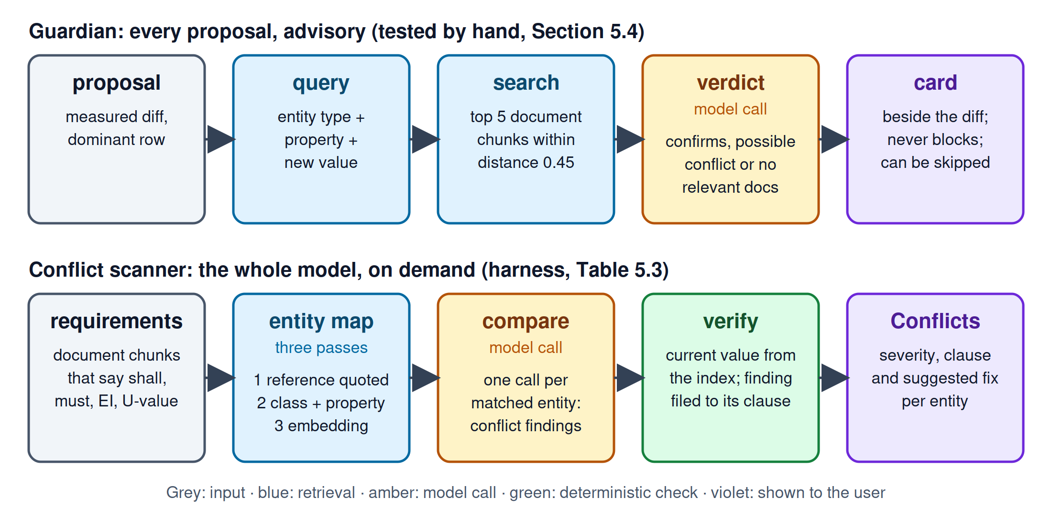
Figure 3. The RAV layer in two places: the Guardian checks each proposal and reports on the card beside the measured diff; the conflict scanner checks the whole model on demand.

6.2 Ethical considerations and data governance

Data sovereignty is a foundational constraint. The default deployment runs on local infrastructure with open-weight models, so no project data leaves the user's environment, which matters under GDPR and ISO 19650 and for commercially sensitive models. BYOK is an explicit, user-initiated opt-out; an operator switch can disable cloud routing for a whole deployment, and provider failures hard-error instead of falling back silently. Every AI-proposed modification needs explicit human approval of a measured diff, and every approved change is a Git commit, an auditable chain of custody consistent with ISO 19650. The evaluation used public buildingSMART samples and documents written by the authors; no client data was used. AGPL-3.0 extends the governance choice to the code: self-hosting is unrestricted, and a modified network service must publish its modifications.

6.3 Risk analysis and open items

Five risks warrant mention. First, the Guardian verdict logic above: a check that flags compliant improvements or passes violations offers little verification value until fixed. Second, sample size: 95 prompts, 26 conflict cases and 36 Ask answers, one machine and one model per row. Third, no load testing has been done; a proposal approved after its file changed is refused by the fingerprint check, but behaviour under many concurrent users is unqualified. Fourth, no expert labelling has been scored against the harness; the per-prompt protocol that would yield an agreement statistic is the highest-leverage open item before the defence. Fifth, security testing in September 2026 found that a viewer-role account could commit a change (erez.csv row 60). The editor tier is now enforced at the HTTP and WebSocket layer and tested. The same testing found that deleting a user or a document removes or anonymises the proposals, commits and conflicts that reference it (rows 63, 66, 96), which destroys audit evidence and remains open.
§ 7

Contributions to AECO practice and future research directions

7.1 Contributions

CastorIQ contributes four elements to the state of practice. First, maximal verification as a governance pattern for LLM-mediated modification of authoritative engineering data: the model writes the change as code, the code runs once on a copy, the measured diff is gated deterministically and explained by a model that has not seen the request, and the reviewed copy is swapped in under version control. It is instantiated against IFC, and applies to any structured artefact whose changes can be diffed. Second, RAV as a distinct component of a write path, a document-grounded second opinion on every proposal, with the retrieval design that made it measurable. Third, the shared vector substrate for IFC entities and document chunks, which makes cross-domain retrieval routine. Fourth, a full-lifecycle platform (4D, 5D, 7D) on one substrate and consumer hardware, without cloud dependency, together with the reproducible harnesses and dated records that measure it. All four are available under AGPL-3.0.

7.2 Future research directions

Three directions follow. First, server-hosted IFC editing through modeller add-ons, answering the CDE round-trip friction of Section 5.4: a Blender add-on that keeps the file in CastorIQ and streams changes back would remove the download-edit-upload cycle, and the pattern extends to Revit, ArchiCAD and Rhino. Second, closing the local model's measured gaps: fine-tuning a code model on execution-verified IfcOpenShell code, which the harness already produces as labelled pairs, and grounding requests against the class hierarchy and material assignments. Third, the Guardian verdict fix and a per-prompt expert labelling scored against the harness, so that the human row of the evaluation carries an agreement statistic.
§ 8

Team contributions
Pavla Hornícká conceived the original CastorIQ concept, the bi-directional linking of IFC models and technical documents from which the platform's lifecycle scope grew; led the BIM domain framing; and designed and implemented the 7D Facilities module across its sub-modules, including the asset-to-IFC write-back, the LLM-assisted work-order and request intake, and the Spaces 360 comparison and plan-to-3D navigation.

Carlo Cogni led full-stack development across both designs of the write-back pipeline, the RAG pipeline and the RAV layer; delivered the GLM-OCR and BYOK subsystems; built the benchmark harnesses and produced the quantitative evaluation; and led IFC schema handling, including the IFC2x3 to IFC4 conversion and the IFC diff that gates the write path.
Islam Mohamed Sabra Ahmed authored the 4D and 5D Schedule module and led workflow testing across the Schedule surfaces.

Maria Makri led market positioning and the competitive analysis, synthesised the reception and usability findings from Zigurat Student Week, led UX evaluation across the seven surfaces, validated the role-dependent user journeys, and ran the Solibri-referenced testing and planted-conflict sets of Section 5.4.

Erez Bader led the marketing strategy, co-authored the market positioning and competitive analysis, initiated the IFC viewer of the 4D Link workspace, and ran the IfcOpenShell-referenced testing of Section 5.4 across two builds of the write path, including the security and chain-of-custody findings.

Glossary
Acronyms and technical terms used in the memory, listed alphabetically. Definitions are the ones this memory works with; the appendices carry fuller technical treatment where relevant.
AECO Architecture, Engineering, Construction and Operations. The industry sector this project addresses.
AGPL-3.0 GNU Affero General Public License, version 3. Copyleft licence requiring that modifications hosted as a network service be released under the same terms.
BIM Building Information Modelling. Structured, machine-readable representation of a built asset.
Blind explanation One sentence written by a model that reads the generated code and the measured diff without seeing the user's request; the user compares it with what they asked.
BYOK Bring Your Own Key. User-supplied API credential for optional cloud model access, as an opt-out of the local-first default.
CDE Common Data Environment. Shared file and workflow platform for a project team; typically vendor-hosted.
DCMA 14-point Defence Contract Management Agency schedule health assessment, applied to Primavera P6 schedules.
GDPR General Data Protection Regulation. European legislation on personal data handling.
GLM-OCR GLM-based Optical Character Recognition model used as the fallback text extractor for scanned and image-dominant PDFs.
Guardian The user-facing name of the RAV layer on the Modify card.
IFC Industry Foundation Classes. Open data model for BIM, standardised as ISO 16739.
ISO 19650 International standard on information management using BIM through the whole lifecycle of a built asset.
LLM Large Language Model.
Maximal verification This project's write-path principle: the model is given full authority to write the change as code, and what the code did to a copy of the file is measured and gated before a human approves it.
MRR Mean Reciprocal Rank. Retrieval quality metric.
OCR Optical Character Recognition.
RAG Retrieval-Augmented Generation. Pattern in which retrieved document excerpts are supplied to an LLM at query time to ground its output.

RAV Retrieval-Augmented Verification. This project's document-grounded second opinion layer, run on every Modify proposal.

RSAA Risk-Stratified Autonomous Action. The four-tier minimal-authority governance ladder of the first write-path design (February to September 2026), replaced on 2026-09-15 by maximal verification.
Scope gate The deterministic check that a change touched nothing outside the selected entities and no geometry; a violation sends the code back to the model, at most twice.
TEK17 Norwegian building technical regulation used as the fire-rating notation reference in project pilot testing.
VRAM Video RAM. GPU memory available for model inference.

References
Cohen, J. (1960). A coefficient of agreement for nominal scales. Educational and Psychological Measurement, 20(1), 37–46.
Du, C., Esser, S., Nousias, S. and Borrmann, A. (2024). Text2BIM: Generating Building Models Using a Large Language Model-based Multi-Agent Framework. arXiv:2408.08054.
FMI Corporation and PlanGrid (2018). Construction Disconnected: The High Cost of Poor Data and Miscommunication. FMI Corporation.

IfcOpenShell contributors (2025). IfcOpenShell, version 0.8.4 [software]. https://ifcopenshell.org.
ISO 16739-1:2018. Industry Foundation Classes (IFC) for data sharing in the construction and facility management industries — Part 1: Data schema. International Organization for Standardization.
ISO 19650-1:2018. Organization and digitization of information about buildings and civil engineering works, including building information modelling (BIM) — Information management using building information modelling — Part 1: Concepts and principles. International Organization for Standardization.
Lewis, P., Perez, E., Piktus, A. et al. (2020). Retrieval-Augmented Generation for Knowledge-Intensive NLP Tasks. Advances in Neural Information Processing Systems (NeurIPS), 33. arXiv:2005.11401.
Love, P.E.D. and Li, H. (2000). Quantifying the causes and costs of rework in construction. Construction Management and Economics, 18(4), 479–490.

Nithyanantham, B.K., Sesterhenn, T., Nedungadi, A., Peral Garijo, S., Zenkner, J., Bartelt, C. and Lüdtke, S. (2025). MCP4IFC: IFC-Based Building Design Using Large Language Models. arXiv:2511.05533.

Ouyang, L., Qu, Y., Zhou, H., Zhu, J., Zhang, R. et al. (2024). OmniDocBench: Benchmarking Diverse PDF Document Parsing with Comprehensive Annotations. arXiv:2412.07626.

pgvector contributors (n.d.). pgvector: open-source vector similarity search for Postgres [software]. https://github.com/pgvector/pgvector (accessed 16 September 2026).

Appendices

The appendices accompanying this memory are delivered as a separate companion document and do not count toward the 5000-word limit. Appendix A: Data Model Reference (auto-generated Django model diagrams for the IFC domain, document ingestion, Ask, Modify and Conflicts, identity and access, Schedule, Facilities, and deployment and observability). Appendix D: Facilities Module Operational Specification. Appendix E: Testing Log, the fourteen findings from testing the rewritten write path, with the row numbers cited in Section 5.4. Appendix F: Checking the Evaluation, which maps every figure of Section 5.2 to the command, code, corpus, tests and run file behind it. The complete testing log, every evaluation record and every run artifact are in the repository at the tag fmp-final.

STEP Physical Format, ISO 10303-21, is the ASCII serialisation format used by IFC files.
GLM-OCR's published figures, not measured on Castor: about 1.86 pages per second at single concurrency, and 94.62 on OmniDocBench V1.5 at release (docs/ocr-pipeline.md).
Security test commit: f1cea365.

