# System design

L’architettura software utilizzata per questa applicazione è del tipo ‘Three Tier’, ovvero è un’architettura che divide il sistema in 3 moduli: client, server e data source.

La scelta è ricaduta su questo tipo di architettura poiché conferisce scalabilità e soprattutto manutenibilità al codice.

Questa divisione, inoltre, rende il client indipendente dal database e permette al server di controllare che le operazioni da eseguire, siano effettuate solo da utenti autorizzati.

The system division is based on the Three-Tier Architecture, which divides the system into three modules: client, server, and data source.  
In this way most of the business logic is located in a central server, the code is more scalable and maintainable and the client is independent of the database.

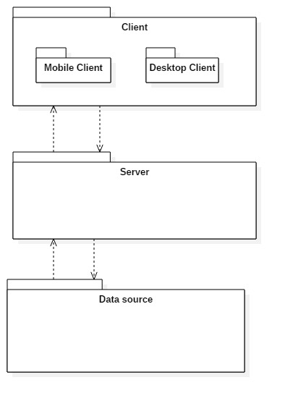

Client:  
Consist of the application which directly interacts with the users.   
This module is divided into two parts: Readings client, which is the mobile app for Readings Operators, and Back Office client, which is the desktop application for Back Office Operators.

Server:  
Represents the application's logical component, which provides authentication tokens, performs and verifies the correctness of the required operations, for example the status of a payment order.  
It was chosen to use only a server to handle application requests, because it is estimated that the number of simultaneous connections is not high.

Database :   
Relational DMBS in which persistent data are saved.

Client and server exchange messages using JSON (JavaScript Object Notation), which is an open-standard data interchange language.