

Dipartimento di Ingegneria Elettrica e Tecnologie dell’Informazione  
Corso di Laurea in Informatica

**Software Engineering I Project**

GCI ‘16

**Customer:**

Sergio Di Martino

**Team:**

GCI16_25

Carlo De Vita N86001634

Mattia Iodice N86001672

Riccardo Grieco N86001614

Table of contents

1 Introduction 4

1.1 Subject 4

1.2 Revision history 6

2 Requirements’ document 7

2.1 Requirements List 7

2.1.1 Functional requirements 7

2.1.2 Non-functional Requirements 7

2.1.3 Domain Requirements 7

2.2 Use Case Diagrams 8

2.2.1 Back office operator use case 8

2.2.2 Readings operator use case 8

2.2.3 Administrator use case 9

2.3 Cockburn Diagrams for Use Cases 10

2.3.1 Create payment order 10

2.3.2 Delete payment order 12

2.3.3 Issue payment order 14

2.3.4 Archive payment order 16

2.3.5 Reissue payment order 18

2.3.6 Saves payment order as paid 20

2.3.7 Saves a payment order as suspended 22

2.3.8 Sends meter readings 24

2.4 User Interface Mockups 26

2.4.1 Login 26

2.4.2 Main Menu 27

2.4.3 Payment Order 28

2.4.4 Candidate Payment Orders 29

2.4.5 Confirm 29

2.4.6 Operation Success 30

2.4.7 Readings Main 30

2.4.8 Save Reading 31

2.4.9 Confirm Reading 32

2.4.10 Successful Sending 33

2.4.11 Failed Sending 34

2.5 Entity-Boundary-Control Class Diagram 35

2.6 Sequence Diagrams 38

2.6.1 Create payment order 38

2.6.2 Delete payment order 39

2.6.3 Issue payment order 40

2.6.4 Save payment order as not pertinent 41

2.6.5 Reissue payment order 42

2.6.6 Save payment order as paid 43

2.6.7 Save payment order as suspended 44

2.6.8 Send readings 45

2.7 State chart diagram payment order 46

2.8 Glossary (A-Z) 46

3 Design documentation 47

3.1 System design 47

3.1.1 Software architecture 47

3.1.2 Client server communication 48

3.2 Technologies 48

3.2.1 Libraries 49

3.3 Object design 50

3.3.1 Class diagrams 50

3.3.2 Sequence diagrams 53

3.4 CRC cards 54

3.4.1 Desktop application 54

3.4.2 Mobile application 54

# Introduction

## Subject

This document represents the documentation with requirements collection, design and testing of the software product GCI ‘16, the analysis is based on a functionality subset selected by the costumer, Sergio Di Martino. In particular we have developed these points: 3, 4 and 6. For more details we have reported the specifications of the product as taken from “Progetto-16-17_V03F” document, published by the customer below.

|  |  |
| --- | --- |
| SoftEngUniNA | Protocollo N.: |
| **3.** | **SPECIFICHE DI PRODOTTO/ SERVIZIO** |

Il ***GCI16*** (Gestione Canoni Idrici) è un Sistema Informativo di una Pubblica Amministrazione Locale, finalizzato a gestire il pagamento di una tassa per il consumo di acqua. Il sistema distribuito presenta una parte di Back-Office per la gestione di contribuenti, ingiunzioni e pagamenti, ed un client su dispositivo mobile, utilizzato dai Controllori per leggere i consumi di acqua presso i contatori.

I principali servizi offerti dal sistema sono i seguenti:

1. Gestione Anagrafica Contribuenti.
2. Generazione Bollette.
3. Gestione Ingiunzioni di Pagamento.
4. Emissione Ingiunzioni di Pagamento.
5. Amministrazione Sistema
6. Lettura Consumi

Gli operatori del sistema, opportunamente autenticati, devono avere la possibilità di effettuare le tipiche operazioni CRUD sulla base di dati contenente l’anagrafica dei contribuenti. Gli operatori possono, ogni trimestre, chiedere la generazione delle bollette per tutte le utenze. Gli operatori possono inoltre creare nuove ingiunzioni di pagamento, specificando una persona fisica o giuridica che risulta essere evasore, un anno di competenza e inserendo le letture prese dai tecnici per il contatore corrispondente. Il sistema, basandosi su alcuni parametri configurabili, deriva l'ammontare dovuto. Un'ingiunzione può essere modificata ed eliminata solo se non emessa, previa opportuna ricerca.

Per emettere un’ingiunzione di pagamento, un operatore del Back-Office può selezionarne una da una lista di ingiunzioni non ancora emesse e, previo inserimento di un numero di protocollo, procedere con l'emissione. Ciò deve generare un documento in formato PDF contenente le comunicazioni che saranno inviate ai contribuenti.

Le ingiunzioni emesse non possono più essere cancellate, ma solo aggiornate. In presenza del relativo pagamento, l’ingiunzione viene archiviata. In presenza di un’opposizione, l’ingiunzione viene sospesa.

Inoltre è possibile effettuare il re-inserimento e quindi la riemissione di quelle ingiunzioni che non è stato possibile notificare (ad esempio per indirizzo errato).

Un amministratore di sistema deve inoltre poter gestire gli operatori, specificare l'ammontare delle spese di spedizione, delle tariffe per metro cubo e la percentuale di IVA da applicare. Infine, gli addetti alla lettura dei consumi utilizzano un dispositivo mobile per specificare, ogni 3 mesi, i consumi d’acqua di un utente, così come rilevabile dai contatori. Il dispositivo invia la lettura al server in modalità wireless.

Le funzionalità da 1 a 4 sono disponibili sul Back-Office ad un operatore opportunamente identificato dal sistema.

La funzionalità 5 è disponibile in forma di App sul client mobile dato in dotazione agli Operatori sul Campo.

**Dato questo insieme di funzionalità, il Committente deciderà insieme al fornitore un sottoinsieme di caratteristiche da modellare e implementare, previo incontro formale secondo le modalità specificate sul sito web.**

SoftEngUniNA Protocollo N.:

Per lo svolgimento della suddetta attività è obbligatorio l’utilizzo di un tool di CASE.

Si richiede tassativamente di astrarre il design per favorire il riutilizzo del codice e la futura implementazione di altre funzionalità.

**Nota:** Tutte le attività devono essere effettuate presso il fornitore tranne per i momenti di condivisione definiti.

## Revision history

|  |  |  |
| --- | --- | --- |
| **Date** | **Version** | **Description** |
| 07/12/2016 | 0.1 | Created first requirements list (functional, non-functional and domain) and Use Cases. |
| 31/03/2017 | 0.1.1 | Updated the requirements list and created Mockups. |
| 13/04/2017 | 0.2 | Updated Use Cases and Mockups. |
| 29/04/2017 | 0.3 | Created Cockburn diagrams for use cases. |
| 3/05/2017 | 0.3.1 | Added the Glossary and the State chart diagram for payment orders. |
| 10/05/2017 | 0.3.2 | Updated and finished Use case, Mockups and Cockburn diagrams. |
| 25/05/2017 | 0.4 | Added Entity Boundary Control Class Diagram. |
| 11/06/2017 | 0.4.1 | Updated Entity Boundary Control and added Sequence Diagrams. |
| 14/06/2017 | 0.5 | Created System design section. |
| 22/07/2017 | 0.5.1 | Created Object design section with the Object Design Class Diagrams. |
| 26/07/2017 | 0.5.2 | Fixed Object Design Class Diagrams. |
| 27/07/2017 | 0.5.3 | Added technologies and libraries for some functionalities. |
| 30/07/2017 | 0.5.4 | Added CRC Cards and Sequence Diagrams. |
| 7/09/2017 | 0.6 | Updated Sequence Diagrams completing Design section and created Testing section. |
| 22/09/2017 | 0.6.1 | Added System testing plan. |
| 8/10/2017 | 0.6.2 | Added Unit Testing and completed the first version of the documentation. |
| 14/10/2017 | 1.0 | Revision of the entire documentation and completed the first version. |

# Requirements’ document

## Requirements List

### Functional requirements

The Back Office Operator must be able to create new payment orders, specifying a bill by a list of candidate payment orders.

The Back Office Operator can issue not-issued payment orders.  
When a payment order is issued, it is given a protocol number generated incrementally.

The Back Office Operator can delete not-issued payment orders.

The Back Office Operator can reissue suspended payment orders.  
When a payment order is reissued his protocol number is not changed.

The Back Office Operator can save as not pertinent suspended payment orders.

The Back Office Operator can save as paid notified payment orders.

The Back Office Operator can save as suspended notified payment orders.

When a payment order is issued the system must generate and store a PDF document with all the useful communications for the contributor.

A user must be able to log in as a Back Office Operator in desktop application.

A user must be able to log in as a Readings Operator in mobile application.

The Readings Operator must have the list of the assigned readings updated automatically.

The Readings Operator can save readings specifying a meter and the water consumed.

The Readings Operator must be able to send saved readings via Internet.

### Non-functional Requirements

Payment orders can be seen and searched specifying a protocol, a debtor, a year, a trimester and/or a status.

The readings are first saved locally on smartphone and sent later only if internet connection is available.

To use the system every user must log in.

### Domain Requirements

Not issued payment orders can only be issued or deleted.

Issued payment orders can only be archived.

Once saved as paid or saved as not pertinent, a payment order must be archivied.

Suspended payment orders can only be reissued or saved as not pertinent.

Every issued payment order is identified by a protocol number.

Notified payment orders can only be saved as paid or as suspended.

The considered unit of measurement of water is m3.

## Use Case Diagrams

### Back office operator use case

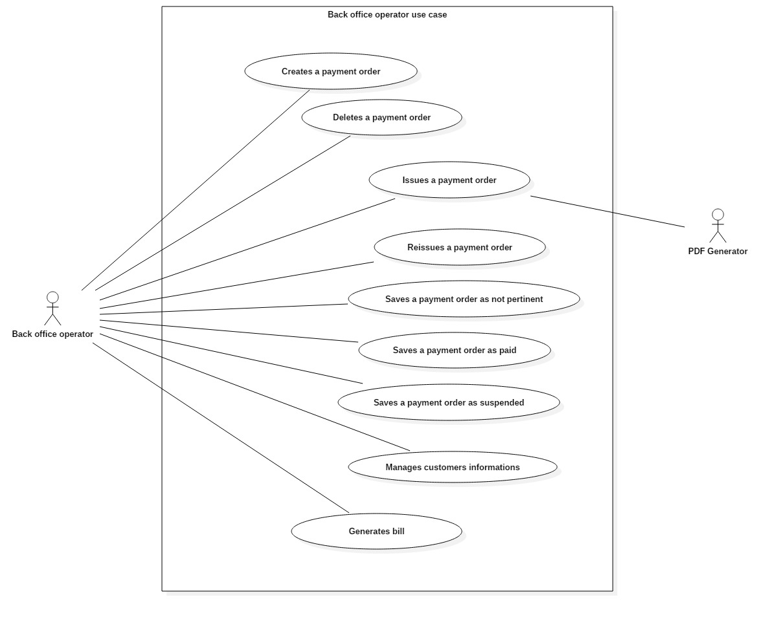

### Readings operator use case

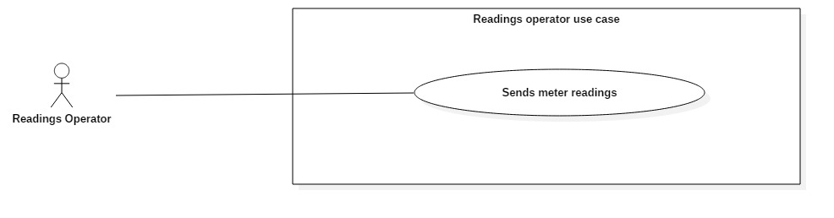

### Administrator use case

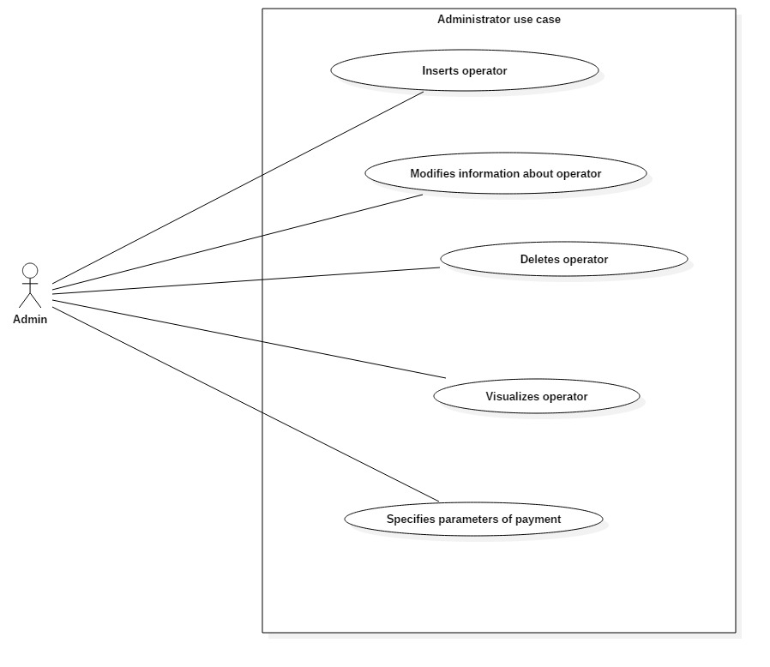

## Cockburn Diagrams for Use Cases

### Create payment order

|  |  |  |  |
| --- | --- | --- | --- |
| USE CASE *#1* | *Create payment order* | | |
| Goal in Context | Generate a new payment order. | | |
| Scope & Level | System under design ; Level = User goal | | |
| Preconditions | The user must be logged in the system. | | |
| Success End Condition | A payment order is created and stored in the system. | | |
| Failed End Condition | The user presses “Home” in “Payment Orders” mockup. | | |
| Primary Actor | Back Office Operator. | | |
| Trigger | The operator presses “Payment Orders” in “Main Menu” mockup. | | |
| DESCRIPTION | **Step n°** | **Back Office Operator** | **System** |
| *1* |  | Shows mockup “Payment Orders” |
| *2* | Presses “New payment order” |  |
| *3* |  | Shows mockup “Candidate Payment Orders” |
| *4* | Selects a bill |  |
| *5* |  | Enables “Create Payment Order” |
| *6* | Presses “Create Payment Order” |  |
| *7* |  | Shows mockup “Confirm” |
| *8* | Presses “Yes” |  |
| *9* |  | Shows mockup “Operation Success” |
| *10* | Presses “OK” |  |
|  | *11* |  | *Returns to mockup “Payment Orders”* |

|  |  |  |  |
| --- | --- | --- | --- |
| EXTENSIONS | **Step n°** | **Back Office Operator** | **System** |
|  | *2.1* | Presses “Home” |  |
|  | *2.2* |  | *Shows mockup “Main Menu”* |
| SUBVARIATIONS | *Step* | **Back Office Operator** | **System** |
|  | *2.2* | Sets filtering parameters and presses “Filter” |  |
|  | *3.2* |  | *Shows the filtered table and return to step #2* |

|  |  |  |  |
| --- | --- | --- | --- |
| USE CASE *#2* | *Delete payment order* | | |
| Goal in Context | Delete a selected payment order. | | |
| Scope & Level | System under design ; Level = User goal | | |
| Preconditions | The user must be logged in the system. | | |
| Success End Condition | A payment order is deleted from the system. | | |
| Failed End Condition | The user presses “Home” in “Payment Orders” mockup. | | |
| Primary Actor | Back Office Operator. | | |
| Trigger | The operator presses “Payment Orders” in “Main Menu” mockup. | | |
| DESCRIPTION | **Step n°** | **Back Office Operator** | **System** |
| *1* |  | Shows mockup “Payment Orders” |
| *2* | Selects a payment order |  |
| *3* |  | Enables “Delete” |
| *4* | Presses “Delete” |  |
| *5* |  | Shows mockup “Confirm” |
| *6* | Presses “Yes” |  |

### Delete payment order

|  |  |  |  |
| --- | --- | --- | --- |
|  | *7* |  | Shows mockup “Operation Success” |
| *10* | Presses “OK” |  |
|  | *11* |  | *Returns to mockup “Payment Orders”* |
| EXTENSIONS | **Step n°** | **Back Office Operator** | **System** |
|  | *2.1* | Presses “Home” |  |
|  | *3.1* |  | *Shows mockup “Main Menu”* |
| SUBVARIATIONS | *Step* | **Back Office Operator** | **System** |
|  | *2.2* | Sets filtering parameters and presses “Filter” |  |
|  | *3.2* |  | *Shows the filtered table and return to step #2* |

### Issue payment order

|  |  |  |  |
| --- | --- | --- | --- |
| USE CASE *#3* | Issue payment orders. | | |
| Goal in Context | User issues a payment order. | | |
| Scope & Level | System Under Design; Level = “User goal” | | |
| Preconditions | User must be logged. | | |
| Success End Condition | A payment order is issued. | | |
| Failed End Condition | User presses ‘Home’ in mockup ‘Payment Orders’. | | |
| Primary Actor | Back office operator. | | |
| Trigger | Back office operator presses ‘Payment Orders’ in mockup ‘Main menu’. | | |
| DESCRIPTION | **Step n°** | **Back Office Operator** | **System** |
| *1* | Presses ‘Payment Orders’ in mockup ‘Main’. |  |
| *2* |  | Shows mockup ‘Payment Orders’. |
| *3* | Selects a not issued payment order. |  |
| *4* |  | Enables button ‘Issue’. |
| *5* | Presses ‘Issue’. |  |
| *6* |  | Shows mockup ‘Confirm’. |
| *7* | Presses ‘Yes’. |  |
| *8* |  | Shows mockup ‘Successful operation’. |
| *9* | Presses ‘Ok’. |  |

|  |  |  |  |
| --- | --- | --- | --- |
|  | *10* |  | Shows mockup ‘Payment Orders’ in which the payment order concerned shall be issued, and UC successfully ends. |
| EXTENSIONS | ***Step*** | **Back Office Operator** | **System** |
|  | *\*.1* | Presses ‘Home’ in mockup ‘Payment Orders’. |  |
| *\*2.1* |  | Shows mockup ‘Main’ and UC fails. |
|  | *5.2* | Presses ‘No. |  |
| *6.2* |  | Back to step 2. |
| SUBVARIATIONS | ***Step*** | **Back Office Operator** | **System** |
|  | *3.3* | Filters a not issued payment order, selects. |  |
| *4.3* |  | Back to step 4. |

|  |  |  |  |
| --- | --- | --- | --- |
| USE CASE *#4* | Archives payment orders. | | |
| Goal in Context | User archives a suspended payment order. | | |
| Scope & Level | System Under Design; Level = “User goal” | | |
| Preconditions | User must be logged. | | |
| Success End Condition | A payment order is archived. | | |
| Failed End Condition | User presses ‘Home’ in mockup ‘Payment Orders’. | | |
| Primary Actor | Back office operator. | | |
| Trigger | Back office operator presses ‘Payment Orders’ in mockup ‘Main menu’. | | |
| DESCRIPTION | **Step n°** | **Back Office Operator** | **System** |
| *1* | Presses ‘Payment Orders’ in mockup ‘Main menu’. |  |
| *2* |  | Shows mockup ‘Payment Orders’. |
| *3* | Selects a suspended payment order. |  |
| *4* |  | Enables button ‘Archive’. |
| *5* | Presses ‘Archive’. |  |
| *6* |  | Shows mockup ‘Confirm’. |
| *7* | Presses ‘Yes’. |  |
| *8* |  | Shows mockup ‘Successful operation’. |
| *9* | Presses ‘Ok’. |  |

### Archive payment order

|  |  |  |  |
| --- | --- | --- | --- |
|  | *10* |  | Shows mockup ‘Payment Orders’ in which there isn’t the payment order concerned because it shall be archived, and UC successfully ends. |
| EXTENSIONS | ***Step*** | **Back Office Operator** | **System** |
|  | *\*.1* | Presses ‘Home’ in mockup ‘Payment Orders’. |  |
| *\*2.1* |  | Shows mockup ‘Main menu’ and UC fails. |
|  | *5.2* | Presses ‘No. |  |
| *6.2* |  | Back to step 2. |
| SUBVARIATIONS | ***Step*** | **Back Office Operator** | **System** |
|  | *3.3* | Filters suspended payment order, selects it. |  |
| *4.3* |  | Back to step 4. |

### Reissue payment order

|  |  |  |  |
| --- | --- | --- | --- |
| USE CASE *#5* | Reissue payment orders. | | |
| Goal in Context | User reissues a suspended payment order. | | |
| Scope & Level | System Under Design; Level = “User goal” | | |
| Preconditions | User must be logged. | | |
| Success End Condition | A payment order is reissued. | | |
| Failed End Condition | User presses ‘Home’ in mockup ‘Payment Orders’. | | |
| Primary Actor | Back office operator. | | |
| Trigger | Back office operator presses ‘Payment Orders’ in mockup ‘Main menu’. | | |
| DESCRIPTION | **Step n°** | **Back Office Operator** | **System** |
| *1* | Presses ‘Payment Orders’ in mockup ‘Main menu’. |  |
| *2* |  | Shows mockup ‘Payment Orders’. |
| *3* | Selects a suspended payment order. |  |
| *4* |  | Enables button ‘Reissue’. |
| *5* | Presses ‘Reissue’. |  |
| *6* |  | Shows mockup ‘Confirm’. |
| *7* | Presses ‘Yes’. |  |
| *8* |  | Shows mockup ‘Successful operation’. |
| *9* | Presses ‘Ok’. |  |

|  |  |  |  |
| --- | --- | --- | --- |
|  | *10* |  | Shows mockup ‘Payment Orders’ in which the payment order concerned shall be issued, and UC successfully ends. |
| EXTENSIONS | ***Step*** | **Back Office Operator** | **System** |
|  | *\*.1* | Presses ‘Home’ in mockup ‘Payment Orders’. |  |
| *\*2.1* |  | Shows mockup ‘Main menu’ and UC fails. |
|  | *5.2* | Presses ‘No. |  |
| *6.2* |  | Back to step 2. |
| SUBVARIATIONS | ***Step*** | **Back Office Operator** | **System** |
|  | *3.3* | Filters suspended payment order, selects it. |  |
| *4.3* |  | Back to step 4. |

### Saves payment order as paid

|  |  |  |  |
| --- | --- | --- | --- |
| USE CASE *#6* | *Saves payment order as paid* | | |
| Goal in Context | Saving a payment order as paid | | |
| Scope & Level | System under design ; Level = User goal | | |
| Preconditions | User must be logged in. | | |
| Success End Condition | The payment order is saved in the system as paid. | | |
| Failed End Condition | There is no payment order that can be saved as paid. The user interrupts the use case. | | |
| Primary Actor | Back Office Operator. | | |
| Trigger | The operator presses button “Payment Order” in “Main Menu” mockup. | | |
| DESCRIPTION | **Step n°** | **Back Office Operator** | **System** |
|  | *1* |  | Shows mockup “Payment Orders” |
| *2* | Selects a “notified” payment order from the table and presses “Save as paid” button |  |
| *3* |  | Shows mockup “Confirm” |
|  | *4* | Presses OK |  |
| *5* |  | Shows mockup “Operation Success” |
| *6* | Presses OK |  |
| *7* |  | *Returns to mockup “Payment Orders”* |

|  |  |  |  |
| --- | --- | --- | --- |
| EXTENSIONS | **Step n°** | **Back Office Operator** | **System** |
|  | *2a* | Presses “Home” |  |
|  | *3a* |  | *Shows mockup “Main Menu”* |
| SUBVARIATIONS | ***Step n°*** | **Back Office Operator** | **System** |
|  | *2b* | Sets filtering parameters and presses “Filter” |  |
| *3b* |  | *Shows the filtered table and return to step #2* |

### Saves a payment order as suspended

|  |  |  |  |  |
| --- | --- | --- | --- | --- |
| USE CASE *#7* | *Saves a payment order as suspended.* | | | |
| Goal in Context | Saving a payment order as suspended. | | | |
| Scope & Level | System under design; Level = User goal. | | | |
| Preconditions | User must be logged in. | | | |
| Success End Condition | The payment order is saved in the system as suspended. | | | |
| Failed End Condition | There is no payment order that can be saved as suspended. The user interrupts the use case. | | | |
| Primary Actor | Back Office Operator. | | | |
| Trigger | The operator presses button “Payment Order” in “Main Menu”. | | | |
| DESCRIPTION | **Step n°** | **Back Office Operator** | **System** | |
|  | *1* |  | Shows mockup “Payment Orders” |
| *2* | Selects a “notified” payment order from the table and presses “Save as suspended” button |  |
| *3* |  | Shows mockup “Confirm” |
| *4* | Presses OK |  |
| *5* |  | Shows mockup “Operation Success” |
| *6* | Presses OK |  |
| *7* |  | *Returns to mockup “Payment Order”* |

|  |  |  |  |
| --- | --- | --- | --- |
| EXTENSIONS | **Step n°** | **Back Office Operator** | **System** |
|  | *2a* | Presses “Home” |  |
|  | *3a* |  | *Shows mockup “Main Menu”* |
| SUBVARIATIONS | ***Step n°*** | **Back Office Operator** | **System** |
|  | *2b* | Sets filtering parameters and presses “Filter” button |  |
| *3b* |  | *Shows the filtered table and return to step #2* |

### Sends meter readings

|  |  |  |  |
| --- | --- | --- | --- |
| USE CASE *#8* | *Sends meter readings.* | | |
| Goal in Context | Reading the water consumption of a customer. | | |
| Scope & Level | System under design ; Level = User goal | | |
| Preconditions | User must be logged in. | | |
| Success End Condition | The Reading Operator saves the water consumption and sends it to the server. | | |
| Failed End Condition | The Readings Operator closes the application.  The Readings Operator doesn’t have readings left to do.  There is no Internet connection to send the readings done. | | |
| Primary Actor | Readings Operator | | |
| Trigger | User logs in the mobile app. | | |
| DESCRIPTION | **Step n°** | **Readings Operator** | **System** |
|  | *1* |  | Shows mockup “Readings Main” |
| *2* | Selects a customer from the list and clicks “Save reading” button |  |
| *3* |  | Shows mockup “Save Reading” |
| *4* | Inserts the amount of water consumed and presses “Save” button |  |
| *5* |  | Shows mockup “Confirm Reading” containing all the reading’s informations |
| *6* | Presses “Yes” button |  |
| *7* |  | *Returns to mockup “Readings Main”* |
| *8* | Presses “Send readings” button |  |

|  |  |  |  |
| --- | --- | --- | --- |
|  | *9* |  | *Shows mockup “Successful Sending”* |
| *10* | Presses OK |  |
| *11* |  | *Returns to mockup “Readings Main”* |
| EXTENSIONS | **Step n°** | **Readings Operator** | **System** |
|  | *9a* |  | *Shows mockup “Failed Sending”* |
| *10a* | Presses OK |  |
| *11a* |  | *Returns to mockup “Readings Main”* |
| SUBVARIATIONS | ***Step n°*** | **Readings Operator** | **System** |
|  | *8b* | Returns to step #1 |  |

## User Interface Mockups

### Login

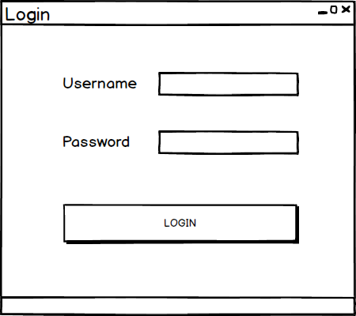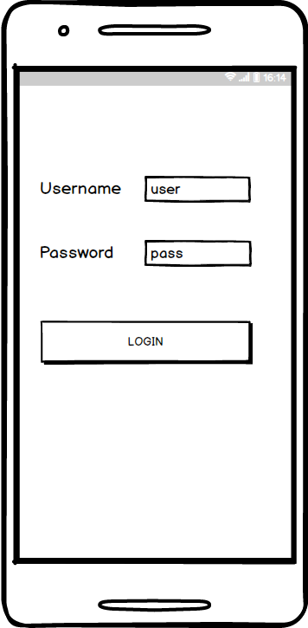

### Main Menu

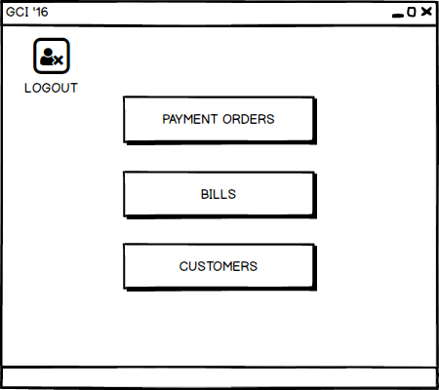

### Payment Order

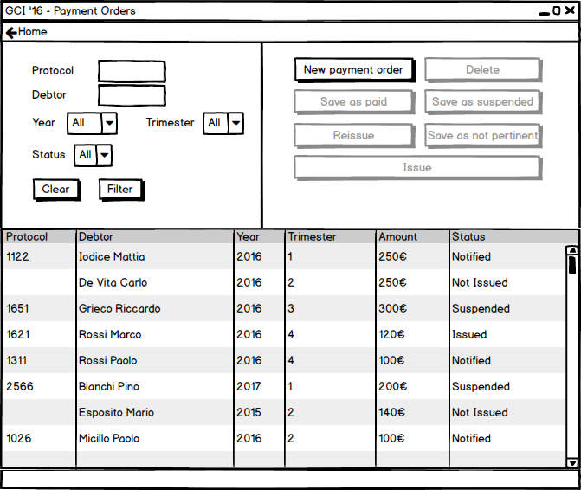

### Candidate Payment Orders

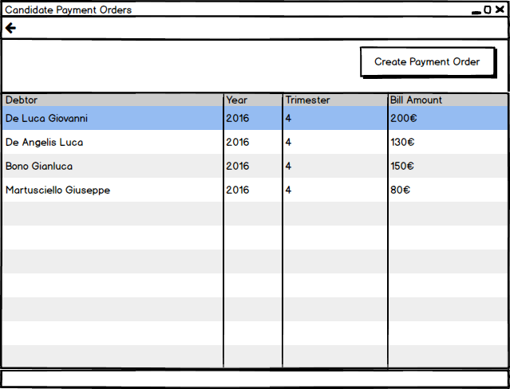

### Confirm

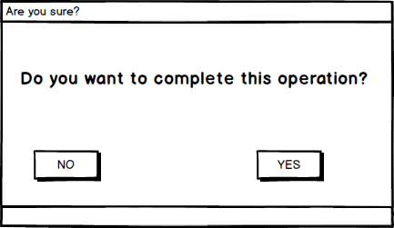

### Operation Success

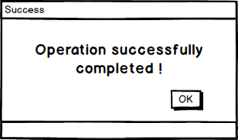

### Readings Main

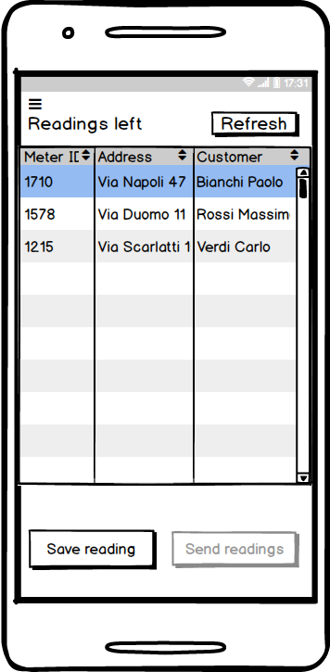

### Save Reading

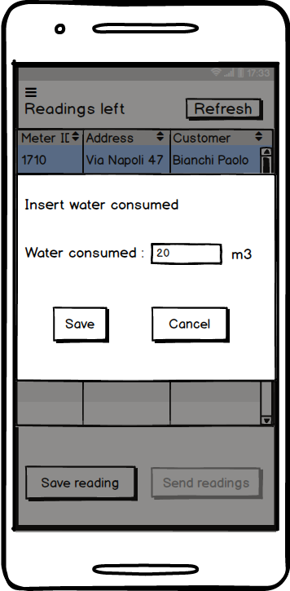

### Confirm Reading

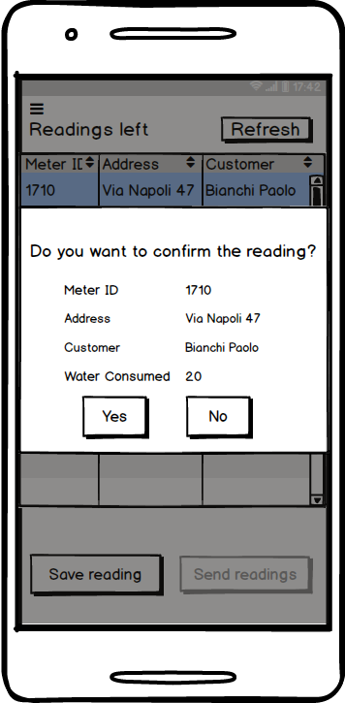

### Successful Sending

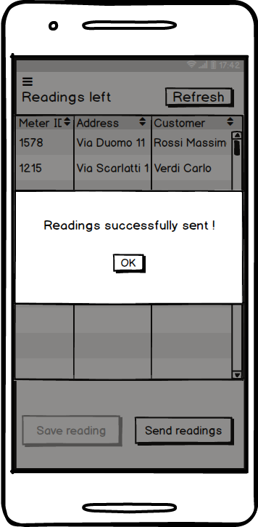

### Failed Sending

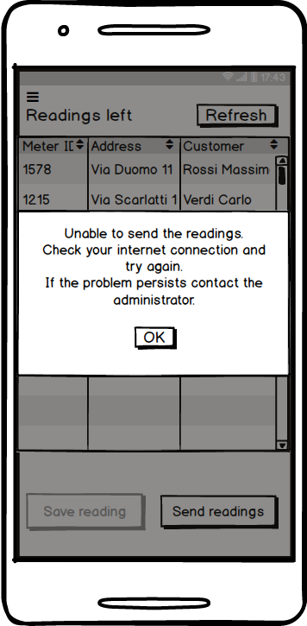

## Entity-Boundary-Control Class Diagram

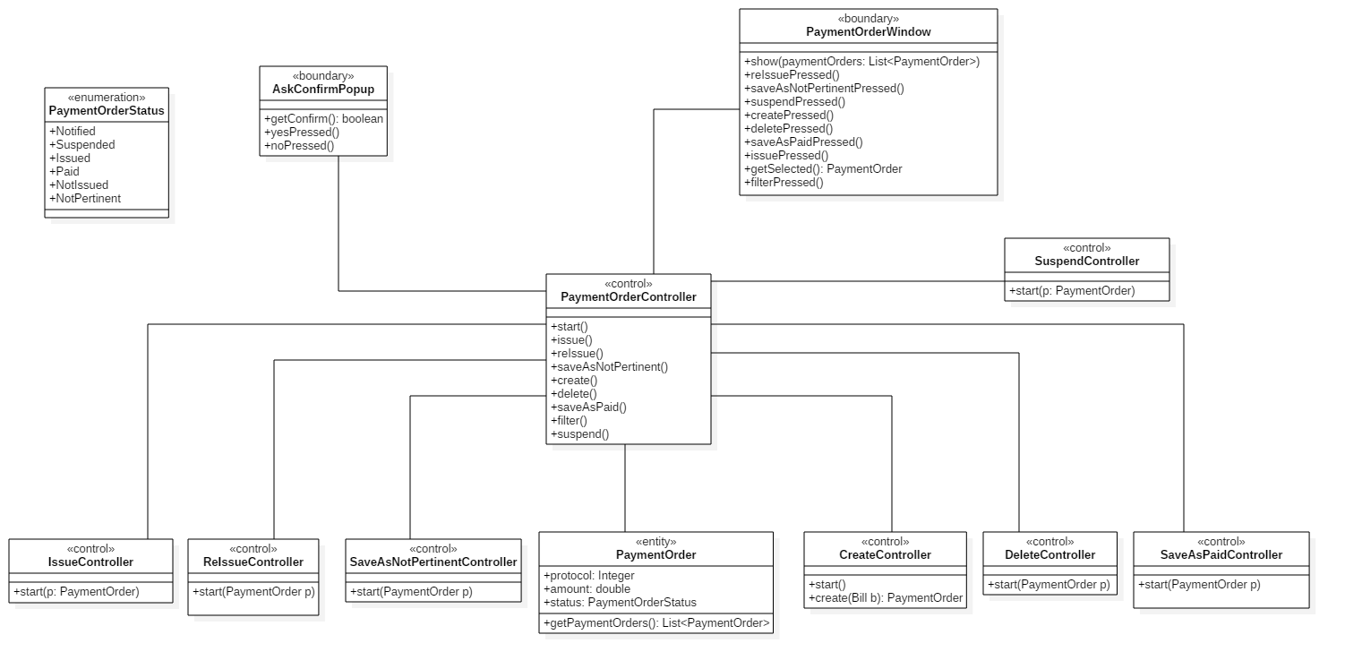

The class diagrams below specify the behaviour of controllers.

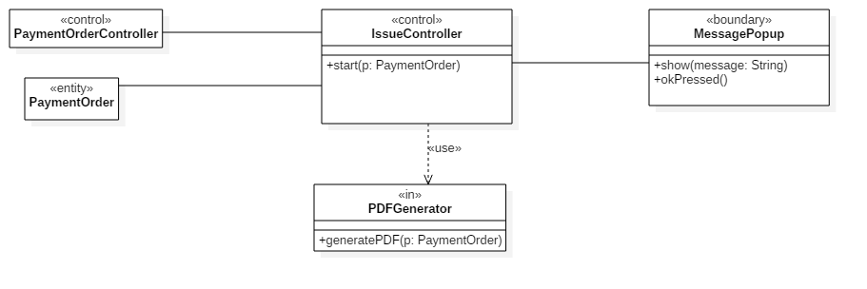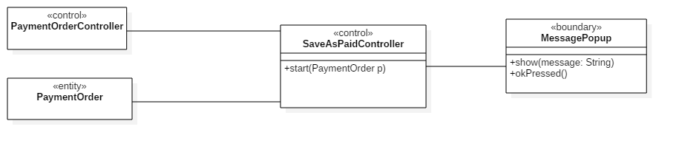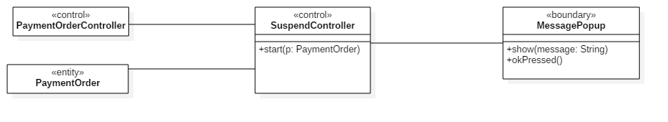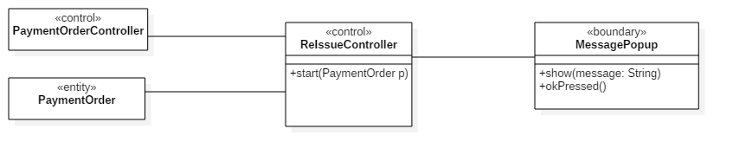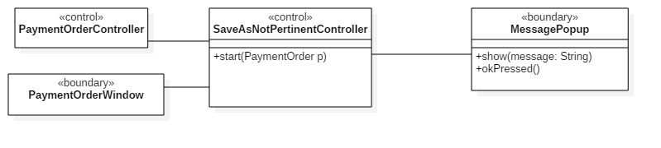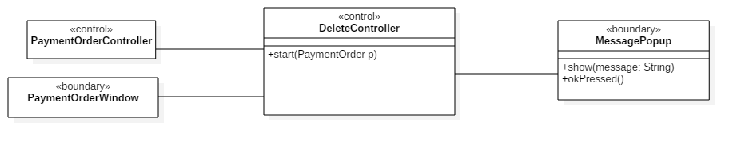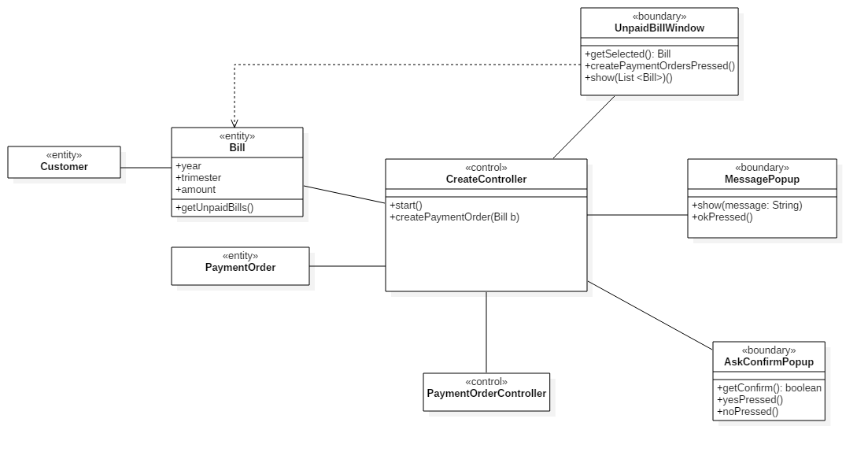

## Sequence Diagrams

### Create payment order

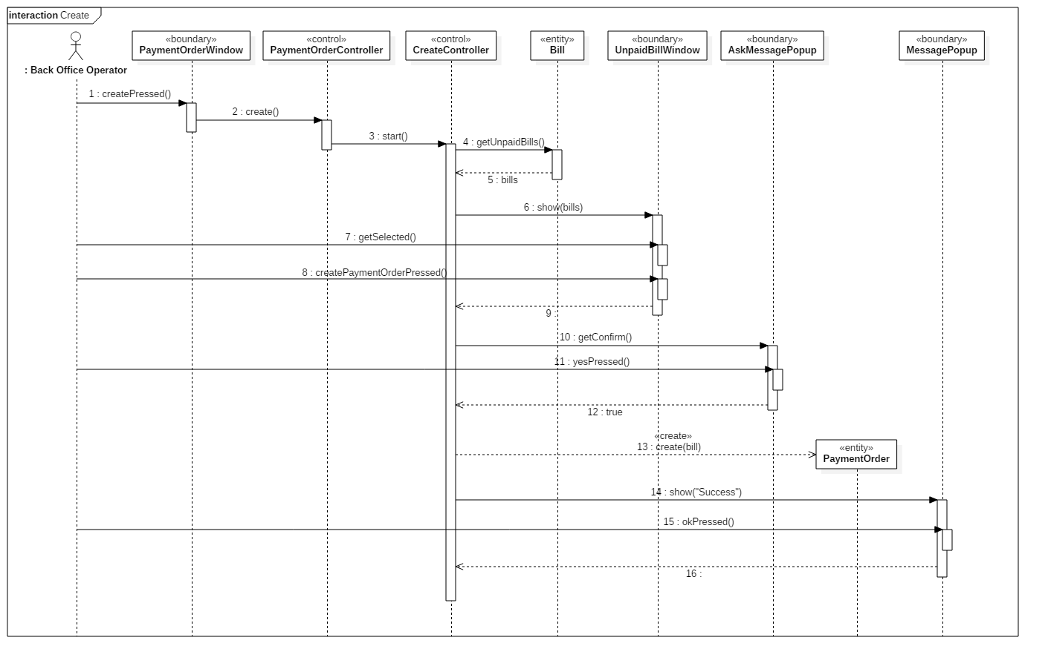

### Delete payment order

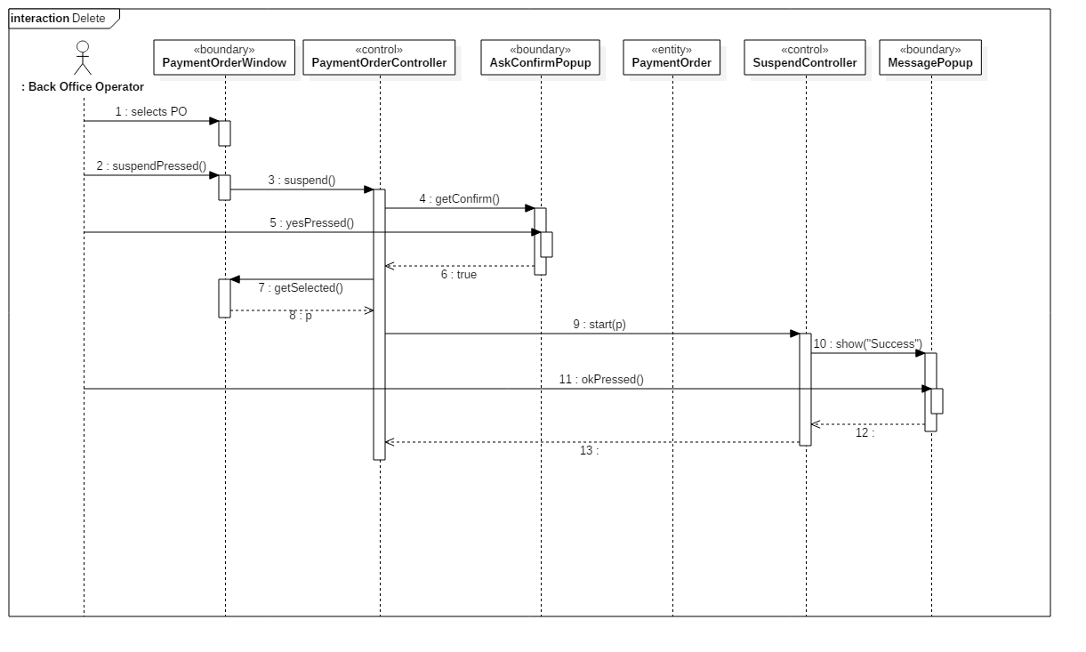

### Issue payment order

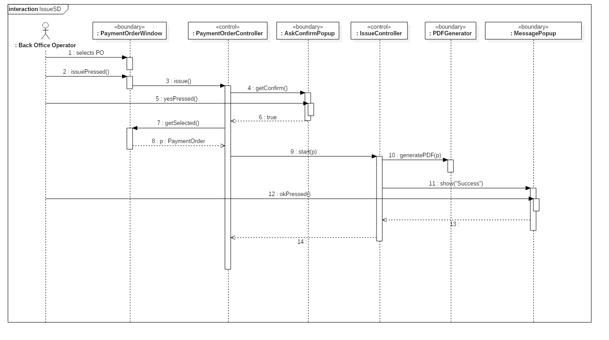

### Save payment order as not pertinent

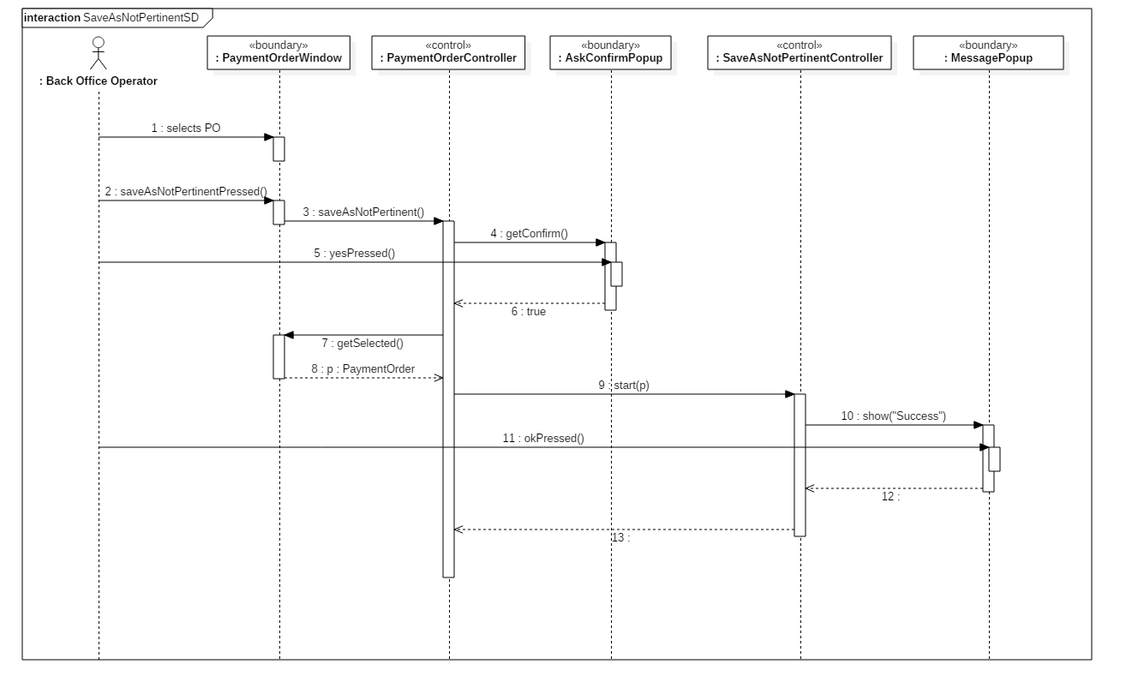

### Reissue payment order

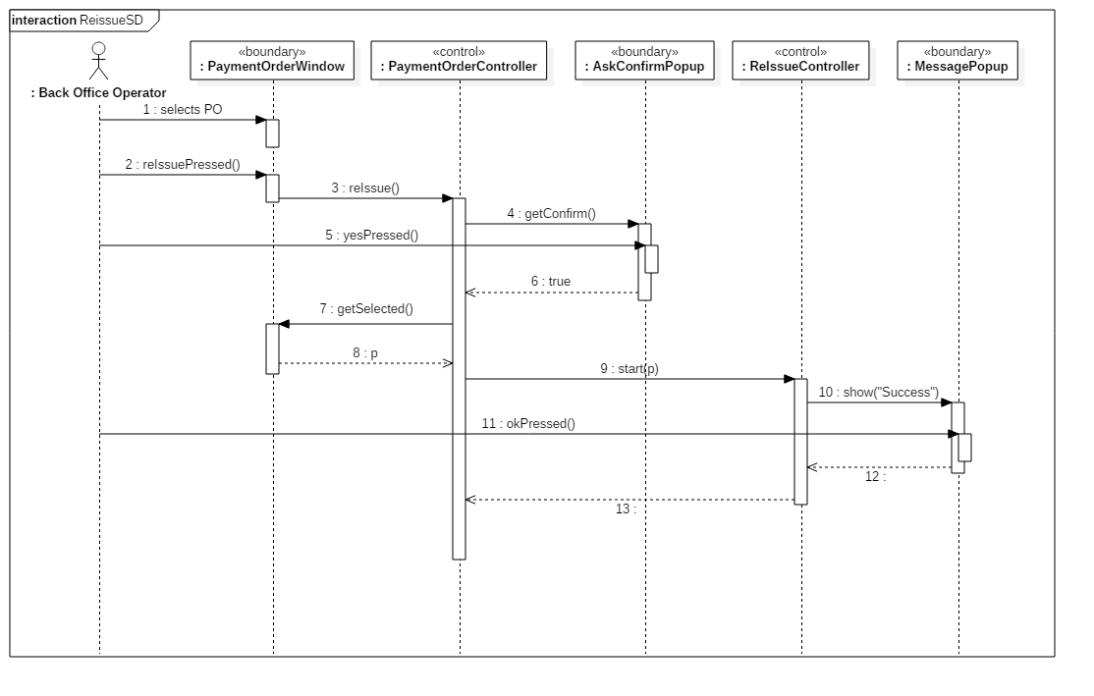

### Save payment order as paid

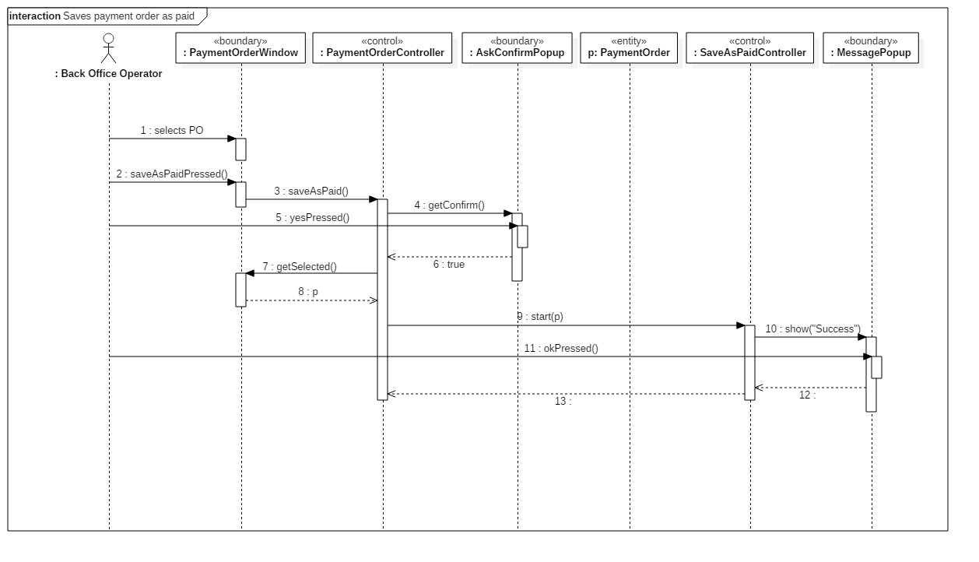

### Save payment order as suspended

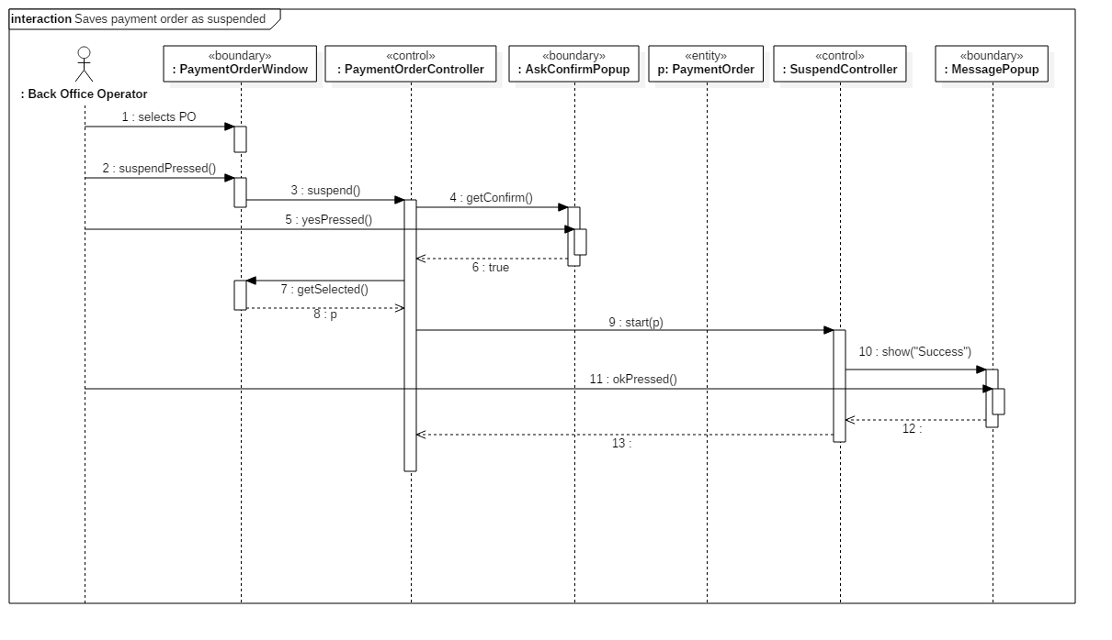

### Send readings

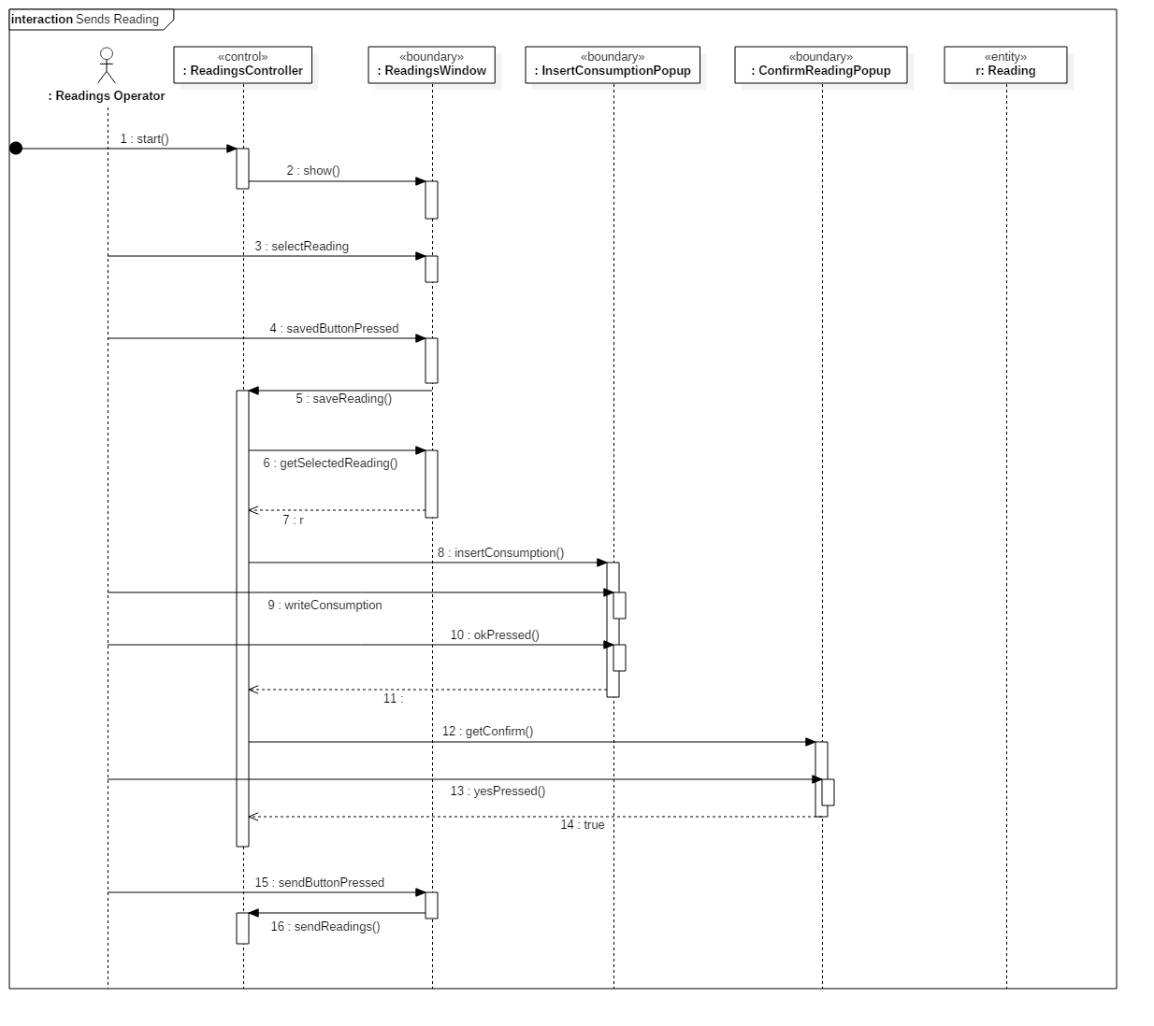

## State chart diagram payment order

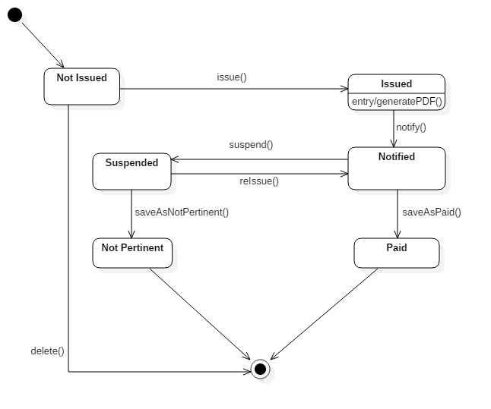

## Glossary (A-Z)

**Back Office Operator** User of desktop application, his goal is to handle the entire payment order management system.

**Issue** Render a payment order effective. After issuing a payment order, it must be paid by the debtor.

**Not pertinent** If the debtor won the legal case, the payment order would be archived. The debtor won’t have to pay the payment order anymore.

**Payment order** Document which requires the debtor to pay within a defined deadline.

**Protocol number** Every issued payment order is labeled by an index, a protocol number, which is considered a unique identifier.

**Suspend** A payment order can be suspended in presence of a legal case.

**Reading** Reading of water consumption reported on the meter.

**Reading Operator** User of mobile application.

# Design documentation

## System design

### Software architecture

The system division is based on the Three-Tier Architecture, which divides the system into three modules: client, server, and data source.  
In this way most of the business logic is located in a central server, the code is more scalable and maintainable and the client is independent of the data source.

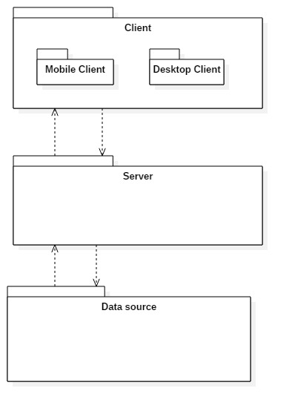

**Client**:  
Consists on the application which directly interacts with the users.   
This module is divided into two parts: client for readings operator, which is the mobile app that lets the users read the consumptions from the assigned meters, and a desktop application for back office operators.

**Server**:  
Represents the application's logical component, which provides authentication tokens, performs and verifies the correctness of the required operations, for example the status of a payment order.  
It was decided to use only a server to handle application requests, because it is estimated that the number of simultaneous connections is not high.

**Data source** :   
Relational DBMS in which persistent data are saved.

### Client server communication

Client and server communicate using HTTP messages. The server provides a session cookie after a succesful login request and the client must send back the cookie for any further communication. The server listens on port 8081 and replies to client requests with the following response codes:

|  |  |  |
| --- | --- | --- |
| Response code | Reason phrase | Description |
| 200 | OK | The request has been succesfully accomplished. |
| 500 | Internal server error | The request could not be accomplished due to an error encountered in the server. |
| 461 | Wrong id or password | The user has submitted a wrong id or password. |
| 462 | No session | The client has not sent a valid session cookie or the cookie sent has expired. |
| 463 | Missing parameter | The request expected a parameter which has not been sent. |
| 464 | Bad parameter values | One or more parameters presented an unexpected value. |
| 465 | Not practicable action | The requested action could not be applied to the given parameter. |

## Technologies

|  |  |  |
| --- | --- | --- |
| Technology | Version | Usages |
| Java | JDK 1.8 | Client application. |
| Apache Tomcat[1] | 8.5 | Server. |
| Java EE | Java EE 6 | Servlet for server web services. |
| JSON[2] |  | Client and server data exchange. |
| Oracle Database | 11g | Database. |
| Android | SDK 16 – API 4.1 | Mobile appliction for Readings Operators. |

### Libraries

*Gson* (Google JSON) is a Java library that can be used to convert Java objects into their JSON representation. It can be used to retrieve an object from a JSON string.

iText is a Java library for creating and manipulating PDF files in Java. It is used to generate the PDF with all the information of payment order after it is issued.

*OJDBC* is a Java library that provides drivers for Oracle Databases.

*Mockito* is a Java library that provides an easy way to create stub classes for jUnit testing.

jUnit---

//TODO tabella

## Object design

### Class diagrams

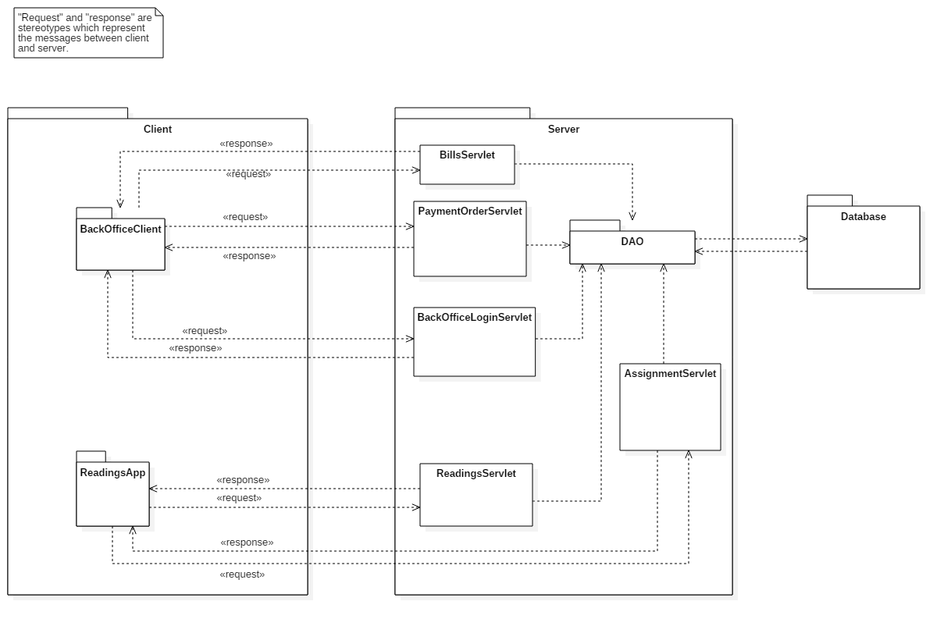

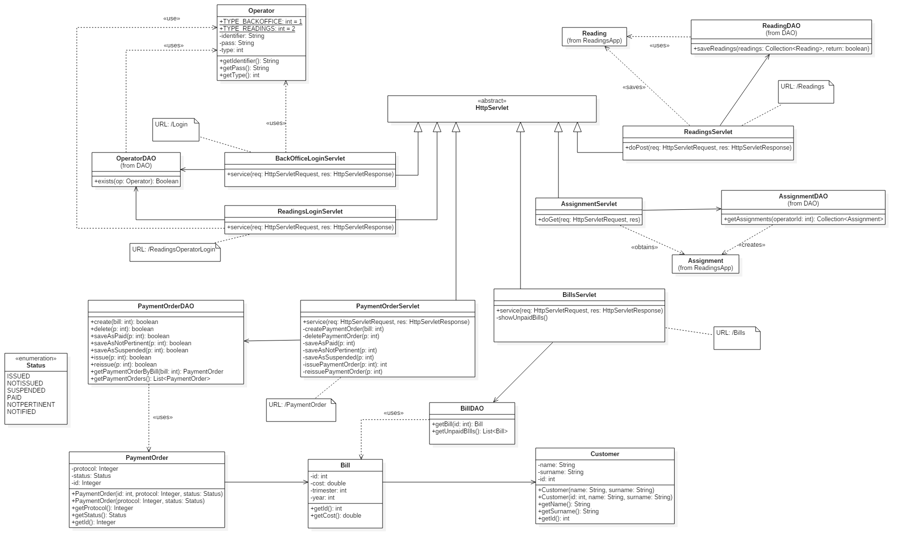

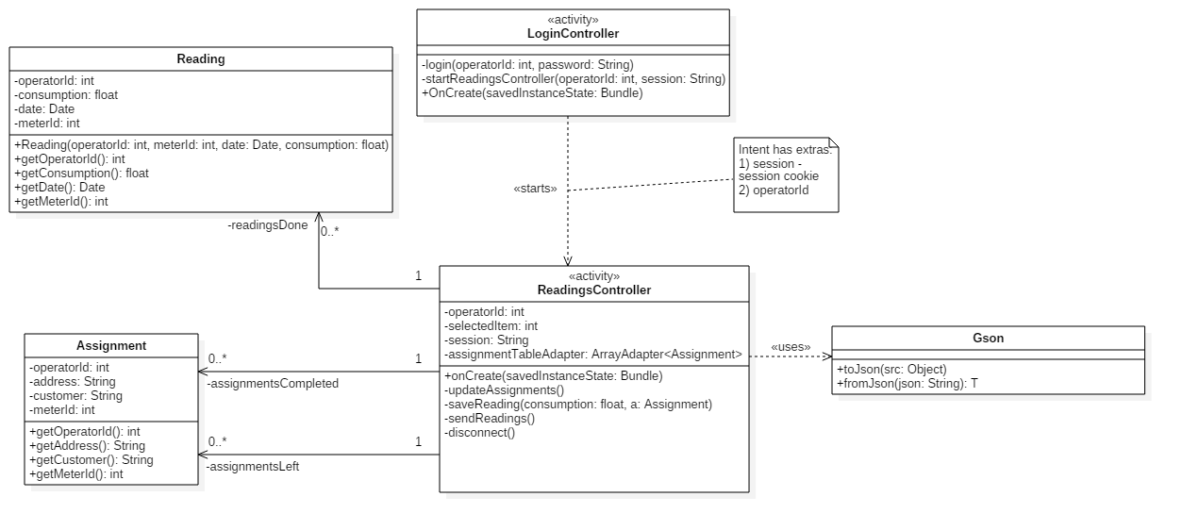

### Sequence diagrams

## CRC cards

### Desktop application

### Mobile application

|  |  |  |
| --- | --- | --- |
| **Class Name** | Assignment | |
| **Superclass** | Object | |
| **Subclasses** |  | |
| **Responsabilities** | | **Collaborators** |
| Represent the task of performing a reading of a meter. | |  |

|  |  |  |
| --- | --- | --- |
| **Class Name** | AssignmentServlet | |
| **Superclass** | HttpServlet | |
| **Subclasses** |  | |
| **Responsabilities** | | **Collaborators** |
| Provide an operator with the list of his assignments. | | Assignment, AssignmentDAO, Gson |

|  |  |  |
| --- | --- | --- |
| **Class Name** | LoginController | |
| **Superclass** | AppCompatActivity | |
| **Subclasses** |  | |
| **Responsabilities** | | **Collaborators** |
| Let the operator login from the mobile application. | |  |

|  |  |  |
| --- | --- | --- |
| **Class Name** | Reading | |
| **Superclass** | Object | |
| **Subclasses** |  | |
| **Responsabilities** | | **Collaborators** |
| Represent the reading of the water consumption reported on a meter. | |  |

|  |  |  |
| --- | --- | --- |
| **Class Name** | ReadingsController | |
| **Superclass** | AppCompatActivity | |
| **Subclasses** |  | |
| **Responsabilities** | | **Collaborators** |
| Let the user save the reading consumption reported on a meter. | | Assignment, Reading, Gson |
| Update user’s list of assignments. | | Assignment, Gson |
| Send the readings done to a remote server. | | Reading, Gson |

|  |  |  |
| --- | --- | --- |
| **Class Name** | ReadingsServlet | |
| **Superclass** | HttpServlet | |
| **Subclasses** |  | |
| **Responsabilities** | | **Collaborators** |
| Save into the database the readings performed by a Readings Operator. | | Reading, ReadingDAO, Gson |