

**Map Viewer Help Guide**

Version 2.1

# Table of Contents

Table of Contents 2

Overview 3

Tools 4

My Location 4

Draw on Map 5

Clear Map 5

Google StreetView 5

Add Shapefile to Map 6

Add XY to Map 6

Property Report 7

Bookmarks 7

Measure 8

Print 8

Share Map – Email 9

Share Map – Copy 9

Frequently Asked Questions 10

How do I get information about my property? 10

How do I view different layers? 11

How can I share a map with someone? 12

How can I add my own data to the map? 12

How do I print a map? 12

Nothing happens after I print a map or request a property report? 12

How do I get this application on my mobile device? 12

Technical Information 13

Contact Us 13

# Overview

Print

Layers/Legend

Tools

Share Map - Email

Share Map - Copy

Help

Change the basemap

Opacity of the basemap slider

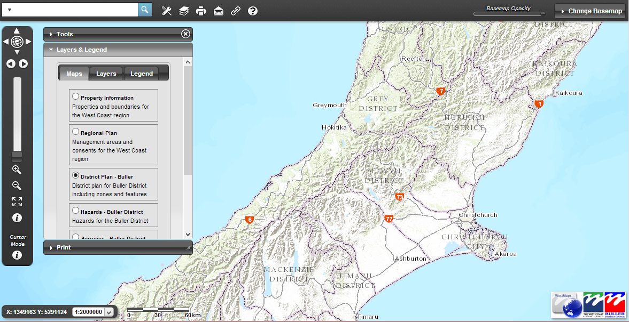

Current cursor mode e.g. Identify, pan, zoom-in

Cursor mode selection

Previous/next extent

Zoom to full extent

Search

Zoom in/out slider

Coordinates of mouse pointer on map

Scale bar

Scale selection

# Tools

A number of tools are available in the Map Viewer, which are available from the tools menu.

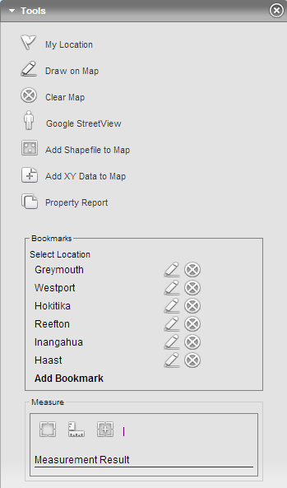

## My Location



Takes you to your current location on the map. This functionality uses the [Geolocation API](http://en.wikipedia.org/wiki/W3C_Geolocation_API), which may not be supported by your browser. A popup will appear:



You need to allow this to see your location. The application will use your WiFi internet/IP address to work out your location if you are on a desktop or GPS/mobile internet if you are using a mobile device. Visit this [address](http://caniuse.com/#feat=geolocation) to discover browser support for the Geolocation API.

## Draw on Map



Opens up a toolbar where a number of different graphics are available to be placed on the map. Click on the tool to activate then click the map to start drawing the graphic (a tooltip will appear with instructions for the specific tool). Change the colour by clicking the colour selector.

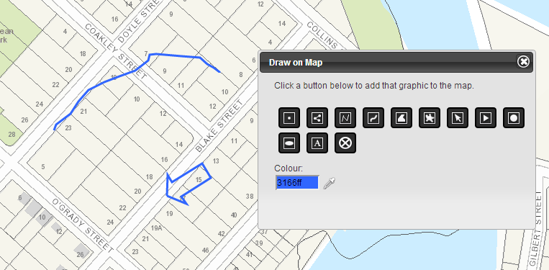

## Clear Map



Clears any graphics that are on the map e.g. From using the measure/drawing tools or searching graphics.

## Google StreetView



Shows the street view from the point clicked on the map. Clicking the button will activate the StreetView mode. You then need to click on the map to show the street view for that location.

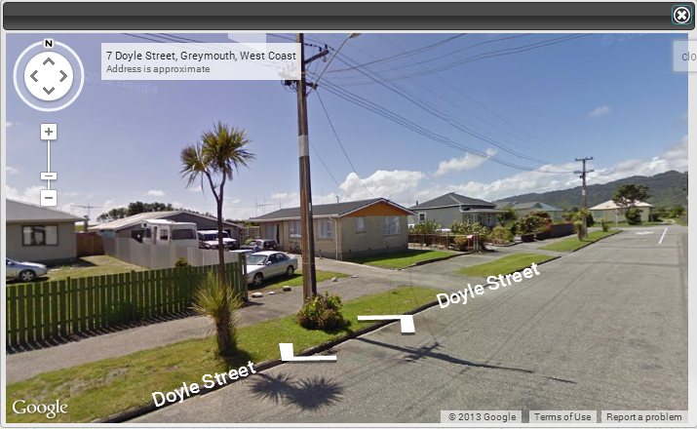

## Add Shapefile to Map



Opens up a dialog where you can select a shapefile to add to the map. The shapefile needs to be zipped up (in .zip format). This is because there are several files that make up a shapefile and the process is made easier by just selecting the one as a .zip file. Opacity and symbol colour can also be set. Once added (by clicking the Choose File button), the features will be added to the map. The features need to be in the same projection system as the map. In most cases this will be New Zealand Transverse Mercator.

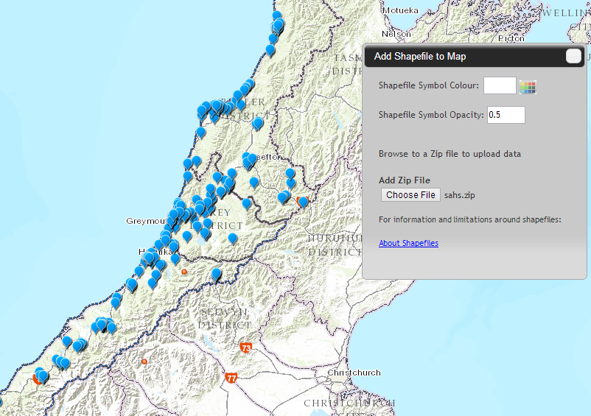

## Add XY to Map



Opens up a dialog where you can select a CSV file to add to the map. The file needs to be in CSV (more info [here](http://en.wikipedia.org/wiki/Comma-separated_values)) format and the field names for each of the coordinates must be either:

* “lat” and “lon/long”
* “latitude” and “longitude”
* “x” and “y”
* “xcenter” and “ycenter”

Once added (by clicking the Choose File button), the features will be added to the map. The features need to be in the same projection system as the map. In most cases this will be New Zealand Transverse Mercator.

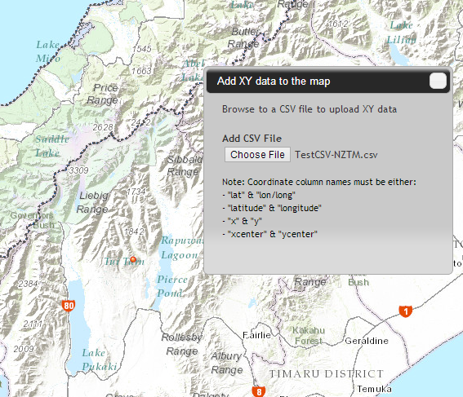

## Property Report



Changes the cursor mode to property report. After the button has been clicked, click the map to select a property. You need to be zoomed in far enough to be able to select the property you want, otherwise a “No property at this location” message will appear. After selecting a property, a popup window will appear with information about the property as well as a “View Report” hyperlink. Click this button to get the property report for this property. After a few seconds loading a PDF will appear with an aerial photograph and information about the property.

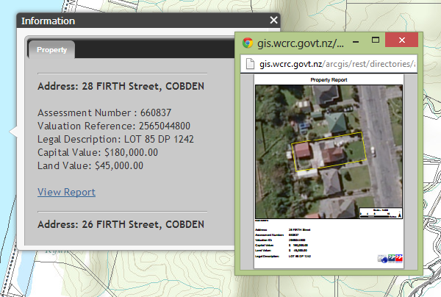

## Bookmarks

A set of predefined common bookmarks have been added. Clicking one of these location will zoom the map to that location. You can add, delete and rename bookmarks, however these bookmarks will only be valid for the current session.

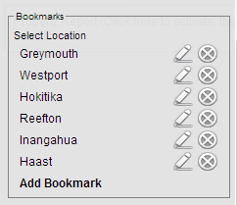

## Measure

There are three types of measurement tools provided, which can be activated by clicking on that button.

* Area enables you to draw an area on the map and be returned with that area under the “Measurement Tool” heading. To create an area click the Area button to activate it, then the map several times to create the shape of the area to be measured.
* Distance enables the straight line distance between a series of points. To create a distance to be measured, click the Distance button, then the map several times to create the line(s) to be measured.
* Location returns the coordinates of a particular point on the map. Click the Location button to activate it, then the map to return the coordinates of that location.

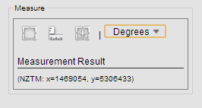

## Print

Activate the print tool by clicking the print button from the toolbar. There are a number of settings you can change to modify the output to your needs.

* Layout – Select from the various layout sizes and types
* Format – The format of the output map, can be PDF, JPG or PNG
* Title – The title to appear at the top of the map
* Scale – Current Scale will produce the map at the current scale of the application and Current Extent will produce the map at the current extent of the application.
* Print Quality – The quality of the map, can be 60 DPI (low), 100 DPI (medium) or 200 DPI (high). The higher the quality the longer the map will take to generate and download.

Click the Print button to generate the map.

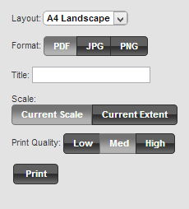

## Share Map – Email

Clicking the Share Map – Email button will open up your email client and paste in a link to send to someone. This link is generated by the layers and configuration of the current map setup you have.

The following parameters are added onto the URL:

* xmin,ymin,xmax,ymax – The extent of the map e.g. <http://gis.wcrc.govt.nz/WestMaps/map.html?xmin=893848&ymin=5038144&xmax=1909851&ymax=5543500>
* baseMap – The basemap selected e.g. <http://gis.wcrc.govt.nz/WestMaps/map.html?baseMap=Imagery1998>
* layerGroup – The group layer selected e.g. <http://gis.wcrc.govt.nz/WestMaps/map.html?layerGroup=Property_Information>
* baseMapOpacity – The opacity of the basemap e.g. <http://gis.wcrc.govt.nz/WestMaps/map.html?baseMap=Imagery1998&basemapOpacity=50>
* theme – If themes are enabled, the theme selected e.g. <http://gis.wcrc.govt.nz/WestMaps/map.html?theme=internal>
* search – The feature to search e.g. <http://gis.wcrc.govt.nz/WestMaps/map.html?search=12%20main%20road> will locate the feature “12 main road”

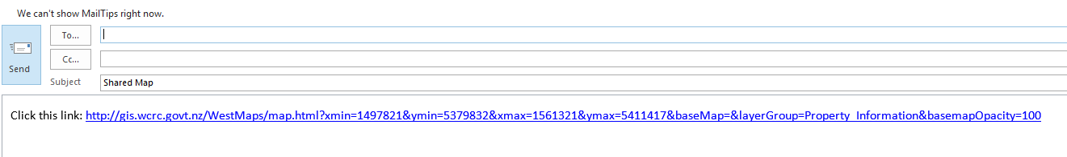

## Share Map – Copy

Clicking the Share Map – Copy will open up a dialog with a text box and paste in a link to copy into a document or send to someone. This link is generated by the layers and configuration of the current map setup you have.

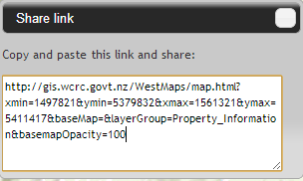

# Frequently Asked Questions

## How do I get information about my property?

Make sure you have the “Property Information” layer selected from the menu.

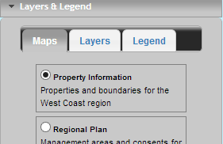

You can search for your property in the search text field

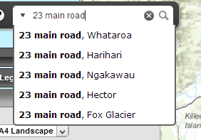

Once you starting typing, potentials results will start to appear in the dropdown for you select from. You can then hit enter, click the search button or select one of the results from the dropdown to navigate to that property. The map will then navigate to that location and show a popup window with information about the property.

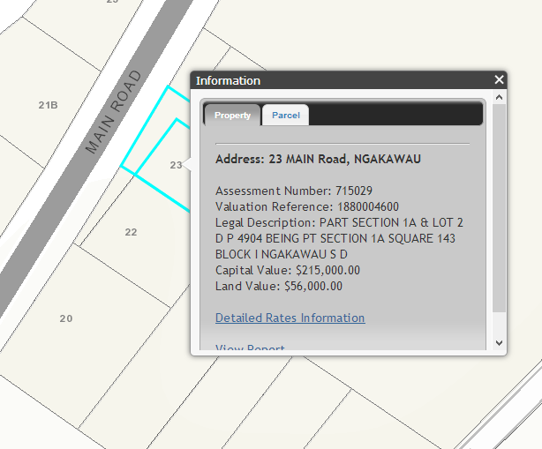

You can also download a property report about this property by clicking the View Report link.

## How do I view different layers?

There are a number of different groupings of layers available from the menu. If the layers menu isn’t open already, click the button from the toolbar and you will see the layer groupings to select from.

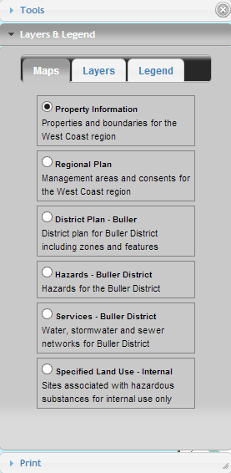

Changing these layer groups will results in different layers appearing on the map. Clicking the Layers tab will show the individual layers that you can turn on/off and legend will show legend information about the currently visible layers. Some layers have popups associated, so if you click on a feature on the map, more information may appear.

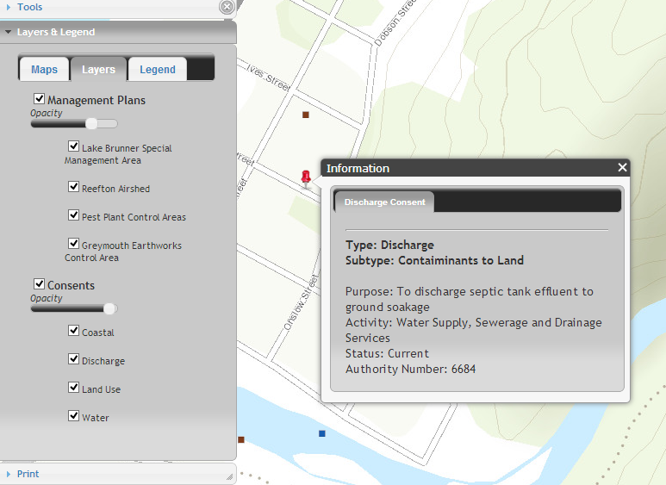

## How can I share a map with someone?

There are two tools that enable you to do this.



Click the email tool and this will open your email client and paste in the URL to the site as well as appending on information on the current map view. When the person clicks on this link, the map will be opened up to the same view as you. The share tool will open up a dialog with the hyperlink in a textbox for you to copy into a word document or email.

## How can I add my own data to the map?

There are a couple of tools that enable you to do this. You can either have your data in shapefile format or in a spreadsheet in CSV format. The shapefile needs to be zipped up (in .zip format). You need to also make sure that the shapefile is in the same projection system as the map. In most cases this will probably be New Zealand Transverse Mercator.

## How do I print a map?

Firstly, navigate to the extent that you would like to print and turn on the layers you would like to include. Once, you have this setup the way you want it open up the print tool by clicking the print button.

## Nothing happens after I print a map or request a property report?

In some web browsers, popups are blocked, so you will need to enable popups for the site to get access to map prints and the property report.



Click “Options for this site” then “Always Allow” to stop Internet Explorer blocking popups for this site.

## How do I get this application on my mobile device?

This application is available on mobile devices such as iPhone, iPad and Samsung Galaxy. The mobile version is a lighter version of the site and optimised to work with touch screens. The mobile version of the site will load automatically when you navigate to the site on a mobile device. You can also navigate to the mobile version also by changing the url end html to “mobile.html” instead of “map.html”. To get to this application you need a web browser on your mobile device.

# Technical Information

The Map Viewer is consuming web services deployed using [ArcGIS for Server](http://www.esri.com/software/arcgis/arcgisserver) technology developed by [Esri](http://www.esri.com). The application is built using the [ArcGIS API for Javascript](https://developers.arcgis.com/en/javascript) as well as [Dojo Toolkit](http://dojotoolkit.org) and [jQuery](http://jquery.com) JavaScript libraries.

Map Viewer version 2.1 has been developed by [Eagle Technology](http://www.eagle.co.nz/GIS) – Official distributor of Esri products and solutions for New Zealand.

# Contact Us

For more information regarding this map viewer or to report any issues/bugs, please email us at this address – [gissupport@eagle.co.nz](mailto:gissupport@eagle.co.nz)