ABANTE, Carlo Jose B. | 2 ECE B

EXPERIMENT 9: Screenshots

Problem 1

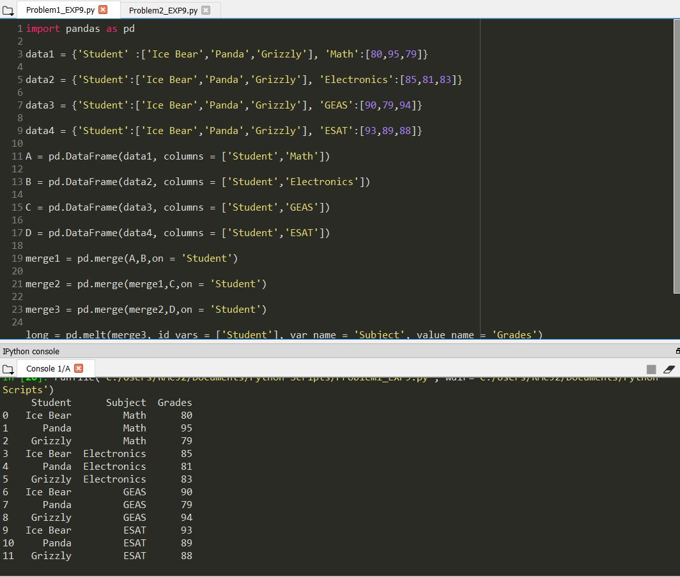

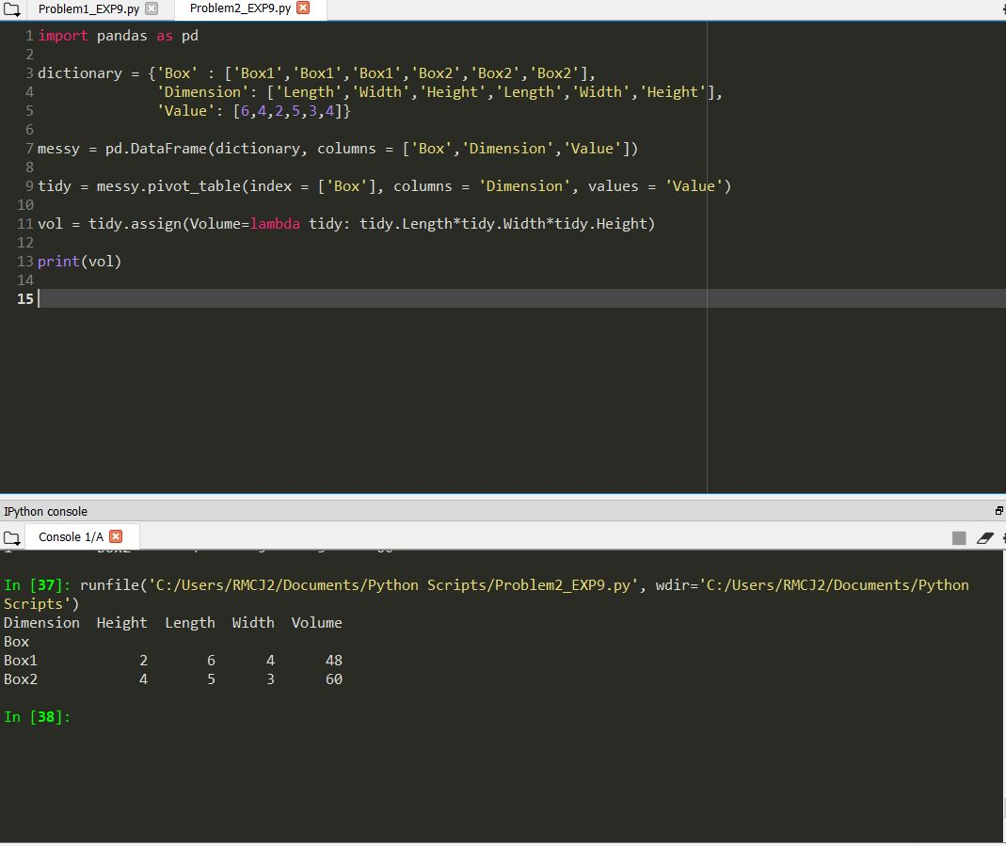Problem 2