ABANTE, Carlo Jose B.

TYCANGCO, Maegan C.

2 ECE B

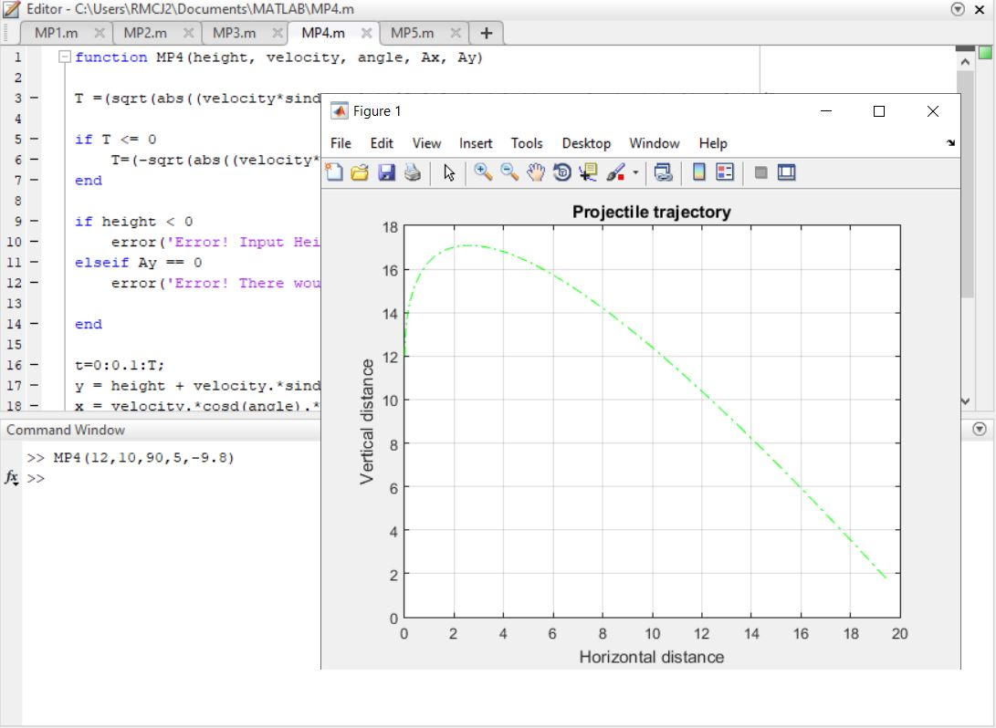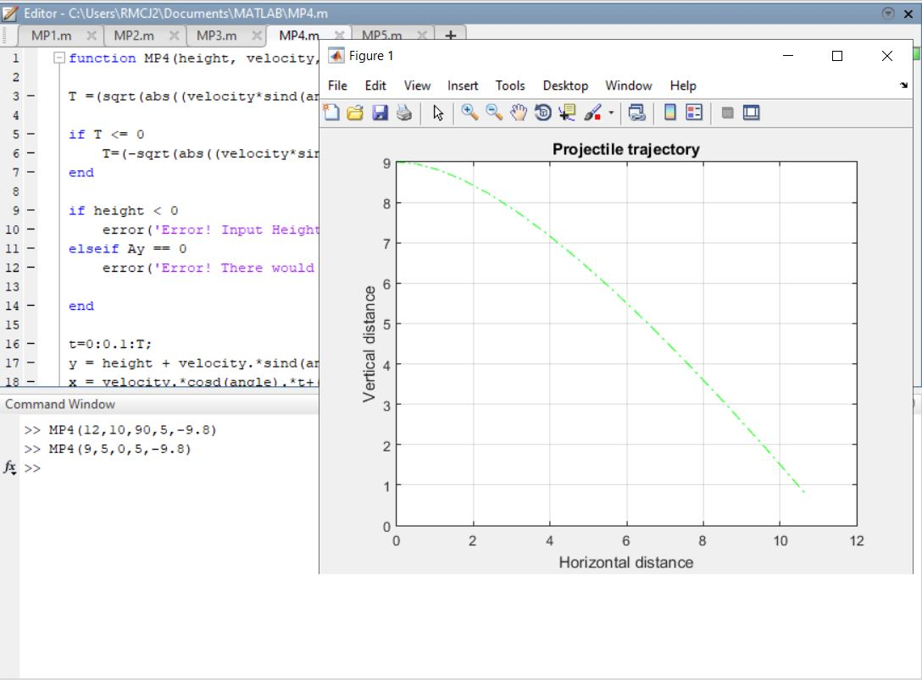Machine Problem 4 – Screenshots(MATLAB)

