**COMP 3550**

|  |  |
| --- | --- |
| **Group Members** | |
| Carlon Baird | 813117817 |
| Andreas Schmitt | 815011256 |
| Kwasi Edwards | 813117992 |
| Dineile Guevara | 813001603 |
| Christine Russell | 813001556 |

Assignment 1

**Documentation**

**Taxonomy**

Sitemap of Clima Organisation Website

**Low fidelity prototype for the layout of the proposed website**

Mobile Screens

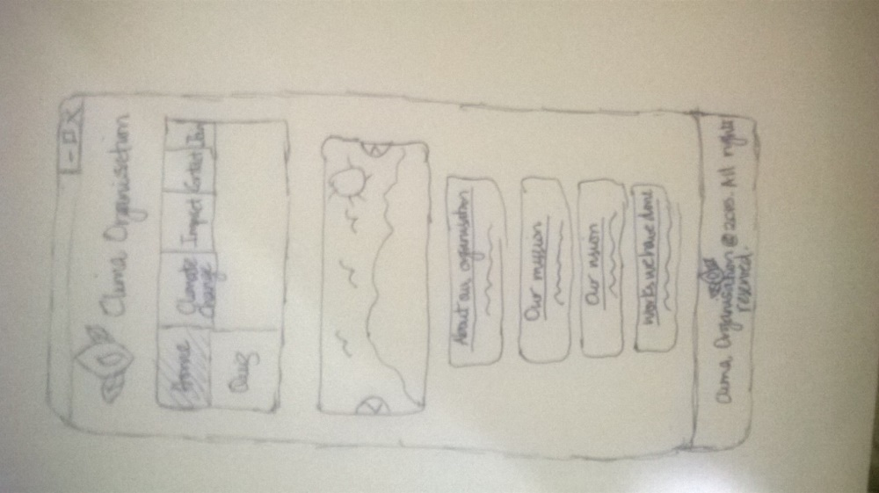

Desktop

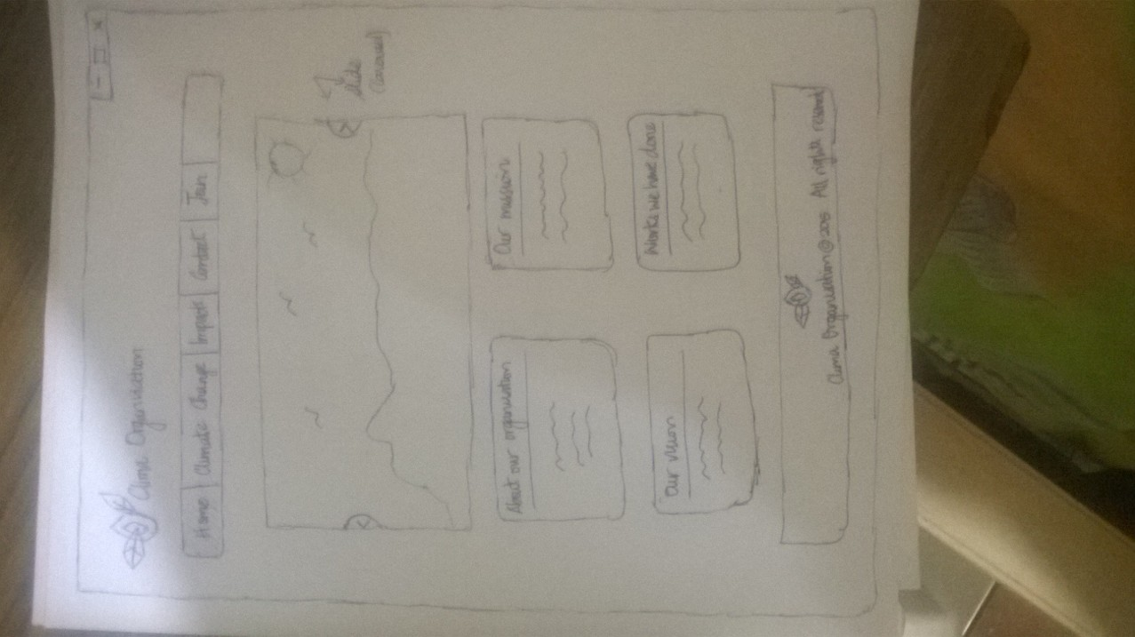

**WOW Factor**

There were three WOW factors that contributed to the enhancement of our website. A carousel, adapted from Jssor, was chosen to display some the natural beauty of our planet. This carousel added a visual appeal to our homepage. It allows users to move the image in a linear manner which, in effect, allows them to interact with this homepage picture content. In addition, a modal was integrated into the website — the impact on water resources page. This gives users the ability to click on a variety of icons so that they can receive information about climate change’s impact on water resources. Likewise, the users can interact with this technology right on our website for entertainment purposes. Lastly, embedded videos were added to the climate change page and evidence page. This added an audio-visual appeal to our website. Thus, ensuring users are educated about climate change through several avenues.