Contents

Project Description 4
Modifications 5
Collaboration 6
Student 1: Diana Ali Silva 6
Diana’s Screenshots 6
Student 2: Carlos David Urra Cabello 7
Carlos’s Screenshots 7
Student 3: Georgii Taisaev 9
Georgii’s Screenshots 9
Student 4: Muslim Muradov 10
Muslim’s Screenshots 10
Planned Improvements for Next Version 11
Link to our repository: 12
References 13


Student name: | Student 1: Diana Ali Silva  Student 2: Carlos David Urra Cabello  Student 3: Georgii Taisaev  Student 4: Muslim Muradov
Student number: | Student 1: 3123965  Student 2: 3125350  Student 3: 3119655  Student 4: 3128794
Faculty: | Computing Science
Course: | BSCH/BSCO/EXCH |  |  | Stage/year: | 2
Subject: | Software Development 2
Study Mode: | Full time |  |  | Part-time
Lecturer Name: | Gemma Deery
Assignment Title: | Review 2
Date due: | 18 April 2025
Date submitted: | 18 April 2025
Plagiarism disclaimer:
I understand that plagiarism is a serious offence and have read and understood the college policy on plagiarism. I also understand that I may receive a mark of zero if I have not identified and properly attributed sources which have been used, referred to, or have in any way influenced the preparation of this assignment, or if I have knowingly allowed others to plagiarise my work in this way.

I hereby certify that this assignment is my own work, based on my personal study and/or research, and that I have acknowledged all material and sources used in its preparation. I also certify that the assignment has not previously been submitted for assessment and that I have not copied in part or whole or otherwise plagiarised the work of anyone else, including other students.
Signed: _____________________ Date: ______________________
Please note: Students MUST retain a hard / soft copy of ALL assignments as well as a receipt issued and signed by a member of Faculty as proof of submission.

Project Description
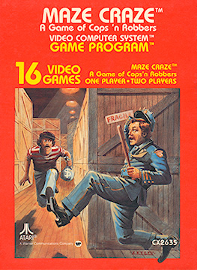
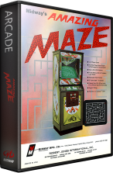
The 2D Multiplayer Maze Game is a Java application inspired by the classic arcade games Amazing Maze (1976) and Maze Craze (1980). The game challenges two players to race through a randomly generated maze to reach the exit first. Each maze is built using a recursive backtracking algorithm to ensure it is always solvable and offers a fresh layout in every round.[1,2]
Figure1.Amazing Maze (1976).
Figure 2. Maze Craze (1980).

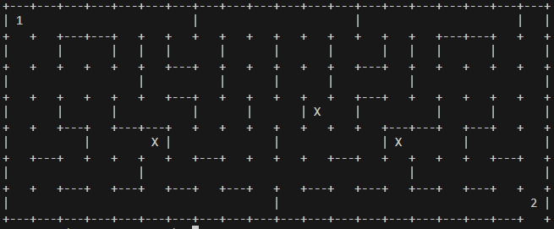
Originally developed as a console-based game using ASCII characters, the project has now moved into a second iteration focused on transitioning to a graphical version using Java Swing. This phase includes the initial integration of a GUI, adaptation of local multiplayer for visual interaction, and enhancements to sprite behavior and maze fairness. Features from separate branches are being merged, and unit testing has been introduced to support continued development.
Figure 3. Maze displaying multiplayer and sprite interaction.

Iteration 1 – Initial Implementation

In the first stage of the project, the team focused on building the foundation for the game. We developed core features, established a basic version of the maze, and prepared the structure for future improvements like the graphical interface and multiplayer support.
Carlos set up a GitHub repository to help the team collaborate and manage versions more efficiently. He implemented the maze generator using recursive backtracking, added the basic single-player logic including exit detection, and organized the project folders based on the structure provided in the Moodle example.
Diana implemented a Java Swing window that opened when running the class. At this point, the window displayed only a white screen, but it marked the beginning of transitioning from the console-based version to a graphical user interface.
Georgii added placeholder sprites, represented as 'X' in the console version, which introduced basic challenge elements to the gameplay. These sprites were designed to be replaced with graphic components once Swing was integrated.
Muslim worked on the local multiplayer logic, allowing both players to use the same keyboard to control their characters. Although simultaneous movement was not yet supported due to console limitations, the basic structure was in place for future expansion.
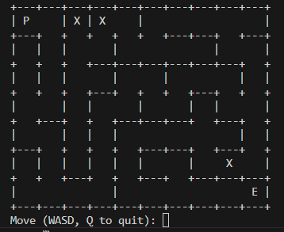

Figure 4. Console-based maze from the previous iteration showing player, exit, and placeholder sprites.

Modifications

Mirrored Maze Generation
The maze generation algorithm was improved to support mirrored layouts. This enhancement ensures fairness by generating symmetric paths, allowing both players to navigate mazes of equal complexity from opposite starting positions.
Player Start and Exit Logic
The start and exit positions for both players were defined to reinforce balanced gameplay. Player 1 begins at the top-left corner and must reach the bottom-right exit, while Player 2 starts at the bottom-right and aims for the top-left. This setup encourages parallel competition within the maze.
Improved Sprite Behavior
The sprites were enhanced to move randomly within the maze, increasing unpredictability and challenge. In addition to navigating around walls, sprites can now actively “catch” players if they land on the same cell, resulting in a game-over scenario. This adds a layer of strategy and urgency to the game.
Unit Testing with JUnit
To ensure functional reliability, a dedicated test class was developed using JUnit. These tests focus on verifying player movement, wall collision, and initial conditions, contributing to better debugging and future-proofing the application.
Branch Integration and Conflict Resolution
Significant effort was dedicated to merging different development branches, each containing unique features such as sprite handling, mirrored mazes, and multiplayer logic. Conflicts were manually resolved, and a consistent, integrated version of the game was successfully established in the main branch.
Game Logic Enhancements
Core gameplay logic was refined to ensure accurate exit detection and player feedback. End-game messages were adjusted to clearly indicate victory or defeat based on player actions and interactions with sprites.

Keyboard Input Translation
A switch-case mapping system was introduced to support dual control schemes. Player 2’s IJKL inputs are now internally translated into WASD commands, allowing both users to interact with the maze using intuitive, non-overlapping keys.

Collaboration

Student 1: Diana Ali Silva

Diana’s Screenshots

Student 2: Carlos David Urra Cabello

Building on the foundation from Iteration 1, where I applied the maze generation algorithm, set up the basic game logic, and organized the repository, I continued supporting the project by integrating new features and streamlining the overall structure.
In this phase, I implemented a switch-case input translation system to support multiplayer. This allowed Player 2 to use the IJKL keys, which are internally mapped to the standard WASD movement used by Player 1. The solution was based on publicly available examples and improved the game’s control system for shared-keyboard gameplay.
I also handled the merging of various development branches, each containing specific updates such as sprite behaviour, maze mirroring, and multiplayer adjustments. During this process, I ensured that all features were properly combined into a single, working version.
Additionally, I added a JUnit test class to check key parts of the game logic. These unit tests help confirm correct player movement, wall detection, and basic setup conditions, supporting code reliability as the game evolves.

Carlos’s Screenshots

Github repository
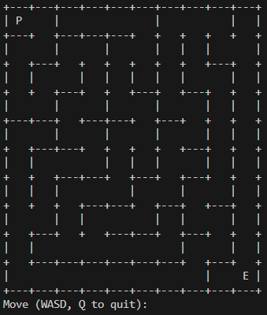
randomly generated maze
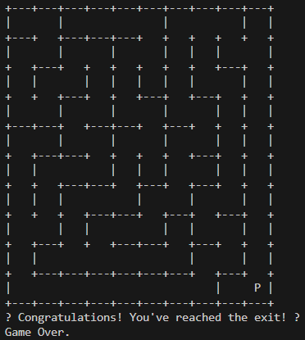
Exit message shown when the player successfully reaches the end of the maze.
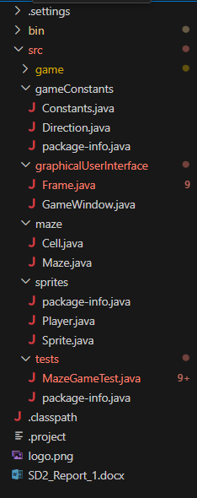
Organized folder structure based on the example provided on Moodle.
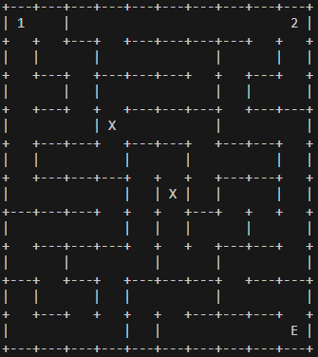
Multiplayer maze view showing Player 1 and Player 2 starting at opposite corners.
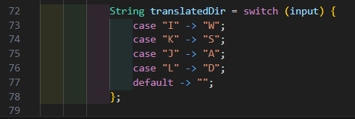
Java switch expression used to translate IJKL inputs into WASD equivalents for Player 2 movement, enabling intuitive local multiplayer control.
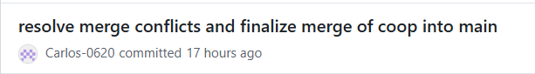
Commits showing Carlos’s work on merging branches and integrating key gameplay features.

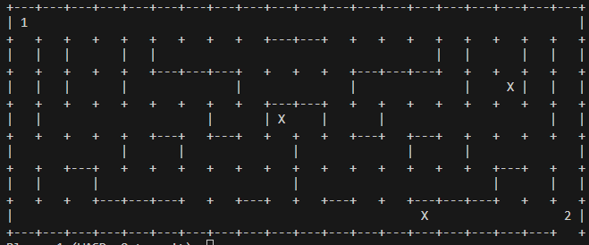
Player 1 starts in the top-left corner and Player 2 in the bottom-right.

Student 3: Georgii Taisaev

Georgii’s Screenshots

Student 4: Muslim Muradov

Muslim’s Screenshots

Planned Improvements for Next Version
For the next stage of the project, our goal is to move from a console-based experience to a more complete and interactive graphical game. One of the main updates will be to fully integrate the Java Swing interface with the game logic, allowing the maze and player movement to be displayed in a window with basic visual elements.[4]
We plan to replace the current console output with a 2D view of the maze, where walls, paths, and players are drawn using simple graphics or placeholder sprites. This will improve the overall user experience and make the game easier to understand and play.
Another important update is to support simultaneous local multiplayer. Right now, players take turns moving through the maze, but in the next version, both players should be able to move at the same time using different keys on the same keyboard. This will make the gameplay more dynamic and competitive.
Other improvements may include adding a simple menu or game start screen, using Swing buttons or key bindings, and possibly updating the placeholder sprites to better represent obstacles or player characters.
These updates will bring the project closer to a fully playable and visually interactive game.

Link to our repository:
https://github.com/Carlos-0620/Software_Development_Project.git

References

- Midway Manufacturing Co. (1976). Amazing Maze [Arcade Game]. International Arcade Museum. Retrieved from https://www.arcade-museum.com/Videogame/amazing-maze

- Atari. (1980). Maze Craze [Atari 2600 Game]. Atari Official Website. Retrieved from https://atari.com/pages/mazecraze

- Buck, J. (2015). Mazes for Programmers: Code Your Own Twisty Little Passages. The Pragmatic Bookshelf. ISBN: 978-1-68050-055-4

- GeeksforGeeks. (n.d.). Introduction to Java Swing. Retrieved from https://www.geeksforgeeks.org/introduction-to-java-swing/

- GeeksforGeeks. (2022). Switch statement in Java. Retrieved from https://www.geeksforgeeks.org/switch-statement-in-java/

