Trigger

CREATE TRIGGER A9

ON LGLINE

AFTER INSERT, DELETE,UPDATE

AS

BEGIN

DECLARE @INV_NUM INT

DECLARE @TOTAL INT

IF (EXISTS (SELECT* FROM inserted))

BEGIN

DECLARE INSERTED_CURSOR CURSOR FOR

SELECT INV_NUM, SUM(LINE_QTY*LINE_PRICE) AS TOTAL

FROM inserted

GROUP BY inv_num

OPEN INSERTED_CURSOR

FETCH NEXT FROM INSERTED_CURSOR

INTO @INV_NUM, @TOTAL

WHILE(@@FETCH_STATUS = 0)

BEGIN

UPDATE lginvoice

SET INV_TOTAL = inv_total - @TOTAL

WHERE inv_num = @INV_NUM

FETCH NEXT FROM INSERTED_CURSOR

INTO @INV_NUM, @TOTAL

END

CLOSE INSERTED_CURSOR

DEALLOCATE INSERTED_CURSOR

END

IF (EXISTS (SELECT* FROM deleted))

BEGIN

DECLARE DELETED_CURSOR CURSOR FOR

SELECT INV_NUM, SUM(LINE_QTY*LINE_PRICE) AS TOTAL

FROM deleted

GROUP BY inv_num

OPEN DELETED_CURSOR

FETCH NEXT FROM DELETED_CURSOR

INTO @INV_NUM, @TOTAL

WHILE(@@FETCH_STATUS = 0)

BEGIN

UPDATE lginvoice

SET INV_TOTAL = inv_total + @TOTAL

WHERE inv_num = @INV_NUM

FETCH NEXT FROM DELETED_CURSOR

INTO @INV_NUM, @TOTAL

END

CLOSE DELETED_CURSOR

DEALLOCATE DELETED_CURSOR

END

END

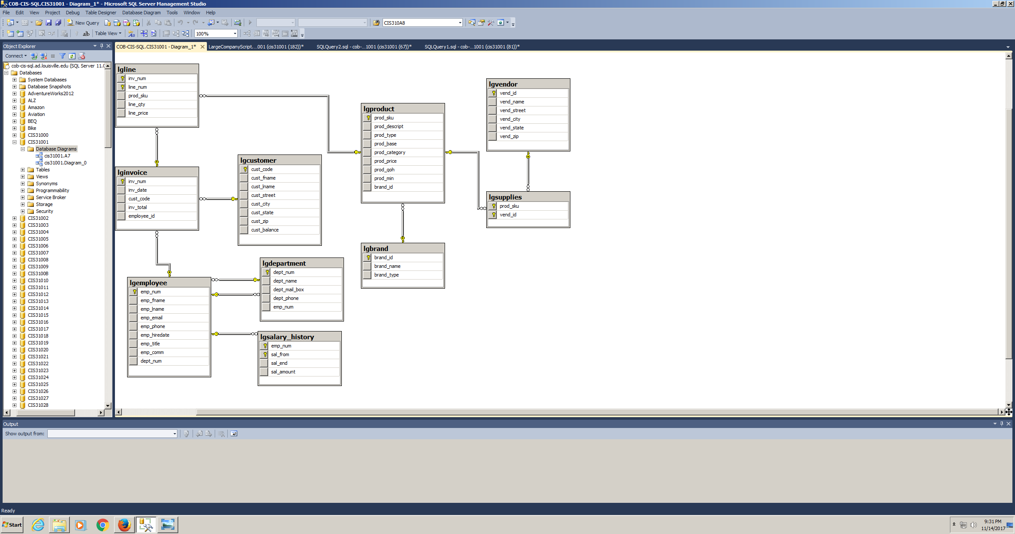ERD

Test code

--CHECK CHANGES

SELECT *

FROM lgline

SELECT *

FROM lginvoice

--INSERT

INSERT INTO LGLINE VALUES (104, 4, '3561-LYU', 9, 3.29);

--DELETE

DELETE FROM lgline

WHERE line_num = 4 AND inv_num=104

--UPDATE

UPDATE LGLINE

SET LINE_QTY = 4

WHERE line_num =4 AND inv_num =104