IDH_LATAM
Carlos Ballon-Salcedo
2025-11-20

Load packages
# Packages
pacman::p_load(
rio,
here,
tidyverse,
ggpubr,
ggsci,
gtsummary,
flextable,
officer,
lmtest,
sandwich,
clubSandwich,
modelsummary,
extrafont,
labelled,
janitor,
epiDisplay,
Hmisc
)
# Scripts
source(here::here("scripts", "plot_zscore_vs_hdi.R"))

Import data
# Prevalence rates
data_prevalencias <- import(here("data", "base_ecologico.dta")) |>
dplyr::select(CountryName, SeriesName, year, value) |>
pivot_wider(
names_from = "SeriesName",
values_from = "value") |>
rename(
anemia659 = `Prevalence of anemia among children (% of children ages 6-59 months)`,
anemiagest = `Prevalence of anemia among pregnant women (%)`,
anemiafertil = `Prevalence of anemia among non-pregnant women (% of women ages 15-49)`,
bajopesoalnacer = `Low-birthweight babies (% of births)`,
sobrepesoinfantil = `Prevalence of overweight (modeled estimate, % of children under 5)`,
retrasocrectallaedad = `Prevalence of stunting, height for age (modeled estimate, % of children under 5)`,
fechas = year,
pais = CountryName) |>
mutate(pais = recode(pais, "Venezuela, RB" = "Venezuela"))
# HDI
data_idh <- import(here("data", "baselat.xlsx")) |>
rename(pais = pais...5) |>
dplyr::select(hdi, pais, fechas) |>
dplyr::filter(pais %in% c(1, 4, 5, 6, 7, 12, 23, 24, 26, 27)) |>
dplyr::mutate(
pais = case_when(
pais == 1 ~ "Argentina",
pais == 4 ~ "Bolivia",
pais == 5 ~ "Brazil",
pais == 6 ~ "Chile",
pais == 7 ~ "Colombia",
pais == 12 ~ "Ecuador",
pais == 23 ~ "Paraguay",
pais == 24 ~ "Peru",
pais == 26 ~ "Uruguay",
pais == 27 ~ "Venezuela"
))
# Join the data
data <- data_prevalencias |>
left_join(data_idh, by = c("pais", "fechas")) |>
filter(fechas >= 2007 & fechas <= 2021)

Export data

Process data

Recode and relevel
# Round to 3 digits
data <- data |>
dplyr::mutate(across(where(is.numeric), round, 3))
# Normalization (scaling)
data <- data |>
mutate(
z_hdi = scale(hdi)[, 1],
z_anemia_child = scale(anemia659)[, 1],
z_anemia_gest = scale(anemiagest)[, 1],
z_anemia_fertil = scale(anemiafertil)[, 1],
z_bpn = scale(bajopesoalnacer)[, 1],
z_sobrepeso = scale(sobrepesoinfantil)[, 1],
z_tallaedad = scale(retrasocrectallaedad)[, 1]
)

Produce outputs
El uso del paquete showtext con ggplot2 y ggsave() resulta problemático principalmente porque modifica la forma en que R interpreta el tamaño de la fuente, lo que a menudo lleva a que el texto se guarde con un tamaño minúsculo en el archivo final, obligándote a escalar el parámetro size del texto a valores inusualmente altos (como 24 o 30) para compensar, interrumpiendo el flujo de trabajo estándar de ggplot2. Por otro lado, la solución extrafont con el comando font_import(pattern = "Lato", prompt = FALSE) es superior, ya que registra la fuente instalada en el sistema de manera selectiva (solo cargando Lato, no todas las fuentes), integrándola al subsistema de gráficos de R de forma más limpia y permitiendo que los valores de size de ggplot2 se comporten de manera predecible. Además, usar loadfonts(device = "pdf") y loadfonts(device = "postscript") es crucial porque le dice a R que ponga las fuentes registradas a disposición de los dispositivos de salida de archivos vectoriales, y especificar device = cairo_pdf en ggsave() es importante para garantizar que las fuentes sean correctamente incrustadas en el archivo PDF final, asegurando que el gráfico se vea idéntico independientemente de las fuentes instaladas en la máquina del visor.

Figure 1. Trends in maternal and child nutrition indicators
# Fonts
font_import(pattern = "Lato", prompt = FALSE)
font_import(pattern = "Syne", prompt = FALSE)
# Plot
figure_1 <- ggplot(data, aes(x = fechas)) +
geom_line(aes(y = anemia659, color = "Anemia in Children")) +
geom_point(
aes(
y = anemia659,
color = "Anemia in Children",
fill = "Anemia in Children",
shape = "Anemia in Children"
),
size = 1.5
) +
geom_line(aes(y = anemiagest, color = "Anemia in Pregnancy")) +
geom_point(
aes(
y = anemiagest,
color = "Anemia in Pregnancy",
fill = "Anemia in Pregnancy",
shape = "Anemia in Pregnancy"
),
size = 1.5
) +
geom_line(aes(y = anemiafertil, color = "Anemia in Women of\nReproductive Age")) +
geom_point(
aes(
y = anemiafertil,
color = "Anemia in Women of\nReproductive Age",
fill = "Anemia in Women of\nReproductive Age",
shape = "Anemia in Women of\nReproductive Age"
),
size = 1.5
) +
geom_line(aes(y = retrasocrectallaedad, color = "Child stunting")) +
geom_point(
aes(
y = retrasocrectallaedad,
color = "Child stunting",
fill = "Child stunting",
shape = "Child stunting"
),
size = 1.5
) +
geom_line(aes(y = bajopesoalnacer, color = "Low Birth Weight")) +
geom_point(
aes(
y = bajopesoalnacer,
color = "Low Birth Weight",
fill = "Low Birth Weight",
shape = "Low Birth Weight"
),
size = 1.5
) +
geom_line(aes(y = sobrepesoinfantil, color = "Overweight in Children")) +
geom_point(
aes(
y = sobrepesoinfantil,
color = "Overweight in Children",
fill = "Overweight in Children",
shape = "Overweight in Children"
),
size = 1.5
) +
scale_y_continuous(breaks = scales::pretty_breaks()) +
scale_x_continuous(breaks = seq(2007, 2021, by = 3)) +
scale_shape_manual(values = c(21:25, 4)) +
ggsci::scale_color_lancet() +
ggsci::scale_fill_lancet() +
labs(
y = "Prevalence (%)",
color = "Indicador",
shape = "Indicador",
fill = "Indicador"
) +
theme_pubclean(base_family = "Lato") +
facet_wrap(~ pais, nrow = 2) +
theme(
legend.position = "bottom",
legend.direction = "horizontal",
legend.box = "horizontal",
legend.title = element_blank(),
legend.text = element_text(color = "black", size = 14),
axis.title.x = element_blank(),
axis.title.y = element_text(color = "black", size = 18),
axis.text.x = element_text(color = "black", size = 12),
axis.text.y = element_text(color = "black", size = 14),
strip.text.x = element_text(color = "black", family = "Syne", size = 14),
panel.grid.major.x = element_line(color = "grey70", linetype = 2),
panel.grid.major.y = element_line(color = "grey70", linetype = 2)
) +
guides(
color = guide_legend(nrow = 1, override.aes = list(size = 3)),
shape = guide_legend(nrow = 1, override.aes = list(size = 3)),
fill = guide_legend(nrow = 1, override.aes = list(size = 3))
)
# View
figure_1
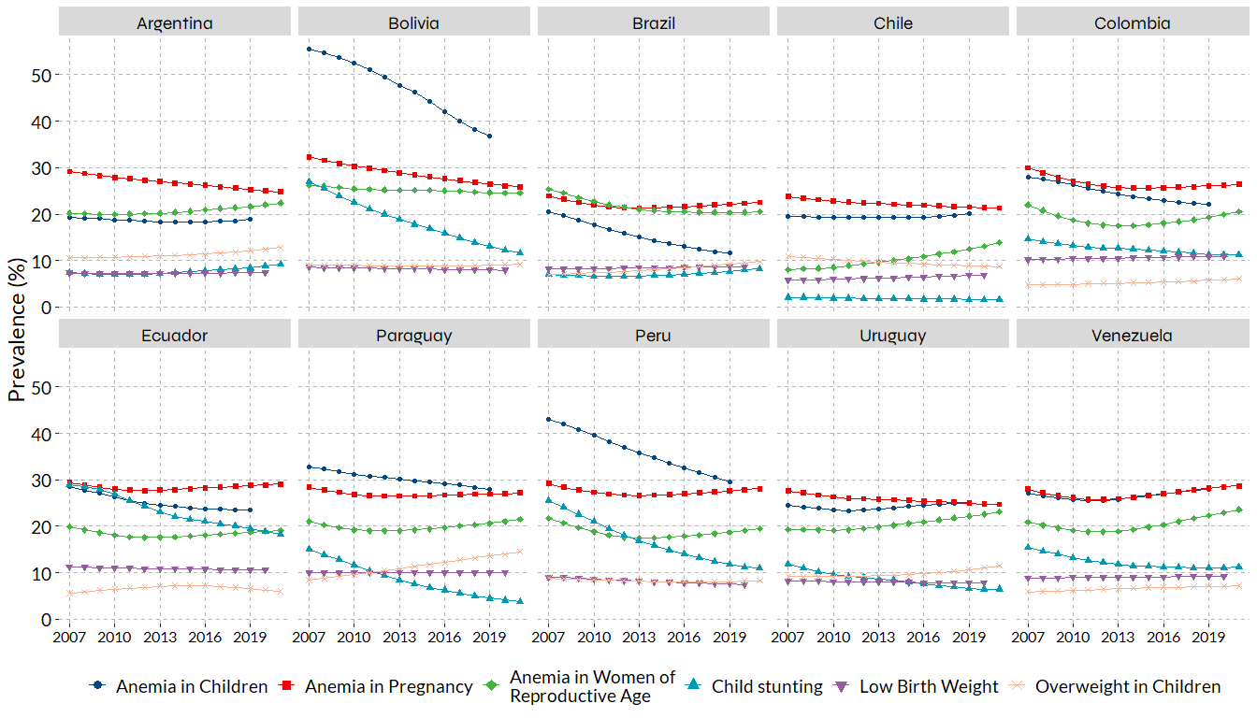

Figure 2. Linear and non-linear associations
# Z-Score Anemia in Children
f1 <- plot_zscore_vs_hdi(data, yvar = z_anemia_child)
# Z-Score Anemia in Pregnancy
f2 <- plot_zscore_vs_hdi(data, yvar = z_anemia_gest)
# Z-Score Anemia in Women of Reproductive Age
f3 <- plot_zscore_vs_hdi(data, yvar = z_anemia_fertil)
# Z-Score Low Birth Weight
f4 <- plot_zscore_vs_hdi(data, yvar = z_bpn)
# Z-Score Child Stunting
f5 <- plot_zscore_vs_hdi(data, yvar = z_tallaedad, xlab = "Z-Score of Human Development Index")
# Z-Score Overweight in Children
f6 <- plot_zscore_vs_hdi(data, yvar = z_sobrepeso)
# Merge plots
figure_2 <- ggarrange(
f1, f2, f3, f4, f5, f6,
ncol = 3, nrow = 2,
common.legend = TRUE,
legend = "bottom",
align = "hv",
labels = c("A", "B", "C", "D", "E", "F"),
font.label = list(size = 18, face = "bold", family = "Lato")
)
# Common label Y
figure_2 <- annotate_figure(
figure_2,
left = text_grob("Z-Score", rot = 90, size = 18, family = "Lato", hjust = 0.5)
)
# View
figure_2
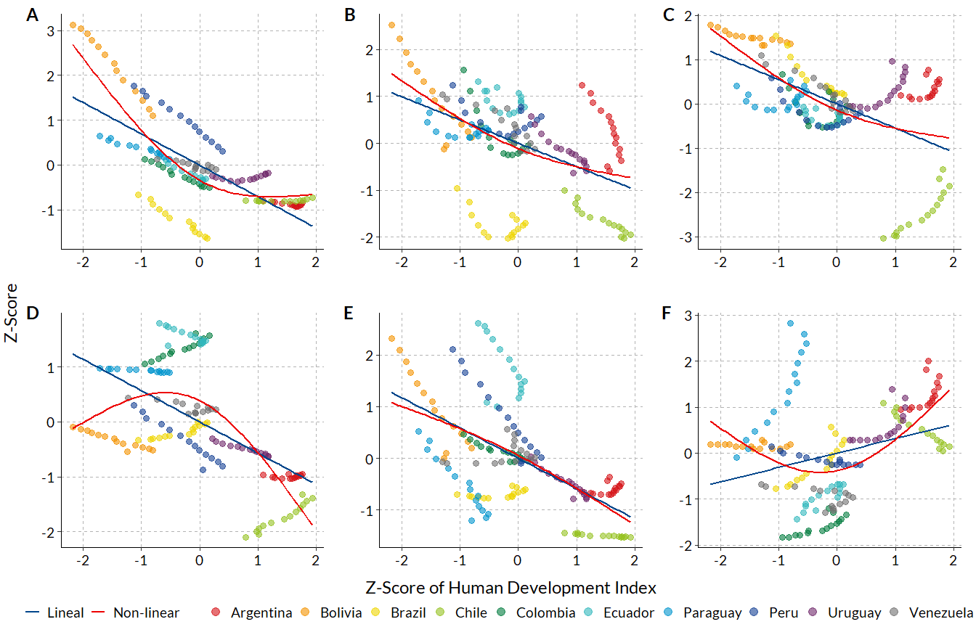

Table 1. Changes in maternal and child nutrition indicators
# Tibble data frame
table_1 <- data |>
dplyr::select(
pais, fechas,
anemia659, anemiafertil, anemiagest,
bajopesoalnacer, sobrepesoinfantil, retrasocrectallaedad
) |>
mutate(fechas = as.Date(fechas)) |>
pivot_longer(
cols = -c(pais, fechas),
names_to = "variable",
values_to = "prevalencia"
) |>
drop_na(prevalencia) |>
arrange(pais, variable, fechas) |>
group_by(pais, variable) |>
summarise(
inicial = first(prevalencia),
final = last(prevalencia),
diferencia = inicial - final,
.groups = "drop"
) |>
pivot_wider(
names_from = variable,
values_from = c(inicial, final, diferencia)
) |>
mutate(across(where(is.numeric), round, 1)) |>
dplyr::select(
pais,
inicial_anemia659, final_anemia659, diferencia_anemia659,
inicial_anemiagest, final_anemiagest, diferencia_anemiagest,
inicial_anemiafertil, final_anemiafertil, diferencia_anemiafertil,
inicial_bajopesoalnacer, final_bajopesoalnacer, diferencia_bajopesoalnacer,
inicial_retrasocrectallaedad, final_retrasocrectallaedad, diferencia_retrasocrectallaedad,
inicial_sobrepesoinfantil, final_sobrepesoinfantil, diferencia_sobrepesoinfantil
)
# Crear flextable a partir de tu tabla
table_1_flextable <- flextable(table_1)
# Añadir spanners (encabezados agrupados de 3 columnas)
table_1_flextable <- set_header_labels(
table_1_flextable,
inicial_anemia659 = "Inicial",
final_anemia659 = "Final",
diferencia_anemia659 = "Δ",
inicial_anemiagest = "Inicial",
final_anemiagest = "Final",
diferencia_anemiagest = "Δ",
inicial_anemiafertil = "Inicial",
final_anemiafertil = "Final",
diferencia_anemiafertil = "Δ",
inicial_bajopesoalnacer = "Inicial",
final_bajopesoalnacer = "Final",
diferencia_bajopesoalnacer = "Δ",
inicial_retrasocrectallaedad = "Inicial",
final_retrasocrectallaedad = "Final",
diferencia_retrasocrectallaedad = "Δ",
inicial_sobrepesoinfantil = "Inicial",
final_sobrepesoinfantil = "Final",
diferencia_sobrepesoinfantil = "Δ"
)
# Definir los spanners
table_1_flextable <- add_header_row(
table_1_flextable,
values = c(
"Pais",
"Anemia in Children",
"Anemia in Pregnancy",
"Anemia in Women of Reproductive Age",
"Low Birth Weight",
"Child Stunting",
"Overweight in Children"
),
colwidths = c(
1, # pais
3, # inicial/final/diferencia anemia659
3, # anemiagest
3, # anemiafertil
3, # bajo peso al nacer
3, # retraso talla/edad
3 # sobrepeso infantil
)
)
# Ajustar estilo
table_1_flextable <- autofit(table_1_flextable) |>
flextable::fontsize(part = "all", size = 10)
# View
table_1_flextable
Pais | Anemia in Children |  |  | Anemia in Pregnancy |  |  | Anemia in Women of Reproductive Age |  |  | Low Birth Weight |  |  | Child Stunting |  |  | Overweight in Children
pais | Inicial | Final | Δ | Inicial | Final | Δ | Inicial | Final | Δ | Inicial | Final | Δ | Inicial | Final | Δ | Inicial | Final | Δ
Argentina | 19.4 | 19.0 | 0.4 | 29.2 | 24.8 | 4.4 | 20.2 | 22.4 | -2.2 | 7.3 | 7.4 | 0.0 | 7.4 | 9.3 | -1.9 | 10.6 | 12.8 | -2.2
Bolivia | 55.6 | 36.9 | 18.7 | 32.3 | 25.9 | 6.4 | 26.2 | 24.5 | 1.7 | 8.6 | 7.9 | 0.6 | 27.0 | 11.7 | 15.3 | 9.0 | 9.2 | -0.2
Brazil | 20.6 | 11.6 | 9.0 | 23.9 | 22.5 | 1.4 | 25.3 | 20.5 | 4.8 | 8.2 | 8.7 | -0.5 | 7.0 | 8.2 | -1.2 | 7.0 | 9.8 | -2.8
Chile | 19.5 | 20.1 | -0.6 | 23.8 | 21.3 | 2.5 | 8.0 | 13.9 | -5.9 | 5.8 | 6.8 | -1.1 | 2.1 | 1.6 | 0.5 | 10.9 | 8.7 | 2.2
Colombia | 28.0 | 22.2 | 5.8 | 30.0 | 26.4 | 3.6 | 22.0 | 20.5 | 1.5 | 10.2 | 11.0 | -0.8 | 14.7 | 11.2 | 3.5 | 4.8 | 6.1 | -1.3
Ecuador | 28.5 | 23.5 | 5.0 | 29.4 | 29.1 | 0.3 | 19.9 | 19.1 | 0.8 | 11.2 | 10.6 | 0.6 | 28.9 | 18.3 | 10.6 | 5.6 | 6.0 | -0.4
Paraguay | 32.7 | 27.9 | 4.8 | 28.4 | 27.2 | 1.2 | 21.0 | 21.5 | -0.5 | 10.1 | 10.0 | 0.1 | 15.1 | 3.7 | 11.4 | 8.4 | 14.5 | -6.1
Peru | 43.0 | 29.6 | 13.4 | 29.2 | 28.1 | 1.1 | 21.7 | 19.5 | 2.2 | 9.1 | 7.5 | 1.6 | 25.6 | 11.0 | 14.6 | 8.9 | 8.3 | 0.6
Uruguay | 24.5 | 25.1 | -0.6 | 27.6 | 24.7 | 2.9 | 19.3 | 23.1 | -3.8 | 8.3 | 7.8 | 0.5 | 11.9 | 6.5 | 5.4 | 9.2 | 11.5 | -2.3
Venezuela | 27.1 | 27.9 | -0.8 | 28.0 | 28.7 | -0.7 | 20.9 | 23.6 | -2.7 | 8.9 | 9.3 | -0.4 | 15.4 | 11.2 | 4.2 | 5.9 | 7.2 | -1.3

Table 2. Linear association between HDI and maternal and child nutrition indicators
# Simple Linear Regression (SLR)
model_anemia_child <- lm(z_anemia_child ~ z_hdi, data = data) |>
tbl_regression(
conf.int = TRUE,
conf.level = 0.95,
tidy_fun = broom.helpers::tidy_parameters,
pvalue_fun = label_style_pvalue(digits = 1),
estimate_fun = ~ style_number(.x, digits = 2),
label = list(z_hdi = "Anemia in Children")) |>
remove_abbreviation() |>
modify_abbreviation("95% CI; 95% Confidence Interval")
model_anemia_gest <- lm(z_anemia_gest ~ z_hdi, data = data) |>
tbl_regression(
conf.int = TRUE,
conf.level = 0.95,
tidy_fun = broom.helpers::tidy_parameters,
pvalue_fun = label_style_pvalue(digits = 1),
estimate_fun = ~ style_number(.x, digits = 2),
label = list(z_hdi = "Anemia in Pregnancy")) |>
remove_abbreviation() |>
modify_abbreviation("95% CI; 95% Confidence Interval")
model_anemia_fertil <- lm(z_anemia_fertil ~ z_hdi, data = data) |>
tbl_regression(
conf.int = TRUE,
conf.level = 0.95,
tidy_fun = broom.helpers::tidy_parameters,
pvalue_fun = label_style_pvalue(digits = 1),
estimate_fun = ~ style_number(.x, digits = 2),
label = list(z_hdi = "Anemia in Women of Reproductive Age")) |>
remove_abbreviation() |>
modify_abbreviation("95% CI; 95% Confidence Interval")
model_bpn <- lm(z_bpn ~ z_hdi, data = data) |>
tbl_regression(
conf.int = TRUE,
conf.level = 0.95,
tidy_fun = broom.helpers::tidy_parameters,
pvalue_fun = label_style_pvalue(digits = 1),
estimate_fun = ~ style_number(.x, digits = 2),
label = list(z_hdi = "Low Birth Weight")) |>
remove_abbreviation() |>
modify_abbreviation("95% CI; 95% Confidence Interval")
model_tallaedad <- lm(z_tallaedad ~ z_hdi, data = data) |>
tbl_regression(
conf.int = TRUE,
conf.level = 0.95,
tidy_fun = broom.helpers::tidy_parameters,
pvalue_fun = label_style_pvalue(digits = 1),
estimate_fun = ~ style_number(.x, digits = 2),
label = list(z_hdi = "Child Stunting")) |>
remove_abbreviation() |>
modify_abbreviation("95% CI; 95% Confidence Interval")
model_sobrepeso <- lm(z_sobrepeso ~ z_hdi, data = data) |>
tbl_regression(
conf.int = TRUE,
conf.level = 0.95,
tidy_fun = broom.helpers::tidy_parameters,
pvalue_fun = label_style_pvalue(digits = 1),
estimate_fun = ~ style_number(.x, digits = 2),
label = list(z_hdi = "Overweight in Children")) |>
remove_abbreviation() |>
modify_abbreviation("95% CI; 95% Confidence Interval")
# Merge
table_2 <- tbl_stack(
list(
model_anemia_child, model_anemia_gest, model_anemia_fertil, model_bpn,
model_tallaedad, model_sobrepeso)) |>
modify_header(label = "**Prevalence (Z-Score)**")
# Convert gtsummary object to a flextable object
table_2_flextable <- table_2 |>
gtsummary::as_flex_table() |>
flextable::fontsize(part = "all", size = 10) |>
flextable::autofit()
# View
table_2
Prevalence (Z-Score) | Beta | 95% CI | p-value
Anemia in Children | -0.70 | -0.83, -0.57 | <0.001
Anemia in Pregnancy | -0.50 | -0.64, -0.35 | <0.001
Anemia in Women of Reproductive Age | -0.55 | -0.68, -0.41 | <0.001
Low Birth Weight | -0.57 | -0.71, -0.43 | <0.001
Child Stunting | -0.59 | -0.72, -0.45 | <0.001
Overweight in Children | 0.31 | 0.16, 0.47 | <0.001
Abbreviation: 95% CI; 95% Confidence Interval

Table 3. Non-linear models with ns between HDI and maternal and child nutrition indicators
En regresiones con errores estándar robustos agrupados por país, existen tres métodos comunes en R con ventajas diferenciadas según el número de clústeres. vcovCL() del paquete sandwich replica el comportamiento de vce(cluster var) de Stata y es eficiente cuando hay muchos clústeres (≥ 50), ya que asume que su número tiende a infinito. Sin embargo, no ajusta los grados de libertad, lo que puede subestimar la varianza y producir valores p sesgados en estudios con pocos clústeres. Para esos casos, vcovCR(type = "CR2") del paquete clubSandwich aplica una corrección tipo Satterthwaite que ajusta los grados de libertad para cada coeficiente, mejorando la precisión de los valores t y p. Esta corrección es especialmente útil en estudios multinivel o ecológicos con pocos países o clústeres (< 50), donde los métodos clásicos tienden a sobreestimar la precisión de los efectos. Por su parte, feols() del paquete fixest ofrece una solución rápida y flexible que permite especificar directamente el agrupamiento con cluster = ~pais, siendo compatible con múltiples clústeres y efectos fijos. Internamente utiliza estimadores tipo vcovCL(), pero puede integrarse con vcovCR() para obtener inferencias más confiables en contextos con baja granularidad.
# Modelo con splines naturales
ns_anemia_child <- lm(z_anemia_child ~ splines::ns(z_hdi, df = 2), data = data)
ns_anemia_gest <- lm(z_anemia_gest ~ splines::ns(z_hdi, df = 2), data = data)
ns_anemia_fertil <- lm(z_anemia_fertil ~ splines::ns(z_hdi, df = 2), data = data)
ns_bpn <- lm(z_bpn ~ splines::ns(z_hdi, df = 2), data = data)
ns_tallaedad <- lm(z_tallaedad ~ splines::ns(z_hdi, df = 2), data = data)
ns_sobrepeso <- lm(z_sobrepeso ~ splines::ns(z_hdi, df = 2), data = data)
# Errores estándar agrupados por país (cluster)
vcov_cluster_ns_anemia_child <- vcovCL(ns_anemia_child, cluster = ~pais)
# vcov_cluster_ns_anemia_child <- vcovCR(ns_anemia_child, cluster = datos$pais, type = "CR2")
vcov_cluster_ns_anemia_gest <- vcovCL(ns_anemia_gest, cluster = ~pais)
vcov_cluster_ns_anemia_fertil <- vcovCL(ns_anemia_fertil, cluster = ~pais)
vcov_cluster_ns_bpn <- vcovCL(ns_bpn, cluster = ~pais)
vcov_cluster_ns_tallaedad <- vcovCL(ns_tallaedad, cluster = ~pais)
vcov_cluster_ns_sobrepeso <- vcovCL(ns_sobrepeso, cluster = ~pais)
# Test con errores robustos agrupados
# lmtest::coeftest(ns_anemia_child, vcov = vcov_cluster_ns_anemia_child)
# coef_test(ns_anemia_child, vcov = vcov_cluster_ns_anemia_child, test = "Satterthwaite")
# modelo <- fixest::feols(z_anemia_child ~ ns(z_hdi, df = 2), data = data, cluster = ~pais)
# summary(modelo)
model_ns_anemia_child <- ns_anemia_child |>
tbl_regression(
vcov = vcov_cluster_ns_anemia_child,
conf.int = TRUE,
conf.level = 0.95,
tidy_fun = broom.helpers::tidy_parameters,
estimate_fun = ~ style_number(.x, digits = 2),
pvalue_fun = ~ style_pvalue(.x, digits = 2),
label = list(
`ns(z_hdi, df = 2)1` = "Spline HDI 1",
`ns(z_hdi, df = 2)2` = "Spline HDI 2")
) |>
remove_abbreviation() |>
modify_abbreviation("95% CI; 95% Confidence Interval")
model_ns_anemia_gest <- ns_anemia_gest |>
tbl_regression(
vcov = vcov_cluster_ns_anemia_gest,
conf.int = TRUE,
conf.level = 0.95,
tidy_fun = broom.helpers::tidy_parameters,
estimate_fun = ~ style_number(.x, digits = 2),
pvalue_fun = ~ style_pvalue(.x, digits = 2),
label = list(
`ns(z_hdi, df = 2)1` = "Spline HDI 1",
`ns(z_hdi, df = 2)2` = "Spline HDI 2")
) |>
remove_abbreviation() |>
modify_abbreviation("95% CI; 95% Confidence Interval")
model_ns_anemia_fertil <- ns_anemia_fertil |>
tbl_regression(
vcov = vcov_cluster_ns_anemia_fertil,
conf.int = TRUE,
conf.level = 0.95,
tidy_fun = broom.helpers::tidy_parameters,
estimate_fun = ~ style_number(.x, digits = 2),
pvalue_fun = ~ style_pvalue(.x, digits = 2),
label = list(
`ns(z_hdi, df = 2)1` = "Spline HDI 1",
`ns(z_hdi, df = 2)2` = "Spline HDI 2")
) |>
remove_abbreviation() |>
modify_abbreviation("95% CI; 95% Confidence Interval")
model_ns_bpn <- ns_bpn |>
tbl_regression(
vcov = vcov_cluster_ns_bpn,
conf.int = TRUE,
conf.level = 0.95,
tidy_fun = broom.helpers::tidy_parameters,
estimate_fun = ~ style_number(.x, digits = 2),
pvalue_fun = ~ style_pvalue(.x, digits = 2),
label = list(
`ns(z_hdi, df = 2)1` = "Spline HDI 1",
`ns(z_hdi, df = 2)2` = "Spline HDI 2")
) |>
remove_abbreviation() |>
modify_abbreviation("95% CI; 95% Confidence Interval")
model_ns_tallaedad <- ns_tallaedad |>
tbl_regression(
vcov = vcov_cluster_ns_tallaedad,
conf.int = TRUE,
conf.level = 0.95,
tidy_fun = broom.helpers::tidy_parameters,
estimate_fun = ~ style_number(.x, digits = 2),
pvalue_fun = ~ style_pvalue(.x, digits = 2),
label = list(
`ns(z_hdi, df = 2)1` = "Spline HDI 1",
`ns(z_hdi, df = 2)2` = "Spline HDI 2")
) |>
remove_abbreviation() |>
modify_abbreviation("95% CI; 95% Confidence Interval")
model_ns_sobrepeso <- ns_sobrepeso |>
tbl_regression(
vcov = vcov_cluster_ns_sobrepeso,
conf.int = TRUE,
conf.level = 0.95,
tidy_fun = broom.helpers::tidy_parameters,
estimate_fun = ~ style_number(.x, digits = 2),
pvalue_fun = ~ style_pvalue(.x, digits = 2),
label = list(
`ns(z_hdi, df = 2)1` = "Spline HDI 1",
`ns(z_hdi, df = 2)2` = "Spline HDI 2")
) |>
remove_abbreviation() |>
modify_abbreviation("95% CI; 95% Confidence Interval")
# Merge
table_3 <- tbl_merge(
tbls = list(
model_ns_anemia_child,
model_ns_anemia_gest,
model_ns_anemia_fertil,
model_ns_bpn,
model_ns_tallaedad,
model_ns_sobrepeso
),
tab_spanner = c(
"**Anemia in Children**",
"**Anemia in Pregnancy**",
"**Anemia in Women of Reproductive Age**",
"**Low Birth Weight**",
"**Child Stunting**",
"**Overweight in Children**"
)
) |>
modify_caption("**Prevalence (Z-Score) Models with Natural Splines**") |>
modify_abbreviation("95% CI; 95% Confidence Interval")
# Convert gtsummary object to a flextable object
table_3_flextable <- table_3 |>
gtsummary::as_flex_table() |>
flextable::fontsize(part = "all", size = 10) |>
flextable::autofit()
# View
table_3
 | Anemia in Children |  |  | Anemia in Pregnancy |  |  | Anemia in Women of Reproductive Age |  |  | Low Birth Weight |  |  | Child Stunting |  |  | Overweight in Children
Characteristic | Beta | 95% CI | p-value | Beta | 95% CI | p-value | Beta | 95% CI | p-value | Beta | 95% CI | p-value | Beta | 95% CI | p-value | Beta | 95% CI | p-value
splines::ns(z_hdi, df = 2)
splines::ns(z_hdi, df = 2)1 | -5.83 | -8.74, -2.93 | <0.001 | -3.25 | -5.36, -1.14 | 0.003 | -3.73 | -5.87, -1.59 | <0.001 | 0.11 | -2.33, 2.55 | 0.93 | -2.42 | -5.02, 0.18 | 0.068 | -1.39 | -2.85, 0.08 | 0.064
splines::ns(z_hdi, df = 2)2 | -1.71 | -2.60, -0.83 | <0.001 | -1.41 | -3.28, 0.45 | 0.14 | -1.53 | -3.94, 0.87 | 0.21 | -2.34 | -3.31, -1.36 | <0.001 | -1.92 | -3.18, -0.67 | 0.003 | 1.51 | 0.17, 2.84 | 0.028
Abbreviation: 95% CI; 95% Confidence Interval

Save outputs

Figures
ggsave(
plot = figure_1,
filename = here("outputs", "figura_1.jpg"),
width = 14,
height = 8,
units = "in",
dpi = 300)
ggsave(
plot = figure_1,
filename = here("outputs", "figura_1.tiff"),
width = 14,
height = 8,
units = "in",
dpi = 300)
ggsave(
plot = figure_2,
filename = here("outputs", "figura_2.jpg"),
width = 14,
height = 9,
units = "in",
dpi = 300)
ggsave(
plot = figure_2,
filename = here("outputs", "figura_2.tiff"),
width = 14,
height = 9,
units = "in",
dpi = 300)

Tables
save_as_docx(
"Table 1" = table_1_flextable,
"Table 2" = table_2_flextable,
"Table 3" = table_3_flextable,
path = here("outputs", "Tables.docx")
)

