The GIG_GNIG Workspace

You will need to install and load the Mpfr package to run the functions in this Workspace
I this workspace there is a function GIG_help, which may be used to obtain help on the user functions, which are GIGpdf, GIGcdf, GIGquant, plotGIGpdf, plotGIGpdf
GNIGpdf, GNIGcdf, GNIGquant, plotGNIGpdf, plotGNIGcdf
> GIG_help(GIGpdf)
******************************************************************************
* ===> GIGpdf(r,l,z,prec,precp) <=== *
* Computes values of the GIG pdf *
* arguments are (first 5 are mandatory): *
* r - list of integer shape parameters for the GNIG distribution *
* l - list of rate parameters for the GNIG distribution *
* z - value where the pdf is to be computed *
* prec - optional argument that indicates the number of precision digits *
* for computations (default value: 50) *
* precp - optional argument that indicates the number of digits for *
* printing the result (default value: 20) *
******************************************************************************
> GIGpdf(c(7,4,6),c(3.4,1.2,5.6),4.6)
0.16898659825321382267
> GIGpdf(c(7,4,6),c(3.4,1.2,5.6),4.6,,30) 0.168986598253213822668320246907
> GIGpdf(c(7,4,6),c(3.4,1.2,5.6),4.6,,55)
0.1689865982532138226683202469067962498636429438084936650
> # If the required printing number of digits exceeds the number of precision digits
> # for computations, the last digits that exceed this value are in general not correct
> GIGpdf(c(7,4,6),c(3.4,1.2,5.6),4.6,60,55)
0.1689865982532138226683202469067962498636429438084813297
> # All user functions, while they give a printed value, they also compute
> # a value which may be stored;
> # this value is a multiple precision value, with 'prec' precision digits
> value<-GIGpdf(c(7,4,6),c(3.4,1.2,5.6),4.6)
0.1689865982532138227 > value
An object of class "mpfr"
[[1]]
'mpfr1' 0.168986598253213822668320246906796249863642943808494
> GIG_help(GIGcdf)
******************************************************************************
* ===> GIGcdf(r,l,z,prec,precp) <=== *
* Computes values of the GIG cdf *
* arguments are (first 5 are mandatory): *
* r - list of integer shape parameters for the GNIG distribution *
* l - list of rate parameters for the GNIG distribution *
* z - value where the pdf is to be computed *
* prec - optional argument that indicates the number of precision digits *
* for computations (default value: 50) *
* precp - optional argument that indicates the number of digits for *
* printing the result (default value: 20) *
******************************************************************************

> GIGcdf(c(7,4,6),c(3.4,1.2,5.6),14.6)
0.99913058737075271510
> GIGcdf(c(7,4,6),c(3.4,1.2,5.6),25.6) 0.99999998750072964845
> GIGcdf(c(7,4,6),c(3.4,1.2,5.6),55.6)
1.0000000000000000000
> GIGcdf(c(7,4,6),c(3.4,1.2,5.6),55.6,,50)
0.99999999999999999999996185377757127161136115034726

> GIG_help(plotGIGpdf)
******************************************************************************
* ===> plotGIGpdf(r,l,ll,ul,step,prec=50) *
* Plots GIG pdfs *
* Its has 6 arguments (the first 5 are mandatory): *
* r - list of shape parameters for the GIG distribution *
* l - list of rate parameters for the GIG distribution *
* ll - lower limit for plot range (usually 0) *
* ul - upper limit for plot range *
* step - step for plotting points between ll and ul *
* prec - (optional argument) number of precision digits for computations *
* (default value: 50) *
******************************************************************************
> plotGIGpdf(c(7,4,6),c(3.4,1.2,5.6),0,15,.1)
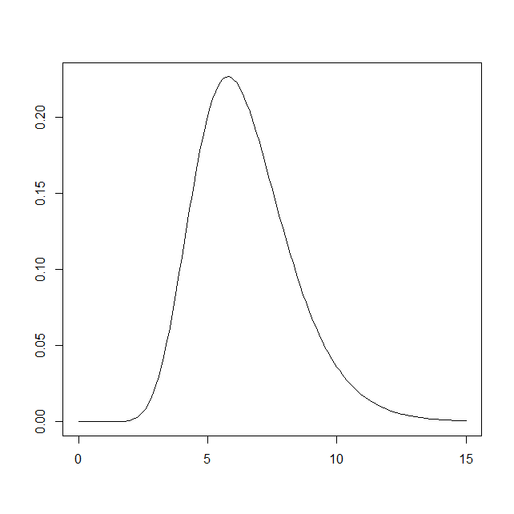

> GIG_help(plotGIGcdf)
******************************************************************************
* ===> plotGIGcdf(r,l,ll,ul,step,prec=50) *
* Plots GIG cdfs *
* Its has 6 arguments (the first 5 are mandatory): *
* r - list of shape parameters for the GIG distribution *
* l - list of rate parameters for the GIG distribution *
* ll - lower limit for plot range (usually 0) *
* ul - upper limit for plot range *
* step - step for plotting points between ll and ul *
* prec - (otpional argument) number of precision digits for computations *
* (default value: 50) *
******************************************************************************
> plotGIGcdf(c(7,4,6),c(3.4,1.2,5.6),0,15,.1)
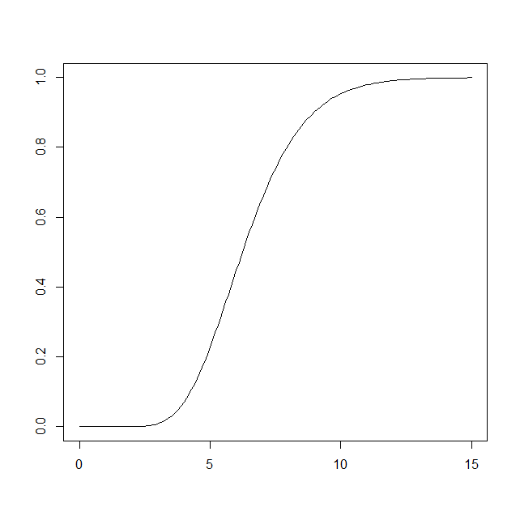

> GIG_help(GIGquant)
***************************************************************************
* ===> GIGquant(r,l,quant,xo,eps=10^-10,prec=50,precp=10) *
* Computes quantiles for the GIG distribution *
* It has 7 arguments (the first 4 are mandatory) *
* r - list of integer shape parameters *
* l - list of corresponding rate parameters *
* quant - quantile to be computed (value between 0 and 1) *
* xo - initial value for the quantile *
* eps - (optional argument) maximum error for the quantile *
* (default value: 10^-10) *
* prec - (optional argument) number of precision digits for computations *
* (default value: 50) *
* precp - (optional argument) number of digits for printing the result *
* (default value: maximum of -log10(eps) and the given value) *
***************************************************************************

> GIGquant(c(7,4,6),c(3.4,1.2,5.6),.05,2)
3.793759456
> q05<-GIGquant(c(7,4,6),c(3.4,1.2,5.6),.05,2)
3.793759456
> q05
An object of class "mpfr"
[[1]]
'mpfr1' 3.79375945550137866276315089080542162561292272932861
> GIGcdf(c(7,4,6),c(3.4,1.2,5.6),q05)
0.050000000000000000000
> GIGcdf(c(7,4,6),c(3.4,1.2,5.6),q05,,50)
0.050000000000000000000016840502747908085373640147559
> q05<-GIGquant(c(7,4,6),c(3.4,1.2,5.6),.05,2,10^-25)
3.79375945550137866276296 > q05
An object of class "mpfr"
[[1]]
'mpfr1' 3.79375945550137866276295641301684711310738303722864
> GIGcdf(c(7,4,6),c(3.4,1.2,5.6),q05,,50)
0.04999999999999999999999999999999999999999999999992 > q05<-GIGquant(c(7,4,6),c(3.4,1.2,5.6),.05,3,10^-25)
3.793759455501378662762956
> q05
An object of class "mpfr"
[[1]]
'mpfr1' 3.79375945550137866276295641301684711310738303722864
> q05<-GIGquant(c(7,4,6),c(3.4,1.2,5.6),.05,3,10^-25,100)
3.793759455501378662762956
> q05
An object of class "mpfr"
[[1]]
'mpfr1'
3.79375945550137866276295641301684711310738303722515973098152040841420473758940723608841607506241489
> GIGcdf(c(7,4,6),c(3.4,1.2,5.6),q05,,50)
0.050000000000000000000000000000000000000000000000344
> GIGcdf(c(7,4,6),c(3.4,1.2,5.6),q05,100,50)
0.050000000000000000000000000000000000000000000000000
> GIGcdf(c(7,4,6),c(3.4,1.2,5.6),q05,100,90)
0.0500000000000000000000000000000000000000000000000000000000000000000000000000000000000000242
> # Several parameters may slightly affect the precision of the quantiles
> # of course the value of eps does, but also the initial value given and the
> # required computing precision, although these last two will in general
> # have a very slight effect, but also we have to consider the precision used
> # to compute the cdf

> GIG_help(GNIGpdf)
*********************************************************************************
* ===> GNIGpdf(r,ro,l,lo,z,prec,precp) <=== *
* Computes values of the GNIG pdf *
* arguments are (first 5 are mandatory): *
* r - list of integer shape parameters for the GNIG distribution *
* ro - non-integer shape parameter *
* l - list of rate parameters corresponding to the integer shape parameters *
* lo - rate parameter corresponding to the non-integer shape parameter *
* z - value where the pdf is to be computed *
* prec - optional argument that indicates the number of precision digits *
* for compuations (default value: 50) *
* precp - optional argument that indicates the number of digits for *
* printing the result (default value: 20) *
*********************************************************************************

> GNIGpdf(c(7,4,6),5.6,c(3.4,1.2,5.6),4.8,4.6)
0.060513926134947235470
> GNIGpdf(c(7,4,6),5.6,c(3.4,1.2,5.6),4.8,4.6,,30)
0.0605139261349472354700402981119
> GNIGpdf(c(7,4,6),5.6,c(3.4,1.2,5.6),4.8,4.6,60,55)
0.06051392613494723547004029811187270191036986315462832261
> GNIGpdf(c(7,4,6),5.6,c(3.4,1.2,5.6),4.8,4.6,,50)
0.060513926134947235470040298111872701910291495463928
> # Computations for the GNIG distribution are quite heavy and quite tough
> # and as such, some of the last digits in the computation, for a given
> # value of precision digits for computations, may be not precise enough;
> # anyway, giving a large value for prec, will get a more precise value

> GIG_help(GNIGcdf)
*********************************************************************************
* ===> GNIGcdf(r,ro,l,lo,z,prec,precp) <=== *
* Computes values of the GNIG cdf *
* arguments are (first 5 are mandatory): *
* r - list of integer shape parameters for the GNIG distribution *
* ro - non-integer shape parameter *
* l - list of rate parameters corresponding to the integer shape parameters *
* lo - rate parameter corresponding to the non-integer shape parameter *
* z - value where the pdf is to be computed *
* prec - optional argument that indicates the number of precision digits *
* for compuations (default value: 50) *
* precp - optional argument that indicates the number of digits for *
* printing the result (default value: 20) *
*********************************************************************************
> GNIGcdf(c(7,4,6),5.6,c(3.4,1.2,5.6),4.8,4.6)
0.033737765820166216771
> GNIGcdf(c(7,4,6),5.6,c(3.4,1.2,5.6),4.8,4.6,,30) 0.0337377658201662167710882990179
> GNIGcdf(c(7,4,6),5.6,c(3.4,1.2,5.6),4.8,4.6,,50)
0.033737765820166216771088299017891187918886021421138

> GNIGcdf(c(7,4,6),5.6,c(3.4,1.2,5.6),4.8,4.6,60,55)
0.03373776582016621677108829901789119221000817933581527981
> GIG_help(plotGNIGpdf)
******************************************************************************
* ===> plotGNIGpdf(r,ro,l,lo,ll,ul,step,prec=50) <=== *
* Plots GNIG pdfs *
* arguments are (first 5 are mandatory): *
* r - list of integer shape parameters for the GNIG distribution *
* ro - non-integer shape parameter *
* l - list of rate parameters for the GIG distribution *
* lo - rate parameter corresponding to the non-integer shape parameter *
* ll - lower limit for plot range (usually 0) *
* ul - upper limit for plot range *
* step - step for plotting points between ll and ul *
* prec - (optional argument) number of precision digits for computations * ******************************************************************************

> # As computations for the GNIG distribution are quite tough, plotting the pdf
> # and mainly pltting the cdf, may take a while, even on faster computers

> plotGNIGpdf(c(7,4,6),5.6,c(3.4,1.2,5.6),4.8,0,15,.2)

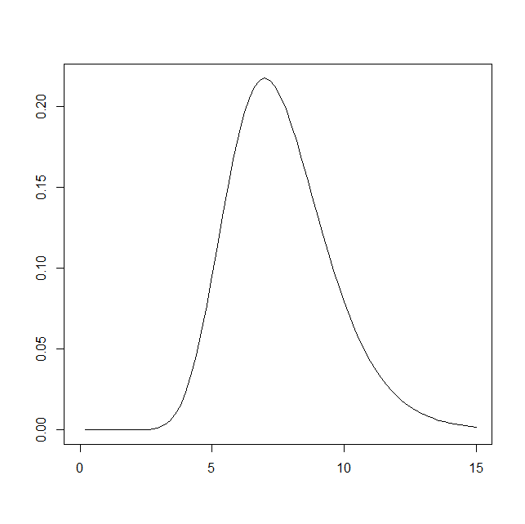

> GIG_help(plotGNIGcdf)
******************************************************************************
* ===> plotGNIGcdf(r,ro,l,lo,ll,ul,step,prec=50) <=== *
* Plots GNIG cdfs *
* arguments are (first 5 are mandatory): *
* r - list of integer shape parameters for the GNIG distribution *
* ro - non-integer shape parameter *
* l - list of rate parameters for the GIG distribution *
* lo - rate parameter corresponding to the non-integer shape parameter *
* ll - lower limit for plot range (usually 0) *
* ul - upper limit for plot range *
* step - step for plotting points between ll and ul *
* prec - (optional argument) number of precision digits for computations * ******************************************************************************
> plotGNIGcdf(c(7,4,6),5.6,c(3.4,1.2,5.6),4.8,0,15,.2)
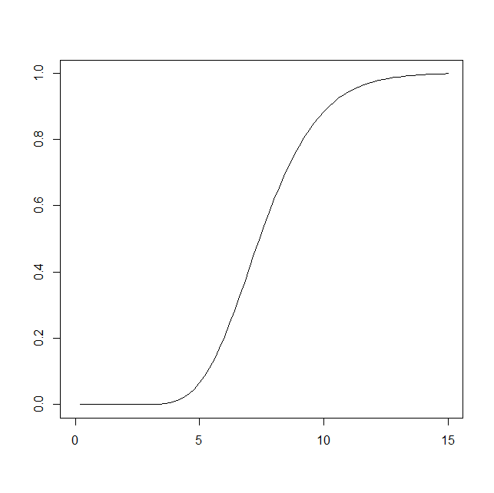
> GIG_help(GNIGquant)
*******************************************************************************
* ===> GNIGquant(r1,r2,l1,l2,quant,xo,eps=10^-10,prec=50,precp=10) *
* Computes quantiles for the GNIG distribution *
* It has 9 arguments (the first 6 are mandatory) *
* r1 - list of integer shape parameters *
* r2 - non-integer shape parameter *
* l1 - list of rate parameters corresponding to the integer shape parameters *
* l2 - rate parameter corresponding to the non-integer shape parameter *
* quant - quantile to be computed (value between 0 and 1) *
* xo - initial value for the quantile *
* eps - (optional argument) maximum erro for the quantile *
* (default value: 10^-10) *
* prec - (optional argument) number of precision digits for computations *
* (default value: 50) *
* precp - (optional argument) number of digits for printing the result *
* (default value: maximum of -log10(eps) and the given value) *
*******************************************************************************
> GNIGquant(c(7,4,6),5.6,c(3.4,1.2,5.6),4.8,.05,2)
4.832361180
> q05<-GNIGquant(c(7,4,6),5.6,c(3.4,1.2,5.6),4.8,.05,2)
4.832361180
> q05
An object of class "mpfr"
[[1]]
'mpfr1' 4.83236118001985006837940527628052795884834063524859
> GNIGcdf(c(7,4,6),5.6,c(3.4,1.2,5.6),4.8,q05)
0.050000000000000000000
> GNIGcdf(c(7,4,6),5.6,c(3.4,1.2,5.6),4.8,q05,,30)
0.0500000000000000000000000568032
> q05<-GNIGquant(c(7,4,6),5.6,c(3.4,1.2,5.6),4.8,.05,5)
4.832361180 q05
An object of class "mpfr"
[[1]]
'mpfr1' 4.83236118001985006837940456466293726415995969748488
> GNIGcdf(c(7,4,6),5.6,c(3.4,1.2,5.6),4.8,q05,,30)
0.0500000000000000000000000000000
> GNIGcdf(c(7,4,6),5.6,c(3.4,1.2,5.6),4.8,q05,,50)
0.050000000000000000000000000000000000117170028409263
> # Note that the minimum precision required for the quantile that is being used in
> # only 10^-10
> q05<-GNIGquant(c(7,4,6),5.6,c(3.4,1.2,5.6),4.8,.05,5,10^-25)
4.832361180019850068379405
> GNIGcdf(c(7,4,6),5.6,c(3.4,1.2,5.6),4.8,q05,,50)
0.049999999999999999999999999999999999754004123152406
> GNIGcdf(c(7,4,6),5.6,c(3.4,1.2,5.6),4.8,q05,100,50)
0.050000000000000000000000000000000021921548168392285
> # Note also that to obtain a more precise quantile, in cases that eps
> # is very small, it may required to increase prec
> # and then also to increase prec when computing the cdf
> q05<-GNIGquant(c(7,4,6),5.6,c(3.4,1.2,5.6),4.8,.05,5,10^-25,100)
4.832361180019850068379405
> GNIGcdf(c(7,4,6),5.6,c(3.4,1.2,5.6),4.8,q05,,50)
0.049999999999999999999999999999999978270720154655498
> GNIGcdf(c(7,4,6),5.6,c(3.4,1.2,5.6),4.8,q05,100,50)
0.050000000000000000000000000000000000000000000000000
> GNIGcdf(c(7,4,6),5.6,c(3.4,1.2,5.6),4.8,q05,100,75)
0.0500000000000000000000000000000000000000000000000000000000000000000000035108

