DGIG Workspace
You will need the package Mpfr to run the functions in this Workspace
The function DGIG_help gives help on the user functions, which are:
DGIGpdf, DGIGcdf, DGIGquant
plotDGIGpdf, plotDGIGcdf
and it may also give help on itself.

> DGIG_help(DGIGpdf)
**********************************************************************************
* ===> DGIGpdf(r1,r2,l1,l2,z,prec,precp) <=== *
* Computes values for the PDF of the DGIG distribution *
* It has 7 arguments, the first 5 are mandatory: *
* r1 - list of shape parameters for the Gamma distributions with positive sign *
* r2 - list of shape parameters for the Gamma distributions with negative sign *
* l1 - list of rate parameters for the Gamma distributions with positive sign *
* l2 - list of rate parameters for the Gamma distributions with negative sign *
* z - running value at which the CDF is to be computed *
* prec - (optional argument) number of precision digits for the computations *
* (default value: 50) *
* precp - (optional argument) number of digits for printing the result *
* (default value: 20) *
********************************************************************************** > DGIGpdf(c(5,3,4),c(2,3),c(3.2,4.5,1.6),c(1.4,1.3),1.2)
0.19089711134150040569
> # One should be careful and know that for a given value of 'prec', not all 'prec'
> # digits in the result will be exact
> DGIGpdf(c(5,3,4),c(2,3),c(3.2,4.5,1.6),c(1.4,1.3),1.2,,50)
0.19089711134150040569284558610654807001361124302019
> DGIGpdf(c(5,3,4),c(2,3),c(3.2,4.5,1.6),c(1.4,1.3),1.2,70,50)
0.19089711134150040569284558610654807001361129292395
> # All user functions, besides giving a printed result, allow for saving the result in
> # a variable which will then have all 'prec' digits
> val<-DGIGpdf(c(5,3,4),c(2,3),c(3.2,4.5,1.6),c(1.4,1.3),1.2)
0.19089711134150040569
> val
1 'mpfr' number of precision 166 bits
[1] 0.190897111341500405692845586106548070013611243020194
> val<-DGIGpdf(c(5,3,4),c(2,3),c(3.2,4.5,1.6),c(1.4,1.3),1.2,70)
0.19089711134150040569
> val
1 'mpfr' number of precision 232 bits
[1] 0.19089711134150040569284558610654807001361129292394637869101812547108985

> DGIG_help(DGIGcdf)
**********************************************************************************
* ===> DGIGcdf(r1,r2,l1,l2,z,prec,precp) <=== *
* Computes values for the CDF of the DGIG distribution *
* It has 7 arguments, the first 5 are mandatory: *
* r1 - list of shape parameters for the Gamma distributions with positive sign *
* r2 - list of shape parameters for the Gamma distributions with negative sign *
* l1 - list of rate parameters for the Gamma distributions with positive sign *
* l2 - list of rate parameters for the Gamma distributions with negative sign *
* z - running value at which the CDF is to be computed *
* prec - (optional argument) number of precision digits for the computations *
* (default value: 50) *
* precp - (optional argument) number of digits for printing the result *
* (default value: 20) *
**********************************************************************************

> DGIGcdf(c(5,3,4),c(2,3),c(3.2,4.5,1.6),c(1.4,1.3),1.2)
0.52826935818589085876
> val<-DGIGcdf(c(5,3,4),c(2,3),c(3.2,4.5,1.6),c(1.4,1.3),1.2)
0.52826935818589085876
> val
1 'mpfr' number of precision 166 bits
[1] 0.528269358185890858759736842929349108110114814275989
> val<-DGIGcdf(c(5,3,4),c(2,3),c(3.2,4.5,1.6),c(1.4,1.3),1.2,70,30)
0.528269358185890858759736842929 > val
1 'mpfr' number of precision 232 bits
[1] 0.52826935818589085875973684292934910811011702394545941854056503024295477

> DGIG_help(plotDGIGpdf)
************************************************************************************
* ===> plotDGIGpdf(r1,r2,l1,l2,ll,ul,step,prec) <=== *
* Plots pdfs of the DGIG distribution *
* arguments are (first 5 are mandatory): *
* r1 - list of shape parameters for the 'positive' part of the DGIG distribution *
* r2 - list of shape parameters for the 'negative' part of the DGIG distribution *
* l1 - list of rate parameters for the 'positive' part of the DGIG distribution *
* l2 - list of rate parameters for the 'negative' part of the DGIG distribution *
* ll - lower limit for plot range *
* ul - upper limit for plot range *
* step - step for plotting points between ll and ul *
* prec - number of precision digits for computation of the pdf *
************************************************************************************
> plotDGIGpdf(c(4,2,3),c(2,1),c(3.6,2.5,4.2),c(1.4,5.3),-5,7,.2)
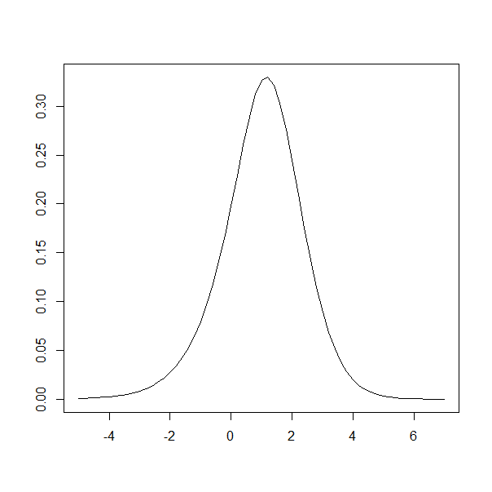

> DGIG_help(plotDGIGcdf)
************************************************************************************
* ===> plotDGIGcdf(r1,r2,l1,l2,ll,ul,step,prec) <=== *
* Plots cdfs of the DGIG distribution *
* arguments are (first 5 are mandatory): *
* r1 - list of shape parameters for the 'positive' part of the DGIG distribution *
* r2 - list of shape parameters for the 'negative' part of the DGIG distribution *
* l1 - list of rate parameters for the 'positive' part of the DGIG distribution *
* l2 - list of rate parameters for the 'negative' part of the DGIG distribution *
* ll - lower limit for plot range *
* ul - upper limit for plot range *
* step - step for plotting points between ll and ul *
* prec - number of precision digits for computation of the cdf *
************************************************************************************
> plotDGIGcdf(c(4,2,3),c(2,1),c(3.6,2.5,4.2),c(1.4,5.3),-5,7,.2)

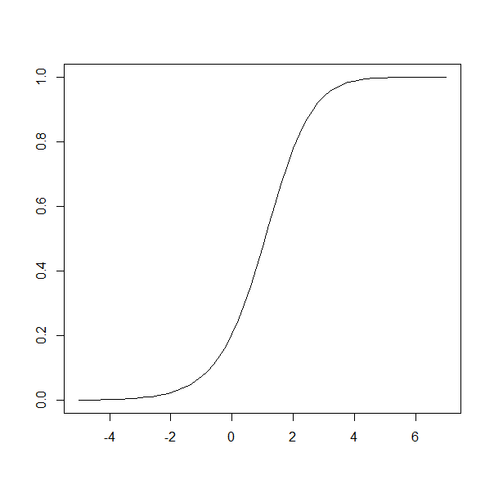

> DGIG_help(DGIGquant)
***************************************************************************
* ===> DGIGquant(r1,r2,l1,l2,quant,xo,eps,prec,precp) <=== *
* Computes quantiles of the DGIG distribution *
* It has 9 arguments, the first 6 are mandatory: *
* r1 - list of shape parameters of the positive part *
* r2 - list of shape parameters of the negative part *
* l1 - list of rate parameters corresponding to r1 *
* l2 - list of rate parameters corresponding to r2 *
* quant - the required quantile (value between 0 and 1) *
* xo - initial value for the quantile *
* eps - (optional argument) largest value of the error for the quantile *
* (default value: 10^-10) *
* prec - (optional argument) number of precision digits for computations *
* (default value: 50) *
* precp (optional argument) number of digits to print the result *
* (default value: maximum of -log10(eps) and the required value)*
***************************************************************************
> q05<-DGIGquant(c(4,2,3),c(2,1),c(3.6,2.5,4.2),c(1.4,5.3),.05,7)
-1.331331651
> q05
1 'mpfr' number of precision 166 bits
[1] -1.3313316514571134749304827089339929924546279285746
> DGIGcdf(c(4,2,3),c(2,1),c(3.6,2.5,4.2),c(1.4,5.3),q05)
0.050000000000000000000
> DGIGcdf(c(4,2,3),c(2,1),c(3.6,2.5,4.2),c(1.4,5.3),q05,,30) 0.0500000000000000000000000000000
> DGIGcdf(c(4,2,3),c(2,1),c(3.6,2.5,4.2),c(1.4,5.3),q05,,50)
0.050000000000000000000000000000000001333712417530146
> # For a given value of 'eps', which for default is 10^-10, one gets usually a much larger precision
> # than only 10 digits
> q05<-DGIGquant(c(4,2,3),c(2,1),c(3.6,2.5,4.2),c(1.4,5.3),.05,-3,10^-20)
-1.3313316514571134749
> q05
1 'mpfr' number of precision 166 bits
[1] -1.33133165145711347493048270893399301616282870521779
> DGIGcdf(c(4,2,3),c(2,1),c(3.6,2.5,4.2),c(1.4,5.3),q05)
0.050000000000000000000
> DGIGcdf(c(4,2,3),c(2,1),c(3.6,2.5,4.2),c(1.4,5.3),q05,,50)
0.049999999999999999999999999999999999999999983745211
> DGIGcdf(c(4,2,3),c(2,1),c(3.6,2.5,4.2),c(1.4,5.3),q05,100,50)
0.049999999999999999999999999999999999999999999475064
> q05<-DGIGquant(c(4,2,3),c(2,1),c(3.6,2.5,4.2),c(1.4,5.3),.05,-3,10^-20,100)
-1.3313316514571134749
> q05
1 'mpfr' number of precision 332 bits
[1] -
1.33133165145711347493048270893399301616282869588646850643074158355360558544271047191090326179 40178116
> DGIGcdf(c(4,2,3),c(2,1),c(3.6,2.5,4.2),c(1.4,5.3),q05,100,80)
0.050000000000000000000000000000000000000000000000000000000000000000000016726142359

