NY5th Fashion Consultancy

CSIS-3275 Software Engineering



Progress Report # 2

October 19, 2024

|  |  |
| --- | --- |
| Andréa Chuang Floriano | 300389010 |
| Carlos Sibaja Jimenez | 300384848 |
| José Burga Nunez de la Torre | 300382749 |
| Nicolas Moreno Castro | 300367883 |

Version History

|  |  |  |
| --- | --- | --- |
| 2024-10-10 | Carlos | Initial Version |
| 2024-10-13 | Nicolas | Worked on Design Goals |
|  |  |  |
|  |  |  |
|  |  |  |
|  |  |  |
|  |  |  |
| 2024-09-19 | All | Final Review and Acceptance. |

PLAN DE TRABAJO

SABADO a MARTES 5.00pm Terminar secciones asignadas.

Miércoles validar contenidos en especial el class diagram y dividir sequence diagrams. La idea es que cada uno haga varios sequence diagrams.

Jueves Video. Para el video usaremos enfoque similar a la presentación anterior. Podríamos tener esta vez la voz.

Viernes Edicion Final de Video y documento.

Table of Content

Contenido

1. Design Goals and Non-functional Requirements NICOLAS 3

1.1 Scalability 3

1.2 Reliability and Correctness 3

1.3 Security 3

1.4 Usability 3

1.5 Performance. 3

1.6 Maintainability 3

1.7 Compatibility 3

1.8 Flexibility 3

Architecture of the System Jose, fuerte dialogo con Nicolas. 3

2.1 System Architecture Diagram. 3

3. Hard and Software Configuration Jose 4

3.1 Development Phase 4

3.2 End User 4

3.3 Production 4

4. Database Design. Carlos 4

5. Interface Design Andrea 4

6. UML Diagrams 5

6.1. Use Case CARLOS - Validacion con el equipo 5

6.2. Class Diagram CARLOS 5

6.3. Sequence Diagram TODOS NOS DIVIDIMOS LOS DIAGRAMAS 5

6.3.1 XXXXX 5

6.3.2 YYYYY 5

6.3.3 ZZZZ 5

# Design Goals and Non-functional Requirements

* 1. **Scalability**
* **Goal**: The system must efficiently handle growing numbers of users, transactions, and data while maintaining optimal performance.
* **Approach**:
  + - **Horizontal Scalability**: The platform will be built using a microservices architecture, allowing for the independent scaling of individual components based on traffic and load.
    - **Database Scalability**: MongoDB will be employed due to its horizontal scaling capabilities using sharding, which ensures the database can handle large datasets across distributed clusters.
    - **Cloud Infrastructure**: We will use cloud services (e.g., Atlas Cloud) to ensure dynamic resource allocation. This means servers can be added or removed based on demand, enabling cost-efficient scaling.
    - **Load Balancing**: Implement load balancers to distribute requests across multiple servers, ensuring smooth performance during peak loads.
  1. **Reliability and Correctness**
* **Goal**: Ensure the system is highly reliable and that its operations perform accurately under all circumstances.
* **Approach**:
  + - **High Availability**: We will implement replication for critical components, such as the database and the web server, ensuring availability even during hardware failures or network issues. This may include deploying services across multiple availability zones or regions.
    - **Transactional Integrity**: Key operations (e.g., payments, user registration) will be executed as atomic transactions to ensure consistency and correctness, even in case of failures.
    - **Error Handling**: Detailed error logging, retry mechanisms, and graceful degradation of features in case of partial failures will ensure that the system continues to operate smoothly.
    - **Redundancy and Failover**: Critical services will have backup systems to automatically take over in case of a failure, ensuring minimal downtime and reliable service.
  1. **Security**
* **Goal**: Protect sensitive user data, prevent unauthorized access, and maintain privacy compliance.
* **Approach**:
  + - **Authentication & Authorization**: We will use OAuth 2.0 for secure login and session management, ensuring user identities are protected, and role-based access control (RBAC) to define what each user type can access.
    - **Data Encryption**: All data transmitted between the client and server will be encrypted using SSL/TLS, and sensitive data at rest (e.g., payment details, personal information) will be encrypted using strong cryptographic algorithms (e.g., AES-256).
    - **Payment Security**: Compliance with PCI-DSS standards will be maintained for secure payment processing. We'll use tokenization to avoid storing sensitive payment information directly.
    - **Monitoring and Incident Response**: Real-time monitoring for unusual activity (e.g., brute force attacks, unauthorized access attempts) will trigger alerts and automatic countermeasures.
  1. **Usability**
* **Goal**: Provide an intuitive, user-friendly experience that enables all users regardless of their technical expertise to navigate and use the platform efficiently.
* **Approach**:
  + - **Responsive Design**: Ensure the platform is fully responsive, offering a seamless experience across a range of devices, from desktops to mobile phones and tablets.
    - **Consistent UI/UX**: Employ modern design patterns and intuitive navigation structures to make it easy for users to find features, consult with advisors, and make purchases. Clear instructions, tooltips, and feedback mechanisms will be integrated to improve usability.
    - **Minimal Clicks to Action**: Optimize the platform to reduce the number of steps required for users to achieve their goals, whether booking a consultation or completing a purchase.
  1. **Performance**
* **Goal**: Ensure fast response times and high throughput for all critical actions, even under high load conditions.
* **Approach**:
  + - **Caching**: Use caching (e.g., Redis or Memcached) to store frequently accessed data such as user preferences, and advisor profiles, significantly reducing the load on the database.
    - **Asynchronous Processing**: Implement asynchronous processing for non-essential tasks like sending email confirmations, logging, or background data updates to ensure the user-facing operations are not delayed.
    - **Efficient Database Queries**: Optimize MongoDB queries by using indexing, sharding, and efficient data models, reducing the time required to retrieve large datasets.
    - **Performance Monitoring**: Tools like New Relic or Prometheus will be used to monitor server performance, pinpoint bottlenecks, and allow for proactive improvements.
  1. **Maintainability**
* **Goal**: Facilitate ongoing development, bug fixes, and updates with minimal disruption.
* **Approach**:
  + - **Modular Codebase**: Follow the SOLID principles of object-oriented design, ensuring that code is well-structured, modular, and easy to extend or refactor as needed.
    - **Automated Testing**: Implement unit testing, integration testing, and end-to-end testing using tools like JUnit, ensuring that code changes are thoroughly validated before deployment.
    - **Version Control and CI/CD**: Use Git for version control, ensuring that all changes are tracked and can be rolled back if necessary. Continuous Integration (CI) and Continuous Deployment (CD) pipelines will be employed to automate testing and deployment.
    - **Documentation**: Maintain clear documentation of both the codebase and APIs to simplify future development and onboarding of new developers.
  1. **Compatibility**
* **Goal**: Ensure compatibility across various platforms, devices, and third-party services.
* **Approach**:
  + - **Cross-Platform Compatibility**: Ensure the web platform works across all major browsers (Chrome, Firefox, Safari, Edge) and operating systems (Windows, macOS, Linux).
    - **API Integration**: Utilize RESTful APIs to integrate third-party services (video conferencing, payments) and ensure they can work smoothly alongside the platform’s own services.
    - **Backward Compatibility**: Implement mechanisms to ensure that updates or changes to the system don’t break existing functionalities for users running older versions of the platform.
  1. **Flexibility**
* **Goal**: Enable the platform to adapt to evolving requirements and the introduction of new features with minimal disruption.
* **Approach**:
  + - **Microservices Architecture**: Each service (e.g., user management, consultations) will function independently, allowing for new features to be added or modified without affecting the entire system.
    - **Configurable Modules**: Design certain features as configurable modules, allowing administrators or developers to toggle features on and off or adjust them as needed (e.g., adding new payment gateways or changing consultation pricing).
    - **Backward Compatibility**: Changes and new features will be designed to work with existing system components to avoid service interruptions for existing users.

# 2. Architecture of the System Jose, fuerte dialogo con Nicolas.

## 2.1 System Architecture Diagram.

# 3. Hard and Software Configuration Jose

## 3.1 Development Phase

Ejemplo Ingresar un sola tabla.

|  |  |  |  |
| --- | --- | --- | --- |
| Element | Software | Hardware | Server |
| OS | Win, Mac or Lunix version not olds than 5 years/ |  |  |
|  |  |  |  |
|  |  |  |  |
| Processor |  | X Cores / Ghz |  |

## 3.2 End User

Ejemplo Ingresar un sola tabla.

|  |  |  |
| --- | --- | --- |
| Element | Software | Hardware |
| OS | Win, Mac or Lunix version not olds than 5 years/ |  |
|  |  |  |
|  |  |  |
| Processor |  | X Cores / Ghz |

## 3.3 Production

Ejemplo Ingresar un sola tabla.

|  |  |  |
| --- | --- | --- |
| Element | Software | Hardware |
| OS | Win, Mac or Lunix version not olds than 5 years/ |  |
|  |  |  |
|  |  |  |
| Processor |  | X Cores / Ghz |

# 4. Database Design. Carlos

For our Web App, we will use MongoDB as our only database solution because it offers several advantages, such as adding new fields without editing data schemes. We can easily add new user attributes as the services grow.

MongoDB allows us to have scalability because it is horizontally scalable, allowing us plan to manage a high volume of data in the future without having to alter or renew the database solution.

As we will need a fast response, MongoDB is known for its excellent performance for read-heavy operations, especially when using indexed queries. This is advantageous for our Web App, which needs to retrieve user profiles and find advising material for the users or services quickly.

Database:  **fashlink**

Collection: **accounts**

|  |  |
| --- | --- |
| Field | Description |
| _id | ObjectId Auto-generated by MongoDB  Example: 6ca4baa7a2dx394e568162fh |
| account_id | Int32. |
| products | Array  0: “free”  1: “premium-trail”  2: “premium”  3: “advisor-general”  4: “advisor-premium”  5: “store” |
|  |  |

Collection: **users**

|  |  |  |
| --- | --- | --- |
| Field | Description | |
| _id | ObjectId Auto-generated by MongoDB | |
| account_id | Int32. | |
| userName | String | |
| userLastname | String | |
| email | String | |
| phone | String | |
| born | Date | |
| address | object  street: String  city: String  province: String  postalCode: String | |
| active | Boolean | |
| account | Array | |
| CreditCard | Array of objects  0: Object | |
|  | Card_id: ObjectId Auto-generated by MongoDB  type: String (visa, mastercard, etc)  cardNumber: Int32  month: Int32 (1,2…12)  year: Int32 (2024,2025….. n)  securityCode: Int32 (001 …. 999)  CardNickname: String |
| website | String | |
| StoreTaxId | String | |
|  |  | |

Collection: **transaction**

|  |  |  |
| --- | --- | --- |
| Field | Description | |
| _id | Auto-generated by MongoDB  Example: 6ca4baa7a2dx394e568162fh | |
| Account_id | Int32. | |
| active | Boolean | |
| transactions | Array of objects  0: Object | |
|  | date: Date  card_id: Auto-generated by MongoDB  service: String  fee: Double  transaction code: String  quantity: int32.  total: Double  transaction paid: Boolean  advisor: account_id  commission fee: Double  commission total: Double  commission status: String ( Paid, Pending, Cancel, Reimburse) |
|  |  | |
|  |  | |

# 5. Interface Design Andrea

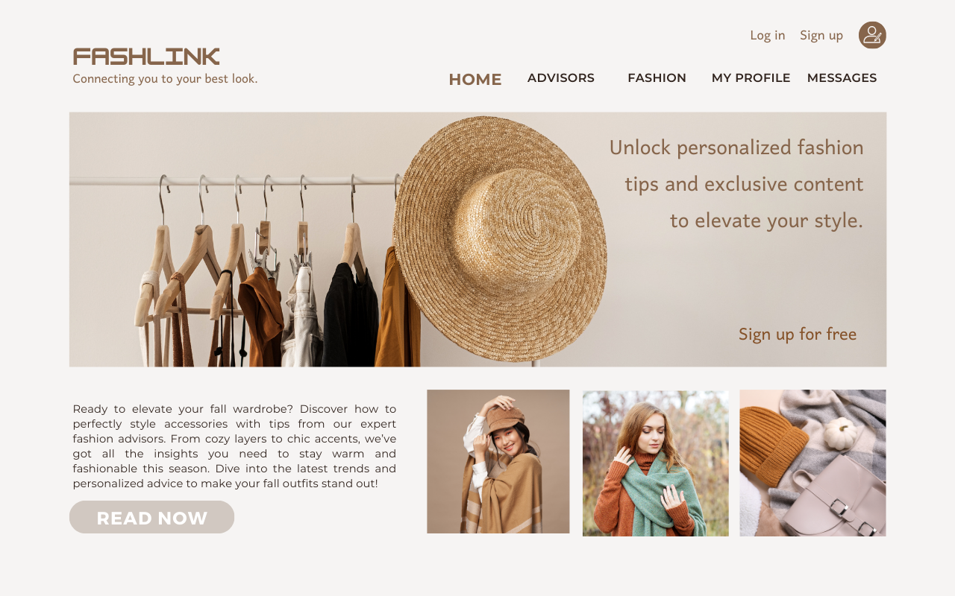

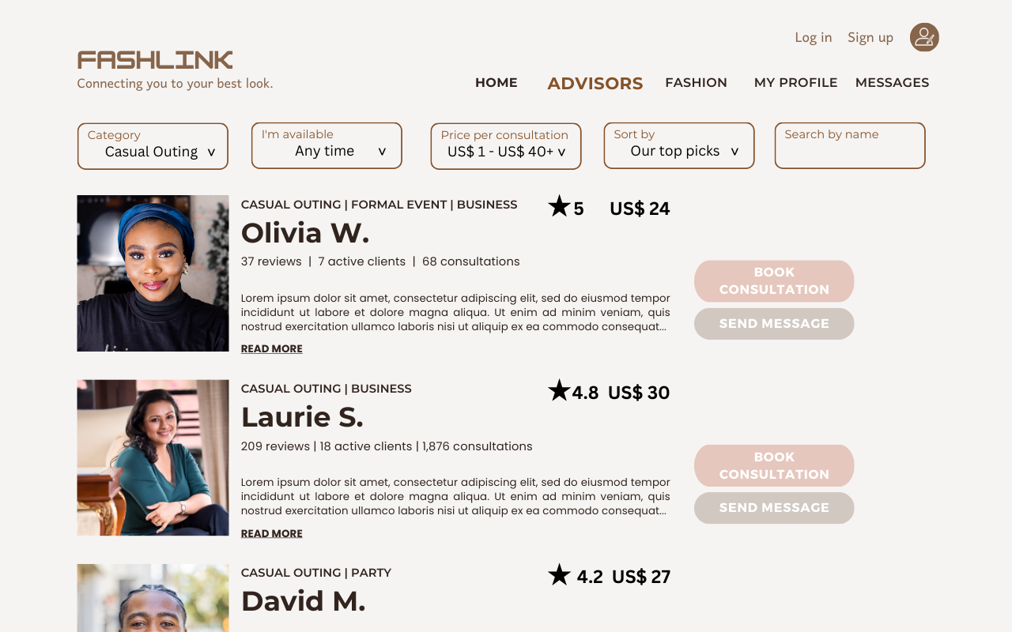

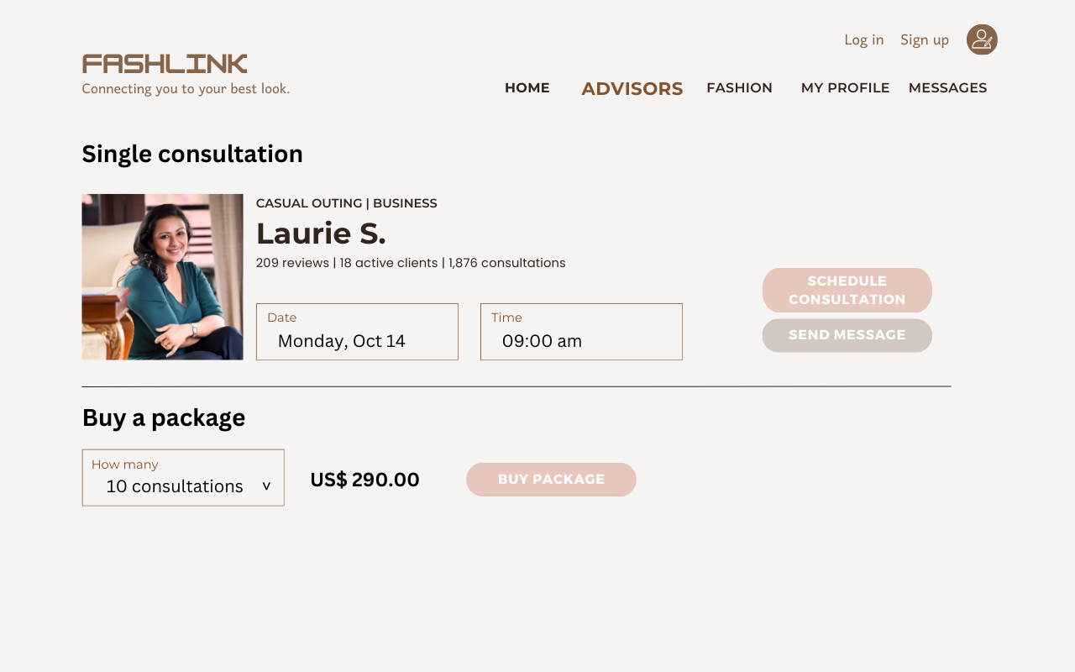

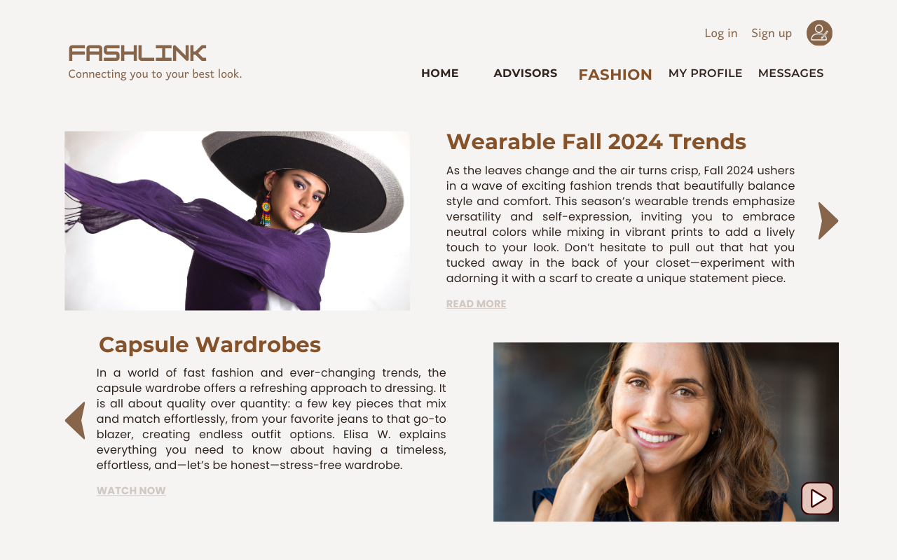

Credit Card Need Update

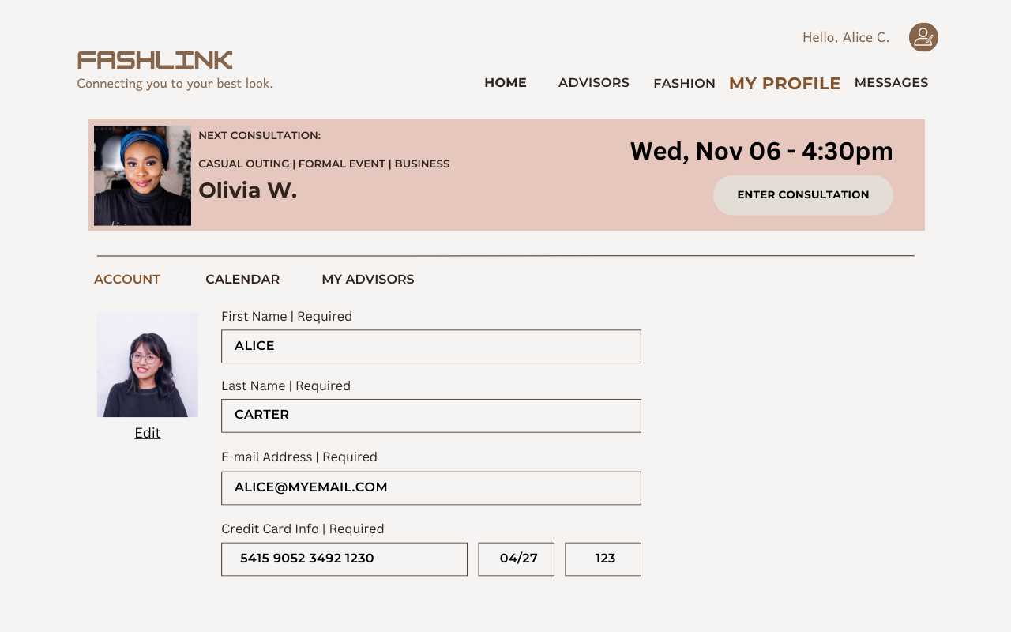

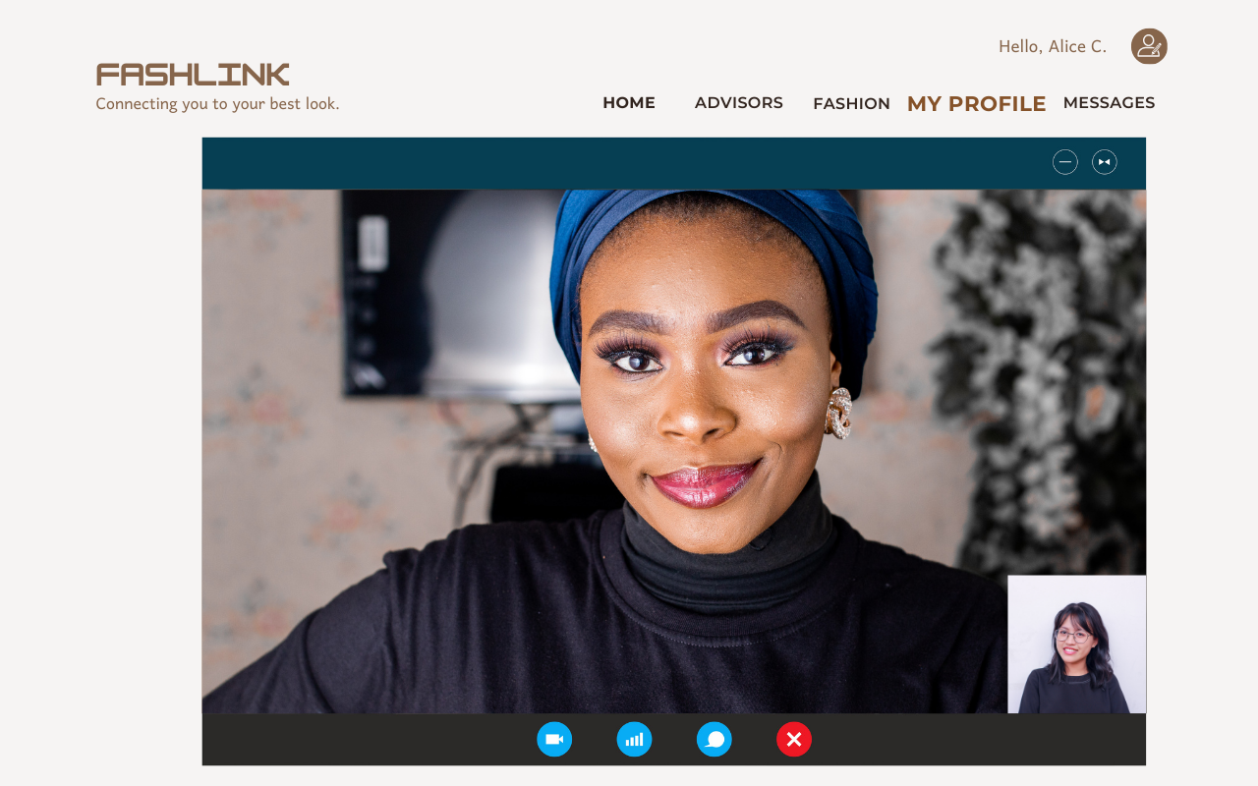

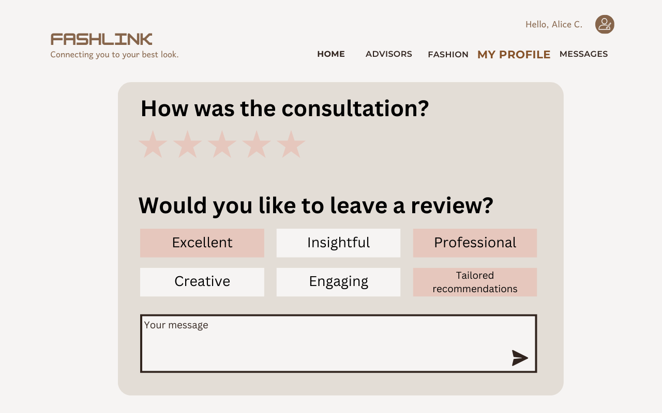

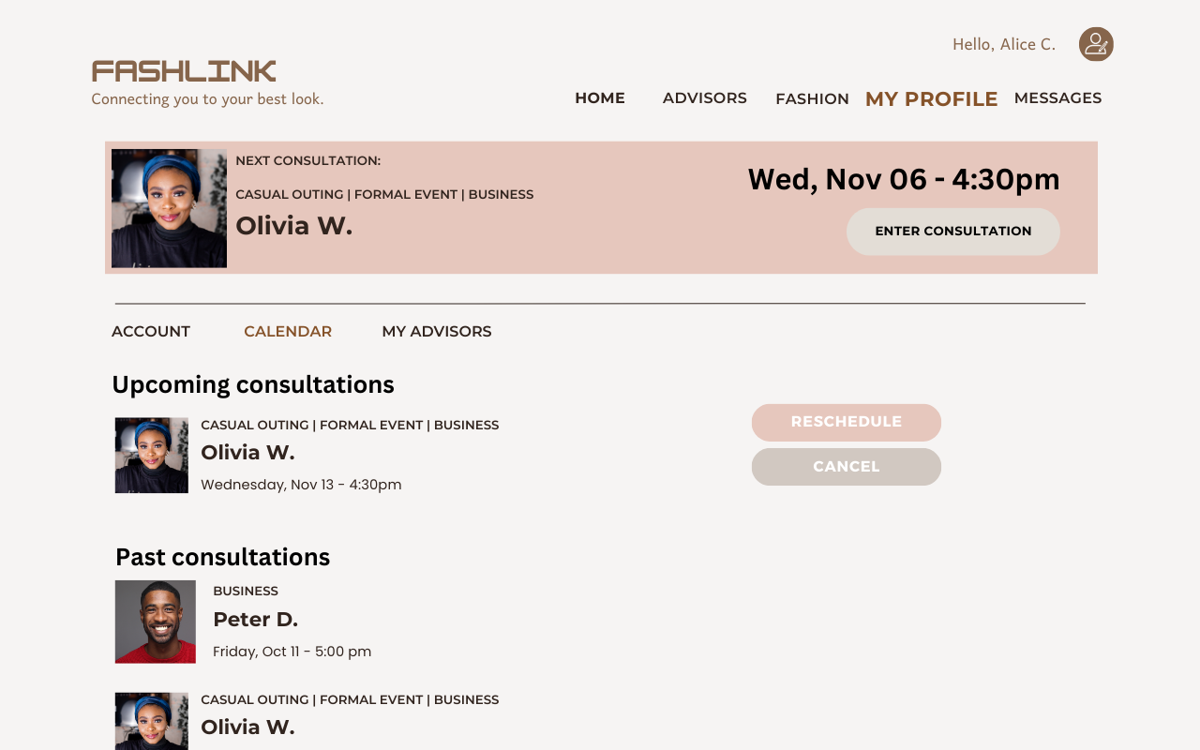

# 6. UML Diagrams

## 6.1. Use Case CARLOS - Validacion con el equipo

## 6.2. Class Diagram CARLOS

## 6.3. Sequence Diagram TODOS NOS DIVIDIMOS LOS DIAGRAMAS

### 6.3.1 XXXXX

### 6.3.2 YYYYY

### 6.3.3 ZZZZ

NY5th Fashion Consultancy

CSIS-3275 Software Engineering



Progress Report

September 21st, 2024

|  |  |
| --- | --- |
| Andréa Chuang Floriano | 300389010 |
| Carlos Sibaja Jimenez | 300384848 |
| José Burga Nunez de la Torre | 300382749 |
| Nicolas Moreno Castro | 300367883 |

Version History

|  |  |  |
| --- | --- | --- |
| 2024-09-16 | Nicolas | Initial version |
| 2024-09-17 | Carlos | Add diagrams + financial feasibility info |
| 2024-09-17 | Andréa | Add current context + market opportunity |
| 2024-09-17 | José | Review feasibility studies + include new KPIs |
| 2024-09-18 | Andréa | Complement executive summary |
| 2024-09-19 | Nicolas | Reviewed use case diagram + made improvements to it |
| 2024-09-19 | Carlos | Update the financial feasibility info -merged with the economic feasibility. |
| 2024-09-20 | All | Review the document. |

Table of Content

[**I. Executive Summary 3**](https://docs.google.com/document/d/14tyTB_oBCq03k927s5BNtTj8y7SNdRuP75n7LLgF9KU/edit#heading=h.mv3vyngx4k41)

[**II. Business Case 4**](https://docs.google.com/document/d/14tyTB_oBCq03k927s5BNtTj8y7SNdRuP75n7LLgF9KU/edit#heading=h.pspez93yci0h)

[Current Context 4](https://docs.google.com/document/d/14tyTB_oBCq03k927s5BNtTj8y7SNdRuP75n7LLgF9KU/edit#heading=h.fm0adl2410w8)

[Market Opportunity 4](https://docs.google.com/document/d/14tyTB_oBCq03k927s5BNtTj8y7SNdRuP75n7LLgF9KU/edit#heading=h.q3b3rakutbs)

[Revenue Model 5](https://docs.google.com/document/d/14tyTB_oBCq03k927s5BNtTj8y7SNdRuP75n7LLgF9KU/edit#heading=h.7yoixb3liojt)

[**III. Project Requirements 6**](https://docs.google.com/document/d/14tyTB_oBCq03k927s5BNtTj8y7SNdRuP75n7LLgF9KU/edit#heading=h.u1ek1jf83jh7)

[Functional Requirements 6](https://docs.google.com/document/d/14tyTB_oBCq03k927s5BNtTj8y7SNdRuP75n7LLgF9KU/edit#heading=h.2qasldi1d3ia)

[Non - Functional Requirements 7](https://docs.google.com/document/d/14tyTB_oBCq03k927s5BNtTj8y7SNdRuP75n7LLgF9KU/edit#heading=h.gxiutvibrthe)

[**IV. Diagrams 8**](https://docs.google.com/document/d/14tyTB_oBCq03k927s5BNtTj8y7SNdRuP75n7LLgF9KU/edit#heading=h.c49zj0c3namn)

[**V. Feasibility Studies 9**](https://docs.google.com/document/d/14tyTB_oBCq03k927s5BNtTj8y7SNdRuP75n7LLgF9KU/edit#heading=h.49q1s97cl0h)

[Technical Feasibility 9](https://docs.google.com/document/d/14tyTB_oBCq03k927s5BNtTj8y7SNdRuP75n7LLgF9KU/edit#heading=h.vdrqtkmvyxfo)

[Economic Feasibility 9](https://docs.google.com/document/d/14tyTB_oBCq03k927s5BNtTj8y7SNdRuP75n7LLgF9KU/edit#heading=h.f23068ef2xdx)

[Income Calculation 9](https://docs.google.com/document/d/14tyTB_oBCq03k927s5BNtTj8y7SNdRuP75n7LLgF9KU/edit#heading=h.oc38lqi3i7er)

[Expenditure 11](https://docs.google.com/document/d/14tyTB_oBCq03k927s5BNtTj8y7SNdRuP75n7LLgF9KU/edit#heading=h.b3v3f5va6i4c)

[Operational Results 11](https://docs.google.com/document/d/14tyTB_oBCq03k927s5BNtTj8y7SNdRuP75n7LLgF9KU/edit#heading=h.3t3mpwblyqgo)

[Schedule Feasibility 12](https://docs.google.com/document/d/14tyTB_oBCq03k927s5BNtTj8y7SNdRuP75n7LLgF9KU/edit#heading=h.wiewn2auxjrx)

[**VI. Key Performance Indicators (KPI) 13**](https://docs.google.com/document/d/14tyTB_oBCq03k927s5BNtTj8y7SNdRuP75n7LLgF9KU/edit#heading=h.5gc5fqhu5qsu)

1. Executive Summary

*NY5th FashLink* is an innovative platform that delivers personalized fashion recommendations for both everyday looks and special occasions. Our platform connects visitors with professional fashion advisors through video calls or text-based interactions, offering real-time style advice tailored to individual preferences. In addition, the platform features curated collections from partner brands, allowing visitors to explore the latest trends and receive expert guidance on selecting the perfect outfits.

What sets *NY5th FashLink* apart is its ability to create a truly immersive fashion experience. Visitors are not just passive recipients of advice — they are actively engaged in a dialogue with industry experts, allowing for a highly personalized approach that caters to individual tastes, body types, and style goals. Whether someone is seeking a quick tip for a casual look or a full wardrobe makeover, our consultants provide recommendations that align with both current trends and timeless fashion principles in one place. *NY5th FashLink* provides a perfect blend of expertise, fashion, and convenience.

Moreover, *NY5th FashLink* employs a forward-thinking revenue model that encompasses multiple income streams, creating value for both visitors and partner advisors. The platform offers flexible subscription plans, catering to different user needs with free access to basic features and premium options unlocking exclusive content and priority consultations. In addition to subscription revenue, personalized, on-demand consultations allow visitors to pay for one-on-one sessions with fashion experts, adding a premium service layer. Our partnership with top fashion advisors introduces a unique commission-based approach, where visitors can discover and purchase outfits directly through the platform, generating sales commissions while ensuring a curated shopping experience.

This multi-faceted approach not only diversifies our revenue streams but also positions *NY5th FashLink* as a trailblazer in the fashion-tech space, merging personalized services with direct e-commerce integration in a way that enhances both user satisfaction and business profitability.

In this progress report, we outline the strategic roadmap for bringing *NY5th FashLink* to market. This contemplates the requirement analysis phase of the project, focusing on understanding customer needs, system interaction, and feasibility studies.

1. Business Case

*Current Context*

Many people struggle to find expert fashion advice, especially when preparing for special events. While fashion blogs and influencers provide some guidance, their advice is often broad and can require considerable time to sift through.

Finding the perfect outfit can be daunting, as individuals often wrestle with choosing styles that not only fit the occasion but also align with their personal taste and body type. This challenge is increased by the enormous volume of options available, which can lead to decision fatigue and frustration.

Besides that, visitors face the challenge of navigating multiple social media platforms, each offering a different perspective on style. This fragmented approach is time-consuming and can lead to overwhelming amounts of information, making it difficult to find cohesive and practical recommendations. *NY5th FashLink* addresses this issue by centralizing fashion advice in one convenient location.

*Market Opportunity*

The Global COVID pandemic accelerated the adoption of virtual styling services. Instead of spending hours scrolling through various feeds and posts, visitors can receive instant, tailored advice directly from professionals. This streamlined approach ensures they get precise, actionable recommendations without the hassle of managing multiple sources. Our company sees an opportunity to bring fashion advising services, making these services accessible to a broader audience throughout a platform.

 Our platform is designed to democratize fashion styling services, making expert advice accessible to everyone. By offering a range of options that cater to different budgets and preferences, we aim to provide a seamless and customized experience that empowers customers to look and feel their best, effortlessly. We connect them to their best look.

At the same time, fashion consultants benefit from a dedicated space to showcase their expertise and monetize their skills, while clothing stores gain access to a broader, engaged audience eager for curated fashion options.

|  |  |
| --- | --- |
| Benefits | |
| For Visitors | Quick, professional, and tailored fashion advice for any occasion. |
| For Advisors | A platform to showcase their expertise and generate income through consultations. |
| For Stores | Enhanced sales and greater visibility. |

Table 1. Benefits for each stakeholder.

*Revenue Model*

Our revenue model is designed to maximize value for all stakeholders while driving the company's sustainable growth.

We generate income through a multifaceted approach: visitors subscribe to our platform through flexible plans, including both free and premium tiers, allowing them to access a range of services and exclusive content. Additionally, on-demand consultations provide personalized fashion advice, creating additional revenue streams. Our partnerships with clothing retailers further enhance our model, as we earn commissions from product sales driven by expert recommendations.

This integrated revenue strategy not only supports the platform’s financial health but also ensures a high-quality, tailored experience for visitors and valuable opportunities for fashion consultants and retail partners.

|  |  |
| --- | --- |
| Revenue Model | |
| For Visitors | **Premium Plan**: Visitors pay a monthly or yearly subscription for access to private one-on-one video or text consultations with fashion consultants.  **Free Plan**: Visitors have limited access to general fashion videos, consultants' recommendations, and partner store products, but no private consultations. |
| For Advisors | Fashion consultants will be charged a small commission on each paid consultation. |
| For Stores | Partner clothing stores will pay a commission on sales made through the platform. |

Table 2. Revenue model.

1. Project Requirements

*Functional Requirements*

To ensure a comprehensive and user-centric experience, our platform is built around a set of essential functional requirements. Visitors will have the ability to register and log in using their email addresses, providing a secure and straightforward entry point. They can then browse a curated list of fashion consultants.

The platform must support seamless booking of consultations, whether via live video or text messaging, enabling flexible communication with advisors, and providing a sophisticated recommendation engine that delivers personalized fashion advice.

Visitors will also have access to a product catalogue featuring items from partner stores, with the ability to save favourites and make purchases directly through the app. Integrated secure payment options will facilitate smooth transactions. Finally, a consultant feedback system allows visitors to rate their experiences, ensuring quality and continuous service improvement.

|  |  |
| --- | --- |
| Functional Requirements | |
| User Registration/Login | Visitors must be able to sign up and log in with an email address. |
| Browse Advisors | Visitors can browse through a list of available fashion consultants, sorted by rating, specialization, and availability. |
| Consultation Booking | Visitors can book video or text consultations with their chosen consultant. |
| Video/Chat Functionality | Visitors can communicate with consultants via live video calls or text messaging. |
| Product Catalog | Visitors can browse partner store products, save favourites, and purchase through the app. |
| Purchase Integration | Visitors can complete transactions for products directly within the platform using secure payment methods, such as debit/credit card or PayPal. |
| Consultant Feedback System | Visitors can rate their consultant after each consultation. |

Table 3. Functional requirements

*Non - Functional Requirements*

The non-functional requirements for our platform outline the essential features and capabilities necessary to deliver a seamless and effective user experience.

The general requirements include a user-friendly interface for browsing and interacting with fashion advisors, and robust video and text communication tools for real-time consultations.

Additionally, the platform must support a secure and efficient subscription management system, integration with retail partners for product recommendations, and analytics tools to track user engagement and satisfaction. By meeting these requirements, we ensure that the platform not only meets user expectations but also supports the operational needs of fashion consultants and retail partners.

|  |  |
| --- | --- |
| Non-Functional Requirements | |
| Performance | - The platform must load any screen (consultants, product catalogue, etc.) rapidly.  - Adapted to work with different devices and operating systems.  - The platform needs to be available 24/7 and globally. |
| Security | - All communications (video calls, chats) and payment transactions will be securely encrypted.  - All stakeholders need to log in to the platform, double authentication is required. |
| Scalability | The system must handle a substantial number of visitors. |
| Usability | The user interface must be intuitive, with no more than three steps required to book a consultation. |

Table 4. Non-functional requirements.

1. Diagrams

To illustrate the practical application of our platform, we present a detailed use case that highlights how visitors engage with the platform to meet their fashion needs. By showcasing a real-world scenario, we aim to provide a clear understanding of how *NY5th FashLink will* facilitate personalized fashion advice and integrate shopping experiences, ultimately delivering value to visitors, advisors, and partner stores, enhancing their overall style journey.

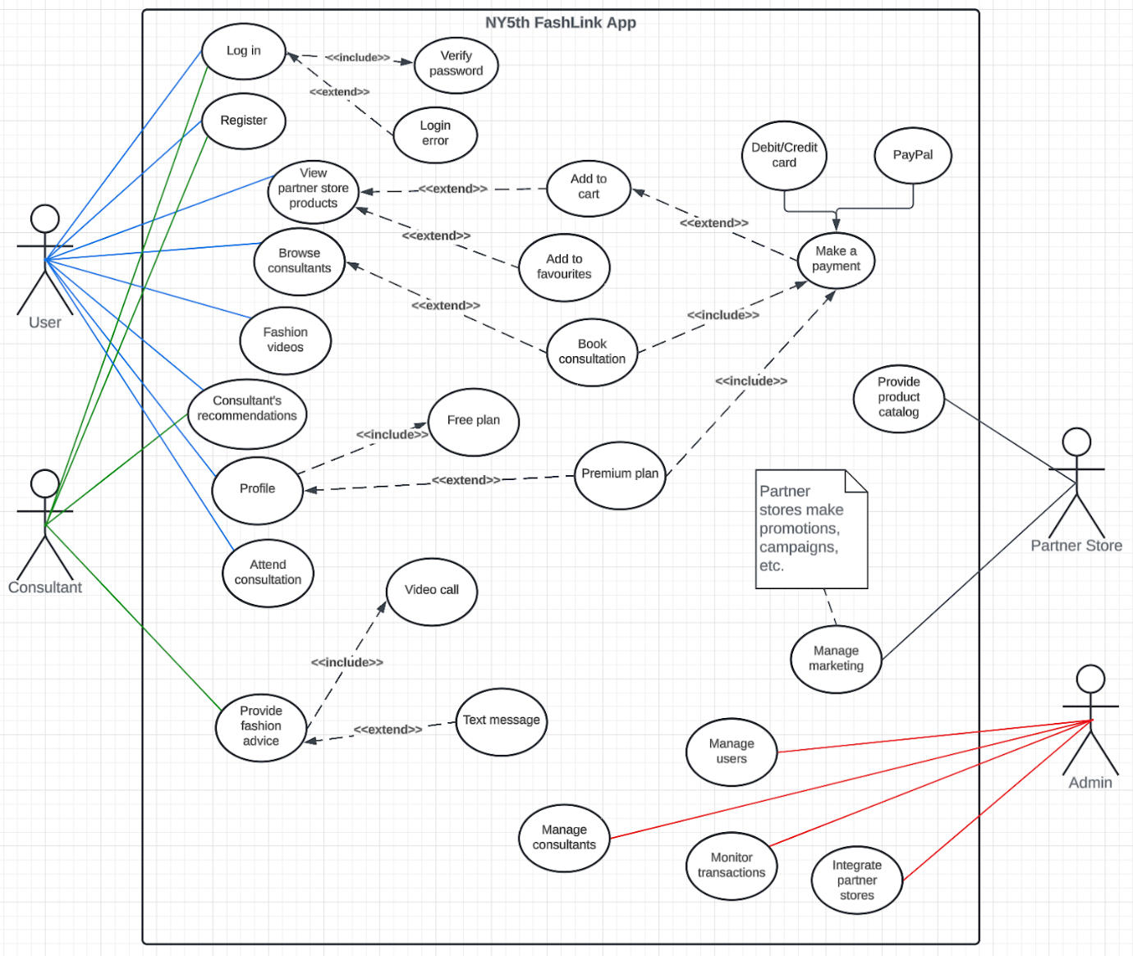

Figure 1.  System Use Case.

1. Feasibility Studies

To ensure the success of our platform, we conduct comprehensive feasibility studies covering technical, economic, schedule, and financial aspects. The technical feasibility study assesses the platform’s technical requirements and infrastructure needs to ensure a robust and scalable platform. The economic feasibility examines the cost-effectiveness of the project, including budget allocation and potential economic impacts. The schedule feasibility evaluates the project timeline, ensuring that key milestones can be met within the proposed timeframe. Finally, the financial feasibility analyzes the overall financial viability, including revenue projections, funding requirements, and profitability potential. These studies provide a thorough evaluation of the project’s viability, guiding strategic decision-making and planning.

*Technical Feasibility*

To deliver a seamless user experience, the platform will leverage APIs for critical functionalities including video calls, secure payments, and product catalogue management. Specifically, we will integrate with reliable video conferencing APIs to enable high-quality, real-time consultations between visitors and fashion advisors.

For transactions, we will utilize secure payment gateways to ensure the safe and efficient handling of payments via debit/credit cards and PayPal. Additionally, a robust product catalogue management API will be employed to facilitate the integration of partner store inventories, allowing visitors to browse, save favourites, and make purchases directly within the platform. By adopting these proven technologies, we ensure that the platform is both scalable and secure, capable of supporting a smooth and reliable user experience as it grows.

*Economic Feasibility*

The projected costs for developing and maintaining the platform encompass several key components. Initial development costs have been preliminarily estimated based on resources for the development of a medium-complexity solution.  This analysis ensures that the platform is not only feasible but also positioned for sustainable financial success.

Income Calculation

According to McKinsey's report "State of Fashion 2024", the fashion industry is projected to grow by 2 to 4 % despite global challenges, while the fashion advisory sector is also expanding. This growth encompasses services such as personal styling, wardrobe audits, sustainable fashion consulting, and ethical purchasing guidance, with the industry grossing $350 billion in 2023.  Sites like *Stich Fix* (est: 2011, revenue in 2023, 1.6 billion) and Rent the Runway (est: 2009, revenue 2023, 300 million) have 4 million and 100.000 subscribers respectively.

Our revenue model capitalizes on these trends with several key streams. The premium subscription plan will be priced at $9.99 per month, providing visitors with enhanced features and exclusive content. Additionally, the company will receive a 20% commission on each consultation fee or membership plan sold, aligning our incentives with the success of our consultants. Affiliate sales from product recommendations are expected to generate a 3%-5% commission, contributing to our overall revenue. Besides that, the company anticipates generating additional revenue through strategic advertising and YouTube channel promotions, though these sources are not expected to significantly impact initial earnings.

This financial structure positions the platform for sustainable growth and profitability, leveraging industry expansion and a well-rounded income strategy:

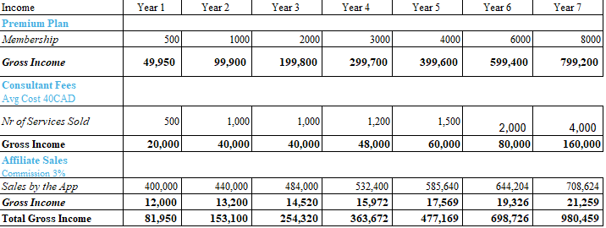

Table 5. Income

 The main source of income will be the subscription services in which the customers will obtain the best services,  it represents 82% of the income. 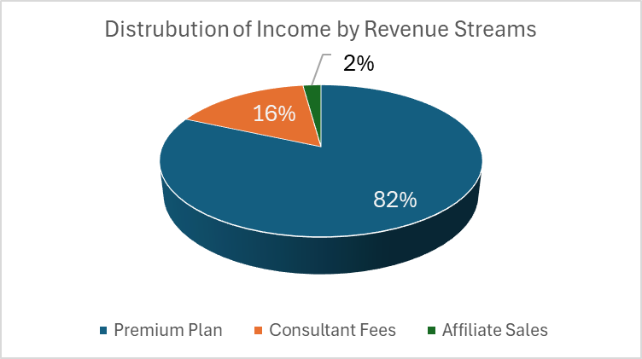

The consultant services despite being one of the best attributes of the platform do not represent an important income stream.

Figure 2. Distribution of income.

Expenditure

The development cost is the main one at the launch of this enterprise.  With an estimate of 1.000 hrs of work of various types of professionals such as project managers, developers, testing engineers and other consultants (fashion specialists).  The labour cost has an average cost of 100 CAD per hour.

Monthly maintenance costs will include server hosting, regular updates, and customer support. However, these costs are anticipated to be offset by revenue generated from user subscriptions and affiliate sales.

After the fifth year expenses will be around 300.000 CAD per year.

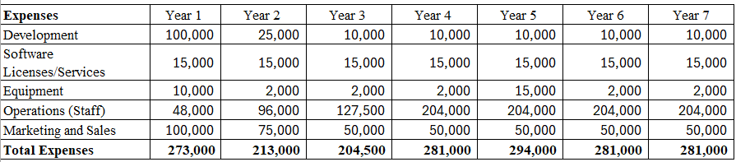

Table 6. Expenses by year.

Operational Results

The financial feasibility of the project includes an initial investment requirement of CAD 300,000 (approximately USD 222,000), essential to cover the minimum operational costs for the first two years. This investment will enable the platform to establish its operations, develop its features, and effectively market its services.

The return on the investment will be reached in year 5,   with an ROI of 2.49 which can be considered very positive, taking into consideration the growing rate of this industry.



 Table 7. Operational result.

Based on projected revenue streams and growth expectations, this investment is anticipated to bring a full return of the investment by the end of the fifth year. This timeline ensures that the platform is well-positioned to achieve financial stability and profitability, providing a clear path to return on investment while supporting long-term business growth.

*Schedule Feasibility*

The schedule feasibility of our platform outlines the projected timeline for key phases of the project to ensure timely delivery and implementation. The first step of this project is the Requirement Analysis phase, estimated to take 2 weeks, during which we will gather and refine the essential requirements for the platform.

This will be followed by the Design & Prototyping phase, lasting 4 weeks, where initial designs and prototypes will be developed to define the platform interface and functionality. The Development phase will span 12 weeks, focusing on the actual coding and integration of features. Testing will be conducted over a period of 3 weeks to identify and resolve any issues before launch. Finally, the Deployment phase, lasting 2 weeks, will involve the official release of the platform to users. This structured timeline ensures that each phase is completed efficiently, paving the way for a successful and timely launch of the platform.

|  |  |
| --- | --- |
| Phase | Time |
| Requirement Analysis | 2 weeks |
| Design and Prototyping | 4 weeks |
| Development | 12 weeks |
| Testing | 3 weeks |
| Deployment | 2 weeks |
| Total | 23 Weeks |

Table 8. Schedule.

1. Key Performance Indicators (KPI)

To effectively measure the success and performance of our platform, we will establish key performance indicators (KPIs) that provide valuable insights into various aspects of the business.

|  |  |  |
| --- | --- | --- |
| **#** | **KPI’s name** | **Description** |
| 1 | Visitor Engagement Rate | Visitor engagement is crucial for a fashion consulting app because it directly reflects how valuable users find the platform. |
| 2 | Subscription Growth | Subscription growth tracks how quickly we are converting free visitors into paying subscribers. This metric is central to our business model, as subscription revenue will be a key driver for the company. |
| 3 | Revenue Per Visitor (ARPV) | Average Revenue Per Visitor (ARPV) helps us understand how much revenue each visitor is generating on average. |
| 4 | Customer Satisfaction Scores (CSAT) | Customer satisfaction is key to ensuring the long-term success of our app. |

Table 9. Main KPIs.

These KPIs will include metrics such as visitor/user engagement rates, subscription growth, revenue per user, and customer satisfaction scores. Additionally, we will monitor:

* Stakeholder interviews conducted, which will measure our engagement with fashion advisors, visitors, and partner stores to gather comprehensive requirements.
* Use cases identified, covering interactions among visitors, advisors, and partner stores.
* Total number of functional requirements documented and validated.
* Stakeholder satisfaction will be assessed through feedback collected during validation sessions to gauge the alignment with expectations.
* User growth rate and user conversion rate to evaluate the platform's effectiveness in attracting and retaining them.

With these indicators, we can assess the effectiveness of our strategies, identify areas for improvement, and make informed decisions to drive continued success.