Lab 2 Portfolio Report
Course: CSE343 Web Development
Student name: Carlos Bassem Adly Tadros
Student ID: 24P0320

1 Portfolio Task
I created a personal portfolio webpage using HTML and basic inline styling. The page includes a header with navigation links, an About Me section, three projects, a contact form, and a footer.

2 GitHub Repository
Repository link: https://github.com/Carlos-bassem/WebDev

3 Portfolio Screenshots
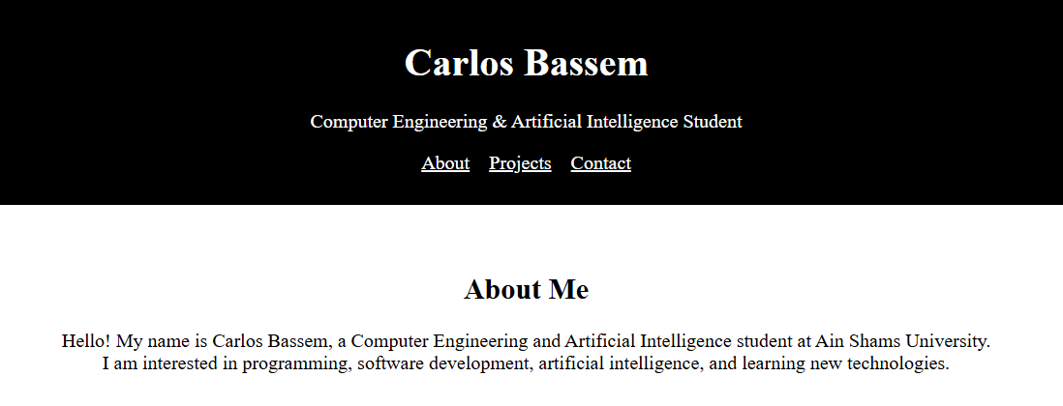
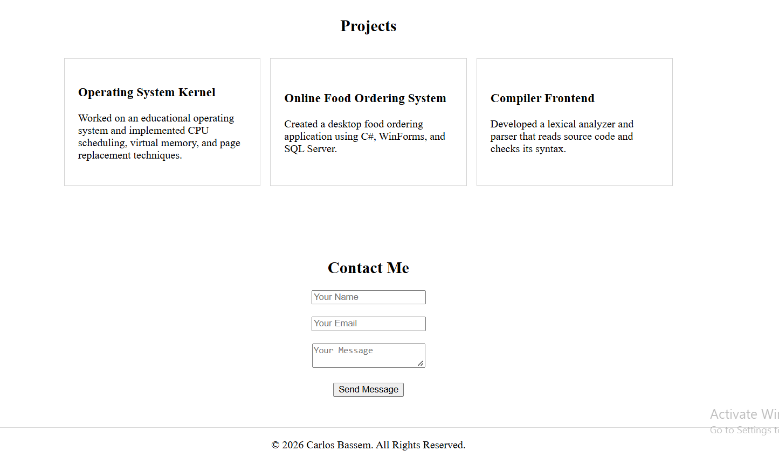

4 Conclusion
In this lab, I practiced using headings, paragraphs, links, tables, forms, and basic styling to create a simple personal portfolio webpage.

