회원인증, fileUpload, MyBatis

1. 요구사항 : 회원가입(감사메일 자동 발송), 로그인, 로그아웃, 회원정보수정 가능

책이미지를 파일첨부하여 책등록, 책상세보기, 책정보수정, 책리스트(페이징처리)

1. pom.xml 추가
2. web.xml 추가
3. 패키지 만들기 ex) controller, service, dto, dao, util
4. 컨트롤러 만들기 (main,member,book)

*@*RequestMapping(value="main",method= {RequestMethod.GET,RequestMethod.POST})

어떤 방식으로 넘어올지에 따라 달라진다

1. properties 설정 하기 (DB와 mail)
2. META-INF/ 폴더 만들기 ex) db, config, mappers

Db 폴더 안에 initDB.sql과 mapper.sql 만들기

InitDb.sql

--SEQUENCE & TABLE DROP/CREATE

--DUMMY DATA INSERT

Mapper.sql

--MEMBER.XML (회원가입, id중복 체크,id로 memberDto 가져오기, 로그인, 정보수정 )

1. Sqlmap/mappers/book.xml & member.xml 만들기

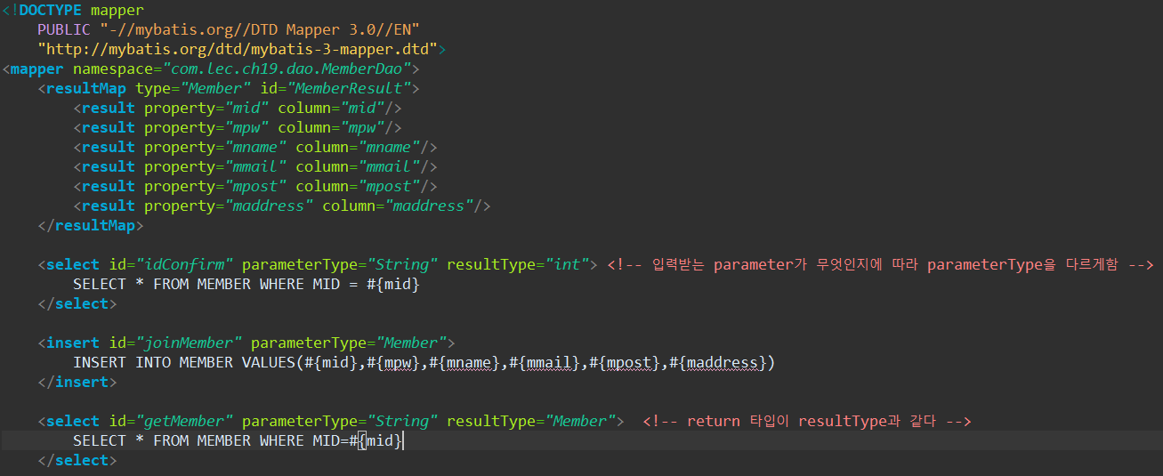

전체적인 틀

DTO(페이징이 필요하면 추가)

-mybatis-config.xml – mappers(쿼리문 xml) – DAO(interface)

-servlet-context.xml에 태그 추가

<mybatis-spring base-package=””>

-root-context.xml에 빈 추가

<**context:property-placeholder** location=*"classpath:META-INF/property/db.properties"*/>

<!-- DataSource 빈 -->

<**bean** name=*"dataSource"* class=*"org.springframework.jdbc.datasource.DriverManagerDataSource"*>

<**property** name=*"driverClassName"* value=*"${db.driverClassName}"*/>

<**property** name=*"url"* value=*"${db.url}"*/>

<**property** name=*"username"* value=*"${db.username}"*/>

<**property** name=*"password"* value=*"${db.password}"*/>

</**bean**>

<!-- SqlSessionFactoryBean 빈 -->

<**bean** id=*"sqlSessionFactory"* class=*"org.mybatis.spring.SqlSessionFactoryBean"*>

<**property** name=*"dataSource"* ref=*"dataSource"*/>

<**property** name=*"configLocation"* value=*"classpath:META-INF/sqlmap/config/mybatis-config.xml"*/>

</**bean**>

<!-- SqlSessionTemplate 빈 필요 -->

<**bean** id=*"sessionTemplate"* class=*"org.mybatis.spring.SqlSessionTemplate"*>

<**constructor-arg** ref=*"sqlSessionFactory"*/>

</**bean**>

-servlet-context.xml에 빈 추가

<**context:component-scan** base-package=*"com.lec.ch19"* />

<**mybatis-spring:scan** base-package=*"com.lec.ch19.dao"*/>

<**context:property-placeholder** location=*"classpath:META-INF/property/mail.properties"*/>

<!-- 메일발송 빈 -->

<**beans:bean** id=*"mailSender"*

class=*"org.springframework.mail.javamail.JavaMailSenderImpl"*>

<**beans:property** name=*"host"* value=*"${mail.host}"*/>

<**beans:property** name=*"port"* value=*"${mail.port}"*/>

<**beans:property** name=*"username"* value=*"${mail.username}"*/>

<**beans:property** name=*"password"* value=*"${mail.password}"*/>

<**beans:property** name=*"javaMailProperties"*>

<**beans:props**>

<**beans:prop** key=*"mail.smtp.auth"*>true</**beans:prop**>

<**beans:prop** key=*"mail.smtp.starttls.enable"*>true</**beans:prop**>

<**beans:prop** key=*"mail.debug"*>true</**beans:prop**>

<**beans:prop** key=*"mail.transport.protocol"*>smtp</**beans:prop**>

<**beans:prop** key=*"mail.smtp.ssl.trust"*>smtp.gmail.com</**beans:prop**>

<**beans:prop** key=*"mail.smtp.ssl.protocols"*>TLSv1.2</**beans:prop**>

</**beans:props**>

</**beans:property**>

</**beans:bean**>

<!-- 파일첨부 -->

<**beans:bean** id=*"multipartResolver"* class=*"org.springframework.web.multipart.commons.CommonsMultipartResolver"*>

<**beans:property** name=*"maxUploadSize"* value=*"10485760"*/>

</**beans:bean**>