**Why there are so few trophic levels: selection against instability explains the pattern**

**For submission to Food Webs**

Jonathan J. Borrelli; Department of Ecology and Evolution, Stony Brook University, Stony Brook, NY 11794

[**jonathan.borrelli@stonybrook.edu**](mailto:jonathan.borrelli@stonybrook.edu)

and

Lev R. Ginzburg; Department of Ecology and Evolution, Stony Brook University, Stony Brook, NY 11794

[**lev.ginzburg@stonybrook.edu**](mailto:lev.ginzburg@stonybrook.edu)

**Statement of authorship**: JB and LG designed the research; JB performed simulations; JB wrote article

Running Title: **Why there are so few trophic levels**

**Keywords:** trophic levels, food webs, food chains, quasi sign-stability

**Number of words in abstract:** 126

**Number of words in main text:** 3408

**Number of sources:** 37 general, 33 data sources (listed in Supplemental)

**Number of figures:** 1

**Number of tables:** 0

**Number of text boxes:** 0

**To whom correspondence should be sent:**

Jonathan Borrelli

Department of Ecology & Evolution  
Stony Brook University  
650 Life Sciences Building  
Stony Brook, NY 11794-5245

Phone: (607) 372-0644

Fax: (631) 632-7626

**Abstract**

Food chains are short, rarely more than five trophic levels long. The cause of this pattern remains unresolved, and no current hypothesis fully explains this phenomenon. We offer an explanation based on the stability of food chains that have been shifted away from linearity to be more web-like. A toy example introduces the idea of “universal omnivory” where each trophic level consumes from all those below itself. The probability of stability for such “universal omnivory” chains declined strongly with chain length, and was as low as 1% with six level chains but highest for two and three level chains. We further explored the influence of chain length on food web stability by testing randomly assembled webs with varying levels of connectance, and altering the relative impacts of predators on prey, and vice-versa. Food webs characterized by low to moderate degrees of connectance, asymmetrical interactions, and relatively weak density dependence showed a pattern of reduced stability with longer trophic chains. The simple view that longer, reticulated chains are less stable seems to resolve the long-standing question of why there are so few trophic levels in nature.

**Introduction**

Food chains are typically short, often having as few as three levels (Elton 1927; Pimm & Lawton 1977) and rarely more than five (Yodzis 1981; Pimm 1982). The distribution of trophic position, measured as 1 plus the average trophic position of a species’ prey, for 50 published food webs shows that most species have a trophic position around 2 or 3 (**Figure 1a**). Very few species have a trophic position higher than 5 in these food webs (see Supplemental Information for details on the webs used). Alternatively, the single longest chain in each of 50 published webs is most frequently between 3 and 5 levels (**Figure S1**). A recent study by Ulanowicz et al. (2013) demonstrated that by accounting for the amount of biomass flowing along the links (links with more biomass flow are weighted more heavily) the number of effective trophic levels is approximately 3 for a set of 16 networks. Ulanowicz et al. (2013) speculated that this pattern may result from the elimination of configurations of interacting species that are less likely to persist that others. We think that our results, outlined below, provide strong support for the general ideas developed in their perspectives paper.

The limitation of food chain length has been addressed in a number of ways from energetics to foraging theory to dynamic constraints (Post 2002). Each hypothesis has both strengths and weaknesses, leading many to believe that the limits of food chain length must be a complex blend of multiple causes (Post 2002). Thus, despite the wealth of literature that has been produced in search of an explanation for what limits the length of food chains, a simple theory predicting no more than five trophic levels has not emerged. In the words of MacArthur (1972; 253): “Scientists are perennially aware that it is best not to trust theory until it is confirmed by evidence. It is equally true, as Eddington pointed out, that it is best not to put too much faith in facts until they have been confirmed by theory.” We suggest that selection against unstable food web structures can explain the observed data (**Figure 1**).

The earliest explanation for food chain shortness is that the efficiency of energy transfer between trophic levels is low. Available energy at trophic level should therefore decrease rapidly going up the chain (Elton 1927; Lindeman 1942; Hutchinson 1959). Areas with higher energy availability (often measured as productivity) should then support longer chains, a prediction not supported by empirical observations. Up to 5 trophic levels are observed in both the highly productive tropics and the low productivity polar regions (Pimm 1982). An alternative explanation is that larger ecosystems allow for longer food chains, although the mechanism for this is unclear (Post 2002). Empirical support for this hypothesis is conflicting, with supporting evidence in lakes and some islands (Post 2002; Takimoto *et al.* 2008) but not on other islands (Young *et al.* 2013). The combination of productivity and ecosystem size, the productive-space hypothesis, has also been proposed to explain variation in food chain length (Schoener 1989; Spencer & Warren 1996; Vander Zanden *et al.* 1999; Post *et al.* 2000). Evidence for the productive-space hypothesis, however, is contradictory with an equal number of studies finding support as those failing to find support (Post 2002, 2007; Young *et al.* 2013).

Morphological or biological constraints (e.g., organism size, gape width, etc.) have been thought to limit food chain length, but this hypothesis is not well supported in the literature, and is generally rejected (Pimm 1982). Alternatively, optimal foraging theory suggests that because there is more available energy, it is evolutionarily more optimal to feed at low trophic levels, (Cohen *et al.* 1986). The question then becomes, why would organisms evolve to feed higher in the food chain, where there is less available energy? Short food chains should result from the balance between feeding at low levels with more energy, and feeding at high levels to fulfill dietary/nutritional restrictions (Hastings & Conrad 1979; Cohen *et al.* 1986). Such a balance is very much in the spirit of our “universal omnivory” hypothesis (see below).

Longer food chains are expected to be dynamically fragile. Pimm and Lawton (1977) explored the role of dynamic constraints in limiting the length of food chains. Using analyses of community matrices of four species food chains, they found that as the number of trophic levels increased, so too did the time it took to return to equilibrium following a small perturbation. A decrease in stability with increasing chain length is also supported by evidence from protist microcosm studies (Morin & Lawler 1996; Holyoak & Sachdev 1998). Sterner *et al.* (1997), however, found that the theoretical result of Pimm and Lawton (1977) was primarily a methodological artifact resulting from differences in the number of negative (density-dependence) terms along the diagonal of the community matrix. Following the results of Sterner *et al.* (1997) studies exploring limits to food chain length have generally not explored the role of dynamic constraints. Most argue that dynamic constraints are less important to regulating the number of trophic levels compared to other mechanisms such as ecosystem size (Post 2002). We argue that dynamic constraints, in the form of systemic selection against dynamically unstable structures, do provide a foundation for determining why the number of trophic levels is typically low.

Systemic selection occurs when unstable food web structures (here referring to patterns of interactions) lead to the loss of some or all of the species in a web, thus altering web topology by eliminating nodes (species) and links (interactions). Food webs that are stable are more likely to persist over time. Food chain and web stability is typically determined by calculating the eigenvalues of the Jacobian matrix, whose elements *aij* represent the impact of the population of species *j* on the *ith* species’ population(May 1972; Pimm & Lawton 1977; Sterner *et al.* 1997). In order to determine eigenvalues the matrix must first be evaluated based on data that most often are not available (e.g., interaction strengths, population sizes), a significant drawback.

Stability may also be determined based on the particular pattern of signs of the elements of the Jacobian matrix. Purely linear food chains (where A only eats B, B only eats C, etc.), for example, are stable based solely on the signs of the elements of the matrix rather than their magnitude. Such structures are termed qualitatively stable or sign-stable (May 1973). Thus, regardless of the number of levels it contains a purely linear food chain will be stable. Hypothetically one could have a stable ecosystem with one hundred trophic levels, with species that consumed each other sequentially down the food chain.

A sign-stable system must fulfill a set of specific conditions (May 1973) that are not met by most natural systems. For example, a sign-stable web cannot contain trophic loops, a feature that is often found in food webs (Neutel *et al.* 2002). Nonetheless, following the very productive idea of Allesina and Pascual (2008), we are able to determine the degree to which a given food chain is sign-stable, termed quasi sign-stability (QSS). QSS is a measure of how often a matrix with a given sign structure is stable given elements (*aij*) whose magnitudes are randomized. We can determine this by the proportion of iterations that a sign structured matrix filled with randomly sampled values is stable.

This proportion is the probability that a matrix with a given sign structure is stable. Because qualitatively stable food chains are stable regardless of changes in the magnitude of the elements of the matrix, chains exhibiting a higher degree of stability (greater QSS) should be able to remain stable given small changes in the values of the *aij.* Webs of interactions that have greater QSS will therefore provide a bufferagainst changes in the magnitudes of the *aij* resulting from stochastic environments, demography, and evolutionary change. Food chains that have greater QSS will therefore be more persistent over time because the region of potentially stable parameter space will be larger, leading to a higher probability that the true values may remain within it. We hypothesize that webs with more trophic levels have lower QSS compared to webs with fewer trophic levels.

Omnivory, feeding on more than one trophic level, was found by Pimm and Lawton (1977, 1978) to reduce the number of randomly parameterized matrices that were stable. This result, however, was given less weight compared to return time to equilibrium. They suggested that omnivory should be uncommon because chains that included omnivory were frequently unstable. Thompson et al. (2007), however, found that omnivory is common among species that occupy a trophic position higher than that of herbivores, with relatively few species occupying an integer trophic position (but see Thompson & Hemberg 2009). Likewise, other studies have found that anywhere between 46% (Williams & Martinez 2004) and 87% (Arim & Marquet 2004) of taxa in a given community feed on more than one trophic level.

Below we articulate a toy example utilizing the idea of “universal omnivory,” recognizing that omnivorous interactions are prevalent in nature, and that food chains are less linear and more reticulate. Each species consumes from all levels below its own, rather than only the level directly below itself leading to more reticulate and less linear food chains. Universal omnivory may seem absurd, there is never a situation where a lynx eats both a hare and grass, but we argue that it is a better representation of a simplified reality than linear chains. In empirical food webs predators consume multiple prey and multiple predators consume prey and our universal omnivory hypothesis reflects that fact. While this does represent the extreme case of the prevalence of omnivory we propose that it presents a realistic counterpoint to the traditional view of simple linear chains. We explore the dynamic constraints of longer food chains in greater depth, following our toy example. In this sensitivity analysis we explore how dynamic constraints change based on our assumptions about omnivory, the relative impact of predators on their prey, the impact of prey on predator populations, and the role that density dependence may play.

**Model Selection**

A sign matrix with (+) indicating the effect of the prey on the predator, (-) indicating the effect of the predator on the prey, and (0) indicating no interaction was generated for each web. We assumed a predator dependent functional response (Abrams & Ginzburg 2000) where there is mutual interference among consumers. On the spectrum of interference between prey-dependence (no interference) and ratio-dependence (complete interference) our assumed predator-dependent functional response is not as extreme as, but is closer to, ratio-dependence (Arditi & Ginzburg 2012: p 141).

Given “hungry” predators a ratio-dependent functional response is approximately linear and the dynamics of the system are donor-controlled (Arditi & Ginzburg 2012: p 92-93). In a donor-controlled system the mortality imposed by predation is independent of predator abundance (when abundance is high) in this idealized example. Predator abundance will therefore have no impact on prey abundance. The linear approximation of the ratio-dependent system away from saturation as a donor-controlled model can be considered similar to the way in which Lotka-Volterra equations represent a linear approximation of Hollings’ nonlinear model.

The sign matrix of a donor-controlled system is triangular, with positive values on one side of the diagonal and 0s on the other side. As May (1974) noted, a triangular matrix would imply qualitative stability, thus in this ideal scenario any number of trophic levels will create a stable structure, the same as in a purely linear food chain. With the assumption of a predator-dependent functional response that lies close to, but not at the ratio-dependent end of the spectrum in our numerical simulations we relaxed the conditions of a perfect donor-control model. Rather than assuming that predators have no impact on their prey we substituted small values relative to the impact of prey on predators.

**Simulation Methods**

Using numerical simulations in R version 2.15.2 (R Core Team 2012), we examined the QSS of food chains shifted from linearity by universal omnivory. See the Supporting Information for details on the code used for this simulation, as well as all other code used in our analysis and figures. For all five sign matrices, each (+) was replaced with a random value drawn from a uniform distribution between 0 and 10 (*U(0, 10)*) for the impact of the prey population on the predator population. Each (-) was replaced with a random value sampled from a uniform distribution between -1 and 0 (*U(-1, 0)*) for the impact of the predator on the prey. The mean impact of the predator on the prey was thus assumed to be 10 times weaker than in the other direction and not 0 as in pure donor-controlled approximations. In order to counter the influence of varying the number of density-dependence terms on the diagonal (Sterner *et al.* 1997), all species were assigned -1 along the diagonal, representing the effect of density-dependence. By including density-dependence for all trophic levels we have taken a conservative point of view by allowing the highest probability that the system will be stable.

For each sign matrix, 10,000 random matrices were sampled from the distributions described above. For each sampled matrix we calculated whether or not it was stable by analyzing the eigenvalues of the matrix. The system was considered stable if all real parts of the eigenvalues of the matrix were negative. We then calculated the probability of stability, QSS, for each sign matrix as the percentage of iterations that yielded a stable matrix.

*Sensitivity Analysis*

We wanted to explore further the role of food chain length in determining quasi sign stability with varying levels of omnivory, and with varying degrees of asymmetry in interaction strength. To accomplish this, we created ten species food webs with 5 different levels of total number of interactions (connectance) and 9 different levels of asymmetry in the interactions (Table 1). For each combination of connectance and asymmetry we simulated 900 random food web configurations, giving a total of 40,500 food webs analyzed. The mean, median, and maximum trophic position were determined for each configuration.

Food web configurations were made by first generating a 10 by 10 species matrix of 0s. The matrix was then started with a chain of 2 to 10 species (100 for each chain length between 2 and 10 for a total of 900) by placing a 1 to represent an interaction. The total number of interactions in the web was set at 12, 16, 20, 24, or 28. The remaining interactions were randomly assigned in the matrix. Webs were constrained so that all species were either consumed by another, or consumed another species.

We sampled 1000 random draws from the underlying distribution (characterized by the asymmetry) for each food web. All distributions used in these simulations were random uniformly distributed. One of three distributions for impact of the predator on the prey was used, with the largest possible impact being: -1, -5, or -10. Likewise the largest possible impact of the prey on the predator was: 10, 5, or 1 (Table 1). A negative value was placed on the diagonal for all species and was always drawn from a random uniform distribution between -1 and 0. The real part of the largest eigenvalue was then calculated for each randomly parameterized web. QSS was calculated as the proportion of randomly parameterized matrices with a negative real part of the largest eigenvalue.

**Results**

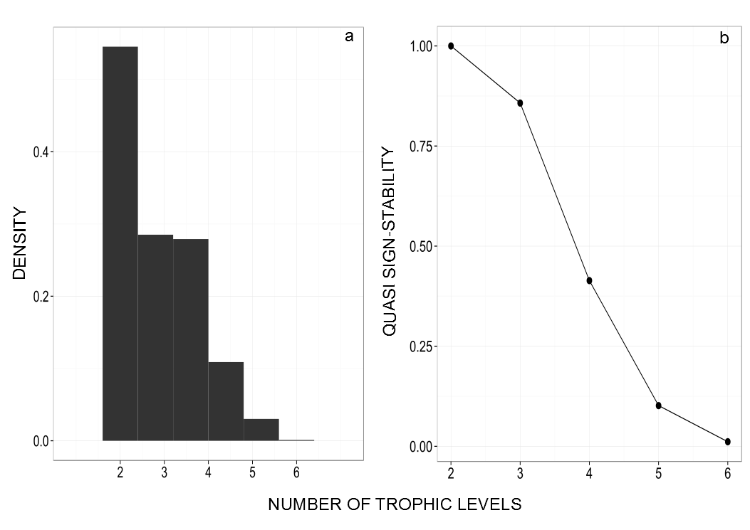

Figure 1: Plot of (a) distribution of trophic levels in 50 empirical food webs and (b) quasi sign-stability as a function of number of trophic levels

As the number of trophic levels in the chain increased, the probability of the chain being stable (QSS) decreased (**Figure 1b)**. The two-species case is a qualitatively stable food chain given our assumptions; it is a pure chain that is always stable. The largest decrease in QSS occurred between three (85.7%) and four levels (41.4%), dropping by 44%. Adding an additional level, to five species reduced the probability of a chain being stable by 31%, to nearly 10%. The chance that a chain of six species would be stable was only approximately 1%.

*Sensitivity Analysis*

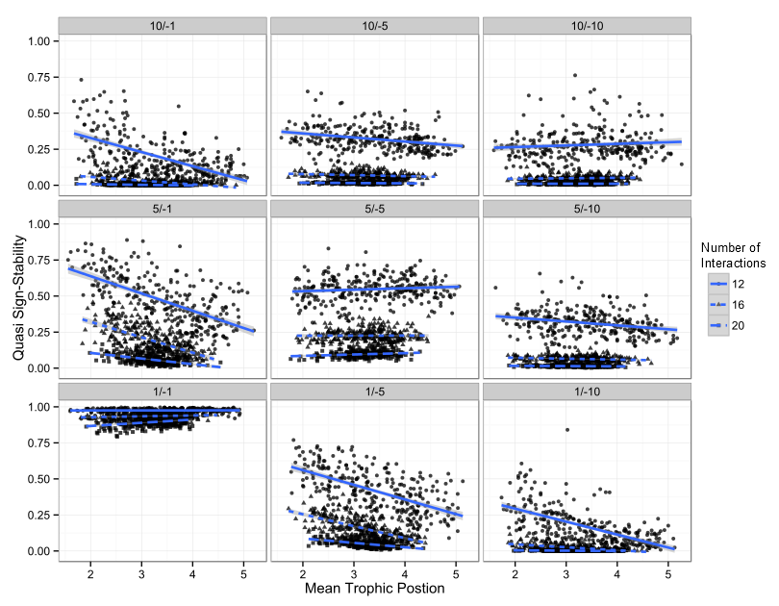

Figure : Results of in depth analysis, not shown are simulated webs with 24 and 28 total interactions

Our results, summarized in Figure 2 show how asymmetry in interaction strength, and number of interactions impact the relationship of QSS and food chain length. As long as there is some degree of asymmetry in the interactions (panels W, X, Y, Z), whether it leans toward the impact of the prey on the predator or vice versa, longer chains are less likely to be stable at equilibrium (lower QSS). When the relative impacts are drawn from symmetrical distributions the negative relationship of QSS and trophic level disappeared, becoming approximately 0. When the distributions are symmetrical and equal in magnitude to the strength of density dependence (on average), however, an increase in maximum trophic level apparently increases quasi sign stability.

Increasing the total number of interactions (connectance) always decreased stability with respect to any given maximum trophic position.

**Discussion**

Our results clearly show support for our hypothesis that webs with more trophic levels are less likely to be stable. We argue that quasi sign-stability is a good predictor of the observed pattern of food chain lengths in nature (**Figure 1**). Food webs with fewer trophic levels have a larger range of parameter space (magnitudes of the elements of the Jacobian matrix) within which they exhibit stability; they have a greater buffer against perturbation due to environmental and demographic stochasticity. The ability to buffer against change has long-term consequences for the dynamics and structure of food webs observed in nature. Over time species participating in webs that are unstable will have a higher likelihood of going extinct, changing the structure of the web. In contrast webs that have a higher probability of being stable will likely persist, increasing the chances that they are observed in nature.

Here we have demonstrated that quasi sign-stability declines with increasing numbers of trophic levels in food chains made more reticulate by omnivory. We found that two- and three-level webs should be most prevalent, with four- and five-level webs less likely, while webs with chains greater than six levels should be rare. Thus, our predictions closely mirror reality, where most species occupy trophic positions between two and three, and very few occupy a position higher than five (Vander Zanden *et al.* 1999; Beaudoin *et al.* 2001).

Our choice for the distributions from which values for the impact of species on each other were drawn was not based on empirical evidence. Instead we made assumptions based on the degree of interference along the spectrum between pure ratio-dependence and prey-dependence. The degree of interference among predators was assumed to be closer to the case of ratio-dependence than prey-dependence. Along with our focus on the case of hungry predators we were confident in assuming a relatively small impact of the predator on the prey population. Sensitivity analysis showed that our results are relatively robust to our choice of the magnitudes of the impact of the predator on the prey and vice versa.

The primary focus of prior work on the impact of omnivory on the stability of food chains (Pimm & Lawton 1978; Morin & Lawler 1996; Holyoak & Sachdev 1998; Long *et al.* 2011) has been on whether or not omnivory should be observed in nature due its destabilizing impact on food chain dynamics. Alternatively, we have chosen to assume omnivory is prevalent, and investigate how that will impact the probability of observing food chain length patterns in food webs. We would not expect that predictions pertaining to purely linear food chains should match the observation of short food chains, and for the most part it has not (Sterner *et al.* 1997). While omnivory may not be as ubiquitous as we have assumed (Thompson & Hemberg 2009), we propose that chains with universal omnivory are a better abstraction than linear chains because in nature food chains are embedded in reticulate webs.

Studies that test the relationship between food chain length and productivity or ecosystem size have found conflicting evidence. Post (2000) found that maximum trophic position increased with ecosystem size (measured as lake volume), but not productivity in lake ecosystems. In contrast, Young et al. (2013) found that food chain length increased with productivity but not ecosystem size (measured as island area) for tropical islands. The variation in trophic chain length in both studies, however, ranged between two and six. In a thorough analysis of food chain length variation in freshwater springs, Glazier (2012) showed that, for a biologically tolerable range of temperatures, food chain length does not change significantly and has a mean around 3.2. Our systemic selection hypothesis eliminates many of these apparent contradictions by proposing a mechanism that predicts the distribution of food chain lengths observed most often in nature (**Figure 1**).

Ecosystem size and productivity influence population dynamics. It is somewhat intuitive that larger areas should support larger populations, on average. Similarly, theory based on predator interference predicts that with increasing basal productivity we should expect proportional increases in equilibrium population sizes for all trophic levels (Ginzburg & Akçakaya 1992). Larger populations are less susceptible to extirpation resulting from stochastically varying demography or environments. Thus, gains in the stability of populations through larger numbers of individuals may buffer against losses in QSS resulting from increased length of chains. Different types of environment (e.g., lakes or islands) may also differ in the relative importance of variables such as ecosystem size and productivity for population size. The contradictory patterns observed by Post (2000) and Young (2013) may therefore be explained by slight modification to the general hypothesis we have outlined above.

**Acknowledgements**

We would like to thank J. Damuth, M. McCann, E. Rollinson, D. Padilla, and S. Baines for helpful discussion and comments on previous versions of this manuscript.

**References**

1.

Abrams, P.A. & Ginzburg, L.R. (2000). The nature of predation: prey dependent, ratio dependent or neither? *Trends Ecol. Evol.*, 15, 337–341.

2.

Allesina, S. & Pascual, M. (2008). Network structure, predator–prey modules, and stability in large food webs. *Theor. Ecol.*, 1, 55–64.

3.

Arditi, R. & Ginzburg, L.R. (2012). *How Species Interact: Altering the Standard View on Trophic Ecology*. Oxford University Press, New York, New York, USA.

4.

Arim, M. & Marquet, P. a. (2004). Intraguild predation: a widespread interaction related to species biology. *Ecol. Lett.*, 7, 557–564.

5.

Beaudoin, C.P., Prepas, E.E., Tonn, W.M., Wassenaar, L.I. & Kotak, B.G. (2001). A stable carbon and nitrogen isotope study of lake food webs in Canada’s Boreal Plain. *Freshw. Biol.*, 46, 465–477.

6.

Cohen, J.E., Briand, F. & Newman, C.M. (1986). A stochastic theory of community food webs III: predicted and observed lengths of food chains. *Proc. R. Soc. B*, 228, 317–353.

7.

Elton, C. (1927). *Animal ecology*. Macmillan Co., New York, New York, USA.

8.

Ginzburg, L. & Akçakaya, H. (1992). Consequences of Ratio-Dependent Predation for Steady-State Properties of Ecosystems. *Ecology*, 73, 1536–1543.

9.

Glazier, D.S. (2012). Temperature affects food-chain length and macroinvertebrate species richness in spring ecosystems. *Freshw. Sci.*, 31, 575–585.

10.

Hastings, H. & Conrad, M. (1979). Length and the evolutionary stability of food chains. *Nature*, 282, 838–839.

11.

Holyoak, M. & Sachdev, S. (1998). Omnivory and the stability of simple food webs. *Oecologia*, 117, 413–419.

12.

Hutchinson, G.E. (1959). Homage to Santa Rosalia or why are there so many kinds of animals? *Am. Nat.*, 93, 145–159.

13.

Lindeman, R. (1942). The trophic-dynamic aspect of ecology. *Ecology*, 23, 399–417.

14.

Long, Z.T., Bruno, J.F. & Duffy, J.E. (2011). Food chain length and omnivory determine the stability of a marine subtidal food web. *J. Anim. Ecol.*, 80, 586–594.

15.

MacArthur, R. (1972). Coexistence of species. In: *Challenging Biol. Probl.* (ed. Behnke, J.). Oxford University Press, New York, New York, USA, pp. 253–259.

16.

May, R.M. (1972). Will a large complex system be stable? *Nature*, 238, 413–414.

17.

May, R.M. (1973). Qualitative stability in model ecosystems. *Ecology*, 54, 638–641.

18.

Morin, P. & Lawler, S. (1996). Effects of food chain length and omnivory on population dynamics in experimental food webs. In: *Food Webs* (eds. Polis, G.A. & Winemiller, K.O.). Chapman and Hall, New York, New York, USA, pp. 218–230.

19.

Neutel, A.M., Heesterbeek, J.A.P. & de Ruiter, P.C. (2002). Stability in real food webs: weak links in long loops. *Science (80-. ).*, 296, 1120–1123.

20.

Pimm, S. (1982). *Food webs*. University of Chicago Press, Chicago, Illinois, U.S.A.

21.

Pimm, S. & Lawton, J. (1978). On feeding on more than one trophic level. *Nature*, 275, 542–544.

22.

Pimm, S.L. & Lawton, J.H. (1977). Number of trophic levels in ecological communities. *Nature*, 268, 329–331.

23.

Post, D.M. (2002). The long and short of food-chain length. *Trends Ecol. Evol.*, 17, 269–277.

24.

Post, D.M. (2007). Testing the productive-space hypothesis: rational and power. *Oecologia*, 153, 973–984.

25.

Post, D.M., Pace, M.L. & Hairston, N.G. (2000). Ecosystem size determines food-chain length in lakes. *Nature*, 405, 1047–1049.

26.

R Core Team, R. (2012). R: A Language and Environment for Statistical Computing. *R Found. Stat. Comput.*

27.

Schoener, T.W. (1989). Food webs from the small to the large: the Robert H. MacArthur award lecture. *Ecology*, 70, 1559–1589.

28.

Spencer, M. & Warren, P. (1996). The effects of habitat size and productivity on food web structure in small aquatic microcosms. *Oikos*, 75, 419–430.

29.

Sterner, R.W., Bajpai, A. & Adams, T. (1997). The enigma of food chain length: absence of theoretical evidence for dynamic constraints. *Ecology*, 78, 2258–2262.

30.

Takimoto, G., Spiller, D. & Post, D. (2008). Ecosystem size, but not disturbance determines food chain length on islands of the Bahamas. *Ecology*, 89, 3001–3007.

31.

Thompson, R. & Hemberg, M. (2009). The ubiquity of omnivory. *Verh. Internat. Verein. Limnol.*, 30, 761–764.

32.

Thompson, R.M., Hemberg, M., Starzomski, B.M. & Shurin, J.B. (2007). Trophic levels and trophic tangles: the prevalence of omnivory in real food webs. *Ecology*, 88, 612–617.

33.

Ulanowicz, R.E., Holt, R.D. & Barfield, M. (2013). Limits on ecosystem trophic complexity: insights from ecological network analysis. *Ecol. Lett.*, 17, 127–136.

34.

Williams, R.J. & Martinez, N.D. (2004). Limits to trophic levels and omnivory in complex food webs: theory and data. *Am. Nat.*, 163, 458–468.

35.

Yodzis, P. (1981). The structure of assembled communities. *J. Theor. Biol.*, 92, 103–117.

36.

Young, H.S., McCauley, D.J., Dunbar, R.B., Hutson, M.S., Ter-Kuile, A.M. & Dirzo, R. (2013). The roles of productivity and ecosystem size in determining food chain length in tropical terrestrial ecosystems. *Ecology*, 94, 692–701.

37.

Vander Zanden, M., Shuter, B., Lester, N. & Rasmussen, J. (1999). Patterns of food chain length in lakes: a stable isotope study. *Am. Nat.*, 154, 406–416.

**Figure Legends**

**Figure 1:** *(a)* Trophic position, measured as one plus the average trophic position of a species’ prey, for 3305 species in fifty food webs. *(b)* Quasi sign-stability of food webs with two to six species with universal omnivory. Dotted lines in *(b)* show the sensitivity of results to our choice of distributions of the impact of the predator on the prey.