Once Upon a Time in America：
The Unrealized Individual Dreams of Ciphers

Abstracts: American Dream is one of the hottest dimensions which appears in a tremendous number of American films. For ciphers are a vital component of American society, their unrealized dreams intensely illustrate some essence of the whole American culture. This paper aims to utilize the movie Once Upon a Time in America and some statistic data, to show the unrealized individual dreams of ciphers.
Keywords: American Dream, Cipher, Individual, Tragedy

American films are noted for a wide range of subjects and a core of deep thoughts. Therefore, it’s reasonable that movies play a reflective part in American culture and society. American Dream, profoundly integrated into traditional values of the U.S., is also put on significant position of reflection in American movies, which makes us gain insight into a momentous aspect on culture difference between U.S. and China. It’s undoubted that the failure of individual dreams can’t be neglected, because of the common problems of the whole American Dream behind them. Through the reflection of movie Once Upon a Time in America, this paper will analyze the tragedy of ciphers’ dreams and the implicit link among individual American Dream and the burning issues of the era.

- The individual dreams of characters in Once Upon a Time in America
There are many factors which trigger the tragedy of Noodles’ dream, including personal ones and social ones. But what is undeniable is that his unrealized dream has cultural significance in depth. It’s a mirror refracting the warp of pursuit to wealth and power in American society, which embodies in Max’s conspiracy and Deborah’s leave. Max seizes his dream, the high social status, through the corpses of their companions, and is faced with accusations and perishes in a garbage truck ultimately; Also Deborah, for her star dream and reputation, goes to Hollywood and becomes the mistress of Max. These fragile interpersonal relationships vividly emerge from the betrayal of friendship and affection Noodles suffering. Last but not least, Noodles participation in the prosperous black market, due to Volstead Act, also illustrates the indifference to collective interests and laws during the pursuit of American Dream. The strong sarcasm unveils the predicament in American Dream. Now a deep question arises from this movie, that is, what is the cultural factors which hinder the achieving of ciphers’ dreams?

- The history of individual dreams
To solve the question above, what can’t be neglected is that the difficulties and unrealization of American Dream are rooted in the history of America. The following historical tracks and figures tell us the variation and the profound historical causes of the distortion of American Dream.
  - Beginning: The Great Migration
Though the term was coined in The Epic of America, 1931, the Great Migration, often seen as the start of the U.S., was also the initiation of the embryonic form of the American Dream. Those aspects, the pursuit of freedom, the adventurous spirit and the emphasis on rights, democracy and equity, etc., immensely manifested the inner core of American Dream. But it’s universally acknowledged that collectivity is an indispensable part in the road of realizing one’s individual dream. Hence, too much stress on individuals might lead to egoism or ignorance of collective benefit, which contained the potential hazard to individual dreams.
Therefore, the beginning of the U.S. was also the beginning of American Dream and its latent issues.
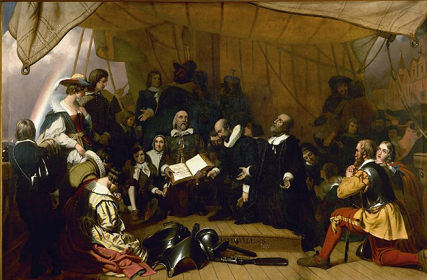
Picture 1
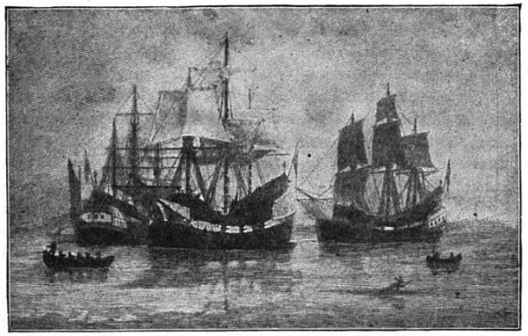
Picture 2

  - Development: Westward Movement and The Gold Rush
The Westward Movement and the Gold Rush were crucial events in formation of American Dream. It seemed to have provided a piece of vast land and a substantial number of chances for Americans’ individual dreams.

Picture 3
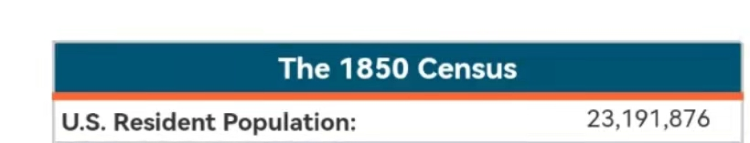
Picture 4
Picture 3 shows that the migrants in the Gold Rush in America, happening in the mid-19 century, were rarely seen in human history. According to the population data from US Census Bureau, there were more than 6.4％ of the Americans involved in this campaign. The campaign itself was in accord with the essence of American Dream, and the extensive participation really promoted the spread of this spirit.
But what was behind it was plenty of unrealized individual dream of many ciphers. Those pioneers that confronted with difficult positions might be defeated and gave up their dreams, or more cruelly, lost their life. Also, the realizing dreams of whites were established on the disillusionment of Indians’ dreams, for the racial massacre during the era. So the demerits of this campaign and American Dream were gigantic and obvious. When casting our sights toward the situation of Indians at that time, the unrealized dreams for Indians to have a better life seemed invaded and heartbroken.
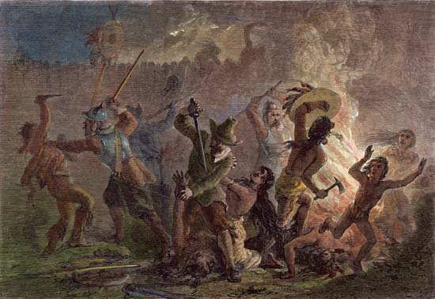
Picture 5

  - Dilemma: The Lost Generation and post World War II era
The American Dream during and after the two world wars came to a dilemma, and Once Upon a Time in America was a persuasive example. The rise of “the lost generation” was on account of the separation of dream and reality to a great extent. The outbreak of the wars led to the doubts and depression in American Dream. The traditional values and foothold of American Dream became vague, which made the lost of direction in pursuit of the individual dreams. The blood and tears in wars were in place of the glorious dream, leaving many unrealized and disoriented dreams in ciphers’ life.

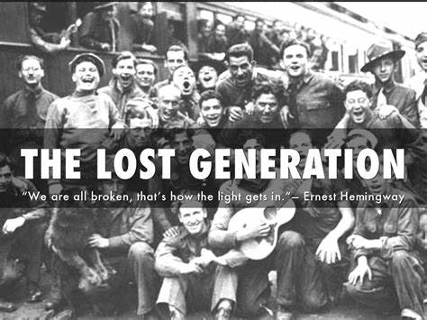
Picture 6

After the Second World War, the trouble in American Dream seriously trended. Hedonism were flourishing and firm belief vanished from the hearts of a large number of people. “The beat generation” was the revolt of the traditional American Dream. They preferred to extreme and riotous life styles, voicing their unrealized individual dream with the abandon of their own lives.
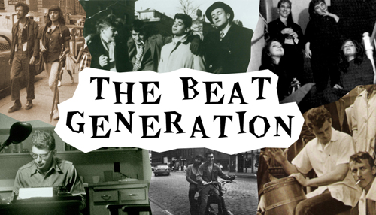
Picture 7

American Dream is still the kernel of American culture and under development nowadays, but it also confronts enormous challenges. The best tellers can be the unrealized American Dream of individuals, which will be discussed next.

- The Unrealized individual dreams and issues
This part is aimed at gaining insight into the question and coming up with the answers by causal analysis and data. The burning issues American Dream now faces are grim but not hopeless. In the following part, the the implicit link between issues and the unrealized individual dreams will be revealed and further analyzed.
  - The common problems of the unrealized individual dreams
Just like the main characters in Once Upon a Time in America, there are many ciphers that are lost or head in the wrong direction when pursuing their own dreams. Undeniably the personal factors can expound considerable reasons for these failures, but the common problems of American culture and society are supposed to be attached great importance to.
American Dream reflects the fundamental values of American culture, individualism and heroism. But once they become excessive or go over the frontier, there will be a catastrophe in the process. Only focusing on oneself brings about the deficiency in cooperation and narrowing of outlook, ultimately, self-destruction.
Also, some social problems have a marked impact on the warping of American Dream. Some harmful social atmospheres, like Mammonism and hedonism, is eroding the enterprising spirit and intrepidity in traditional American values, and only the ruins of the American Dream remain.
The external causes are equally significant. The America has witnessed several burgeoning centuries, but seemingly it’s hard for American Dream to keep pace with times. There is a sense of disillusionment and confusion caused by the world wars and the cold war, which is anchored in the hearts of country and occupies a high position in American societies. But American Dream can’t guarantee a realistic path to rid of these feelings. “I have money, I become success, and then, what? All I can do is to lose my life in battlefield or fall in vicious competition on money and power.” The problem urges American Dream to generate a profound self-revolution.
  - The burning issues behind them
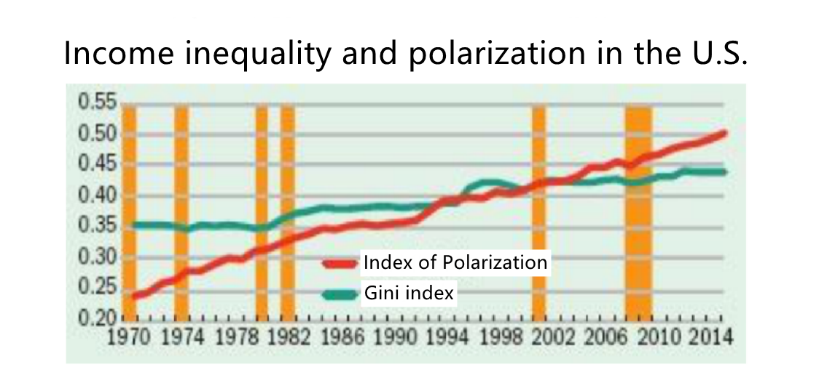
Picture 8
What can’t be seriously emphasized too much is the burning economic issues, which is the foundation of all other problems. From the Picture 8, Index of Polarization has ascended from 0.25 in 1970 to 0.50 in 2014 approximately. Also Gini Index, a quota measuring the income inequality, has increased from 0.35 in 1970 to 0.43 in 2014 approximately. These all mean the inequity in the structure of income is deteriorating. With the obstacles becoming heavier on the road to success for the middle and lower classes, American Dream, which calls for life to be better and richer and fuller for everyone regardless of the fortuitous circumstances of birth or position, is more suspicious and weakens the prestige in Americans’ minds. In a nutshell, the legitimacy of American Dream, built on economic system, becomes more and more instable.

- Conclusion
The unrealized individual dreams of ciphers are a momentous part in American Dream. Through the historical tracks, the growth and dilemma of American Dream can be clearly seen, and contemporary challenges American Dream is confronted with are still severe. The analysis of the unrealized individual dreams of ciphers provides a new perspective to understand the hardship of American Dream. It affords us useful lessons in the construction of Chinese Dream.

References
- Peter Widdowson. The American Dream Refashioned: History, Politics and Gender in Toni Morrison's Paradise［DB/OL］. Journal of American Studies, 2001, 35(2), 313-335.
- http://historyofmassachusetts.org/the-great-puritan-migration/
- https://www.census.gov/history/www/through_the_decades/fast_facts/1850_fast_facts.html
- https://www.haikudeck.com/the-shape-of-the-lost-generation--events-presentation-dd6b930137
- http://www.sciencedirect.com/science/article/pii/S2214790X19300267
- 姜德琪：《西进运动对美国民族精神的影响》，《山东社会科学》，济南：山东省社会科学界联合会，2003年，第3期，第90-93页.
- 边卫红：《中等收入阶层“空洞化” 美国梦何去何从》，《宏观观察》，北京：中国银行研究院，2017年，第34期，第1-8页.

