An Analysis of Word Formation in Political Philosophy

1. Introduction

Political Philosophy is a branch of philosophy that studies the essence of political relations, the definition of political concepts and the general law of politics development. The significance of words in political philosophy can’t be emphasized too much, because the establishment of this field is mainly based on the appropriate clarification and utilization of proper noun. Even another subfield of philosophy, linguistic philosophy, specializes in the study of lexical phenomenon in it. Another reason for my further research on words of political philosophy is its realistic importance. By understanding the alternation in commonly used vocabulary, the values and expectations of people at different epochs can be summarized and provide insight into human society. The comprehension can guide us to preferably confront some of the challenges in life and face politics with a sounder attitude.

2. Literature review

The topic on words in political philosophy has abundant literature resources, and there are two main research approaches: The first direction concentrate on the lexicon and concepts in political philosophy from the macro perspective. "Creating a space where political thinking could flourish was, from the beginning, at the center of the 'political concepts' project" (Jay M. Bernstein,2018: 1)[1], illuminates the research on words and their concepts in political philosophy has a strong practicality. Then according to Jan Srzednicki, the linguistic research in this field is also urgent for "Political Philosophy is a very unsatisfactory discipline, one is tempted either to give it up altogether, or to provide a solid basis for it by thorough analysis of concepts” (Jan Srzednicki,1963: 229)[2]. Also there are many attempts related to the clarification in the language of political philosophy, like diachronic method (Melvin Richter,1990: 38-70)[3] and synchronic method (Jean Bethke Elshtain,1985: 20-26)[4].

The second way is to analyze the language phenomenon of vital proper nouns from the micro level, concerning etymology, word-formation, proper context, etc. SCP is one of the most authoritative encyclopedias in Political Philosophy, with most of its entries involving the linguistic phenomenon of related terms, like "Liberalism" [5] and "Republicanism" [6]. Papers and monographs mainly discuss on the comparative linguistic study of terminology to correct obstructive misconceptions, and the most debatable subject is the distinction between "Libertarianism" and "Liberalism" (Mack, E. & Gaus, G. F.,2004: 124-129)[7].

3. Research purpose

There are two considered factors in choosing "Word Formation in Political Philosophy" as the analyte of the paper. Theoretically, the word formation in this field embodies inner structure between morphemes, which plays equally critical role in philosophical analysis. Therefore, further research in word formation can also be transferred to the field of philosophy and enrich its methodology. And from a more realistic perspective, currently few literature perfectly combines the macro study in political philosophy with the word formation which is more mature in the micro field, so this topic may have a high research value.

In terms of the result, I hope to explore the patterns of word formation behind terminology of political philosophy, and better gain insight into the development of the discipline and people's notion on the value of politics through analysis.

4. Results and discussion

4.1 Results

4.1.1 Subjects

In order to better balance the authority and popularity, the analysis article I selected is "Part Ⅱ: Political Philosophy" in What is this thing called philosophy (Duncan Pritchard,2016: 33-80)[8]. Due to the length of the part, I have excerpted the introduction sections in it (approximately 8000 words). This introduction to political philosophy includes popular and valuable issues on freedom and justice, comprehensively considering the mainstream viewpoints on the theories of political philosophy, which is representative of various historical periods. Further more, the author of this part, Thom Brooks, is the founding editor of the Journal of Moral Philosophy and a leading figure in political philosophy. It is also the official textbook of the course "Introduction to Philosophy" in Peking University.

4.1.2 Method

My first step is to pick out the most general segments in the whole text, and the standard for selection is that the subtitles of the segments contain words like "introduction" (or other synonyms). Next I perform detailed reading, identify the terms related to political philosophy and remove some irrelevant content like "study questions" and "introductory further reading". Also the judgement whether a word is a term requires a clear criterion, so I determine the word should be included in the analysis based on its appearance in the SEP. Finally, I use the knowledge on word formation to determine their types and ascertain their frequency of occurrence in the segments to mirror their intensity in use. Through the above project, I obtain some initial data.

4.1.3 Result

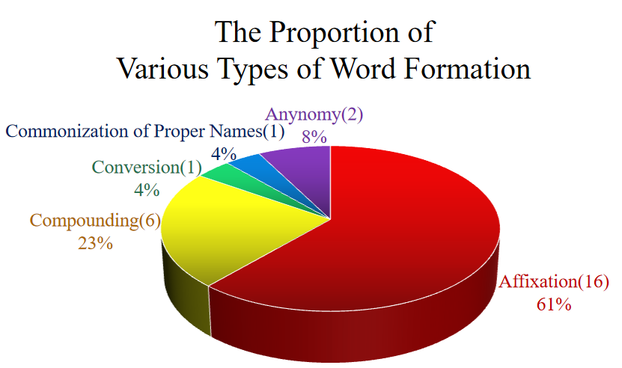

Figure1: The Proportion of Various Types of Word Formation

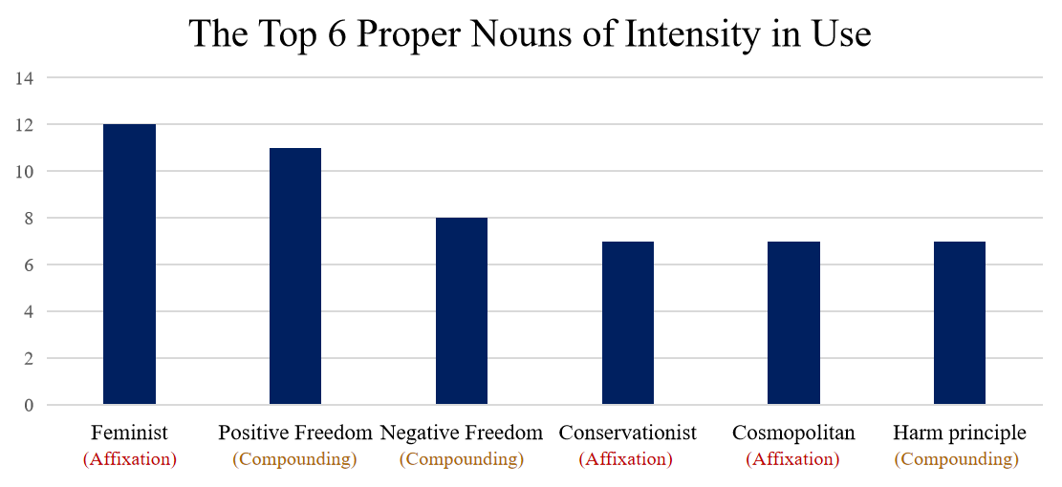

Figure2: The Top 6 Proper Nouns of Intensity in Use

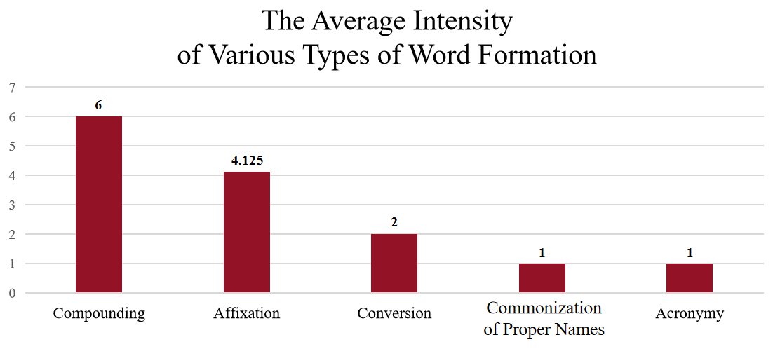

Figure3: The Average Intensity of Various Types of Word Formation

4.2 Discussion

4.2.1 Word Formation

I try to classify the extracted terms according to the modes in word formation, and there are just 5 different types in this term group: "Affixation", " Compounding", "Conversion", "Acronymy" and "Commonization of Proper Names" according to the general method for categorizing (Weiyou Zhang, 2015: 59-105)[9]. My analysis has shown that among these terms, the most widely used modes of word formation are Affixation (61%) and Compounding (23%) (in figure 1), which are in line with the overall trend of English vocabulary.

However, there is slight differentiation in formation between the vocabulary and the terms of political philosophy. In general, Compounding takes the lion’s share (40%) among the approaches of word formation and followed by Affixation (28%) (Weiyou Zhang, 2015: 59-105)[9]. In political philosophy, the situation is reversed and Affixation accounts for more than half in use. I attempt to propose hypotheses about the usage of each method of word formation and provide explanations for the anomaly.

I would like to start with the ones that take a relatively small proportion. Conversion, like "Reasoning", is not the mainstream of word formation in political philosophy, although it occupies a high proportion in vocabulary. The reason why the phenomenon happens probably is philosophers’ willingness to use new words or phrases to express precise meanings rather than using other forms of existing words, as the latter may lead to misunderstandings. However, sometimes they also use Conversion to form the words whose connotation is partial to daily routines.

And Acronymy and Commonization of Proper Names also own a certain proportion. The former may due to specialized system of logical arguments, which is indispensable for any branch of philosophy: "Logic informs nearly every area of philosophy" (Theodore Sider, 2010: 1)[10]. Because of the fixed usage of many obscure words in the steps of logic arguments, the use of acronyms is capable of effectively reducing the reiteration of difficult phrases, and thus alleviate the burden of memory. There are also plenty of acronyms in this field, like MT (modus tollens) , RAA (reductio ad absurdum) and EF (ex falso).

Also the latter in political philosophy mainly comes from the reuse of religious language, especially in Indian Buddhism. It is widely acknowledged that the unique content of Eastern religions has a strong impact on modern political philosophy, and philosophers find it difficult to find current vocabulary to accurately describe the values and actions of believers in politics. So they generalize some transliterated proper nouns, like karma (retribution for sin), samsara (the endless cycle of birth and suffering and death and rebirth) and bodhisattva (person able to reach nirvana but delaying doing this because of the suffering of other humans).

Now I argue that the quantity of Affixation outweigh Compounding is triggered by the feature of political philosophy. With the development of the era and the promotion of overall education level, the values of the masses have become more diverse, and they are more willing to express their opinions on different political issues. By enormously adding suffixes like "-ism" and "-ist" after the word that summarize the core political proposition of a typical type of group, philosophers are convinced they seize the key points in the the field political philosophy: Clearness. This also illuminates why the words formed in Affixation appear in pair (in Appendix), because typical political propositions always align with their identity group. Affixation can effectively avoid some fatal problems: "There one is faced by a difficulty – political and social terms are vague and formless; everybody bends them to their own use." (Jan Srzednicki,1963: 229)[2]

As for the words of Compounding, due to its difficulty in carrying the realistic function like Affixation, its number in political philosophy is not significant. Though the quantity of Compounding words is not too large, but this mode of word formation is actually the most vital aspect in the establishment of political philosophy terminology. So I want to turn to another perspective to continue the discussion: studying the average usage intensity of vocabulary with different word formation methods.

4.2.2 Average Intensity

First I find out the top 6 terms in usage frequency, and half of them are formed in Affixation and Compounding respectively (in figure 2). This result seems normal initially, but if I consider the quantity in figure 1, the proportion of high-frequency words in Compounding (3 in 6, 50%) far exceeds that in Affixation (3 in 16, 18.75%). And the distance in proportion isn’t an incidental. I also investigate the average intensity (average usage frequency) in different patterns of word formation. Compounding also defeats Affixation in this aspect, since the average intensity of Compounding and Affixation is 6 and 4.125 respectively. That indicates the frequency of occurrence of the former is 50% higher than that of the latter in general. I can basically believe that in terms of intensity, words of Compounding obviously has an advantage over other modes.

So the answer to how this the abnormal phenomenon can happen is based on the attribute of political philosophy. As Leo Strauss argued, "Political philosophy will then be the attempt to replace opinion about the nature of political things by knowledge of the nature of political things" (Leo Strauss,2007: 26)[11], so the core of political philosophy is to excavate the permanent law (at least temporarily unchanged) behind the flow of political landscape. And the words of compounding is the best way to carrying this basic principle.

In these segments, 2 main different types of freedom, "Negative Freedom" and "Positive Freedom", even transcend political philosophy and rise to one of the core concerns in entire of philosophy, so no wonder they have extremely high frequency in our analyte, which embodies a very vivid example that words of Compounding play an indispensable role in the philosophical issues. Another prominent situation is the principle put forward by "immortal" philosophers in human society, like "Categorical Imperative" created by Kant, which becomes his "fundamental moral principle" (Duncan Pritchard,2016: 18)[8]. And "Harm Principle" proposed by Mill is "the best known and influential view of paternalism" (Duncan Pritchard,2016: 45)[8].

If the dimension of usage intensity is taken into consideration, the words of Compounding reflect a distinguished merit in the formation of terms. It is able to provide summary words for the universal patterns that exist above the underlying phenomenon often expressed by words of Affixation, thus occupying a dominant position of word formation in theoretical field.

5. Conclusion

From my analysis above, I try to focus on the quantity of words and usage intensity of different word formation modes, and expect to explore the usage preferences of different word formations in the field of political philosophy. Unlike other researches that focus on a specific word formation or simply listing words and their formation, I mentioned areas where different word formation methods are more applicable in the discussion, which can be of help in understanding the generation and application standards of terms.

In a nutshell, the utilization of word formation in terminology of political philosophy is ultimately closely related to its disciplinary objectives. By using word formation to deepen our understanding of various terms, we can further appreciate the mechanisms behind the value tendencies and behavioral choices of diverse individuals in politics.

Reference
[1] Bernstein, Jay M.; Ophir, Adi; Stoler, Ann Laura. 2018. Political Concepts: A Critical Lexicon. New York: Fordham University Press.
[2] Jan Srzednicki. 1963. Basic Political Concepts [J]. The Philosophical Quarterly, 1963(52): 229-237.
[3] Melvin Richter. 1990. Reconstructing the History of Political Languages: Pocock, Skinner, and the Geschichtliche Grundbegriffe [J]. History and Theory, 1990(01): 38-70.
[4] Jean Bethke Elshtain. 1985. The Relationship between Political Language and Political Reality [J]. PS, 1985(01): 20-26.
[5] https://plato.stanford.edu/entries/liberalism/. 06/01/2023.
[6] https://plato.stanford.edu/entries/republicanism/. 06/01/2023.
[7] Mack, E. & Gaus, G. F. 2004. Classical liberalism and libertarianism: The liberty tradition [M]. Handbook of political theory, 115: 124-129.
[8] Duncan Pritchard. 2016. What is this thing called philosophy. New York: Fordham University Press.
[9] 张维友. 2020. 英语词汇学教程（第三版）[M], 武汉: 华中师范大学出版社.
[10] Theodore Sider. 2010. Logic for philosophy. Oxford: Oxford University Press.
[11] Richard O. Brooks (Eds). 2007. Plato and Modern Law. London: Routledge.

Appendix
 | Word | Type of word formation | Intensity: time(s)
1 | Paternalism | Affixation | 2
2 | Feminism | Affixation | 4
3 | (Feminist) | Affixation | 12
4 | Multiculturalism | Affixation | 5
5 | (Multiculturalist) | Affixation | 2
6 | Conservationism | Affixation | 2
7 | (Conservationist) | Affixation | 7
8 | Liberalism | Affixation | 2
9 | (Liberal) | Affixation | 6
10 | Statism | Affixation | 2
11 | (Statist) | Affixation | 3
12 | Republicanism | Affixation | 2
13 | (Republican)  (not include ~ Freedom) | Affixation | 3
14 | Cosmopolitanism | Affixation | 2
15 | (Cosmopolitan) | Affixation | 7
16 | Alienation | Affixation | 5
17 | Negative Freedom | Compounding | 8
18 | Positive Freedom | Compounding | 11
19 | Republican Freedom | Compounding | 6
20 | Categorical Imperative | Compounding | 2
21 | Happiness Principle | Compounding | 2
22 | Harm principle | Compounding | 7
23 | Reasoning | Conversion | 2
24 | Nirvana | Commonization of Proper Names | 1
25 | OA (ontological argument) | Acronymy | 1
26 | MP (modus ponens) | Acronymy | 1
Table1: Word Formation and Intensity in Use of Terms in the Article

 | Type of word formation | Quantity | Total Intensity | Average Intensity
1 | Affixation | 16 | 66 | 4.125
2 | Compounding | 6 | 36 | 6
3 | Conversion | 1 | 2 | 2
4 | Commonization of Proper Names | 1 | 1 | 1
5 | Acronymy | 2 | 2 | 1
Table2: Quantity, Total Intensity and Average Intensity for Types of Word Formation

SCP: Stanford Encyclopedia of Philosophy

