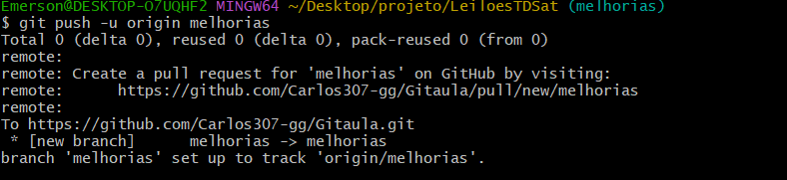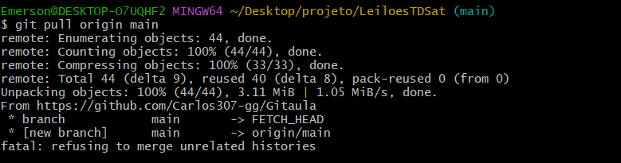https://github.com/Carlos307-gg/Gitaula/tree/melhorias

