8.3.- The natural origin of the deeper patterns on my solutions.

As you might have seen, there is a pattern through all these dilemmas: the power dynamics one and the resource distribution one.

While recording one of the first classes about resource distribution as a side project to this book, when trying to argue against socialism, I realized I was wrong. There was, somehow a deeper truth to unveil. At that same moment, it is all recorded in camera and on Youtube, I figured out the intuitive explanation on the graph theory approach to understand the existence of a State and I thought… wait this all looks too similar. And then, after the video, the questions about private corporations also being a hierarchy yet functioning for lots of people struck and realized one of my main arguments against socialism was just demolished.

Due to life reasons, I had “stuff to do” and delayed the writing. This was fortunate because during this delay I read Robert Michel’s book on how large human organizations with democratic values eventually fall into oligarchies. I loved the book, and I realized that, it felt really similar to my thoughts explained above this paragraph.

This books was written 113 years ago, as of when I’m writing this line for the first time: 30th of December 2025. Yet still, all said felt as if it was written today, the arguments between people, the dynamics etc etc Robert not only analyzed the social group of his time but also realized similar mechanics appeared through history. This was fascinating to me, there has to be some “truth” in these patterns, and they feel too similar to what I’m thinking.

Therefore, I kept thinking, thinking like an engineer. Here are the conclusions I’ve arrived to after all this time of thinking and reading about human organizations.

8.3.1.- The general way of understanding human organizations.

The foundations for thinking about the general case are mainly those explained on part 4.1.2.1.- A graph theory understanding on the complexity of anarchism.

The base principle is that as a society grows by an individual at a time, the complexity of the society, understood as amounts of relations to understand per citizen, grows faster than a unit at a time. This, combined that with the principle of the limited cognitive capabilities of our biological brain and our inability to enhance it or alter it in complex enough ways, creates the need for hierarchical societies.

Recalling from the other section, a society can be simply understood as a complete graph:

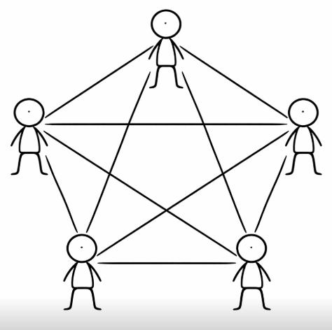

Yet when the limit of human cognition is reached, this graph becomes what in graph theory we call a tree, which its shape should look familiar to as a hierarchy:

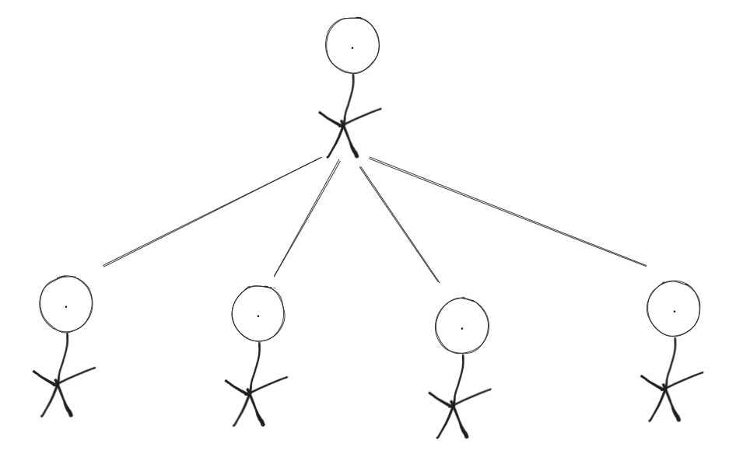

It is called a tree because it visually can be interpreted as an upside down tree. Where the nodes (people in this case), at the bottom of the hierarchy are the “leafs” and the one at the top is the “root”:
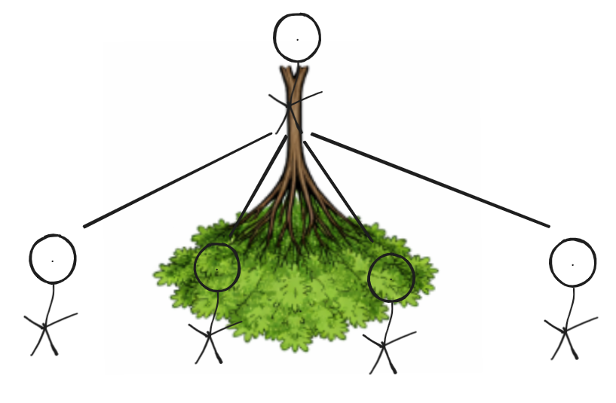

In reality, this is more complex, as the leafs of the tree (the people at the bottom) can have relations to each other, so it might look like:

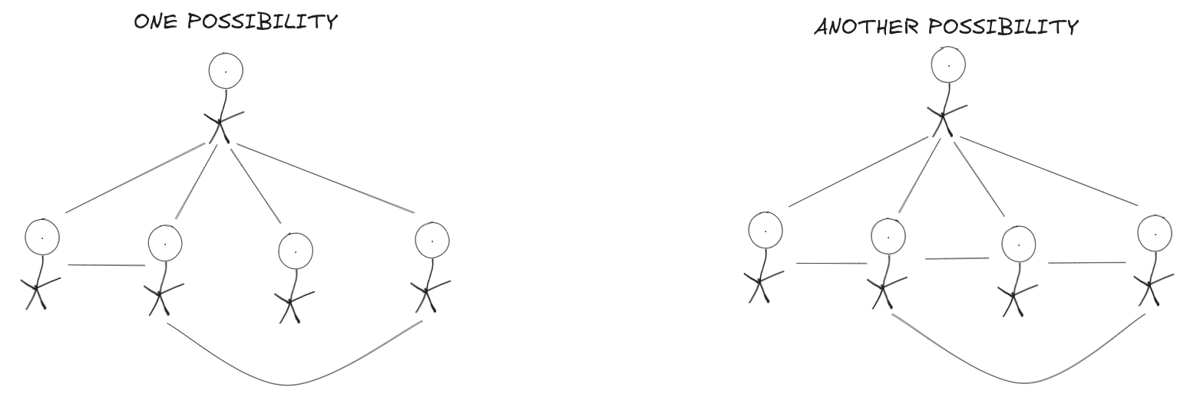
I hope you are slowly getting comfortable on thinking about organizations this way, if you are a software engineer this might be boring to you, please keep in mind I’m trying to make anyone be able to understand this book.

Let’s continue adding layers of complexity to our visualizations to fully reflect reality.

So, in reality, a society does not need to be a complete graph. In small villages or tribes, indeed everyone has some sort of relation to each other and that forms a complete graph, but for example, in a city, it doesn’t. Imagine the “city” has only 5 citizens, the graph can look something like:

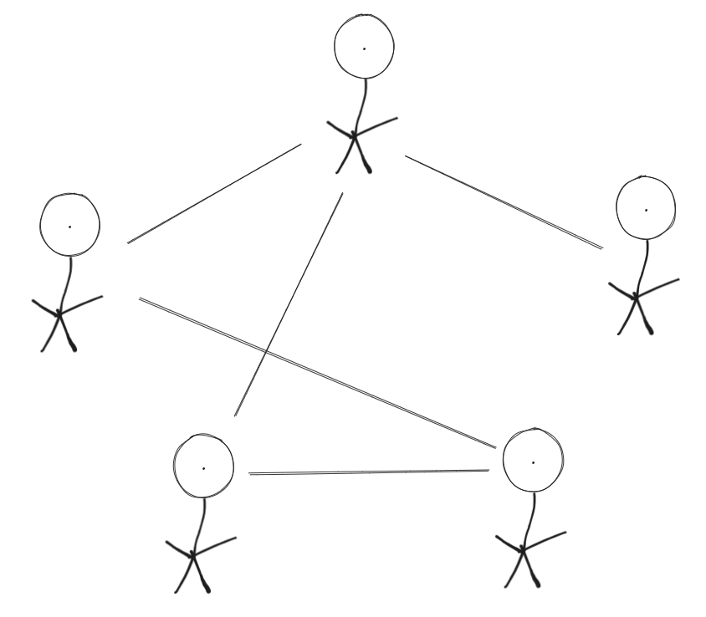

But as said, a city is too complex for a single citizen not to feel stressed, and to feel things as predictable, as familiar enough so to not needing a hierarchy. So a real city looks more like:

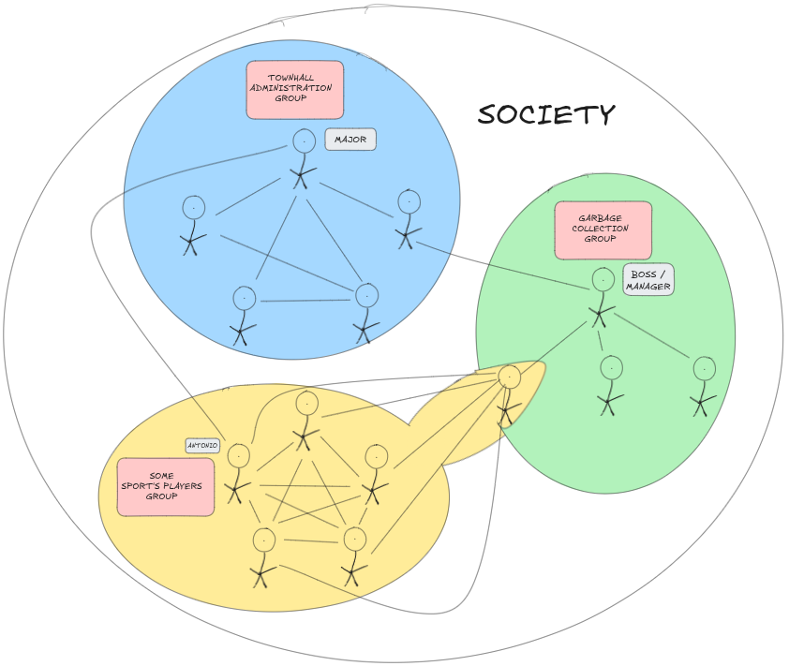

As you can see, this is a way more complex graph. This though, represents better what a society truly looks like.

Lots of individuals that know each other to some extent and which coordinate with each other via the formation of groups, which, if big enough, become a hierarchy.

We can observe in our simple society that we have 3 main groups (the different colors). Let’s note some interesting natural dynamics that can happen in this society.

Note that, the sports player group is not hierarchic, as it is a complete graph. The amount of people who play that sport and the complexity of that sport are not that big so as for the people in that group (or community if you like) to need a hierarchic organization. However, coordinating the garbage collection system, even if they are less people, can be such a complex task that does require hierarchy, like the town hall. As we have seen, this means the variables that needed to be handled per individual carrying out the action grew too large.

Now, as you might see, there is another sport player that works as a garbage collector. This showcases the existence of hobbies alongside main occupancies to make money (jobs) in a society. This also showcases how groups are a dynamic and interconnected thing. Not isolated islands. And we can also observe that the sport’s group might grow in the future if the employer convinces the manager to hang out with him after work to try out the sport and he eventually likes it. This fluidity of the groups is what leads to spies and other kind of phenomena in real life you might be familiar with.

As the sport’s group grows, the complexity will do so and it will eventually take a hierarchic shape. Possibly even becoming 2 distinct groups, 2 sport teams. Possibly requiring now a central coordinator to set the general rules in case these 2 groups want to play against each other in a tournament. Coming back again to a hierarchic structure:

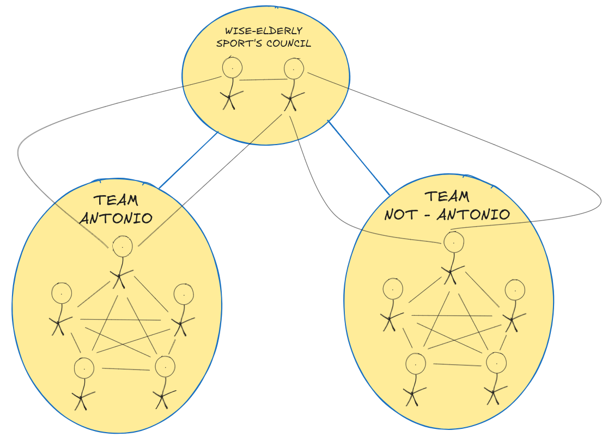

As you can see, the natural flow of things in this still small but complex society happened to create a council with 2 elderly citizens (very experienced players on their youth) which happened to know people from each team, therefore both teams trust their knowledge and their friendship so they actually become impartial and generate good rules for exciting competitions.

Highlighted in blue lines you will find the meta-hierarchy, the new hierarchy formed, the sports federation, the sports institution. On black you will see all the connections between the people, who personally knows who.

We can learn something really natural about this example. When needing to solve complex organizational problems on a society, people tend to find a “leader” or “organizer”, on someone who has expertise and who they actually like, therefore trust, therefore it does not stress them giving them organizational power as they are friendly and therefore predictable, which reduces stress and generates trust.

Coming back to the first complex image, we also see that groups are not isolated as its members are not. At the group level though, it can happen that the town hall does control to some extent the garbage collection group but has no influence on the sport group. Yet, because they all live together in a physical space, they all can know each other regardless of the groups they belong to.

Each person, as per their personalities, desires, and “desires and needs” of their own group will behave in some way or another, it will vote or follow some rule and maybe not another one. Sport team will enjoy the construction of a new stadium, whereas part of the garbage collection team might not care at all, sure, the one who we can see that also plays sport will like it.

But what if the money is limited and we have to chose between a new stadium or raising wages to garbage collectors? Then a complex decision will be put upon this sport player who also is a garbage collector. Will he prefer its passion for sport or the ability to do more with more money? The answer to this question is really dynamic and quasi-unpredictable as it depends on lots of factors. We can see in the graph that there at least 5 relationships influencing this (the other sport players), 1 desire of playing the sport better, 1 desire more of earning more, 1 desire more of not being fired from the garbage collection organization if he votes against the wage increase…

If for whatever reason he decides to go against the salary increase, the manager on its own (dictatorship-like), or in an internal voting of the group (democracy-like), might opt to kick him out. Here we observe that the formation and destruction of groups is dynamic not only at a personal level like with the example of the worker inviting the boss to play the sport, but also at a internal level from withing the group. Adding way more layers of complexity to the matter.

Let’s now notice another dynamic, Antonio from the sport team knows the major, a powerful figure. Therefore, if the sports grows too much and ever has to decide a leader, Antonio might be more likely to become it because he has a greater influence in other important groups.

This explanation of the dynamic is slightly messy on purpose, so you can feel the complexity and difficulty of thinking about each of them logically with all possible combinations.

Societies are in fact way more complex than this, religious groups, bureaucracy groups, other thousand more jobs groups, each with different needs to carry out their job, endless friendship groups that are born and die, family groups, sexual groups, hobbies groups etc etc

However, there are dynamics that appear over and over again. Like the one Robert observed:

- There is something about large human organizations that is inherently, naturally, hierarchical. -

Then inside those organizations, different dynamics arise which tend to consolidate on the formation of an oligarchy so the group does not disappear and can keep functioning.

Sometimes, the thing to do so the groups grows or does not vanishes are contradictory with the things its members are meant to do. Making it feel like the group itself is a living organism, an emergent phenomena that behaves differently than the parts it is conformed by. How can that be? How can that make sense?

This usually happens, as we saw, when economic incentives of members within a group differ, like for the sports player but at the same time garbage collector man. If you analyze the system on its own, and the actors into play, you can “understand” why it happens, but just for the specific cases. You would be understanding it “economically”.

In the case of the voting mechanism to maybe kick out a useful worker, you would be understanding it “poli-tically”. Because economically in this case, it doe not make sense to kick a useful worker. The only way this starts to make sense if you understand the social part of it too, the city, the polis (which means city I Greek), and the dynamics of desires, which need power of action to be carried out. In this case, you would be going down one extra layer of complexity.

But how deep can you go? How can you find the deepest “truth” that helps you reason no matter how complex the system (society) you are analyzing?

The deepest you can go is to the the individual and its free, natural and unavoidable ability to belong to multiple groups, which its initial creation is also shaped by individual interests or needs that lead to the formation of the group.

And as we know and you know by living your own life, the desires and needs of the individuals are ever changing influenced by oneself but also the environment and beings around. The fundamental reason for this is adaptation and survival. The boredom or the hunger reactions that leads us to explore so we better adapt or jut keep existing.

The social dimension is needed because we can not survive without others, and the individual desire is born as a way to move us to find others in case we are completely alone and so to create a slight extra randomness to promote adaptiveness to our also “randomly” (unpredictably given enough time) changing environment.

Hierarchic organizations are a a logical deduction from the way living beings keep being what we call alive. Creating order from disorder. Creating predictability from unpredictability. That is what living beings do.

Therefore it even makes sense the “emergent phenomena” of these patterns also applying when groups, organizations, start to feel like they are alive on its own, independently from some of its members.

Just as an individual use the fixed-variable resolution technique and defines temporary “truths” we might call beliefs, organizations parallel and execute this behavior and higher levels by creating laws, rules.

Because all these observations, I think it is correct and useful to aim for a great societal organization shaping its rules and dynamics based on individual or small groups dynamic principles. Like I’ve been doing all along the book.

By the way, doesn’t the graph I drew on the complex society look to you like biological cells? Doesn’t it look like amoebas merging when the sports player is also a garbage collector mixing the groups? Fascinating.

While writing this book and when I while I was reading Robert Michels book,

We can have a deeper analysis on the third factor, is the violence of neighbors also a natural tendency due to its size also being big? Is violence a sign of societies who grew too large for their intellect? Most likely, as of my current thoughts.

Might here reside an intuitive understanding to the statement from Robert Michels, rephrased a bit: “There were there is organization, there is an oligarchy.”?

Very interesting and more curious questions can be asked from here: Could anarchism be possible if we manage to create smaller societies? Is this the path to an assured world peace? Can technological advancements in information processing increase the threshold from which anarchism starts being impossible, therefore, can we create big anarchist societies through technological advancements in information processing capabilities?

What should we do in our reality where anarchism is not possible? Sure, if we can not fly we should not just jump out of planes. If we can not be anarchist for now, should we then not vote or promote anarchist-like behavior?

8.3.2.- The most fundamental argumentation in favor of democratic organizations.

The realization on how and why societal structures parallel living beings unlocks new strong arguments in favor of decentralized and dynamic systems.

We can now confidently observe and understand simple yet thriving organisms so to get inspiration on their mechanics to better shape our institutions. Let’s take one of the longest living beings which also happen to be the simplest: the cell.

TO THINK:
Maybe make this sections marked as incomplete and complete them when the idea of feedback loops is propely defied???Feedback loops and error correcting codes, physical (social), unavoidable noise that deters integrity of information (abusive traits, envy etc and personal non-subjective limitations)

5.2.2.4.- A naive critique to libertarianism.

Now coming back to where we left the previous section.

Libertarianism is not perfect, essentially because free people can still take bad decisions. So it can also lead to inefficiencies. Decrease the citizen’s intelligence factors’ values on the equation from before to see that the equation also mimics this mechanic.

But socialism and communism nowadays have guaranteed incredibly obvious inefficiencies. Sure there are lots of factors coming into play, and it might not be the fault of the resource distribution protocol, but at this point after years and years of history, just by taking an empiric, data analytic approach, we can conclude in a not that crazy way that these centralized protocols are just worse in our current era.

However, it is not useful to throw an apple thousands of times and see that it does fall. It is useful to understand why it falls, or at least, exactly how it falls, or where it will fall. Therefore, a complete rejection and/or censorship of the inefficient protocols is the least scientific approach you can have, the least adaptive approach.

As it should feel familiar by now, all protocols human invent are not appearing out of the blue, they are based on our nature and experiences, on who we actually are, and neglecting part of them would be neglecting the understanding of a part of ourselves. And as seen, a one-eyed approach is just not the most effective way of solving problems, we would likely be fixing way more variables than needed.

If we want to reach an utopia we must understand the basics, their mechanics and relations and not blindly follow forever a protocol or blindly ignore forever other despite of their repeated inefficiencies.

My father always told me: “Hasta el más tonto te puede enseñar algo.” (“Even the dumbest person can teach you something.”). That phrase encapsulates fairly well what I’m trying to explain in these paragraphs. I will clarify that with this statement I’m not calling any protocol dumb. As we will see later, there are more factors than dumbness that come into play when taking conclusions of this nature.

For the sake of critical thinking, even if I’m a human with libertarian tendencies as you can read so far, I will explicitly leave here a section criticizing it, even though I think it is a great part of how a brighter future can look like.

I see a possible reality, in decades or a century, where humans live in libertarian societies where they take decisions with the aid of AI and communicate with their neighbors more peacefully and transparently using trustless CDNs technology. Leveraging these decentralized or trust-minimized databases to minimize betrayal and corruption.

But before elaborating further on how these technologies impact resource distribution, let me critique libertarianism a little bit.

This section will be an exception. I will use libertarianism as per its current perceived social meaning. Not purely as the definition I gave at the beginning of the chapter.

I'm an advocate for libertarianism, but I acknowledge its imperfections. It operates on the hope that individuals will act wisely when shaping their life's path, which isn't always the case. Hence, I believe there should be a socialist touch when educating people, whether in public school or in the family household, about the importance of considering others and the medium to long-term consequences of your actions in them.

It is true that libertarianism already considers others in its discourse, I just want to emphasize that, in my opinion, it clearly requires a greater highlight with a clearer definition.

The problem with libertarianism is that, spoiler, it is actually very similar to socialism and it has been branded in modern times as something fundamentally different. Both are protocols that require a State and some public resource distribution, the difference is not fundamental, it is in percentages of public management, in gray areas.

Yet people are consistently told that libertarianism is fundamentally different. That it is the supremacy of the individual allowing him to create its own life project. This is not fundamentally different from socialism. Let me elaborate.

Labeling these 2 protocols as completely different leads to people justifying their actions with an ultimately authoritarian argument: you must respect the individual, me. Which, if delved deeper into libertarianism you realize it is not exactly like that, but in our simplification lead society people eventually think like that and it becomes problematic.

My critique to libertarianism is that it needs a re-branding, it needs to be explained with a socialist touch, because that is ultimately what it is, “a softer socialism”. Correctly speaking, the softest statism. Let me keep elaborating.

Libertarianism says that you, the individual, are the supreme leader of your life and everyone should respect your life project and ambitions, yet just as long as they don’t cause damage to other people’s life projects.

Sounds good right? Well this is actually useless even though it is a true sentence. It is like saying: Apples are blue as long as they do not become red. Why this?

It marks the individual as the unbreakable, impregnable unit of society. And all action should be taken in order to respect the individual as he is the supreme leader of his life. But, only as long as he is not negatively impacting other supreme leaders of their own lives, other humans.

These negative impacts you can have in other lives are commonly known to libertarians as: negative externalities.

But… what if I got a definition of what I want that aggressively clashes with what you want, who decides who is the actual supreme leader of its own life? One of us has to get the supremacy and become the leader of its own life while the other doesn’t. Then what? Libertarianism is true for some and false for others? Indeed.

And if you coordinate your society in a truth that only applies to some, even if they are the majority, you will still for sure be acting in an inadequate way to other realities.

Not necessarily in all situations, but eventually the supremacy of one individual will come at the cost of the supremacy of another individual. Basing your line of action in the freedom of the individual is impossible. Because it is impossible to not suppress any individual in a society forever.

You can’t always be the supreme leader of your life if you are surrounded by others. Humans will never be, we have always needed and depended on each other since ancient times. It is in our nature the need for coordination with others, whether through cooperation or domination. Thinking it is possible for individuals to always be free is anti-natural and false.

Even matter does not follow this principle. Matter can not do whatever it wants, forces move its parts, and if they are moved against other parts, they will clash, and then the greater force will determine where matter goes. The simplified understanding of libertarianism from nowadays society would make people think that each force would be applied independently from one another even when they clash. And, well, it is just not like this. People will think that the matter will move in some direction and ultimately it won’t, worsening their prediction capabilities, essential for solving problems.

Saying that individuals are the shapers of their own life-path as long as they do not cause negative externalities to others’ paths is an always true, useless phrase. It’s like saying apples are blue as long as they do not become red. It is like saying two objects traveling in parallel lines through a 2D space will never clash as long as they are parallel. Because of course a human is free until someone else appears, and of course that someone else was doing whatever he wanted until I appeared.

“Something is always true as long as it does not become false”. Logically true, and useless.

We humans need others to survive, we inherently have a natural dependency on others. Basing all decision making or repeatedly arguing that we are the only one who decides our life-path leads to some inconsistencies and conflicts in coordination.

So no, I do not think relying solely on libertarianism will make this world an utopia because of how mindlessly this useless core phrasing is repeated over and over again in the hope of differentiating it from socialism.

I do not think libertarian principles, even though it mentions it vaguely accepting the need for a State, ultimately focus properly on the real empathy you need to coordinate a society as efficiently as possible.

Do what you want but if you cause negative externalities to others you will be punished. Then it can’t always be what I want. Who defines what a negative externality is? The individual? Which individual? You? Me? Different things bother each of us and the clear definition of what things are a negative externality will change depending on who you ask to.

In survival related matters, most of the times, we can agree, as we all need food and water, yet, when societies thrive and happiness becomes the next goal, then a clearly subjective matter joins the chat. Note that I did not mention security when talking of survival, security is eventually a perception, therefore it has some degree of subjectivity which can lead to disagreement too.

To agree upon this natural subjectivity it is why libertarianism defends the existence of a State, as minimal as possible, but a State. A State that rules over the individuals while at the same time governs for them...? That will, unavoidably, be true for some and false for others.

Libertarianism has premises that are incompatible with each other, a minimal State next to individual freedom? Next to respecting private property, freedom of association? I doesn’t matter with how many words libertarianism tries to describe the freedoms of action of an individual, these won’t be real freedoms, in the sense of created by the individual, these will be allowed freedoms. Allowed by the State and by society. With a State freedom will always be suppressed to some extent. And even without it too, by unavoidable natural forces and social ones.

In the same way, socialism has no fundamental difference with all said. People in the socialist protocol still have the ability to own stuff, to move and decide their path, as long as they obey the State and do not bother neighbors too much. So, people under socialist societies are also the supreme leaders of their own lives as long a they do not cause negative externalities to others.

Libertarianism is just the softest of the socialisms. And not being able to clearly acknowledge it from the get go is libertarianism’s weak spot in modern times.

Because if you mindlessly deny it and think it is fundamentally different than socialism, you are accepting the supremacy of the individual regardless of negative externalities. You are accepting the impossible, the abuse over others justified on a: I’m right because I say so, because I must be respected. And that eventually creates conflict with others. Likely fueled by arrogance.

To make libertarianism really fundamentally different than socialism you have to delete the negative externalities part. Because freedom of individuals unless they bother someone else requires a State to control, just like socialism. If you delete that you do not require a State and humans are truly free.

Unfortunately, you can only delete it from the phrasing, but not from reality. We are social animals. This is the fatal mistake of libertarianism these days. I like it though, it has a very clever and simple design, but, as far as I’ve seen so far, it committed a deep marketing and phrasing mistake. Its contradictions, and the lack of emphasis about them limits its efficiency.

But, to be fair with libertarianism, all ideologies seem to fall for continuously ignoring their natural contradictions and then not to give up on their justifications with lots of books of hundreds of pages. To be even more fair, this time with all of them, I can be wrong as I’m saying all this having read close to none of these books. And I might never will, as they start with nonsensical premises. Who would read a mathematical proof that starts assuming that A is B and B is not A. It just feels pointless to read, I feel it is more useful to live, talk and think on my own.

I wonder if this continuous logical-blindness of people married to ideologies arises from the simplification of truths need which the non-linear way in which social relations scale on societies creates. I’m referring to section 4.1.2.1.- A graph theory understanding on the complexity of anarchism.

Likely, all this behavior is just the natural need for humans to fix some variables, even if they make no sense, so they can start thinking and solve a close in time problem to them. Then, after you have put so much effort and time into building a big, yet flawed to some extent, understanding, your brain will do anything, like writing tens of books, to not destroy the base and then needing to maybe start all over again. It is like if our brain had a tendency to refuse to acknowledge that the energy spent might have been futile in some cases.

Is Cheerfulism doing the same? Am I doing the same? I do not think so, because, in the definition itself of this -ism, Cheerfulism, I acknowledge the ever evolving cyclic nature of rational thinking and with that, I embed into this human philosophy what others seem to forget, the natural acceptance of the theoretical impossibility of absolute knowledge. Mixing it with the thing that makes knowledge, whatever that is if it even is, practical and usable, happiness. This is getting close to metaphysics, I wrote about it later, let’s come back to ideologies and the naive critique to libertarianism.

These days, communism is build on a straight up wrong premise of any human productive interaction being an abuse, libertarianism is build on a useless ever true premise explained inadequately, and anarchism is also build on a straight up wrong premise in history so far. This one being that humans never have extreme discrepancies with each other and can in practice just not to abuse. Socialism might be the truest protocol to modern human reality.

Yet, even with all this, for reasons that will be explained along the book, I think we should aim to get away from socialism as much as we can and try to be as libertarian as possible.

Interestingly enough I reached this conclusion without thinking about freedom or subjective terms, just about biological human facts on happiness and information processing capabilities.

So, summing up so far, libertarianism’s mistake was to brand itself as something fundamentally different to socialism. Likely this happened due to the human nature of needing a differentiation of 2 concepts to start thinking, fixing some definitions, even if non-sense, to guide themselves through life. If you have a true, there must be a false, and from that and little more we build logic. If you have socialism, there must be an anti-socialism, so we can start reasoning along whatever problem we are trying to solve, and we created, fixing too many variables, libertarianism. And when we weren’t being able to make the variables vary again quickly enough, we created the absurd simplifications of our modern society, like risking thinking the individual is the supreme leader of its own life, which lead to significant misunderstandings and coordination conflicts.

Then, some shitty inefficiencies of coordination are potentiated by political actors utilizing the tool mentioned in chapter 4 to oppose people with simplified concepts to gain power. The potentiation came from the political class selling this mastery of theirs on the confrontation technique to the highest bidder, the richest, wether nationally or internationally, so they can better influence their wealth in a forced way, the resources they “own”, and make sure they never lose them, and sometimes, that they will have more. Even though some others, poorer, less free, might lose them, and did lose them. Some of them even lost their most precious resource, life. This is one of the risks libertarianism has. And, being fair again, socialism too, both. In the end this is a risk arising from pure power dynamics, from a State.

The thing is that this section is a critique to libertarianism and so I will continue this phrase writing that libertarians sort of lie to themselves, they think of their ideas as perfect, as if they can even counter human nature. But ideas, ideas are, and reality, reality is.

We created an ideological belief where everyone can, but specially powerful individuals, specially the richest, can repeatedly think they have the right of holding power thanks to individualistic principles, promoting arrogance.

Some keep thinking that the individual is powerful, mighty, very wise and intelligent, specially if they managed to gather so much money. Thinking that their money is their ultimate representation of their worth and they must do anything to protect it. Thinking that their dominance-based freedom, therefore it must create submission, is at the core of their existence, they think it is a natural and normal freedom to have because the individual is the supreme leader of its life, and not thinking about what it actually is, a power.

And because everyone else is a supreme leader too, if they agree using money, that must 100% correlate with that they agree to be enslaved if they are poorer than you. They keep thinking that what deeply defines an individual at its core it is not its happiness, it is not its empathy, it is its freedom, the capability to do whatever you want, regardless. Which in modern societies this is granted by having lots of money.

So they see that, hey I can do whatever I want, I might as well just do it, and I will do stuff that potentiates my freedom, because what truly matters is freedom, that is the ultimate goal of an individual, the ultimate goal that generates wealth for everyone, because sure, I know better, I have the right to know better. The State is there in case I was doing wrong, if I did not have the right to do better they would have stopped me right? So what I’m doing must be right, justified.

And, if for whatever reason I bribe the State, why is that bad? At the end of the day the State exists because supreme leaders of their own lives, individuals, created it, so even if indirectly, they agree on me bribing it. And, anyway, I have more money, I managed to be freer, I managed to be worth more, so why not my opinions and desires be worth more too? Furthermore, why can’t I spend my money freely? If I want to “support” my politician friend I will do so, because we are meant to be free and I, the supreme individual, have the right to be free, regardless.

So what if I influence the State, why lean towards a democracy that would give power to poor people? That is dangerous, these people have been proven to not be able to provide value for others, by the all-mighty impersonal market. So let power better be in the hands of the proven ones, either the rich or very knowledgeable ones, let’s aim for a mix of plutocracy (power given to wealth) and technocracy (power given to the wise and technical in different fields of knowledge).

Hey reader I’m back. Now, do not get me wrong, I’m just describing the risks and thoughts that individualistic principles can lead to, I’m not stating how often they happen. In fact and for now, I’m not even stating if these thoughts are good or bad, I might be labeling them with adjectives associated with a bad picture as per nowadays culture, but remember, life is gray, you can define spectrum using the positive or negative ends as reference to influence how your discourse is perceived. I’m doing just that, for reasons I hope you later understand.

Even if what I wrote in the above paragraphs might sound bad to some we mut admit that, powerful people and rich people, the ones who are more free, can take good decisions too. In fact, to some extent they have taken them more often than not, otherwise the overall life quality on Earth would not have increased. I was just describing the negatively perceived consequences which the core of libertarianism leads to sometimes.

Sure, if you are free, you can be exactly who you want to be every time. But that does not mean that freedom is who you are. Furthermore, being free comes at a cost, what cost? That behavior is not natural, we are never born to be completely free, that is not our natural state. We need each other, and an excess of freedom will at some point correspond to chaos somewhere else, and the slavery, understood as loss of freedom, of someone somewhere else. They will lose more or less freedom, maybe the freedom they lose is just that they can only chose between 4 brands of drinks instead of 6, or maybe, in the worst cases, they lose the freedom to rest their bodies properly, a.k.a. work exploitation.

Trying to artificially create the natural freedom of the individual by giving the artificial right for power to money won’t make us escape from the truth that, we will never create a natural good life that feels good for everyone’s nature if we forever create artificial anti-natural behavior based principles to guide us through. The blind focus on freedom make some forget about power.

Focusing on freedom has been the most effective and efficient method so far, but it has limits, because it is anti-natural in the sense that it contradicts natural human behavior. Even if it is the best we have so far, it does not mean we can not create something better or it does not mean it does not have negative side effects.

The market is not perfect, it will never be. Because it is driven by the subjective desires of humans, and humans use action, power, to satisfy them. The market is just the best imperfection so far.

We did not come here to be free, biologically, at the core, we are here to survive and try to be happy.

Anyway, they think money is freedom, and it is under our modern context, the freedom of the holder to force you to do what he does not want or can not do. Then these people might want to abuse directly, or they might want something that indirectly abuses others, and in their arrogance originated on the libertarian principle and fueled by the impersonal and infinite power of money they will take a while to realize they abused. And then they will take a while to say sorry, or fix the mess. Because they will eventually have to, because we are social animals, and you can not escape that, not forever, regardless if you think yourself as a god of freedom.

All this creates a tendency for lots of people to not properly think about others’ real needs, their own real needs even, and just indirectly, and likely unknowingly, abuse them and abuse themselves.

I think we all can imagine a modern nation that behaves like this pretty frequently. But names do not matter, I’m not seeking blame nor revenge, I’m seeking to thrive, to understand, to cooperate, not to dominate or to be free, but to be happy.

The described behavior feels very natural given the historical context. As the richest have not been intelligent enough to realize, or have just been blinded by individualism-based arrogance and the abstract nature of money.

Money producing money, saving, investment of private goods, what is commonly perceived as that thing called capitalism, is not bad. Storing money reflects the natural tendency of a human to store meat just in case winter comes. Investing it, reflects the natural tendency of humans to optimize their meat management. In fact, it is the only way so far we can coexist and live together being as many humans as we are. Without money we would be killing each other way more frequently. The problem comes with what you use that money for and what is moving you to use it.

As another example, shallowly mentioned a bit ago, of issues derived from individualistic arrogance we can see how rich people or entities saw the service of, cheaper in less democratic countries, buying an assurance that their resources distribution rights (money) will not decrease, so they bought it. Buying politicians, resources, terrorist even, influencing the world in such a way that their wealth is protected. Libertarians will say, but that is the State’s problem, that is easy to corrupt socialism, it is socialism’s fault! Then I would answer, but hey, you also have a State. You might be better, but just the lesser evil. Not the objective good you tend to think you are. Yet, to be honest, I would probably just not answer. Because discussing this problem from one-eyed ideologies is kind of futile and has already been done for enough years already. Having similar conversations as the ones our parents had will not generate a real progress in the understanding of the matter and it will lead to poorer or non-improving solutions. I will propose later better methods of analysis.

Now we must not rush into blaming nor aggression. In the same ways citizens are not intelligent enough, the political and richest of people are not either. They must soon become Cheerful too. The same way you can not blame yourself for not developing efficient learning skills, because there is a whole system in place promoting you do not, you can not fully blame rich or powerful people for abusing their power to protect their wealth, and then justify it with their right to be free, or their right to enslave you if you want to say it harshly. The very same system, even our nature sometimes I would dare to say, makes the indirect or direct abuse of the powerful through freedom maximization a real risk that they do not really realize and limits their ability to think further, to think about more complex and fundamental principles. Then, as any human does, they strongly follow their herd, their system.

As said, some might just be evil, psychopaths, but I think most of them are just dumb or too ignorant, lacking creativity. Because at the end of the day we are humans, and if citizens have these problems caused by these human traits in the observed proportions, then, why would powerful people (from capital wealth or political power) be special and full of psychopaths? They are raised in actually very similar ways to us. I still do not know “politics-powerful” people, but I know rich people, and I am optimistic that they have the same root of problems as the citizens and in similar proportions. Powerful or not, everyone seems to be limited by the same things, and we just have to adapt to deeper truths, leading to better coordination, by becoming more intelligent.

Let’s finish this section. Here are more risks “of” libertarianism. Thinking of yourself and others as the owners of your own lives makes you see each other as competitors, denying full trust. If I’m a god and he is a god, and if I can do whatever I want and you too, you might some day want me to not want something. Fueling distrust. And deep in your brain, even if you do not realize, subconsciously, because you are human, you know that any of you are actually a god of freedom. You will create in your head the image of you and others being an unstoppable force and an unmovable object at the same time, things which its existence, by definition, is incompatible. The fundamental lack of logic in your understanding will create stress, your human nature will create fear, you will fear the other, and afraid dogs are the ones who will likely bite. Because you are denying the truth, you say you both are always free and respect each other’s freedom on the surface, but in reality you are not, you can not, not always, and that fuels distrust, promoting aggressive competition over cooperation.

Let competition be it, libertarians will say, let perfect competition be it, they will say, let the free market decide. And in theory, sure, but in reality, the free market is anything but free and perfect. The market are humans, and humans are not free, we are social animals. Disguise it with different wordings if you will, fool yourself with your own words if you will, but no-one is the supreme leader of its own life. And market is not objective, it is subjective and power based.

Furthermore, there is not such a thing as human perfection. Perfection is subjective. And we must embrace that, we must find a way to operate with that, not to negate it.

Competition is not a good sign, if you are competing is because there has to be a winner. Why? Because life is a zero sum game? Because we lack resources? Or actually because we have too much unnecessary desires? What are we competing for that is scarce? Food? Water? Freedom? Time? Happiness? Trust? Why not cooperating instead?

The world is currently facing an issue way deeper than any economic theory can explain, than any political theory can explain. Than any of them both together can explain.

Because the issues stem from misunderstanding intelligence and happiness. From misunderstanding human instincts themselves. And then failing to successfully leverage them.

We face the challenge of taming our ancient-selves, our true selves. Controlling our instinct to dominate our fear, this time economically speaking. In a similar way we can control our sexual desires and not rape if rejected, we must do that so, but economically and politically-wise.

Wealth increased because we increased our capabilities with technology and we had a really crazy high step up in technological efficiency. There was more for everyone, and even in a freedom first tendency, everyone could just have more without abusing.

Yet after the invention of the internet, progress slowed down for some decades. And the true nature and limits of our understanding started showing up. Our true limitations appeared. We got too used to unlimited potential, addicted to our lives feeling better thanks to the improvement of resource allocation driven by technological progress, but not because of a significant increase in intelligence or in our happiness understanding and control.

We have naturally disregarded intelligence and happiness by decades, because more resources were available, because better ways of organizing them were. That made us freer, and we confused freedom as the source. But, in a parallelism way, like said in the power dynamics chapter, we can’t run to uncharted lands forever. Once there is no land to run, so once there is no new technology to give us more and more sparks of happiness due to discovering new more optimal stuff, then we must dialogue or fight.

Happiness has not been as cheap anymore, we did not have crazy technological discoveries for decades and some started hurting each other, stealing resources from each other, just to feel something. We had to slow down our exploration and forgot to enjoy life while becoming addicted to the high amounts of happiness that frequently discovering fancy new things brings. Like an addicted person who needs more of that drug, we need more of those fresh new resources, more and more. So we create wars, to dominate and abuse, to have control and get easy solutions to satisfy our addiction. Even if it comes at the cost of other humans kilometers away.

In the same ways drug addicts don’t even think of their addiction, societies don’t even think of their unnecessary abusive actions by using simplified truths, yet they called them ideologies to sound intellectual.

We praise the freedom that allowed us to explore, to feel the happiness rush. We got addicted to it.

Fortunately we got AI, which will clearly increase productivity, yet it will just be like a drug addict injecting another drug dose to the blood stream, how much will it last until we start suffering again from withdrawal and start driving crazy?

Fortunately, now we have Cheerfulism too. Which will allow us to understand ourselves and each other better, tame our instincts, and coordinate based on cooperation as much as possible and not based on domination like junkies on the street. More on chapter 7.

So, does all this make libertarianism actually something good in concept that has just been misunderstood? Is it truly flawed?

Indeed, it has just been inadequately explained and misunderstood. This has lead to the appearance of similar risks to the ones described. As mentioned in the previous section, libertarianism is really logically optimal.

All these inefficiencies would not have happened, or they would have happened way less frequently, in a Cheerful society. One where people care as much as they can about detail, about seeking detail, seeking understanding, questioning, exploring and all under the common goal of happiness.

5.2.2.4.1.- Why happiness over freedom?

If you get clever enough, you can deduce similar risks for people who fix as the core priority happiness. So why should we chose happiness over freedom?

First, it is not one or the other, it is which one should we prioritize and use as the main guidance.

I think a better engine, a better core principle that leads to more human well-being can be reached if we focus mainly on happiness and not on freedom, because it is more natural and its search is always real, all the time, regardless.

Sure, only after survival is granted. But freedom operates in the same way, no-one seeks freedom when they starve, they seek food. I’m assuming granted survival as said earlier.

People gather and party together, they bond together, because they are ultimately feeling happy, not because they are feeling free. Freedom can make you feel happy, and that is why we ultimately like it and can get addicted to it. Not vice-versa.

Any source of happiness brings the risk of addiction with it. Some are easier to fall into, some are harder, but all do bring the risk. This is another reason why we must not ignore the intelligence part.

Regardless of freedom seekers or protection seekers, if you seek happiness, you can talk to both and they will not perceive you as the other, because you have common ground. Because happiness is a deeper shared truth, it can help us coordinate with less conflict too.

As a metaphor for this. Libertarianism and socialism are a couple that broke up due to misunderstandings and lack of communication lead arguments. Cheerfulism would be the common friend who still hangs out with both, which is listened by and listens to both, and has the capability of fixing the relationship in the future.

When we guide ourselves based on deeper principles that always hold, we can reach deeper understandings and reach greater goals by crafting more effective and complex solutions. And for successful guidance, regardless of what is the core you choose, regardless of freedom or happiness, you have to mix it with the maximization of intelligence for optimal well-being and being able to handle chaos and uncertainty, which conform risk. Cheerfulism is both, happiness and intelligence.

I do not dislike freedom, as said I’m an advocate for libertarianism but I acknowledge its imperfections. Libertarianism is build upon a belief, like a religion. That is not good nor bad, that is just how humans operate. I do sometimes use libertarianism and guide myself taking it into account, because it is natural to do so.

But ultimately I’m Cheerful, I can only think of deeper principles always true when I think of happiness, and that, overall, always leads to more understanding that has greater potential of prosperity.

As a scientific parallelism, some Einstein equations can be “simplified” logically and correctly into Newton’s ones. This doe not mean Newton is always wrong, the same way in which putting individual freedom at the core is not always wrong, it just means that Einstein’s equations hold true for a larger set of reality’s contexts. Happiness focus would be Einstein, Newton would be freedom focus. However, you need to be intelligent to discover and use any of them.

Sure, the same way I messed around with libertarianism, you can criticize, let’s call it happynism, using only happiness as guidance. The simplest example of a risk of that is someone deciding to abuse drugs to be happy and then he drives on drugs and damages someone else accidentally. The same way someone can abuse others for the sake of “I’m the sole builder of my life path”, they can do so by thinking “I have to be happy”. This is what intelligence maximization is meant to minimize, more on how later.

Sure, we can create a new philosophy, libertarianism mixed with intelligence maximization, let’s call it libertynism. But still I think Cheerfulism, happiness with maximized intelligence is superior, due to focusing on deeper truths, in the sense that they hold true in more contexts of reality and that they even conform part of the truth of freedom.

Even when freedom leads to periods of pain, people still choose to face them because ultimately they will get the chemical reward of happiness. So they should not forget about it.

I think of freedom as a more shallow guide. And as humans become more intelligent, they will seek deeper and more complex ones, like happiness.

I choose Cheerfulism, but I really like libertarianism. In fact in later chapters I will propose combining both as a realistic transition to utopias. I just added this section so people reading realize I’m not dogmatic and I can apply rough self-criticism to my ideas, proposals and tendencies. Just like an engineer re-defines systems and goes back and forth when thinking.

FROM THE PEACE CHAPTER, REMOVED:
People who reject this fact will throw data at you on how the well-being and wealth has increased over the last hundred years. But they will ultimately undermine the fact that the improvement indeed was allowed by freer markets, but it ultimately, at the real core, it came from the improvements in the amount of information we can process and the improvement of our intelligence, not only and purely from the amount of money we can process or posses.

As said, more freedom is not necessarily more good, only if you are intelligent enough. The new era of information processing just allowed us to access more information, to train our brains in more intelligent ways. And this, linked to the natural fact that we all are humans, made us more clearly realize that the others are not others, thus we strove for the improvement of the world, and “free” markets allowed it.

They were a natural consequence, not the natural cause. Now both, cause and consequence are in action and fuel one another, but we are reaching the limits and we have stopped reducing the amount of conflicts. Because our information processing capabilities were reaching the limits, not because we must need more freedom. The recent advancements in AI that unlock more information access will still fuel the illusion for some years that freedom is at the core though, but it isn’t.

Freedom might be the thing that allows for greater limits of intelligence to develop, but if not developed you risk messing up your life. Prioritizing freedom is just sub optimal to maximizing intelligence, getting happiness and then if needed, which will be needed because we get bored and then explore by default, go for freedom.

Prioritizing freedom in practice leads to abuse to the ones who are not intelligent enough or adapt slower, creating uncontrolled chaos that eventually retaliates. I can not assure it, but being Cheerful would be more optimal, it is like when a colonization event happens. If no or minimal abuse is made, no future strong destabilizing movements will ever emerge and thus we will reach optimal coordination earlier.

Nowadays, blinded by thinking capital and growth is at the core, we are internationally abusing each other, creating a natural counterforce of stronger Statisms and nationalisms to balance things out and help the ones in need to adapt slower.

If we were Cheerful, we would coordinate better, opposing nations would understand and respect each other more and successfully, without threats, with less conflict and more diplomacy. Because no-one is consciously Cheerful yet, I can not show it with historical data, but it makes sense so far.

Cheerfulism is to libertarianism, in the philosophical realm, what anarchy is to democracy in the power realm. The next level of complexity, the next step, which if done it will be better. And, contrary to anarchism, Cheerfulism is very clear, basic and doable. Just think like an engineer to maximize your intelligence and know what makes you happy. Everything else will just follow if you are not alone and/or too dumb.

Another fact is that lots of libertarians are actually very intelligent people, so there must be something deeper that blinds them, it must be an instinct. The human instinct of tending not to care about what is perceived as the others, in this case, there is even no others to perceive, it is an invisible hand, an emergent always objectively good phenomena. But it isn’t, the coordination comes from desires, which are subjective and made true by human power.

So my guess is that these people are likely very empathetic people who refuse to accept the deeper complex truth, they crave for a solution that hurts no-one, and consciously or not, they choose to believe in the invisible hand. No matter how much simple real and true facts you throw at them, they chose not to accept it and answer back with the data that allegedly proofs “free” markets and capitalism always generates well-being.

Are you sure that a little boy from a poorer nation is better on a sweat shop rather than being on his family’s land helping grow cows? Yes? Why? Because some magic number called gross domestic product says so? Who defines that number? Oh, the greater the more things I can do to be happy because I’m richer? Therefore that is well-being? Forcing someone that “has to” do something for me because I give him imaginary numbers associated with subjective value?

I guess they do this because it is not a choice, it is a natural reaction to protect them against the harm of realizing there is actually another person that will be abused. Because they actually do care and do see any other human as an equal, as a member of the tribe. Recognizing that their method does lead to abuse would make their empathetic personas feel real deep pain and discomfort, and an existential crisis.

Libertarianism says so, everyone has the right to pursue their life path. So it makes sense that some followers are quite empathetic, they see each others as equals, and then they blind themselves camouflaging the potential perverse nature of their desires by calling it invisible hand. As said, libertarianism is aiming well, but fails sometimes when shooting. Because they chose contradictory definitions, they had a marketing mistake. They failed to market their ideas, to put them, frame them and sell them properly in the realm of modern reality, in the realm of human biology’s reality even.

// deleted form 5:
5.2.2.1.- A simple mathematical model to understand a society’s capability to distribute resources effectively.

While trying to grasp my head around what are the factors involved in an effective resource distribution I realized there are lot of variables involved. Here I will explain the conclusions I arrived to via the development of a simple mathematical model.

Overall, when I was done thinking, I realized the key is always to measure it in how much variables you can handle per variables needed to be handled. This just meant, give each problem of resource distribution to someone intelligent enough to solve it correct it.

This is very generic statement, it is basically the basic measurement on if someone will be able to solve a problem or not.

The interesting thing comes when you slowly substitute the variables into others that represent meaningful parameters that help your brain reason or at least take into account all real life factors, like technological development, which result in a better resource distribution.

So, this section is not mainly about a working model or cool math that unveils truth. But a description of all parameters that influence resource distribution expressed in math.

There are a bunch of variables on the latest explanations. If you read them, understand them, and do it multiple times, thinking about it will become intuitive. Yet doing the analysis via just words, as there are quite a bunch of variables, can take more time than if done via equations.

So, here I will use an equation to clearly visualize all these essential relations in the problem of resource distribution.

The following equation is representing how well a group of people, a society, organizes resources, this is measured on how much variables you can handle per variables needed to be handled:
f(v, V) = v / V

v = variables your society can handle
V = amount of variables that need to be handled

The greater the output the better your society manages resources. For a greater output we must increase the numerator of the division or decrease the denominator. And for a smaller output we must increase the denominator or decrease the numerator.

Note that, as with the power dynamics equation, I’m just describing the relations between variables, I’m not saying that they are 100% like this in real life. Some multiplications might be exponential, or some divisions might be subtractions etc. This equation is not meant to fully reflect reality like a physics equation. It is just meant to fully help an individual to guide its reasoning about reality.

I will start describing each variable in the equation with the components its composed by. Slightly making the equation more complex to fully and intuitively represent the relations of all concepts mentioned earlier, these are:

t = degree of technological advancement
ic = intelligence of the citizens, amount of variables each citizen can handle
cp = citizen population
vc = variables handled per citizen
ip = intelligence of the political class, amount of variables each politician can handle
pp = political class population
vp = variables handled per politician

I also mentioned other factors which arise from these ones. You don’t need to mathematically try to make sense of these now:

VP = variables that can be handled by the politicians = ip * pp
Pc = political centralization factor = (VP / vp)
VC = variables that can be handled by the citizens = ic * cp
Cc = civil centralization factor = (VC / vc)
I = intelligence of all society = ic + ip

Alright, these are all the factors, let’s start adding them to the equation:

This:
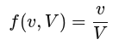

f(v, V) = v / V

Becomes:
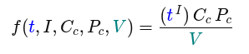

f(t, I, Cc, Pc, V) = ((t^I) * Cc * Pc) / V

As you can see, now the amount of variables that a society can handle (v) has been broken down into the degree of technological advancement (t), the total intelligence of the society (I ), the civil centralization factor (Cc) and the political centralization factor (Pc).

All of these are part of the numerator, so the greater they are the bigger the output.

So we can see that the higher the degree of technological advancement the greater the output will be, thus this means the better your resource distribution capabilities are.

We also see that intelligence also contributes to increasing technological advancement. Because t is powered to the I. So the more we increase intelligence, not only we increase technological advancement, but also how well we distribute resources. Because the amount of variables we can handle (v), compared to the ones we need to handle (V ), is greater.

We also see that the greater the political centralization factor (Pc), the greater the output too… Wait, didn’t we logically deduced from biological principles that the opposite can occur too? Indeed, the key is that Pc is a rational number, as it comes from the division (VP / vp), so its value can be smaller than 1. If you multiply a positive number by a number smaller than 1 then you get another number which is smaller than the initial one. Yet if the number you use to multiply by happens to be greater than one, the output will be bigger.

This reflects the natural fact that centralized entities can take efficient decisions distributing resources. These can be measured and seen reflected in the factors that describe the centralization of power. The factors are the previously mentioned intelligence of the politicians (ip), number of people in the population pertaining the political class (pp) and variables assigned per politician (vp).

So let’s now break down Pc to make it all clear. We are taking the previous equations and substituting for:
Pc = (VP / vp)
As VP = ip * pp, then we can write
Pc = (ip * pp / vp)

Similar logic to the starting point applies here, the more intelligent the politicians the better they will be, so the less likely is that Pc’s value falls below 1. And the more politicians the more variables they will be able to handle and the less likely too that Pc is under 1. Yet the more tasks are demanded from them (vp), the more variables they have to handle and then the output of the division conforming Pc decreases, making it probably smaller than 1. If so, it overall decreases the general equation’s numerator, worsening the resource distribution capabilities of a society:

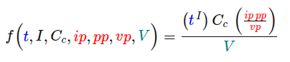

f(t, I, Cc, ip, pp, vp, V) = ((t^I) * Cc * (ip * pp/ vp)) / V

This same yet more complex equation, now reflects more clearly the biological limits of politicians.

Note that these centralization factors have a very similar mathematical shape to the initial: (v / V). Reaching these shapes from observing “different” facts is not coincidence because at the end of the day we are describing the same idea of humans solving problems, therefore similar factors and mechanics must apply.

Let’s now break down Cc, the civil centralization factor. It is meant to reflect a very similar behavior as the Pc, after all, politicians and citizens are all humans.

The more variables citizens can handle (VC) compared to what is demanded from them (vc), the greater the output too. As said, this reflects similar reasoning, if your capabilities are superior to the complexity brought by the amount of tasks you have to handle, then your resource distribution capability, which is the task we are trying to understand now, improves.

Let’s now then break down the other big component Cc:

Cc = (VC / vp)
As VC = ic * cp, then we can write
Cc = (ic * cp / vp)

The overall equations looks now like:

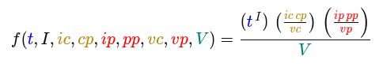

f(t, I, ic, cp, ip, pp, vp, V) = ((t^I) * (ic * cp / vp) * (ip * pp/ vp)) / V

Now let’s break down another simple component, the total intelligence (I ). Which is just (ic+ip):

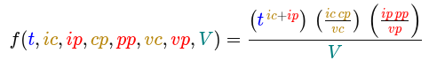

f(t, ic, ip, ic, cp, ip, pp, vp, V) = ((t^(ic+ip)) * (ic * cp / vp) * (ip * pp/ vp)) / V

The mechanics represented on t ^I are just that how much technological advancement contributes in more efficient resource distribution is directly proportional to how intelligent people are. And, the more intelligent people are, represented as the sum of the intelligences, the better they will distribute resources to.

Finally, let’s break down V (amounts of variables that need to be handled):

V = d * (cp + pp)
d = average number of desires and needs per person

These relations highlight that, the more desires and needs the harder it will be to manage resources effectively to satisfy all of them. Because that leads to a higher denominator, leading to a smaller result in the (v / V) division. Furthermore, the more people the more desires and needs you will have and the greater the denominator too.

Curiously, one of my previous arguments is also reflected on the equation. For the betterment of the output you can increase the numerator by playing around with the factors that conform it. And note that, just by increasing intelligence, all factors on the numerator increase. So, this is why I say that, regardless of the resource distribution protocol of preference, Cheerfulism can help.

Like so, the final detailed equation results as:

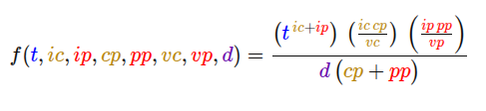

f(t, ic, ip, ic, cp, ip, pp, vp, d) = ((t^(ic+ip)) * (ic * cp / vp) * (ip * pp/ vp)) / d * (cp + pp)

If you remember the power equation from last chapter:

f(m, y) = m * (1 + y)

In this equation y was how well the society managed information.

Because the better a society does this the better they can solve their problems, then the better they distribute resources. So we could substitute the y factor for the (v / V) one presented.

How to answer who will win in a fight between civilizations? Just, even if impossible today, somehow measure all these variables, represent their mathematical relations as per measured reality, like physics, and you should get a realistic answer. You could even, theoretically and patiently, measure all the data, and as conflicts surge and collapse, see the relation between the data and craft the actual mathematical formula.

There is still one factor missing though, time. This equation can help reason through the present of a civilization, but not its future. That is what next chapter is about.

Anyway, here you have it. An iterative process explaining each variable so you can better understand how effective resource distribution works. You can try plug in numbers to the variables to visualize it even better. Like we did in the power dynamics chapter.

I would like to highlight the process with which I build this equation: I observed natural phenomena, natural facts, thought about them and described their relations.

Then I noted the relations and the phenomena had too many parts (ic, cp, ip, pp, t, etc). So I started grouping up the problem’s variables into “bigger-variables” encapsulating them. Creating things like the centralization factor, the total intelligence etc.

In the engineer’s terms, I saw a really complex system involving lots of variables. So I decided to break down the system into other smaller, still slightly complex systems, encapsulating on each the different variables that appeared on the original one. Like for example the centralization factors.

Then I analyzed those modules and then revisited the original module of effective resource distribution to see how it would make sense for it to relate and connect each of these new other sub-modules. Adjusting definitions on the original system or sub-systems if necessary.

Sometimes it was better for me to focus on how to mathematically represent a bigger module first, sometimes a smaller one, anyway, I had to go back and forth. Define, observe, redefine, make it all make sense and not contradict itself. Via thinking like an engineer.

Taking all variables on the original system, grouping them up in smaller components and breaking down like so the problem is smaller parts. Slowly defining, analyzing, the relations between them. Math representations might not be the most comfortable representation for all of you. At least they work very well for me.

However when problems get complex you must be methodical, slow, thinking, go back and forth and have some way of easily representing that information just in case you can not remember previous conclusions or relations. Simple math operations come very handy for that. Yet, who knows, maybe other methods fit you better, what are you waiting for? Try it out, invent better methods for yourself.

Regardless of how you represent it, please do it, learn, analyze, it is the only way to keep improving our world.

This model I created does not determine which protocol of resource distribution is best. It is build upon the simple idea of not giving anyone more stuff that he can handle. Wether politicians or citizens.

I just added this section so to have another example of imperfect, in the sense of incomplete, analysis of a system. So the reader can see how thinking truly looks like most of the time.

Usually you do not nail the truth at first try. We need the fixed variable resolution technique, revise definition, imagine new ones, connect etc etc

Notice that I have not justified my bet yet, why is libertarianism the end game? Trying to find reasons that fully explain that answer is how I created this equation that helped me organize all my thoughts and keep progressing.

||.1|-|-|1-1-1-1-1-1-|.|-|.1.1

Then this leads to a progressive decentralization of societies at the rhythm of the governors’ class boredom tolerance.

Stepping aside for a second. This latter idea I had, the one of societies decentralizing at the pace of the governor’s class boredom tolerance, it looks kinda true. Like, most of the inventors, philosophers etc whose ideas lead to progress, pertained to some elite classes, “bored”, just thinking. This might just be a natural phenomena of human societies, a sociology principle. Anyway.

PASTED: maybe these, modified, should go chapter to chapter 8
On feedback loops of abusive information: price and State intervention.

As we have seen in previous chapters, humans have a static-dynamic dilemma. We are driven by exploration and dynamism yet we require a static point of reference.

And, as we saw, what we should do to minimize abuse, therefore to optimize good, is to align those static and dynamic forces. If you want or need to do something out of our dynamic needs and desires, the static force should not make it impossible.

If they do not, you are not being abused and we all live nice together.

Non-miniml Is just an incoherence on my definitions, read the following as: when to abuse edge cases.
EDGE CASE for non-minimal abuse: what if a minority, like 1 person is actually correct and others are not. Then, should it abuse? Theoretically: yes if it is a vital matter. If not, then there is no way of knowing, too much variables (like what if poliamorous were right?). [the not-rape principle]

In practice: it can not. At least a single individual. And if a group, or small groups coordinated, to some extent. (should they??? => gun-to-monkey principle) If vital yes, if not, well the some chaos due to revolutions (big or small), if they control okay, if not mmmm… Not measurable… too much variables… then… let follow The not-rape principle: bad to do force others do stuff which is non-vital. Cheerfulism follows the not-rape principle.

(on peace, add security, gray perception area based on the national-entity???)

Best you can do is let them communicate the wrongness to others. Less chaotic.

5.2.2.3.- Why socialism or communism can’t handle these variables? Allegedly.

In previous versions of the book, I used the argumentation you will read now. Which I now think it is incomplete and insufficient. But I’m going to keep it so the presentation of ideas flows more smoothly to the reader.

Let’s invoke a textual time traveling machine and read what I used to think as a complete and indisputable argumentation.

Whenever you see the word donkey again, we will be back to the present (imagine time traveling noises) :

First, nowadays sometimes a human can’t even handle properly the struggles and intricacies of its own life. The smartest of us can do it and help a few of their friends on the way. But, how to expect a government conformed by a small group of people to be able to allocate resources and satisfy needs effectively for a population way bigger than them. The amount of variables they gotta take into account escalates so rapidly that it easily creates unexpected, uncontrollable consequences with or without butterfly effects. There is just a very high chance they mess up on the try.

Even if they are the smartest people, there is no way they can allocate resources effectively for populations that are X times larger. The number of variables doesn’t escalate linearly, nor quadratically, it escalates, at least, cubically. Because desires and needs are influenced by lots of ever changing factors.

Then increase the State’s size you might be thinking, but at this point, if most of the population are the State and have the power to take decisions on how to handle their resources, then we end up in libertarianism, don’t we?

I will develop this further in a bit but this is the essence on why socialism and communism are always so inefficient compared to libertarianism. They assign too many variables to a reduced group of humans who can’t, biologically and technologically, handle them. Leading to bad or less good outcomes.

Old section: 5.2.2.2.- Why does libertarianism handle this issue way much more gracefully?

Libertarianism breaks down the responsibility of handling variables to the smallest size, the individual. So as long as the individuals are intelligent enough to organize their life with their neighbors, it will work out.

Libertarianism distributes all variables in a more even way. Giving each human holding the State’s power the minimum amount of variables to handle when distributing its resources. Thus there is the highest likelihood for each public worker to be successful managing them. As it has been assigned the smallest amount of variables possible by default.

From the citizen level, it does increase the amount of variables they must handle compared to a more centralized statist protocol. Then, some individuals will be capable, some won’t. So the more intelligent each citizen is, the higher the likelihood of a case where the citizen will handle the variables correctly.

In the general picture, and as per recent history, the likelihood of success per individual, wether with or without institutional power, is higher in more decentralized protocols. Resulting in, on mathematical tendencies terms, libertarianism succeeding further than socialism or communism.

For now it is indisputable that decentralized protocols tend to have greater growth, whether it is sustainable is another question, but it is indisputable they do have better growth within the recent history. Why? Because people in these protocols were intelligent enough, using their biology and technology, to handle the variables, a.k.a. manage the information, so as to solve their problems.

More centralized protocols did not do that good, or even did bad, mainly because of leaving complex problems, a.k.a. too many variables, to a limited amount of people. So they could not solve problems as fast or as well as other more decentralized nations.

Yet do not be an innocent and believe everything I write, libertarianism is not perfect. More on this in a bit.

donkey.

Can you come up with a question that makes this whole argumentation shake? I encourage you to think about it. If not here is the question I asked myself:

Wait, aren’t big private corporations a smaller set of people who manage resources for sets of people way lager than themselves? And they, allegedly, are successful at it. In the sense that people can be content and consume their products or services willingly.

Therefore, the argumentation that a centralized and small group of people in a public institution can not efficiently distribute resources due to its small size starts feeling off.

Yet, it has some element of truth, the size of a dominant group clearly affects its capability to coordinate and influence other groups. Ease to see in this mental exercise: If a large worldwide modern corporation suddenly had half of its members, their services likely become infeasible.

So I kept thinking. Combining my knowledge (fixed variables) and the artistic part of thinking like an engineer I felt like there has to be, at least, one more basic principle of human organizations I’m missing. This system can be broken down in other more fundamental ones.

My first hunch was pointing at power. The reduced group of public people can use all sorts of power to do as they please. If we assume anything more centralized than a perfect democracy, like oligarcracies or dictatorships, we can see that gaps appear, bigger or smaller, where abusive traits can be used by the smaller group to abuse the bigger group they work for, tutor, or maybe enslave.

The private groups don’t have “raw power”, due to their lack fo physical army, they must abide by the law most of the time, or at least they must seduce it. A.k.a. corrupt it.

Are these gaps of abuse, which, as explained earlier, even if they benefit the abuser, they overall do not really accelerate the thriving of the species, a nice understanding and complement to the critique? Is allowing a non-minimal State size (socialism) leading to the more frequent appearance of these arbitrage opportunities of power abuse?

Taking a more libertarian starting approach to destroy the argumentation, some people would argue that the private smaller groups are better because of competition. The free market allows only the fittest groups to survive, the ones who serve “better” the interest of the consumer. And, because public institutions have no competing agent, due to their monopoly of violence, they have no continuous incentive to make things better. Therefore, when we create a public institution we are letting ourselves be dependent on which mood the bureaucrat woke up with that day, willing to improve society and work as hard as he can? Or feeling lazy and conformist?

This, at least, until the threat of new elections, if we assume the presence of a voting system with a decent set of competitors. Or the threat of other States from other countries trying to seduce their citizens to immigrate to theirs because of better conditions. Or maybe other States trying to create defamation campaigns to destabilize the country and gain a competitive advantage over them. Or even conquering them. External nations also create natural competition in the market of power. However, for initial simplicity, let’s also assume there is just one country in the world.

In a single country context, the principle is that, if the institution under-performs, and the people notice, allegedly in a system with voting, people will vote them out in the next election. Therefore, the “threat” of elections should incentivize lesser corruption.

Elections are every X years, usually 4, so the feedback loop of adaptation to inefficiencies is way slower than in the market. In the, allegedly, free flow of money. If a merchant’s product is jut not worth it, the people stop buying it tomorrow, right away, not in X years from then. And then, the merchant either improves and becomes useful again, or the business disappears.

But as explored, as per biological principles, we do need some degree of stability and static-ness to function as organisms. Therefore we can’t just let the elections be every month, every week, or even be about every single small decision some institution has to make.

Our brains can’t be just voting every day and/or about everything instead of working or enjoying life, which are things we must do at a biological level.

Here is where power and economics mix. And if we want to understand and reach deeper principles we must abstract ourselves from both, because otherwise we will always be missing some part of the picture. The perspective of a one-eyed human.

And precisely here, I will stop this section, for now. I want to keep explaining more thoughts on these topics, I feel incapable of reaching convincing explanations, for myself and for others, using current modern political and economical concepts. I first need to explain to you more ideas in order to actually and properly answer the question of: why is libertarianism theoretically better than any other protocol?

Now, let’s keep understanding.

///// THINK ABOUT LATER, MAYBE SOME SMALL PHRASING IS HELPFUL

12.1.10.- Isn’t the minimization of abuse the maximization of happiness? What is actually the optimization of happiness?

No bcs less abuse is less evil and more good, more good is subjective, not more good is more drug for me, but more good as individual defines, but individual has max intel so we are not just maximizing drug consumption and lust control when we minimize abuse in institutions, but we are maximizing everyone’s ability to do good, as per what their own intelligent thinks the diretion of that is. That is why I keep insisting in maximizing happiness

RELATED????:::: As we have seen, a social institution is a power organization to aim to satisfy as much desires possible for the society it governs for or over. We have also seen that for people to live happy live abuse must be the minimal. The only way to minimize abuse is to maximize everyone’s intelligence, and even in that case, that is just a minimization.

Therefore, if someone is just intelligent and powerful enough it will abuse. Therefore if we leave powerful positions to technocrats without democratic mechanisms they will abuse with higher frequency than not as intelligent individuals. So, an oligarchy of technocrats is not what we need to live the happiest of lives. But as per human nature observed, happiness is optimized, not maximized. So this observation still aligns with human nature. Maybe we do need some sacrifice on the chance of a technocrat abusing sometimes in order to organize society better. In the same way we not always as individuals must seek immediate happiness responses or we must do something that is at first glance bad for us.

