Received 00th January 20xx,
All authors are with the Fraunhofer Institute for Solar Energy Systems ISE, Freiburg, Germany..
† Corresponding author: frank.dimroth@ise.fraunhofer.de

Accepted 00th January 20xx
DOI: 10.1039/x0xx00000x

Direct Solar Hydrogen Generation with Silicon-Based Tandem Solar Cells Reaching 25% Conversion Efficiency
Carlos Andrés Castañeda López, Juan Francisco Martínez Sánchez, Tom Smolinka,
Juliane Borchert, Henning Helmers, Frank Dimroth†
Directly coupling photovoltaic cells to water electrolysers offers a streamlined route to solar hydrogen, yet achieving high conversion efficiency under realistic operating conditions remains challenging. Here we report a compact photovoltaic-electrolysis system that directly couples state-of-the-art silicon-based tandem solar cells to a polymer electrolyte membrane electrolyser without external bias or power electronics. Under outdoor operation, a GaInP/Si tandem cell achieves a peak solar-to-hydrogen (STH) efficiency of 25.2% based on the higher heating value (HHV) of hydrogen at an irradiance of 967 W m⁻², with a mean efficiency of 24.4% sustained over four days of testing. Remarkably, the system’s STH efficiency increases with temperature – from 25% at 25 °C to a modelled 26.5% at 80 °C – because the reduction in electrolyser overpotential outpaces the photovoltaic voltage loss. In controlled indoor experiments, we compare this system to a Perovskite/Si tandem, which achieves a peak STH of 22.5% (HHV) but suffers significant efficiency loss (>8%) above 35 °C as the operating point slides off the knee of the current-voltage curve. These results establish that robust current-voltage matching across operating temperatures – enabled by the voltage headroom inherent to our III-V/Si tandems – is the critical design parameter for high-efficiency solar water splitting.

Broader context (Box)
Green hydrogen produced from renewable electricity is essential for decarbonising sectors where direct electrification is impractical, including steelmaking, ammonia synthesis, and long-distance transport. Directly coupling photovoltaic cells to electrolysers without intermediate power electronics represents the simplest and potentially most efficient route to solar hydrogen generation but requires photovoltaic devices that simultaneously deliver high voltage and high current. Here we demonstrate that silicon-based tandem solar cells – combining either III-V or perovskite top cells with a silicon bottom cell – can drive water splitting at >25% solar-to-hydrogen efficiency under real outdoor conditions. This milestone demonstrates a practical, scalable pathway toward cost-competitive green hydrogen at conversion efficiencies approaching those of fossil-fuel-based production.
1. INTRODUCTION
The production of green hydrogen through water electrolysis powered by renewable electricity is central to global decarbonisation strategies, particularly for hard-to-abate sectors including heavy industry, long-haul transport, and seasonal energy storage.[REF] Among the various production architectures, the direct electrical coupling of photovoltaic (PV) cells to polymer electrolyte membrane (PEM) electrolysers – termed photovoltaic-electrolysis (PV-E) – represents the most streamlined approach, eliminating power conversion electronics and their associated efficiency losses.[REF]
The fundamental prerequisite for direct PV-E is that the photovoltaic device must generate a voltage exceeding the electrolysis operating potential (typically 1.5-1.8 V at practical current densities).[REF] Single-junction crystalline silicon solar cells, with open-circuit voltages of approximately 0.6-0.8 V, cannot satisfy this requirement individually. Two-terminal (2T) tandem solar cells, which connect two complementary-bandgap subcells in series, naturally generate voltages above 1.8 V while simultaneously reducing thermalization losses found in single-junction devices.[REF]
Two silicon-based tandem architectures have emerged as leading candidates for high-efficiency solar hydrogen generation. Monolithic III-V/Silicon tandems, combining wide-bandgap absorbers like GaInP and GaInAsP with a silicon bottom cell (1.12 eV), have demonstrated photovoltaic power conversion efficiencies up to 36.1%.[REF] Dual-junction GaAsP/Si cells grown directly on silicon reached 23.4% [Ref.]. Perovskite/Silicon tandems have progressed remarkably, reaching a certified photovoltaic efficiency of 34.6%,[REF] though concerns regarding thermal stability, moisture sensitivity, and operational lifetime persist. [REF] Both architectures generate sufficient voltage for direct water splitting.
The current state of the art for PV-driven water splitting includes demonstrations at 31.3%/26.5% STH higher heating value (HHV)/lower heating value (LHV) under concentrated sunlight using III-V four-junction cells,[REF] and 24.6%/20.8% STH HHV/LHV using integrated perovskite/silicon photoelectrochemical cells under simulated AM1.5g illumination.[REF] However, no prior work has demonstrated >25% STH efficiency (higher heating value, HHV) with a directly-coupled, unconcentrated silicon-based tandem system under real outdoor operating conditions. Moreover, a direct experimental comparison of III-V/Si and Perovskite/Si tandem technologies for water splitting under identical electrolyser conditions has not been reported.
The performance of a direct-coupled PV-E system is governed by the operating point – the intersection of the solar cell’s current-voltage (I-V) characteristic and the electrolyser’s polarisation curve. Under dynamic outdoor conditions, solar irradiance fluctuations modulate the photocurrent, while temperature variations simultaneously shift both the PV voltage (decreasing with temperature) and the electrolyser overpotential (also decreasing with temperature). Whether these opposing thermal effects result in a net gain or loss in STH efficiency depends critically on the voltage margin between the solar cell’s maximum power point (MPP) and the electrolyser’s operating voltage.[REF]
Here, we demonstrate a directly-coupled PV-E system achieving a peak STH efficiency of 25.2% (HHV) under outdoor conditions using a GaInP/Si tandem solar cell, with a mean efficiency of 24.4% sustained over four days of operation. We show that this system exhibits a positive temperature coefficient for STH efficiency, reaching a modelled 26.5% at 80 °C. Through controlled indoor experiments, we compare this system directly to a Perovskite/Si tandem cell and reveal that the thermal resilience of the III-V/Si system originates from its substantial voltage headroom, which maintains the operating point on the stable plateau of the I-V curve across all tested temperatures. In contrast, the Perovskite/Si system suffers catastrophic efficiency loss above 35 °C due to thermal mismatch that forces the operating point off the I-V curve knee.
2. RESULTS AND DISCUSSION
2.1 System Design and Operating Principle
The PV-E system comprises a custom-designed PEM electrolyser directly coupled to a 4 cm² tandem solar cell (Fig. 1a,b). The electrolyser employs a Greenerity E400.Gen3 catalyst-coated membrane (CCM) with an IrO₂ anode and Pt cathode, housed between titanium electrodes with an active area of 3.98 cm². The solar cell’s positive terminal contacts the electrolyser anode directly through the gold-coated copper substrate, while a wire connects the negative terminal to the cathode. No external bias, maximum power point tracker, or DC-DC converter is used – the system self-selects its operating point at the intersection of the PV I-V curve and the electrolyser polarisation curve.
The active area of the electrolyser was dimensioned specifically to ensure that this intersection occurs near the solar cell’s maximum power point at the target operating temperature. Figure 1c illustrates this design approach: at 60 °C, the polarisation curve for a 3.98 cm² active area intersects the GaInP/Si I-V curve on its current plateau, ensuring maximum hydrogen production rate.
Two tandem solar cell technologies were employed: (i) a GaInP/Si dual-junction cell (4 cm² active area, η=29.1% at 25 °C) fabricated by wafer bonding a GaInP top cell onto a silicon bottom cell with TOPCon passivation; and (ii) a monolithic Perovskite/Si tandem cell (4 cm², η=25.9% at 25 °C) encapsulated with glass and epoxy for environmental protection.

2.2 Modelled Current-Voltage Matching Across Temperature
To evaluate the feasibility and thermal behaviour of direct water splitting, we modelled the intersection of the GaInP/Si tandem cell I-V curves with the electrolysis polarisation curves across a temperature range of 25 °C to 80 °C (Fig. 2). Despite the characteristic reduction in photovoltaic voltage with increasing temperature (β=-0.097% K⁻¹), the high initial V_{mpp} of the III-V/Si tandem structure (1.75 V at 25 °C, 1.58 V at 60 °C) ensures that the operating point remains well above the water-splitting thermoneutral potential and firmly on the current plateau of the I-V curve at all temperatures.
The electrolysis polarisation curve shifts to lower voltages at elevated temperatures due to reduced activation and ohmic overpotentials (approximately -2.5 mV K⁻¹). This shift exceeds the PV voltage loss rate, creating a net positive effect: as temperature increases, the operating current – and therefore the hydrogen production rate – increases.
The modelled STH efficiency (HHV) increases from approximately 25% at 25 °C to 26.5% at 80 °C for the III-V/Si system. This counterintuitive result – where a system becomes more efficient as it heats up – is a direct consequence of the generous voltage headroom provided by the GaInP/Si tandem. The operating point shifts along the flat plateau of the I-V curve, where voltage changes produce negligible current changes, while the electrolyser benefits from improved kinetics.

2.3 Outdoor Solar Hydrogen Generation
The III-V/Si PV-E system was tested outdoors at Fraunhofer ISE (Freiburg, Germany) over four days in September 2025, mounted on a two-axis solar tracker maintaining ±0.2° pointing accuracy (Fig. 3a). The system operated under fluctuating global normal irradiance (GNI) and temperature conditions representative of Central European late summer.
Figure 3b presents the measured STH efficiency as a function of time, showing stable operation with a mean efficiency of 24.4% (HHV). The system achieved a maximum instantaneous STH efficiency of 25.2% (HHV) at a GNI of 967 W m⁻² and a cell temperature of 35.2 °C, corresponding to a peak photocurrent of 66.4 mA (16.6 mA cm⁻²). Peak efficiencies reached 25.5% under optimal conditions.
Figure 3c reveals a key finding: the system maintains STH efficiency above 24% across the entire measured temperature range (25-80 °C), with a slight positive temperature dependence. This behaviour validates the modelling predictions from Section 2.2 and demonstrates that the III-V/Si system requires no active thermal management for sustained high-efficiency operation.
The daily integrated STH efficiencies ranged from 24.2% to 25.1% (HHV) across the four test days, corresponding to 20.1-20.8% on an LHV basis. The highest daily efficiency of 25.1% was achieved on a clear-sky day with uninterrupted operation, while the lowest (24.2%) occurred on a day with multiple system interruptions for diagnostic I-V measurements.
These results were obtained assuming a Faradaic efficiency of 99.3%, modelled from literature data for PEM electrolysis at the relevant low current densities (~15 mA cm⁻²). At these current densities and atmospheric pressure operation, gas crossover losses are minimal.

2.4 Comparison of III-V/Si and Perovskite/Si Systems
To analyse the contrasting thermal responses of the two tandem technologies, controlled indoor experiments were performed using a calibrated solar simulator at three irradiance levels (900, 1000, and 1100 W m⁻²) with controlled temperature ramps (Fig. 4).
III-V/Si system (25-60 °C): The system exhibited a highly linear and predictable thermal response. The operating voltage decreased at -0.097% K⁻¹, consistent with standard photovoltaic theory. Critically, the operating current density increased slightly with temperature (α=+0.08% K⁻¹), resulting in a net positive temperature coefficient for STH efficiency. The system achieved a peak indoor efficiency of 25.0% (HHV) at 1000 W m⁻² and 56 °C. Across the full temperature range, the STH efficiency variation was less than 2.5%, confirming exceptional thermal stability.
Perovskite/Si system (25-40 °C): The system displayed markedly different behaviour. At 25 °C, it achieved a peak STH efficiency of 22.5% (HHV) at 900 W m⁻². However, as temperature increased beyond approximately 30 °C, the operating current density decreased sharply (α=-0.3 to -0.45% K⁻¹), resulting in an STH efficiency loss of 5-9% over just a 15 °C temperature increase.
The root cause of this divergent behaviour is revealed by the I-V matching analysis (Fig. 4c,d). For the III-V/Si system, the operating point remains on the flat plateau of the I-V curve at all temperatures – the 90 mV voltage headroom between V_{mpp} (1.58 V at 60 °C) and the electrolysis operating voltage (~1.49 V) ensures stability. For the Perovskite/Si system, the operating point at 25 °C already sits near the I-V curve knee. As temperature rises, the I-V curve shifts to lower voltages faster than the electrolyser polarisation curve, pushing the operating point over the knee and down the steep portion of the I-V curve where small voltage changes produce large current losses.
This finding has important implications for system design. The Perovskite/Si tandem used here (η = 25.9% at 25 °C) actually has a lower V_{mpp} (1.55 V) than the III-V/Si cell (1.75 V), providing insufficient voltage margin for the 3.98 cm² electrolyser at elevated temperatures. Redesigning the electrolyser with a smaller active area – which would shift the polarisation curve to lower voltages – could restore I-V matching for the Perovskite/Si system, albeit at reduced total hydrogen production rate.
Additionally, the Perovskite/Si system exhibited metastability effects including light-soaking-induced voltage recovery and sequence-dependent hysteresis, which are characteristic of mobile ion dynamics in perovskite absorbers.[REF] These effects introduce additional unpredictability for direct-coupled operation where a stable, well-defined operating point is essential.

2.5 Origin of the Record Efficiency and Comparison with Literature
The 25.2% STH (HHV) achieved here represents, to our knowledge, the highest demonstrated efficiency for a directly-coupled PV-E system using silicon-based tandem solar cells under real outdoor operating conditions. Table 1 places this result in context with prior work.
The record efficiency originates from three synergistic factors:
First, the high photovoltaic quality of the GaInP/Si tandem cell (29.1% PCE at STC) provides the fundamental energy conversion. The GaInP top cell (Eg ≈ 1.7 eV) is well-matched to the silicon bottom cell, with the top junction confirmed as current-limiting (J_{sc,GaInP} = 17.55 mA cm⁻² vs. J_{sc,Si} = 21.08 mA cm⁻² from EQE measurements).
Second, the electrolyser operates in its most efficient regime. At the low current densities dictated by the solar cell (~15 mA cm⁻²), the PEM electrolyser operates near its thermoneutral voltage with minimal overpotentials, yielding voltage efficiencies exceeding 99% (V_{th}/V_{op} ≈ 1.48/1.49).
Third, and most critically, the I-V matching is near-optimal. The operating point sits within 1% of the solar cell’s maximum power point, meaning nearly all generated photovoltaic power is transferred to the electrolyser. The coupling efficiency η_{coupling} = (V_{op} × I_{op})/(V_{mpp} × I_{mpp}) exceeds 98%.

Table 1: Comparison with State of the Art
System | PV Technology | STH (HHV) | STH (LHV) | Conditions | Ref.
This work | GaInP/Si tandem | 25.2% | 20.9% | Outdoor, 1-sun | –
This work | Perovskite/Si tandem | 22.5% | 18.7% | Indoor, 1-sun | –
Fehr et al., 2023 | Perovskite/Si (integrated PEC) | 24.6% | 20.8% | Indoor, AM1.5G | [REF]
Kistler et al. | Perovskite/Si | [VALUE?] | [VALUE?] | Outdoor | [REF]
Jia et al., 2016 | InGaP/GaAs/GaInNAsSb | ~36%  [VALUE?] | >30% | 42× concentration | [REF]
Karuturi 2020 | Perovskite/Si | 17.6% TBC
Wang et al., 2025 | all-perovskite tandem | 17.8% TBC |  | 1 sun | [REF]
Martínez et al., 2026 | 4j … | 31.3% | Value? | Outdoor, concentrated | [REF]

2.6 Scalability Pathway
To assess the scalability of these results, we modelled a system comprising 26 GaInP/Si tandem solar cells (each 4 × 6 cm² = 24 cm²) connected in parallel, directly driving a 30 × 30 cm² PEM electrolyser (Fig. 5). In this configuration, the parallel connection maintains the tandem voltage (~1.7 V) while summing the individual cell currents, providing sufficient current to drive a larger electrolyser active area.
The modelled system achieves STH efficiencies of 24.4% at 25 °C, increasing to 25.5% at 80 °C with active thermal management. The slight reduction from the single-cell efficiency reflects interconnection losses and area utilisation factors in the module.
A modular electrolyser concept has been developed (Fig. 5b) using interchangeable PEEK holders that define the active area. This approach enables the electrolyser to be precisely matched to any given PV source by swapping a single component – transforming the device from a fixed system into an adjustable research and production platform.
3. CONCLUSIONS
We have demonstrated that a directly-coupled photovoltaic-electrolysis system using a GaInP/Si tandem solar cell achieves a solar-to-hydrogen conversion efficiency of 25.2% (HHV) under real outdoor operating conditions at 1-sun illumination without external bias or power electronics. The system sustains a mean efficiency of 24.4% over multiple days of outdoor operation and exhibits a positive temperature coefficient, with modelling predicting 26.5% at 80 °C. A comparative study reveals that III-V/Si tandems maintain stable operation across 25-80 °C due to their inherent voltage headroom, while Perovskite/Si systems suffer catastrophic efficiency loss above 35 °C due to thermal mismatch at the I-V curve knee. These findings establish that robust current-voltage matching under dynamic conditions – not merely peak photovoltaic efficiency – is the critical design parameter for high-performance solar water splitting. A scalable 30 × 30 cm² system concept demonstrates a pathway toward practical deployment of >25%-efficient solar hydrogen generation.

Proposed Figures
Figure 1: System Design and Operating Principle
What it shows: (a) Schematic cross-section of the integrated PV-E device showing PV cell, electrolyser, and direct electrical connections. (b) Photograph of assembled device. (c) I-V matching design: GaInP/Si I-V curve at 60 °C intersecting with polarisation curves for different active areas, showing the 3.98 cm² selection.
Why essential: Establishes the device architecture and design rationale for the reader. Shows the elegance of the direct-coupling approach.
Source: Fig. 3.1 and Fig. 3.2 from thesis. Needs adaptation: combine into multi-panel figure, improve labelling for journal quality.
Suggested caption: "Fig. 1. Design of the directly-coupled PV-electrolysis system. (a) Schematic cross-section showing the GaInP/Si tandem cell directly bonded to the PEM electrolyser anode. (b) Photograph of the assembled 9 × 6 cm² device. (c) I-V matching analysis at 60 °C showing the GaInP/Si I-V curve (purple) intersecting polarisation curves for electrolyser active areas of 1-6 cm² (coloured lines). The 3.98 cm² area (green) places the operating point on the PV cell’s current plateau near its maximum power point."

Figure 2: Modelled I-V Matching Across Temperature (25-80 °C)
What it shows: GaInP/Si I-V curves at 25, 40, 60, and 80 °C superimposed with electrolyser polarisation curves at corresponding temperatures. Operating points marked showing the upward current trend with temperature.
Why essential: Core conceptual figure – demonstrates why the system gains efficiency with temperature. This is the key insight of the paper.
Source: From structure document "Modelled I-V-Matching" section. May need to be created/refined from thesis data (Fig. 6.9 provides partial basis).
Suggested caption: "Fig. 2. Modelled current-voltage matching for the GaInP/Si PV-E system across operating temperatures. Solid coloured lines: GaInP/Si I-V curves from 25 °C (blue) to 80 °C (red). Dashed lines: electrolyser polarisation curves at corresponding temperatures. Filled circles: predicted operating points. Despite decreasing PV voltage, the operating current increases with temperature because the electrolyser overpotential reduction dominates. Inset: modelled STH efficiency (HHV) vs. temperature, increasing from ~25% to ~26.5%."
Status: [NEEDS CREATION from modelling data]

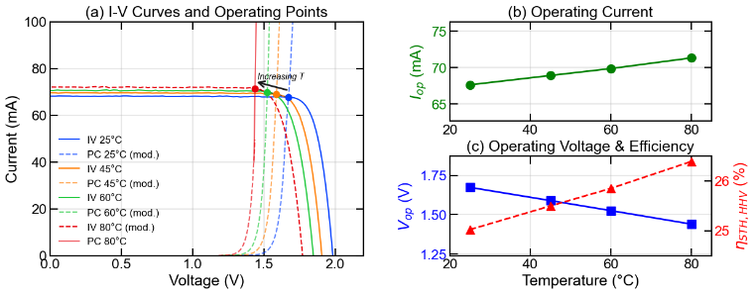
To evaluate the practical feasibility of direct water splitting, we modeled the intersection of GaInP/Si tandem cell I-V curves with electrolysis polarization curves from indoor measurements across a temperature range of 25°C to 80°C. Despite the characteristic voltage reduction of solar cells with increasing temperature, the high initial Vmpp of the III-V/Si tandem structure ensures that the operating point remains well above the water-splitting equilibrium potential.
Interestingly, while the solar cell's electrical efficiency typically drops with heat due to voltage loss, the total STH efficiency actually increases for this particular combination from roughly 25% to ~26.5% as the operating temperature rises to 80°C because the electrolyzer efficiency increases at a higher rate given that the voltage required for electrolysis decreases.

Figure 3: Outdoor Results – III-V/Si System
What it shows: (a) Time series over 4 days showing GNI and STH efficiency. (b) Scatter plot of STH efficiency vs. cell temperature, demonstrating stability above 24% across 25-80 °C range.
Why essential: Presents the headline experimental result – the record efficiency under real conditions.
Source: From structure document "Outdoor Results – III-V/Si System" plots. These appear to be updated/refined versions of thesis Fig. 6.1 and Table 6.1 data.
Suggested caption: "Fig. 3. Outdoor performance of the III-V/Si PV-E system over four days in September 2025 (Freiburg, Germany). (a) Time series showing global normal irradiance (top, grey) and instantaneous STH efficiency (HHV, bottom, blue), demonstrating a mean efficiency of 24.4% with peak values reaching 25.5%. (b) STH efficiency vs. operating temperature, showing that efficiency remains above 24% across the full 25–80 °C range and exhibits a slight positive temperature dependence. The dashed line indicates 25% STH."
Status: Plots exist in structure document; may need reformatting for EES style.

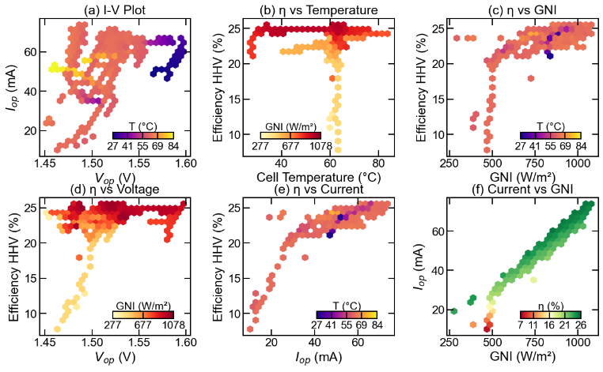
Outdoor testing of the III-V/Si tandem cell over four days in September 2025 confirmed the system's ability to maintain high performance under fluctuating Global Normal Irradiance (GNI) and temperature conditions. The system achieved a mean STH conversion efficiency according to the Higher Heating Value (HHV) of H2 of 24.4%, with peak efficiencies reaching 25.5%. These values closely align with our predictions. Do not forget to mention that you used active heating and when.
Plot (b) reveals that the device maintains stable efficiency (clustering near 25%) across a wide operating temperature range. You have a lot of nice and relevant correlations to explain in this multi-vignette Figure. Make sure to address them all.

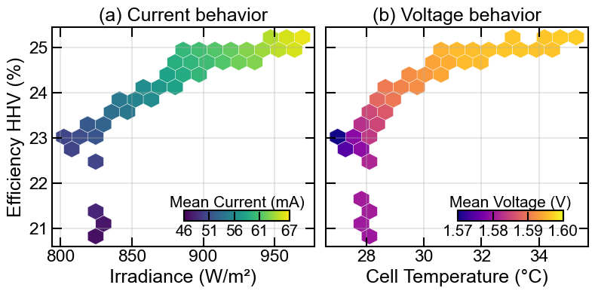
Under natural convection operation, the III-V/Si system achieved a maximum STH efficiency of 25.2% (HHV) at an irradiance of 967 W/m². This system demonstrated high solar-to-hydrogen (STH) conversion without the need for external heating reaching a cell temperature of 35.20°C with a high peak current of 66.4 mA under those conditions. As can be seen in the plots, irradiance with a relative change of ~20% has a stronger impact on STH conversion efficiency than cell temperature which changed by ~27% in the same period.

Figure 4: Indoor Comparison – III-V/Si vs. Perovskite/Si
What it shows: (a,b) STH efficiency vs. temperature for both systems at three irradiance levels. (c,d) I-V matching diagrams showing operating point trajectories – III-V/Si stays on plateau while Perovskite/Si falls off knee.
Why essential: The comparative figure that delivers the paper’s explanatory message – why voltage headroom matters.
Source: From structure document "Indoor Results" section, combining thesis Figs. 6.8 and 6.9/6.11.
Suggested caption: "Fig. 4. Comparative thermal performance of III-V/Si and Perovskite/Si PV-E systems under controlled indoor conditions. (a) GaInP/Si STH efficiency vs. temperature at 900 (blue), 1000 (orange), and 1100 W m⁻² (green), showing stable performance with a slight positive trend up to 60 °C. (b) Perovskite/Si STH efficiency vs. temperature, showing severe efficiency collapse above ~30 °C. (c) I-V matching for the GaInP/Si system: the operating points (coloured dots) remain on the I-V curve plateau at all temperatures. (d) I-V matching for the Perovskite/Si system: the operating point slides down the I-V curve knee as temperature increases, causing the sharp current and efficiency loss observed in (b)."
Status: Plots exist in structure document; need combination into single multi-panel figure.

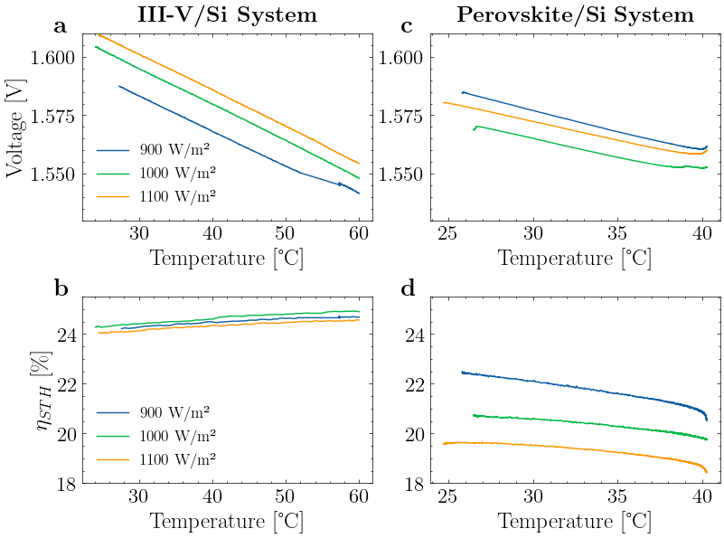

When compared to Perovskite/Si tandems, the III-V/Si system showed a more stable thermal behavior, maintaining efficiency levels above 24% across a wide temperature range in the indoor testing carried out at different irradiance levels.
The Perovskite/Si operating point was observed to drop "down the knee" of the I-V curve as temperature increased because the solar cell voltage decreased at a higher rate than the required electrolysis voltage did, hence, leading to significant efficiency losses (Plot d). This system shows its best performance only at low temperatures and low irradiance, which indicates that a larger Vmpp is required to increase STH conversion efficiency.

Figure 5: Scale-Up Concept and Modelled Performance
What it shows: (a) 3D render of the 30 × 30 cm² modular electrolyser with 26-cell PV module. (b) Modelled STH efficiency for the scaled system vs. temperature.
Why essential: Demonstrates practical relevance and scalability pathway. Connects lab result to application.
Source: Structure document "Scale-Up concept" + Appendix B of thesis.
Suggested caption: "Fig. 5. Scalable PV-E system concept. (a) 3D render showing 26 GaInP/Si tandem cells (4 × 6 cm² each) connected in parallel, directly integrated with a 30 × 30 cm² modular PEM electrolyser featuring interchangeable PEEK holders for active-area tuning. (b) Modelled STH efficiency (HHV) for the scaled system, ranging from 24.4% at 25 °C to 25.5% at 80 °C."
Status: Render exists (Appendix B); performance plot needs creation.
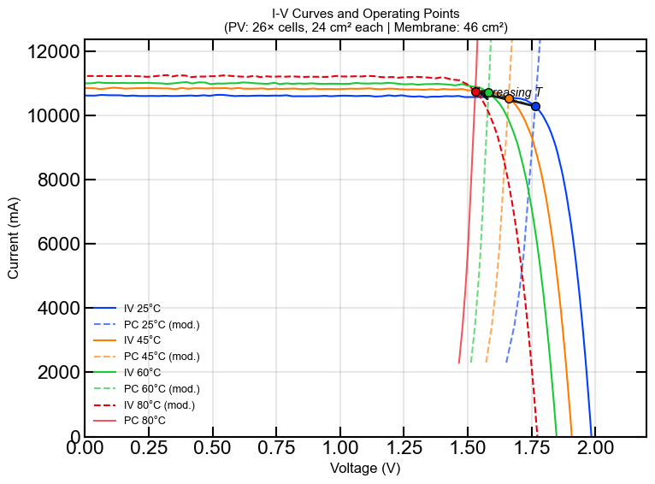

The system displayed great insights for scalability. For 26 24cm² GaInP/Si. This model translates to efficiencies ranging form 24.4% at 25ºC to 25.5% for a system with active heating working at 80ºC. Here, I think it would be worth mentioning the self-optimization of a well-designed system. For that I would show IV curves only at 35 and 80C but at 500 and 1000 W/m2. This way you could show that under practical operating conditions the system is expected to maintain a stable STH conversion efficiency.

4. EXPERIMENTAL
4.1 GaInP/Si Tandem Solar Cell
The dual-junction solar cell comprises a GaInP top cell (Eg ≈ 1.7 eV) wafer-bonded to a crystalline silicon bottom cell with TOPCon passivation contacts.[REF] The active area is 4 cm² (2 × 2 cm²). Two cells from the same wafer were used: EX-123 x2y3 and EX-123 x4y2. Under standard test conditions (STC: AM1.5G, 1000 W m⁻², 25 °C), the standalone cell exhibits V_{oc} = 1.98 V, J_{sc} = 17.1 mA cm⁻², FF = 86.1%, and η = 29.1%. External quantum efficiency (EQE) measurements confirm the GaInP junction as current-limiting (J_{sc,GaInP} = 17.55 mA cm⁻², J_{sc,Si} = 21.08 mA cm⁻²).
For integration with the electrolyser, the cell was bonded to a gold-coated copper substrate using electrically conductive adhesive. The substrate provides the positive electrical connection, while wire bonds from the cell’s bus bar to an insulating FR4 pad provide the negative connection. After mounting, the cell efficiency at 25 °C decreased to 28.0% (FF reduced from 86.1% to 82.3%) due to a slight shunt introduced during integration.

4.2 Perovskite/Si Tandem Solar Cell
The monolithic two-terminal Perovskite/Si tandem cell (4 cm² active area) comprises a perovskite top cell deposited on a silicon heterojunction bottom cell with ITO transparent conductive oxide layers. Under STC, the unencapsulated cell exhibits V_{oc} = 1.86 V, J_{sc} = 17.9 mA cm⁻², FF = 78.0%, and η = 25.9% (forward sweep). Negligible hysteresis was observed in I-V measurements (forward–reverse difference < 0.4% absolute).
The cell was encapsulated using epoxy resin and a protective glass substrate to prevent moisture-induced water splitting experiments. A conductive silver strip contacts the front bus bar to provide the negative electrical connection. EQE measurements on the encapsulated cell confirm top-cell current limitation (J_{sc,Perovskite} = 14.99 mA cm⁻², J_{sc,Si} = 17.33 mA cm⁻²), with the lower J_{sc} compared to the unencapsulated state attributable to optical losses from the encapsulant.

4.3 PEM Electrolyser Design and Fabrication
A compact PEM electrolyser was custom-designed and fabricated for direct integration with the tandem solar cells. The electrolyser employs a Greenerity E400.Gen3 catalyst-coated membrane (Nafion N115, ~125 μm; IrO₂ anode catalyst; Pt/C cathode catalyst) with an active area of 3.98 cm² (defined by the porous transport layer dimensions).
Electrodes were CNC-machined from Grade 2 titanium, with a parallel-channel flow field (10 channels) for uniform water distribution. Platinum-coated titanium felt (Bekaert 2GDL40-1.0, 1 mm thick) serves as the porous transport layer on both anode and cathode sides. The cell is sealed with NBR O-rings and clamped with eight M3 bolts at 1.8 N m torque, validated by pressure-sensitive film to provide 2-4 MPa uniform compression on the CCM.
The total device height is 10 mm (5 mm per electrode), minimising thermal resistance between the PV cell mounting surface and the flow field (ΔT < 0.1 K by thermal simulation). Overall device dimensions are 9 × 6 cm².
Electrochemical characterisation at 80 °C yielded a polarisation curve in excellent agreement with reference data for the E400.Gen3 CCM at current densities below 250 mA cm⁻² (the operating regime for solar-driven electrolysis). Two identical cells (EC-1, EC-2) were fabricated.

4.4 Outdoor Testing Protocol
Outdoor experiments were conducted in September 2025 at Fraunhofer ISE, Freiburg, Germany (48.01°N, 7.83°E). The integrated PV-E device was mounted on a two-axis solar tracker (pointing accuracy ±0.2°). Global normal irradiance (GNI) was measured with a co-mounted pyranometer. Cell temperature was monitored using a Pt1000 sensor embedded in the anode electrode.
Deionised water was supplied at 0.02 l min⁻¹ and controlled temperature (25-80 °C) via a closed-loop system comprising a recirculating thermostat (Julabo HD-4), a deioniser cartridge, and 80 μm filters. Operating voltage was measured directly across the electrolyser terminals, and operating current was determined from the voltage drop across a precision 0.1 Ω shunt resistor. All parameters were recorded at 2-second intervals.

4.5 Indoor Testing Protocol
Controlled experiments were conducted using the calibrated solar simulator at Fraunhofer ISE’s CalLab. Irradiance was set to 900, 1000, and 1100 W m⁻² with AM1.5G spectral distribution. Temperature was ramped from 25 °C to the target maximum (60 °C for III-V/Si, 40 °C for Perovskite/Si) using the recirculating thermostat while continuously logging operating voltage, current, and temperature at 1-second intervals.

4.6 STH Efficiency Calculation
The instantaneous STH efficiency based on HHV is calculated as:
$$η_{\text{STH,HHV}}=\frac{J_{\text{op}}×V_{\text{th}}}{G_{\text{NI}}}×η_{F}$$
where J_{op} is the operating current density (A cm⁻²), V_{th} = 1.48 V is the thermoneutral voltage (corresponding to the total enthalpy change of water splitting), GNI is the global normal irradiance (W cm⁻²), and η_{F} = 99.3% is the Faradaic efficiency. The LHV-based efficiency uses V_{rev} = 1.23 V in place of V_{th}.
Daily integrated efficiencies are calculated as:
$$η_{\text{STH,HHV,daily}}=\frac{∫(I_{\text{op}}(t)×V_{\text{th}})⋅η_{F} dt}{∫(A×G_{\text{NI}}(t)) dt}$$
The Faradaic efficiency of 99.3% was adopted based on a Michaelis-Menten model fitted to literature data for PEM electrolysis, validated for the low current density regime (~15 mA cm⁻²) relevant to this work. At atmospheric pressure operation with a 125 μm-Nafion membrane, gas crossover losses are minimal at these current densities.
Author contributions
XXX
Conflicts of interest
XXX
Data availability
XXX
Acknowledgements
XXX
Funding
AI-tools based on large language models were used to support drafting, language editing and improvement of clarity. The authors take full responsibility for the content and integrity of this work.

Notes and references

A Headings are the primary heading type e.g. Introduction, Results and discussion, Experimental

B Headings should always be subordinate to A headings e.g. Synthetic procedures, Materials and methods, Crystallography.

C headings should always be subordinate to B headings e.g. General procedure for synthesis of compound X. The main paragraph text follows directly on here.

The main text of the article should appear here with headings as appropriate.
Conclusions
The conclusions section should come in this section at the end of the article, before the acknowledgements.
Author contributions
We strongly encourage authors to include author contributions and recommend using CRediT for standardised contribution descriptions. Please refer to our general author guidelines for more information about authorship.
Conflicts of interest
In accordance with our policy on Conflicts of interest please ensure that a conflicts of interest statement is included in your manuscript here. Please note that this statement is required for all submitted manuscripts. If no conflicts exist, please state that “There are no conflicts to declare”.
Data availability
A data availability statement (DAS) is required to be submitted alongside all articles. Please read our full guidance on data availability statements for more details and examples of suitable statements you can use.
Acknowledgements
The acknowledgements come at the end of an article after the conclusions and before the notes and references.
Notes and references
‡ Footnotes relating to the main text should appear here. These might include comments relevant not central to the matter under discussion, limited experimental and spectral data, and crystallographic data.
§
§§
etc.

- Citations should appear here in the format A. Name, B. Name and C. Name, Journal Title, 2000, 35, 3523; A. Name, B. Name and C. Name, Journal Title, 2000, 35, 3523.
- …
We encourage the citation of primary research over review articles, where appropriate, in order to give credit to those who first reported a finding. Find out more about our commitments to the principles of San Francisco Declaration on Research Assessment (DORA).
Formatting – please delete this box prior to submission
- Our template aims to give you an idea of what your article will look like, however the final version will be formatted in our house style and may look different.
- Please consult the Styles menu for recommended formatting for all text, including footnotes, references, tables, images and captions.
- Text should not be wrapped around graphics.
During production:
- Graphics, including tables, will be located at the top or bottom of the column following their first citation in the text. Graphics can be single column or double column as appropriate and require captions.
- Equations will be placed in the flow of the text.
- Sufficient space will be inserted around graphics for clarity of reading; a horizontal bar will also be used to separate all inserted graphics, tables and their captions from the text.
If you are experiencing difficulty using our template, please consult our ‘Using the Template’ guide, found here.

