| **SERVICIO NACIONAL DE APRENDIZAJE SENA** |
| --- |

**~~Taller de Aprendizaje – Bil~~ingüismo**

**WORKSHOP ACCOUNTING VOCABULARY**

**Full name: _______________________________________________________Date: ______________**

**1. Check these links:**

https://www.esl-lab.com/easy/daily-schedule/

https://www.businessenglishsite.com/business-english-grammar-verb-tenses1.html **2. Match the method of payment with the definition**

| 1. **Credit Card** | * A piece of paper which transfers money from your account to somebody else's account 4 |
| --- | --- |
| 1. **Debit Card** | * Similar to a credit card, but usually operated by a chain of shops or another retailer 2 |
| 1. **Charge Card** | * The money is deducted from your bank account almost immediately 3 |
| 1. **Cheque** | * These can be exchanged for foreign currency, or in some cases used instead of cash 5 |
| 1. **Travellers’s cheque** | * You owe the card provider money. You can pay it back in one instalment or over a longer period if you wish. 1 |
| 1. **Charge account** | * You owe the retailer mone 6 |

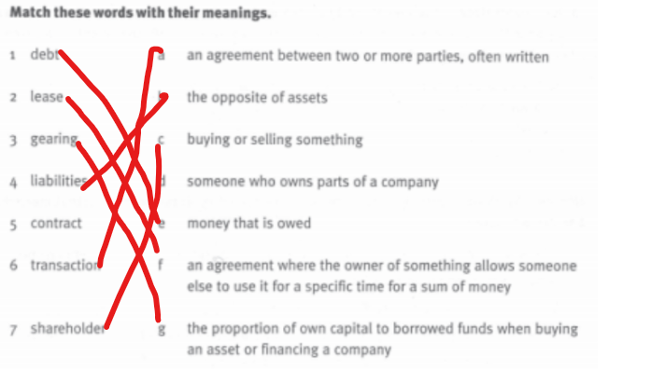

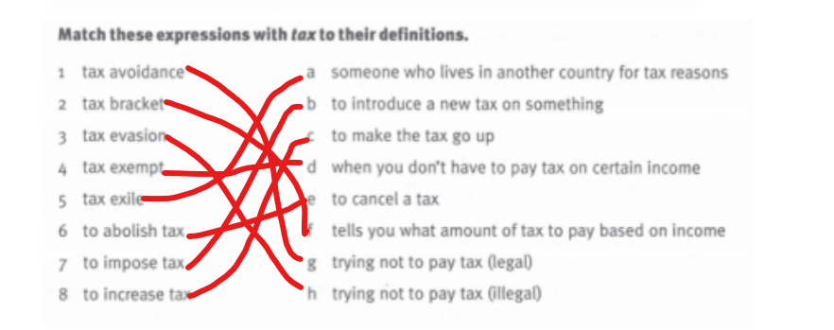

**3. Complete the chart**

For each item, indicate whether it is an Asset, a Liability, or Capital in *Column A*.

|  | A |
| --- | --- |
| 1. Tools | Asset |
| 1. Salaries payable | Liability |
| 1. Additional investment of owner | Liability |
| 1. Cash on hand | Asset |
| 1. Cash deposited in Prime Bank | Asset |
| 1. Delivery truck | Asset |
| 1. Obligation to pay supplier | Liability |
| 1. Loan from bank, 5 years | Liability |
| 1. Investment in long-term bonds | Asset |
| 1. Prepaid insurance | Asset |
| 1. Patent (an intangible) | Asset |
| 1. Withdrawals made by owner | Liability |
| 1. Merchandise for sale | Asset |
| 1. Building used as office space | Asset |
| 1. Accounts receivable | Asset |

For each item, indicate whether it is an Income or an Expense. If it is neither income nor expense, write its

proper classification.

| 1. Rent revenue | Income |
| --- | --- |
| 1. Rent payable | Expense |
| 1. Salaries of employees | Expense |
| 1. Sales | Income |
| 1. Light, water, and electricity | Expense |
| 1. Loss from flood | Expense |
| 1. Accumulated depreciation | Expense |
| 1. Prepaid advertising | Expense |
| 1. Delivery costs | Expense |
| 1. Gain on sale of land | Income |
|  |  |