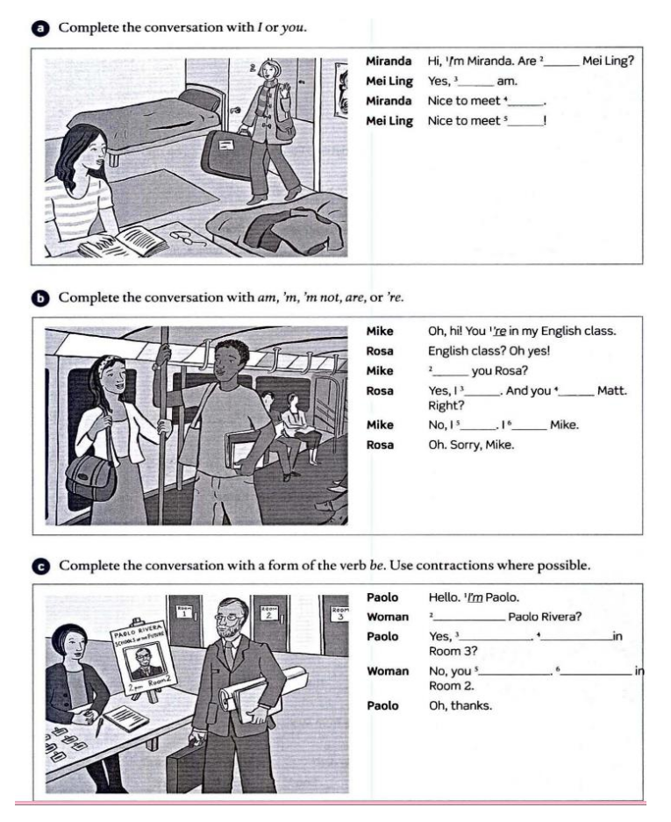

You

I

You

You

Are

Am

Are

m not

Am

Are you

I am

Am I

Aren’t

I am

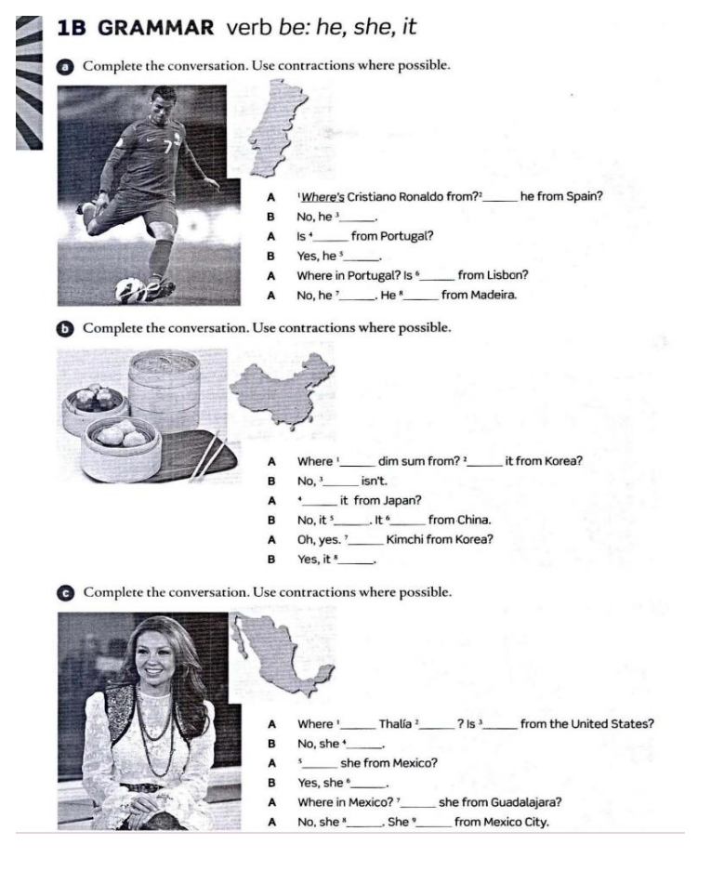

is

isn’t

he

is

he

isn’t

is

is

is

It

is

isn’t

is

is

from

is

is

She

isn’t

is

is

is

isn’t

is

1. 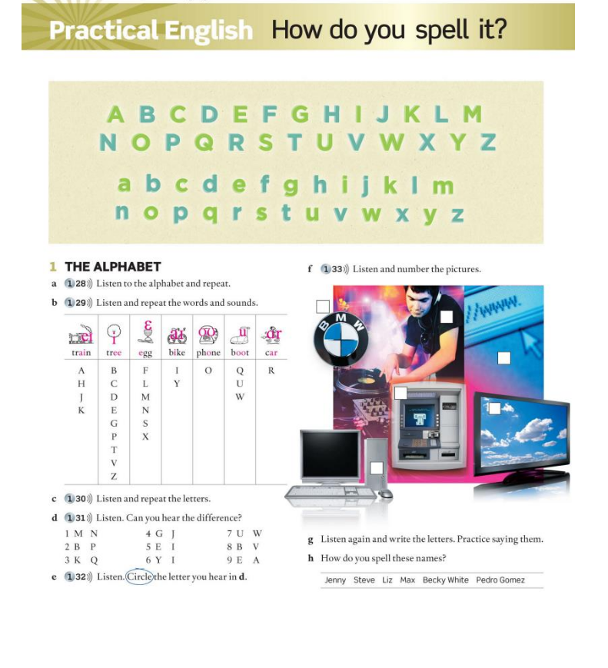ETM
2. BMW
3. TV
4. PC
5. DJ
6. WWW

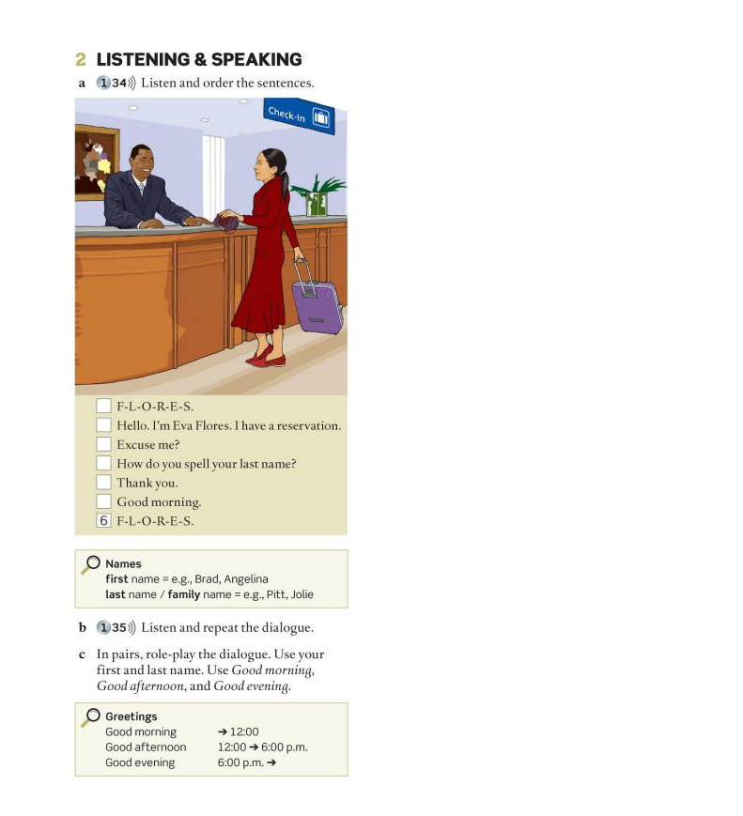

1

2

7

3

5

4

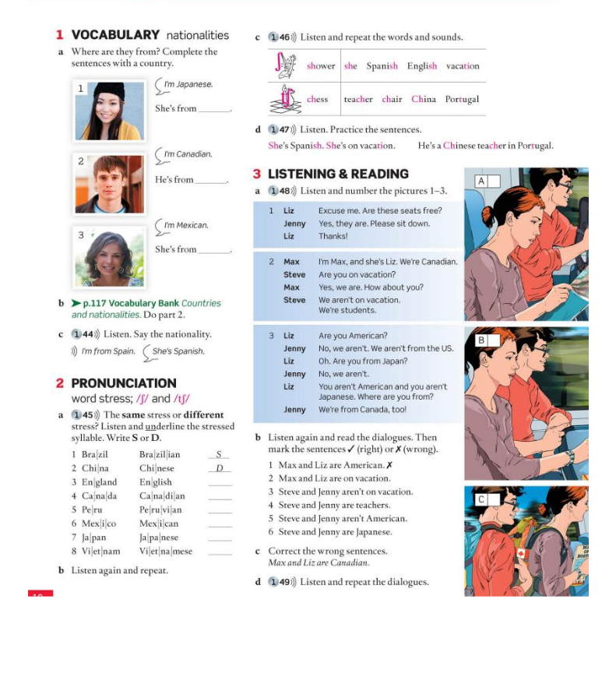Corregidas Apartado 3, inciso b:

Max and Liz are canadian

Steve and Jenny are students

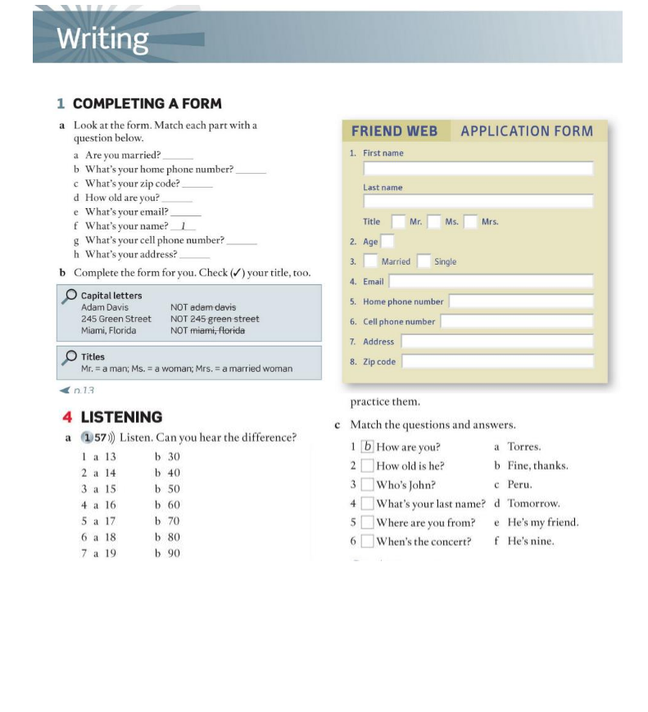

3

5

6

7

4

2

8

1 - B

2 - F

3 - E

4 - A

5 - C

6 - D