Contenido
Esquema tipos de zona: 2
Diccionario de cada label: 2
Piezas: 2
ANÁLISIS PARA DATASETS DE ZONAS 2
Análisis para JSONs Originales 2
Zona: 1 2
Zona: 2 2
Zona: 3 2
Zona: 4 2
Zona: 5 2
Zona: 6 2
Análisis para JSONs Editadas 2
Zona: 1 2
Zona: 10 2
Zona: 2 2
Zona: 3 2
Zona: 4 2
Zona: 5 2
Zona: 6 2
Zona: 7 2
Zona: 8 2
Zona: 9 2
Resumen del Análisis Combinado de ZONAS 3
Sumatorio Total de 'Pieces' y 'Labels' en ZONAS (Originales + Editadas) 3
Conteo total de JSONs en los que aparece cada 'Piece' 3
Conteo total de JSONs en los que aparece cada 'Label' 3
ANÁLISIS PARA EL DATASET DE PIEZAS 3

Esquema tipos de zona:

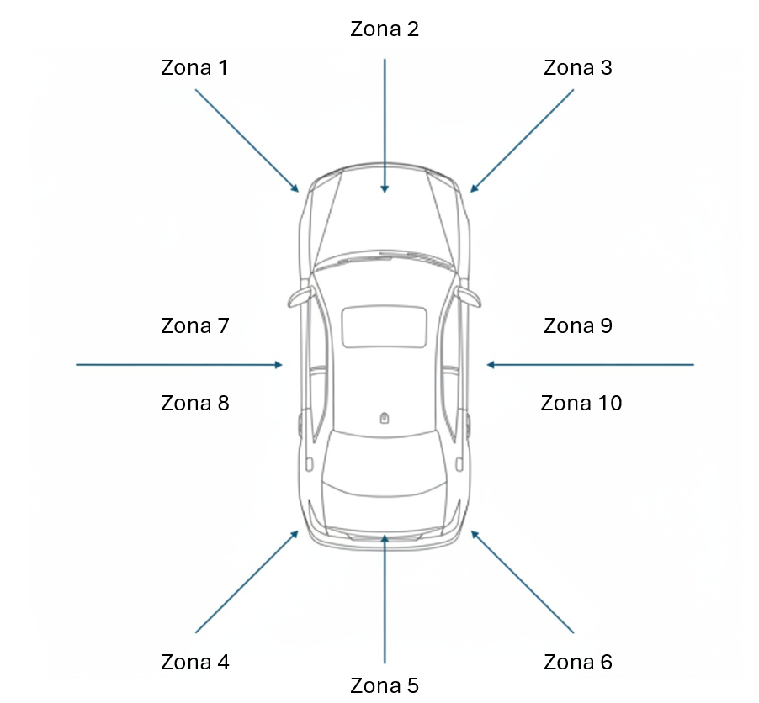

Diccionario de cada label:
Label 1- Arañazo general
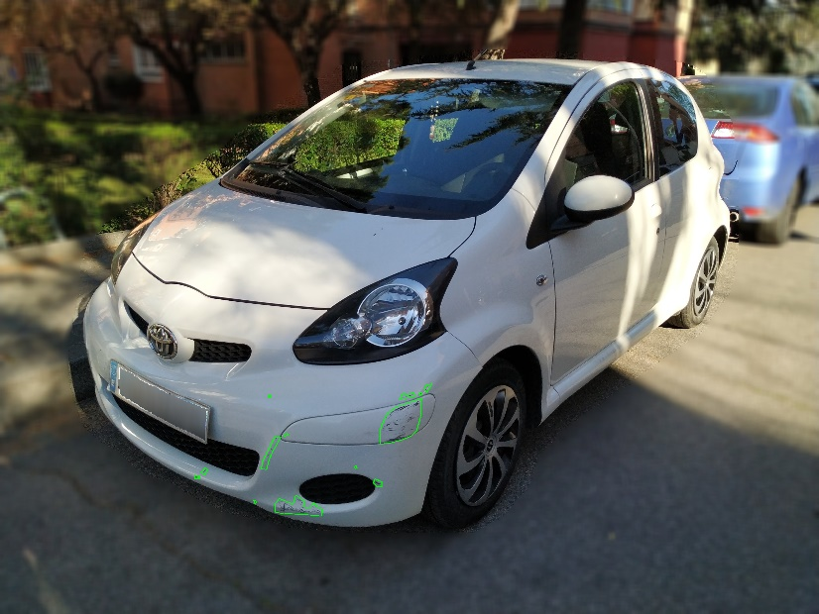
Label 2- Abolladura (color azul)
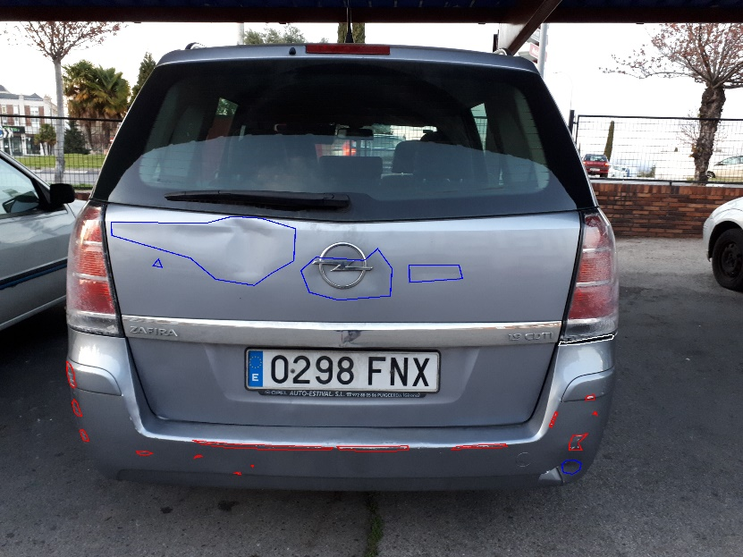

Label 3- Pintura levantada
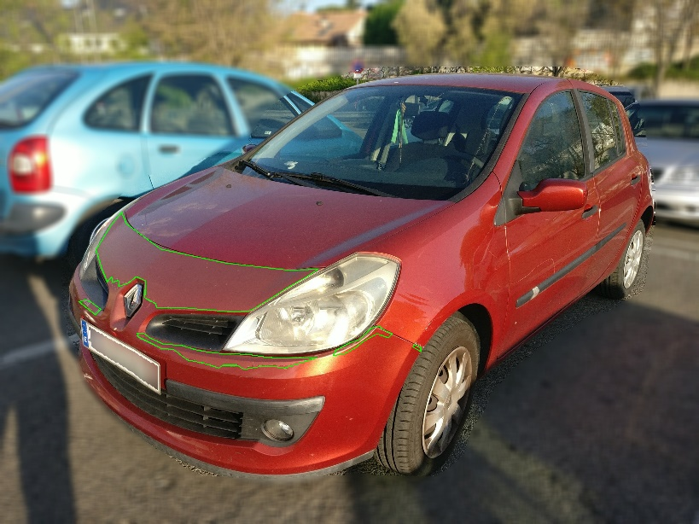
Label 4- Arañazo Grande?
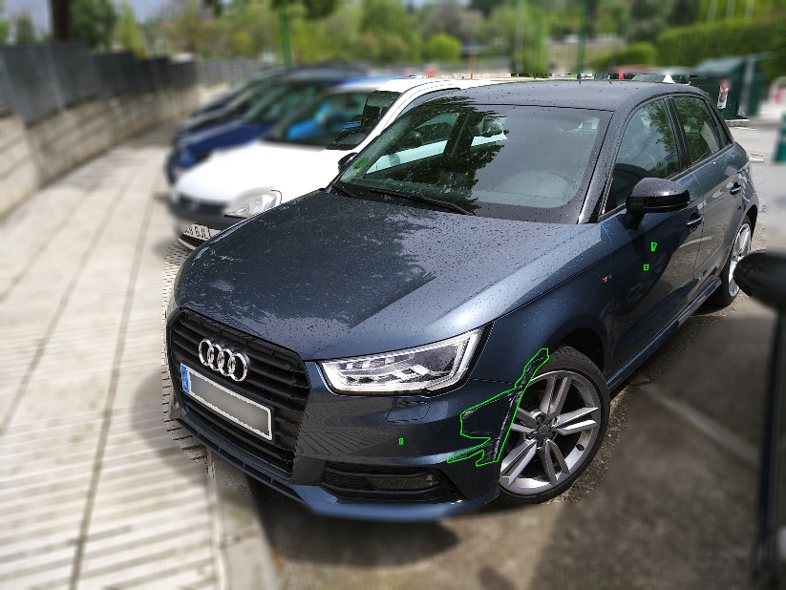
Label 5- Grieta (Polígono Fucsia)
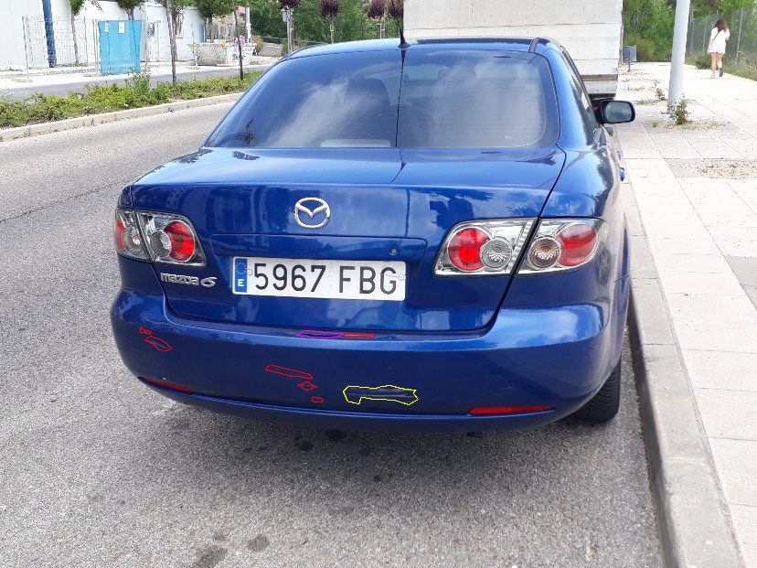
Label 6- Falta trozo de coche (polígono cian)
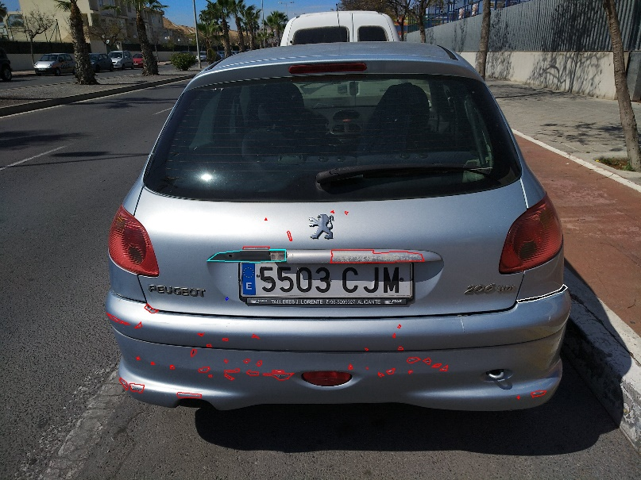
Label 7- Falta algo generico del coche (tapón, marca, letras, etc…)( polígono naranja)
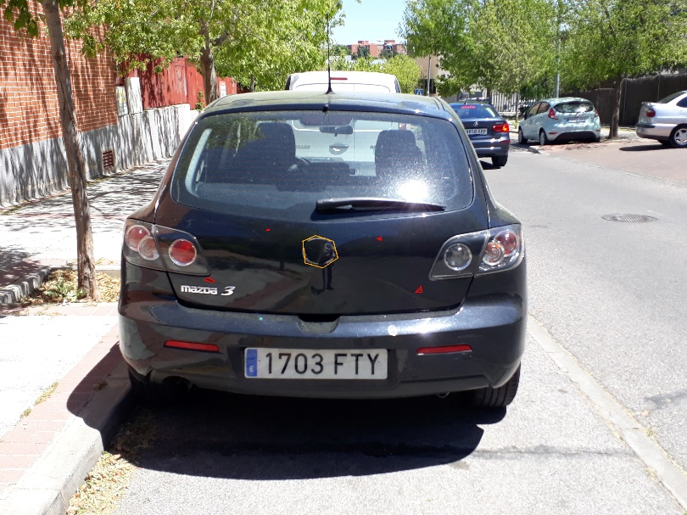
Label 8- Pieza ligeramente salida o desviada ( polígono blanco)
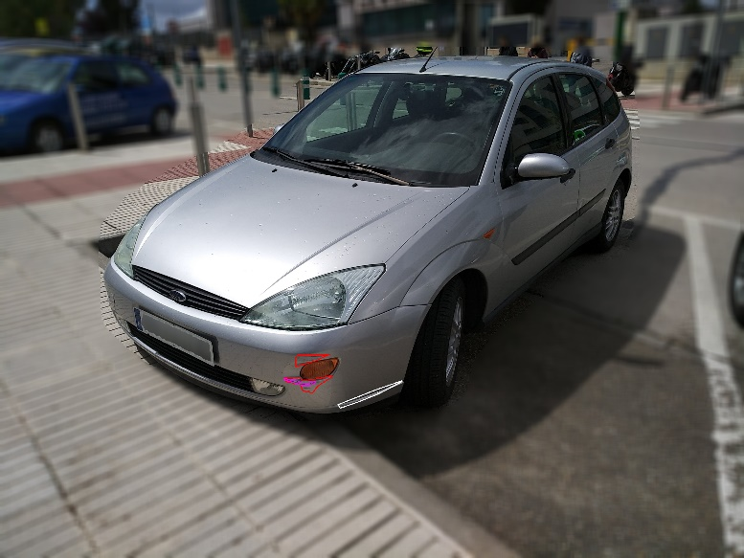

Piezas:
01: Paragolpes Delantero
02: Paragolpes Trasero
04: Luna Trasera
05: Capo Delantaro
06: Portón Trasero
11: Retrovisor Izquierdo
12: Retrovisor Derecho
15: Llanta Delantera Izquierda
16: Llanta Delantera Derecha
17: Llanta Trasera Izquierda
18: Llanta Trasera Derecha
19: Puerta Delantera lzquierda
20: Puerta Delantera Derecha
21: Puerta Trasera lzquierda
22: Puerta Trasera Derecha
23: Aleta Delantera lzquierda
24: Aleta Delantera Derecha
25: Aleta Trasera lzquierda
26: Aleta Trasera Derecha
27: Ventanilla Delantera lzquierda
28: Ventanilla Delantera Derecha
29: Ventanilla Trasera lzquierda
30: Ventanilla Trasera Derecha
31: Matricula

Análisis para el dataset de zonas:

Análisis para JSONs Originales
- Imágenes que SÍ tienen un JSON correspondiente: 18559

- JSON que NO tienen una imagen correspondiente: 0

- Desglose por Zona y tipo de anotación en JSONs:

Zona: 1
JSONs totales: 1532
- Conteos de JSON con un único tipo de par:
- piece:1-label:1: 972 JSONs
- piece:1-label:2: 10 JSONs
- piece:1-label:6: 1 JSONs
- piece:2-label:1: 4 JSONs
- piece:5-label:1: 52 JSONs
- piece:5-label:2: 4 JSONs
- piece:5-label:6: 1 JSONs
- JSONs con múltiples tipos de pares : 488 JSONs
- [piece:1-label:1, piece:1-label:2]: 366 JSONs
- [piece:1-label:1, piece:1-label:2, piece:1-label:6]: 42 JSONs
- [piece:1-label:1, piece:1-label:2, piece:1-label:6, piece:5-label:1]: 1 JSONs
- [piece:1-label:1, piece:1-label:2, piece:5-label:1]: 12 JSONs
- [piece:1-label:1, piece:1-label:2, piece:5-label:1, piece:5-label:2]: 1 JSONs
- [piece:1-label:1, piece:1-label:6]: 24 JSONs
- [piece:1-label:1, piece:5-label:1]: 28 JSONs
- [piece:1-label:1, piece:5-label:1, piece:5-label:2]: 4 JSONs
- [piece:1-label:1, piece:5-label:2]: 2 JSONs
- [piece:1-label:2, piece:1-label:6]: 1 JSONs
- [piece:1-label:2, piece:5-label:1, piece:5-label:2]: 1 JSONs
- [piece:5-label:1, piece:5-label:2]: 6 JSONs

Zona: 2
JSONs totales: 1780 JSONs
- Conteos de JSON con un único tipo de par:
- piece:1-label:1: 1161 JSONs
- piece:1-label:2: 10 JSONs
- piece:2-label:1: 3 JSONs
- piece:5-label:1: 123 JSONs
- piece:5-label:2: 8 JSONs
- piece:5-label:6: 1 JSONs
- JSONs con múltiples tipos de pares: 474 JSONs
- [piece:1-label:1, piece:1-label:2]: 262 JSONs
- [piece:1-label:1, piece:1-label:2, piece:1-label:6]: 39 JSONs
- [piece:1-label:1, piece:1-label:2, piece:1-label:6, piece:5-label:1]: 3 JSONs
-[piece:1-label:1, piece:1-label:2, piece:1-label:6, piece:5-label:1, piece:5-label:2]: 2 JSONs
- [piece:1-label:1, piece:1-label:2, piece:5-label:1]: 11 JSONs
- [piece:1-label:1, piece:1-label:2, piece:5-label:1, piece:5-label:2]: 4 JSONs
- [piece:1-label:1, piece:1-label:2, piece:5-label:2]: 1 JSONs
- [piece:1-label:1, piece:1-label:6]: 61 JSONs
- [piece:1-label:1, piece:1-label:6, piece:5-label:1]: 1 JSONs
- [piece:1-label:1, piece:5-label:1]: 55 JSONs
- [piece:1-label:1, piece:5-label:1, piece:5-label:2]: 12 JSONs
- [piece:1-label:1, piece:5-label:2]: 4 JSONs
- [piece:1-label:2, piece:1-label:6]: 3 JSONs
- [piece:1-label:2, piece:5-label:1]: 1 JSONs
- [piece:2-label:1, piece:2-label:2, piece:5-label:1]: 1 JSONs
- [piece:5-label:1, piece:5-label:2]: 14 JSONs

Zona: 3
JSONs totales: 2767
- Conteos de JSON con un único tipo de par:
- piece:1-label:1: 1849 JSONs
- piece:1-label:2: 33 JSONs
- piece:1-label:6: 3 JSONs
- piece:2-label:1: 4 JSONs
- piece:5-label:1: 72 JSONs
- piece:5-label:2: 8 JSONs
- piece:5-label:6: 2 JSONs
- JSONs con múltiples tipos de pares: 796 JSONs
- [piece:1-label:1, piece:1-label:2]: 596 JSONs
- [piece:1-label:1, piece:1-label:2, piece:1-label:6]: 51 JSONs
- [piece:1-label:1, piece:1-label:2, piece:1-label:6, piece:5-label:1]: 5 JSONs
- [piece:1-label:1, piece:1-label:2, piece:1-label:6, piece:5-label:1, piece:5-label:2]: 2 JSONs
- [piece:1-label:1, piece:1-label:2, piece:5-label:1]: 16 JSONs
- [piece:1-label:1, piece:1-label:2, piece:5-label:1, piece:5-label:2]: 2 JSONs
- [piece:1-label:1, piece:1-label:2, piece:5-label:2]: 2 JSONs
- [piece:1-label:1, piece:1-label:2, piece:5-label:6]: 1 JSONs
- [piece:1-label:1, piece:1-label:6]: 50 JSONs
- [piece:1-label:1, piece:1-label:6, piece:5-label:1]: 3 JSONs
- [piece:1-label:1, piece:5-label:1]: 51 JSONs
- [piece:1-label:1, piece:5-label:1, piece:5-label:2]: 5 JSONs
- [piece:1-label:1, piece:5-label:2]: 6 JSONs
- [piece:5-label:1, piece:5-label:2]: 5 JSONs
- [piece:5-label:1, piece:5-label:6]: 1 JSONs

Zona: 4
JSONs totales: 3628
- Conteos de JSON con un único tipo de par:
- piece:1-label:1: 1 JSONs
- piece:2-label:1: 2896 JSONs
- piece:2-label:2: 26 JSONs
- piece:2-label:6: 2 JSONs
- piece:6-label:1: 11 JSONs
- piece:6-label:2: 5 JSONs
- JSONs con múltiples tipos de pares: 687 JSONs
- [piece:1-label:1, piece:1-label:2]: 1 JSONs
- [piece:1-label:1, piece:5-label:1, piece:5-label:2]: 1 JSONs
- [piece:2-label:1, piece:2-label:2]: 579 JSONs
- [piece:2-label:1, piece:2-label:2, piece:2-label:6]: 24 JSONs
- [piece:2-label:1, piece:2-label:2, piece:2-label:6, piece:6-label:1]: 1 JSONs
- [piece:2-label:1, piece:2-label:2, piece:6-label:1]: 5 JSONs
- [piece:2-label:1, piece:2-label:2, piece:6-label:1, piece:6-label:2]: 3 JSONs
- [piece:2-label:1, piece:2-label:2, piece:6-label:2]: 1 JSONs
- [piece:2-label:1, piece:2-label:6]: 24 JSONs
- [piece:2-label:1, piece:6-label:1]: 22 JSONs
- [piece:2-label:1, piece:6-label:1, piece:6-label:2]: 11 JSONs
- [piece:2-label:1, piece:6-label:1, piece:6-label:6]: 2 JSONs
- [piece:2-label:1, piece:6-label:2]: 5 JSONs
- [piece:6-label:1, piece:6-label:2]: 7 JSONs
- [piece:6-label:1, piece:6-label:6]: 1 JSONs

Zona: 5
JSONs totales: 3475
- Conteos de JSON con un único tipo de par:
- piece:1-label:1: 1 JSONs
- piece:2-label:1: 3021 JSONs
- piece:2-label:2: 8 JSONs
- piece:6-label:1: 16 JSONs
- piece:6-label:2: 1 JSONs
- JSONs con múltiples tipos de pares: 428 JSONs
- [piece:1-label:1, piece:1-label:2]: 1 JSONs
- [piece:2-label:1, piece:2-label:2]: 282 JSONs
- [piece:2-label:1, piece:2-label:2, piece:2-label:6]: 13 JSONs
- [piece:2-label:1, piece:2-label:2, piece:6-label:1]: 4 JSONs
- [piece:2-label:1, piece:2-label:2, piece:6-label:1, piece:6-label:2]: 3 JSONs
- [piece:2-label:1, piece:2-label:2, piece:6-label:1, piece:6-label:2, piece:6-label:6]: 1 JSONs
- [piece:2-label:1, piece:2-label:2, piece:6-label:2]: 3 JSONs
- [piece:2-label:1, piece:2-label:6]: 51 JSONs
- [piece:2-label:1, piece:6-label:1]: 45 JSONs
- [piece:2-label:1, piece:6-label:1, piece:6-label:2]: 16 JSONs
- [piece:2-label:1, piece:6-label:1, piece:6-label:6]: 2 JSONs
- [piece:2-label:1, piece:6-label:2]: 1 JSONs
- [piece:2-label:1, piece:6-label:6]: 1 JSONs
- [piece:6-label:1, piece:6-label:2]: 4 JSONs
- [piece:6-label:2, piece:6-label:6]: 1 JSONs

Zona: 6
JSONs totales: 5376
- Conteos de JSON con un único tipo de par:
- piece:1-label:1: 8 JSONs
- piece:2-label:1: 4460 JSONs
- piece:2-label:2: 8 JSONs
- piece:2-label:6: 1 JSONs
- piece:5-label:1: 1 JSONs
- piece:6-label:1: 10 JSONs
- piece:6-label:2: 1 JSONs
- JSONs con múltiples tipos de pares: 888 JSONs
- [piece:1-label:1, piece:1-label:2]: 10 JSONs
- [piece:1-label:1, piece:1-label:6]: 1 JSONs
- [piece:2-label:1, piece:2-label:2]: 777 JSONs
- [piece:2-label:1, piece:2-label:2, piece:2-label:6]: 16 JSONs
- [piece:2-label:1, piece:2-label:2, piece:2-label:6, piece:6-label:1, piece:6-label:2]: 1 JSONs
- [piece:2-label:1, piece:2-label:2, piece:6-label:1]: 6 JSONs
- [piece:2-label:1, piece:2-label:2, piece:6-label:1, piece:6-label:2]: 2 JSONs
- [piece:2-label:1, piece:2-label:2, piece:6-label:1, piece:6-label:2, piece:6-label:6]: 1 JSONs
- [piece:2-label:1, piece:2-label:2, piece:6-label:2]: 1 JSONs
- [piece:2-label:1, piece:2-label:6]: 30 JSONs
- [piece:2-label:1, piece:2-label:6, piece:6-label:1, piece:6-label:2]: 1 JSONs
- [piece:2-label:1, piece:6-label:1]: 21 JSONs
- [piece:2-label:1, piece:6-label:1, piece:6-label:2]: 11 JSONs
- [piece:2-label:1, piece:6-label:2]: 3 JSONs
- [piece:2-label:2, piece:2-label:6]: 2 JSONs
- [piece:6-label:1, piece:6-label:2]: 5 JSONs

Análisis para JSONs Editadas
Imágenes que SÍ tienen un JSON correspondiente: 17000
JSON que NO tienen una imagen correspondiente: 1

Desglose por Zona y tipo de anotación en JSONs :

Zona: 1
JSONS totales: 1945
- Conteos de JSON con un único tipo de par:
- piece:1-label:1: 1204 JSONs
- piece:1-label:2: 1 JSONs
- piece:1-label:3: 4 JSONs
- piece:1-label:4: 2 JSONs
- piece:1-label:5: 2 JSONs
- piece:1-label:6: 2 JSONs
- piece:1-label:7: 7 JSONs
- piece:1-label:8: 8 JSONs
- piece:2-label:1: 3 JSONs
- piece:5-label:1: 124 JSONs
- piece:5-label:2: 3 JSONs
- piece:5-label:3: 4 JSONs
- piece:5-label:8: 1 JSONs
- JSONs con múltiples tipos de pares : 299 JSONs
- [piece:1-label:1, piece:1-label:2]: 36 JSONs
- [piece:1-label:1, piece:1-label:2, piece:1-label:4]: 1 JSONs
- [piece:1-label:1, piece:1-label:2, piece:1-label:5]: 1 JSONs
- [piece:1-label:1, piece:1-label:2, piece:1-label:5, piece:1-label:6, piece:1-label:7]: 1 JSONs
- [piece:1-label:1, piece:1-label:2, piece:1-label:5, piece:1-label:8]: 2 JSONs
- [piece:1-label:1, piece:1-label:2, piece:1-label:6]: 5 JSONs
- [piece:1-label:1, piece:1-label:2, piece:1-label:7]: 1 JSONs
- [piece:1-label:1, piece:1-label:2, piece:1-label:8]: 3 JSONs
- [piece:1-label:1, piece:1-label:2, piece:5-label:1]: 3 JSONs
- [piece:1-label:1, piece:1-label:3]: 6 JSONs
- [piece:1-label:1, piece:1-label:4]: 25 JSONs
- [piece:1-label:1, piece:1-label:4, piece:1-label:5, piece:1-label:6, piece:1-label:8]: 1 JSONs
- [piece:1-label:1, piece:1-label:4, piece:1-label:6]: 1 JSONs
- [piece:1-label:1, piece:1-label:4, piece:1-label:8]: 3 JSONs
- [piece:1-label:1, piece:1-label:5]: 13 JSONs
- [piece:1-label:1, piece:1-label:5, piece:1-label:6]: 2 JSONs
- [piece:1-label:1, piece:1-label:5, piece:1-label:6, piece:1-label:8]: 1 JSONs
- [piece:1-label:1, piece:1-label:5, piece:1-label:8]: 2 JSONs
- [piece:1-label:1, piece:1-label:6]: 25 JSONs
- [piece:1-label:1, piece:1-label:6, piece:1-label:7]: 1 JSONs
- [piece:1-label:1, piece:1-label:6, piece:1-label:7, piece:1-label:8]: 1 JSONs
- [piece:1-label:1, piece:1-label:6, piece:1-label:8]: 2 JSONs
- [piece:1-label:1, piece:1-label:6, piece:5-label:1]: 1 JSONs
- [piece:1-label:1, piece:1-label:6, piece:5-label:1, piece:5-label:2]: 2 JSONs
- [piece:1-label:1, piece:1-label:7]: 27 JSONs
- [piece:1-label:1, piece:1-label:7, piece:1-label:8]: 3 JSONs
- [piece:1-label:1, piece:1-label:7, piece:5-label:1]: 1 JSONs
- [piece:1-label:1, piece:1-label:8]: 51 JSONs
- [piece:1-label:1, piece:1-label:8, piece:5-label:1]: 5 JSONs
- [piece:1-label:1, piece:1-label:8, piece:5-label:1, piece:5-label:2]: 1 JSONs
- [piece:1-label:1, piece:1-label:8, piece:5-label:1, piece:5-label:2, piece:5-label:7]: 1 JSONs
- [piece:1-label:1, piece:1-label:8, piece:5-label:1, piece:5-label:3]: 1 JSONs
- [piece:1-label:1, piece:5-label:1]: 40 JSONs
- [piece:1-label:1, piece:5-label:1, piece:5-label:2]: 6 JSONs
- [piece:1-label:1, piece:5-label:1, piece:5-label:2, piece:5-label:3]: 1 JSONs
- [piece:1-label:1, piece:5-label:1, piece:5-label:3]: 1 JSONs
- [piece:1-label:1, piece:5-label:2]: 5 JSONs
- [piece:1-label:1, piece:5-label:2, piece:5-label:3]: 1 JSONs
- [piece:1-label:2, piece:1-label:5, piece:1-label:8, piece:5-label:1]: 1 JSONs
- [piece:1-label:2, piece:1-label:6]: 1 JSONs
- [piece:1-label:3, piece:5-label:1, piece:5-label:3]: 1 JSONs
- [piece:1-label:6, piece:5-label:1]: 1 JSONs
- [piece:2-label:1, piece:2-label:3]: 1 JSONs
- [piece:2-label:1, piece:6-label:1]: 1 JSONs
- [piece:5-label:1, piece:5-label:2]: 5 JSONs
- [piece:5-label:1, piece:5-label:3]: 5 JSONs

Zona: 10
JSONs totales: 1687
- Conteos de JSON con un único tipo de par:
- piece:2-label:1: 1 JSONs
- piece:22-label:1: 265 JSONs
- piece:22-label:2: 3 JSONs
- piece:26-label:1: 467 JSONs
- piece:26-label:2: 87 JSONs
- piece:26-label:3: 2 JSONs
- piece:26-label:4: 88 JSONs
- piece:26-label:7: 1 JSONs
- piece:26-label:8: 1 JSONs
- JSONs con múltiples tipos de pares: 636 JSONs
- [piece:22-label:1, piece:22-label:2]: 28 JSONs
- [piece:22-label:1, piece:22-label:2, piece:22-label:4, piece:26-label:1, piece:26-label:2]: 1 JSONs
- [piece:22-label:1, piece:22-label:2, piece:22-label:5, piece:26-label:1, piece:26-label:2]: 1 JSONs
- [piece:22-label:1, piece:22-label:2, piece:22-label:6, piece:26-label:1]: 1 JSONs
- [piece:22-label:1, piece:22-label:2, piece:22-label:7]: 1 JSONs
- [piece:22-label:1, piece:22-label:2, piece:22-label:7, piece:26-label:1, piece:26-label:2]: 1 JSONs
- [piece:22-label:1, piece:22-label:2, piece:26-label:1]: 23 JSONs
- [piece:22-label:1, piece:22-label:2, piece:26-label:1, piece:26-label:2]: 18 JSONs
- [piece:22-label:1, piece:22-label:2, piece:26-label:2]: 4 JSONs
- [piece:22-label:1, piece:22-label:2, piece:26-label:4]: 4 JSONs
- [piece:22-label:1, piece:22-label:3]: 3 JSONs
- [piece:22-label:1, piece:22-label:3, piece:26-label:1]: 2 JSONs
- [piece:22-label:1, piece:22-label:3, piece:26-label:4]: 1 JSONs
- [piece:22-label:1, piece:22-label:4]: 6 JSONs
- [piece:22-label:1, piece:22-label:4, piece:26-label:1]: 2 JSONs
- [piece:22-label:1, piece:22-label:4, piece:26-label:4]: 3 JSONs
- [piece:22-label:1, piece:22-label:6]: 2 JSONs
- [piece:22-label:1, piece:22-label:6, piece:26-label:1]: 1 JSONs
- [piece:22-label:1, piece:22-label:6, piece:26-label:1, piece:26-label:4]: 1 JSONs
- [piece:22-label:1, piece:22-label:6, piece:26-label:4]: 2 JSONs
- [piece:22-label:1, piece:22-label:7]: 3 JSONs
- [piece:22-label:1, piece:26-label:1]: 158 JSONs
- [piece:22-label:1, piece:26-label:1, piece:26-label:2]: 36 JSONs
- [piece:22-label:1, piece:26-label:1, piece:26-label:4]: 11 JSONs
- [piece:22-label:1, piece:26-label:1, piece:26-label:4, piece:26-label:6]: 1 JSONs
- [piece:22-label:1, piece:26-label:1, piece:26-label:6]: 1 JSONs
- [piece:22-label:1, piece:26-label:1, piece:26-label:7]: 1 JSONs
- [piece:22-label:1, piece:26-label:1, piece:26-label:8]: 1 JSONs
- [piece:22-label:1, piece:26-label:2]: 20 JSONs
- [piece:22-label:1, piece:26-label:2, piece:26-label:4]: 1 JSONs
- [piece:22-label:1, piece:26-label:4]: 19 JSONs
- [piece:22-label:2, piece:26-label:1, piece:26-label:2]: 1 JSONs
- [piece:22-label:2, piece:26-label:2]: 1 JSONs
- [piece:22-label:2, piece:26-label:2, piece:26-label:4]: 1 JSONs
- [piece:26-label:1, piece:26-label:2]: 188 JSONs
- [piece:26-label:1, piece:26-label:2, piece:26-label:3]: 3 JSONs
- [piece:26-label:1, piece:26-label:2, piece:26-label:3, piece:26-label:4]: 2 JSONs
- [piece:26-label:1, piece:26-label:2, piece:26-label:4]: 10 JSONs
- [piece:26-label:1, piece:26-label:2, piece:26-label:6]: 4 JSONs
- [piece:26-label:1, piece:26-label:2, piece:26-label:7]: 1 JSONs
- [piece:26-label:1, piece:26-label:3]: 1 JSONs
- [piece:26-label:1, piece:26-label:4]: 43 JSONs
- [piece:26-label:1, piece:26-label:4, piece:26-label:7]: 1 JSONs
- [piece:26-label:1, piece:26-label:6]: 4 JSONs
- [piece:26-label:1, piece:26-label:7]: 7 JSONs
- [piece:26-label:1, piece:26-label:8]: 1 JSONs
- [piece:26-label:2, piece:26-label:4]: 8 JSONs
- [piece:26-label:2, piece:26-label:6]: 1 JSONs
- [piece:26-label:2, piece:26-label:8]: 1 JSONs
- [piece:26-label:4, piece:26-label:7]: 1 JSONs

Zona: 2
JSONs totales: 1945
- Conteos de JSON con un único tipo de par:
- piece:1-label:1: 1222 JSONs
- piece:1-label:2: 2 JSONs
- piece:1-label:5: 2 JSONs
- piece:1-label:6: 4 JSONs
- piece:1-label:7: 5 JSONs
- piece:1-label:8: 1 JSONs
- piece:2-label:1: 4 JSONs
- piece:5-label:1: 141 JSONs
- piece:5-label:2: 4 JSONs
- piece:5-label:3: 2 JSONs
- JSONs con múltiples tipos de pares: 325 JSONs
- [piece:1-label:1, piece:1-label:2]: 27 JSONs
- [piece:1-label:1, piece:1-label:2, piece:1-label:3]: 1 JSONs
- [piece:1-label:1, piece:1-label:2, piece:1-label:3, piece:5-label:1, piece:5-label:3]: 1 JSONs
- [piece:1-label:1, piece:1-label:2, piece:1-label:5]: 2 JSONs
- [piece:1-label:1, piece:1-label:2, piece:1-label:5, piece:1-label:8]: 1 JSONs
- [piece:1-label:1, piece:1-label:2, piece:1-label:5, piece:5-label:1]: 1 JSONs
- [piece:1-label:1, piece:1-label:2, piece:1-label:5, piece:5-label:1, piece:5-label:2]: 1 JSONs
- [piece:1-label:1, piece:1-label:2, piece:1-label:6]: 2 JSONs
- [piece:1-label:1, piece:1-label:2, piece:1-label:7]: 2 JSONs
- [piece:1-label:1, piece:1-label:2, piece:1-label:8]: 1 JSONs
- [piece:1-label:1, piece:1-label:2, piece:5-label:1]: 2 JSONs
- [piece:1-label:1, piece:1-label:2, piece:5-label:1, piece:5-label:3]: 1 JSONs
- [piece:1-label:1, piece:1-label:2, piece:5-label:2]: 2 JSONs
- [piece:1-label:1, piece:1-label:3]: 3 JSONs
- [piece:1-label:1, piece:1-label:3, piece:5-label:1, piece:5-label:3]: 1 JSONs
- [piece:1-label:1, piece:1-label:4]: 4 JSONs
- [piece:1-label:1, piece:1-label:4, piece:1-label:5]: 1 JSONs
- [piece:1-label:1, piece:1-label:4, piece:1-label:8, piece:5-label:1, piece:5-label:3]: 1 JSONs
- [piece:1-label:1, piece:1-label:5]: 25 JSONs
- [piece:1-label:1, piece:1-label:5, piece:1-label:6]: 3 JSONs
- [piece:1-label:1, piece:1-label:5, piece:1-label:6, piece:1-label:8]: 1 JSONs
- [piece:1-label:1, piece:1-label:5, piece:1-label:7, piece:1-label:8, piece:5-label:1]: 1 JSONs
- [piece:1-label:1, piece:1-label:5, piece:1-label:7, piece:5-label:1]: 1 JSONs
- [piece:1-label:1, piece:1-label:5, piece:1-label:8]: 4 JSONs
- [piece:1-label:1, piece:1-label:5, piece:5-label:1]: 2 JSONs
- [piece:1-label:1, piece:1-label:5, piece:5-label:1, piece:5-label:2]: 1 JSONs
- [piece:1-label:1, piece:1-label:6]: 37 JSONs
- [piece:1-label:1, piece:1-label:6, piece:1-label:7]: 1 JSONs
- [piece:1-label:1, piece:1-label:6, piece:1-label:8]: 1 JSONs
- [piece:1-label:1, piece:1-label:6, piece:1-label:8, piece:5-label:1]: 1 JSONs
- [piece:1-label:1, piece:1-label:6, piece:5-label:1]: 1 JSONs
- [piece:1-label:1, piece:1-label:7]: 46 JSONs
- [piece:1-label:1, piece:1-label:7, piece:1-label:8]: 4 JSONs
- [piece:1-label:1, piece:1-label:8]: 33 JSONs
- [piece:1-label:1, piece:1-label:8, piece:5-label:1]: 4 JSONs
- [piece:1-label:1, piece:5-label:1]: 72 JSONs
- [piece:1-label:1, piece:5-label:1, piece:5-label:2]: 5 JSONs
- [piece:1-label:1, piece:5-label:1, piece:5-label:2, piece:5-label:3]: 2 JSONs
- [piece:1-label:1, piece:5-label:1, piece:5-label:3]: 2 JSONs
- [piece:1-label:1, piece:5-label:1, piece:5-label:6]: 1 JSONs
- [piece:1-label:1, piece:5-label:1, piece:5-label:7]: 1 JSONs
- [piece:1-label:1, piece:5-label:2]: 1 JSONs
- [piece:1-label:1, piece:5-label:3]: 2 JSONs
- [piece:1-label:3, piece:5-label:1, piece:5-label:2, piece:5-label:3]: 1 JSONs
- [piece:1-label:3, piece:5-label:1, piece:5-label:3]: 1 JSONs
- [piece:1-label:3, piece:5-label:3]: 1 JSONs
- [piece:1-label:4, piece:5-label:1]: 1 JSONs
- [piece:1-label:7, piece:1-label:8]: 1 JSONs
- [piece:2-label:1, piece:5-label:1]: 1 JSONs
- [piece:5-label:1, piece:5-label:2]: 8 JSONs
- [piece:5-label:1, piece:5-label:2, piece:5-label:3]: 1 JSONs
- [piece:5-label:1, piece:5-label:3]: 2 JSONs
- [piece:5-label:2, piece:5-label:3]: 2 JSONs

Zona: 3
JSONs totales: 1945
- Conteos de JSON con un único tipo de par:
- piece:1-label:1: 1232 JSONs
- piece:1-label:2: 4 JSONs
- piece:1-label:3: 1 JSONs
- piece:1-label:5: 2 JSONs
- piece:1-label:6: 6 JSONs
- piece:1-label:7: 4 JSONs
- piece:1-label:8: 9 JSONs
- piece:2-label:1: 4 JSONs
- piece:5-label:1: 95 JSONs
- piece:5-label:2: 17 JSONs
- piece:5-label:3: 6 JSONs
- piece:5-label:7: 1 JSONs
- JSONs con múltiples tipos de pares: 272 JSONs
- [piece:1-label:1, piece:1-label:2]: 30 JSONs
- [piece:1-label:1, piece:1-label:2, piece:1-label:4]: 1 JSONs
- [piece:1-label:1, piece:1-label:2, piece:1-label:5, piece:1-label:7]: 1 JSONs
- [piece:1-label:1, piece:1-label:2, piece:1-label:7]: 1 JSONs
- [piece:1-label:1, piece:1-label:2, piece:1-label:7, piece:1-label:8]: 1 JSONs
- [piece:1-label:1, piece:1-label:2, piece:1-label:8]: 2 JSONs
- [piece:1-label:1, piece:1-label:2, piece:5-label:1]: 1 JSONs
- [piece:1-label:1, piece:1-label:3]: 7 JSONs
- [piece:1-label:1, piece:1-label:3, piece:5-label:3]: 1 JSONs
- [piece:1-label:1, piece:1-label:4]: 23 JSONs
- [piece:1-label:1, piece:1-label:4, piece:1-label:6]: 1 JSONs
- [piece:1-label:1, piece:1-label:4, piece:1-label:6, piece:1-label:8]: 1 JSONs
- [piece:1-label:1, piece:1-label:4, piece:1-label:7, piece:5-label:1]: 1 JSONs
- [piece:1-label:1, piece:1-label:5]: 18 JSONs
- [piece:1-label:1, piece:1-label:5, piece:1-label:7]: 1 JSONs
- [piece:1-label:1, piece:1-label:5, piece:1-label:7, piece:5-label:1]: 1 JSONs
- [piece:1-label:1, piece:1-label:5, piece:1-label:8]: 6 JSONs
- [piece:1-label:1, piece:1-label:5, piece:5-label:1]: 1 JSONs
- [piece:1-label:1, piece:1-label:6]: 15 JSONs
- [piece:1-label:1, piece:1-label:6, piece:1-label:7]: 1 JSONs
- [piece:1-label:1, piece:1-label:6, piece:1-label:8]: 2 JSONs
- [piece:1-label:1, piece:1-label:6, piece:5-label:1]: 1 JSONs
- [piece:1-label:1, piece:1-label:7]: 34 JSONs
- [piece:1-label:1, piece:1-label:7, piece:1-label:8]: 3 JSONs
- [piece:1-label:1, piece:1-label:8]: 76 JSONs
- [piece:1-label:1, piece:1-label:8, piece:5-label:1]: 1 JSONs
- [piece:1-label:1, piece:1-label:8, piece:5-label:2]: 1 JSONs
- [piece:1-label:1, piece:5-label:1]: 21 JSONs
- [piece:1-label:1, piece:5-label:1, piece:5-label:2]: 1 JSONs
- [piece:1-label:1, piece:5-label:1, piece:5-label:2, piece:5-label:3, piece:5-label:7]: 1 JSONs
- [piece:1-label:1, piece:5-label:1, piece:5-label:3]: 2 JSONs
- [piece:1-label:1, piece:5-label:2]: 1 JSONs
- [piece:1-label:1, piece:5-label:3]: 1 JSONs
- [piece:1-label:2, piece:1-label:4]: 1 JSONs
- [piece:1-label:2, piece:1-label:6]: 2 JSONs
- [piece:1-label:4, piece:1-label:8]: 1 JSONs
- [piece:5-label:1, piece:5-label:2]: 5 JSONs
- [piece:5-label:1, piece:5-label:3]: 4 JSONs

Zona: 4
JSONs totales: 1945
- Conteos de JSON con un único tipo de par:
- piece:2-label:1: 1421 JSONs
- piece:2-label:2: 3 JSONs
- piece:2-label:3: 1 JSONs
- piece:2-label:4: 4 JSONs
- piece:2-label:5: 3 JSONs
- piece:2-label:6: 1 JSONs
- piece:2-label:7: 3 JSONs
- piece:2-label:8: 6 JSONs
- piece:6-label:1: 32 JSONs
- piece:6-label:2: 3 JSONs
- JSONs con múltiples tipos de pares: 242 JSONs
- [piece:2-label:1, piece:2-label:2]: 34 JSONs
- [piece:2-label:1, piece:2-label:2, piece:2-label:4]: 1 JSONs
- [piece:2-label:1, piece:2-label:2, piece:2-label:4, piece:2-label:8]: 1 JSONs
- [piece:2-label:1, piece:2-label:2, piece:2-label:5]: 1 JSONs
- [piece:2-label:1, piece:2-label:2, piece:2-label:5, piece:2-label:8]: 1 JSONs
- [piece:2-label:1, piece:2-label:2, piece:2-label:5, piece:6-label:1]: 1 JSONs
- [piece:2-label:1, piece:2-label:2, piece:2-label:6]: 1 JSONs
- [piece:2-label:1, piece:2-label:2, piece:2-label:6, piece:2-label:8]: 1 JSONs
- [piece:2-label:1, piece:2-label:2, piece:2-label:8]: 2 JSONs
- [piece:2-label:1, piece:2-label:2, piece:6-label:1]: 1 JSONs
- [piece:2-label:1, piece:2-label:2, piece:6-label:2]: 1 JSONs
- [piece:2-label:1, piece:2-label:3]: 2 JSONs
- [piece:2-label:1, piece:2-label:3, piece:2-label:8]: 1 JSONs
- [piece:2-label:1, piece:2-label:3, piece:6-label:3]: 1 JSONs
- [piece:2-label:1, piece:2-label:4]: 11 JSONs
- [piece:2-label:1, piece:2-label:5]: 7 JSONs
- [piece:2-label:1, piece:2-label:5, piece:2-label:8]: 3 JSONs
- [piece:2-label:1, piece:2-label:5, piece:6-label:1]: 1 JSONs
- [piece:2-label:1, piece:2-label:6]: 11 JSONs
- [piece:2-label:1, piece:2-label:6, piece:2-label:8]: 1 JSONs
- [piece:2-label:1, piece:2-label:6, piece:2-label:8, piece:6-label:1, piece:6-label:2]: 1 JSONs
- [piece:2-label:1, piece:2-label:7]: 5 JSONs
- [piece:2-label:1, piece:2-label:7, piece:2-label:8]: 1 JSONs
- [piece:2-label:1, piece:2-label:8]: 28 JSONs
- [piece:2-label:1, piece:2-label:8, piece:6-label:1]: 3 JSONs
- [piece:2-label:1, piece:2-label:8, piece:6-label:1, piece:6-label:2]: 1 JSONs
- [piece:2-label:1, piece:6-label:1]: 68 JSONs
- [piece:2-label:1, piece:6-label:1, piece:6-label:2]: 20 JSONs
- [piece:2-label:1, piece:6-label:1, piece:6-label:2, piece:6-label:3]: 1 JSONs
- [piece:2-label:1, piece:6-label:1, piece:6-label:3]: 3 JSONs
- [piece:2-label:1, piece:6-label:1, piece:6-label:3, piece:6-label:7]: 1 JSONs
- [piece:2-label:1, piece:6-label:1, piece:6-label:7]: 1 JSONs
- [piece:2-label:1, piece:6-label:2]: 14 JSONs
- [piece:2-label:1, piece:6-label:7]: 3 JSONs
- [piece:2-label:2, piece:6-label:2]: 1 JSONs
- [piece:2-label:5, piece:2-label:6]: 1 JSONs
- [piece:6-label:1, piece:6-label:2]: 7 JSONs

Zona: 5
JSONs totales: 1945
- Conteos de JSON con un único tipo de par:
- piece:2-label:1: 1460 JSONs
- piece:2-label:2: 3 JSONs
- piece:2-label:5: 3 JSONs
- piece:2-label:6: 4 JSONs
- piece:2-label:7: 1 JSONs
- piece:6-label:1: 38 JSONs
- piece:6-label:7: 1 JSONs
- JSONs con múltiples tipos de pares: 251 JSONs
- [piece:2-label:1, piece:2-label:2]: 19 JSONs
- [piece:2-label:1, piece:2-label:2, piece:2-label:5]: 1 JSONs
- [piece:2-label:1, piece:2-label:2, piece:2-label:5, piece:6-label:1]: 1 JSONs
- [piece:2-label:1, piece:2-label:2, piece:2-label:8]: 1 JSONs
- [piece:2-label:1, piece:2-label:2, piece:6-label:1]: 5 JSONs
- [piece:2-label:1, piece:2-label:3]: 3 JSONs
- [piece:2-label:1, piece:2-label:4]: 2 JSONs
- [piece:2-label:1, piece:2-label:4, piece:2-label:5]: 1 JSONs
- [piece:2-label:1, piece:2-label:5]: 5 JSONs
- [piece:2-label:1, piece:2-label:5, piece:2-label:6]: 1 JSONs
- [piece:2-label:1, piece:2-label:5, piece:6-label:1, piece:6-label:2]: 1 JSONs
- [piece:2-label:1, piece:2-label:5, piece:6-label:2]: 1 JSONs
- [piece:2-label:1, piece:2-label:6]: 9 JSONs
- [piece:2-label:1, piece:2-label:6, piece:2-label:8]: 1 JSONs
- [piece:2-label:1, piece:2-label:7]: 6 JSONs
- [piece:2-label:1, piece:2-label:7, piece:6-label:1]: 3 JSONs
- [piece:2-label:1, piece:2-label:8]: 10 JSONs
- [piece:2-label:1, piece:2-label:8, piece:6-label:1]: 2 JSONs
- [piece:2-label:1, piece:2-label:8, piece:6-label:1, piece:6-label:2]: 1 JSONs
- [piece:2-label:1, piece:2-label:8, piece:6-label:1, piece:6-label:6]: 1 JSONs
- [piece:2-label:1, piece:2-label:8, piece:6-label:2]: 1 JSONs
- [piece:2-label:1, piece:6-label:1]: 101 JSONs
- [piece:2-label:1, piece:6-label:1, piece:6-label:2]: 33 JSONs
- [piece:2-label:1, piece:6-label:1, piece:6-label:2, piece:6-label:3]: 3 JSONs
- [piece:2-label:1, piece:6-label:1, piece:6-label:2, piece:6-label:6]: 2 JSONs
- [piece:2-label:1, piece:6-label:1, piece:6-label:3]: 2 JSONs
- [piece:2-label:1, piece:6-label:1, piece:6-label:6]: 1 JSONs
- [piece:2-label:1, piece:6-label:1, piece:6-label:7]: 1 JSONs
- [piece:2-label:1, piece:6-label:2]: 6 JSONs
- [piece:2-label:1, piece:6-label:3]: 3 JSONs
- [piece:2-label:2, piece:6-label:1]: 1 JSONs
- [piece:2-label:5, piece:6-label:1, piece:6-label:2, piece:6-label:3]: 1 JSONs
- [piece:6-label:1, piece:6-label:2]: 17 JSONs
- [piece:6-label:1, piece:6-label:2, piece:6-label:6]: 2 JSONs
- [piece:6-label:1, piece:6-label:6]: 1 JSONs
- [piece:6-label:1, piece:6-label:7]: 2 JSONs

Zona: 6
JSONs totales: 1945
- Conteos de JSON con un único tipo de par:
- piece:1-label:1: 5 JSONs
- piece:2-label:1: 1429 JSONs
- piece:2-label:2: 1 JSONs
- piece:2-label:7: 2 JSONs
- piece:2-label:8: 4 JSONs
- piece:6-label:1: 44 JSONs
- piece:6-label:2: 1 JSONs
- piece:6-label:3: 2 JSONs
- JSONs con múltiples tipos de pares: 233 JSONs
- [piece:1-label:1, piece:1-label:6]: 1 JSONs
- [piece:1-label:1, piece:1-label:8]: 1 JSONs
- [piece:1-label:1, piece:5-label:1]: 1 JSONs
- [piece:2-label:1, piece:2-label:2]: 29 JSONs
- [piece:2-label:1, piece:2-label:2, piece:2-label:5, piece:2-label:8]: 1 JSONs
- [piece:2-label:1, piece:2-label:2, piece:2-label:6]: 1 JSONs
- [piece:2-label:1, piece:2-label:2, piece:2-label:8]: 2 JSONs
- [piece:2-label:1, piece:2-label:2, piece:6-label:1]: 3 JSONs
- [piece:2-label:1, piece:2-label:2, piece:6-label:1, piece:6-label:2]: 1 JSONs
- [piece:2-label:1, piece:2-label:3]: 1 JSONs
- [piece:2-label:1, piece:2-label:4]: 9 JSONs
- [piece:2-label:1, piece:2-label:4, piece:6-label:2]: 1 JSONs
- [piece:2-label:1, piece:2-label:5]: 13 JSONs
- [piece:2-label:1, piece:2-label:5, piece:2-label:8]: 1 JSONs
- [piece:2-label:1, piece:2-label:5, piece:6-label:1]: 1 JSONs
- [piece:2-label:1, piece:2-label:6]: 13 JSONs
- [piece:2-label:1, piece:2-label:7]: 4 JSONs
- [piece:2-label:1, piece:2-label:7, piece:2-label:8, piece:6-label:2]: 1 JSONs
- [piece:2-label:1, piece:2-label:8]: 40 JSONs
- [piece:2-label:1, piece:2-label:8, piece:6-label:1]: 1 JSONs
- [piece:2-label:1, piece:2-label:8, piece:6-label:1, piece:6-label:2]: 1 JSONs
- [piece:2-label:1, piece:6-label:1]: 66 JSONs
- [piece:2-label:1, piece:6-label:1, piece:6-label:2]: 16 JSONs
- [piece:2-label:1, piece:6-label:1, piece:6-label:2, piece:6-label:6]: 1 JSONs
- [piece:2-label:1, piece:6-label:1, piece:6-label:3, piece:6-label:7]: 1 JSONs
- [piece:2-label:1, piece:6-label:1, piece:6-label:6]: 2 JSONs
- [piece:2-label:1, piece:6-label:1, piece:6-label:7]: 1 JSONs
- [piece:2-label:1, piece:6-label:2]: 11 JSONs
- [piece:5-label:1, piece:5-label:2]: 1 JSONs
- [piece:6-label:1, piece:6-label:2]: 7 JSONs
- [piece:6-label:1, piece:6-label:3]: 1 JSONs

Zona: 7
JSONs totales: 1141
- Conteos de JSON con un único tipo de par:
- piece:19-label:1: 372 JSONs
- piece:19-label:2: 4 JSONs
- piece:23-label:1: 182 JSONs
- piece:23-label:2: 34 JSONs
- piece:23-label:3: 1 JSONs
- piece:23-label:4: 1 JSONs
- piece:23-label:5: 1 JSONs
- piece:23-label:6: 5 JSONs
- piece:23-label:8: 1 JSONs
- JSONs con múltiples tipos de pares: 446 JSONs
- [piece:19-label:1, piece:19-label:2]: 70 JSONs
- [piece:19-label:1, piece:19-label:2, piece:19-label:3, piece:23-label:2]: 1 JSONs
- [piece:19-label:1, piece:19-label:2, piece:19-label:3, piece:23-label:2, piece:23-label:3]: 1 JSONs
- [piece:19-label:1, piece:19-label:2, piece:19-label:3, piece:23-label:2, piece:23-label:7]: 1 JSONs
- [piece:19-label:1, piece:19-label:2, piece:19-label:4]: 1 JSONs
- [piece:19-label:1, piece:19-label:2, piece:19-label:7, piece:23-label:1, piece:23-label:2]: 2 JSONs
- [piece:19-label:1, piece:19-label:2, piece:19-label:7, piece:23-label:2]: 1 JSONs
- [piece:19-label:1, piece:19-label:2, piece:23-label:1]: 33 JSONs
- [piece:19-label:1, piece:19-label:2, piece:23-label:1, piece:23-label:2]: 25 JSONs
- [piece:19-label:1, piece:19-label:2, piece:23-label:1, piece:23-label:2, piece:23-label:6]: 1 JSONs
- [piece:19-label:1, piece:19-label:2, piece:23-label:1, piece:23-label:2, piece:23-label:7]: 1 JSONs
- [piece:19-label:1, piece:19-label:2, piece:23-label:1, piece:23-label:3, piece:23-label:8]: 1 JSONs
- [piece:19-label:1, piece:19-label:2, piece:23-label:1, piece:23-label:4]: 1 JSONs
- [piece:19-label:1, piece:19-label:2, piece:23-label:2]: 5 JSONs
- [piece:19-label:1, piece:19-label:3]: 4 JSONs
- [piece:19-label:1, piece:19-label:3, piece:23-label:1]: 1 JSONs
- [piece:19-label:1, piece:19-label:3, piece:23-label:3]: 2 JSONs
- [piece:19-label:1, piece:19-label:4]: 1 JSONs
- [piece:19-label:1, piece:19-label:4, piece:23-label:1]: 1 JSONs
- [piece:19-label:1, piece:19-label:6]: 1 JSONs
- [piece:19-label:1, piece:19-label:6, piece:23-label:1]: 4 JSONs
- [piece:19-label:1, piece:19-label:6, piece:23-label:2]: 1 JSONs
- [piece:19-label:1, piece:19-label:6, piece:23-label:6]: 1 JSONs
- [piece:19-label:1, piece:19-label:7]: 3 JSONs
- [piece:19-label:1, piece:23-label:1]: 117 JSONs
- [piece:19-label:1, piece:23-label:1, piece:23-label:2]: 42 JSONs
- [piece:19-label:1, piece:23-label:1, piece:23-label:2, piece:23-label:3]: 1 JSONs
- [piece:19-label:1, piece:23-label:1, piece:23-label:2, piece:23-label:6]: 1 JSONs
- [piece:19-label:1, piece:23-label:1, piece:23-label:3]: 1 JSONs
- [piece:19-label:1, piece:23-label:1, piece:23-label:4]: 3 JSONs
- [piece:19-label:1, piece:23-label:1, piece:23-label:6]: 2 JSONs
- [piece:19-label:1, piece:23-label:1, piece:23-label:8]: 1 JSONs
- [piece:19-label:1, piece:23-label:2]: 23 JSONs
- [piece:19-label:1, piece:23-label:2, piece:23-label:4]: 1 JSONs
- [piece:19-label:1, piece:23-label:4]: 1 JSONs
- [piece:19-label:1, piece:23-label:5]: 1 JSONs
- [piece:19-label:2, piece:19-label:3, piece:23-label:1, piece:23-label:4]: 1 JSONs
- [piece:19-label:2, piece:23-label:1]: 3 JSONs
- [piece:19-label:2, piece:23-label:1, piece:23-label:2]: 1 JSONs
- [piece:19-label:2, piece:23-label:4]: 1 JSONs
- [piece:23-label:1, piece:23-label:2]: 70 JSONs
- [piece:23-label:1, piece:23-label:2, piece:23-label:3]: 1 JSONs
- [piece:23-label:1, piece:23-label:2, piece:23-label:5]: 1 JSONs
- [piece:23-label:1, piece:23-label:2, piece:23-label:8]: 1 JSONs
- [piece:23-label:1, piece:23-label:4]: 3 JSONs
- [piece:23-label:1, piece:23-label:5]: 1 JSONs
- [piece:23-label:1, piece:23-label:8]: 1 JSONs
- [piece:23-label:2, piece:23-label:3]: 1 JSONs
- [piece:23-label:2, piece:23-label:4]: 1 JSONs
- [piece:23-label:2, piece:23-label:6]: 1 JSONs
- [piece:23-label:2, piece:23-label:7]: 2 JSONs

Zona: 8
JSONs totales: 1025
- Conteos de JSON con un único tipo de par:
- piece:21-label:1: 257 JSONs
- piece:21-label:2: 10 JSONs
- piece:21-label:6: 1 JSONs
- piece:25-label:1: 203 JSONs
- piece:25-label:2: 43 JSONs
- piece:25-label:4: 20 JSONs
- piece:25-label:5: 1 JSONs
- JSONs con múltiples tipos de pares: 411 JSONs
- [piece:21-label:1, piece:21-label:2]: 33 JSONs
- [piece:21-label:1, piece:21-label:2, piece:21-label:3, piece:25-label:2, piece:25-label:3]: 1 JSONs
- [piece:21-label:1, piece:21-label:2, piece:21-label:4]: 1 JSONs
- [piece:21-label:1, piece:21-label:2, piece:21-label:4, piece:25-label:1]: 1 JSONs
- [piece:21-label:1, piece:21-label:2, piece:21-label:5]: 1 JSONs
- [piece:21-label:1, piece:21-label:2, piece:21-label:6]: 2 JSONs
- [piece:21-label:1, piece:21-label:2, piece:21-label:7]: 1 JSONs
- [piece:21-label:1, piece:21-label:2, piece:21-label:7, piece:25-label:1]: 1 JSONs
- [piece:21-label:1, piece:21-label:2, piece:25-label:1]: 20 JSONs
- [piece:21-label:1, piece:21-label:2, piece:25-label:1, piece:25-label:2]: 10 JSONs
- [piece:21-label:1, piece:21-label:2, piece:25-label:1, piece:25-label:2, piece:25-label:4]: 3 JSONs
- [piece:21-label:1, piece:21-label:2, piece:25-label:1, piece:25-label:2, piece:25-label:6]: 2 JSONs
- [piece:21-label:1, piece:21-label:2, piece:25-label:1, piece:25-label:3, piece:25-label:4]: 1 JSONs
- [piece:21-label:1, piece:21-label:2, piece:25-label:1, piece:25-label:4]: 1 JSONs
- [piece:21-label:1, piece:21-label:2, piece:25-label:1, piece:25-label:8]: 1 JSONs
- [piece:21-label:1, piece:21-label:2, piece:25-label:2]: 3 JSONs
- [piece:21-label:1, piece:21-label:2, piece:25-label:2, piece:25-label:4]: 2 JSONs
- [piece:21-label:1, piece:21-label:2, piece:25-label:4]: 1 JSONs
- [piece:21-label:1, piece:21-label:3]: 1 JSONs
- [piece:21-label:1, piece:21-label:3, piece:25-label:1]: 1 JSONs
- [piece:21-label:1, piece:21-label:3, piece:25-label:1, piece:25-label:2]: 1 JSONs
- [piece:21-label:1, piece:21-label:3, piece:25-label:1, piece:25-label:3]: 1 JSONs
- [piece:21-label:1, piece:21-label:4, piece:25-label:1]: 1 JSONs
- [piece:21-label:1, piece:21-label:4, piece:25-label:1, piece:25-label:4]: 1 JSONs
- [piece:21-label:1, piece:21-label:4, piece:25-label:2]: 1 JSONs
- [piece:21-label:1, piece:21-label:4, piece:25-label:4]: 1 JSONs
- [piece:21-label:1, piece:21-label:6]: 1 JSONs
- [piece:21-label:1, piece:21-label:6, piece:25-label:1]: 1 JSONs
- [piece:21-label:1, piece:21-label:6, piece:25-label:1, piece:25-label:2]: 1 JSONs
- [piece:21-label:1, piece:21-label:7]: 1 JSONs
- [piece:21-label:1, piece:21-label:7, piece:25-label:1]: 1 JSONs
- [piece:21-label:1, piece:25-label:1]: 114 JSONs
- [piece:21-label:1, piece:25-label:1, piece:25-label:2]: 35 JSONs
- [piece:21-label:1, piece:25-label:1, piece:25-label:2, piece:25-label:4]: 2 JSONs
- [piece:21-label:1, piece:25-label:1, piece:25-label:2, piece:25-label:6]: 1 JSONs
- [piece:21-label:1, piece:25-label:1, piece:25-label:4]: 13 JSONs
- [piece:21-label:1, piece:25-label:2]: 14 JSONs
- [piece:21-label:1, piece:25-label:2, piece:25-label:4]: 1 JSONs
- [piece:21-label:1, piece:25-label:4]: 16 JSONs
- [piece:21-label:2, piece:21-label:7]: 1 JSONs
- [piece:21-label:2, piece:25-label:1]: 1 JSONs
- [piece:21-label:2, piece:25-label:1, piece:25-label:2]: 2 JSONs
- [piece:21-label:2, piece:25-label:2]: 3 JSONs
- [piece:21-label:2, piece:25-label:4]: 1 JSONs
- [piece:25-label:1, piece:25-label:2]: 81 JSONs
- [piece:25-label:1, piece:25-label:2, piece:25-label:3]: 1 JSONs
- [piece:25-label:1, piece:25-label:2, piece:25-label:4]: 4 JSONs
- [piece:25-label:1, piece:25-label:3]: 2 JSONs
- [piece:25-label:1, piece:25-label:4]: 13 JSONs
- [piece:25-label:1, piece:25-label:6]: 2 JSONs
- [piece:25-label:1, piece:25-label:7]: 2 JSONs
- [piece:25-label:2, piece:25-label:4]: 3 JSONs
- [piece:25-label:2, piece:25-label:4, piece:25-label:8]: 1 JSONs

Zona: 9
JSONs totales: 1478
- Conteos de JSON con un único tipo de par:
- piece:20-label:1: 375 JSONs
- piece:20-label:2: 7 JSONs
- piece:20-label:7: 2 JSONs
- piece:24-label:1: 303 JSONs
- piece:24-label:2: 126 JSONs
- piece:24-label:3: 2 JSONs
- piece:24-label:4: 4 JSONs
- piece:24-label:6: 2 JSONs
- piece:24-label:7: 2 JSONs
- piece:24-label:8: 4 JSONs
- piece:24-label:9: 1 JSONs
- JSONs con múltiples tipos de pares: 483 JSONs
- [piece:20-label:1, piece:20-label:2]: 58 JSONs
- [piece:20-label:1, piece:20-label:2, piece:20-label:3]: 1 JSONs
- [piece:20-label:1, piece:20-label:2, piece:20-label:4]: 1 JSONs
- [piece:20-label:1, piece:20-label:2, piece:20-label:4, piece:24-label:1]: 1 JSONs
- [piece:20-label:1, piece:20-label:2, piece:20-label:5, piece:24-label:1]: 1 JSONs
- [piece:20-label:1, piece:20-label:2, piece:20-label:6, piece:24-label:1]: 1 JSONs
- [piece:20-label:1, piece:20-label:2, piece:20-label:7]: 1 JSONs
- [piece:20-label:1, piece:20-label:2, piece:20-label:7, piece:24-label:1, piece:24-label:2]: 1 JSONs
- [piece:20-label:1, piece:20-label:2, piece:20-label:7, piece:24-label:2]: 1 JSONs
- [piece:20-label:1, piece:20-label:2, piece:24-label:1]: 17 JSONs
- [piece:20-label:1, piece:20-label:2, piece:24-label:1, piece:24-label:2]: 15 JSONs
- [piece:20-label:1, piece:20-label:2, piece:24-label:1, piece:24-label:2, piece:24-label:4, piece:24-label:8]: 1 JSONs
- [piece:20-label:1, piece:20-label:2, piece:24-label:1, piece:24-label:2, piece:24-label:8]: 1 JSONs
- [piece:20-label:1, piece:20-label:2, piece:24-label:2]: 12 JSONs
- [piece:20-label:1, piece:20-label:3, piece:24-label:1]: 1 JSONs
- [piece:20-label:1, piece:20-label:3, piece:24-label:1, piece:24-label:2]: 1 JSONs
- [piece:20-label:1, piece:20-label:4]: 2 JSONs
- [piece:20-label:1, piece:20-label:6]: 1 JSONs
- [piece:20-label:1, piece:20-label:6, piece:24-label:1]: 1 JSONs
- [piece:20-label:1, piece:20-label:6, piece:24-label:2, piece:24-label:8]: 1 JSONs
- [piece:20-label:1, piece:20-label:7]: 1 JSONs
- [piece:20-label:1, piece:20-label:7, piece:24-label:1]: 1 JSONs
- [piece:20-label:1, piece:20-label:7, piece:24-label:1, piece:24-label:2]: 1 JSONs
- [piece:20-label:1, piece:24-label:1]: 122 JSONs
- [piece:20-label:1, piece:24-label:1, piece:24-label:2]: 33 JSONs
- [piece:20-label:1, piece:24-label:1, piece:24-label:3]: 1 JSONs
- [piece:20-label:1, piece:24-label:1, piece:24-label:4]: 3 JSONs
- [piece:20-label:1, piece:24-label:1, piece:24-label:7]: 1 JSONs
- [piece:20-label:1, piece:24-label:1, piece:24-label:8]: 1 JSONs
- [piece:20-label:1, piece:24-label:2]: 24 JSONs
- [piece:20-label:1, piece:24-label:2, piece:24-label:3]: 1 JSONs
- [piece:20-label:1, piece:24-label:2, piece:24-label:4]: 1 JSONs
- [piece:20-label:1, piece:24-label:2, piece:24-label:7]: 1 JSONs
- [piece:20-label:1, piece:24-label:4]: 3 JSONs
- [piece:20-label:1, piece:24-label:6]: 2 JSONs
- [piece:20-label:1, piece:24-label:8]: 1 JSONs
- [piece:20-label:2, piece:20-label:3, piece:24-label:1, piece:24-label:2]: 1 JSONs
- [piece:20-label:2, piece:24-label:1]: 4 JSONs
- [piece:20-label:2, piece:24-label:2]: 1 JSONs
- [piece:20-label:7, piece:24-label:2]: 1 JSONs
- [piece:24-label:1, piece:24-label:2]: 123 JSONs
- [piece:24-label:1, piece:24-label:2, piece:24-label:4]: 2 JSONs
- [piece:24-label:1, piece:24-label:2, piece:24-label:5]: 1 JSONs
- [piece:24-label:1, piece:24-label:2, piece:24-label:6]: 2 JSONs
- [piece:24-label:1, piece:24-label:2, piece:24-label:7]: 1 JSONs
- [piece:24-label:1, piece:24-label:3]: 1 JSONs
- [piece:24-label:1, piece:24-label:4]: 8 JSONs
- [piece:24-label:1, piece:24-label:4, piece:24-label:6]: 1 JSONs
- [piece:24-label:1, piece:24-label:6]: 2 JSONs
- [piece:24-label:1, piece:24-label:7]: 3 JSONs
- [piece:24-label:1, piece:24-label:8]: 8 JSONs
- [piece:24-label:2, piece:24-label:4]: 3 JSONs
- [piece:24-label:2, piece:24-label:7]: 4 JSONs
- [piece:24-label:2, piece:24-label:8]: 1 JSONs

Resumen del Análisis Combinado de ZONAS
Imágenes que SÍ tienen un JSON correspondiente: 35559
JSON que NO tienen una imagen correspondiente (suma de ambos directorios, Originales filtrados): 1
Imágenes que NO tienen un JSON correspondiente: 29711

Sumatorio Total de 'Pieces' y 'Labels' en ZONAS (Originales + Editadas)

Conteo total de JSONs en los que aparece cada 'Piece'
- 1 (Paragolpes Delantero): 10387 JSONs
- 2 (Paragolpes Trasero): 17454 JSONs
- 5 (Capo Delantaro): 1187 JSONs
- 6 (Portón Trasero): 793 JSONs
- 19 (Puerta Delantera lzquierda): 739 JSONs
- 20 (Puerta Delantera Derecha): 707 JSONs
- 21 (Puerta Trasera lzquierda): 570 JSONs
- 22 (Puerta Trasera Derecha): 628 JSONs
- 23 (Aleta Delantera lzquierda): 591 JSONs
- 24 (Aleta Delantera Derecha): 862 JSONs
- 25 (Aleta Trasera lzquierda): 636 JSONs
- 26 (Aleta Trasera Derecha): 1239 JSONs

Conteo total de JSONs en los que aparece cada 'Label'
- 1: 34985 JSONs
- 2: 6947 JSONs
- 3: 388 JSONs
- 4: 969 JSONs
- 5: 434 JSONs
- 6: 1016 JSONs
- 7: 844 JSONs
- 8: 727 JSONs
- 9: 2 JSONs

Análisis para el dataset de piezas:

Se han cargado 8591 imágenes desde el archivo de piezas.
Total de imágenes con JSON correspondiente: 8503

Pieza: 01_ParagolpesDelantero
- Imágenes que SÍ tienen un JSON correspondiente: 965
- JSON que NO tienen una imagen correspondiente: 0

Pieza: 19_PuertaDelanteraIzquierda
- Imágenes que SÍ tienen un JSON correspondiente: 403
- JSON que NO tienen una imagen correspondiente: 0

Pieza: 20_PuertaDelanteraDerecha
- Imágenes que SÍ tienen un JSON correspondiente: 467
- JSON que NO tienen una imagen correspondiente: 0

Pieza: 21_PuertaTraseraIzquierda
- Imágenes que SÍ tienen un JSON correspondiente: 460
- JSON que NO tienen una imagen correspondiente: 0

Pieza: 22_PuertaTraseraDerecha
- Imágenes que SÍ tienen un JSON correspondiente: 678
- JSON que NO tienen una imagen correspondiente: 0

Pieza: 23_AletaDelanteraIzquierda
- Imágenes que SÍ tienen un JSON correspondiente: 481
- JSON que NO tienen una imagen correspondiente: 52

Pieza: 24_AletaDelanteraDerecha
- Imágenes que SÍ tienen un JSON correspondiente: 582
- JSON que NO tienen una imagen correspondiente: 0

Pieza: 25_AletaTraseraIzquierda
- Imágenes que SÍ tienen un JSON correspondiente: 576
- JSON que NO tienen una imagen correspondiente: 0

Pieza: 26_AletaTraseraDerecha
- Imágenes que SÍ tienen un JSON correspondiente: 709
- JSON que NO tienen una imagen correspondiente: 0

Pieza: 2_ParagolpesTrasero
- Imágenes que SÍ tienen un JSON correspondiente: 1346
- JSON que NO tienen una imagen correspondiente: 0

Pieza: 5_CapoDelantaro
- Imágenes que SÍ tienen un JSON correspondiente: 777
- JSON que NO tienen una imagen correspondiente: 0

Pieza: 6_PortonTrasero
- Imágenes que SÍ tienen un JSON correspondiente: 1059
- JSON que NO tienen una imagen correspondiente: 13

