Software requirements specification project: QuickQuote Catering

Document validated by the parties on date:

|  |  |
| --- | --- |
| For the supplier | For the customer |
| CodeSynergy | Maria Yubaila |

1. Introduction

This document presents the requirements specification of the QuickQuote Catering system, a web development project oriented to optimize the process of quoting catering services for events. The purpose of the document is to establish a clear and detailed basis on which the system will be designed, developed and validated.

* 1. Purpose

The purpose of this document is to specify the functional and non-functional requirements of the QuickQuote Catering system, a web application intended to facilitate quick and efficient quoting of catering services for events. This document will serve as a guide for both the project team and stakeholders, ensuring a common understanding of the objectives and functionalities of the system.

* 1. Scope

QuickQuote Catering will allow users to select customized catering services based on the type of event, number of guests and food preferences. The system will generate automatic quotes, offer pre-designed templates and allow menu customization. It will also include administrative functionalities for managing services, users and reports.

* 1. Personnel involved

|  |  |
| --- | --- |
| Name | Carlos Danny Campoverde Encarnación |
| Role | Analyst, designer and programmer |
| Professional category | Software Engineering |
| Responsibility | Information analysis, design and security. |
| Contact information | [cdcampoverde@espe.edu.ec](mailto:cdcampoverde@espe.edu.ec) |

|  |  |
| --- | --- |
| Name | Moises Sebastian Benalcázar Farinango |
| Role | developer |
| Professional category | Software Engineer |
| Responsibility | Develops and implements application features. Assists in technical analysis and solution design. |
| Contact information | msbenalcazar1@espe.edu.ec |

|  |  |
| --- | --- |
| Name | David Gustavo Cepeda Salguero |
| Role | Analyst / Project Assistant |

|  |  |
| --- | --- |
| Professional category | Software Engineer |
| Responsibility | Supports the collection and documentation of requirements. Coordinates with stakeholders. |
| Contact information | Dgcepeda1@espe.edu.ec |

|  |  |
| --- | --- |
| Name | Mrs. Maria Yubaila |
| Role | Customer |
| Professional category | Catering owner |
| Responsibility | delivery of food |
| Contact information | 0986540377 |

|  |  |
| --- | --- |
| Name | Jorge Edison Lascano |
| Role | Supervisor |
| Professional category | Magister |
| Responsibility | Monitor project progress |
| Contact information | [jelascano@espe.edu.ec3](mailto:jelascano@espe.edu.ec3) |

* 1. Definitions, acronyms and abbreviations

|  |  |
| --- | --- |
| Name | Description |
| User | Person who will use the system to manage processes |
| ERS | Specification of software requirements |
| UI | user interface |
| CRUD | Create, Read, Update, Delete |
| Quote | Cost estimation according to customer requirements |

* 1. References

IEEE Std 830-1998. *IEEE Recommended Practice for Software Requirements Specifications*. Institute of Electrical and Electronics Engineers, 1998.

QuickQuote Catering project documentation: interviews, meeting notes, and requirements gathering forms (2025).

* 1. Summary

This document specifies the requirements for the development of the wen QuickQuote Catering system, which will allow users to generate automatic and customized quotes for catering services for different types of events. Both functional and non-functional requirements are included, as well as a general description of the system, its interfaces, involved users and constraints. This specification will serve as the basis for the design, implementation, testing and validation of the system.

1. General Description
   1. Product perspective

QuickQuote Catering is a web application developed as a stand-alone system, oriented to customers looking to quote catering services in a fast, clear and personalized way. The system will be integrated only with the client's web browser, and will use technologies such as HTML, JavaScript and PHP, as well as a MySQL database for data storage.

* 1. Product functionality

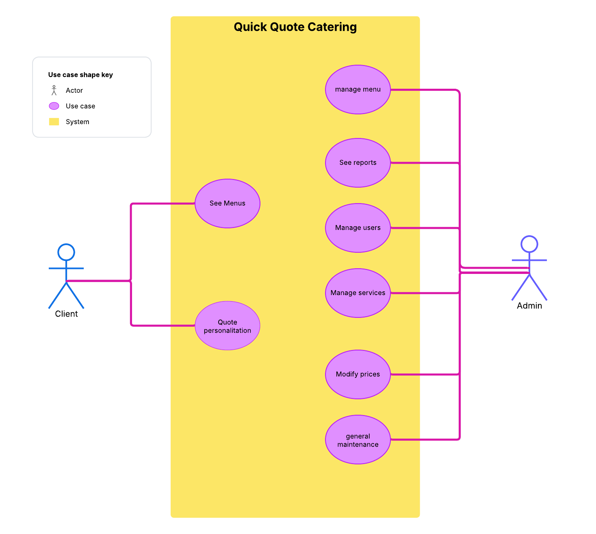

* 1. User characteristics

|  |  |
| --- | --- |
| User type | Customer |
| Training | No technical training required. Basic knowledge of web browsers. |
| Activities | * Select event type * Choose menu or customize it * Generate and visualize quotation. * Download or send quotation. |

|  |  |
| --- | --- |
| User type | Administrator |
| Training | Basic computer training or experience in web platform management. |
| Activities | * Manage menus and services. * Modify prices and contents. * Supervise quotations made. * Manage users and access. * Display system reports. |

* 1. Restrictions

# Browser compatibility:

The system will be accessible only through modern web browsers with support for HTML5, CSS3 and JavaScript such as: Google Chrome, Firefox, Microsoft Edge.

# Specific languages and technologies:

The system will be developed using open source technologies, including HTML, CSS, JavaScript, PHP and MySQL, which limits the development and execution environment.

# Dependence on internet connection:

The system requires an internet connection to access all its functionalities, since it will be hosted on a web server.

# Restricted access to administrative functionalities:

Only users with an administrator profile can modify content, prices, services, and manage users.

# Absence of payment gateway:

In this version of the system, no online payment method is disintegrated. The platform will only generate informative quotes.

2.5. Assumptions and dependencies

# Stable connectivity:

It is assumed that users will have a stable internet connection when using the application.

# Web server availability:

The system will be hosted on a server with PHP and MySQL support, whose continuous availability is essential for the operation of the system.

# Content update:

It is assumed that the administrator will periodically update the menus, prices and services offered, in order to keep the system information updated and accurate.

# Use from compatible devices:

It is assumed that users will access the system from devices with modern browsers that support HTML5 and JavaScript.

# No integration with external systems:

The system will operate autonomously and will not rely on external services such as payment platforms, social networks or electronic invoicing systems in this version.

1. Specific requirements
   1. Functional Requirements

|  |  |
| --- | --- |
| **Identification of the requirement:** | RF-01 |
| **Name of the requirement:** | Display services |
| **Characteristics:** | Public, with authentication |
| **Description:** | The customer will be able to view the types of catering available from the home page. |
| **Priority:** | High |

|  |  |
| --- | --- |
| **Identification of the requirement:** | RF-02 |
| **Name of the requirement:** | Customize quotation |
| **Characteristics:** | Data entry, dynamic |
| **Description:** | The user will be able to enter details of the event (people, type of menu, place) to generate a quote. |
| **Priority:** | High |

|  |  |
| --- | --- |
| **Identification of the requirement:** | RF-03 |
| **Name of the requirement:** | Generate quotation |
| **Characteristics:** | Automatic, real-time calculation |
| **Description:** | The system will calculate and display the estimated cost based on the customer's selections. |
| **Priority:** | High |

|  |  |
| --- | --- |
| **Identification of the requirement:** | RF-04 |
| **Name of the requirement:** | Download/Send quotation |
| **Characteristics:** | PDF, email |
| **Description:** | The customer will be able to download the quotation in PDF |
| **Priority:** | low |

|  |  |
| --- | --- |
| **Identification of the requirement:** | RF-05 |
| **Name of the requirement:** | Administrator authentication |
| **Characteristics:** | Login, restricted access |
| **Description:** | The administrator accesses his panel with a username and password. |
| **Priority:** | High |

|  |  |
| --- | --- |
| **Identification of the requirement:** | RF-06 |
| **Name of the requirement:** | Service management |
| **Characteristics:** | CRUD (create, read, update, delete) |
| **Description:** | The administrator may modify the information of the catering offered. |
| **Priority:** | High |

|  |  |
| --- | --- |
| **Identification of the requirement:** | RF-07 |
| **Name of the requirement:** | Price management |
| **Characteristics:** | Editable fields, by service or menu |
| **Description:** | The administrator will be able to update the prices of each item. |
| **Priority:** | Media |

|  |  |
| --- | --- |
| **Identification of the requirement:** | RF-08 |
| **Name of the requirement:** | System reports |
| **Characteristics:** | Charts, quote history |
| **Description:** | The administrator will be able to consult on usage, quotations issued and menus requested. |
| **Priority:** | Low |

|  |  |
| --- | --- |
| **Identification of the requirement:** | RF-09 |
| **Name of the requirement:** | User management |
| **Characteristics:** | Permissions, editing and deletion |
| **Description:** | The administrator can register new administrator users and manage their permissions. |
| **Priority:** | Media |

* 1. Non-functional Requirements

|  |  |
| --- | --- |
| **Identification of the requirement:** | RNF-01 |
| **Name of the requirement:** | Performance |
| **Characteristics:** | Fast response, low latency |
| **Description:** | The system must generate quotations in less than 2 seconds. |

|  |  |
| --- | --- |
| **Identification of the requirement:** | RNF-02 |
| **Name of the requirement:** | Usability |
| **Characteristics:** | Intuitive interface, easy navigation |
| **Description:** | The interface must be easy to use for non-technical customers |
| **Priority:** | High |

|  |  |
| --- | --- |
| **Identification of the requirement:** | RNF-03 |
| **Name of the requirement:** | Compatibility |
| **Characteristics:** | Modern browsers (HTML5,CSS3,JS) |
| **Description:** | The system must be accessible from all current major browsers. |
| **Priority:** | Media |

|  |  |
| --- | --- |
| **Identification of the requirement:** | RNF-04 |
| **Name of the requirement:** | Availability |
| **Characteristics:** | High availability (minimum 95%) |
| **Description:** | The system must be available most of the time, avoiding prolonged downtime. |
| **Priority:** | High |

|  |  |
| --- | --- |
| **Identification of the requirement:** | RNF-05 |
| **Name of the requirement:** | Security |
| **Characteristics:** | Authentication, access control |
| **Description:** | The system must restrict administrative functions by secure login. |

|  |  |
| --- | --- |
| **Identification of the requirement:** | RNF-06 |
| **Name of the requirement:** | Scalability |
| **Characteristics:** | Support for multiple simultaneous users |
| **Description:** | Must support at least 50 active users without loss of performance |
| **Priority:** | Media |

|  |  |
| --- | --- |
| **Identification of the requirement:** | RNF-07 |
| **Name of the requirement:** | Maintainability |
| **Characteristics:** | Modular and documented code |
| **Description:** | The system must allow for easy modifications and upgrades |
| **Priority:** | Media |

|  |  |
| --- | --- |
| **Identification of the requirement:** | RNF-08 |
| **Name of the requirement:** | Portability |
| **Characteristics:** | Compatible with mobile devices |
| **Description:** | The system must work correctly on different screen sizes (responsive). |
| **Priority:** | High |

* 1. Common interface requirements

# User interfaces

The system will have a modern, responsive web interface, accessible from current browsers. It will have the following views:

* + - * **Client's public view**: Home page, event type selection, available menus, quote customization.
      * **Quotation form**: Event data, number of people, selection of services.
      * **Result view**: Quote generated with price breakdown, button to download or send by mail.
      * **Administration panel**: Accessible only with login, it allows you to manage services, menus, prices, users and reports.

The interfaces will be intuitive, with clear buttons, validated forms and smooth navigation.

# Hardware interfaces

The system will be designed to run on personal computers, laptops, tablets and smartphones. It does not require specialized hardware. The server shall be hosted in an Apache/Nginx and MySQL database compatible environment.

# Software interfaces

The system will be developed with:

* + - * **Frontend**: HTML5, CSS3, JavaScript.
      * **Backend**: PHP.
      * **Database**: MySQL.
      * Third party libraries: jsPDF (for PDF), PHPMailer (for mail).
      * Supported browsers: Google Chrome, Firefox, Edge (latest versions).
      * Server operating system: Windows with PHP support.

# Communication interfaces

The communication between client and server will be through **HTTP/HTTPS** protocol. The frontend requests will communicate with the backend using forms and asynchronous requests (AJAX). The system will send emails using SMTP protocol.

* 1. **Non-functional requirements**

# Performance requirements

The system must process and display a quote in less than 2 seconds. It must be able to serve at least 50 simultaneous users without loss of performance.

# Security

* + - * Restricted access to administrative functions through login.
      * Validation of forms against injections.
      * Secure handling of sessions and user data.
      * No sensitive personal or banking data is stored.

# Reliability

The system must be stable and reliable under normal conditions of use. Errors should be recorded in a log file and not disrupt general operation.

# Availability

A minimum availability of 95% must be guaranteed, avoiding long downtimes. It is recommended to use servers with monitoring and alerts.

# Maintainability

The code will be modularized, documented and structured to allow easy understanding and modifications. A version control system (such as Git) will be used.

# Portability

The system will be responsive and will work correctly on mobile devices, tablets and computers, adjusting its design to the screen size.