Script to identify the intersection over union with several bounding boxes.

Software designed to measure the accuracy in systems that they have not a identification method. To achieve this goal has been used two method and large manipulation of the data. The two methods used are Iou and GIOU. And the data treatment has been realized with dictionaries.

This script needs two dictionaries, one with the ground truth bounding boxes and other with the predicted bounding boxes. The ground truth bounding boxes dictionary is achieved for a public source or do it ourself. In the next figure is possible to see the form of this dictionary.

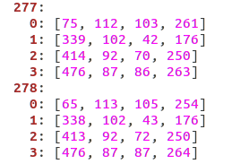

The dictionary has a index number that belong s to the frame number, within it has several dictionaries with the person identification and within of these identification is the position in the screen being these number (u,v,w,h), this type of nomenclature is the used by the dataset. These dictionaries are saved in YAML file, because this kind of files can be used either in different types programming languages or other programs.

On the other hand, it is necessary to save the predicted bounding boxes data in other YAML, this file save the data of the same way that the below file but with a little difference. The nomenclature is the standard nomenclature used by computer vision (xA, yA, xB, yB), being xA and yA the coordinates of the up left square and xB and yB the coordinates of the down right square. In the next figure is possible to see the form of this dictionary.

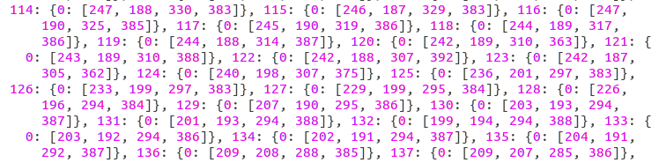

Once that these two dictionaries are prepared to be used it is already possible to apply the IOU and the GIOU.

These both methods are used to check the percentage the common area between two bounding boxes. In this case, the two areas to be compared will be the ground truth bounding box and the predicted bounding box. Thus, if the IOU or GIOU of both areas is superior than X percentage will be assigned like coincident areas.

But, what is the IOU and GIOU?

The IOU or also called inference over union is an evalutation metric used to measure the accuracy of an object detector on a particular dataset. The typical and most popular dataset for this type evaluation is PASCAL VOC. To apply the intersection over union is necessary:

- The ground-truth bounding boxes: Normally this pictures are hand labeled and they are used to calibrate and check systems.
- The predicted bounding boxes: are the bounding boxes drew by the system that it will be evaluated.

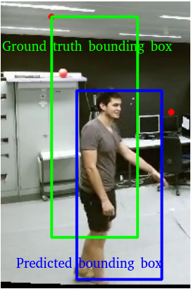

The IOU would be the Area of Overlap divided by the area of union, this is the area enclosed between the two bounding boxes. In the next picture is more easy to understan this concept.

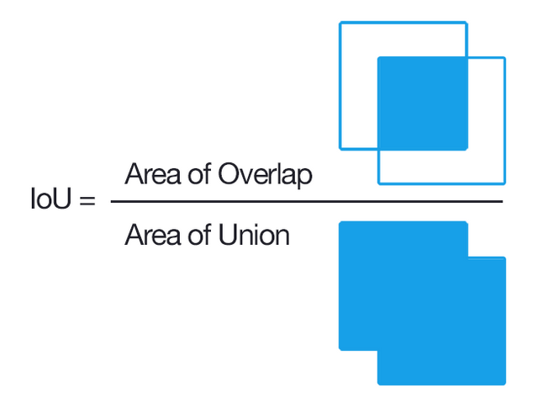
With this in mind and with this value, it is possible to link a predicted bounding box with a ground-truth bounding box when there is a high IOU and thus, to claim that the predicted bounding box is in the correct place. This is a reliable form to test if the system detects of a correct way.

This method has a good results but it has a large problem. When in the system there are more of one bounding box and there is overlap between bounding box is difficult to assign a correct result even with the IOU. For this reason it is necessary to use a trusted method. In the literature exists a modern way of the IOU, this form is called GIOU (General intersection over union). This metod is explained in the next article (poner referencia al articulo). This mehod uses the IOU but also it adds a normalized component that achieves better results that IOU. In the next picture is possible to see the difference between the loss function IOU and GIOU.

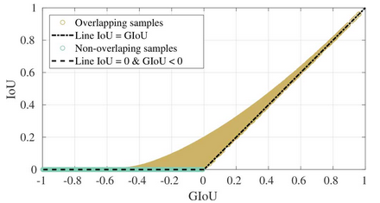

These mechanisms will be used to generate a metric of the values obtained in the detector

