**Availabilities Code Challenge**

Asp Core Web application that displays the dataset contained in GS, MS and BAML excel files.

**Fuctionalities:**

* Display Availabilities dataset in a paginated grid
* Sort by symbol
* Search by symbol

**Requirements to run the Code:**

* Visual Studio 2017
* Sql Server Express
* .Net Core 1.1 Runtime

**Tech Stack:**

* Mvc Core Net
* Sql Server
* C#

**How to run:**

1. Restore the database (File: AvailabilitiesTest/DB/AvailabilityDB.bak)

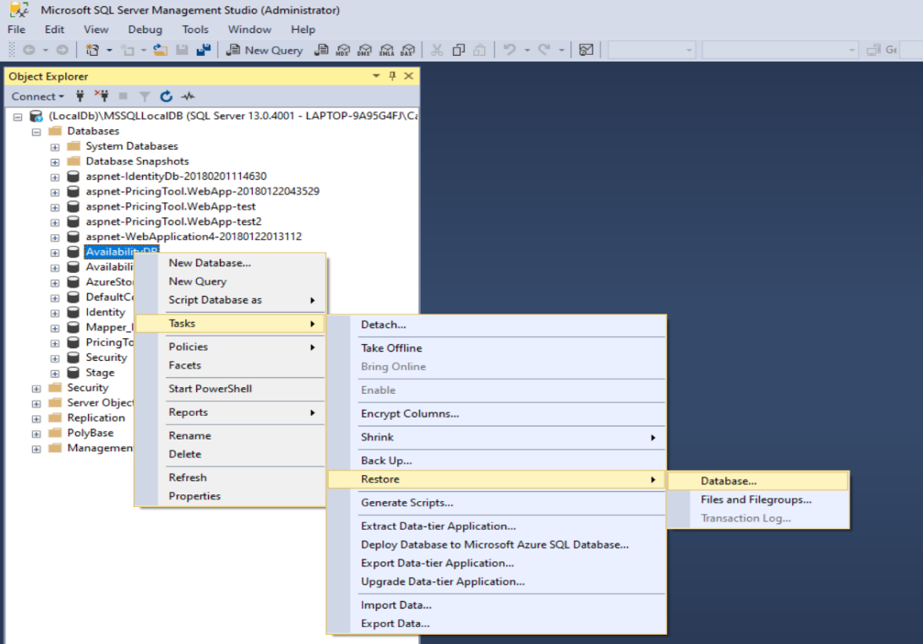

1. Open and run the solution in Visual Studio 2017 (File: AvailabilitiesTest.zip\AvailabilitiesTest\VS Solution\AvailabilityUI\ AvailabilityUI.sln)

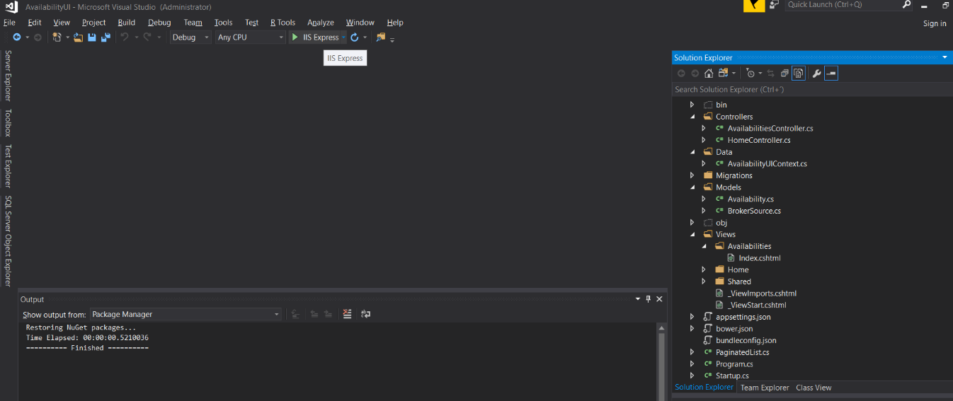

1. Click on Availabilities on the top menu.

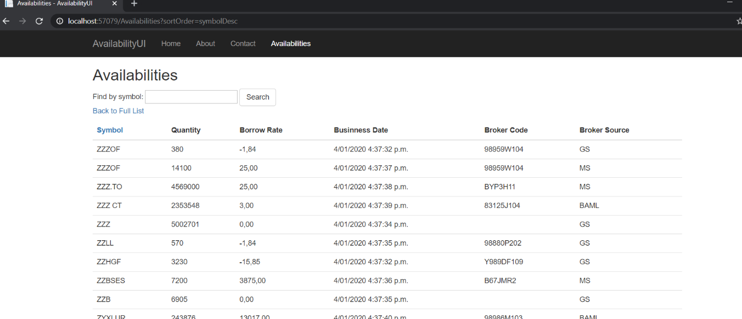

**Assumptions:**

* CUSIP, Security ID and H | 20191202 columns were taken as BrokerCode.
* Business Date existed only in one file and had the same value on every row so it was filled in the database as getdate.