Lab 1
Due: | February 15, by 11:59PM
Grading: | Lab is worth 100 points
Requirements: | - Reading of section A.9 of class text’s appendix A

Learning Objective

At the end of this Lab, the student will be able to:
- Use the SPIM software simulator for the MIPS32 architecture
- Create programs in assembly language that can be run on the SPIM simulator
- Develop an MIPS assembly language program that is capable of doing input/output to the screen console

Description and point distribution

In order to get full credit for this lab, the student has to create an assembly language program (MIPS) that does the following:

Points | Description
10 | Displays the message “Hello World from SPIM!!!” to the simulator console.
10 | Jumps to the next line.
10 | Displays the message “terminate? (1=Yes, 2=No)” to the simulator console, and waits for input from the user.
30 | If the user enters a “1” program terminates, if user enters a “2” program displays “Hello World from SPIM!!!” again and everything repeats.
30 | If user enters a character different of “1” or “2” the message “invalid option!!!” is displayed and in the next line message “terminate? (1=Yes, 2=No)” gets displayed again
10 | Program is properly documented (comments)

Screen shot

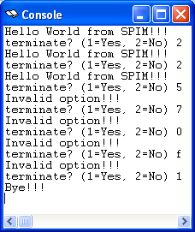

What to submit

Please use the link under “Assignments” at the class website (blackboard) to submit your solution. Submit the code (“.asm” file) with proper comments regarding author, course, lab number and comments for the code lines.

Important notes

- Students are encouraged to collaborate but must not share ANY CODE. All code submitted has to be UNIQUE even if students collaborated to find the solution, coding must be done (implemented) in an individual basis (it’s ok to share algorithms/ideas/etc, not code).
- Any questions you might have, please send an e-mail ask at class time or office hours.

