Lab 2
Due: | February 29, by 11:55 PM
Grading: | Lab is worth 100 points
Requirements: | - Reading of section 2.13 would definitely help

Learning Objective

At the end of this Lab, the student will be able to:
- Use the stack of the MIPS architecture to store values
- Implement loops in MIPS assembly code
- Implement conditionals in MIPS assembly code
- To use the stack, loops and conditionals to create MIPS applications, programs

Description and point distribution

You are asked to create an assembly language (MIPS) program that generates the Fibonacci numbers less than 1000 and displays them in reverse order on individual lines; program terminates after displaying last number. (Code 10)

Points | Description
10 | Displays the message:  Fibonacci series...numbers < 1000  Reverse order
60 | Generation of numbers
30 | Display of numbers in reverse order.
25 EXTRA | Identify somehow if the current series' number displayed is prime *
*instructor will mention 1 or 2 suggestions

IMPORTANT

Please no “magic numbers”, neither for the series,
nor for the quantity of numbers less than 1000

Except may be for the first 2 numbers (“0”, “1”) of the series.

Screen shot

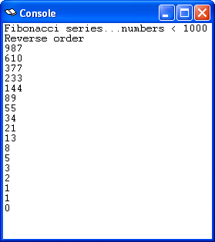

What to submit

Please use the link under “Assignments” at the class website (blackboard) to submit your solution. Submit the code (“.asm” file) with proper comments regarding author, course, lab number and comments for the code lines.

Important notes

- Students are encouraged to collaborate but must not share ANY CODE. All code submitted has to be UNIQUE even if students collaborated to find the solution, coding must be done (implemented) in an individual basis (it’s ok to share algorithms/ideas/etc, not code).
- Any questions you might have, please send an e-mail ask at class time or office hours.

