Nombre: Carlos Franco Blancas Chávez

Pregunta 1 :
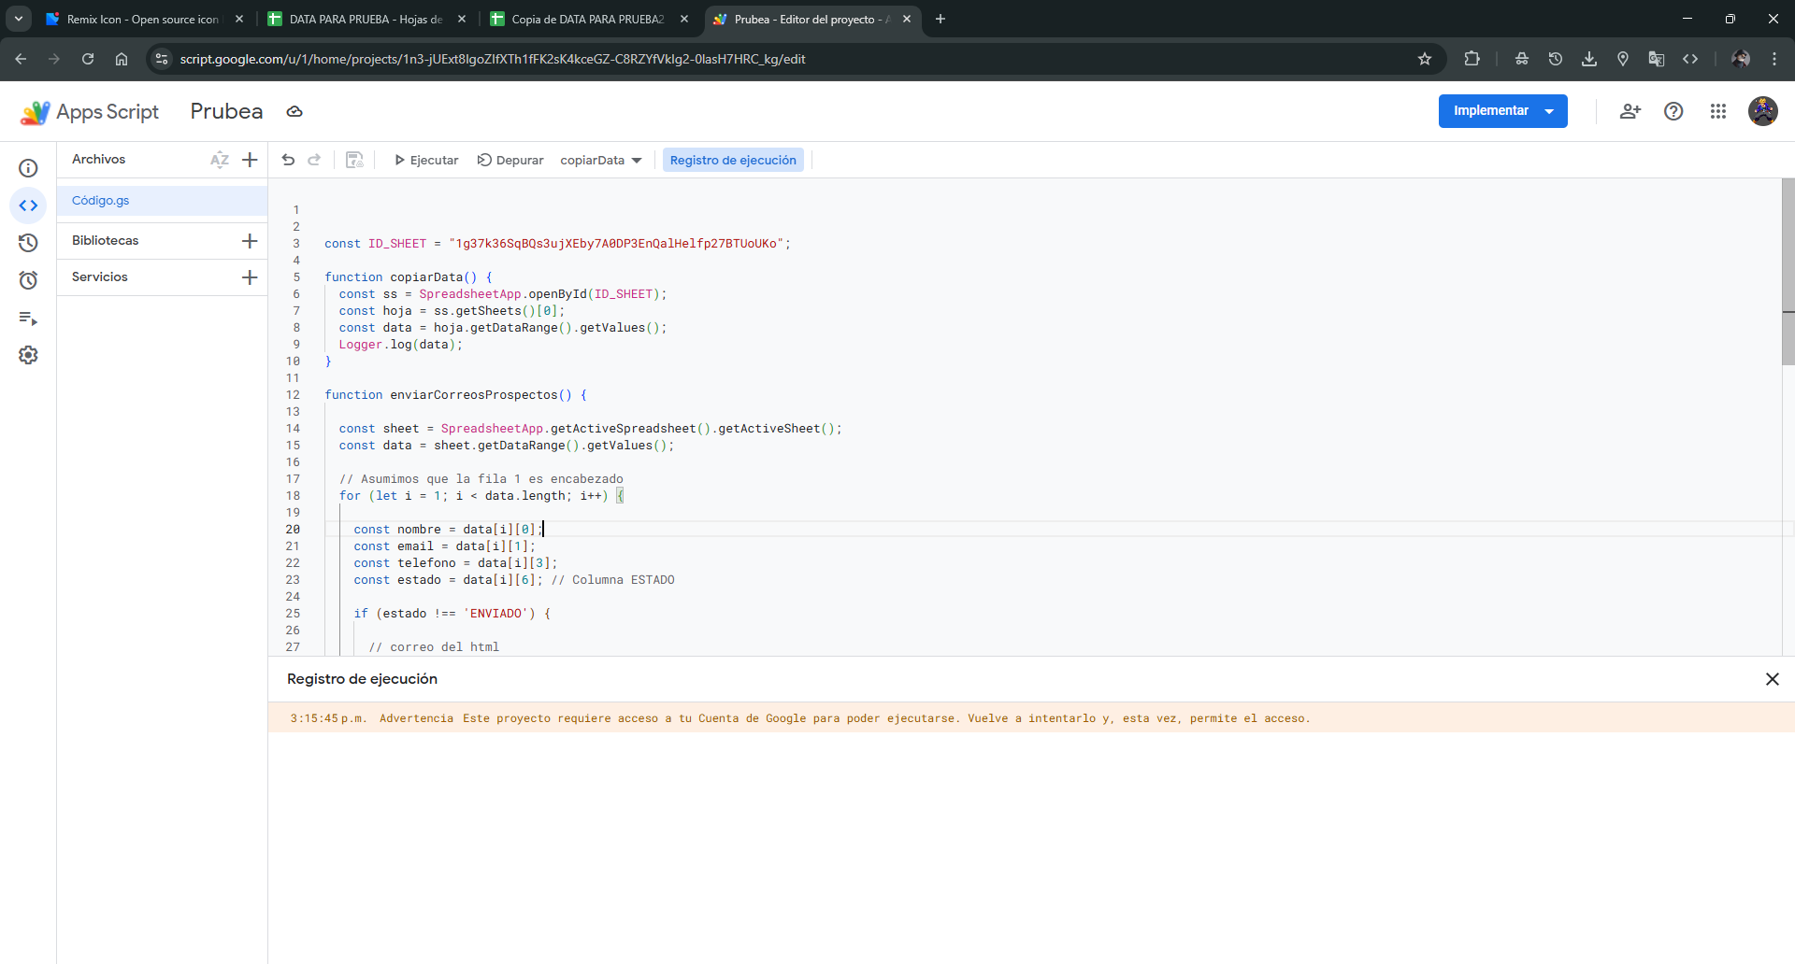

Link del video: https://drive.google.com/file/d/1N96ZKHPqyEgDjELtRyRFlCfFhUNjBqdQ/view?usp=drive_link

