IAC-19-B5.2.10

**Robust Forest Classification using Hyperspectral Imaging, Laser Scanning and Satellite Imagery**

**Vasilii Mosin a*, Roberto Aguilar a, Alexander Platonov a, Albert Vasiliev b, Alexander Kedrov b, and Anton Ivanov a**

a Space Center, Skolkovo Institute of Science and Technology, Moscow, Russian Federation, v.mosin@skoltech.ru

b Perm State University, Perm, Perm Krai, Russian Federation

* Corresponding Author

**Abstract**

Wood products are an important export for Russia. Understanding the status of trees and their classification is an ongoing task for many organizations. Currently, documentation of forests is done manually and there is a number of initiatives to implement automatic forest classification. A particular case described in the present paper showcases how aerial survey data supplements satellite imagery in order to achieve higher classification accuracy of forest tree species. Moreover, applicability of different data types, such as LiDAR and hyperspectral (NIR and VIS) for the task at hand is investigated. In the paper, we present the experiment to use hyperspectral forest classification (using a UAV), which is then used in the context of satellite imagery, airborne laser scanning, and manual identification. We actively employ machine learning algorithms for classification and recognition tasks.

The project began with an expedition to the northern region of Arkhangelsk (Russia) in August 2018. The main goals of the expedition were data acquisition with the help of UAVs, as well as observing various weather conditions and their effect on the data collected. Validation of the results was performed in four separate polygons, where in-situ data was collected by manually recording tree locations and species. In this project we evaluated the precision of trees identification from UAV hyperspectral data, helped by ALS and high-resolution satellite imagery (50 cm).

Supervised machine learning algorithms, namely Support Vector Machine (SVM) and Random Forest (RF), were applied and evaluated for automatic tree species classification task. An object-based classification has been performed by delineating individual tree crowns beforehand with the help of LiDAR data. Various spectral features have been identified for use in classification algorithms complemented by on-ground spectroscopic benchmark data.

In this paper, we prove applicability of the proposed method and workflow in forestry operations. Results validation was done using data from the observation parcels, where trees were manually labeled. We aim at classification accuracy of 90% that will allow for change proposal for current forestry policy and legislature to enable the use of UAVs and satellites in forestry for classification purposes.

**Keywords:** hyperspectral imagery, LiDAR data, machine learning, forest inventory, tree species, tree detection

**Acronyms/Abbreviations**

AHI Airborne Hyperspectral Imagery

ALS Airborne Laser Scanning

CHM Canopy Height Model

CV Cross-validation

DBH Diameter at Breast Height

DTM Digital Terrain Model

DSM Digital Surface Model

EO Earth Observation

GCPs Ground Control Points

ITCs Individual Tree Crowns

LiDAR Light Detection and Ranging

LM Local maximum

NDVI Normalized Difference Vegetation Index

NIR Near-infrared

RF Random Forest

SMI Spaceborne Multispectral Imagery

SVM Support Vector Machines

UAV Unmanned Aerial Vehicle

VIS Visible

1. **Introduction**

The mass consumption of wood from forests is a current issue that can be considered as a result of technology development and the ever-increasing demand from markets. This calls for more robust and optimal forestry management for many reasons.

First, companies need to know where to look for wood. Second, environmental organizations need intelligence to protect forests from deforestation, illegal forest cutting and predict wildfires. Third, governments need reliable data to make regulations regarding taxation and protecting the environment.

Forest inventory is especially relevant in case of Russia, since its territories cover around 20% of world’s forest reserves [1]. According to the current forestry legislation in Russia, forest inventory shall be done manually, hence time consuming and expensive. In this project, an attempt to build an automatic trees detection and classification technology, based on remote sensing and machine learning is presented and tested. In order to allow a widespread use of this technology in the industry for forest inventory, classification accuracy of 95% shall be achieved. A combination of machine learning and remote sensing has demonstrated a great potential for solving different tasks in such areas as precision agriculture, land cover changes detection, urban environment monitoring, maritime navigation and control, etc. Additionally, it has application in forest classification, a particular case of land cover classification. In general, any land cover classification task can be categorized either as pixel-based or as object-based, but the latter usually shows better results [2-4]. Moreover, in forestry applications object-based trees species classification is more valuable, since it gives more detailed information about a forest structure. There are two approaches for object-based forest classification: classification at the individual tree level, classifying every tree separately, or area-based classification, when dominant tree species are predicted for different areas of a forest.

In this work, the case of individual tree level forest species classification is considered, because forestry legislation requires to have information for each tree rather than general statistics for whole parcels of a forest. Nowadays, hyperspectral data has become extensively used in different land cover classification tasks, as it contains more information than multispectral imagery and, therefore, allows to catch subtle differences in akin materials. For example, Utsav et al. [5] have described different remote sensing scenarios, in which a high number of spectral bands is important. Also, Kang et al. [6] have presented a performance comparison of different algorithms applied on hyperspectral imagery for land cover classification, providing a benchmark data. Moreover, there are various deep learning approaches for hyperspectral data processing [7-9]. Furthermore, current research on forest classification is based on hyperspectral imaging. Existing investigations describe different approaches based on using different instruments and algorithms classifying different tree species in different regions. For instance, Support Vectors Machine (SVM) algorithm was applied on hyperspectral imagery with 160 bands (410-990 nm) to classify 3 groups of trees (Spruces, Pines, and Deciduous trees) in Norway and the accuracy of 92% was achieved [10] .89% classification accuracy was obtained when classifying 13 tree species (8 Deciduous and 5 Coniferous) in Austria using the same hyperspectral imaging, as in the previous example, but with Random Forest (RF) classifier [11]. Nevalainen et al. [12] have managed to achieve 95% accuracy for tree species classification in Finland. They classified 4 tree species (Spruce, Birch, Pine, and Larch) by RF algorithm using hyperspectral imagery with spectral resolution of 33 channels (500-900 nm).

The approach for trees detection and classification presented in this work consists of two steps. First, individual trees are detected using LiDAR data. Then, detected trees are classified by their hyperspectral properties using machine learning classifiers. With the aim to compare results of airborne technologies with technical characteristics of cheaper and more scalable one, the same experiment was performed using space-borne technology, in this case, using a sub-metric multispectral sensor. Section 2 surveys methods and algorithms used for trees detection and classification in this project as well as an expedition for collection of LiDAR, hyperspectral, and reference trees data followed by description of satellite imagery together with instruments characteristics and data pre-processing procedures. Section 3 contains results of the experiments done in this project and description of evaluation schemes and performance metrics. Sections 4 and 5 are devoted to discussion of the results and conclusions accordingly.

1. **Data and Methodology**

At the beginning, a special expedition to Arkhangelsk region (northern Russia) was performed in August 2018 for data collection purposes. Experimental area belongs to Krasnoborsky district forestry division (Figure 1).

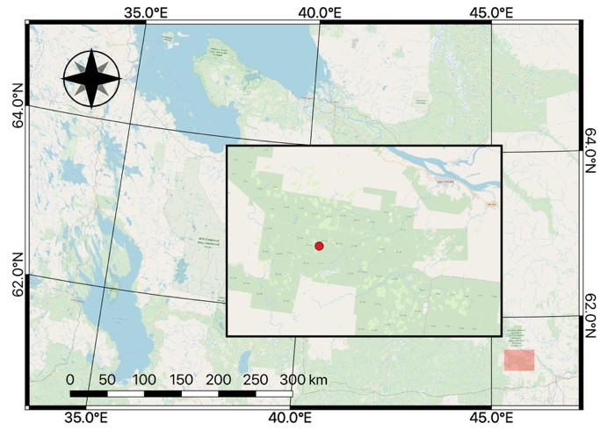

Figure 1. Geographic location of Arkhangelsk region, Russia with the highlighted area (red rectangle) corresponding to Krasnoborsky district at 61°28' N 45°34' E.

This territory is covered by plain cultivated boreal forests. Four test polygons with a size of 150 m by 200 m each were selected for experimental data collection (Figure 2). Detailed descriptions of the data collection procedures, instruments characteristics, as well as pre-processing steps for LiDAR, airborne hyperspectral imagery (AHI), spaceborne multispectral imagery (SMI), and reference trees data are given in Sections *2.1*, *2.2*, *2.3*, and *2.4* respectively. Individual Tree Crowns (ITCs) detection strategy is described in Section *2.5*. Section *2.6* is devoted to tree species classification procedure.

* 1. *Airborne Laser Scanning*

Canopy Height Model (CHM) enables the analysis of trees height and crowns area. It is obtained by calculating the difference between the Digital Surface Model (DSM) and Digital Terrain Model (DTM). In our case, it was derived from a point cloud sampled using airborne laser scanning (ALS) LiDAR sensor Leica ALS70, onboard a manned aircraft. The overall result of mapping was a 5 points/m2 density point cloud.

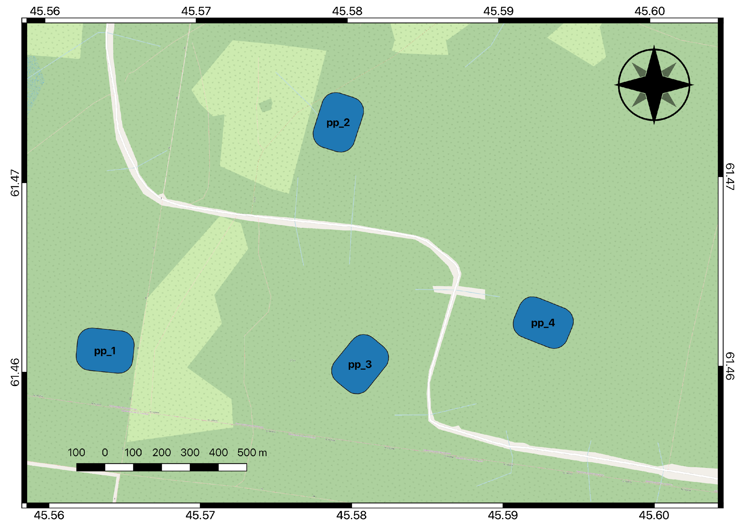

Figure 2. Location of the four experimental polygons, each of them with an area 0.03 km2.

As first step, raw point cloud was pre-processed with Terrasolid software. This software takes LiDAR raw data, and outputs a file in *las* format, which contains position and classification of every point based on ASPRS Standard [13]. For later steps, a pipeline to automatically generate the CHM was developed, taking as input a *las* file, and producing a raster.

In order to generate the DTM, all points classified as *ground* were selected. As the density of points in this classification was only 0.5 points/m2, the rasterization was performed using a linear interpolation method with a resolution of 1 m by 1 m.

As for the DSM calculation, all points classified as *high vegetation* were processed. For the rasterization, cell size of the grid is a key parameter, an appropriate cell size will help to avoid raster gaps and preserve sufficient details. Grid cell size was obtained from , *c* is grid cell size, and *n* is the density of points [14], that in this area was 6.3 points/m2, obtaining a 0.4 m grid cell size. Per each cell, the highest point within its area was selected (Figure 3).

Finally, CHM in raster format was calculated with the operation *CHM = DSM – DTM*, having the same DSM resolution of 0.16 m2. After generating the raster, data noise or errors may still exist in the CHM. A first attempt of filtering using Gaussian smoothing was performed as described by Wu et al. [14], but due to the low density of points, the top and mean height of trees was considerably decreasing, up to 30%. For this reason, another approach was followed, instead grey dilation was used for filtering. As shown in Figure 4, it improved the persistence of canopy height, since it only enlarges bright regions (tree crowns), and without altering the height of the top of the trees.

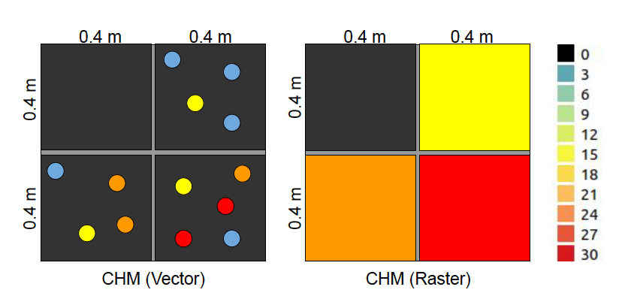

Figure 3. Process of DSM rasterization, from a point cloud gathered from ALS, by selecting points with highest value per each square. Per each cell of 0.16 m2 in the grid, the highest point in the vector is selected, and its height value is assigned to the raster.

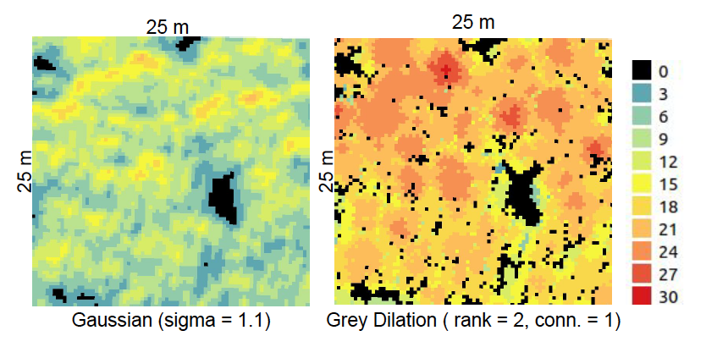

Figure 4. Comparison of results between Gaussian smoothing and grey dilation for resulting CHM filtering in the same region, with an area of 625 m2.

* 1. *Airborne Hyperspectral Imagery*

For hyperspectral data collection, a OXI VNIR-40 hyperspectral camera from Gamaya company, mounted on a fixed-wing drone Geoscan-101 was used. The camera has 16 bands in visible (VIS) range (450-670 nm) and 25 bands in near-infrared (NIR) range (600-900 nm). The flights were done in early afternoon when the sun was at a maximum elevation angle, in order to minimize shadowing effects. The flights were performed at the constant altitude of 250 m with the speed of 60 km/h. The spatial resolution of hyperspectral sensor was set to 5.5 cm/pixel.

Hyperspectral imagery pre-processing included optical and radiometric calibration. On ground spectroscopy measurements were acquired during each flight and it was used as a calibration information to transform raw pixel values into reflectance values. However, changing weather conditions (sunny and cloudy) during the flights have resulted in significant brightness differences in hyperspectral values along the same flight, and between flights. Nevertheless, these effects were partially mitigated by normalization procedure applied when performing tree species classification. Optically and radiometrically calibrated images were then stitched together into orthophotoplans. Afterwards, bad quality spectral bands were removed, and the resulting dimensionality of hyperspectral cubes was reduced to 32 (15 VIS and 17 NIR) spectral bands and 10 cm ground resolution.

Due to low geolocation accuracy, additional georeferencing procedure using ground control points (GCPs) was applied to collocate LiDAR and hyperspectral imagery. CHM rasters computed from LiDAR point clouds served as a base layer for this georeferencing procedure. For each test site, between the 5 and 7 most recognizable tree tops were found on both CHM rasters and hyperspectral cubes and used as GCPs.

* 1. *Spaceborne Multispectral Imagery*

Satellite multispectral imagery is extensively used in remote sensing area for land cover classification tasks [26]. For example, medium-resolution spaceborne optical data, from such satellites as Sentinel 2 or Landsat 8, can be used to perform object-based classification of agricultural field parcels [27]. The same imagery can be used for area-based analysis of forest territories, however to perform more detailed classification at the individual trees level high-resolution spaceborne data is required [28].

High-resolution WorldView-2 satellite imagery is used in the experimental part in this project. The sensor has one panchromatic band with 0.46 m ground resolution at Nadir and eight multispectral bands in visible and near-infrared spectral ranges (400-1040 nm) with 1.84 m ground resolution at Nadir. To make the experiment consistent the satellite image should be taken close to the date of hyperspectral image acquisition and during leaves-on period. However, due to frequent cloudiness in the region of experiments the nearest available date of suitable WorldView image was 30 May 2016. Visual comparison of this satellite image with hyperspectral data has shown that no significant changes in forest coverage happened for three summer seasons (2016, 2017, and 2018 years), so it was decided to use this image in the experiments. Eight multispectral bands were preliminarily pansharpened with panchromatic band for farther usage in tree species classification algorithms.

Figure 5 demonstrates how the same territory is presented in true color composites from airborne hyperspectral imagery and spaceborne multispectral imagery. The resolution of satellite imagery is five times smaller than the resolution of hyperspectral imagery used in this project, which is visible in the figure. Moreover, the shapes of the crowns look differently in airborne and spaceborne images, since the latter was captured at 15 degrees off Nadir, whereas the former was captured exactly in Nadir. Nevertheless, these two layers of airborne and spaceborne images were aligned using the same crowns as GCPs to be able to perform tree species classification experiments. The number of GCPs varied from 5 to 7 for different test polygons (same as in Section 2.2).

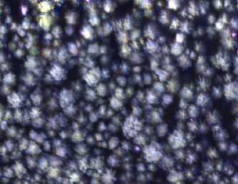 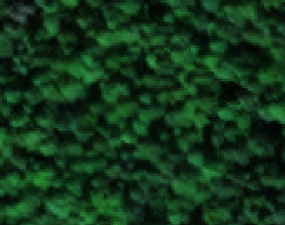

Figure 5. Examples of true color composites from airborne hyperspectral imagery (left) and spaceborne multispectral imagery (right) for the same area.

* 1. *Reference data*

For every polygon described in Figure 2, there is a sub polygon, 100 m by 50 m size that contains annotations of the four main tree species presented in test region: *Spruce, Birch, Fir, and Pine*. All trees with diameter at breast height (DBH) larger than 6 cm were labeled, 3000 trees in total. Table 1 contains the amount of different reference tree species for every test polygon.

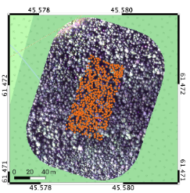

Figure 6. Example of the test polygon (red dot on the left map) with true color composite obtained from hyperspectral imagery (Red: 622 nm, Green: 578 nm, Blue: 461 nm) and the labeled reference trees location.

Table 1. Distribution of reference trees by class in every polygon.

|  |  |  |  |  |  |
| --- | --- | --- | --- | --- | --- |
| Polygon | Spruce | Birch | Fir | Pine | Total |
| pp1 | 603 | 224 | 20 | - | 847 |
| pp2 | 464 | 322 | 89 | - | 875 |
| pp3 | 210 | 98 | - | 227 | 535 |
| pp4 | 528 | 153 | 7 | - | 688 |
| Total | 1805 | 797 | 116 | 227 | 2945 |

One of the issues with the labeling process on field was that there was no information about the tree height. Moreover, trees were labeled regardless their visibility from above. For this reason, non-visible trees from remote optical sensors were filtered out. Heights of the labeled trees were estimated using regression models based on DBH values and heights information for some of the model trees in the test polygons. Locations of remaining trees were adjusted visually in QGIS software using CHM rasters and true color composites from hyperspectral imagery for exact matching their positioning with the corresponding tree crowns. Table 2 presents the final numbers of the reference trees collected.

Table 2. Final number of the labeled reference trees.

|  |  |  |  |  |  |
| --- | --- | --- | --- | --- | --- |
| Polygon | Spruce | Birch | Fir | Pine | Total |
| pp1 | - | - | - | - | - |
| pp2 | 424 | 181 | 41 | - | 471 |
| pp3 | 66 | 43 | - | 139 | 248 |
| pp4 | 231 | 19 | 3 | - | 327 |
| Total | 539 | 324 | 41 | 39 | 1046 |

Unfortunately, it was not possible to co-locate most of the reference trees with the hyperspectral imagery in the first test polygon, thus it was decided to exclude all the labeled trees in this polygon from further analysis completely.

* 1. *Individual Tree Crowns Detection*

Individual tree crowns detection (ITCd) is a preliminary step for object-based tree species classification. Most of the existing methods for ITCd are based on local maximum (LM) filtering applied either on CHM rasters obtained from LiDAR data [15-17] or on high spatial resolution imagery [18-21]. The results are more stable when using LiDAR data, since LM points correspond to the real tree crown tops in this case. While in the case of using imagery for ITCd, LM points may actually be just the brightness peaks and not the real tree crown tops. Moreover, it was shown that detection accuracy using imagery is more or less comparable with detection accuracy using LiDAR data only if imagery resolution is high (around 5-15 cm) and for lower resolution imagery (less than 30 cm) detection accuracy is significantly lower [20]. There is another approach for ITCd using deep learning [22, 23], but it requires a considerable amount of training data.

In this work, the following approach for ITCd was used. Firstly, non-vegetation areas, such as roads, dead trees, etc., were excluded by masking out Normalized Difference Vegetation Index (NDVI) raster using threshold value of 0.6. NDVI is calculated for every pixel according to:

where NDVI - pixel's NDVI value, NIR - pixel's value in near-infrared range, RED - pixel's value in red range.

After, low vegetation areas, with value lower than 10 m on CHM, were masked out. Therefore, only the areas containing high vegetation are left for further analysis. Finally, for these areas ITCs were detected on CHM rasters using the approach based on LM filtering described by Popescu et al. [15].

* 1. *Tree Species Classification*

There are two approaches for classification tasks in remote sensing as it was discussed in Section 1. In pixel-based classification each pixel is classified separately. This approach is usually applied with coarse resolution imagery, for instance field crop classification using 30 m resolution Landsat 8 satellite. In the other hand, object-based classification is performed using the information about the whole object, for either individual crowns, or areas. In general, it was shown that object-based approach is more stable and outperforms pixel-based approach in most cases; for this reason, object-based tree species classification is used along this work.

First of all, boundaries of the classified objects shall be defined to be able to extract features inside these regions. Tree crowns delineation methods are usually applied for segmentation of exact shapes of the crowns, and can follow different approaches, including point clouds obtained from LiDAR [15-17], and some other methods just relying on the image brightness values in the absence of structural information [19, 20, 21]. However, in case of high-resolution imagery, it is enough to use more simple strategies to define object boundaries, as, for example, Nevalainen et al. [12] extracted features for tree species classification inside a circle area around detected tree top. In Figure 7 it is shown how tree crowns areas for both hyperspectral airborne and multispectral satellite imagery are cropped using 1 m radius distance, and in Section 1 it is explained how to determine the optimal radius dimension based on cross validation for different classification algorithms. In case of satellite imagery tree crowns areas are represented by only several pixels due its low resolution comparing to airborne imagery (Figure 7).

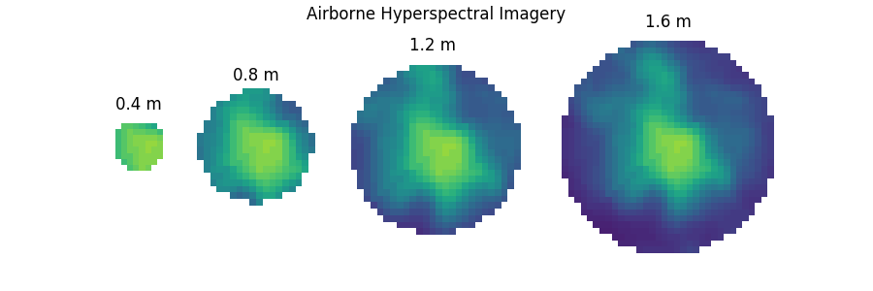

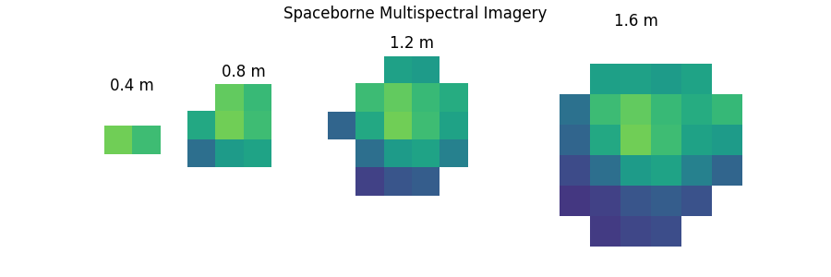

Figure 7. Examples of differences in amount of extracted pixels of tree crowns in hyperspectral airborne and multispectral satellite data during features calculation step due to different imagery resolutions.

There exist several strategies to construct feature vectors for classification from hyperspectral data. For example, Nevalainen et al. [12] used mean, median, and some of their threshold values as features. In this project, it was decided to use only mean values per each spectral band as features, since there is one-to-one correspondence between features and spectral bands in this case and, therefore, the results will be more interpretable, and it is possible to estimate the importance of the spectral bands for tree species classification. The number of extracted features for hyperspectral airborne data is 32, which is the total number of bands in hyperspectral imagery used in this project. Additionally, normalization is applied in order to reduce the effects of brightness differences in hyperspectral imagery as well as the shadowing effects. Moreover, normalization improves the overall accuracy of hyperspectral imagery classification, which was demonstrated by Cao et al. [24] where it is recommended to use normalization per spectral bands, but in this project normalization per pixel values is applied, since it gives better results in case of changing weather conditions during the flights. The exact formula for normalization used in this project is the following:

where - the value of the pixel in the spectral band , - the total number of bands and - normalized value of the pixel in the spectral band . Figure **8**8 shows mean normalized spectral values averaged from hyperspectral airborne data per tree species for the reference trees in different test polygons.

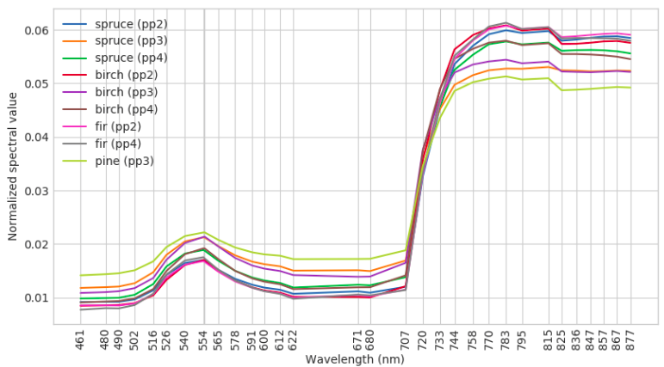

Figure 8. Mean (normalized) spectral values of the reference trees for four tree species in different test polygons using hyperspectral airborne imagery.

In terms of the multispectral satellite data, 8 features were extracted, following the same normalization process as for hyperspectral imagery. Figure 9 shows mean normalized spectral values averaged from multispectral satellite data per tree species for the reference trees in different test polygons.

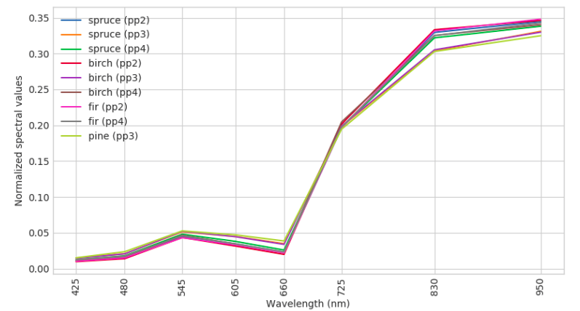

Figure 9. Mean (normalized) spectral values of the reference trees for four tree species in different test polygons using multispectral satellite imagery.

1. **Results**

The dataset presented in Table 2 was split into two halves, 523 samples for training and 523 for testing, preserving the ratio of each tree species.

In order to determine the optimal crown radius for spectral features calculation, a linear search among 0.4 m and 1.6 m with step of 0.2 m using 10-fold cross-validation (CV) on the training subset was performed, on both airborne hyperspectral and spaceborne multispectral imagery. For this, the following two metrics were measured: Overall Accuracy (OA) – the proportion of correctly classified samples and F-score – harmonic mean of precision, and recall:

where *N* – the total number of samples, *TP* – the number of true positive classifications, *FP* – the number of false positive classifications, *FN* – the number of false negative classifications. The results of OA and F-Score are presented in Figure 11 and Figure 12 accordingly.

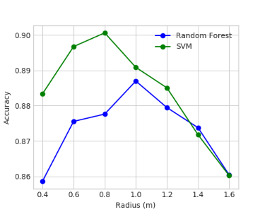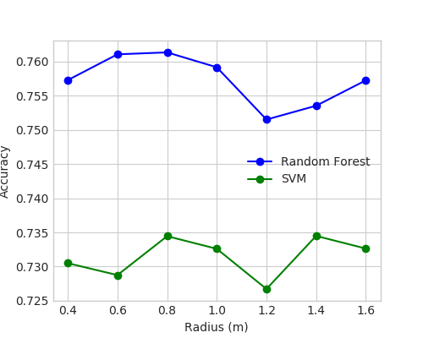

Figure 10. Classification accuracy for hyperspectral airborne (left) and multispectral spaceborne (right) imagery in 10-fold CV with RF and SVM, using a step size of 0.2 m.

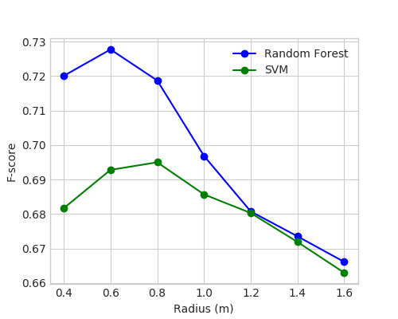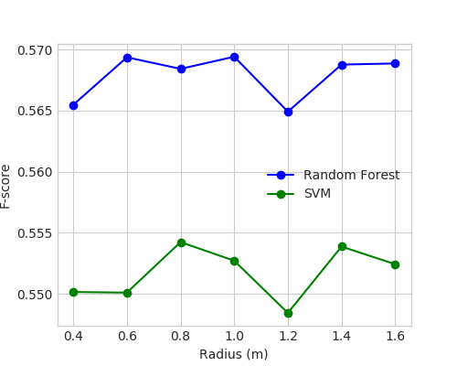

Figure 11. Classification F-Score for hyperspectral airborne (left) and multispectral spaceborne (right) imagery in 10-fold CV with RF and SVM, using a step size of 0.2.

As for airborne hyperspectral data, crown radius significantly influenced both metrics. For SVM algorithm, a 0.8 m crown radius was chosen as optimal, since the OA and F-score measurements have their maximums at this value. In case of RF algorithm, we selected 0.8 m as a tradeoff, which optimized OA and F-score results.

In case of satellite imagery, there was no clear dependency between classification performance and crown radius. For this reason, 0.8 m was selected as optimal crown radius to be consistent with airborne hyperspectral results, thus, simplifying following experiments.

With the aim to compare the algorithms, with the chosen optimal crown size, classification performance was calculated on the testing subset. Results for airborne hyperspectral, as well as, spaceborne multispectral data are presented in Table 3.

Table 3. Classification performance on the test.

|  |  |  |  |
| --- | --- | --- | --- |
|  |  | **AIR** | **SAT** |
| Random Forest | OA (%) | 90.1 | 70.9 |
|  | F-score | 0.83 | 0.53 |
| SVM RBF | OA (%) | 88.7 | 72.1 |
|  | F-score | 0.68 | 0.55 |

To understand how different tree species were classified on the testing subset, confusion matrices for Random Forests and SVM classifiers were calculated, using its corresponding optimal circle radius tree crown area, for hyperspectral airborne imagery (Figure 12) and multispectral satellite imagery (Figure 13).

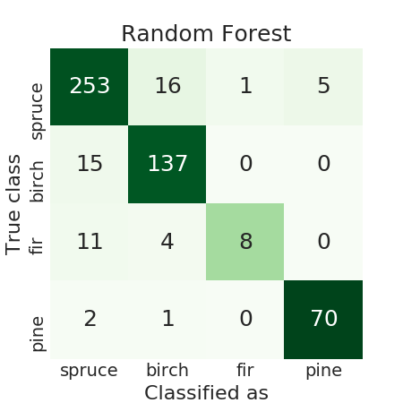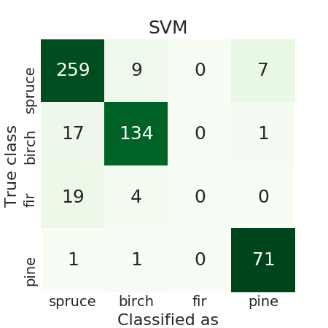

Figure 12. Confusion matrices using hyperspectral airborne imagery.

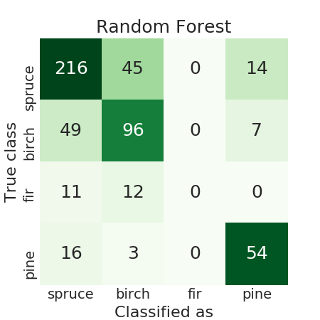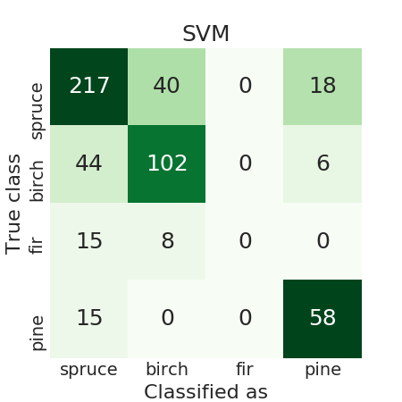

Figure 13. Confusion matrices using multispectral satellite imagery.

RF algorithm with the optimal radius size was chosen to make final tree species classification maps in four test polygons. Firstly, individual trees were identified using the approach described in Section 2.5. Around 70% of the reference trees were detected within a distance of 1.5 m from the real tree tops. For all detected trees in four test polygons, RF classifier retrained on the full reference trees dataset was applied. Results for airborne hyperspectral imagery are shown in Table 4, which contains the count of detected tree species in each test polygon, as well as the mean probabilities of the classification, which represent a confidence of the classifier when making tree species prediction. In Table 5, same statistics for spaceborne multispectral data are presented.

Table 4. Trees detection and classification results in four test polygons using airborne hyperspectral imagery.

|  |  |  |  |  |  |
| --- | --- | --- | --- | --- | --- |
|  | **Polygon** | **pp1** | **pp2** | **pp3** | **pp4** |
| Spruce | N | 1305 | 1114 | 526 | 1310 |
| P mean | 0.81 | 0.87 | 0.69 | 0.89 |
| Birch | N | 291 | 666 | 331 | 379 |
| P mean | 0.80 | 0.82 | 0.79 | 0.85 |
| Fir | N | 0 | 74 | 0 | 2 |
| P mean | - | 0.65 | - | 0.73 |
| Pine | N | 194 | 14 | 594 | 25 |
| P mean | 0.74 | 0.87 | 0.88 | 0.81 |

Table 5. Trees detection and classification results in four test polygons using spaceborne multispectral imagery.

|  |  |  |  |  |  |
| --- | --- | --- | --- | --- | --- |
|  | **Polygon** | **pp1** | **pp2** | **pp3** | **pp4** |
| Spruce | N | 1289 | 1006 | 663 | 1246 |
| P mean | 0.63 | 0.75 | 0.59 | 0.79 |
| Birch | N | 401 | 840 | 161 | 446 |
| P mean | 0.71 | 0.69 | 0.54 | 0.76 |
| Fir | N | 0 | 9 | 0 | 0 |
| P mean | - | 0.48 | - | - |
| Pine | N | 100 | 13 | 627 | 24 |
| P mean | 0.52 | 0.54 | 0.69 | 0.60 |

A visual example of trees detection and classification results is presented in Figure 14.

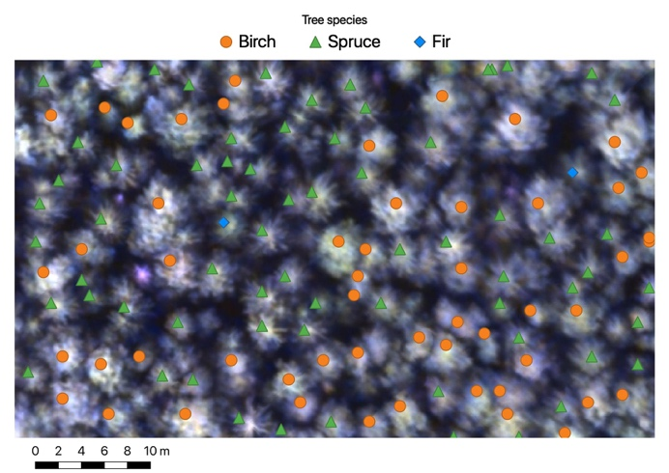

Figure 14. Example of the resulting tree species classification map (true color composite obtained from hyperspectral imagery (Red: 622 nm, Green: 578 nm, Blue: 461 nm) as a background).

1. **Discussion**

The plot curves in Figures 8 and 9 have similar behavior, which demonstrates that both airborne hyperspectral and spaceborne multispectral sensors detect the same properties of trees. Nevertheless, the spectral plot in case of multispectral imagery are sharper than those obtained from hyperspectral data, since the spectral resolution is lower. Moreover, in both sensors, trees in the third polygon have higher values in visible range and lower values in NIR, which is the consequence of large portion of dead trees in this polygon.

10-fold CV on the training subset of the reference trees was used in order to perform the linear search of the optimal tree crown radius, the search range was selected based on average crown sizes in the region. This procedure showed that there is a clear dependency between the classification performance and tree crown area sizes used for features calculation in case of hyperspectral imagery. Considering smaller tree crown areas doesn't allow to capture enough information about hyperspectral properties of a tree, thus resulting in lower classification accuracy. When taking into account bigger crown areas, it is possible that some parts, which do not belong to the classified tree, can be included and used for features extraction, that also decreases classification performance. Therefore, the optimal choice of the radius parameter is important to obtain better tree species classification results. However, the experiments in this project demonstrated that classification algorithms using spaceborne multispectral data are not sensitive to tree crown area sizes.

Once the optimal radius parameter was selected, classification algorithms were validated on the testing subset of the reference trees. As shown in Table 3, RF classifier has the best performance in case of airborne hyperspectral imagery. For SVM algorithm OA is just slightly lower, but F-score was significantly decreased comparing to RF. In case of spaceborne multispectral imagery, tree species classification performance is worse

According to the Table 3 RF algorithm has the best performance for tree species classification task in terms of both OA and F-score values in almost all cases. SVM classifier with RBF kernel shows a comparable to RF algorithm OA score, but has a significantly smaller F-score value. Classification using spaceborne satellite imagery showed noticeably worse performance with both RF and SVM algorithms.

Final trees detection and classification results (Tables 4, 5) show that the more particular tree specie samples are presented in the test polygon – the more trees are classified as this tree specie with higher classification probability in this polygon. For example, reference *Spruce* samples are mostly presented in the test polygons 1, 2 and 4 and the bigger numbers of predicted *Spruce* species correspond to these polygons. Mean classification probabilities for *Spruces* are also high in the test polygons 2 and 4, but in the test polygon 1 it has a smaller value since tree samples from this polygon were not used for training. *Birch* samples are almost always predicted with high classification probability because it is the only broadleaf tree specie in the training dataset, and it can be easily distinguished due to its distinctive hyperspectral properties. *Firs* are the minority class in the training dataset, as it was mentioned earlier, which has influenced classification results, and *Fir* is the worst predicted tree specie. Reference *Pine* samples are only presented in the test polygon 3 and they have highest classification probabilities in this polygon that also supports hypothesis formulated above.

Figure 14 is just for illustrative purposes. It is visible that some of the adjacent tree crowns, which do not have clear borders between, can be missed at the detection step. With higher LiDAR point clouds densities, it will be possible to obtain higher resolution CHM rasters and it might allow to get better ITCd accuracy. It is also visible in Figure 14 that dead trees (bright purple spots) and low trees (dark tree crowns) are properly filtered out and, as a consequence, they were not detected. It is difficult to distinguish tree species for such trees using their hyperspectral properties, so they were decided to be excluded from the analysis in this work.

1. **Conclusions**

In this work, remote sensing airborne LiDAR and hyperspectral data, along with satellite imagery, with the help of machine learning were used to detect forest trees and their species in Arkhangelsk region, Russia. Two different machine learning algorithms using different classification schemes were tested for prediction of four species presented in the experimental area (Spruce, Birch, Fir, and Pine). The highest classification performance on the test set (90.1% overall accuracy and 0.83 F-score) was achieved using RF algorithm with hyperspectral airborne imagery.

In this work, boundary definition of individual trees was performed using fixed radius circle, rather than delineating exact shapes. The choice of the radius had significantly importance in the accuracy of the classification. For this reason, a linear search, with a step of 0.2 was run, in order to find the optimal radius.

One of the concerns around data acquisition from airborne is its low scalability for large extensions. As a solution for this, satellite-based technologies, with sub-metric spatial resolution, was tested for classification, with the same methodology used for hyperspectral airborne data. Spaceborne imagery doesn’t seem to be an alternative for forestry inventories with a high accuracy of classification. Since the spatial and spectral resolution of current commercial satellites for Earth Observation (EO) are not comparable to airborne sensor characteristics, they don’t enable detection of details of tree crowns shapes and composition.

Provided results of the experiments and their analysis show that the presented automatic procedure for trees detection and classification may have a high potential for forest inventory task and supplement manual work in forest taxation process. However, further improvements are necessary in order to get 95% classification accuracy and to make this technology legal to apply for industrial forest inventory.

**Acknowledgements**

We are grateful to Alexander Trufanov and to his group from Gamaya company (Russia) for their support in arranging flights with hyperspectral camera.

**References**

[1] “World bank open data.” https://data.worldbank.org (2016). (Accessed: 12 August 2019).

[2] Whiteside, T. G., Boggs, G. S., and Maier, S. W., “Comparing object-based and pixel-based classifications for mapping savannas,” International Journal of Applied Earth Observation and Geoinformation 13(6), 884– 893 (2011).

[3] C Weih, R. and D Riggan, N., “Object-based classification vs. pixel-based classification: Comparative importance of multi-resolution imagery,” International Archives of the Photogrammetry, Remote Sensing and Spatial Information Sciences - ISPRS Archives 38 (01 2010).

[4] Juniati, E. and N. Arrofiqoh, E., “Comparison of pixel-based and object-based classification using parameter sand non-parameters approach for the pattern consistency of multi scale land cover,” ISPRS – International Archives of the Photogrammetry, Remote Sensing and Spatial Information Sciences XLII-2/W7, 765–771(09 2017).

[5] Gewali, U. B., Monteiro, S. T., and Saber, E., “Machine learning based hyperspectral image analysis: Asurvey,” ArXivabs/1802.08701(2018).

[6] Kang, X., Li, S., and Benediktsson, J. A., “Hyperspectral image classification: A benchmark,” in [2017 IEEE International Geoscience and Remote Sensing Symposium (IGARSS)], 3632–3639 (July 2017).

[7] Li, Y., Xie, W., and Li, H., “Hyperspectral image reconstruction by deep convolutional neural network for classification,” Pattern Recognition 63, 371 – 383 (2017).

[8] Lee, H. and Kwon, H., “Going deeper with contextual CNN for hyperspectral image classification,” IEEE Transactions on Image Processing 26, 4843–4855 (Oct 2017).

[9] Zhang, M., Li, W., and Du, Q., “Diverse region-based CNN for hyperspectral image classification,” IEEE Transactions on Image Processing 27, 2623–2634 (June 2018).

[10] Dalponte, M., Ørka, H. O., Ene, L. T., Gobakken, T., and Nsset, E., “Tree crown delineation and tree species classification in boreal forests using hyperspectral and ALS data,” Remote Sensing of Environment 140, 306– 317 (2014).

[11] Maschler, J., Atzberger, C., and Immitzer, M., “Individual tree crown segmentation and classification of 13 tree species using airborne hyperspectral data,” Remote Sensing 10(8) (2018).

[12] Nevalainen, O., Honkavaara, E., Tuominen, S., Viljanen, N., Hakala, T., Yu, X., Hyypp ̈a, J., Saari, H., P ̈ol ̈onen, I., Imai, N. N., and Tommaselli, A. M. G., “Individual tree detection and classification with uav-based photogrammetric point clouds and hyperspectral imaging,” Remote Sensing 9, 185 (2017).

[13] The Imaging & Geospatial Information Society, “LAS SPECIFICATION,” (08 2011).

[14] Wu, B., Yu, B., Wu, Q., Huang, Y., Chen, Z., and Wu, J., “Individual tree crown delineation using localized contour tree method and airborne LiDAR data in coniferous forests,” International Journal of Applied Earth Observation and Geoinformation52, 82 – 94 (2016).

[15] Popescu, S., Wynne, R., and Nelson, R., “Estimating plot-level tree heights with LiDAR: local filtering with a canopy-height based variable window size,” Computers and Electronics in Agriculture37, 71–95 (12 2002).

[16] Popescu, S. and Wynne, R., “Seeing the trees in the forest: Using lidar and multispectral data fusion with local filtering and variable window size for estimating tree height,” Photogrammetric Engineering and Remote Sensing70, 589–604 (05 2004).

[17] Tiede, D., “A full gis-based workflow for tree identification and tree crown delineation using laser scanning.,” International Archives of Photogrammetry, Remote Sensing and Spatial Information Sciences XXXVI, 9 –14 (01 2005).

[18] Wulder, M., Niemann, K., and Goodenough, D., “Local maximum filtering for the extraction of tree locations and basal area from high spatial resolution imagery,” Remote Sensing of Environment73, 103–114 (07 2000).

[19] S Culvenor, D., “19: An algorithm for the delineation of tree crowns in high spatial resolution remotely sensed imagery,” Computers & Geosciences - COMPUT GEOSCI28, 33–44 (02 2002).

[20] 20, D., King, D., Bell, F. W., and Pitt, D., “Automated tree crown detection and delineation in high-resolution digital camera imagery of coniferous forest regeneration,” Remote Sensing of Environment82,322–334 (10 2002).

[21] Novotn ́y, J., “Individual tree crowns delineation using local maxima approach and seeded region growing echnique,” (2011).

[22] Li, W., Fu, H., Yu, L., and Cracknell, A. P., “Deep learning based oil palm tree detection and counting for high-resolution remote sensing images,” Remote Sensing 9, 22 (2016).

[23] Tianyang, D., Jian, Z., Sibin, G., Ying, S., and Jing, F., “Single-tree detection in high-resolution remote-sensing images based on a cascade neural network,” ISPRS International Journal of Geo-Information7,367 (09 2018).

[24] Cao, F., Yang, Z., Ren, J., Jiang, M., and Ling, W., “Does normalization methods play a role for hyper-spectral image classification?,” CoRRabs/1710.02939(2017).

[25] Pedregosa, F., Varoquaux, G., Gramfort, A., Michel, V., Thirion, B., Grisel, O., Blondel, M., Prettenhofer,P., Weiss, R., Dubourg, V., Vanderplas, J., Passos, A., Cournapeau, D., Brucher, M., Perrot, M., and Duchesnay, E., “Scikit-learn: Machine learning in Python,” Journal of Machine Learning Research12,2825–2830 (2011).

[26] Gómez, C., White, J., and Wulder, M., “Optical remotely sensed time series data for land cover classification: A review,” ISPRS Journal of Photogrammetry and Remote Sensing 116, 55-72 (2016).

[27] Li, Q., Wang, C., Zhang, B., and Lu, L., “Object-Based Crop Classification with Landsat-MODIS Enhanced Time-Series Data,” Remote Sensing 7(12), 16091-16107 (2015).

[28] Verlič, A., ĐURIĆ, N., Kokalj, Ž., Marsetič, A., Simončič, P., and Oštir, K., “Tree Species Classification using WorldView-2 Satellite Images and Laser Scanning Data in a natural Urban Forest.”, Sumarski List 138, 477-488 (2014).