Carlos Granillo

October 1st, 2024

ITAI 1378

Professor McManus

Assignment 06

Workshop 1 Journal

While working on this lab I was able to learn many new things about coding and how each code cell leads to the expected result. For example, while we were working on the Chihuahua and Muffin lab the goal was to train and test the dataset while fixing some minor issues on the codes. By fixing the errors shown on the codes, we were then able to gain access to the visualization examples we were looking for. In addition, the deep learning libraries are the first and most important part of coding because without them none of the codes will be able to be ran. Therefore, once we loaded all our libraries successfully, we just had to focus on making some minor changes to some of the code cells with the question marks that could not be ran.

Some of the key concepts that I learned more about while working on this project were Image classification and how important it is when it comes to coding. This is because when we code, we often use images and graphs that can provide us with information we could not get elsewhere. Another key concept I really improved on while working on this assignment, was the ability to use transfer learning within the machine and realizing that a lot of the codes were remarkably like one another in their own ways. I was also able to improve my coding ability and knowledge since most of the code was already written. Because of this, I had more time to go through it and understand each one of the output cells being displayed.

During this assignment, I was not met with too many difficulties or problems since most of the code was ready to be ran after making some minor changes. However, I did have some trouble when trying to upload the new notebook into my Google Colab account. This was because I did not have it ready in my GitHub account but then after downloading it, I was able to continue without many issues. I also had some problems at first because I had not run the cell for importing the libraries before trying to continue with the rest. Once I ran the libraries everything was much easier to understand for me, and I did not continue to receive any more error codes.

Some of the more important machine learning Insights that I was able to learn during this assignment were that many of the codes results consists of patters and relate to one another in a way. For example, when you code for images using the Show function and it leads to the image or graph results you were expecting to get. Another example would be how you may use the print function to highlight and display any kind of code in the cell below. In conclusion, I learned that above all these machines are great for making any predictions and can become extremely useful tools to have when you know how to use them as effectively and efficiently as possible.

Some of the most important techniques I used for this assignment was patience and getting involved more with having to fix some of the errors. I feel that the more I can get involved and work on the coding assignments hands on then I start to understand where and why the issues are happening. With this assignment, I also had to work on understanding why each code cell was leading to the output and I have previously met the same issues in real life. For example, when I first started coding, I had a difficulty understanding the difference between code cells and text cells which lead to many error codes and uncompleted notebooks. In summary, not only did this assignment help with my learning techniques but it also helped me get a better understanding of all the work by becoming more involved in it.

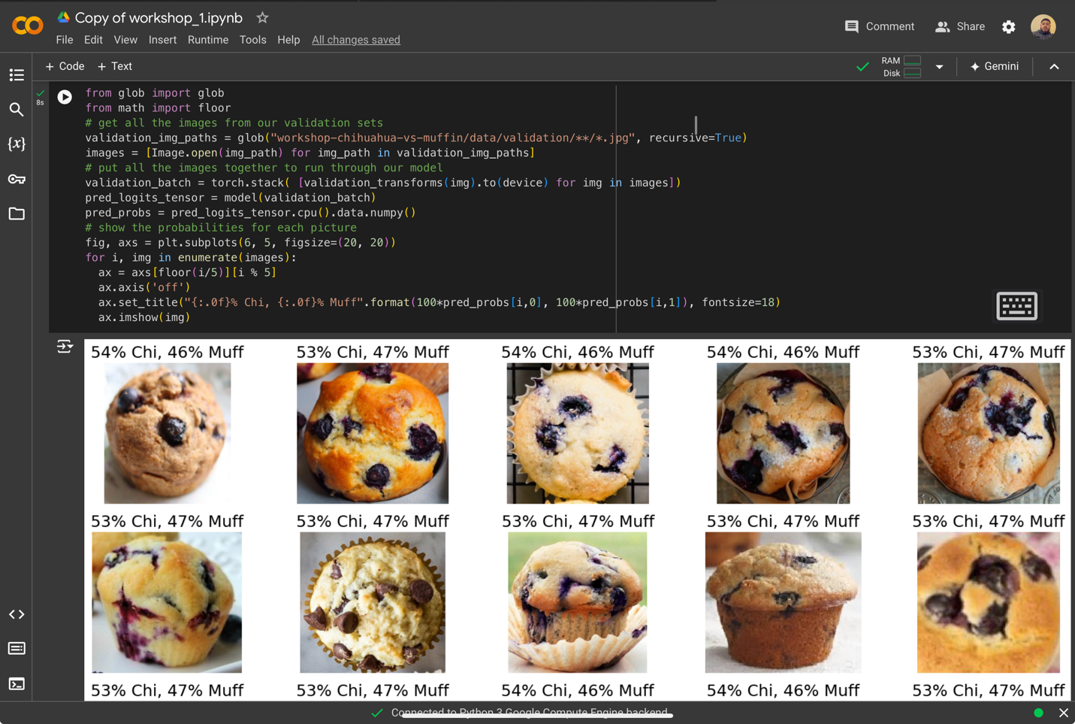 Finally, this assignment was especially important to myself because it helped me improve and practice my learning techniques and abilities while also preparing me for the future. I feel that after working on this assignment, and with a little more practice, I can work through a notebook and completely understand what is going on with every cell. Working on this assignment alone also helped me understand it a lot better because I had to meet the error codes on my own. In conclusion, understanding all the code cells was mostly important because if not I would not have been able to complete any of it.

<https://colab.research.google.com/drive/1KZicE7J47-GMbSNKPSMbAMzfLOnvLaUm#scrollTo=Lo1qp9UFScdG>