LOW COST EDUCATIONAL PLATFORM FOR ROBOTICS, USING OPEN-SOURCE 3D PRINTERS AND OPEN-SOURCE HARDWARE
Carlos García-Saura¹, Juan González-Gómez²
¹Escuela Politécnica Superior, Universidad Autónoma de Madrid (SPAIN)
²Robotics and Cybernetics Group, Universidad Politécnica de Madrid (SPAIN)
carlos.garciasaura@estudiante.uam.es, jggomez@etsii.upm.es
Abstract
In this paper, we present a new design methodology for educational robotic platforms. Using printbots (open-source 3D-printable robots) as a starting point in our designs has allowed us to create custom robots with very little effort. Using this new methodology we have designed the ArduSkybot, a robot that has enough features for its usage at different educational levels while keeping a very reduced cost. The robot is based on Arduino and the Printshield, our new electronics platform. It provides integration of various sensors (light, distance and line sensors) and actuators (motors, lights and speaker). It is also easy to expand by students and researchers. We describe our designs, and document their performance in various workshops with college, primary and secondary students. Our methodology is described and suggestions are given regarding future printbot-based workshops.
Keywords: Printbot, robotic platform, 3D printing, Arduino, open-source, open-hardware, low cost

INTRODUCTION
Robots have been successfully used for educational purposes during decades. The main advantage of teaching Robotics is that it is an interdisciplinary field that involves mechanics, electronics and programming. Students can learn from all these subjects at the same time, while having fun building robots. According to [1], a robotic platform should be cheap (to allow one robot per student or working in small groups), easy to repair (since we will be working with a large number of them), and flexible enough to allow expandability. In [2] it is suggested that educational robots should not only allow education but also provide enough features to allow research, even in its basic versions. Other authors [3] highly recommend the use of real robots instead of simulated environments, showing that it is possible to do really impressive amount of work in a robotics introductory course even with simple platforms. For instance, at Universidad Autónoma de Madrid our simple custom-designed robot (the Skybot) has been used since 2004 to give robotics lessons with great results.
Robotic platforms can be divided in two main groups: commercial and custom. Commercial educational robots are usually the easiest option for teachers, since there is a wide variety available on the market [2]. Prices range from 100€ to 4500€ per robot. Each design has different features such as big processing power, multiple sensors, simple logic and so forth. The teacher has to evaluate these platforms according to the required features and price constrains. A very popular platform is the LegoTM NXT [1,4,5]. The main disadvantage of commercial platforms is that they are closed and proprietary. Students can use them as black boxes, but the manufacturer doesn't allow to study how they have been designed. Hence, students cannot easily extend or modify commercial designs. As an additional disadvantage, the company may decide to discontinue that robot design (when they create a new version, for example). In that case, teachers should search for a new robot and re-write a new robotic course.
The other group comprises custom robots. Main advantages of custom-designed robots are that teachers or Universities fully own the robot design and therefore can decide what upgrades to do. They can adapt the robot for its use in different subjects, and students can also learn the whole robot design process. Some examples of fully-custom robots are the e-puck [2] and the RobEx [6]. On the other hand, custom robots are usually more expensive, and it takes more time to write a course since the robot has to be designed and built previously. For that reason, some authors have chosen a mixed approach were commercial kits are used for the mechanics, and then custom electronics are added. One example is [3], based on the Parallax Boe-Bot robot.
A new approach was taken with the Miniskybot robot [7], were the concept of printbot was presented. These are 3D-printable open-source robots. They can be easily built on open-source 3D printers at a very low cost. Therefore, printbots are low cost easy-to-build custom robots. Furthermore, as printbots are open, communities have grown around them, sharing the designs. This has given users the ability to improve their robots and adapt them to their needs. The result is that printbots are already evolving and diversifying. This is shown in sites like Thingiverse, where more than 75 printbots have emerged: from simple wheeled robots to complex four-legged robots or even robotic arms.
Usage of printbots for educational purposes was covered in [8]. It was shown that these kind of robots are a very good tools to stimulate students and develop their creativity. For the first time ever, students can easily expand the capabilities of the robots they are given.
Now there is a new alternative for universities and teachers who need to choose a robotic platform. Instead of buying a commercial robot or designing a custom robot from scratch, they can choose an already existing printbot design and create a derivative robot.
In this paper, we present our new 3D-printable robotic platform for education and research. It has been designed using this new methodology based on printbots. Section 2 covers the election of adequate electronics. Section 3 explains the design process of the ArduSkybot. Section 4 shows the results of using our robotic platform as an educational tool. Section 5 discusses the new methodology used. Finally, the conclusions and future work are given.

ELECTRONICS WITH ARDUINO
Each robotic platform includes its own controlling board. Electronics are usually commercial, such as the brick used in LegoTM NXT, the BasicStamp from Parallax [3] or the Dwengo-board [1]. Some others are custom boards based on micro-controllers (Atmel, Microchip and so forth). This has resulted in an heterogeneous landscape of electronic boards for robotic education.
Arduino is one of the most popular and fastest growing generic-purpose electronics platform. It is based on Atmel micro-controllers and offers a wide variety of boards with an standardized programming interface, simplifying the first contact with electronics while being powerful enough for its use in any kind of project.
Some interesting conclusions have been stated in [9]. First, it shows that students that use Arduino usually come up with more creative projects than students that use other platforms (this is due to the high availability of Arduino kits, good documentation and support forums). Second, it gives a warning: the Arduino community is usually focused in making things work, rather than choosing the optimal way to implement them. When teaching specific low-level optimization it is usually better to switch to other platforms. An example on how to use Arduino with educational robots is presented in [10], where they take the results obtained in [3] with the Boe-Bot and solve the complexity of the electronics (and programming) by replacing them with an Arduino board.
In addition, Arduino is open-hardware. All the designs are available for anyone to use, study or modify. Furthermore, Arduino has a huge community of people that develop tools (both software and hardware), share their projects and give support.
For these reasons, we have chosen to use Arduino in our robots.

Usage of shields for a better integration
As we have mentioned before, Arduino is a general purpose board. It only provides I/O pins, so we can't use it directly in our robots: we need to provide external circuitry in order to connect sensors and actuators. Using prototype boards usually ends with a mess of wires and connections (an example is shown in Fig 2.1). These kind of solutions work very well and are a good way to teach low-level electronics, but the resulting circuits are usually far away from being robust and compact.
Thanks to the Arduino community, there are plenty of “shield” designs available. These are circuit boards that are designed to easily fit on the top of an Arduino board. One example of how these shields are plugged is shown in Fig. 2.1. We are going to set our focus on the Arduino UNO board since it is the most simple and widespread, to the point that it can be considered as the standard.
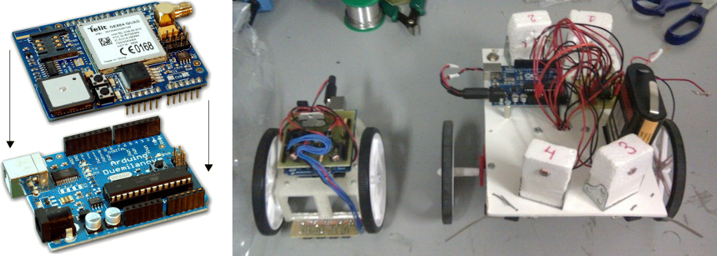
Fig. 2.1 Example shield (left) and a practical case of compacting circuitry (right)
This huge variety of shields (Wi-Fi shield, motor shield, GPS shield and more) is intended to provide an easy way to interact with many different peripherals simplifying electronic connections. However, we haven't been able to find a commercially-available shield intended for robotics. None of them offers a good way to plug the amount of sensors, motors and extension connectors required to build a compact full-featured robot.
Our solution was to use custom-designed shields (like the CRM-Shield mounted on the HKTR-9000 that is shown in Fig. 2.1), described with detail in next section.

DESIGNING OUR ROBOT
One of the great advantages of using printbots is that they can be redesigned to utilize available resources. For our first robotic workshop at the Robotics and Mechatronics Club we wanted to make use of components that we already had available: many different sensors, lots of Arduino UNO boards, some Pololu micro-motors with compatible wheels, a few ball casters, screws and so on.
Regarding the electronics, we concluded that the best solution was to custom-design our own shield focusing on robotics. The main requirements were to provide a good integration in order to reduce size and complexity, and to make robust electronics. As we like working with open-source, Kicad has been used to design the boards. We have developed all our printed circuit boards using simple toner transfer techniques.
Our first approach resulted in the CRM-Shield. This shield integrates two light sensors, one LED, an L298 motor driver and provided an easy way to connect a line sensor.
We were able to design our custom 3D-prinable chassis in a few hours, and the full robot prototype of the HKTR-9000 (Fig. 3.1) was working the next week. Only one week after that, we had five of these robots assembled. The additional cost for out robotics club was zero, since we already had all the required parts, and the 3D printed plastic cost was marginal.
The CRM-Shield didn't even have push buttons. Light sensors were connected to a pin header and were easily taken apart. Also, the motor driver used many of the space and pins available on the Arduino. Nevertheless, the CRM-Shield behaved surprisingly well in our first workshop (view Section 4.1).
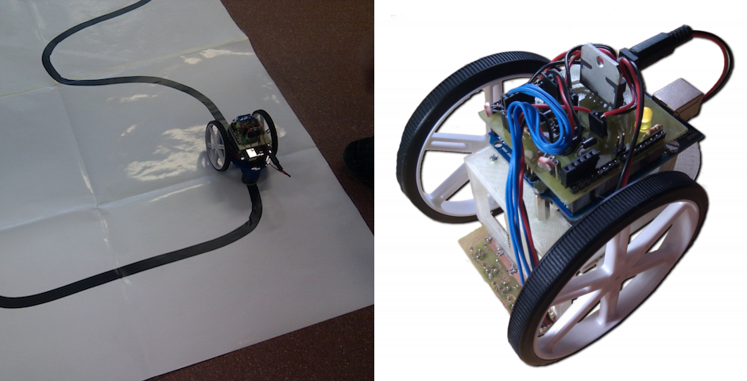
Fig. 3.1 HKTR-9000 possible usage as a line follower (left) and detail view (right)
Encouraging results obtained with the CRM-Shield prompted us to re-design it trying to fix existing problems: The Printshield (Fig. 3.2) was the result of our efforts. We decided to switch back to continuous rotation servos (like the ones used in the original MiniSkybot) since they don't require a motor driver, but only one digital pin to be driven. Easy to use motors and a standardized connector allow an easy expandability. Two push-buttons were added (reset and function) and we found a much robust way to attach light sensors using a screw terminal instead of pin headers.
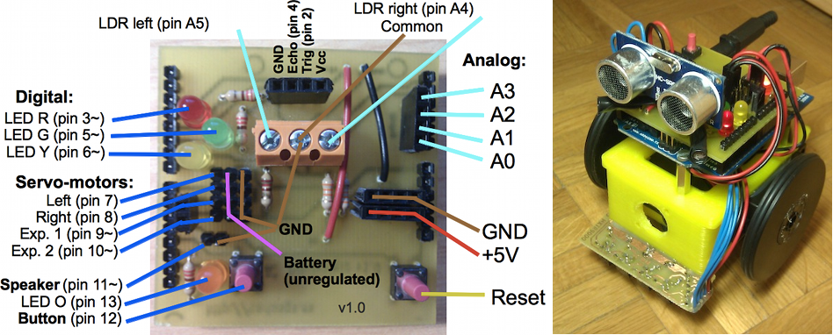
Fig. 3.2 Printshield connection diagram (left) and usage example in the ArduSkybot (right)
Printshield integrates many LEDs (that are very good to teach basic programming as they serve for debugging purposes), various sensors (light and distance), and provides an easy way to connect peripherals (servo motors, speaker, line sensors and more).
The Printshield uses very common electronic components and thus is very cheap (around 5€ per board). It is also very easy to reuse in other printbots.
ArduSkybot uses the 3D printable chassis and wheels from the MiniSkybot v2.0. As a result, we have created a simple mobile platform that benefits from the Printshield providing many sensors (distance, light and line sensor), two motors (continuous rotation servos), LED lights, push-buttons and a speaker.
The production cost has been kept really low (around 55€), which is very similar to the price of the MiniSkybot shown in [7]. Later on, we have validated the educational capabilities of the ArduSkybot in a small workshop.

VALIDATION OF THE NEW PLATFORM
We have tested our printbot designs in two workshops: one with college students and the other one with primary and secondary students.

Robotics introductory course with the HKTR-9000
The Robotics introductory course took place the 23, 24, 25, 28 and 29 of May 2012, and was organised by the Robotics and Mechatronics Club at Universidad Autónoma de Madrid.

Target and group characteristics
The workshop was aimed to a group of 20 engineering students (18 to 23 years old). The target was to give an introduction on basic robotics. We didn't require any robotics knowledge prior to the workshop: they learnt the basics (electronics with Arduino and the CRM-Shield, and simple mechanics), and built a total of five HKTR-9000 robots. They already had experience with at least one programming language.

Duration and workflow
This workshop had a length of 15 hours, divided in five sessions of three hours each. Workflow consisted in an initial 20 minute explanation, and after that students had to solve the proposed exercises. They worked in five groups following the provided instructions. Regarding material resources, we used a laboratory with computers, a projector for presentations, and five HKTR-9000 kits that were made previously.

Workshop contents
First two lessons explained the basic components of a robot, and Arduino was introduced. Students learned how to use sensors and motors at a low level using prototype boards. After that, they programmed the required functions for controlling the motors.
Next two lessons included the assembly of the HKTR-9000 and some programming examples. Students learned how to make the robot follow a light source, and some basic PD control algorithms in order to make the robot follow a black line.
Final lesson was left for students to decide what to do, providing them with distance sensors and speakers. They came up with very creative ideas: for example, some students were able to get the robot to avoid obstacles while playing sounds, and others made the robot follow light and play notes according to the distance read by the sensor.

Results
During the workshop, some students asked for a reduction of theoretical content while others were missing more complex exercises. The solution was to simplify the presentations and also the exercises while providing additional ones for advanced students.
We found that is was really hard to install the distance sensor in the HKTR-9000. This was the main reason for the later integration of this sensor in the Printshield.
The workshop was a success, since students were very satisfied at the end and all the program was covered. It also motivated some students to join the robotics club, which is also a very good sign.

ArduSkyBot 2012 Summer Workshop
The ArduSkyBot 2012 Summer Workshop took place from July 30 to August 2 in Palo Alto, and was organised by Carlos García Saura.

Target and group characteristics
The target was to give an introduction on robotics to a small group of four 12-14 year old kids. They learnt the basics of robotics (electronics with Arduino and Printshield, programming and mechanics), built their own ArduSkyBot and made their own program modifications.

Duration and workflow
This workshop had a length of roughly 10 hours, divided in four lessons of two and a half hours each. Workflow consisted in an initial 15-30 minute explanation, and after that we gave the students some example code and simple exercises that they had to solve (giving additional ones for advanced students, as we had learned from the previous workshop), helping them when they needed so. Regarding material resources, we used two tables, a display for presentations and four ArduSkyBot kits. Students were required to bring their own laptop, and an Arduino board with its USB cable.

Workshop contents
First lesson included the explanation of what is a robot and what are its main components. Arduino was presented, together with the Printshield, and students assembled and tested basic examples with LEDs and audio tones.
Next two lessons included the introduction of the ArduSkybot and its assembly. They first made the robot move modifying basic code examples. We gradually presented them with more complex examples as following light or avoiding obstacles. Some students solved the advanced exercise, managing to make the robot follow light while avoiding obstacles.
In the last lesson, the line sensor was provided and students were able to make the robot follow a black line. The proposed challenge was to avoid an obstacle while following a line, and then returning to the path. We were amazed to see that some students succeeded on this!

Results
For the preparation of the lessons for this workshop we followed the recommendations given in [4] for working with small kids: since it is much different than working with college students it required a different approach.
We structured the lessons in a very simple way, first exposing what they would learn and using an example-based system. Yet, smaller kids said that everything was extremely complex! It is very important to simplify things a lot when working with small kids.
One interesting discovery was that kids love using the speaker: they had lots of fun just by changing the playback speed of the melody example given. Also, when using the measurements from the distance sensor to generate tones they were amazed by this new musical instrument. The speaker was present during the whole workshop, and the buzzer-like sounds helped to create a friendly work environment for the kids.
As we have said, kids were required to bring their own Arduino board. We decided this after seeing that they already had an Arduino kit at home (we confirmed this was their parents failed attempt to get them into electronics). This fact cut production cost of the robots to more than a half (around 25€) since the Arduino board is the most expensive part. Thanks to the low price of the parts we were able to let kids take the robot home at the end of the course, which made them really happy.
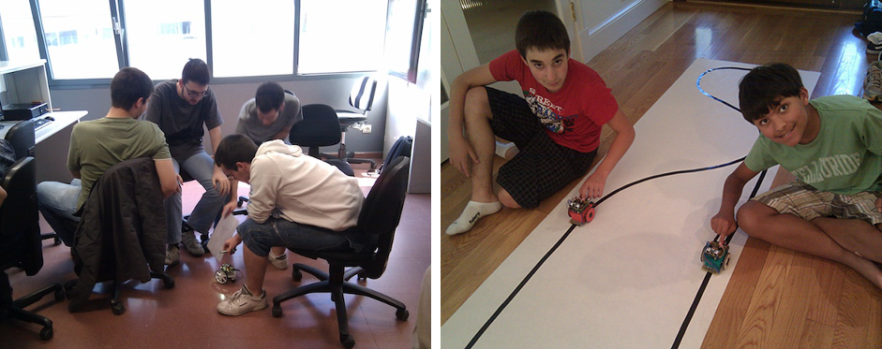
Fig 4.1 Robotics introductory course (left) and ArduSkybot 2012 summer workshop (right)

DISCUSSION
It took a surprisingly small amount of time to set up the HKTR-9000 and the ArduSkybot for our workshops. Taking in account that the assembly process of the large robot that appears in Fig. 2.1 took us about two weeks, we were really impressed when we saw that we were able to design and produce five HKTR-9000 robots in that same period of time.
Our experience with the ArduSkybot has been even more impressive: The design and manufacture process for five of them (including the prototype) took around one week.
The ArduSkybot was designed as a derivative of the existing MiniSkybot, and the final cost is very similar (around 55€). For this reason, we must indicate the improvements that were made:
- Now the robot is based on Arduino UNO, and it is possible to connect with USB directly. Many people already have one of these boards, and that drops down the price of the robot since they only need to add the cheap Printshield and sensors.
- A line sensor has been added. It is made with four CNY70 infra-red sensors.
- Integrated light sensor, made of two LDR firmly attached using a screw terminal.
- Easy to use integrated distance sensor, using a cheap SR-04 module.
- Finally, it has two pulse-buttons, some LED lights and a piezoelectric buzzer.
Using a 3D printer has allowed the fast replication of our robots, but using printbots as a start point has been the key for an accelerated custom design process. More importantly, we have used the resulting robots in various workshops that have shown positive results. We truly believe these kind of approaches will mean a revolution in how robotic courses are given.

CONCLUSIONS AND FUTURE WORK
Our new printrbot-based methodology has been proven to work: robotic courses aren't restricted to use commercial robotic platforms, nor design their robots from scratch any more. Using printbots as a starting point, it is possible to design custom educational robots with very little effort and great results.
The ArduSkybot has been developed using this new methodology, and Printshield is our answer to the lack of Arduino shields that are specific for robotics. It provides a compact solution for integrating basic sensors and actuators in Arduino-based robots like the ArduSkybot.
As future work, we want to keep improving these kind of robots. Using tracks instead of wheels will increase stability, and a new version of the Printshield will have infra-red connectivity to allow communication between robots and therefore the study of more complex algorithms.
All the documentation and designs required to build our designs are available online as open-source. We have also published all the slides and exercises used in our workshops.
Updates on our work and all related resources can be found in our websites: http://www.carlosgs.es and http://www.iearobotics.com.

ACKNOWLEDGEMENTS
We want to thank the Robotics and Mechatronics Club at Universidad Autónoma de Madrid for providing the material resources, as well as Mr. Lucas Polo and Mr. Miguel Gargallo for their direct collaboration in the organization of the course. We are also thankful to Mrs. Carmen Saura for providing the workspace and helping in the organization of our robotic course in Palo Alto.
REFERENCES
- Wyffels, F., Hermans, M. & Schrauwen, B. (2010), "Building robots as a tool to motivate students into an engineering education", In Proceedings of the 1st international conference on Robotics in Education, RiE2010. September 2010. pp. 49-52. FEI STU, Slovakia.
- Mondada, F., Bonani, M., Raemy, X., Pugh, J., Cianci, C., Klaptocz, A., Magnenat, S., Zufferey, J.-C., Floreano, D. and Martinoli, A. (2009), “The e-puck, a Robot Designed for Education in Engineering”, Proceedings of the 9th Conference on Autonomous Robot Systems and Competitions, 1(1) pp. 59-65.
- Balogh, R. (2008) “Basic Activities with the Boe-Bot Mobile Robot”, In DidInfo2008. 14th International Conference. FPV UMB, Banská Bystrica, Slovakia.
- Peter van Lith (2007), "Teaching Robotics in Primary and Secondary schools", ComLab Conference 2007, November 30 - December 1, Radovljica, Slovenia.
- Carter, J. & Coupland, S. (2010), "Teaching Robotics at the Postgraduate Level: Delivering for On Site and Distance Learning Students", In Proceedings of the 1st international conference on Robotics in Education, RiE2010. September 2010., pp. 149-154. FEI STU, Slovakia.
- J. Mateos, A. Sánchez, Luis J. Manso, Pilar Bachiller, Pablo Bustos (2010), "RobEx: an open-hardware robotics platform". Proceedings, Workshop en Agentes Físicos (WAF2010), Valencia, Spain.
- Juan Gonzalez-Gomez, Alberto Valero-Gomez, Andres Prieto-Moreno, Mohamed Abderrahim (2011), "A New Open Source 3D-printable Mobile Robotic Platform for Education", Proc. of the 6th International Symposium on Autonomous Minirobots for Research and Edutainment, May, 23-25, Bielefeld, Germany.
- A. Valero, J. González-Gómez, V. Gonzalez, M.A. Salichs (2012), “Printable Creativity in Plastic Valley UC3M”. IEEE Educon 2012. Marrakech. Morocco. Apr, 2012.
- P. Jamieson (2011) “Arduino for teaching embedded systems. Are computer scientists and engineering educators missing the boat?”, International Conference on Frontiers in Education: Computer Science and Computer Engineering.
- Balogh, R. (2010), "Educational Robotic Platform based on Arduino", In Proceedings of the 1st international conference on Robotics in Education, RiE2010. September 2010., pp. 119-122. FEI STU, Slovakia.

http://www.iearobotics.com/wiki/index.php?title=Skybot
http://mindstorms.lego.com
http://www.parallax.com/go/boebot
http://reprap.org/wiki/Main_Page
http://www.thingiverse.com/thing:18264, http://www.thingiverse.com/thing:18045 and http://www.thingiverse.com/thing:30163
http://www.parallax.com/BASICStampGeneralInformation/tabid/214/Default.aspx
http://www.dwengo.org/products/dwengo-board
http://arduino.cc
http://shieldlist.org
http://www.pololu.com/catalog/category/60
http://www.thingiverse.com/thing:23593
http://www.thingiverse.com/thing:26818
https://github.com/Obijuan/Miniskybot
http://spock.ii.uam.es/actividades/taller-de-iniciacion-a-la-robotica
http://carlosgs.es/2012-summer-workshop

