Revise el resultado obtenido. ¿Qué codigo de error sale?, revise el significado del mismo en la lista de códigos de estado HTTP.

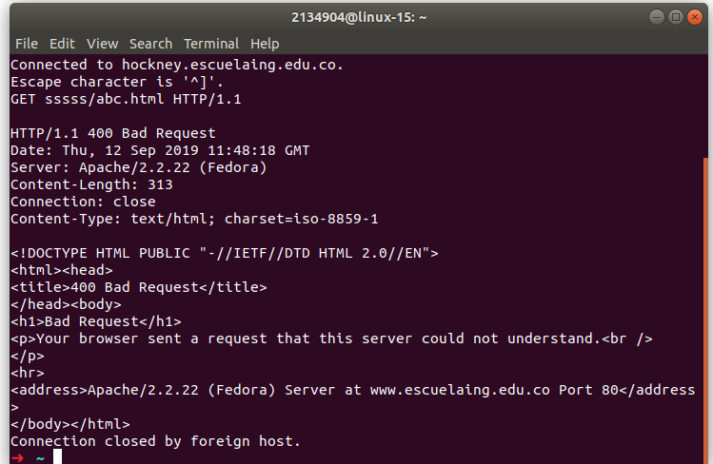

¿Qué otros códigos de error existen?, ¿En qué caso se manejarán?

Realice una nueva conexión con telnet, esta vez a:

- Host: www.httpbin.org
- Puerto: 80
- Versión HTTP: 1.1
Ahora, solicite (GET) el recurso /html. ¿Qué se obtiene como resultado?
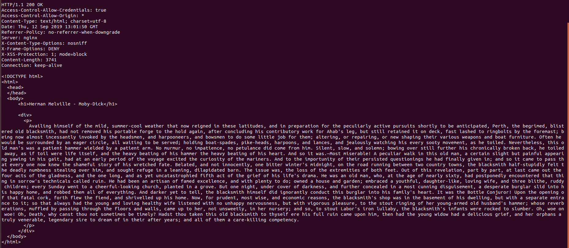

Ejecutar el comando wc (word count) para contar palabras con la opción -c para contar el número de caracteres:
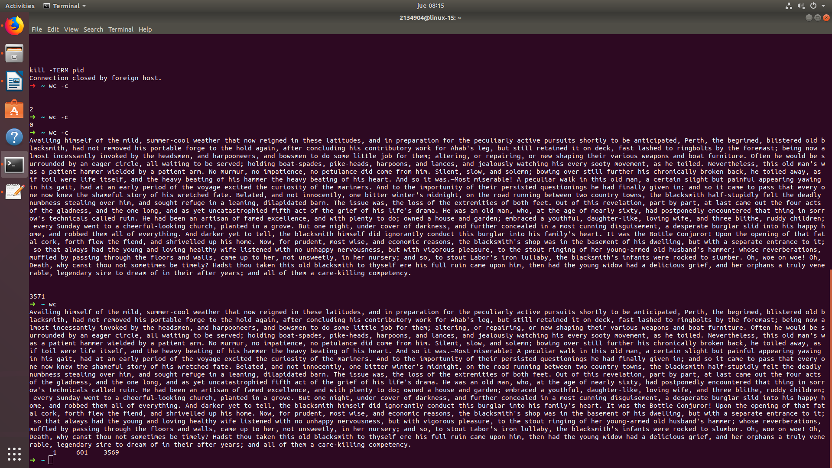

¿Cuál es la diferencia entre los verbos GET y POST? ¿Qué otros tipos de peticiones existen?

The GET method means retrieve whatever information (in the form of an
entity) is identified by the Request-URI. If the Request-URI refers
to a data-producing process, it is the produced data which shall be
returned as the entity in the response and not the source text of the
process, unless that text happens to be the output of the process.
The POST method is used to request that the origin server accept the
entity enclosed in the request as a new subordinate of the resource identified by the Request-URI in the Request-Line. POST is designed to allow a uniform method to cover the following functions:

- Annotation of existing resources;
- Posting a message to a bulletin board, newsgroup, mailing list,or similar group of articles;
- Providing a block of data, such as the result of submitting a
form, to a data-handling process;
- Extending a database through an append operation.
¿Cuáles son las diferencias con los diferentes parámetros?
If curl fails where it isn't supposed to, if the servers don't let you in, if you can't understand the responses: use the -v flag to get verbose fetching. Curl will output lots of info and what it sends and receives in order to let the user see all client-server interaction (but it won't show you the actual data).
