

Course Number: 420-P34-AS

Course Title: Advanced Object Programming

Session: Autumn 2017

**final project**

**Hi-Tech Management System**



**Due DATE: December 13, 2017.**

**submitted**

**to**

**TEACHER: Quang Hoang Cao**

**By**

**Carlos goncalves**

**Student Id: 201630169**

1. **Project description**

The system Hi-Tech Distribution Inc is an ALFA version that has to be proven before its launching. It was made for Hi-Tech Distribution Inc. whose function is to sell computer science books and software to all colleges and universities in Quebec. This system is composed of four windows, each window can be only managed by a specific employee. To log in employees must pass a validation process where the system is going to check the accuracy of the information submitted and will allow depending on the employee and the information entered the access to a determined window. The manager will have access to a window where he/she will be able to handle employees and create their users that will allow them entry into the system. The sales manager will be allowed to arrange clients’ information that afterward will be used by order clerks to generate the order. Inventory controller is will be able to drive inventory, in addition, he/she is going to be capable to add new authors, books or publisher and organize this information to make it Order clerks will be allowed to generate the order checking first if products are available in stock, and link the order with the client who made the order. The system was made to organize the information, make easy the company’s functioning, hence making its performance effective, and in this manner accomplishing the company’s target.

1. **project development**

**1. Class Library**

To develop the system I separated the Business, Data Access and Validation classes from the Graphical User Interface using the library class. This will allow me to be able to use this class for another project in the future.In the business folder are all the definitions of the different classes used in the system.In the Data Access folder are the methods used in the different functions of the system. And in the Validation folder is the class Validation that has all the methods to validate the data that will be enter by the different users.

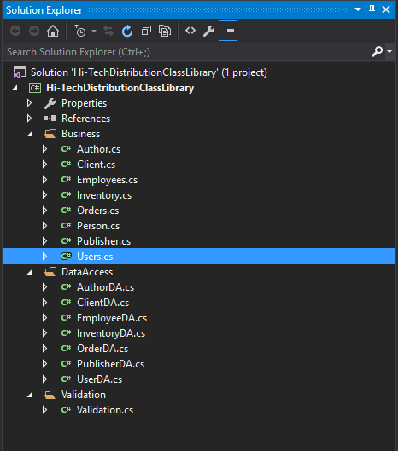

1. **Login.**

The system starts with a login form where users have to enter a valid information to access the system. The required information is UserID and Password. This information is created by the General Manager of the company. Also in case a user forgets his/her password, the system has a function to reset it, the user must first validate his/her user ID and, if the information provided is correct, the system allows the user to reset his/her password.

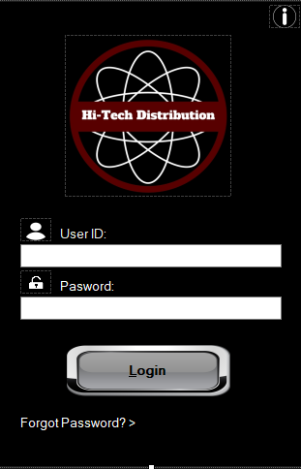

The following file is used as a Data Base to store the information of the different users, the symbol "|" It serves as a split between the UserID, Password and Job Title. When the user enters the information requested, the system validates UserID and Password, depending on their Job title the user gets access to a window to perform their different functions.

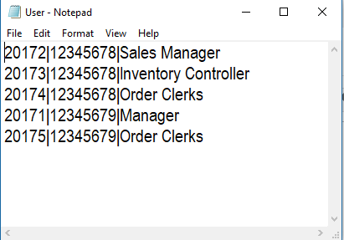

The symbol with the “I” in the upper right corner gives the user access to a window with basic system information as Product Name, Version, Copyrights, Company Name and Description.

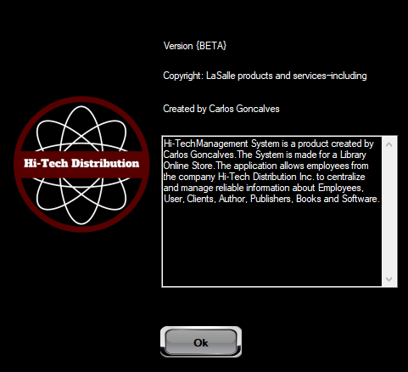

As it is mentioned above if the user forgets his/her password, he or she can press the option “Forgot Password?->” and the following window will appear. Where the user can change his/her password.

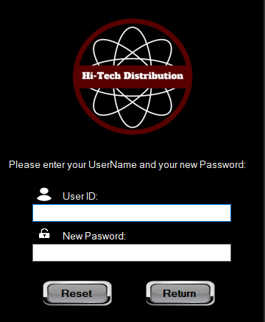

1. **MIS_Management.**

To get access to the MIS_Management form the user has to be the General Manager in this case the user is Henry Brown. In this window of the application, the manager can return to the login form using the button return or log out from the system using the button log out. The main function of this window is to manipulate the Employees’ information using the button save to store the information in a Data Base (file). Also in the case that the manager needs to update or delete any employee information, he can find the record using the function search and then he can apply all the changes that he needs.

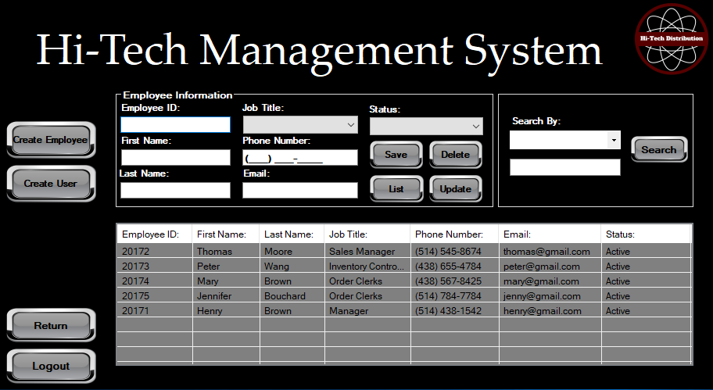

The button “Create User” allows the manager to get access to the second main function of this window.

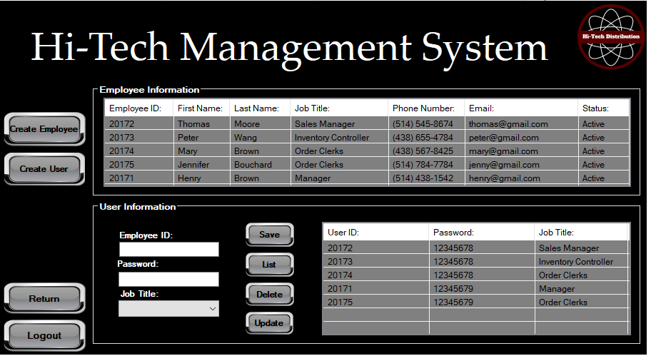

In this section the manager can create the UserID for the employees of the company, to be able to create a UserID first, the manager needs to enter a valid EmployeeID. If the information provided is wrong an error message will appear.

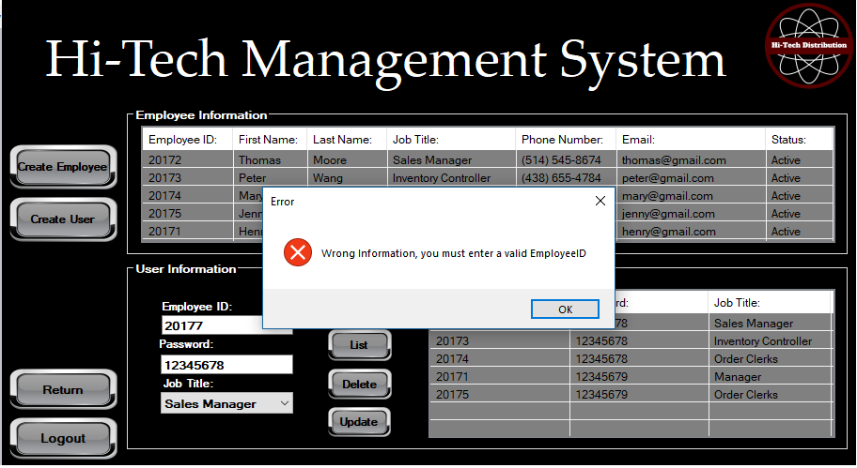

1. **Sales Manager**

To get access to the Sales_Management form the user has to be the Sales Manager in this case the user is Thomas Moore In this window of the application, the Sales Manager can return to the login form using the button return or log out from the system using the button log out. The main function of this window is to manipulate the Clients’ information using the button save to store the information in a Data Base (file). Also in the case that the manager needs to update or delete any client information, he can find the record using the function search and then he can apply all the changes that he needs. This client information will be used by the Order Clerk to generate the final order.

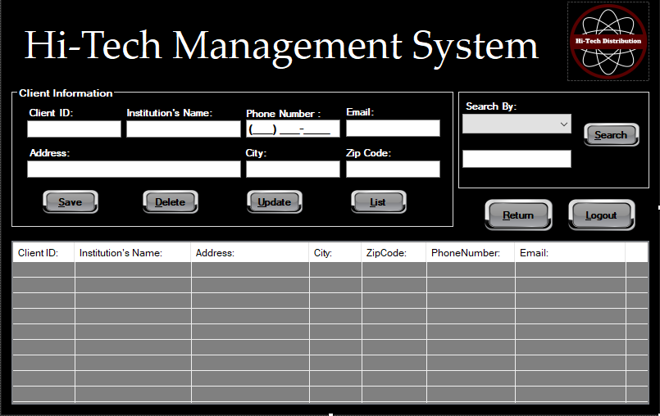

1. **Inventory Controller**

To get access to the Inventory_Control form the user has to be the Inventory Controller in this case the user is Peter Wang In this window of the application, the Inventory Controller can return to the login form using the button return or log out from the system using the button log out. The main function of this window is to manipulate the Products’ information using the button save to store the information in a Data Base (file). Also in the case that the Inventory Controller needs to update or delete any product information, he can find the record using the function search and then he can apply all the changes that he needs. To be able to add a new product, in case that the author or publisher information is not in the database, the Inventory Controller needs to add them to the Data Base first using the buttons in the left panel. This product information will be used by the Order Clerk to generate the final order.

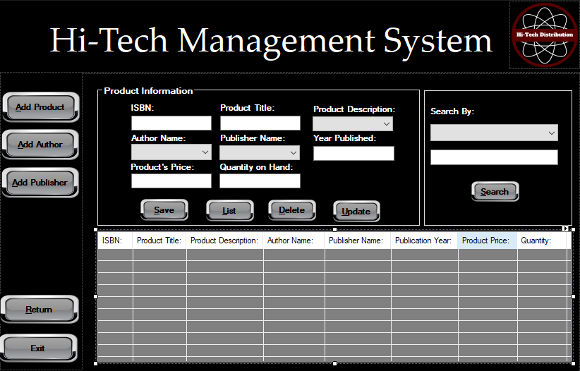

This is the main section of this window where the Inventory Controller can add a new product to the DataBase. To change the Production Description, Author Name, Publisher Name the Inventory Controller has to use the comboBox for each case, these contain the information previously added.

1. **Order_Clerks**

To get access to the Order_Clerks form the user has to be an Order Clerk in this case the user is Mary Brown In this window of the application, the Order Clerk can return to the login form using the button return or log out from the system using the button log out. The main function of this window is to generate the Orders. Using the list of products the Order Clerk can add the product selected to add it to the order. Using the comboBox with the Client ID the Order Clerk does not have to enter the name of the client, with the information that is stored in the database the information is generated by the system.

Using the button save the Order Clerk can store the information in a Data Base (file). Also in the case that he/she needs to update or delete any order information, he/she can find the record using the function search and then he/she can apply all the changes that he needs. To generate a new and unique Order Number the Order Clerk has to press the button generate.

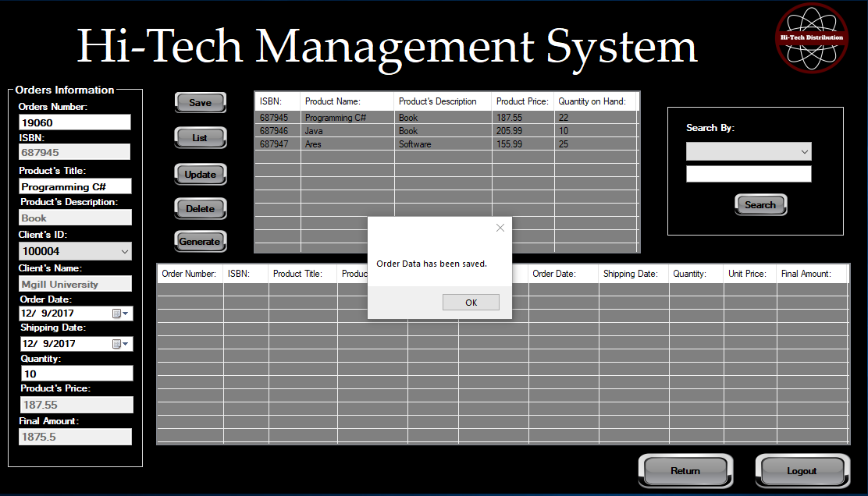

1. **Project Conclusion**

What I learned from this project is to manipulate better the Class Library, also to create new and better methods. I would like to learn more about Graphical Interfaces to make my programs nicer and friendly to the view of the users, now I know that there are different frameworks as Metro or Bunifu that for sure I will implement in my future projects.