

TP1 : 20%

Access Database Creation

|  |  |
| --- | --- |
| **Course Identification** | |
|  |  |
| Program’s Name – Code: | **TECHNIQUES DE L’INFORMATIQUE -SPECIALISATION EN INFORMATIQUE DE GESTION (420.A0/A)**  **PROGRAMMEUR ANALYSTE EN TECHNOLOGIES DE L'INFORMATION (LEA.3Q)** |
| Course Title : | **Events Programming** |
| Course Number : | **420-P46-AS** |
| Group: |  |
| Teacher’s Name : | Fodé Toure |
| Session: | Winter 2018 |

PROJECT  TITLE: Mini Microsoft Access 2018

Description :

Students must analyse, conceive and build a window based application thats will allow a user to create an access database with a minimum of efforts (user friendly interface).

These are the functionalities of your application :

* F1 : Display a nice and user-friendly interface (MDI forms, Colors and images),
* F2 : Create a database (Name and path specified by user),
* F3 : Create Tables in database, Fields (Name, types, properties), Index,
* F4 : Create Relations between tables,

Technologies :

* Microsoft Visual Studio, language C# and windows Form as type of project.
* Use the model object of DAO (Data Access Object)

Remarks:

* Your application does not modify an existing database.
* Your application does not manage (see, add, delete, ..) records in tables.
* Must be done individually, any resemblance will be penalized.

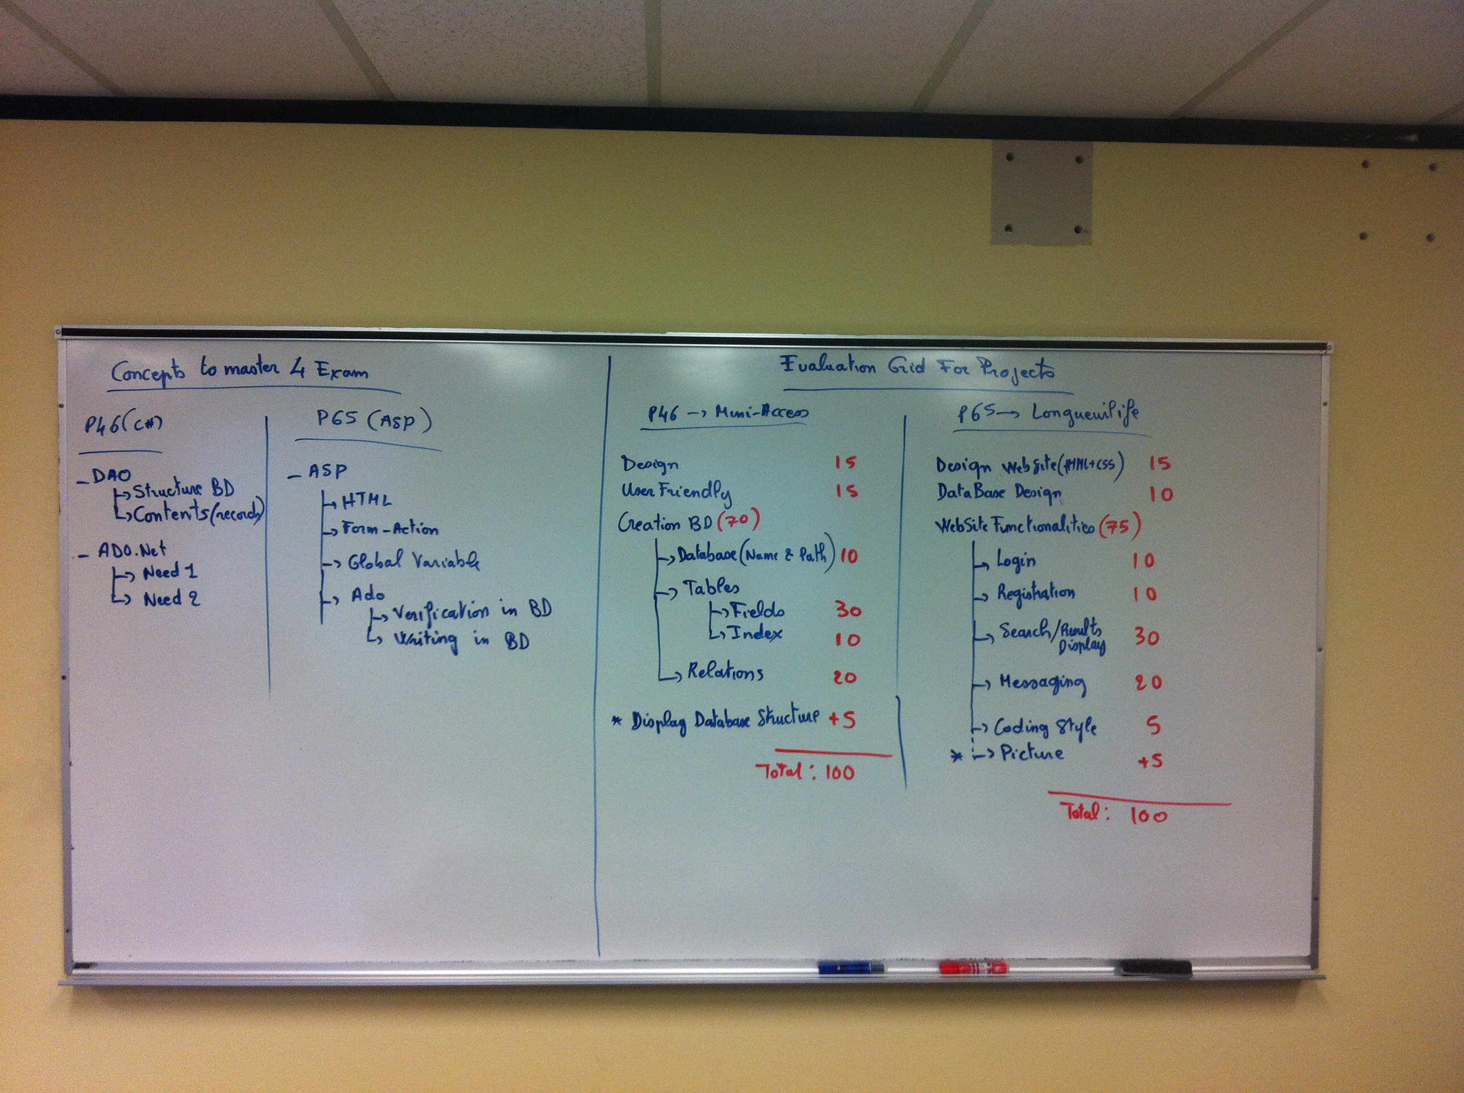

Evaluation criterias

|  |  |
| --- | --- |
| Functions | Points |
| F1 : Design | 15 |
| F1 : User Friendly | 15 |
| F2 : Create Database |  |
| F2 : - DB Name & path | 10 |
| F3 : Table : Fields | 30 |
| F3 : Table : Index | 10 |
|  |  |
| F4 : Relations | 20 |
| Bonus | +5 |
| TOTAL | 105 |

Date of submission : 7 of March 2018