[Working title] Who is the Pronoun Pro? Comparing LLMs and Humans at Number-Disambiguation of they
Table of contents

- Check for other publications on LLM annotations and see if journals apply; otherwise Corpus Linguistics and Linguistic Theory, and format accordingly
- Find out what LLMs have been used for in linguistics and/or NLP for introduction
- Background on they; move the general purpose of the present research there or into the introduction
- Conclusion and Intro
- ensure all mentions of linguistic material are italicized
- ensure “generic singular they” vs “generic they” is well planned and then used consistently
- Tutorial on exporting to Word

1. Introduction
Large Language Models (LLMs) have not only permeated wider society, they have also begun changing the methodological landscape in the humanities and linguistics more specifically. The promise of the team behind GPT-3 was that Natural Language Processing (NLP) as a whole would shift away from specially-created models for specific tasks “to using task-agnostic pre-training and task-agnostic architectures” Brown et al. (2020), i.e. general-purpose language models able to perform a wide range of tasks without task-specific training. Indeed, half of a decade later, LLMs have already found their way into different parts of linguistics research, among them morphological pattern matching (Jubelius 2025), authorship verification (Huang and Grieve 2024), or semantics-based corpus extraction (Dallas and Hartmann 2026). Indeed, it seems like the field is in a state of newfound enthusiasm, finding new potential of LLMs as they themselves evolve.
The present work is the continuation of an older, foresighted effort starting in my Master’s thesis (2022). The then-new GPT-3 was tested for its performance at disambiguation uses of they between plural and singular (see below). This is, in essence, an example of coreference resolution as the number-disambiguation of they hinges on the pronoun’s referent . Coreference resolution as a field precedes LLMs (cf. Gan et al. 2025; “Coreference Resolution and Entity Linking” 2026), though it was always limited by the many challenges posed by the nature of coreference, such as real-world knowledge required for textual understanding and context-dependency (Seminck et al. 2025; Novák et al. 2025). What is more, English pronouns have shifted in recent years (Newman 1997; Paterson 2014), most notably with the extension of they as a personal pronoun for people of non-binary gender (Conrod 2019), but also with the growing visibility of neologistic pronouns (Baron 2020; Rose et al. 2023; Remsö, Bäck, and Renström 2026). To study this, therefore, established coreference resolution techniques were bound to hit performance limits for innovative language (Cao and Daumé III 2020). LLMs, on the other hand, showed promise because they exhibited context-sensitive performance and even some level of textual understanding in several areas (Brown et al. 2020; Pavlovic and Poesio 2024). While its performance with singular they in the dataset of the Master’s thesis was unsatisfactory (Hartmann 2022, sec. 5.6), the same test was later repeated using newer models as preliminary testing for the present research. When Anthropic’s LLM Claude Sonnet reached both recall and precision of over 80% on the same dataset in late 2024, it was hypothesized that LLMs had reached human-like performance in this task. To assess this reliably and accurately, the research question was formulated: “To what extent are number-annotations of authentic uses of they by LLMs reliable when compared to trained human annotators?”
This research is now situated in a broader context of LLMs expanding in use even beyond their original intended purpose of solving once-off tasks. Through the development of techniques like hidden prompts, chain-of-thought prompting, and reasoning models more generally, LLMs have attained the status of assistants who take over entire workflows. One prominent example is the model implemented in Google’s search interface, which engages in choosing sources, summarizing them, and building a well-balanced argument based on the gained information. In short, it is a research assistant that easily outperforms a human intern that might normally be hired for such a task; if not in output quality, certainly in cost and speed. The consequence for research in linguistics and similar areas might be that entry-level positions for research assistants are in danger of being replaced by LLMs. The present research is thus not only about the performance of LLMs at the specific task at hand, but about the broader question about the viability of employing them in a fashion that is comparable to the work of human research assistants. Therefore, the present study is conceived as a simulation of handing off an annotation task to a student assistant, which is reflected in the recruitment strategy and task design. As the notion of high-quality annotations from an assistant is more complex than a simple scored performance, the present research will investigate several measures, both quanitatively and qualitatively.

1.1 Hypotheses
At the outset of the present research, three levels of performance were defined in the form of three falsifiable, quantitative hypotheses:
- Hypothesis 1: The most accurate number-disambiguator of they is going to be an LLM.
- Hypothesis 2: The most accurate LLM at number-disambiguating they is going to perform at a higher accuracy than the mean human accuracy.
- Hypothesis 3: The performance of the most accurate LLM is not going to be significantly worse at rare and innovative uses of they than the mean human performance.
The three hypotheses were formulated so that even if hypothesis 1 is not confirmed by the results, hypothesis 2 would still attest that LLMs largely outperform humans. If that were not confirmed either, hypothesis 3 would still justify the use of LLMs for semantically-complex tasks such as resolution of innovative pronouns.
In addition to the three hypotheses, the following aspects of annotation quality and performance variation were examined: the role of English proficiency when solving this task, the risk of employing crowdworkers as opposed to local students, strategies to counteract those risks, the effect of context-dependence on human and LLM performance, the effect of linguistic innovativenes (i.e. specific singular they) on human and LLM performance, and finally the cost and time differences between human and LLM annotation.

2. Background
The present study incorporates contextual and methodological knowledge from two main fields: the field of Coreference Resolutions (CRR) and the history of change that the pronoun they has undergone in recent decades. Both fields inform the design of the task and the gained insights will be relevant in both fields. However, it should be pointed out that this research is relevant for any kind of task in linguistics that goes beyond the written surface level but cannot be performed by a human annotator. Jubelius 2025 and Dallas and Hartmann 2026 are examples of such tasks as they aim to extract linguistic patterns from large corpora that were only accessible through manual labor before. For example, the latter investigates constructions other than the have + past participle construction to express perfect aspect in English, requiring understanding of the semantics of every verb phrase in a corpus, a task equally demanding in time and expertise.

2.1 Coreference resolution as performed by LLMs
The task of coreference resolution is based on deep understanding of the text. The first step is to identify all “mentions” of real-world entities (i.e. specific linguistic material denoting entities or even implying them) and then to identify which of those mentions refer to the same entity, i.e. which mentions “corefer” (Jurafsky and Martin 2026). As many tasks in NLP, it started with rule-based approaches and then moved to machine learning-based approaches (Gan et al. 2025). The most complete history of automatic CRR is provided in Seminck et al (2025). The current stage of research, very briefly summarized, is that LLMs are entering the field (Kong aand Tan 2026) but have not yet outperformed traditional approaches across the board (Novak et al. 2025, Section 5).
The traditional approach has the main advantage of being computationally cheap compared to LLMs (Seminck et al. 2025, Section 3.1.2). The disadvantages are, however, numerous: it requires highly specialized training material, which is not only scarce but often varies in annotation standards, making generalizable training difficult (Seminck et al. 2025, Section 3.1.2). This makes it difficult to expand to other languages or to language innovations such as singular they which is not found in the often-used standard dataset OntoNotes (Hartmann 2022, Section 4.3). Like in other areas of NLP, the step towards using LLMs [^ The term “Large Language Model” denotes a variety of different model architectures. In the present work, the term is used to denote generative, decoder-only models.] therefore introduces a great deal of flexibility as they are independent from task-specific training material at a remarkably high cost of computation.
The state of the art of LLMs as annotators for CRR could be observed at the Eighth Workshop on Computational Models of Reference, Anaphora and Coreference (CRAC 2025) hosted by the Association of Computational Linguistics. They had issued a shared task on multilingual coreference resolution with two tracks, one for traditional or hybrid approaches and one exclusively for LLM-based approaches. Their dataset was varied not just by language but also by domain and genre. The shared task was clearly won by traditional approaches (Novak et al. 2025, Section 5). Seminck et al. 2025 contributed the approach that won the LLM track (Section 4). The following insights can be drawn from the papers of the shared task:
Seminck et al. (2025) frame context management as a central bottleneck for LLM-based CRR. They report that shorter prompts work better than longer ones, plausibly because they leave more room for input context and, in my interpretation, reduce over-determination of the task. At the same time, they observe “disastrously bad” outcomes when inputs become too long, with the model appearing to lose track of the objective (Section 3.2.2). This fits Novak et al’s (2025) broader shared-task interpretation: LLM systems still underperform specialized coreference pipelines, but show clear potential on a task that reflects a broader spectrum of real-world phenomena and is shaped by practical constraints such as bias, computational cost, and privacy.
Their broader conclusion is therefore ambivalent: adding information is often necessary, but careful context-window management remains both crucial and constraining (Section 5). This trade-off is also practical rather than only conceptual. In their setup, a traditional pipeline processed the data in 16 minutes, whereas the LLM-based approach took roughly 1.5 days (Section 4). Sajid et al. (2025) similarly flag computational cost as a limitation, but do not report end-to-end runtime.
Prompting vs. fine-tuning remains an open methodological question. The best contribution in the LLM-track of the shared task used fine-tuning (Seminck et al. 2025) and later research did find that fine-tuning helped with the notoriously difficult task of zero-anaphora identification (Arslan, Erol, and Eryigit 2026), but the second-scoring LLM system was purely prompting-based and only 1% lower in F1 (Novak et al. 2025, Section 5). For the present study, I prioritize prompting: beyond compute concerns, fine-tuning may introduce domain-specific biases or constraints that reduce flexibility. More importantly, out-of-the-box LLMs are more directly comparable to human annotators, who also encounter task instructions and data without prior task-specific adaptation. Besides, it is currently not clear if prompting strategy or fine-tuning setup are truly more important than simply the size of the LLM as this has been shown to be a major factor in performance (Haq et al. 2025, Section 4.2). The present research will therefore focus on prompting and will not attempt to fine-tune any LLMs.
Seminck et al. further argue that LLM-based CRR forces a reformulation of coreference as text generation and raises concerns about the stability of research objects when everything is represented as strings (Section 4). The researchers feel “out of control of the objects we want to calculate and manipulate”. They, in a seemingly begrudging tone, conclude: “But we have to reflect on the question whether we can and want to accept it” (Section 5). This is a logical consequence of using LLMs for such tasks as they are, in principle, only trained on text data. They also outline modular alternatives in which different CRR substeps are handled by separate LLM calls (Section 5.4), potentially as selective add-ons to classical pipelines. In my own opinion, the best opportunity to gain some measure of control and stability over LLM-outputs is the concept of reasoning models, which arrive at their conclusions via explicit reasoning steps that can be inspected and evaluated. Equipping such reasoning models with NLP-specific knowledge could further enhance their suitability for linguistic tasks.
For this study, these points motivate treating LLM annotation quality and LLM reasoning behavior as distinct targets: high task accuracy alone is not sufficient if control, interpretability, and methodological stability remain uncertain. In my estimation as a researcher in linguistics, the most effective contribution to linguistics research would be a reasoning model that is equipped with NLP-specific reasoning abilities and thus retains flexibility for any linguistic task while also being able to perform well on semantically complex tasks such as the one at hand. What the literature review also demonstrates is that the field of LLM-based approaches to complex linguistic tasks is still fairly open and every contribution is likely to be valuable. And not unimportantly, the present research also asks about the human in the loop which has broader implications for the field of linguistics and the use of LLMs in it.
To my knowledge, only one other study compared the performance of LLMs and humans on a CRR task, namely by Shore et al. (2025). Using the AmbiCoref dataset of template-generated minimal pairs, they demonstrated a persistent trade-off: while LLMs can achieve high accuracy on unambiguous sentences or strong ambiguity detection, they cannot achieve both simultaneously. Crucially, they found that models fail to shift their response patterns between ambiguous and unambiguous cases as humans naturally do. The present study will likewise demand different behavior depending on ambiguity of the input. Shore et al. (2025) also observe gender bias in LLM output, an issue often discussed and so-far never successfully mitigated (Bolukbasi et al. 2016, Lucy and Bamman 2021, Lee et al. 2025 section 5, Shore et al 2025 section 4). Gender bias could still represent a hurdle for LLMs in this task, as the number-disambiguation of they is often related to the gender of the referent.

2.2 Three kinds of they
The pronoun they is generally used as a plural pronoun of the third person, meaning that it refers to groups of people or things that are not directly addressed. However, it is rather well-known that its usage is not limited to plural reference but that a “singular they” exists as well. The reason that this grammatical ambiguity is so well-known is that feminist discourses of the latter half of the 20th century drew attention to contexts in which writers would use the pronoun he despite the context not strictly mandating a masculine pronoun. This is known as “generic he”. To avoid linguistic and thus cognitive erasure of women, the use of the they in such contexts was advocated instead. This discourse seamlessly flowed into a new era of gender politics that drew attention to at least two new pronoun-related concerns: 1) the use of they to mask gender wherever it is not strictly necessary to reveal it, and 2) the use of they as a personal pronoun for people of non-binary gender. The first concern is perhaps not as prominent as the second, and speakers are perhaps not as aware of it. The following examples illustrate how this tendency reveals itself:
#TODO EXAMPLES
Example N comes from a public figure in science communication of mathematics, Matt Parker. It is perhaps surprising that he avoids using the gendered pronoun he in reference to a known male mathematician. In Example M, Parker avoids using a gendered pronoun when talking about a person who the audience has not seen yet, and therefore does not know their gender. In my personal correspondence with Parker, he revealed that this was indeed a deliberate choice that he decided to make in his public speaking since he did not want “the audience to form any opinions based on that”. Parker continued to explain that examples such as N came about due to unconsciously learning to use they as a default. Such use of they corresponds to the self-reported use in Konnelly and Cowper. Example(s) O (etc) show that the masking of gender also happens in other, less monitored, contexts, indicating that a more general language change is underway, albeit most likely motivated by the first concern mentioned above. The second concern, the correct gendering of non-binary indnividuals, is more straightforward and is best explained by linguists and other writers who are more directly involved in the discourse around non-binary gender, such as X and Y.
What both concerns mean for the present research is that they make the use of truly singular, and not merely generic, they more likely. It can also, and perhaps more usefully, be called “referential singular they”. It was alluded to above that they was propagated to replace generic he in the second half of the 20th century, and indeed it has been found that they has since expanded to more contexts that had not been considered before (#REFS). To better grasp the changing use of they, synchronically and diachronically, it is thus necessary to highlight the distinction between these two innovations of they use.
Generic singular they is the use of they in contexts that are grammatically singular but generic in meaning. “Generic” means that (#TODO: dictionary-sourced definition). Grammatically speaking, generic statements can make use of singular or plural forms. The former can be called “instantiation” (#TODO, reference Newman here) and could take the form of expressions such as the average worker or anyone in their right mind. Using they to refer to such expressions was not always regarded as correct, but a rich history of such usage is well-documented (#REF). Judging generic singular they as (in)correct was always related to positions about linguistic gender-fairness, as the following examples exemplify:
In these examples, the phenomenon of instantiation is to some degree problematic as a male pronoun instantiates a male person in most people’s minds, potentially exacerbating an already overly male-centric worldview. And indeed, it is well attested that opposition or promotion of generic singular they is often motivated by ideological stances on gender-fairness (#REF). Most notably, the mid-19th century saw a wave of androcentrist grammatical prescriptivism that led to the decline of generic singular they in formal writing, and the late 20th century saw a wave of feminist advocacy that led to the comeback of generic singular they in formal writing. Some scholarship suggests that the use generic singular they in informal speech and literary writing was generally unaffected by these trends.
“Specific singular they” denotes the use of they to refer to a specific individual in the real world. As they does not carry gender, instances of specific singular they do not carry any information about the gender of the referent. This has been promoted by people who do not identify as either male/man or female/woman as an appropriate way of referring to them. However, the use of specific singular they is not limited to non-binary individuals. It can also be used to refer to a specific individual whose gender is unknown to the speaker, or to refer to a specific individual without revealing their gender for any reason.
Both generic and specific singular they can be differentiated further. For example, the subject of generic statements can carry semantic gender. For illustration, the average worker … they is likely less controversial than the average mother … they. Specific singular they, especially since it is an innovative form, could be found in an array of different contexts. One important distinction can be based on speaker knowledge: my friend … they might be more likely to be used when the hearer does not know the referenced friend’s gender, or perhaps when the hearer will never learn that friend’s gender. Both cases might still be less likely than cases in which the speaker does not know the referenced person’s gender, such as the backstage manager … they. And most saliently, current discourse around singular they is focused on the use of they as a personal pronoun for non-binary individuals, the use of which is likely to correlate with knowledge about and acceptance of gender diversity (Remsö et al 2026).
Thus, the phenomenon usually subsumed under the term “singular they” is actually a heterogeneous set of uses that differ in their discursive function and likely also in their patterns of use over time. This is not a new insight and others have attempted to differentiate all possible and/or plausible uses of they in the literature. One particularly thorough attempt is that of Newman (1994, 1997), who situates every use of they along several axes (#TODO) and thus really only lacks non-binary they as Newman was seemingly unaware of the possibility of such a use. (#TODO: check that one footnote in which he talks about transvestites etc)
However, for the present purpose a balance needs to be struck between the granularity of the typology and the feasibility of annotating it with LLMs. Gauging speaker/hearer knowledge and other nuances of each context is not relevant when specific singular they is still fairly rare on the whole and is likely even absent in many datasets. For most research intents, the task of annotating instances of they is really only about differentiating between plural uses and any of the innovative ones. The latter can then be studied closely by a human researcher. However, I maintain that some depth is necessary when analyzing in order to differentiate between generic and specific singular they for the simple reason of scalability. To provide a broad picture of how they has changed broadly over time across different contexts and speaker groups, close analysis of each instance is not necessary or feasible. Instead, it would be preferable to blindly trust the annotator(s). Based on the different timeframes and socio-political contexts in which the two innovations of they emerged, it is likely that they show different patterns of use over time. While generic singular they likely acted as a pivot for the latter innovation, the two are not the same and will show different patterns of use and change.
=> I am proposing a typology that differentiates uses that are distinct in a discursive sense and likely to show different patterns of use over time. I am not going any further in differentiating specific uses because I don’t see that as a task for LLMs. That is ultimately at the heart of any investigation into changing uses of they. The role of LLMs is to filter first and thus enable humans to study they better.

3. Data and Methods
The present research is not about coreference resolution as a whole but about a specific aspect of it, i.e. the number-disambiguation of they. Mention detection of classical CRR is thus precluded as the mention is defined as any instances of the pronoun they. Similarly, the goal is not to point to the antecedent in the text but to identify the number of the referent.

3.1 Task Design
In the very beginning, each participant was given a 250-word length explanation of my typology of they (see above). Following this, they were shown ten example items in random order that were cherry-picked to ensure each category was represented at least once and that N examples were context-dependent. The interface for those ten examples looked the same as the one for the actual annotation, and the participants likewise had access to the Reddit context via a URL. This allowed them to understand the design of the task proper.
Mention 10 intro examples that were cherry-picked for balance and had a precise reasoning behind the solution and were identical for all human participants. Clarify if those 10 examples were part of the test set for LLMs (shouldn’t have been but need to ensure).
- TODO: figure that shows the annotation process as a flowchart in order to explain what tasks were being tested; point out that this applies to other datasets as well; explain that LLMs only mimic reasoning, and that, depending on the task, fairly successfully

3.2 Dataset
Table 1: Dataset composition by category and context-(in)dependence
 | Plural | Generic | Singular | Total
Context-dependent | 14 | 8 | 12 | 34
Context-independent | 45 | 48 | 47 | 140
Total | 59 | 56 | 59 | 174

The items for this study were sourced from data used in previous unpublished research that used randomly sampled instances of any form of they from the social media website Reddit. 69% of the dataset were sampled without any subreddit constraints from the two months of October 2019 and June 2021. Each instance of a form of they was treated as a separate item and considered by the sampling algorithm. Each item is thus centered around a single instance of they and its surrounding context. 31% were sampled from British and Australian subreddits from the entire year 2013 and the month of October 2022. The latter were sampled under a length restriction of minimum 50 characters and maximum 450 characters. The 174 items in this study were sampled from the two larger datasets to ensure a balance of items between plural, generic, and singular they. There was, however, a dearth of context-dependent examples of generic and singular they, and some sampled examples had to be discarded as their original annotation was found to be incorrect or they were found to be completely ambiguous which was incompatible with the task design based on a ground truth. The intra-annotator agreement between past annotations and the new ones was found to be 0.75, which is considered good agreement. This measure is, however, not fully reliable, as some annotations had to be changed due to the original annotation scheme disregarding context and the current one including it if it helped to disambiguate. Consequently, some labels changed from “ambiguous” to a specific category without any actual disagreement between the two annotation rounds.
The choice of Reddit data was made due to the naturalistic and contemporary nature of the language found on the platform. In their study on evaluating LLMs on coreference resolution, Le and Ritter opt for data from OntoNotes (#REF) because they find that other datasets are too artifical, i.e. they seem “designed more as an AI challenge task”. A sentiment echoed by Novak et al. (2025, Section 1). For example, Yuan et al. (2023) employ sentence-level items exclusively when the real challenge of coreference resolution often lies in the multitude of potential referents and variable distance between pronouns and antecedents. However, OntoNotes was compiled in a way that excluded innovative uses of they (#REF) and thus would not be suitable for the present research. Additionally, annotating Reddit comments is a better simulation of authentic tasks in linguistics research because jargon and other domain-specific language is frequently found and because context may or may not be needed for correct annotation, which poses its own challenge. Thus, the present dataset addresses the artificiality concerns raised by Le and Ritter (#REF) while still being suitable for the task at hand that centers around innovative language use.
Each annotation instance was treated as an item-level trial for scoring and condition-wise breakdowns, while inferential comparisons were conducted on aggregated participant or run-level performance
Randomly sampled for each participant to avoid bias
System of blocks with overlap
Point out that dataset is available

3.3 Methods
Explain basic GT comparison
Justify choice of accuracy (F1 doesn’t necessarily make sense over accuracy as the three classes are balanced. Also mention that MCC was considered.)
The annotation scheme was tested by a colleague with expertise in linguistics but no direct experience in my specific research area, and the inter-annotator-agreement was found to be good (Cohen’s kappa of 0.83 which is considered almost perfect agreement).
Confirmatory and quasi-experimental study

4. Participants

4.1 Humans
Local pilots were employed to avoid ethical concerns associated with crowdsourced labor and to maintain a controlled environment for evaluating task design and prompting strategies. However, nearly all available local participants were L2 speakers of English, an uncommon demographic for such experiments, especially seeing as they are chosen as experts, a status usually associated with native speakers. Therefore, two additional groups of participants were recruited through Prolific, one of which was composed of self-identified linguists who were also native speakers of English, and the other of non-linguists with English as L1. As such, the groups of human participants are either linguistis or not, and either L1 or L2 speakers of English, or both. The results will thus be able to show, in addition to the human-LLM comparison, how the performances of different groups of human participants compare to each other.
All human participants were stratified into four blocks to manage study duration and mitigate participant fatigue effects while still maintaining a fairly high dataset size to ensure statistical power and diversity in the dataset. Each block received an overlapping set of 15 examples common to all participants, supplemented with block-specific items. Example distribution across blocks was randomized whilst maintaining within-block balance of antecedent types.
Blocks A–D comprised 11, 12, 10, and 8 participants respectively, with the pilot group comprising 7 participants. All participants annotated 48 examples, yielding a study duration of approximately one hour per participant.

4.1.1 Demographics
Women, age range (+ bibliographic justification)

4.1.2 Expertise
Explain issue with Prolific setup. Explain possibility of post-hoc culling the participants by attentiveness to still get appropriate data.

4.2 LLMs
Follows QA template described in Gan et al. 2024 and 2025. Reasoning for that is given in Gan et al. 2025, section 7.2.
- LLMs come in two groups: commercial and open source
- in each LLM group, there are different combinations of LLMs and prompting strategies, of which several runs may exist
- each combination of LLM and prompting strategy is treated as a participant.
- For every run of that combination, a dictionary is found in which every data point is found with their annotation and their full response saved like human annotators’ comments

4.2.1 Models
(so far) only the largest commercially available LLMs from the Claude & GPT family
Open Source:
Used this as my main guiding resource to tick the most important boxes: https://www.bentoml.com/blog/navigating-the-world-of-open-source-large-language-models
So far run: - Deepseek latest few models - Qwen3 latest few models - Mimo V2 Flash (only non-free available on OpenRouter)
Fully local models make somewhat less sense for this kind of “piloting for the field” experiments as researchers having access to machines with 20+GB of RAM is less realistic than researchers getting access to computing clusters that can run far larger models. The latter is a more typical setup that you will see at research institutions and is often more readily financed than a machine that is only used by one person and costs double or triple of what their allocated funds typically allow.
Hence, the “local” category will comprise open source models run in a university-run computing cluster.

4.2.2 Prompting Strategies
Context-agnostic or with URL which only works for commercial models.
Invented examples were used as dev set to develop a prompting strategy.
The task description has brief examples interspersed, not fully-fledged ones.
Structured output reduced to just the last word. Worked perfectly.

5. Results

5.1 Hypothesis 1
The first hypothesis aims to test if any LLM-based approach would yield the highest overall performance. As the results in Table 2 demonstrate, the highest-performing participant was, in fact, not an LLM. Table 2 shows accuracies which is a measure of the proportion of correct responses. However, two LLMs, Gemini 3 Pro and GPT-5, occupate places 2, 3, and 4. So from 73 total human participants, these two LLMs outperformed all except one. The hypothesis is thus not supported, but the results do suggest that LLMs are approaching human-level performance on this task. In the spirit of self-criticism,
Table 2: The ten highest-performing participants by accuracy. Human participants are named according to their block and participant number, while LLM participants are named according to their LLM and prompting strategy.
Participant | Accuracy
Human Pilot-5 | 95.7%
Gemini 3 Pro Preview with URL Access | 92.3%
GPT-5 with URL Access | 90.6%
GPT-5 Context on Demand | 90.2%
Human A-8 | 89.6%
Human B-4 | 89.6%
Human B-5 | 89.6%
Human C-4 | 89.6%
Human D-5 | 89.6%
Human D-6 | 89.6%

5.2 Hypothesis 2
Hypothesis 2 posits that the highest-performing LLM would outperform the mean human accuracy. In the spirit of testing LLMs against human performances more generally, there are several ways to define “mean human accuracy”. The available data points generated by humans vary in suitedness in terms of linguistics expertise and English proficiency. Also, since a big part is sourced from crowdsourced labor, there is a risk of inattentive participants. Therefore, I want to first perform a sanity check by comparing linguists’ performance and non-linguists’ performance, the latter of which is strongly expected to be lower. Then, I will address the question of English proficiency, i.e. if L1 speakers outperform L2 speakers, an expectation that was voiced on many occasions while preparing the study. Following that, I will address the question of inattentive participants in two different ways. Finally, hypothesis 2 will be answered.

5.2.1 Laypeople vs. linguists
Table 3: Overall accuracy by three human groups
Group | Accuracy
Non-Pilot Humans (L1 linguists) | 68.5%
Pilot Humans (L2 linguists) | 80.8%
Non-Linguists | 69.0%

Table 3 shows that, surprisingly, the crowdworkers performed on the same level on average, regardless if they self-identified as having expertise in linguistics or not. The implication is probably less that knowledge in linguistics is not helpful for this task, but rather that Prolific’s explanation of what expertise on “English language” meant did not clearly communicate the meaning of linguistics specifically. This shows that for the intended purpose of comparing potential student assistants with LLMs, the crowdworkers were not a suitable control group.

5.2.2 L1 vs. L2 speakers
Table 3 also shows that the local students who were all L2 speakers of English performed better than the crowdworkers. However, a Mann-Whitney U test indicates that this difference is not statistically significant (p = 0.104, α = 0.05, two-sided). A larger sample of local students would be needed to produce a more robust result. The possible implications are two-fold: English proficiency is either not as important as often assumed for this kind of task, and/or the sampling of local students by their high grades in linguistics was simply more effective than Prolific’s system of self-reported expertise.

5.2.3 Inattentive participants
To make use of the ample data sourced from Prolific despite their obvious quality issues caused by inattentive participants, they are manipulated post-hoc to better simulate the intended use case of student assistants. This is done in two ways: by taking a human majority vote and by culling participants with low context-dependent accuracy.
The human majority vote is generated by taking the most common annotation for each data point across the Prolific-sourced linguists and the local students. This simulates a scenario in which multiple student assistants collaborate and reach a consensus annotation for each data point.
The human data were also culled by filtering out participants with a below-chance accuracy for context-dependent items in the dataset, and then taking the top half of the remaining participants by accuracy. This simulates a scenario in which a researcher would only select the most attentive and high-performing student assistants to work with.
The group of culled participants has 20 participants, of which two are local students and 18 are crowdworkers.
Benchmark | Participants | Accuracy
Human Majority Vote (all linguist humans) | 48 | 86.2%
Culled Human Mean | 20 | 78.5%
As the highest-performing LLM, Gemini 3 Pro, has an accuracy of 92.3%, it outperforms any of the human benchmarks, including the human majority vote and the culled participants. Therefore, hypothesis 2 is supported: the highest-performing LLM does outperform the mean human accuracy, even when considering a more stringent benchmark of culled participants.
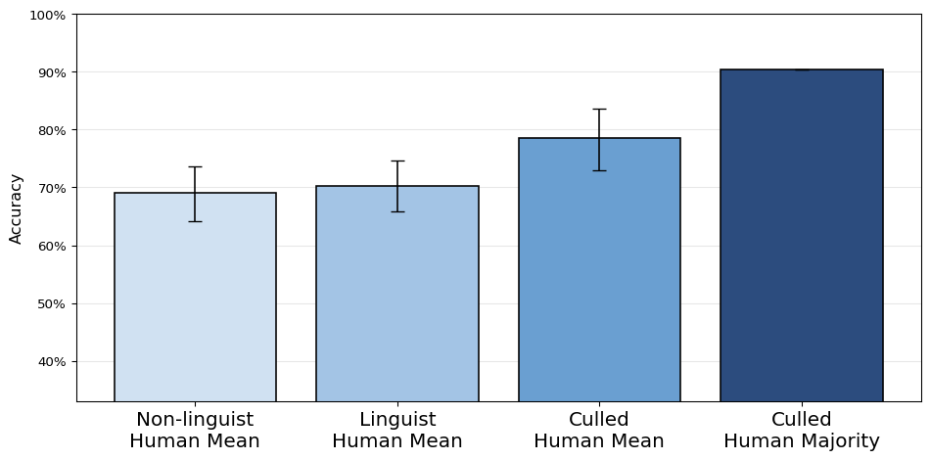  (a) Human Group Accuracies | 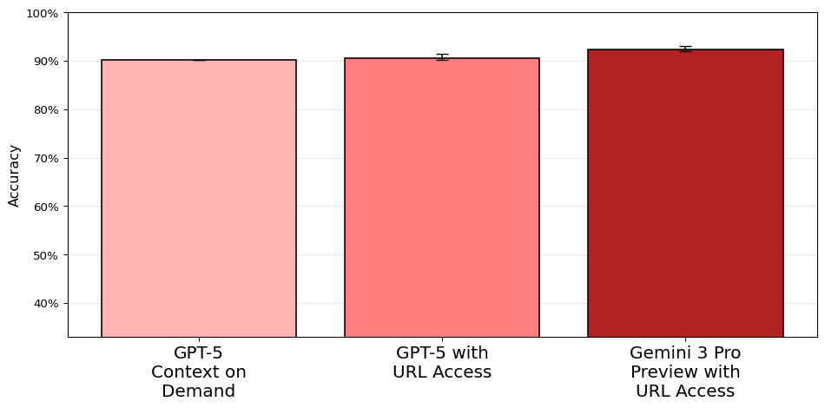  (b) Commercial LLM Accuracies

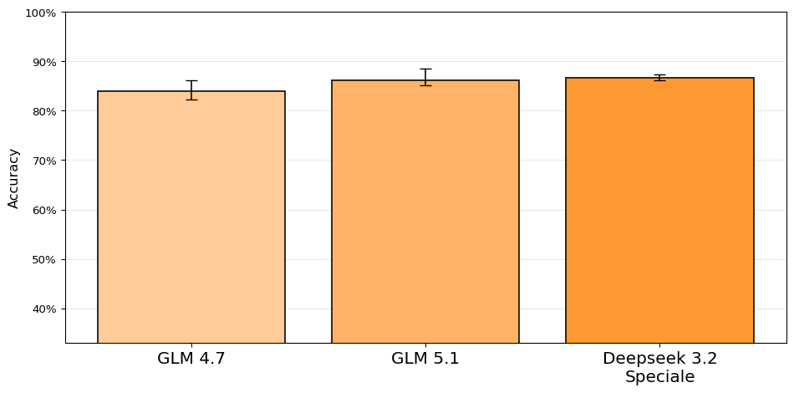  (c) Open Source LLM Accuracies | 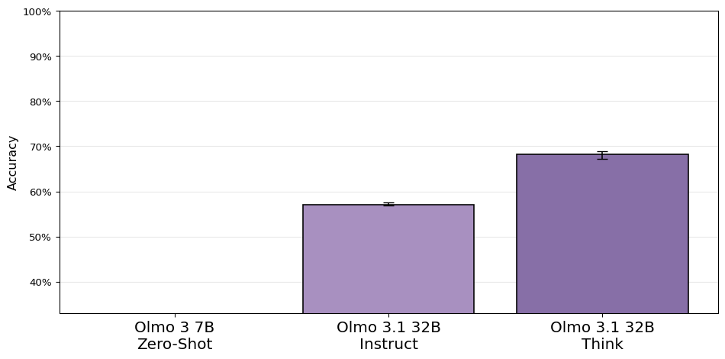  (d) Local LLM Accuracies
Figure 1: Participant accuracies with 95% confidence interval

5.3 Hypothesis 3
Hypothesis 3 said that the performance of the most accurate LLM would not be significantly worse at rare and innovative uses of they than the mean human performance. In my classification of they uses, “rare and innovative uses of they” corresponds to specific singular they as opposed to merely generic they. Therefore, I will compare the accuracy of the best LLM and the culled human mean for singular they as opposed to plural they. Confusion matrices will show the detailed performance for each category by both participant groups. As an additional metric, I will also compare the human and LLM approaches in terms of recall of generic and specific singular they.
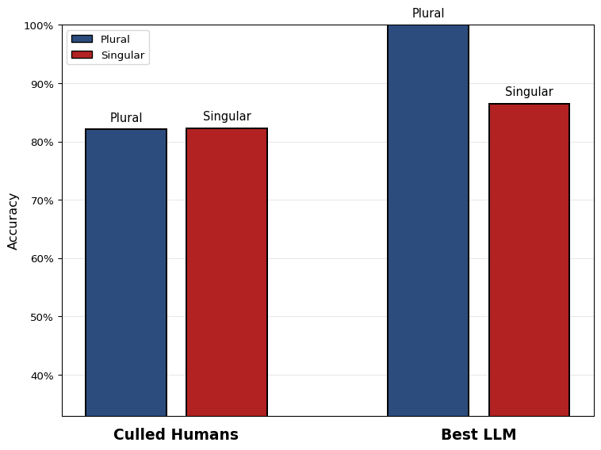
Figure 2: Accuracy difference between plural/singular they and LLMs/humans
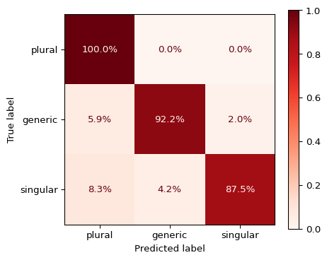
Figure 3: Confusion matrix for the best LLM
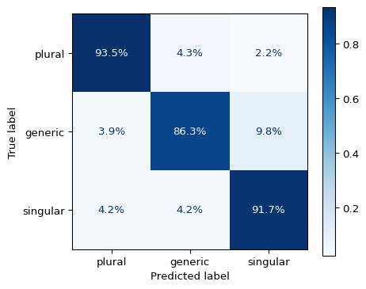
Figure 4: Confusion matrix for culled human mean
Figure 2 shows that humans were not affected by the singular/plural distinction, meaning that they had little to no issue with innovative forms of using they. The best LLM, however, was significantly worse at singular they than plural they (p = 0.023, α = 0.05, Mann-Whitney U one-sided test), which is consistent with various observations in the field pertaining to LLMs’ tendency for common and standard language. It is also plausible that the reported persistent gender bias in LLMs may have contributed to this performance gap, as singular they is often used in contexts where gender is unknown or non-binary. Still, the performance of the best LLM on singular they was not significantly worse than the culled human mean, as shown by the TOST test for non-inferiority (p_lower = 0.019, α = 0.05, Δ = 0.02), which supports hypothesis 3.
The confusion matrices in Figure 3 and Figure 4 further illustrate the differences in performance between the best LLM and the culled human mean. Figure 3 again shows that singular they is the most challenging category for the best LLM, while Figure 4 shows that the most challenging category for humans was generic they. The reason for that is most likely the inconsistent explanation for generic they in the training materials (see Section 3.1), which may have led to confusion among participants.

5.3.1 Recall of generic vs specific singular they
For a potential situation in which a researcher wishes to extract all non-plural instances of they from a large corpus, it is interesting to know how many of them, on average, they would be able to retrieve by using the best LLM vs. relying on a good assistant. Table 4 shows that the performances are very close to each other in terms of this metric, repeating the observed patterns of humans struggling with generic they and singular they being more difficult for an LLM. Crucially, the recall is very high for both groups and both categories, which suggests that the best LLM is a viable tool for retrieving innovative uses of they from large corpora, and that it can perform this task at a level comparable to that of a good human assistant.
Table 4: Recall for generic and specific singular they for the best LLM and the culled human mean
Label | Best LLM Recall | Culled Human Mean Recall
generic | 92.2% | 86.3%
specific singular | 87.5% | 91.7%

5.4 Additional Metrics
To draw a more complete picture of what the results of this study tell us about the capabilities of LLMs and humans in processing innovative uses of they, I will present the following metrics in addition to the main analyses above: the performance for context-(in)dependent items in quantitative and qualitative terms, the projection of results onto a hypothetical distribution of all possible items, and a calculation of cost and time for humans vs. LLMs.

5.4.1 Input length
#TODO: check if accuracy negatively correlated with input length in my data as well

5.4.2 Context-(in)dependence
Table 5, visualized in Figure 5, shows the accuracy for context-dependent and context-independent items for the best LLM and the culled human mean. The result is striking as context-dependent items, which one could reasonably expect to be more difficult due to the added complexity of analysis, are actually easier for human participants. One can only speculate as to why this is the case, but perhaps human participants pay closer attention and review the material more critically when they realize that additional work is necessary. To assess this rather unexpected finding, some qualitative observations based on human participants’ comments and the LLMs’ responses are presented below.
Table 5: Accuracy for context-dependent and context-independent items for the best LLM and the culled human mean
Group | Context-Dependent | Context-Independent
Best LLM | 83.3% | 94.5%
Culled Human Mean | 90.0% | 77.5%

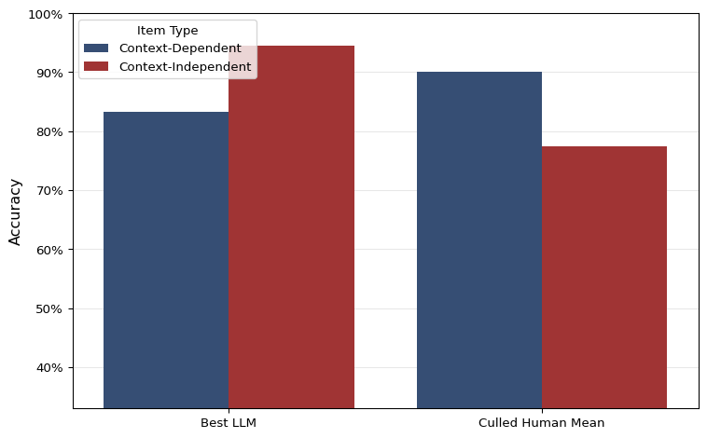
Figure 5: Accuracy for context-dependent and context-independent items for the best LLM and the culled human mean
When looking at the behavior of GPT-5 with URL access, it shows a difference between my own expectations of what examples required context for disambiguation and which ones did not. Of the 34 items that I marked as context-dependent, less than half (14) caused the model to access the context via provided URL. In turn, of the 25 items that did cause the model to check context, only 14 were marked as context-dependent by me. Among the cases that the model failed to look up context I had marked as necessary, however, its accuracy at disambiguating the meaning of they still lay at a relatively high 80.0%, which is very close to the average accuracy of my local study pilots over all items, 80.8%. Among the cases that the model had correctly decided to look up context, its accuracy was only 76%, showing that it likely lacks capabilities in navigating heterogenous and complex contexts. This means that the model’s behavior does not fully align with my expectations of what items require context for disambiguation, and it also accesses context for some items that I would have considered context-independent. It is not clear what causes this difference in behavior but it does point to LLMs’ reasoning capabilities being different from human reasoning, generally to the detriment of the results. In light of study design, it suggests that LLMs fare better without having to research information on their own in order to complete a task, as noticing the lack of necessary information seems to be still too great a challenge for such models. This may impede the study of especially complex linguistic phenomena that require contextual and semantic understanding of text.
When not specifying that the model should access context only in doubtful cases, thus leaving it up to the model, there is a clear tendency for the model to access context more often. Namely, of the 34 context-depentend cases 28 were checked for context, which is a recall of 82%. However, the model checked a total of 106 cases for their context, of which only 28 were actually context-dependent, meaning that the precision of the model’s decision to check context was only 26%. This means that while the model is relatively good at recalling cases that require context, it also checks for context in many cases where it is not necessary, which may lead to worse performance due to the model’s difficulties in navigating complex contexts. Indeed, in the specific context of this study, there was a measurable drop in accuracy by 10% (from 94% to 84%) when the model accessed context vs when it did not. For this reason, the same model performed better when it did not have the option to access context (89%) than when it did (86%), as shown in the previous section.

5.4.3 Projection onto naturalistic data
It might make sense to apply the per-class performance measures to a hypothetical test set with naturalistic frequency splits (take from own data) to then generate MCC and get an estimation of how well the different participants would do on naturalistic data. This will address the lingering question if the artificial selection of data points skewed the results or hid anything about the truth
This will be an important point for the conclusion.

5.4.4 Cost
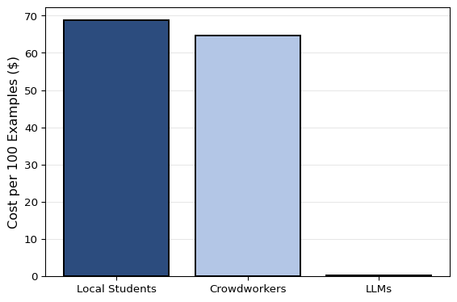
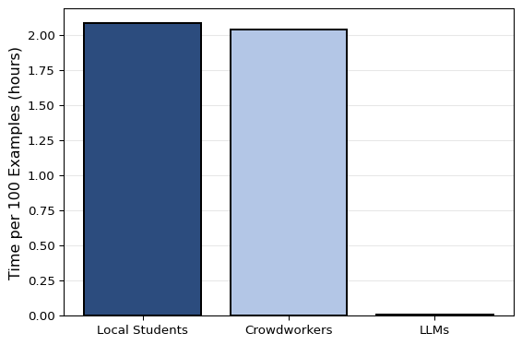
- The cost of crowdworkers was inflated in this study due to filtering inattentive participants only post-hoc and not being able to tell the meaning of “educated in English language” before carrying out the study. Appropriate numbers were obtained thanks to the culling. This means in turn that the responses of 56.1% of crowdowkers were disregarded and their cost was spent fruitlessly.

6. Discussion

6.1 L1 Crowdworkers vs Local L2 Students
The results showed that this task in particular is not automatically solved better by native speakers than by informed L2 speakers. The latter performed at 81.0% as opposed to the 68.0% achieved by native speakers. This is not solely due to the L1 vs L2 status but also a question of competence. The local students had been selected based on their previous high academic achievements and specific knowledge of English linguistics of gender. The difference in performance is not, however, statistically significant. Still, it shows that at this level the native speaker status should no longer be taken as a prerequisite for (annotation) work in this and similar fields or activities. Local students are also preferable due to ethical and practical reasons as communication is easier and there are better mechanisms in place to ensure fairness and research ethics. (Alternative AI suggestion for more adequate phrasing: In this sample, local L2 student pilots showed similar or higher mean accuracy than non-pilot crowdworkers. Because this comparison is observational and groups differ in selection and expertise, it should not be interpreted as an isolated L1 versus L2 effect. The result instead supports the practical point that trained local student annotators can be competitive with crowdworker annotators in this task. And: These data do not support treating native-speaker status alone as a sufficient criterion for annotator selection in this task.) ## Hypothesis 1
Table 2 reveals that the group of top performers is populated by more humans than LLMs, although most top performances cluster around the 90% mark. To directly address Hypothesis 1, the top performer is not an LLM but indeed a human. This participant was furthermore from the pilot participants recruited from the local student body. Hypothesis 1 is therefore rejected.

6.2 Hypothesis 2
The second Hypothesis aims to test if LLM accuracy at the task outperforms the mean human accuracy. As the overall goal of this research is to assess if LLMs could plausibly replace proper student assistants, it makes sense to define “mean human accuracy” more closely. The participants were recruited more liberally than a standard selection process for a student assistant position. They were recruited from only two seminar groups and were prioritized by availability. The crowd workers self-selected by ticking a box that said they had an education in “English language”, without specifying their level of expertise and, in some cases, not actually having studied linguistics, judging by their answers to the screening. To approximate what level of performance one might expect from an actual student assistant, I additionally report a culling-based benchmark variant as sensitivity analysis. This benchmark is defined by removing inattentive annotators and retaining the top half of the remainder. As this benchmark is interpretive and operational and not design-neutral, its results should be interpreted cautiously. still, it may serve as an estimate for what might be “true human performance.” Inattentiveness is formalized in terms of context-dependent performance, i.e. if their performance is at or below 33% when context is necessary to understand an example.
Figure 1 reveals that there is a marked difference between the overall and the culled human mean. This shows once again that crowdworkers as a whole are not a reliable resource for annotation work. The culled human mean, which is supposed to approach the performance level of a specialized student assistant, still falls short of the best three LLMs’ performance. There, it seems that the prompting strategy had only a minor impact, improving performance by just a few percent. The strongest combination of LLM and prompting strategy, {‘label’: ‘Gemini 3 Pro Preview with URL Access’, ‘value’: 0.9233716475095785}, shows a performance that is , however, not significantly better than the culled human mean at p = 0.480682373046875, α = 0.05 according to a McNemar’s test. Hypothesis 2 can therefore not be confirmed. It is still remarkable that the best result of the study is achieved by taking the majority vote of the culled human group. Applying this to a real-world setting, it suggests that teams of experts are still the strongest at this kind of annotation task.

6.3 Research question 2
In an attempt to assess the problem-solving behaviors qualitatively, three aspects of human and LLM responses were analyzed: the optional comment fields in the human survey, the LLMs’ reasoning steps, and the accuracy of LLMs in determining context-dependency in the items.
Human-supplied comments were analyzed to reveal the strengths and weaknesses of their reasoning. The following themes were identified: the biggest issue was their understanding of the in-between category of generic they, followed by some minor cognitive barriers. Their biggest strength seemed to be their skill in discerning when they needed additional context to make a decision (though the quantitative results show that this did not give them an edge over LLMS). The cognitive barrier for humans in this task lies in the processing of very long input texts. While most items in the dataset are fewer than ten sentences long, item 23 is 38 sentences long and the pronoun in question is located in the penultimate sentence. On top of that, the text uses several uncommon words and therefore requires additional research for most. Human participants, potentially also fatigued when they encounter this item, have to choose how much context they read. In all likelihood, they do not want to read such a lengthy text. LLMs, on the other hand, are much less sensitive to the length of text, as long as the input is well within their window (#SOURCE). Indeed, humans answered wrong N times while LLMs only M (#TODO). As previously discussed (#REF), the category of generic is neither plural nor singular. It is not taught as standard grammar teaching to laypeople and not even linguists are assured to have come across it in their studies or work. Thus, some items in the dataset caused trouble for the human participants. For instance, item 20 shows they referring to hypothetical football players, a plural referent. However, the hypothetical nature of the statement seemed more salient to the purarticipants than the plural number of the referent, leading them to classify it as generic. Similarly, item 134 shows they referring to your ancestor, which is an impersonal use of the second person possessive pronoun yo, thus making the reference generic. Most human reasonings focus on tthe use of your but fail to understand its impersonal meaning. The biggest issue with the generic category for human participants were the cases of they referring to everyone and noone. According to the annotation instructions they were to annotate these as plural. The instructions explicitly referred to everyone, noone, and nobody for the plural category. Instead, human participants seemed to have retained the instruction that statements “that [apply] to all X” and accordingly classified these items as generic. This reveals a crucial difference between human and LLM annotators. The latter famousyl exceed at repeating patterns and are thus strong at recognizing cases they received instructions for, regardless of any potential weaknesses in the internal logic of the instructions. Humans, on the other hand, seem to grasp the underlying logic of instructions and override inconsistent instructions. Had the participants been in a real-world annotation setting, they would have likely asked for clarification on the instructions, thus revealing this inconsistency and helping to improve my annotation scheme. Their quantitative weakness (i.e. incorrectly annotating examples involving everyone and noone according to the instructions) is thus really a strength, i.e. because they understood the faults of the underlying logic. Though correct usage of an LLM may have also brought this weakness to the forefront.
When analyzing the LLMs’ reasoning steps, #TODO
- problems unique to LLMS:
** maybe umkao example and how LLMs made more base assumptions in that case
- strengths unique to LLMs:
Some errors were shared among human and LLM participants, #TODO
To determine the LLMs’ accuracy in identifying context-dependency, the prompting strategy that includes the context URL was modified to additionally ask the LLM to declare whenever it decided to access the

7. Conclusion
The results are mixed and it is not straightforward to say if LLMs have truly attained human level at this particular task.
– Results show that semantically complex annotation in linguistics may be done by LLMs at much cheaper cost. The human-machine margin in cost arguably more than compensates the margin in quality.
– The results also show that the under-the-hood reasoning of LLMs has already diminished the importance of prompt engineering for this task, further reducing the risk of human variability and reducing the importance of human expertise altogether.
– Potentially applicable to any other variable dependent on situational, pragmatic, … context, i.e. ‘distant reading’
– Similar research tends to confirm this finding.
– However, some cursory analysis of LLM errors shows that LLMs are prone to being fooled by context.
– Also, bias towards standard English still a limitation, i.e. innovative forms like specific singular they at disadvantage.
- Reasoning models are likely to become better for a while before hitting a plateau.
Ich nehme an, dass LLMs weite Teile der aktuellen linguistischen Forschung tangieren oder massgeblich prägen werden. Dabei befürchte ich aber, dass es zu Problemen verschiedener Art kommen wird. In etwa, weil die Fähigkeiten der LLMs überschätzt oder falsch eingeordnet werden. Oder weil sich, in Anlehnung an den Papst, zu viel Macht und/oder Wissen in den Händen weniger Firmen sammeln wird. Letzteres führt zu einem Plädoyer für wissenschaftsorientierte Open-Weight-Modelle.

7.1 Limitations
Because inferential analyses were primarily based on aggregated accuracies rather than a full item-level hierarchical model, residual item-difficulty effects may remain.
Fully ambiguous cases (even when researching context etc) were not included in this study.
Other languages have their own examples of gender-neutral language with different properties and etymologies/histories. This study may or may not be generalizable to those cases.
I did not investigate a human-LLM cooperative approach and how it would compare to either group alone. This would be an interesting avenue for future research, especially given the complementary strengths but also weaknesses of humans and LLMs revealed in the qualitative analysis. And not least because public discourse often proposes the idea that humans are not threatened by LLMs as long as they work together, a claim worth testing in practice.
The fact that {lores_proportion:.0%}" of the items in their dataset had been filtered for length may have made the task easier for LLMs, as they are sensitive to input length.
The chosen path of LLM-based CRR has the disadvantage of lacking confidence scores and therefore not allowing for recall/precision optimization when processing large corpora.

7.2 Outlook / Future Avenues
Maybe improving cross-document CRR like Kong and Tan (2026) would be a good next step for improving LLM performance on this task for cases where the antecedent is located deeper in a long chain of comments.
– To do:
– – Further qualitative analysis of human & LLM responses
– – Application and evaluation of open source LLMs (replicability!), N-shot prompting, fine-tuning
– – Analyze uses of they in various corpora, potentially uncovering the history of its change and diffusion – – Threat to entry-level / student assistant positions?
– – Environmental impact concerns?

7.3 Debugging etc.

7.4 References
Baron, Dennis E. 2020. What’s Your Pronoun? Beyond He & She. New York: Liveright Publishing Corporation, a division of W. W. Norton & Company.
Brown, Tom B., Benjamin Mann, Nick Ryder, Melanie Subbiah, Jared Kaplan, Prafulla Dhariwal, Arvind Neelakantan, et al. 2020. “Language Models Are Few-Shot Learners.” arXiv. http://arxiv.org/abs/2005.14165.
Cao, Yang Trista, and Hal Daumé III. 2020. “Toward Gender-Inclusive Coreference Resolution.” In Proceedings of the 58th Annual Meeting of the Association for Computational Linguistics, 4568–95. https://doi.org/10.18653/v1/2020.acl-main.418.
Conrod, Kirby. 2019. “Pronouns Raising and Emerging.” Ph.{D}. thesis, University of Washington.
“Coreference Resolution and Entity Linking.” 2026. In Speech and Language Processing: An Introduction to Natural Language Processing, Computational Linguistics, and Speech Recognition with Language Models, 3rd ed. https://web.stanford.edu/~jurafsky/slp3/.
Dallas, Bethany, and Carlos Hartmann. 2026. “A Perfect Annotator? Comparing the Performance of Humans and LLMs as Annotators of Perfective Constructions.” In. Koblenz, Germany.
Gan, Yujian, Yuan Liang, Yanni Lin, Juntao Yu, and Massimo Poesio. 2025. “Improving LLMs’ Learning for Coreference Resolution.” arXiv. https://doi.org/10.48550/ARXIV.2509.11466.
Hartmann, Carlos. 2022. “Shifting Pronouns and Disruptive Technology: Studying Singular They with GPT-3.” Master’s thesis, Zurich: University of Zurich. https://www.zora.uzh.ch/id/eprint/231828/.
Huang, Weihang, and Jack Grieve. 2024. “Authorial Language Models for AI Authorship Verification.” CEUR Workshop Proceedings 3740 (August): 2645–52.
Jubelius, Lena. 2025. “Coding Corpus Data with LLMs. A Case Study on German Double Superlatives.” Mannheim.
Newman, Michael. 1997. “Epicene Pronouns: The Linguistics of a Prescriptive Problem.” Outstanding Dissertations in Linguistics. Ph.{D}. thesis, New York.
Novák, Michal, Miloslav Konopik, Anna Nedoluzhko, Martin Popel, Ondrej Prazak, Jakub Sido, Milan Straka, Zdeněk Žabokrtský, and Daniel Zeman. 2025. “Findings of the Fourth Shared Task on Multilingual Coreference Resolution: Can LLMs Dethrone Traditional Approaches?” In Proceedings of the Eighth Workshop on Computational Models of Reference, Anaphora and Coreference, 95–118. Suzhou, China: Association for Computational Linguistics. https://doi.org/10.18653/v1/2025.crac-1.9.
Paterson, Laura Louise. 2014. British Pronoun Use, Prescription, and Processing: Linguistic and Social Influences Affecting ’They’ and ’He’. Houndmills, Basingstoke, Hampshire ; New York, NY: Palgrave Macmillan.
Pavlovic, Maja, and Massimo Poesio. 2024. “The Effectiveness of LLMs as Annotators: A Comparative Overview and Empirical Analysis of Direct Representation.” In Proceedings of the 3rd Workshop on Perspectivist Approaches to NLP (NLPerspectives) @ LREC-COLING 2024, edited by Gavin Abercrombie, Valerio Basile, Davide Bernadi, Shiran Dudy, Simona Frenda, Lucy Havens, and Sara Tonelli, 100–110. Torino, Italia: ELRA; ICCL. https://aclanthology.org/2024.nlperspectives-1.11/.
Remsö, Amanda, Hanna Bäck, and Emma A. Renström. 2026. “Gender-Inclusive Pronouns and Mental Representation of Nonbinary Individuals: The Role of Political Orientation.” Journal of Language and Social Psychology, March, 0261927X261430393. https://doi.org/10.1177/0261927X261430393.
Rose, Ell, Max Winig, Jasper Nash, Kyra Roepke, and Kirby Conrod. 2023. “Variation in Acceptability of Neologistic English Pronouns.” Proceedings of the Linguistic Society of America 8 (1). https://doi.org/10.3765/plsa.v8i1.5526.
Seminck, Olga, Antoine Bourgois, Yoann Dupont, Mathieu Dehouck, and Marine Delaborde. 2025. “GLaRef@CRAC2025: Should We Transform Coreference Resolution into a Text Generation Task?” In Proceedings of the Eighth Workshop on Computational Models of Reference, Anaphora and Coreference, 119–29. Suzhou, China: Association for Computational Linguistics. https://doi.org/10.18653/v1/2025.crac-1.10.

The linguistic element to which a pronoun points is normally called antecedent. The “referent” denotes the real-world entity behind that antecedent. Since pronouns can sometimes have a referent without having an antecedent and it is the referent that truly number-disambiguates the meaning of they, the term “referent” is preferred in this paper
they, them, their, theirs, themself and themselves.
/r/UnitedKingdom and /r/BritishProblems.
/r/Australia, /r/Sydney, /r/Melbourne, /r/Brisbane, and /r/Adelaide.

