Carlos Hernandez

Professor Dinesh Sthapit

CSC120

2 April 2021

Base Number System Assignment

Summary: The video is an explanation on converting to different number bases from base 10. The man explains that you would take whatever number of the base you are converting to, put it to the highest power divisible, and then divide the remainder by the previous power minus 1 until eventually you are left with the number in the new base form. Each number is the number of times it was divisible by the exponent. For example, in 66 base 10 to base 8, we would do an exponent of 2 on 8 which equals 64, leaving us with a remainder of 2, it was divisible 1 time so we note down the 1. We move on to the next exponent which is 1 which equals 8, and that isn’t divisible so it we note down the 0. Finally, 8 to the 0 power is 1 and that divides 2 times into the remainder of 2 with no remainder so the conversion stops and we are left with 102 in base 8.

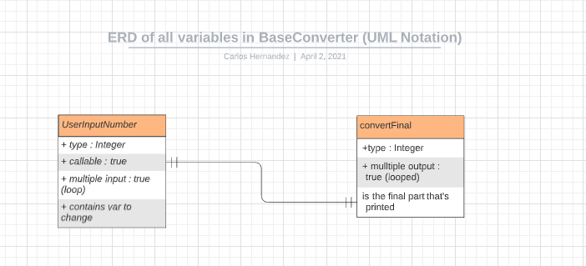

Here’s my ERD design documentation for this program. It denotes the attributes and relationships of the 2 variables my program is built on.