This document gives an overview on the order of events necessary to submit information about your trial. This can be done using the wizard.

It further names all fields required for the submission of a new plant trial.

**BIP user account**

In order to submit content to the Brassica Information Portal, you need to sign in with your ORCiD account. If you don’t have an ORCiD account yet, you will be referred to their services from our Sign in:

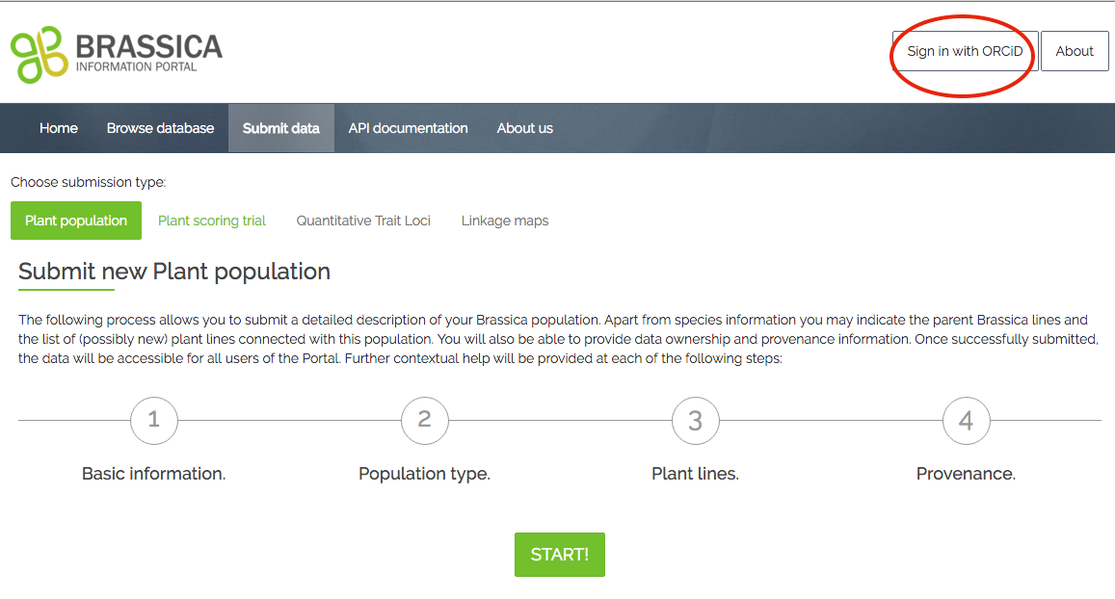

Your data submission to the Brassica Information Portal is split into two different submissions and need to be executed in the following order:

1)  Population Submission

2)  Trial Submission.

The Population Submission documentation can be found in context with population submissions, here: https://bip.earlham.ac.uk/submissions/new

**Trial submission using the wizard**

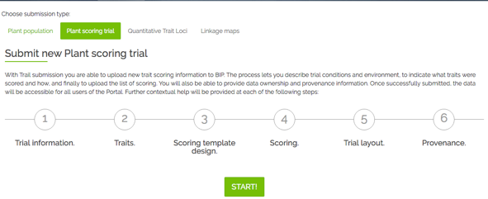After submitting your experimental plant population, you can submit the trait scoring data (your measured traits) of your trial. This is a 6-step process, during which you also submit metadata that describes your trial. Go to [bip.earlham.ac.uk](https://bip.earlham.ac.uk/) and click on submit data. Choose “Plant scoring trial” and click “START!”.

The wizard walks you through all the steps, offering compulsory and optional fields to be filled out. In the table below you see a list of all fields during the submission process. Those fields marked with * are compulsory for the submission.

|  |  |  |  |  |  |  |  |  |  |  |  |  |  |  |  |  |  |  |  |  |  |  |  |  |  |  |  |  |  |  |  |  |  |  |  |  |  |  |  |  |  |  |  |  |  |  |  |  |  |  |  |  |  |  |  |  |  |  |  |  |  |  |  |  |  |  |  |  |  |  |  |  |  |  |  |  |  |  |  |  |  |  |  |  |  |  |  |  |  |  |  |  |  |  |  |  |  |  |  |  |  |  |  |  |  |  |  |  |  |  |  |  |  |  |  |  |  |  |  |  |  |  |  |  |  |  |  |  |  |  |  |  |  |  |  |  |  |  |  |  |  |  |  |  |  |
| --- | --- | --- | --- | --- | --- | --- | --- | --- | --- | --- | --- | --- | --- | --- | --- | --- | --- | --- | --- | --- | --- | --- | --- | --- | --- | --- | --- | --- | --- | --- | --- | --- | --- | --- | --- | --- | --- | --- | --- | --- | --- | --- | --- | --- | --- | --- | --- | --- | --- | --- | --- | --- | --- | --- | --- | --- | --- | --- | --- | --- | --- | --- | --- | --- | --- | --- | --- | --- | --- | --- | --- | --- | --- | --- | --- | --- | --- | --- | --- | --- | --- | --- | --- | --- | --- | --- | --- | --- | --- | --- | --- | --- | --- | --- | --- | --- | --- | --- | --- | --- | --- | --- | --- | --- | --- | --- | --- | --- | --- | --- | --- | --- | --- | --- | --- | --- | --- | --- | --- | --- | --- | --- | --- | --- | --- | --- | --- | --- | --- | --- | --- | --- | --- | --- | --- | --- | --- | --- | --- | --- | --- | --- | --- | --- | --- |
| **Step 1** asks you for general trial information. When coming up with a Plant trial name, try to follow the nomenclature in the table to the right.  An already existing Trial name is called U.Nottm_2016_RIPRleafminerals_REMLmeans. In this step you also link your previously submitted plant_population to your plant_trial, by selecting your experimental plant_population from a drop-down menu.  **In step 2** you define the traits which you have investigated during your trial. If you have measured traits with the same method as are already registered in the database, you start typing the trait’s name in the box beneath “trait descriptor list”. If the trait does not yet exist, you can define a new trait by clicking “add new trait descriptor”. When adding new traits, some fields are compulsory, following the Crop Ontology model of <Trait><Method><Scale>. Other information can be added in case it is available.  **In step 3** you specify what information you will upload together with your trait scores.  Here, you specify whether you give information on the plant_lines or plant_varieties associated with your germplasm.  In case you are submitting raw data, you will be asked to add information on the trial design in case you want to submit raw data. For examples, please look in step 3-scoring template design in the table on the right. Also, you can specify the number of technical replicates, if present. Keep it at “1”, if no technical replicates are present.  **In step 4** you will be able to download the template (see figure 1) you use for the submission of your trait data. It has been created according to the choices you have made so far in your submission (e.g. traits to be submitted, see Fig 2). If you see that the headers don’t correspond to the data you want to submit, navigate back to previous submission steps and amend them accordingly. An altered template can then be downloaded at this step.  Please **be careful when pasting your trait scores** beneath the correct headers, as they may not appear in the order they are recorded in your source spreadsheet.  **Step 5** is optional, where you can submit an image of the trial layout, in case you submit raw data. Such an image would be helpful to interpret patterns in the raw data- in the workshop we don’t have such information.  **Step 6** asks you to fill in some information about the provenance of the data you just submitted. You can choose to put an embargo on the data and wait with the submission until for example your paper is ready to be published. | |  |  |  | | --- | --- | --- | | **Step 1 - Trial information** | | | | Plant trial name*  <institute id>_<YYYY>_<trialSubject>_<raw/processed > | | | | Project name* | | | | Experimental plant population*  Your previously submitted plant population n | | | | Trial year* | | | | Trial description* | | | | select: data status: raw vs. processed (analysed) data | | | | Institute* | | | | Terrain | | | | Soil type | | | | Statistical factors | | | | Country* | | | | Place name* | | | | Trial location site name | | | | Latitude | | | | Longitude | | | | Altitude | | | |  | | | | Step 2 -Traits | | | | Select trait descriptors* | | | | | When adding new trait descriptor: | | | | Descriptor name* | Materials | Precautions | | Trait category* | Instrumentation required | Scoring  method | | Units of measurements* | Calibrated against | Possible interactions | | Score type | Likely ambiguities | Additional annotations | | Where to score | Controls |  | |  |  | | | Step 3 - Scoring template design | | | | Select genetic material origin | | | | plant lines or plant varieties | | | | select design factors:block,plot,rep etc (raw data) | | | | specify technical replicate numbers (raw data) | | | |  | | | | Step 4 - Scoring Template Submission | | | | download .csv file template | | | | add trait scores to corresponding header | | | | add plant scoring unit (=sample_id)*, plant accession*, originating organisation*, | | | | Plant line or variety* | | | | upload .csv file* | | | |  | | | | Step 5 Submit Trial Layout | | | | Submit image of trial layout | | | |  | | | | Step 6- Provenance | | | | Data owned by | | | | Data provenance | | | | Comments | | | | Visibility-public/private* | | | |

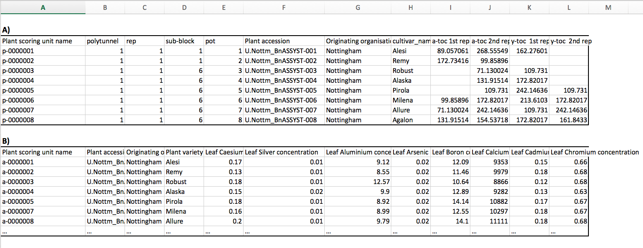

**Figure 2** Readily filled out submission templates, which would be uploaded to the BIP in Trial submission step 4. The user determines the final content of the trial submission template depending on the type of data submitted. **A)** A submission template enabling raw data submission was filled out with information on the trial design (columns B-E) as well as technical replicates (columns J, L) **B)** A submission template generated for processed data, where the trait measurements (columns E-L) are derived from statistical analysis.

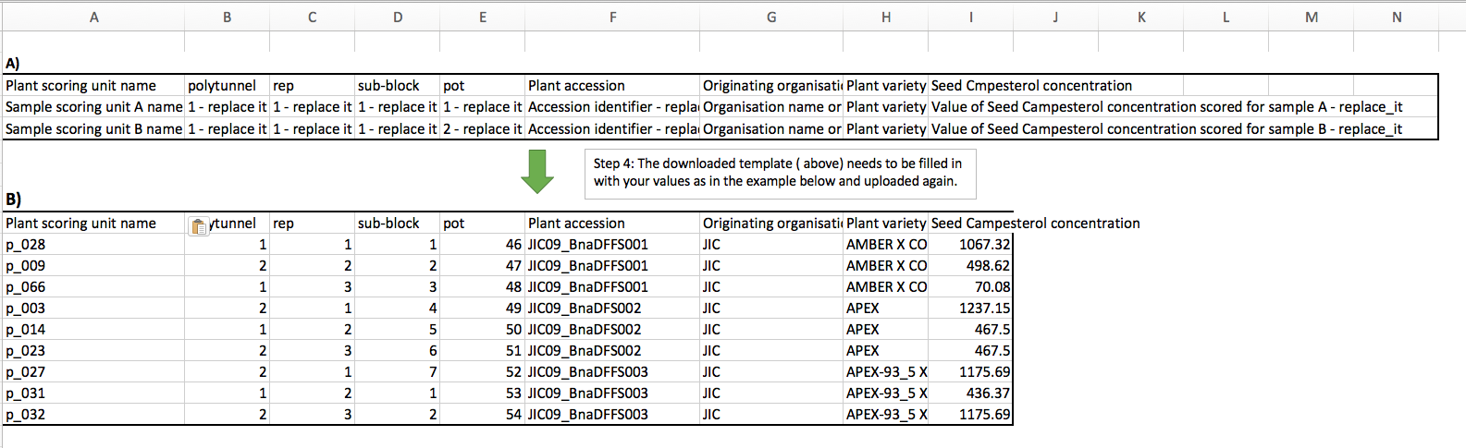

**Figure 1** Example trial submission template in step 4 **A)** a user’s constructed submission template based on the user’s dataset. Prior to downloading this template, the user would have specified information about the dataset to be submitted, which has resulted in the final template. **B)** The filled in template previously seen in A). In all cases, fields like Plant scoring unit name (column A), Plant accession (column F), originating organization(column G) and Plant variety or Plant line (column H) are compulsory fields to be filled out.