**Introduction**

This document gives an overview on the order of steps necessary to submit information on your experimental population to the Brassica Information Portal. This can be done using the wizard and the ruby client. Later, it names all fields required for the submission of your new experimental plant population.

Data submission to the Brassica Information Portal is split into two different submissions and need to be executed in the following order:

1. Population Submission
2. [Trial Submission](https://bip.earlham.ac.uk/manuals/upload_trial_submission.pdf)

Plant population is a collection of the genetically distinct plant material used in your trial. Because trial submission requires the name of your experimental population, it is necessary to submit population information first.

This document describes

1. Population Submission using the wizard
2. Population Submission using the Ruby client

Training material available to practice the upload may be find with [BIP training materials](https://github.com/TGAC/BIP_training).

**BIP user account**

In order to submit content to the Brassica Information Portal, you need to sign in with your ORCiD account. If you don’t have an ORCiD account yet, you will be referred to their services from our Sign in.

To register, go to [bip.earlham.ac.uk](https://bip.earlham.ac.uk/) and click on the ‘sign in with ORCiD’ button in the top right corner.

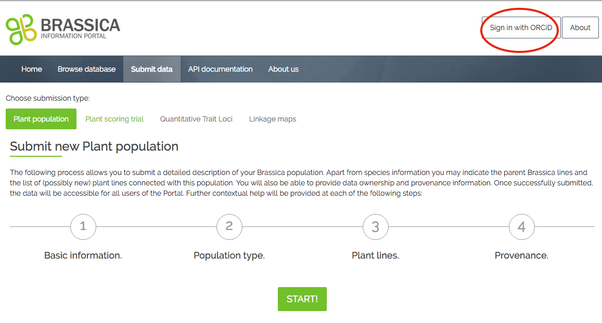

**Population Submission using the wizard**

We start with an example to learn the wizard before attempting submitting your own population data.

Open the 1_BnaDFFS file you will be using for the upload and become familiar with the data. The file contains all columns necessary for the submission of this population.

It reflects a subset of the Diversity Fixed Foundation Set produced by OREGIN project. Imagine, your institution has received OREGIN germplasm material, bulked it up and conducted phenotyping experiments on it.

Population Submission is a 4-step process during which you also submit metadata that describes your experimental plant population.

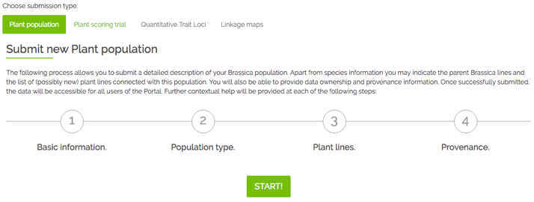

Figure 1 To access the population submission wizard, please go to https://bip.earlham.ac.uk/submissions/new

The wizard walks you through all the steps of the submission, offering compulsory and optional fields to be filled out. In the table below you see a list of all fields during the submission process. Those fields marked with * are compulsory for the submission.

Go to [bip.earlham.ac.uk](https://bip.earlham.ac.uk/) and click on submit data. Choose “Plant population” and click “START!”.

**Step 1.** asks for basic information on your population. You may apply the following nomenclature when submitting the experimental plant population name: <Genus initials><Population type abbreviation>

Nomenclature examples: BnaTNDH (Doubled Haploid mapping population derived from cross between Tapidor DH and Ningyou 7) or BnaDFS (a Brassica napus diversity foundation set).

**Step 2.** Information about parents is not required in this case, as we are submitting a diversity foundation set. A column ‘Species’ will turn up in the template that is downloadable in step 3. Leave these fields blank.

**Step 3**. Download a template for the submission of plant_lines and associated information. Copy and paste the content in file 1_BnaDFFS under the appropriate header.

**Step 4**. Provide information about the provenance, list personnel involved in generating the data you are about to submit. You can choose to put an embargo on the data and wait with the submission until for example your paper is ready to be published. Whilst under embargo, the data is only visible to you (when logged in).

|  |  |  |
| --- | --- | --- |
| **Step 1 - Basic information** | | |
| Population Name* | |  |
| Description  Population type*  Establishing organization* | | |
| Population owned by | |  |
|  |  |  |
| **Step 2 - Population Submission** | | |
| Taxonomy term | |  |
| Female parent line  Male parent line | |  |
|  |  |  |
| **Step 3 - Plant lines** | |  |
| download .csv file template  (see below for example)  suggest adding missing plant lines  upload file ready for submission | | |
|  |  |  |
| **Step 4 - Provenance** | |  |
| Data owned by | |  |
| Data provenance | |  |
| Comments | |  |
| Visibility-public/private* | | |
|  |  |  |

Figure 2 shows a filled-out template for a DFFS submission. In this specific example, we don’t have information for some of the fields and need to leave it blank. Please do not remove columns even if you do not submit any values for them. Note that the ‘Establishing Organisation’ field, which in this case refers to the Institution that has bulked up the particular seed lot (Accessions).



Figure 2 Population submission template that can be downloaded in step 3. Note that this feature is not yet implemented in the current version of our database.

**Population Submission using the ruby client**

The population submission client is a ruby script parsing information (objects) from a .csv spreadsheet provided by the user to the mapped location in the BIP database via the BIP-API. In order to understand the underlying resource and attribute names used in the script, please see the respective tables in the [API-documentation](https://bip.earlham.ac.uk/api_documentation).

During your submission, you will be using the terminal window. Therefore, you need to be familiar with the basics in navigating folders and moving and manipulating files in Linux or DOS (Windows command line). If you are new to command line, click on the links for basic information on how to navigate your computer [using Terminal (OSX)](https://www.youtube.com/watch?v=-Vl4rpZVA6I) or [Command Prompt (Windows)](https://www.youtube.com/watch?v=MNwErTxfkUA) .

**Install software:**

Step 1. Get ruby 2.3+

On OS X you may use brew (<http://brew.sh/)>

>brew install ruby

On Windows, use rubyinstaller (<http://rubyinstaller.org/>)

**Files required:**

Access the ruby client and an example .csv-file here:

<https://github.com/TGAC/brassica/tree/master/public/population_submission>

The population_submission.rb client currently enables the submission of all fields listed in table 2.

If you are not familiar with ruby, the [training material](https://github.com/TGAC/BIP_training) walks you through each step that needs to be taken in order to modify the client and input template for your own population submission. Some important file manipulation will be described below.

The .csv –file is an input template that goes with the current structure of the client. You have to change your input .csv file according to the information you have on your population.

**File manipulation:**

**The ruby client**

Open the file population_submission.rb and scroll through the client-file

Beneath “ 1. Creating experimental plant_population “, you will see information as displayed in figure 3.

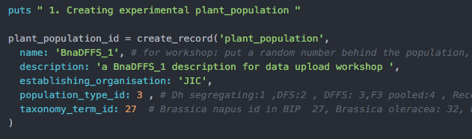

Figure 3 example text describing the plant population in population_submission.rb

Please enter the following information on your population directly in the script:

- name,

- description

- establishing_organisation

- population_type_id

- taxonomy_term_id

Nomenclature examples for the plant_population.name are: BnaTNDH (Doubled Haploid mapping population derived from cross between Tapidor DH and Ningyou 7) or BnaDFS (a *Brassica napus* diversity foundation set).

|  |
| --- |
| **Table 2. Fields required* for the submission of an experimental Population. They are presented below by <resource_name>.<attribute_name>.**   * Plant_populations.name * Plant_populations.population_type * Plant_populations.description * Plant_population.establishing_organization * Plant_lines.plant_line_name * Taxonomy_terms.id * Plant_varieties.plant_variety_name * Plant_accessions.plant_accession * Plant_accessions.year_produced * Plant_acessions.originating_organisation   *Note that more fields are available for submission of information to the BIP; to find the description of their names, please go to our [API-documentation](https://bip.earlham.ac.uk/api_documentation). |

**The .csv file**

With the help of the client population_submission.rb you are able to read in the content of your own .csv input file with your population metadata to the Brassica Information Portal.

The template PopSub_metadata_example.csv (Figure 2) reflects the current commands in the population_submission.rb client to read in data from that .csv file. It can be altered to the information available on your experimental plant population.

The template files (Figure 1 and 2) contain the minimal requirements of information for a population submission to the Brassica Information Portal. More fields are available in the database. To find out which information can be added, please go to our [API-documentation.](https://bip.earlham.ac.uk/api_documentation)

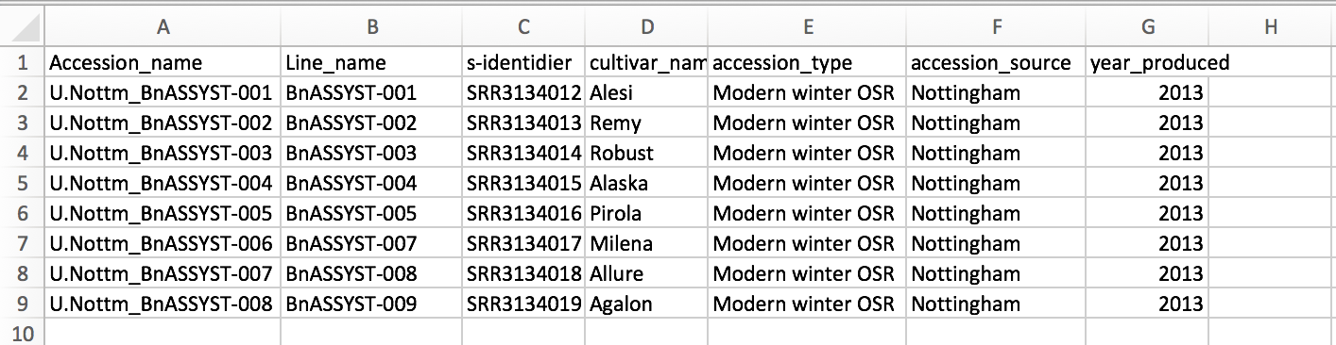

Figure template of a .csv file that corresponds to the population submission client's commands. If you have more metadata to submit in your .csv, you need to change the ruby client accordingly.

**Retrieve your API key:**

Sign in to BIP to retrieve your API key

1. Click on API key in the popup bar under your user name.
2. Copy the API key and paste in your command to run the submission client (see below).

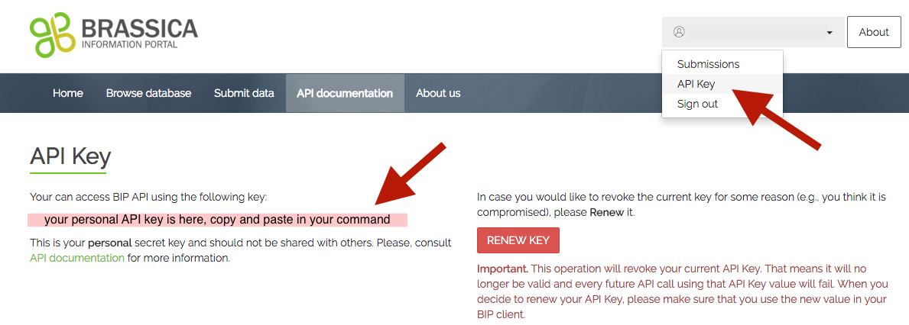

**Run submission client:**

First, double-check your submission file and script.

To finally submit your population, use your terminal or command prompt to navigate into the folder your ruby- client and population metadata -.csv files are located.

Run the command below. Make sure your input file and the submission script are located in the same folder or add the paths to their name:

>ruby population_submission.rb <your_input_file.csv> <your_api_key>