**nTrace screenshot**

Error checking:

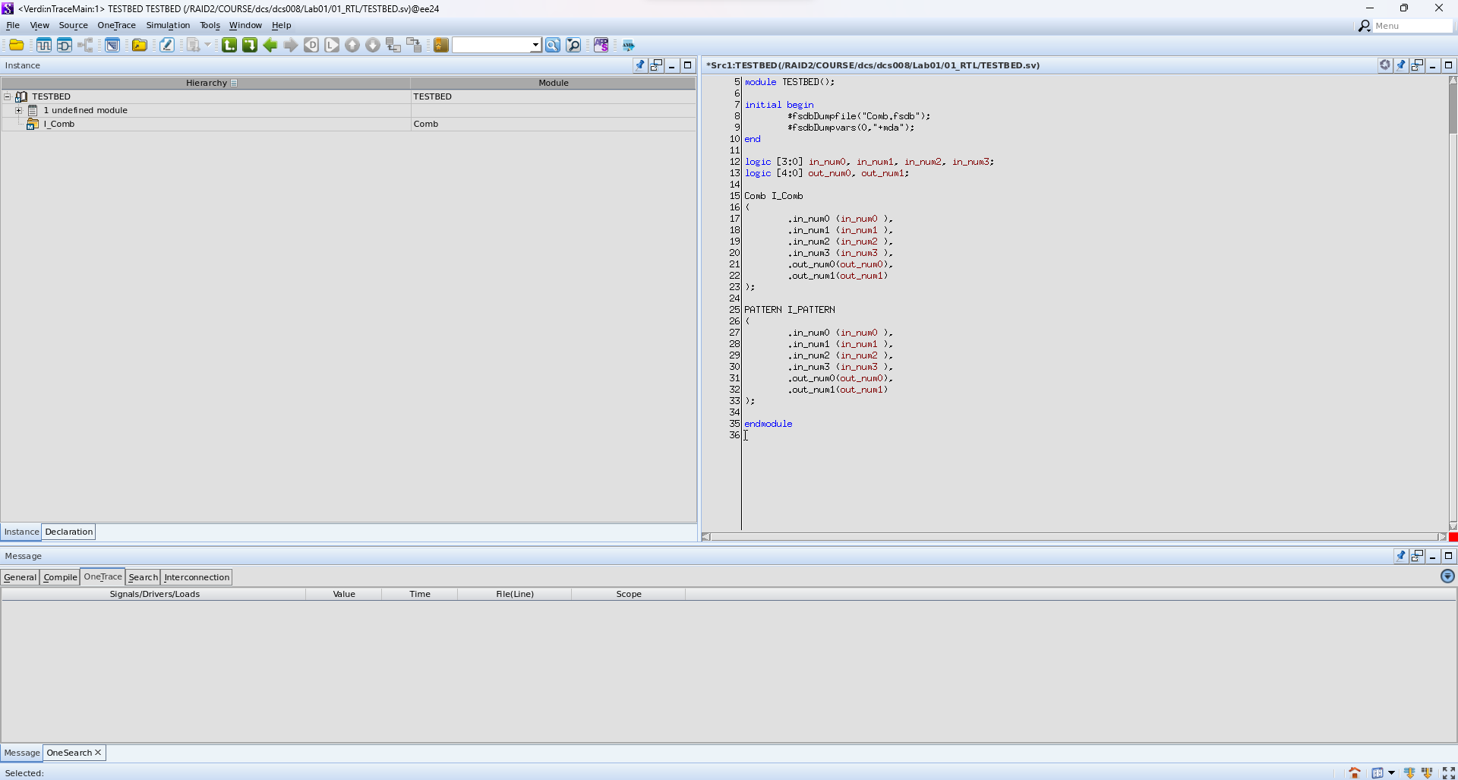

Hierarchy tracing:

(1)model “TESTBED” calling submodule “I_Comb”

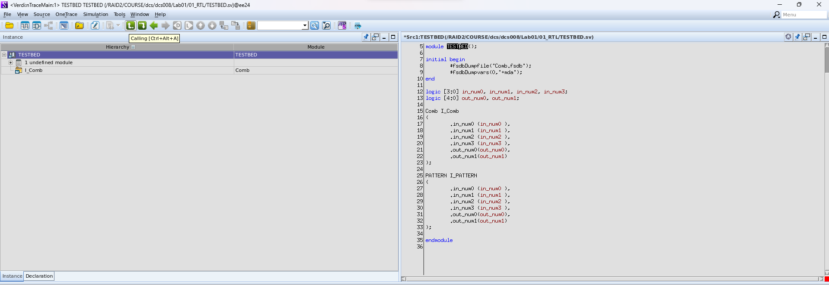

(2)definition of submodule “I_Comb”

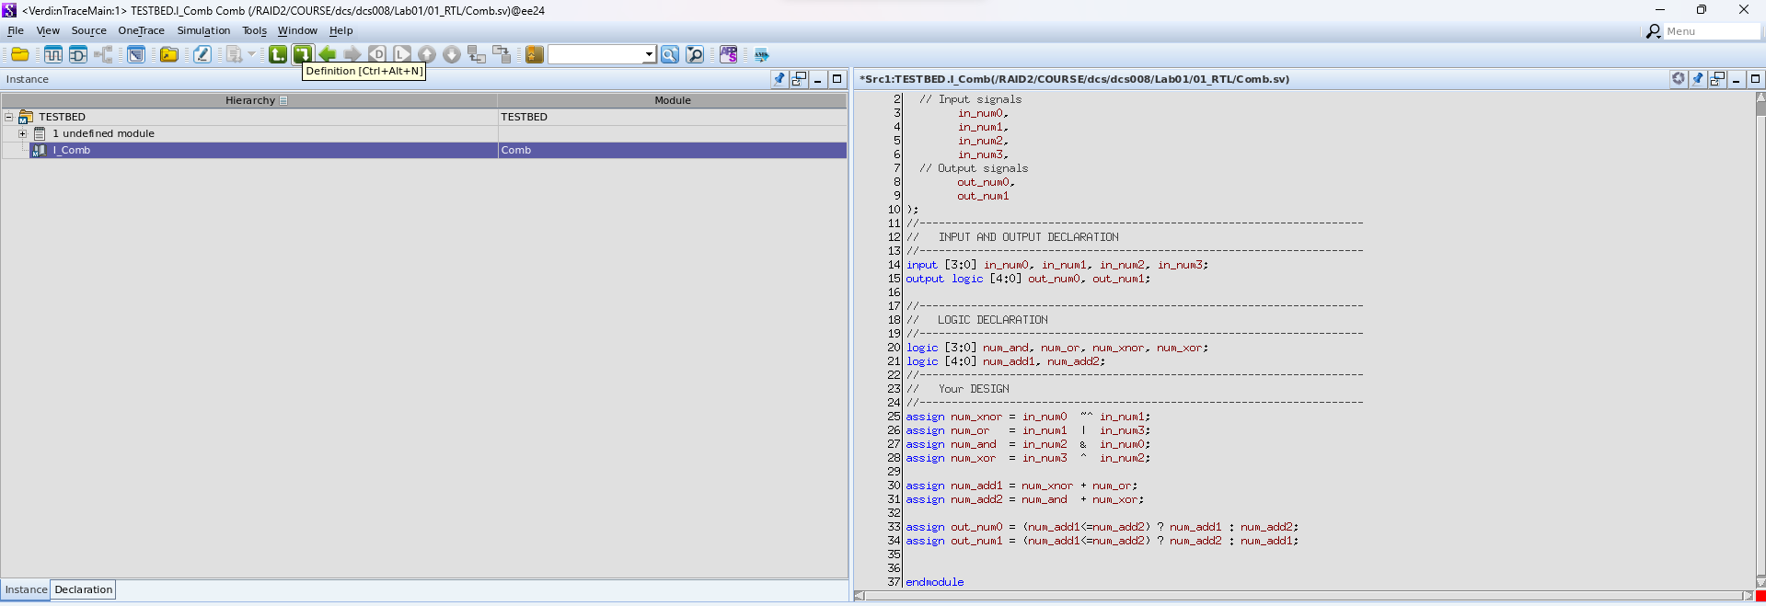

Signal tracing:

(1)trace the signal is driven by which signals.

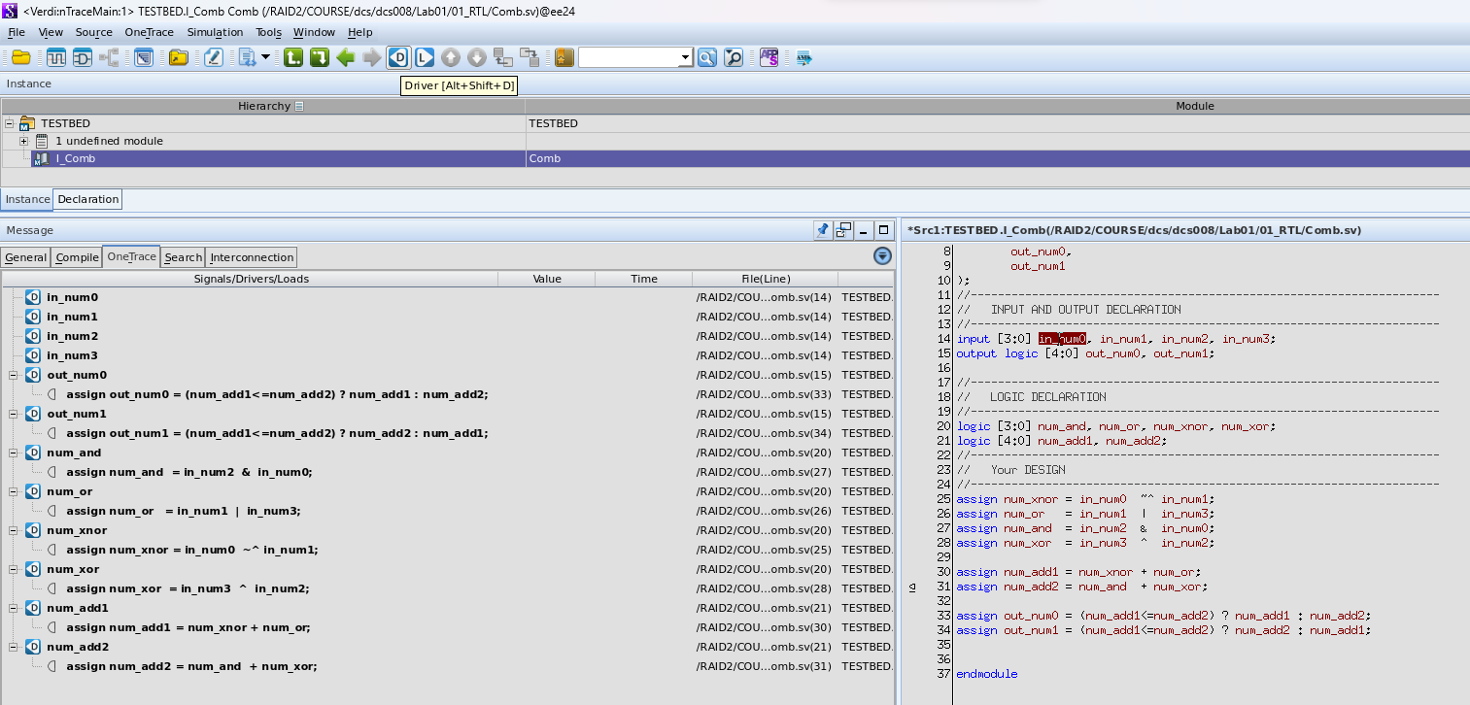

(2)trace the signal is loading to which signals.

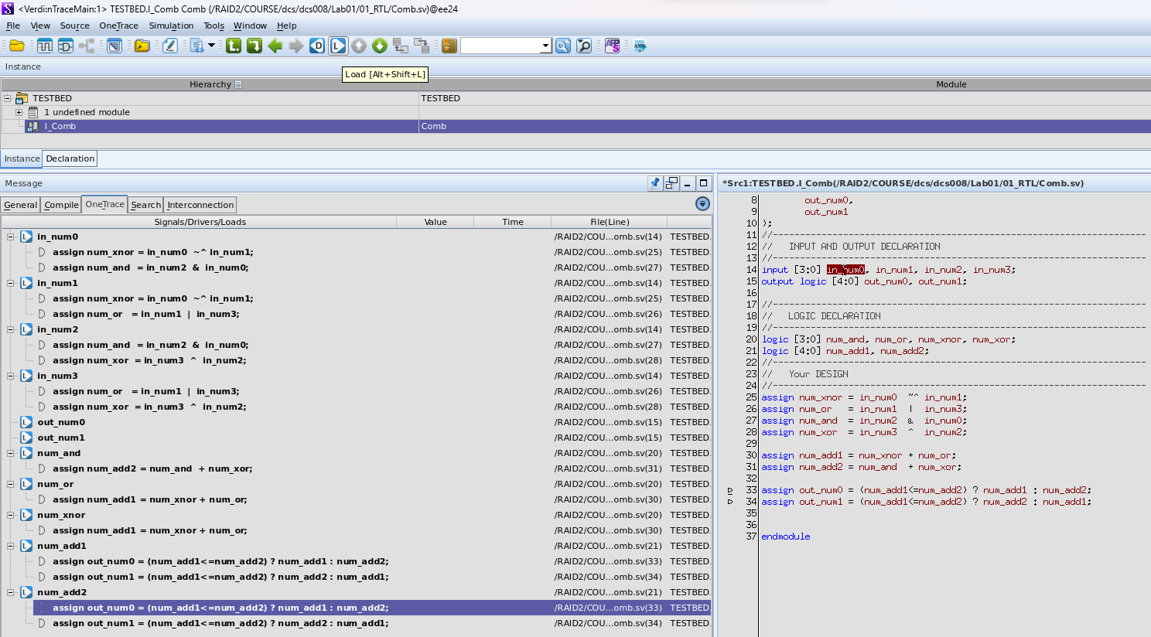

**nSchema screenshot**

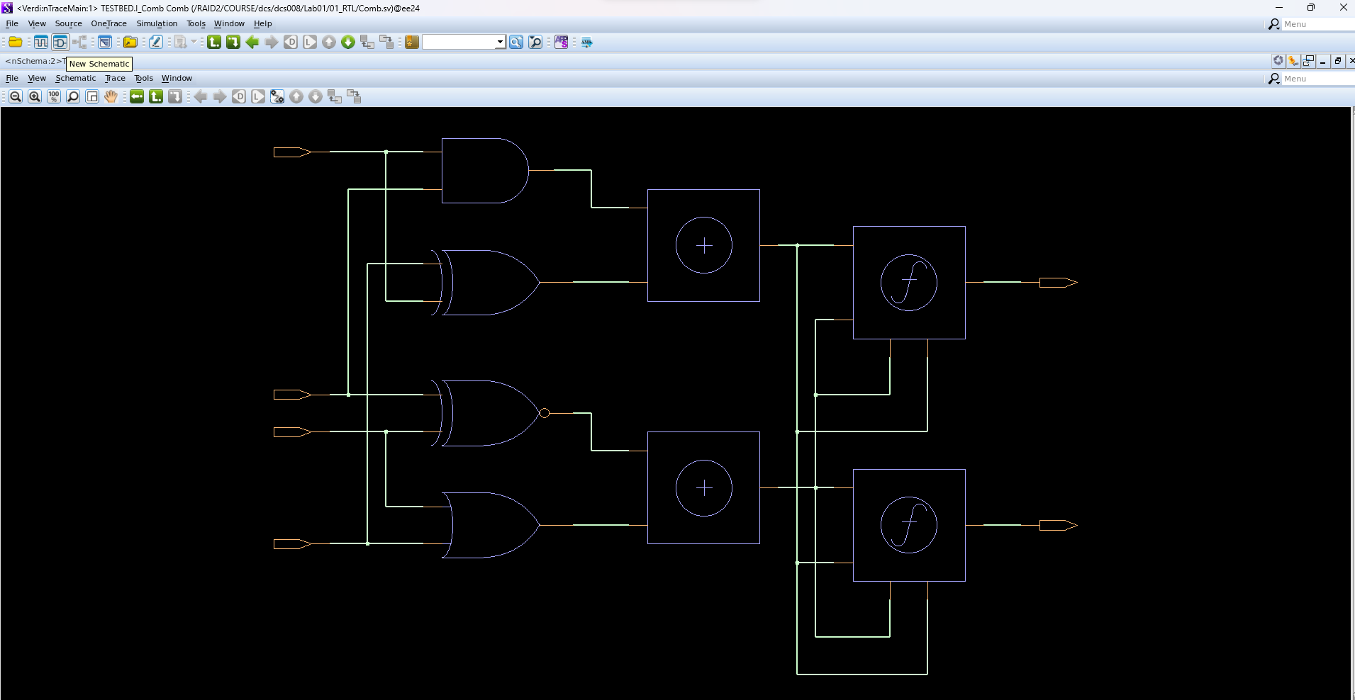

**nWave screenshot**

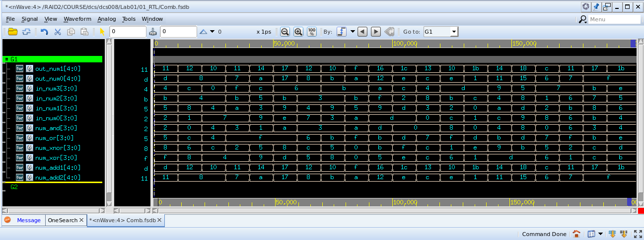

**Questions**

• At 60ns, what’s the value of num_xor and num_add2 in decimal?

num_xor[3:0] = 13->5

num_add2[4:0] = 23->8

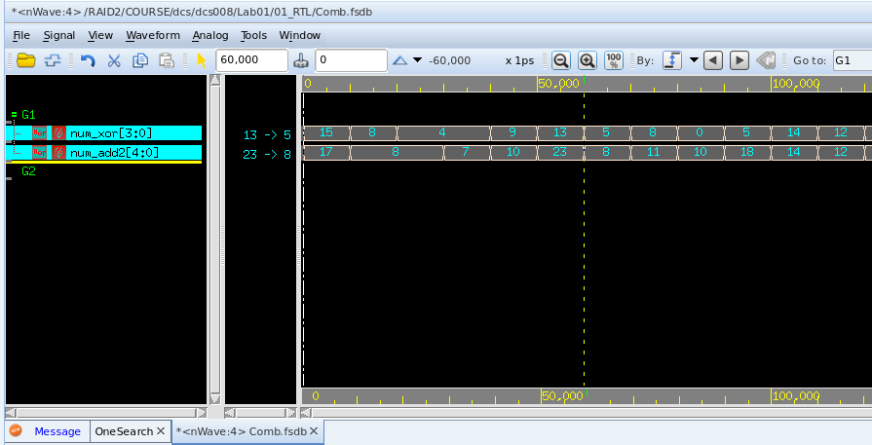

• At 100ns, what’s the value of num_xnor and out_num0 in binary?

num_xnor[3:0] = 1011->1111

out_num0[4:0] = 1_0010->1110

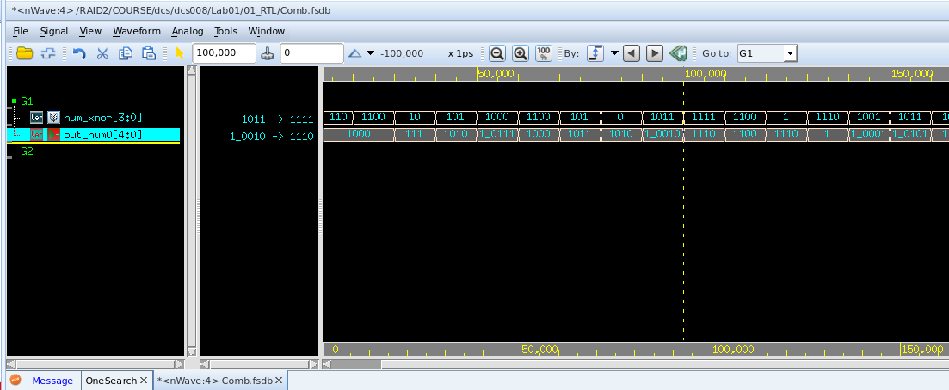

• Trace which signals drives out_num0 (use nTrace)

Signal “num_add1”, “num_add2” drives out_num0.

• Trace which signal is loading from num_xor (use nTrace)

Signal “num_add2” is loading from num_xor.

